**Supplementary data for the manuscript entitled:**

**Molecular, biochemical and behavioural evidence for a novel oxytocin receptor and serotonin 2C receptor heterocomplex.**

**Barbara Chruścickaaf, Caitlin S.M. Cowana, Shauna E. Wallace Fitzsimonsa, Dasiel O. Borroto-Escuelab,Clémentine M. Druellea, Panagiota Stamoua, Cristian A. Bergmanna, Timothy G. Dinana,c, David A. Slatteryd,Kjell Fuxeb, John F. Cryana,e,Harriët Schellekensa,e,\***

aAPC Microbiome Ireland, University College Cork, Cork, Ireland.

bDepartment of Neuroscience, Karolinska Institutet, Stockholm, Sweden.

cDepartment of Psychiatry and Neurobehavioural Science, University College Cork, Cork, Ireland.

dDepartment of Psychiatry, Psychosomatic Medicine and Psychotherapy, University Hospital Frankfurt, Frankfurt, Germany.

eDepartment of Anatomy and Neuroscience, University College Cork, Cork, Ireland.

fMałopolska Centre of Biotechnology, Jagiellonian University, Kraków, Poland.

**Corresponding author**

*Harriët Schellekens, Department of Anatomy and Neuroscience, 3.85 Western Gateway Building, University College Cork, Cork, Ireland.   
E-mail [H.Schellekens@ucc.ie](mailto:H.Schellekens@ucc.ie)

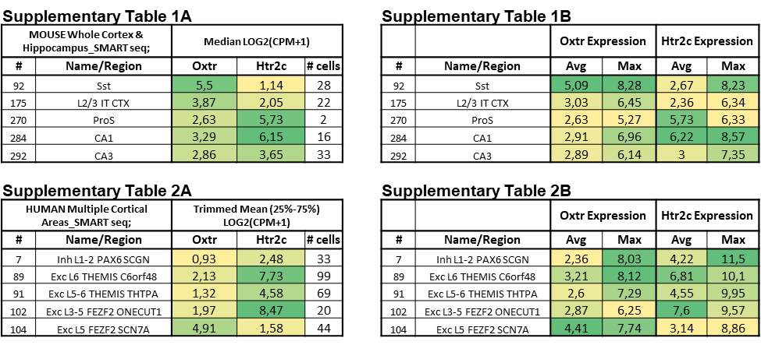

**Fig. S1.** ***In silico* analysis of the 5-HTR2C and OTR co-expression in the brain.** *In silico* analysis of the 5-HTR2C (*Htr2c*) and OTR (*Oxtr*) co-expression in the brain using RNA-sequencing data of the mouse whole cortex and hippocampus (Table 1) and human cortex (Table 2) in the Allen Brain Atlas (<https://celltypes.brain-map.org/rnaseq/mouse_ctx-hip_smart-seq>). The median expression values (Table 1A) are depicted for the mouse cortex and hippocampus, the trimmed mean expression values for expression in human cortical neurons (Table 2A), and the averages and maximum expression (Table 1B and Table 2B).

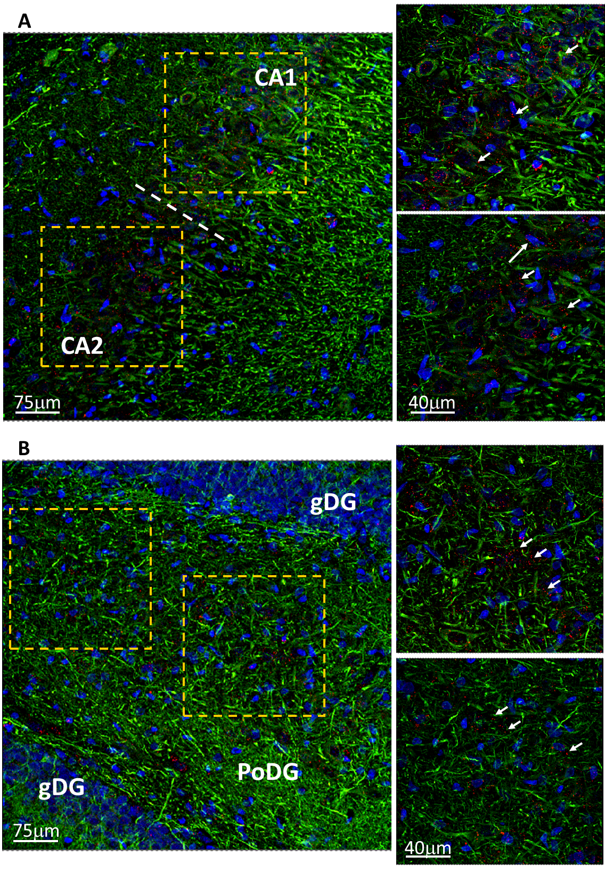

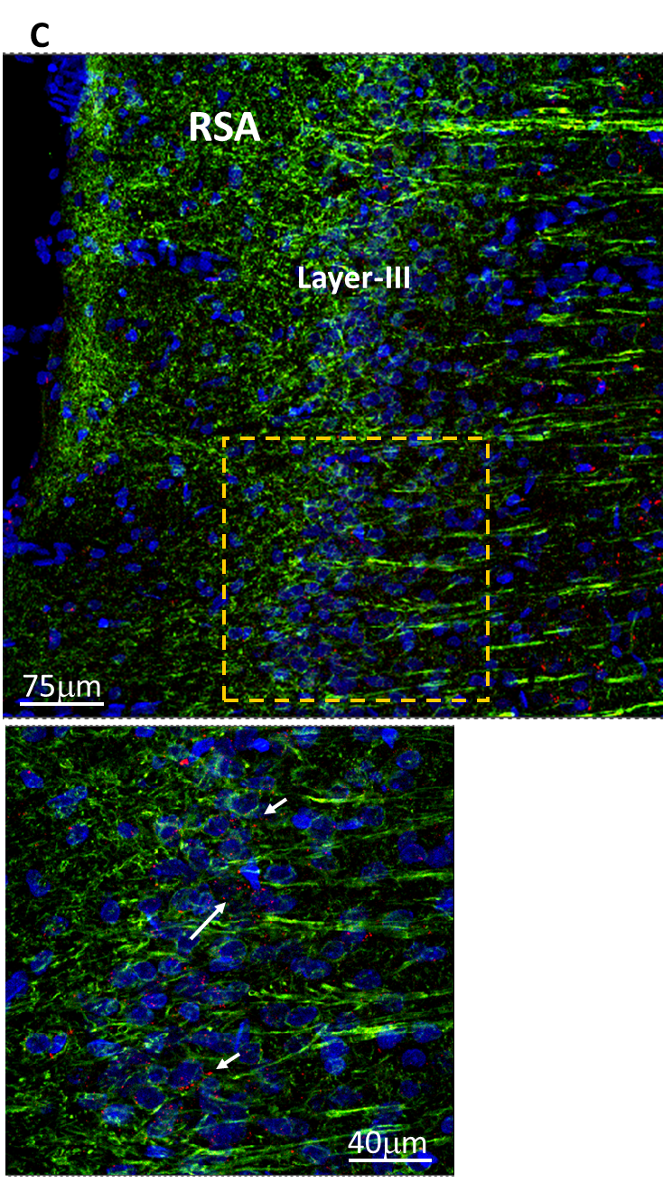

**Fig. S2. PLA signal between the** **5-HTR2C and OTR in distinct brain regions.** Photomicrophotographs from transverse sections of the rat brain show the distribution of OTR/5-HTR2C heteroreceptor complexes in the pyramidal cell layer and in GABA interneurons of CA1 and CA2 regions of hippocampus (**A**), in the polymorphic layer of dentate gyrus (**B**) and in the retrosplenial granular and agranular cortex (**C**) using the in-situ proximity ligation assay (PLA) technique and confocal laser microscopy. The positive PLA signal is demonstrated as red blobs (clusters with examples indicated by white arrows), nuclei are shown in blue (DAPI), and neuronal cells in green (Alexa488 conjugated Neuro-Chrom Pan neuronal marker).

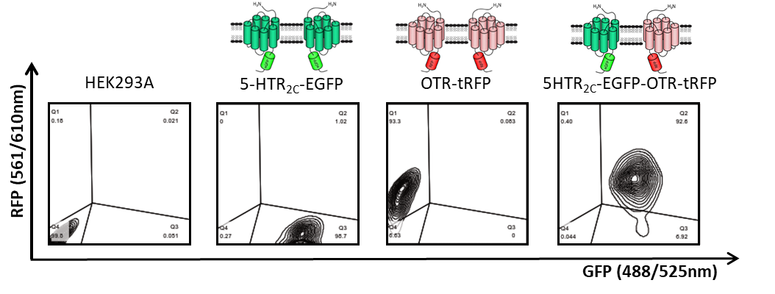

**Fig. S3. Flow cytometry analysis of the 5-HTR2C and OTR with EGFP and tRFP tags.** Dot plots demonstrate thepercentage of EGFP or/and tRFP positive cells. Cells stably expressing the 5-HTR2C tagged with EGFP showed 95.7% of EGFP positive cells. Wild-type HEK293A cells after transient transduction with the OTR tagged with tRFP show 93.3% of tRFP positive cells. Cells stably expressing the 5-HTR2C tagged with EGFP after transient transduction with the OTR tagged with tRFP show 82.6% of double EGFP/tRFP positive cells.



**Fig. S4. Co-expression of the OTR and 5-HTR2C-VSV depletes OTR-mediated Gαq-dependent signalling.** Intracellular calcium release induced by increasing concentration of OT in HEK293A cells stably expressing the 5-HTR2C-VSV-EGFP, in cells transiently expressing the OTR-tRFP, and in cells co-expressing both receptors. Intracellular calcium mobilization is presented as a percentage of maximal calcium response elicited by the control (3% FBS). Graphs represent means ± SEM from two independent experiments run in duplicates.



**Fig. S5. No effect of 5-HTR2C antagonists on intracellular calcium release in cells.** None of the 5-HTR2C antagonists (RS102221, SB242084) were able to induce a calcium influx in HEK293A cells stably expressing the 5-HTR2C, in cells transiently expressing the OTR, and in cells co-expressing both receptors. Intracellular calcium mobilization is presented as a percentage of maximal calcium response elicited by the control (3% FBS). Graphs represent means ± SEM from five independent experiments run in duplicates.

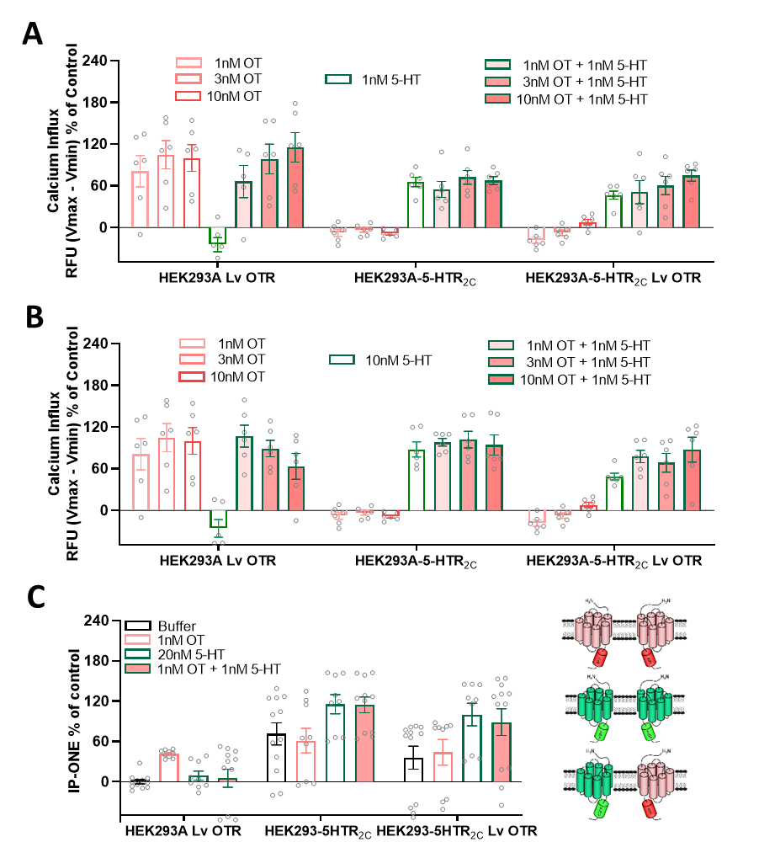

**Fig. S6.** **No additive/synergistic effect of OT and 5-HT co-administration on Gαq-dependent signalling.** Intracellular calcium release induced by increasing concentration of OT in the presence of 1nM 5-HT (**A**) and 10nM 5-HT (**B**) in HEK293A cells stably expressing the 5-HTR2C-EGFP, in cells transiently expressing the OTR-tRFP, and in cells co-expressing both receptors. IP1 production induced by co-administration of 1nM OT and 20nM 5-HT in HEK293A cells expressing 5-HTR2C-EGFP, OTR-tRFP, and co-expressing both receptors (**C**). Results are presented as a percentage of maximum response. All graphs represent means ± SEM from at least two independent experiments run in triplicates, presented as percentage of maximum response.



**Fig. S7.** **Co-expression of the OTR and 5-HTR2C attenuates basal IP1 production.** Ligand independent IP1 production in cells expressing 5-HTR2C-EGFP, OTR-tRFP, and co-expressing both receptors. Graph represents means ± SEM from eight independent experiments run in quadruplicates presented as fluorescence signal (raw data) inversely proportional to the level of endogenous IP1 (fluorescence from labelled IP1). Statistical significance compared to cells solely expressing OTR denoted by #, and compared to cells solely expressing 5-HTR2C denoted by *.



**Fig. S8. Cellular trafficking of the OTR.** Qquantitative analysis of basal and ligand-mediated internalisation of the OTR tagged with tRFP in cells expressing a single receptor versus cells co-expressing both receptors after 30 minutes incubation with ligands (100 nM OT or 1 µM 5-HT). Graphs represent mean ± SEM from four independent experiments. Statistical significance compared to cells solely expressing a single receptor denoted by *. Statistical significance compared to untreated control condition in cells solely expressing OTR denoted by ^.