Greener Methodology for the Synthesis of α-Diazocarbonyl Compounds and a Novel Approach to Dioxinone Derivatives

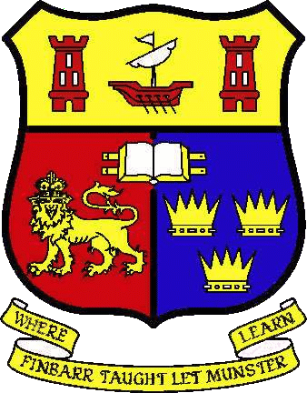

Claire O’Brien, B.Sc.

A Thesis Presented for the Degree of
Doctor of Philosophy
to

THE NATIONAL UNIVERSITY OF IRELAND

Department of Chemistry
University College Cork

Supervisor: Dr. Stuart Collins
Head of Department: Prof. Justin Holmes

March 2016

