Supplementary Data Liang et al

Methods

Oligonucleotides used in the study are listed in Table S1. Polyphosphate extraction in Figure S2 was carried out using a GENECLEAN™ kit (MP Biomedicals Europe) as described [1]. Briefly, 4 M guanidine isothiocyanate (GITC)–50 mM Tris-HCl, pH 7.0 (GITC lysis buffer), prewarmed to 95°C was used to lyse pelleted cells, then 10% sodium dodecyl sulphate (SDS), 95% ethanol, and Glassmilk was added to adsorb polyphosphate, washing with New Wash buffer. Polyphosphate was eluted from the pellet by adding 50 l of 50 mM Tris-HCl (pH 8.0) at 95°C for 2 min, recovery of polyphosphate was completed with two additional elutions.

Polyphosphate chain length in polyphosphate extracts (Fig S2) was visualised in polyacrylamide gels by 4’,6-diamidino-2-phenylindol (DAPI) negative staining [2]. Gels were agitated for 30 min in 2 mg/mL DAPI in fixative at room temperature. Gels were then exposed to 365 nm light via a UV transilluminator for 2 – 20 min to induce specific photobleaching of polyphosphate bound to DAPI.

References
1. Ault-Riche D, Fraley CD, Tzeng C-M, Kornberg A. Novel Assay Reveals Multiple Pathways Regulating Stress-Induced Accumulations of Inorganic Polyphosphate in Escherichia coli. J Bacteriol. 1998;180:1841-1847.
2. Serafim LS, Lemos PC, Levantesi C, Tandoi V, Santos H, Reis MAM. Methods for detection and visualization of intracellular polymers stored by polyphosphate-accumulating microorganisms. Journal of Microbiological Methods. 2002;51:1-18.

Oligonucleotides used in this study

Table S1

Name | Sequence (5’-3’)
PPK1-F | AGTGAGCTCATGGGTCAGGAAAAGCTATACATCGAAAAAGAACTC
PPK1-R | AATAAAGCTTTTATTCAGGTTGTTCGAG
PPX-F | GGATCCAAATGGAAGGACGTTTCCGT
PPX-R | GAATTCCCCGCAAAGTATTAAGCGG
ACYCDuetUP1 | GGATCTCGACGCTCTCCCT
DuetDOWN1 | GATTATGCGGCCGTGTACAA
DuetUP2Primer | TTGTACACGGCCGCATAATC
T7 Terminator Primer. | GCTAGTTATTGCTCAGCGG

Fig. S1

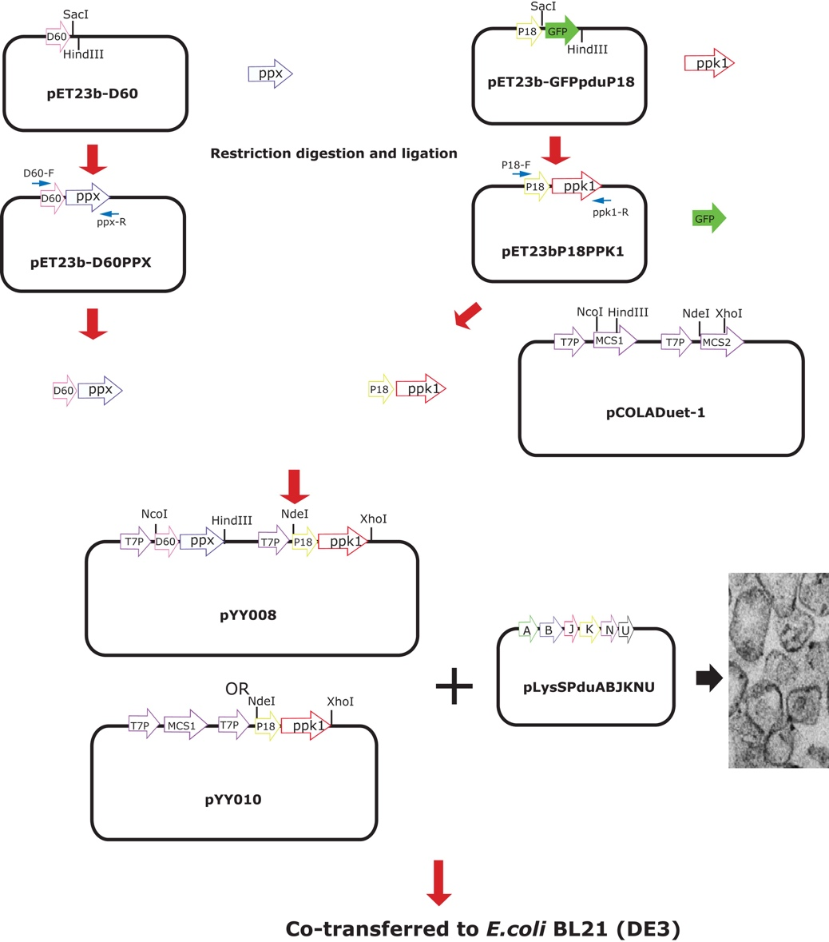

Fig. S2
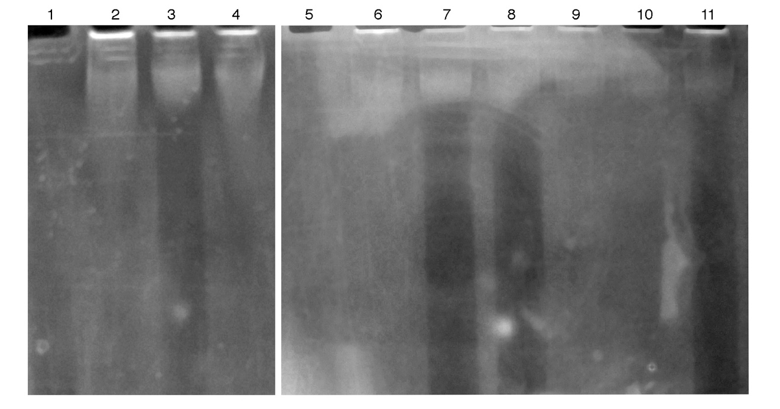

Figure Legends

Figure S1 Vector Cloning Strategy

Figure S2 Size distribution of whole cell extracted polyphosphate. DAPI
PAGE gel of polyphosphate extractions from E. coli quantified in Figure 3.
Polyphosphate associated with DAPI is bleached by prior UV exposure and
appears as a dark vertical band. High molecular weight shadows below the
inoculation well correspond to lipid (extracts treated with micrococcal nuclease to
remove DNA). Lane 1, 5 Sodium phosphate glass Type 45 (Sigma)
Lane 2,3,4 Time zero extractions. Lane 6,7,8 time 24 hours Lane 9,10,11 time 48
hours. Lane 2,6,9 E.coli BL21 (DE3) control. Lane 3,7,10 E. coli BL21 (DE3)
pML1 (p18ppk1). Lane 4,8,11 E.coli BL21 (DE3) pML1 (p18ppk1)
pLysSPduABJKNU .

