Appendices

Appendix 1

Table S1: Benzodiazepines and Z-drugs classified according to ATC code and half-life value
Benzodiazepine | ATC code | Half-life (hours)  [active metabolite] [1, 2] | Duration of action
clonazepam | N03AE01 | 18-50 | Long-acting
diazepam | N05BA01 | 20-100 [36-200] | Long-acting
chlordiazepoxide | N05BA02 | 5-30 [36-200] | Long-acting
potassium clorazepate* | N05BA05 | [36-200] | Long-acting
lorazepam | N05BA06 | 10-20 | Short-acting
bromazepam | N05BA08 | 10-20 | Short-acting
clobazam | N05BA09 | 12-60 | Long-acting
prazepam | N05BA11 | [36-200] | Long-acting
alprazolam | N05BA12 | 6-12 | Short-acting
flurazepam | N05CD01 | [40-250] | Long-acting
nitrazepam | N05CD02 | 15-38 | Long-acting
flunitrazepam** | N05CD03 | 18-26 [36-200] | Long-acting
triazolam | N05CD05 | 2 | Short-acting
lormetazepam | N05CD06 | 10-12 | Short-acting
temazepam | N05CD07 | 8-22 | Short-acting
midazolam | N05CD08 | 1.5 -2.5 | Short-acting
Z-drug | ATC code | Half-life (hours)  [active metabolite] [1, 2] | Duration of action
Zopiclone | N05CF01 | 5-6 | Short-acting
Zolpidem | N05CF02 | 2 | Short-acting
Zaleplon*** | N05CF03 | 2 | Short-acting
* Marketing authorisation withdrawn in 2005
** Marketing authorisation withdrawn in 2013
*** Marketing authorisation withdrawn in 2015

Appendix 2

Additional results data
Note: Tables and figures presented in order of relevance to results section of main paper.

Population sample

Table S1: Proportions of GMS eligible individuals during study period categorised according to gender and age
Study year | % male |  |  | % female |  |  | Total number of GMS patients
 | 16-44 years | 45-64 years | ≥65 years | 16-44 years | 45-64 years | ≥65 years
2005 | 13.2 | 11.2 | 18.3 | 19.3 | 13.0 | 24.9 | 914505
2006 | 13.5 | 11.2 | 18.0 | 20.1 | 13.0 | 24.2 | 958866
2007 | 14.0 | 11.1 | 17.9 | 20.4 | 12.8 | 23.8 | 997759
2008 | 15.3 | 11.1 | 17.3 | 20.8 | 12.6 | 22.9 | 1052254
2009 | 18.0 | 11.4 | 15.5 | 21.9 | 12.5 | 20.7 | 1143063
2010 | 19.1 | 11.6 | 14.8 | 22.4 | 12.5 | 19.6 | 1245455
2011 | 19.5 | 11.9 | 14.4 | 22.6 | 12.6 | 19.0 | 1304675
2012 | 20.3 | 11.9 | 13.7 | 23.6 | 12.5 | 18.0 | 1416837
2013 | 20.4 | 12.0 | 13.4 | 23.9 | 12.6 | 17.7 | 1427880
2014 | 19.9 | 12.4 | 13.4 | 23.8 | 13.0 | 17.5 | 1366491
2015 | 19.0 | 12.8 | 13.9 | 22.7 | 13.5 | 18.1 | 1344123

Prescribing trends

Table S2: Prescribing rates per 1000 GMS population for individual benzodiazepine and Z-drugs

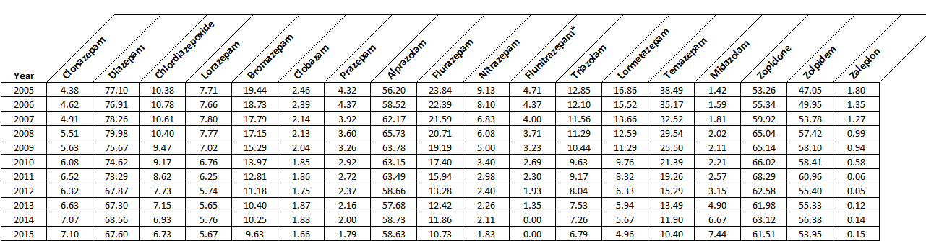
**
*Marketing authorisation for flunitrazepam was withdrawn in 2013
** Marketing authorisation for zaleplon was withdrawn in 2015

Figure S1: Prescribing rates for (a) benzodiazepines [BZDs] and (b) Z-drugs issued to GMS eligible patients aged ≥16 years from 2005 to 2015 according to gender and age
- Benzodiazepine prescribing rates based on gender and age
- Z-drug prescribing rates based on gender and age

Long-term use
- Benzodiazepines

Figure S2: Duration of consecutive (a) benzodiazepine and (b) Z-drug use among patients during study period according to gender and age
- Z-drugs

