Low loss photonic nanocavity via dark magnetic dipole resonant mode near metal
Ning Liu^{*1}, Christophe Silien¹, Greg Sun², Brian Corbett³
¹Department of Physics and Bernal Institute, University of Limerick, Limerick, Ireland
²Department of Engineering, University of Massachusetts Boston, Boston, MA 02125
³Tyndall National Institute, University College Cork, Cork, Ireland

Supporting Information

- H_{z} solution of TE mode in the dielectric-semiconductor-dielectric-metal 4-layered planar structure
To complete the solution of the simplest TE mode in the 4 layered structure of planar geometry as given in the main texts, the H_{z} components are given below:
$$\left\{\begin{matrix}\begin{matrix}H_{z}\left(z\right)=B_{t}{\frac{β}{ωμ_{0}}e}^{iβx}e^{{-k}_{d}(z-a)} \\ H_{z}\left(z\right)=A{\frac{β}{ωμ_{0}}e}^{iβx}\cos\left(k_{c}z-θ\right) \\ H_{z}\left(z\right)=B_{b1}{\frac{β}{ωμ_{0}}e}^{iβx}e^{k_{d}\left(z+a\right)}+B_{b2}{\frac{β}{ωμ_{0}}e}^{iβx}e^{{-k}_{d}(z+a)}\end{matrix} \\ H_{z}\left(z\right)=C{\frac{β}{ωμ_{0}}e}^{iβx}e^{k_{m}(z+a+h)}\end{matrix}\right. \begin{matrix}for z>a \\ for |z|<a \\ for -\left(a+h\right)<z<-a \\ for z<-(a+h)\end{matrix}$$

- Plasmonic mode at a single dielectric-metal interface
Starting from the central equation of electromagnetic wave theory:
$∇^{2}E-\frac{ε}{c^{2}}\frac{∂^{2}E}{∂t^{2}}=0$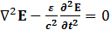
Assuming the E has a single harmonic time dependence E(r,t)=E(r)e^{-iωt}, we can then obtain Helmholtz equation:
${ ∇}^{2}E+\frac{ω^{2}ε}{c^{2}}E=0$ (S1)
For a single dielectric-metal interface, there are only two media and one interface. We choose x as the propagation direction of the plasmonic wave and z the direction perpendicular to the infinitely large planes. The solution to Eq. (S1) can be found from ref. [1]. The boundary conditions allow only TM mode to propagate at the interface of infinitely large planes, with ${k_{d}}/{k_{m}=-{ε_{d}}/{ε_{m}}}$, and $k_{i}^{2}=β^{2}-\frac{ω^{2}ε_{i}}{c^{2}}$ (i=d,m and k_{i} > 0). Combining these three equations, we can obtain the well known surface plasmon dispersion relation at a single interface:
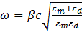$ω=βc\sqrt{\frac{ε_{m}+ε_{d}}{ε_{m}ε_{d}}}$ (S2)
The analytical solution to Eq. (S2), assuming $ε_{m}=1-\frac{ω_{p}^{2}}{ω^{2}}$ is:
$$ω^{2}=\frac{ω_{p}^{2}}{2}\left\{1+\frac{β^{2}c^{2}}{{ε_{d}ω}_{p}^{2}}\left(1+ε_{d}\right)-\sqrt{1+\frac{β^{4}c^{4}}{{{ε_{d}}^{2}ω}_{p}^{4}}{\left(1+ε_{d}\right)}^{2}+\frac{{2β}^{2}c^{2}}{{ε_{d}ω}_{p}^{2}}\left(ε_{d}-1\right)}\right\}$$
The above formula is used to calculate the plasmonic dispersion curves at a single metal-dielectric interface used in Fig. 1c. For real transition metals (Ag, Au, Cu) with ω < ω_{p}, the permittivity is better described by $ε_{m}=ε_{∞}-\frac{ω_{p}^{2}}{ω^{2}+iγω}$ [1], where γ is a damping constant. Simulation results presented in Fig. 1d, Fig. 2 and Fig. 3 are obtained using realistic material parameters.
- Guided fundamental TE mode in the dielectric-semiconductor-dielectric planar structure
For a multilayer (> 2 layers) system, we can solve Eq. (S1) in each domain and determine their coefficients using appropriate boundary conditions. For the simplest 3 layered system, we can choose the top and bottom domains the same materials, with the core using a different material. In photonic case, both the core and cladding materials are dielectric with ε > 0. In this case, when ε_{core} > ε_{cladding}, guided modes are supported. Both TE and TM modes can be achieved. If we choose z = 0 at the middle of the core layer and let thickness of the core be 2a. For the lowest order TE mode, the electric and magnetic fields satisfy [2,3]:
$\left\{\begin{matrix}E_{y}\left(z\right)=B_{t}e^{iβx}e^{{-k}_{d}(z-a)} \\ H_{x}\left(z\right)={-iB}_{t}{\frac{k_{d}}{ωμ_{0}}e}^{iβx}e^{-k_{d}(z-a)} \\ H_{z}\left(z\right)=B_{t}{\frac{β}{ωμ_{0}}e}^{iβx}e^{{-k}_{d}(z-a)}\end{matrix} for z>a\right.$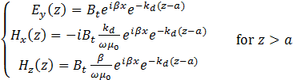
$\left\{\begin{matrix}E_{y}\left(z\right)=Ae^{iβx}cos⁡(k_{c}z) \\ H_{x}\left(z\right)=-iA{\frac{k_{c}}{ωμ_{0}}e}^{iβx}sin⁡(k_{c}z) \\ H_{z}\left(z\right)=A{\frac{β}{ωμ_{0}}e}^{iβx}cos⁡(k_{c}z)\end{matrix} for |z|<a\right.$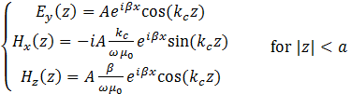
$$\left\{\begin{matrix}E_{y}\left(z\right)=B_{b}e^{iβx}e^{k_{d}(z+a)} \\ H_{x}\left(z\right)={iB}_{b}{\frac{k_{d}}{ωμ_{0}}e}^{iβx}e^{k_{d}(z+a)} \\ H_{z}\left(z\right)=B_{b}{\frac{β}{ωμ_{0}}e}^{iβx}e^{k_{d}(z+a)}\end{matrix} for z<-a\right.$$
Continuity of E_{y} and H_{x} at the interface leads to the conditions that $B_{b}=B_{t}=Acos(k_{c}a)$ and $tank_{c}a=\frac{k_{d}}{k_{c}}$, with $\left\{\begin{matrix}k_{c}^{2}=\frac{ω^{2}ε_{c}}{c^{2}}-β^{2} \\ k_{d}^{2}=β^{2}-\frac{ω^{2}ε_{d}}{c^{2}}\end{matrix}\right.$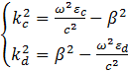 .

- Electric field distribution of TE mode in photonic 3 layered planar structure, TE mode in 4 layered planar structure and TM mode in 4 layered planar structure
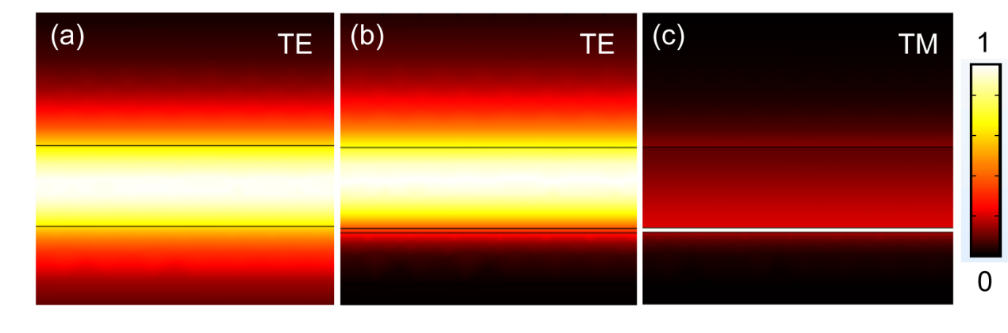
Figure S1 (a-c) Normalized E field |E| distribution of TE mode in the dielectric-semiconductor-dielectric 3 layered structure, TE mode in the dielectric-semiconductor-dielectric-metal 4 layered structure and TM mode in the dielectric-semiconductor-dielectric-metal 4 layered structure, respectively. In this 2D simulation, d = 110 nm, h = 6 nm, ε_{core} = 13, ε_{d} = 2.9 and wavelength is 820 nm. The metal is assumed lossless with plasma frequency at 2.27×10¹⁵ Hz.

- Additional field distribution of TE₀₁ on glass and TE₀₁ and TM₁₁ modes on Al₂O₃/Ag
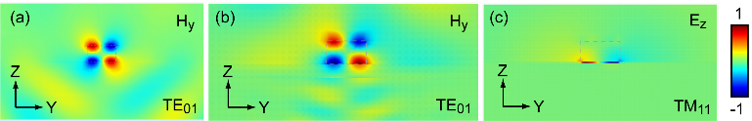
Figure S2 (a, b) COMSOL simulations of normalized TE₀₁ mode magnetic field H_{y} distribution on zy plane at x = 0, for semiconductor disk on glass and semiconductor disk on Al₂O₃/Ag (diameter of 200 nm for both cases). (c) Normalized TM₁₁ mode electric field E_{z} distribution on zy plane at x = 0, for semiconductor disk (200 nm in diameter) on Al₂O₃/Ag. The dashed rectangles indicate the physical contours of the semiconductor disks.
- Q of TE₀₁ on Al₂O₃/Ag as a function of Al₂O₃ thickness
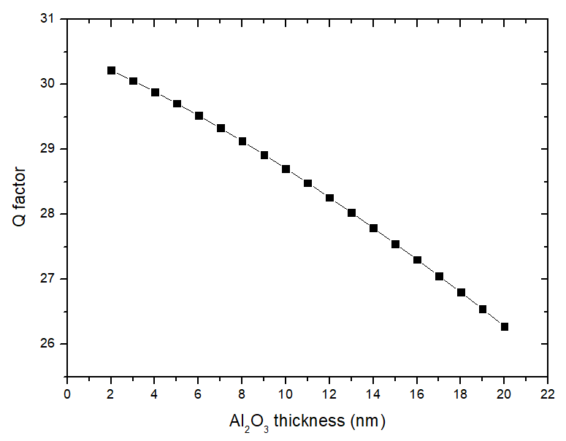
Figure S3 COMSOL simulated quality factor Q of TE₀₁ mode on Al₂O₃//Ag vs. the thickness of
Al₂O₃. In this simulation, the diameter of the AlGaInP disk is fixed at 200 nm.

Reference:

- S. A. Maier, Plasmonics: Fundamentals and Applications (Springer, 2007).
- J. D. Jackson, Classical Electrodynamics (John Wiley&Sons, Inc., New York, 1999), 3rd edn.
- D. K. Cheng, Field and wave electromagnetics (Addison – Wesley Publishing Company, Inc., 1983).

