**Figure S1. Flow diagram outlining colony isolation and detection of antimicrobial activity**

**Figure S2** Heat Stability and Protease Sensitivity

**Supplementary information**

17 of the 25 isolated from BHI plates

8 of the 25 isolated from MSA plates

25 confirmed antimicrobial producing isolates based on activity in WDA against

*L. delbrueckii ssp bulgaricus*

73 of 101 were isolated from original colony purification + overlay from BHI plates

101 potential antimicrobial producing isolates

28 of 101 were isolated from original colony purification + overlay from MSA plates

90, 000 colonies screened

Colonies that showed possible inhibitory activity in overlay

Colonies that showed possible inhibitory activity in overlay

**Colony Isolation**: MSA BHI

Distinct colonies from MSA & BHI plates purified & grown in BHI and were spotted

10 μL spotted on BHI agar

**Antimicrobial**

**Activity**: Overlaid with *L. delbrueckii* ssp *bulgaricus*

Overlaid remaining colonies on BHI plates with *L. delbreuckii* ssp *bulgaricus*

Overlaid remaining colonies with

*L. innocua* & MRSA

All antimicrobial producing strains tested via WDA against *L. delbrueckii ssp bulgaricus*

PFGE to determine number of genetically different strains

21 Coagulase negative *Staphylococcus* isolated

*S. hominis* (3), *S. warneri* (4), *S. epidermidis* (1), 1 *S. simulans* (1), *S. capitis* (3)

*S. capitis* (9), *S. hominis* (4), *S. epidermidis* (1), *S. simulans* (1), *S. warneri* 6)

**Identification of Antimicrobial Producing Isolates**

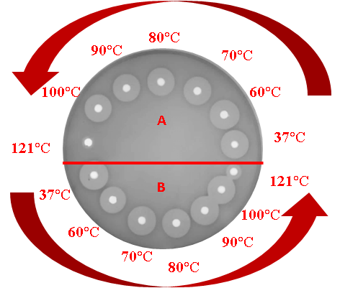

**Figure S2 A:** Shows sample ‘A’ on top half of plate and sample ‘B’ on lower half of plate exposed to a range of high temperatures increasing in an anticlockwise fashion. All isolates producing heat-sensitive antimicrobials are tolerant to 100°C for 10 min, as shown by stable zone size, but after treatment to 121°C for 15 min activity is greatly reduced or diminished.

Figureure M. Shows sample ‘A’ on top half of plate and sample ‘B’ on lower half of plate exposed to a range of high temperatures increasing in an anticlockwise fashion. All isolates producing heat-sensitive antimicrobials are tolerant to 100°C for 10 min, as shown by stable zone size, but after treatment to 121°C for 15 min activity is greatly reduced or diminished.

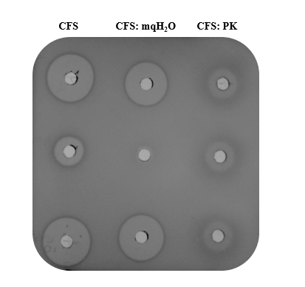

**Figure S2 B:** Illustrates the effect of Proteinase K (PK) on CFS of skin isolates. Column 1 on left of plate is CFS of skin isolates. CFS: mqH2O is CFS diluted 1:1 in water, so that it has the same concentration when mixed with PK. All activity is reduced/ diminished showing antimicrobials produced are of a peptide nature.

Proteinase K was the only enzyme used to determine protease sensitivity of these isolates.

Figureure L. Illustrates the effect of Proteinase K (PK) has on CFS of skin isolates. In column 1 on left of plate is CFS of skin isolates. CFS: mqH2O is CFS diluted 1:1 in water, so that it has the same concentration when mixed with PK. All activity is reduced/ diminished showing antimicrobials produced are of a peptide nature.

Proteinase K was the only enzyme used to determine protease sensitivity of these isolates.

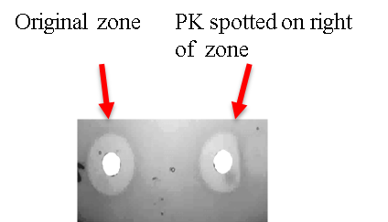

**Figure S2 C:** ‘half-moon test’ , well on left hand side shows actual zone size, well on right shows morphed zone shape after Proteinase K is spotted on right hand side of well- highlighting the proteinaceous nature of antimicrobial being produced.

Figureure H: ‘half-moon test’ , well on left hand side shows actual zone size, well on right shows morphed zone shape after Proteinase K is spotted on right hand side of well- highlighting the proteinaceous nature of antimicrobial being produced.

.

Antimicrobial activity in CFS of antimicrobial skin isolates remained stable following exposure to a range of high temperatures which is characteristic of bacteriocins. Proteinase K assays performed on the CFS from the antimicrobial skin isolates resulted in significant or complete reduction in antimicrobial activity revealing the proteinaceous nature, characteristic of bacteriocins (Cotter et al., 2005).

**Figure S3:** MALDI TOF mass spectrometry trace of peptides extracted from colonies of the 13 genetically distinct antimicrobial producing skin isolates.

**(a) *Staphylococcus warneri*** *Staphylococcus warneri* APC 2922

*Staphylococcus warneri* APC 2937

*Staphylococcus warneri* APC 2947

 *Staphylococcus warneri* APC 2930

**(b) *Staphylococcus capitis***

*Staphylococcus capitis* APC 2918

*Staphylococcus capitis* APC 2934

*Staphylococcus capitis* APC 2923

 *Staphylococcus capitis* APC 2927

**(c) *Staphylococcus hominis***

*Staphylococcus hominis* APC 2924;

 *Staphylococcus hominis* APC 2925

*Staphylococcus hominis* APC 3365

**(d) *Staphylococcus epidermidis***

*Staphylococcus epidermidis* APC 3477

**(e) *Staphylococcus simulans***

*Staphylococcus simulans* APC 2926.