Supplementary Materials

The Role of the Microbiota in Acute Stress-Induced Myeloid Immune Cell Trafficking

Marcel van de Wouw¹, Joshua M. Lyte^{1#}, Marcus Boehme¹, Marzia Sichetti², Gerard Moloney^{1,3}, Michael S. Goodson⁴, Nancy Kelley-Loughnane⁴, Timothy G. Dinan^{1,5}, Gerard Clarke^{1,5}, John F. Cryan^{1,3}

¹APC Microbiome Ireland, University College Cork, Cork, Ireland
²Unit of Biochemical Sciences and Health, Department of Pharmaceutical Sciences, University of Perugia, Italy
³Department of Anatomy and Neuroscience, University College Cork, Cork, Ireland
⁴711th Human Performance Wing, Air Force Research Laboratory, Wright-Patterson Air Force Base, Dayton, Ohio, USA. michael.goodson.4@us.af.mil; nancy.kelley-loughnane.1@us.af.mil
⁵Department of Psychiatry and Neurobehavioral Science, University College Cork, Cork, Ireland

#Present address: Poultry Production and Product Safety Research Unit, Agricultural Research Service, United States Department of Agriculture, Fayetteville, AR 72701, United States

Corresponding author:
J.F. Cryan: APC Microbiome Ireland; Department of Anatomy and Neuroscience, University College Cork, Cork, Ireland. Email: j.cryan@ucc.ie.

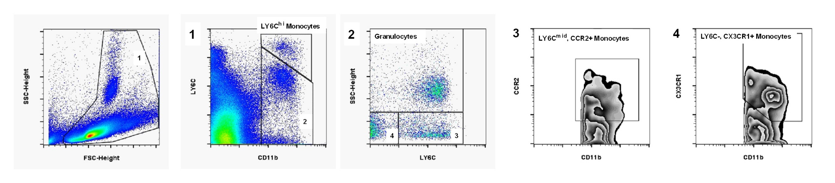 sFigure 1. Flow cytometry gating strategy of splenic myeloid cells. Gating was performed as following. Cells were selected based on FSC-height and SSC-height. 1) LY6C^{hi} monocytes (CD11b+, LY6C^{hi}) were subsequently selected, whereas CD11b+, LY6C^{low}/- cells were used to select other populations. 2) Granulocytes (CD11b+, SSC^{hi}) were then selected. 3) While SSC^{hi}, LY6C- cells were used to gate LY6C^{mid}, CCR2+ monocytes (CD11b+, SSC^{low}, LY6C^{mid}, CCR2+). 4) SSC^{hi}, LY6C- cells were used to gate LY6C, CX3CR1+ monocytes (CD11b+, SSC^{low}, LY6C-, CX3CR1+).
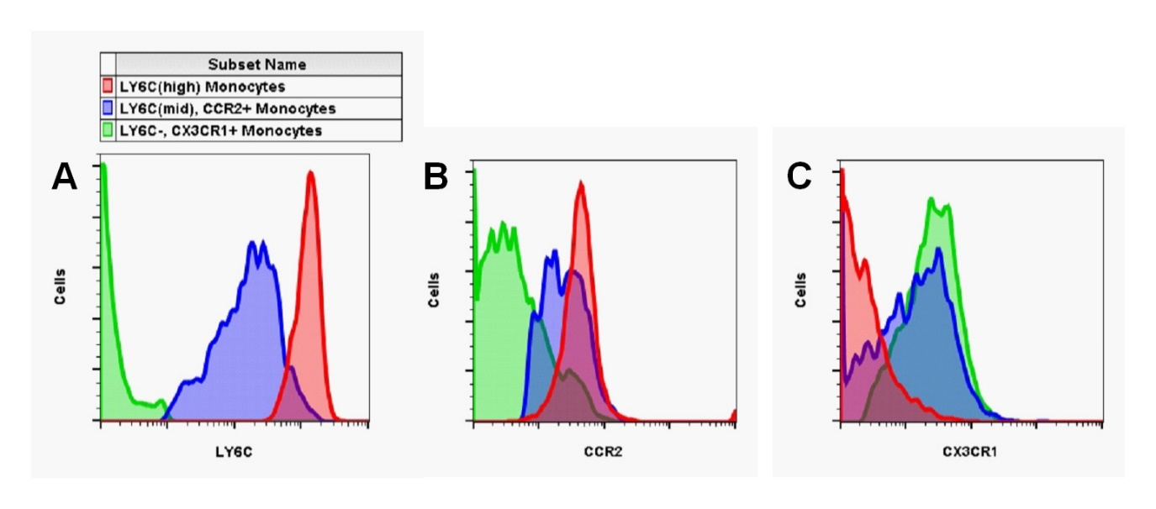
sFigure 2. Phenotyping of monocyte subtypes. LY6C, CCR2 and CX3CR1 receptors expression patterns were similar to previous reports (Ginhoux et al. 2014, Yang et al. 2014). Specifically, LY6C^{hi} Monocytes: LY6C^{hi}, CCR2+, CX3CR1-; LY6C^{mid} Monocytes: LY6C^{mid}, CCR2+, CX3CR1+; LY6C^{low} Monocytes: LY6C-, CCR2-, CX3CR1+.

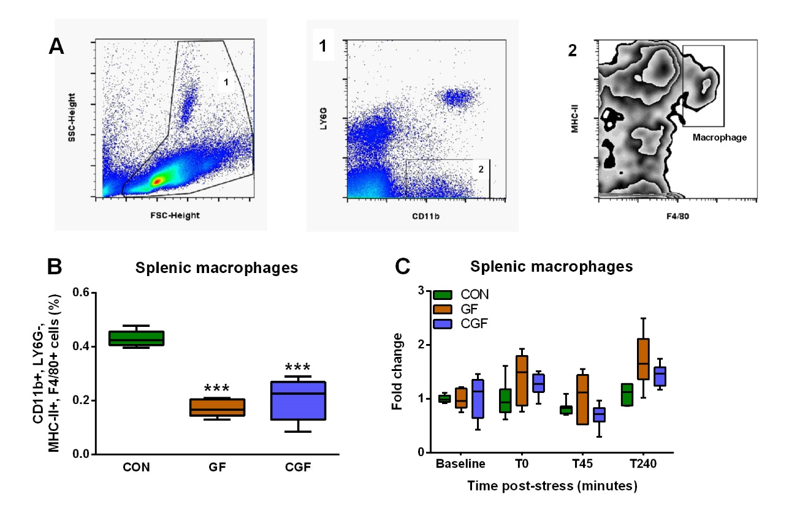 sFigure 3. GF and CGF mice have deficits in splenic macrophages. Gating was performed as following (A). Cells were selected based on FSC-height and SSC-height. CD11b+, LY6G- cells were subsequently gated after which macrophages (CD11b+, LY6G-, F4/80+, MHC-II+) were selected. GF and CGF mice showed deficits in splenic macrophages (B), whereas stress did not impact splenic macrophages (C). There was an effect of microbiota status on splenic macrophage levels (X²(2) = 13.079, p < 0.001), where levels were decreased in GF and CGF mice (p < 0.001; p < 0.001). Data were non-normally distributed and analysed using the Mann-Whitney U test. Significant differences are depicted as: ***p < 0.001 compared to CON. Post-stress data from animals were normalized to baseline data (pre-stress). Data are presented as boxplots (n = 7-9). Abbreviations: CON = Conventionally raised; GF = Germ-free; CGF = Conventionalized germ-free.
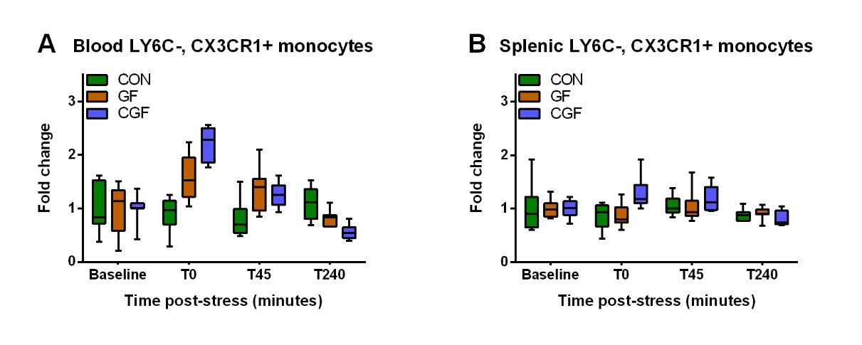
sFigure 4. Stress does not impact circulating and splenic LY6C-, CX3CR1+ monocytes. LY6C-, CX3CR1+ monocytes were quantified in blood (A), and the spleen (B), before and after acute stress. No differences were observed. Post-stress data from animals were normalized to baseline data (pre-stress). Data are presented as boxplots (n = 7-9). Abbreviations: CON = Conventionally raised; GF = Germ-free; CGF = Conventionalized germ-free.

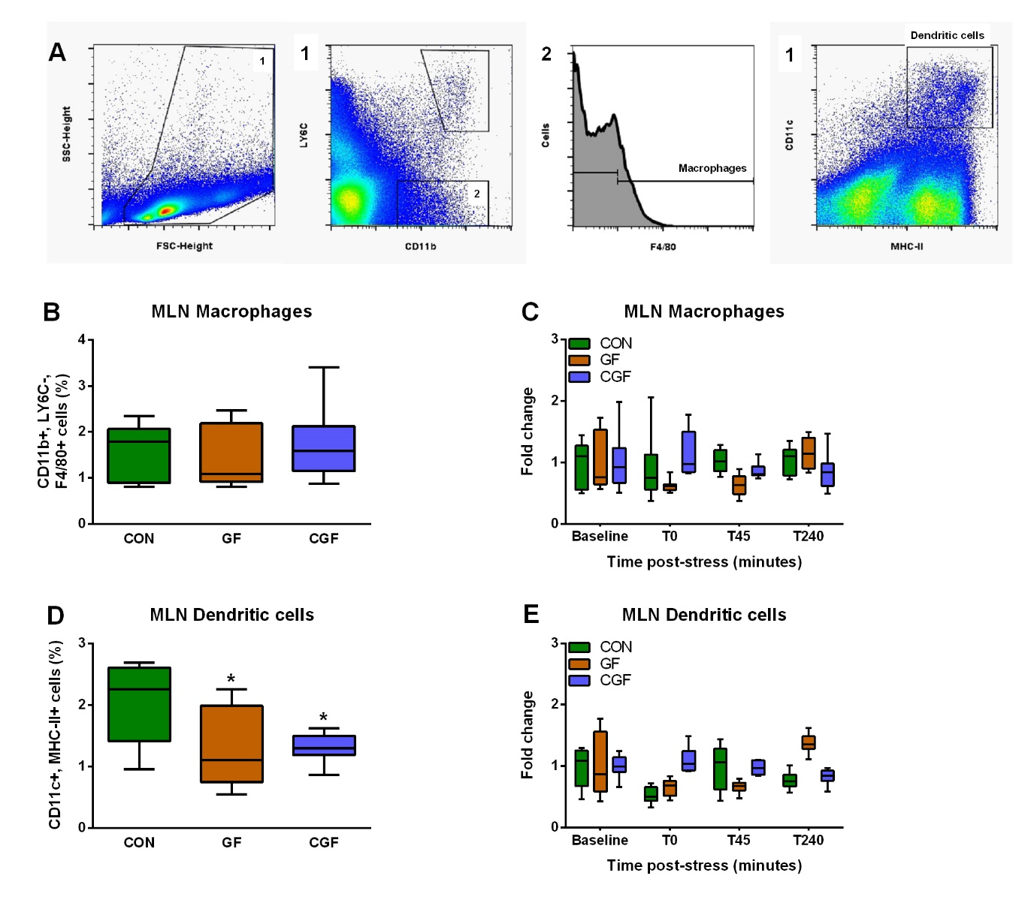
sFigure 5. Acute stress does not impact MLN dendritic and macrophage levels. Gating was performed as following (A). Cells were selected based on FSC-height and SSC-height. 1,2) CD11b+, LY6C- cells were subsequently gated, after which macrophages (CD11b+, LY6C-, F4/80+) were selected. 3) In addition, MLN dendritic cells (CD11c+, MHC-II+) were selected. Both microbiota status and stress did not impact MLN macrophage levels (B, C). GF and CGF mice did have decreased MLN dendritic levels (D), which remained unaffected by stress (E). There was an effect of microbiota status on MLN dendritic cell levels (X²(2) = 6.628, p = 0.036), where levels were decreased in GF and CGF mice (p = 0.037; p = 0.023). Data were non-normally distributed and analysed using the Mann-Whitney U test. Significant differences are depicted as: *p < 0.05 compared to CON. Post-stress data from animals were normalized to baseline data (pre-stress). Data are presented as boxplots (n = 7-9). Abbreviations: CON = Conventionally raised; GF = Germ-free; CGF = Conventionalized germ-free; MLN = mesenteric lymph node.

Literature
Ginhoux, F. and S. Jung. (2014). Monocytes and macrophages: developmental pathways and tissue homeostasis. Nat Rev Immunol, 14(6), 392-404. doi:10.1038/nri3671
Yang, J., L. Zhang, C. Yu, X. F. Yang and H. Wang. (2014). Monocyte and macrophage differentiation: circulation inflammatory monocyte as biomarker for inflammatory diseases. Biomark Res, 2(1), 1. doi:10.1186/2050-7771-2-1

