Supplemental figures
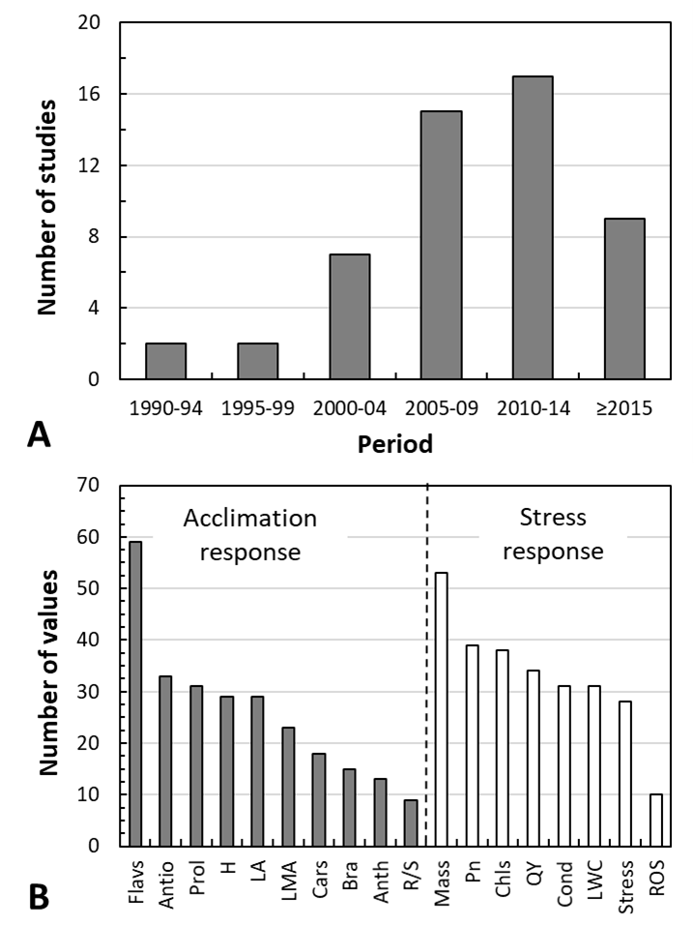
Supplemental figure 1. (A) A total of 52 papers were analysed, and these were published in peer-reviewed journals in the period 1990 through to 2019. (B) Variables investigated were grouped into two main categories characterising plant acclimation responses (black columns), and plant stress responses (white columns). Investigated variables are: Flavs = Flavonoid content, Antio = Antioxidant capacity, Prol = Proline content, H = Height, LA = Leaf area, LMA = Leaf mass per area, Cars = Carotenoid content, Bra = Branching, Anth = Anthocyanin content, R/S = Root-to-shoot ratio, Mass = Plant biomass, Pn = Photosynthetic CO₂ uptake, Chls = Chlorophyll content, QY = Quantum yield of photosystem II photochemistry, Cond = Stomatal conductance, LWC = Leaf water content, Stress = Stress markers, ROS = Reactive Oxygen Species..

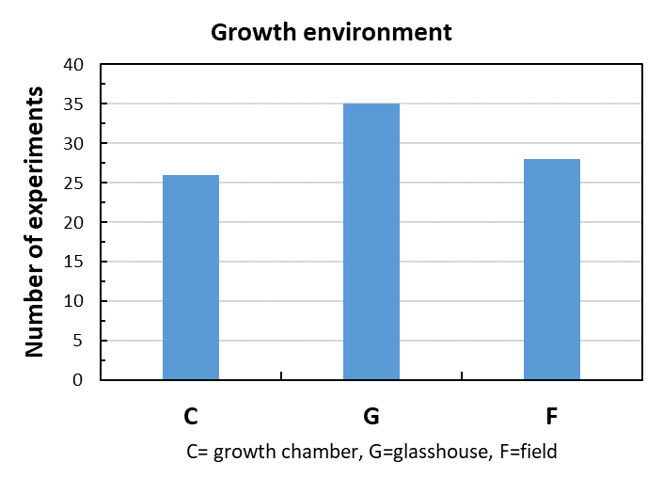
Supplemental figure 2. A total of 89 experiments were analysed, of which just 32% were performed under field conditions (28 experiments). Some 68% of experiments were performed under more artificial conditions, including growth chambers and/or glasshouses (26 and 35 studies, respectively).

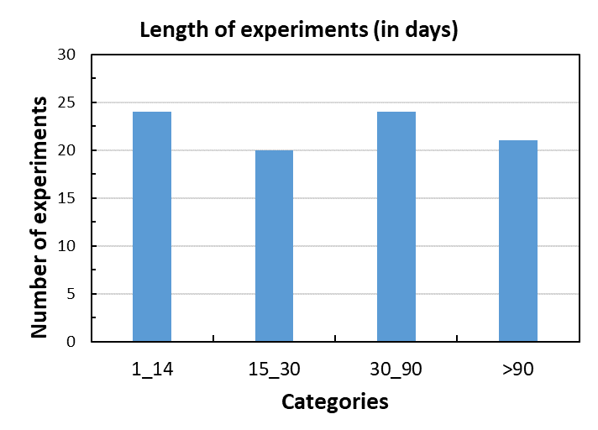
Supplemental figure 3. Duration of the analysed experiments. The duration of the experiments varied between 3 and 900 days. Moreover, there is one extraordinary long study by Arróniz-Crespo et al. (2011) in Annals of Botany 108: 557-565 on Bryophytes – 13-15 years.

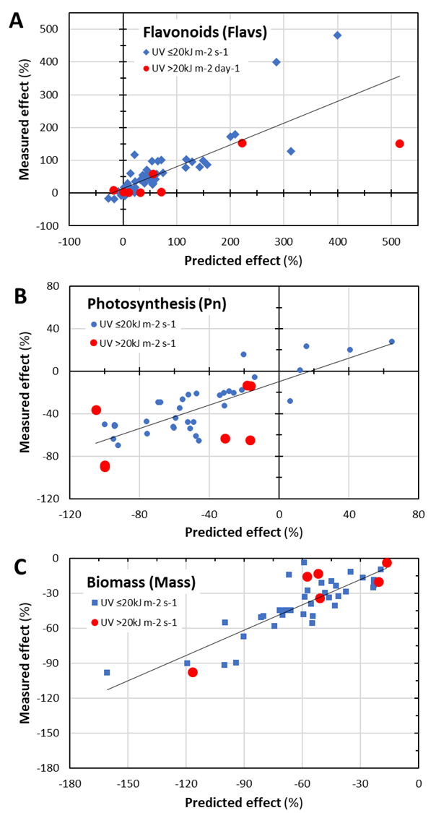
Supplemental figure 4. Relationship between observed (Measured effect) and calculated (Predicted effect) effects of combined exposure to UV radiation and drought for selected variables (Flavonoids – panel A, Photosynthetic CO₂ uptake – panel B, and Biomass – panel C). The experiments where high UV doses (above 20 kJ m^{–2} day^{–1}) were applied are shown in red. The data were fitted using linear regression (best linear fit).

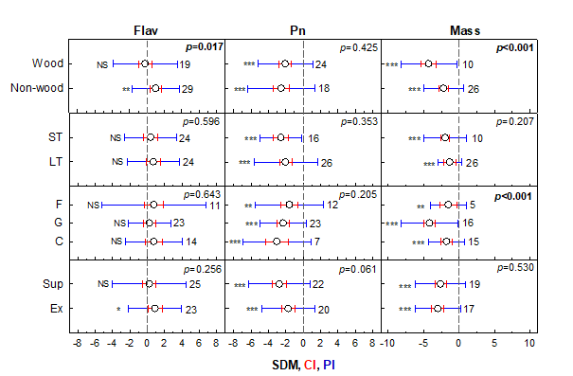
Supplemental figure 5. Detailed analysis of drought effects on flavonoid content (Flav), photosynthetic CO₂ uptake (Pn), and plant biomass (Mass). The data are categorized according to anatomical structure (woody × non-woody plants), duration of the experiment (short- × long-term), treatment conditions (field × greenhouse × growth chamber), and UV application (supplementary × excluded). SDM = Standard Difference in Means, CI = 95% Confidence Interval, PI = 95% Prediction Interval. Stars (*) refer to significance of the experimental treatment * (p ≤ 0.05), ** (p ≤ 0.01), *** (p ≤ 0.001), NS = Not Significant (p > 0.05). p-values in the top right-hand corner indicate the significance of the differential response between compared categories. The numbers indicate the number of experiments included in the meta-analysis.

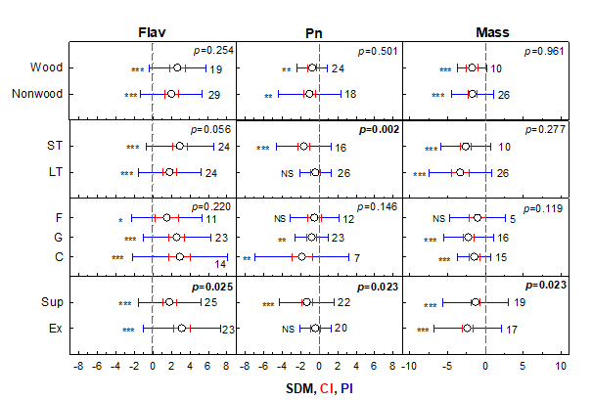
Supplemental figure 6. Detailed analysis of UV effects on flavonoid content (Flav), photosynthetic CO₂ uptake (Pn), and plant biomass (Mass). The data are categorized according to anatomical structure (woody × non-woody plants), duration of the experiment (short- × long-term), treatment conditions (field × greenhouse × growth chamber), and UV application (supplementary × excluded). SDM = Standard Difference in Means, CI = 95% Confidence Interval, PI = 95% Prediction Interval. Stars (*) refer to significance of the experimental treatment * (p ≤ 0.05), ** (p ≤ 0.01), *** (p ≤ 0.001), NS = Not Significant (p > 0.05). p-values in the top right-hand corner indicate the significance of the differential response between compared categories. The numbers indicate number of experiments included in the meta-analysis.

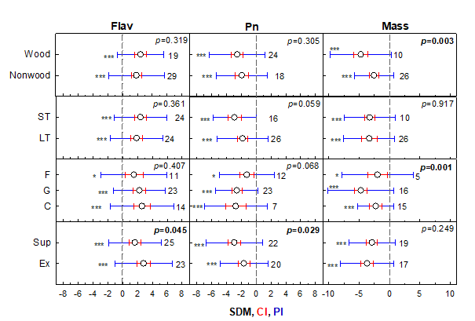
Supplemental figure 7. Detailed analysis of combined effects of UV and drought on flavonoid content (Flav), photosynthetic CO₂ uptake (Pn), and plant biomass (Mass). The data are categorized according to anatomical structure (woody × non-woody plants), duration of the experiment (short- × long-term), treatment conditions (field × greenhouse × growth chamber), and UV application (supplementary × excluded). SDM = Standard Difference in Means, CI = 95% Confidence Interval, PI = 95% Prediction Interval. Stars (*) refer to significance of the experimental treatment * (p ≤ 0.05), ** (p ≤ 0.01), *** (p ≤ 0.001), NS = Not Significant (p > 0.05). p-values in the top right-hand corner indicate the significance of the differential response between compared categories. The numbers indicate number of experiments included in the meta-analysis.

Supplemental table 1
Overview of all analysed experiments including details on plant material, experimental set up and measured variables. (Uploaded as a separate supplementary file.)

Supplemental table 2
The percentage of statistically significant (p < 0.05) effects on specific variables, and across the experiments included in the database. Variables are grouped into two main categories characterising plant acclimation responses (dark grey; Prol = Proline content, Flavs = Flavonoid content, Antio = Antioxidant capacity, Anth = Anthocyanin content, Cars = Carotenoid content, LA = Leaf area, LMA = Leaf mass per area, H = Height, R/S = Root-to-shoot ratio), and stress responses (while cells; Stress = Stress markers, ROS = Reactive Oxygen Species, QY = Quantum yield of photosystem II photochemistry, Pn = Photosynthetic CO₂ assimilation rate, Cond = Stomatal conductance, LWC = Leaf water content, Chls = Chlorophyll content, Mass = Plant biomass).
 | UV | Drought | UV + drought
Prol | 47.6 | 71.4 | 71.4
Flavs | 60.9 | 43.8 | 70.3
Antio | 38.2 | 75.0 | 25.0
Anth | 90.9 | 18.2 | 81.8
Cars | 20.0 | 10.0 | 10.0
LA | 32.0 | 59.1 | 72.0
LMA | 23.8 | 23.8 | 42.9
H | 38.5 | 38.5 | 50.0
R/S | 25.0 | 71.4 | 75.0
Stress | 57.1 | 82.1 | 78.6
ROS | 70.0 | 70.0 | 70.0
QY | 38.2 | 64.7 | 50.0
Pn | 48.4 | 70.3 | 65.6
Cond | 33.3 | 81.0 | 69.0
LWC | 10.3 | 62.1 | 65.5
Chls | 43.3 | 30.0 | 43.3
H | 38.5 | 38.5 | 50.0
Mass | 45.8 | 66.7 | 75.0

Supplemental table 3
Summary of comprehensive meta-analysis outcomes: SDM = Standard Difference in Means, 95% CI = 95% confidence interval, 95% PI = 95% prediction interval. Effects of ultraviolet radiation (UV), drought (D) and their combination (UV+D) are shown. Variables are grouped into two main categories characterising plant acclimation responses (grey cells; Prol = Proline content, Flavs = Flavonoid content, Antio = Antioxidant capacity, Anth = Anthocyanin content, Cars = Carotenoid content, LA = Leaf area, LMA = Leaf mass per area, H = Height, R/S = Root-to-shoot ratio), and stress responses (while cells; Stress = Stress markers, ROS = Reactive Oxygen Species, QY = Quantum yield of photosystem II photochemistry, Pn = Photosynthetic CO₂ assimilation rate, Cond = Stomatal conductance, LWC = Leaf water content, Chls = Chlorophyll content, Mass = Plant biomass). Bold rows (Antio* and Mass*) indicate additional analyses whereby duplicate (or triplicate) entries were removed from the “antioxidant” and “biomass” datasets.

 | SDM | 95% CI |  | 95% PI
UV
Prol | 1.09 | 0.55 | 1.63 | -0.81 | 2.99
Flavs | 2.13 | 1.66 | 2.60 | -0.82 | 5.09
Antio | 2.43 | 1.73 | 3.13 | -1.04 | 5.90
Antio* | 2.02 | 1.27 | 2.77 | 1.24 | 5.28
Anth | 3.19 | 2.20 | 4.18 | -0.98 | 7.36
Cars | 0.55 | 0.17 | 0.92 | -2.69 | 3.93
LA | -0.79 | -1.17 | -0.41 | -2.40 | 0.82
LMA | 0.36 | -0.21 | 0.93 | -1.59 | 2.31
H | -1.08 | -1.66 | -0.50 | -3.38 | 1.21
R/S | 0.23 | -0.26 | 0.71 | -1.00 | 1.45
Stress | 2.18 | 1.43 | 2.93 | -1.34 | 5.69
ROS | 2.68 | 1.78 | 3.57 | 0.09 | 5.26
QY | -0.74 | -1.31 | -0.16 | -3.25 | 1.78
Pn | -0.88 | -1.32 | -0.44 | -3.04 | 1.28
Cond | -0.96 | -1.32 | -0.60 | -2.86 | 0.94
LWC | -0.31 | -0.68 | 0.05 | -1.21 | 0.58
Chls | -1.00 | -1.48 | -0.51 | -3.11 | 1,12
Mass | -1.54 | -2.01 | -1.07 | -3.74 | 0.66
Mass* | -1.56 | -2.05 | -1.08 | -4.03 | 0.91
Drought (D)
Prol | 2.48 | 1.88 | 3.07 | 0.19 | 4.76
Flavs | 0.43 | -0.02 | 0.87 | -3.11 | 3.96
Antio | 0.83 | 0.33 | 1.32 | -1.57 | 3.22
Antio* | 0.62 | 0.20 | 1.21 | -1.90 | 3.13
Anth | 0.86 | 0.03 | 1.69 | -1.32 | 3.03
Cars | 0.08 | -0.69 | 0.84 | -0.97 | 1.12
LA | -1.92 | -2.46 | -1.38 | -4.43 | 0.59
LMA | 0.21 | -0.37 | 0.79 | -2.24 | 2.66
H | -1.68 | -2.29 | -1.07 | -4.05 | 0.70
R/S | 1.86 | 1.02 | 2.70 | -0.76 | 4.47
Stress | 2.74 | 2.00 | 3.48 | -0.38 | 5.86
ROS | 2.57 | 1.51 | 3.63 | -0.78 | 5.92
QY | -1.64 | -2.23 | -1.05 | -5.27 | 1.99
Pn | -2.09 | -2.55 | -1.63 | -5.76 | 1.58
Cond | -2.39 | -2.97 | -1.81 | -5.81 | 1.03
LWC | -1.89 | -2.29 | -1.49 | -4.10 | 0.33
Chls | -0.13 | -0.60 | 0.34 | -2.29 | 2.04
Mass | -2.53 | -3.01 | -2.05 | -5.49 | 0.43
Mass* | -2.69 | -3.33 | -2.04 | -6.07 | 0.70
UV+D
Prol | 2.34 | 1.74 | 2.93 | -0.15 | 4.82
Flavs | 1.92 | 1.45 | 2.40 | -1.44 | 5.28
Antio | 2.56 | 1.91 | 3.20 | -0.90 | 6.01
Antio* | 2.05 | 1.36 | 2.75 | -0.86 | 4.97
Anth | 2.29 | 1.36 | 3.22 | -0.55 | 5.13
Cars | 0.53 | 0.16 | .90 | -2.52 | 3.86
LA | -2.29 | -2.84 | -1.73 | -5.20 | 0.63
LMA | 0.55 | -0.04 | 1.14 | -2.30 | 3.41
H | -1.50 | -2.11 | -0.90 | -4.21 | 1.20
R/S | 1.74 | 0.18 | 3.30 | -3.77 | 7.24
Stress | 2.15 | 1.28 | 3.08 | -1.74 | 6.04
ROS | 2.57 | 1.51 | 3.63 | -0.78 | 5.92
QY | -1.58 | -2.17 | -0.98 | -5.96 | 2.81
Pn | -2.05 | -2.52 | -1.58 | -5.42 | 1.32
Cond | -2.71 | -3.35 | -2.09 | -6.42 | 1.00
LWC | -1.58 | -1.97 | -1.19 | -3.40 | 0.24
Chls | -0.71 | -1.19 | -0.22 | -3.51 | 2.10
Mass | -2.79 | -3.26 | -2.31 | -5.83 | 0.26
Mass* | -3.18 | -3.93 | -2.43 | -7.08 | 0.73

Supplemental table 4
Summary of slopes and intercepts of linear regression between observed and predicted values for individual variables, and their statistically significant differences from 1:1_fit. Variables are grouped into two main categories characterising plant acclimation responses (Prol = Proline content, Flavs = Flavonoid content, Antio = Antioxidant capacity, Anth = Anthocyanin content, Cars = Carotenoid content, LMA = Leaf mass per area, LA = Leaf area, H = Plant height, R/S = Root-to-shoot ratio), and plant stress responses (Stress = Stress markers content, ROS = Reactive Oxygen Species, Pn = Photosynthetic CO₂ assimilation rate, QY = = Quantum yield of photosystem II photochemistry, Cond = Stomatal conductance, LWC = Leaf water content, Chls = Chlorophyll content, Mass = Plant biomass). DF = Degree of freedom, s.e. = standard error; statistically significant differences in slopes and intercepts between 1:1_fit and best-linear_fit are shown in bold (p).

