Supplementary material

SM - 1.
The descriptor for the survey (colours indicating questions with unifying theme)
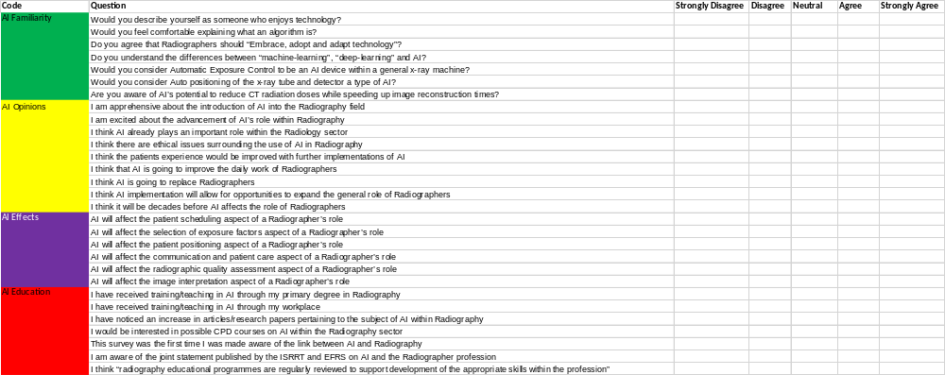

Supplementary material

SM - 2.
Association of Demographics against Unifying Theme
