Figure S2a-f. Time series of hydrological, hydrochemical and faecal indicator/marker data over six phases of flow from baseflow to stormflow. Note varying first y-axis scales for these phases.

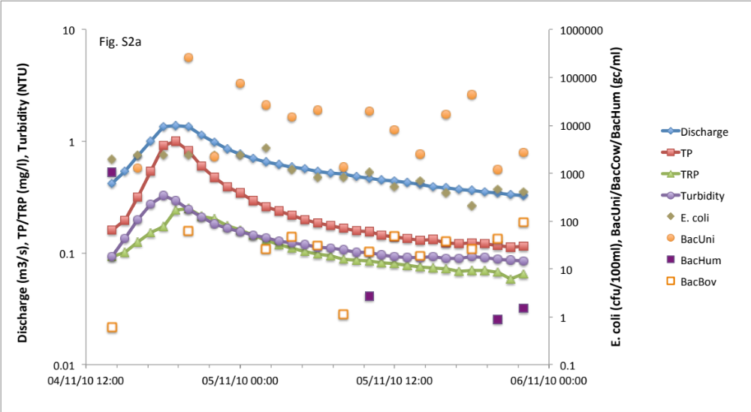

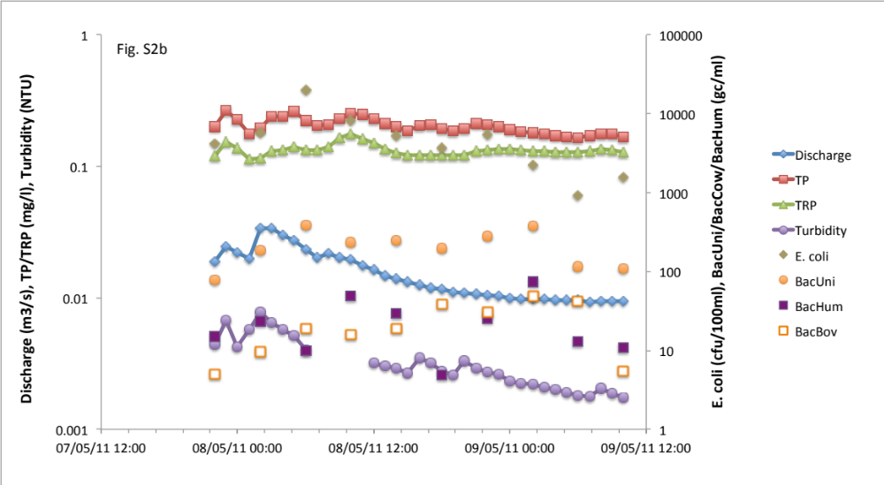

Figures S2a-f continued.

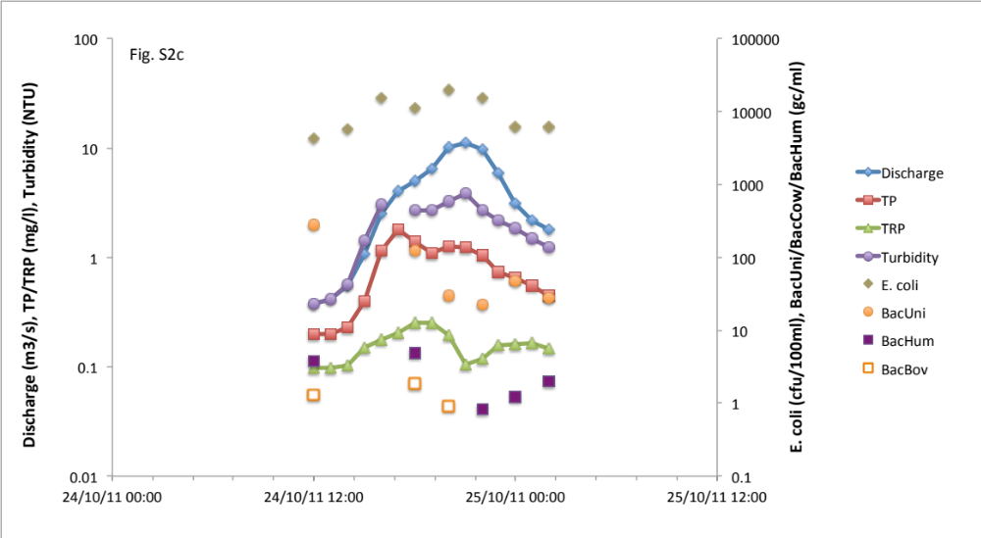

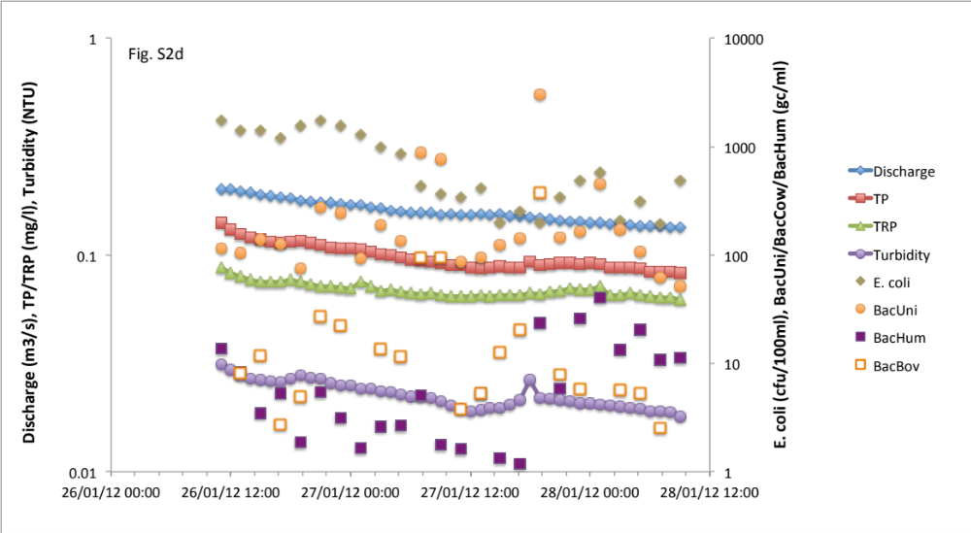

Figures S2a-f continued.

