Supplementary Information

Fig SI-1. Convergent beam electron diffraction from undistorted Ge substrate for the determination of the TEM accelerating voltage.

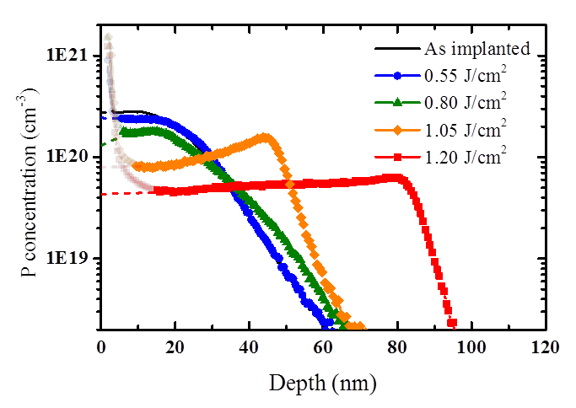

Fig SI-2. SIMS profiles (continuous lines) of P-implanted samples subjected to LTA at energies ranging from 0.55 to 1.20 J/cm². The profiles have been extrapolated (dashed lines) in the first ≈ 10 nm from the surface, where the SIMS technique exhibits artefacts.

Disorder recovery investigated by Raman Spectroscopy

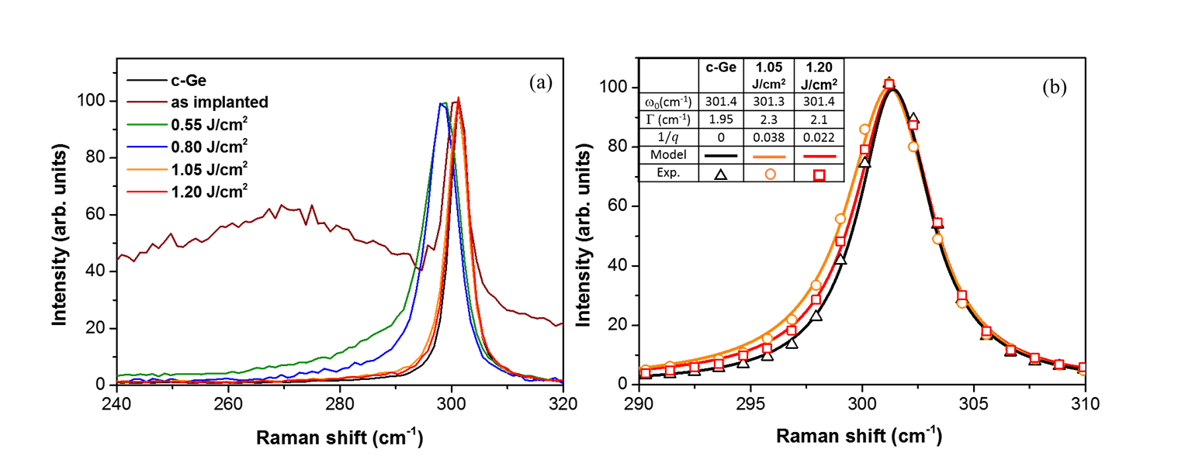
In a disordered material, the crystal momentum conservation criteria are relaxed, due to the lack of translational invariance, resulting in Raman spectra exhibiting a shift of the first-order optical peak accompanied by an asymmetric broadening []. In Fig. SI-3 we report the Stokes spectra recorded as a function of the laser energy density treatment.

Fig. SI-3. (a) Raman Stokes spectra of as implanted P-doped Ge (brown line), and after LTA at 0.55 (green line), 0.80 (blue line), 1.05 (orange line), and 1.20 J/cm² (red line). The spectrum of c-Ge (black line) was recorded as a reference. All these Raman spectra have been arbitrary normalized using the intensity of the first order optical mode as a reference. (b) Fit of the Raman first order peak of the c- Ge, taken as a reference (black line), P-doped Ge after LTA at 1.05 (red line), and at 1.20 J/cm² (orange line).

The spectrum corresponding to the as implanted sample (brown curve) presents a broad band centered at 270 cm⁻¹ assigned to the ensemble of optical modes originating from the amorphous layer located at the surface [] and a sharp peak at 301 cm⁻¹ corresponding to the long wavelength optical phonon from the underlying crystalline Ge (cf. black curve recorded from a reference unimplanted Ge). Raman spectra corresponding to the LTA annealed samples are characterized by the absence of the amorphous contribution already after a 0.55 J/cm² anneal (green line), in agreement with the absence of amorphous regions in TEM analysis. In contrast, in all LTA samples, the optical phonon peak is asymmetric and broader than the underlying crystalline Ge, with a full width at half maximum (FWHM) decreasing when the laser energy density increases (i.e. from 3.3 cm⁻¹ at 0.80 J/cm² to 2.3 cm⁻¹ at 1.05 J/ cm²). For the samples annealed at low energy density (0.55 and 0.8 J/cm²), the peak broadening is accompanied by a downshift (equal to 2.5 cm⁻¹ for 0.80 J/cm²) with respect to the reference Ge bulk.
The FWHM enlargement of the Raman optical peak indicates a lack of translational invariance, that could be caused by several effects, such as phonon confinement [], disorder [], and strain inhomogeneity []. In samples annealed at low energy densities (0.55 and 0.80 J/cm²), where a perfect crystallinity is not yet restored (cf Fig. 1a), these effects may all contribute to the recorded Raman signal. As a consequence, the reduction of the FWHM observed when moving from 0.55 J/cm² to 0.80 J/cm² qualitatively indicates that the long range order is progressively restored []. In contrast, samples annealed at higher laser energy density (1.05 and 1.20 J/cm²) are perfectly re-crystallised, as seen by TEM analysis (cf. Fig. 1b). In this case, the observed frequency downshift and asymmetry of the Raman peak are directly related to the doping process and can be quantitatively described as a “Fano resonance line-shape” (i.e. as the result of an interference between the continuum of electronic states and discrete optical phonon mode []). The Raman signal can be accounted for as follows:
$I\left(ω\right)=I\left(ω_{0}\right)×\frac{{\left(1-\frac{ε}{q}\right)}^{2}}{\left(1+ε^{2}\right)} with ε=\frac{\left(ω-ω_{0}\right)}{Γ}$ (1)

where ω₀ is the resonance frequency, Γ the broadening parameter, and $1/q$ an adjustable asymmetry parameter that is proportional to the doping level. Figure SI-3 (b) shows a perfect agreement between model and experiment for the fully crystallized samples annealed at 1.05 (orange line) and 1.20 J/cm² (red line). The concomitant decreases of Γ and $1/q$ with increasing laser energy density can be valuably interpreted as a lowering of the doping concentration. Indeed, when the laser energy increases, the P atoms are redistributed over larger melted regions, therefore resulting in a decrease of the dopant concentration, as shown by SIMS analyses.

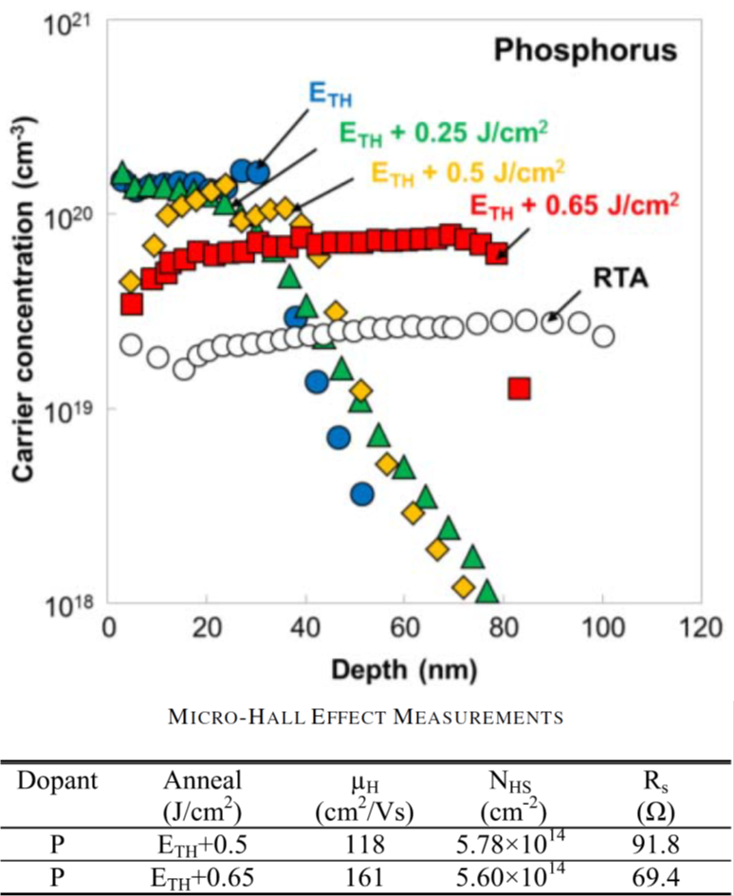

Fig SI-4. (a) Active carrier concentration from P-implanted samples obtained by ECV. Comparison of ECV and SIMS profiles for each of the laser energies (ETH is equal to 0.55 J/cm²) shows a good agreement between the two techniques. Therefore it appears, within the error bars of the two characterization techniques, all the retained dose of P is activated, with a maximum active concentration of 1.65 × 10²⁰ cm⁻³. (b) Summary of the Hall-effect measurements from the samples annealed at high energy density (1.05 and 1.20 J/cm²). Hall effect measurements indicate that higher laser energy in both sets of samples resulted in improved carrier mobility (μH) and also lower sheet resistance (RS). This is consistent with the observations from material studies where the higher laser energy repaired the crystal lattice after the implantation process. Extracted sheet carrier densities with Hall measurements (NHS) is in good agreement with the active integrated concentrations obtained using ECV profiling technique. These data were published by our group in Ref. [18].

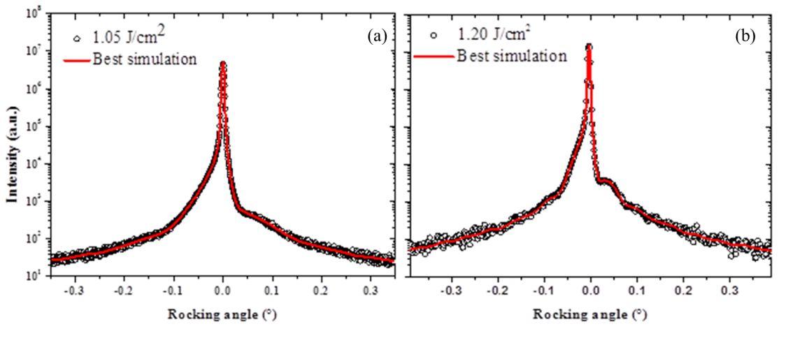

Fig SI-5. HR-XRD rocking curves from samples annealed with (a) 1.05 J/cm² and (b) 1.20 J/cm². The two samples give qualitatively similar rocking curves, with a shoulder on negative angles, indicating positive perpendicular strain.

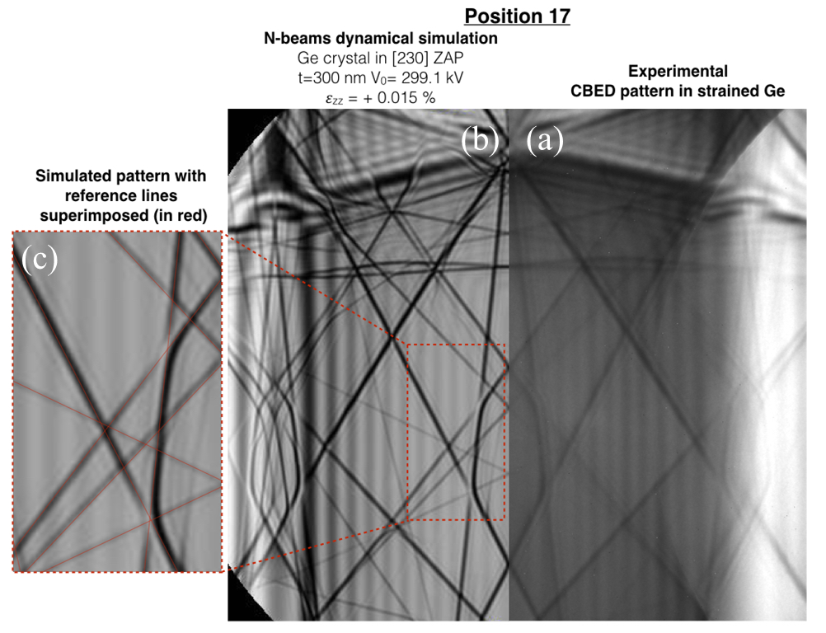

Fig SI-6. Experimental (a) and simulated (b) CBED pattern taken at ~30 nm from the surface. The comparison between the simulated CBED pattern (in grey) and reference (in red) are reported in (c). The shift of HOLZ lines positions, marked by arrows, is ascribed to a variation of lattice parameter.

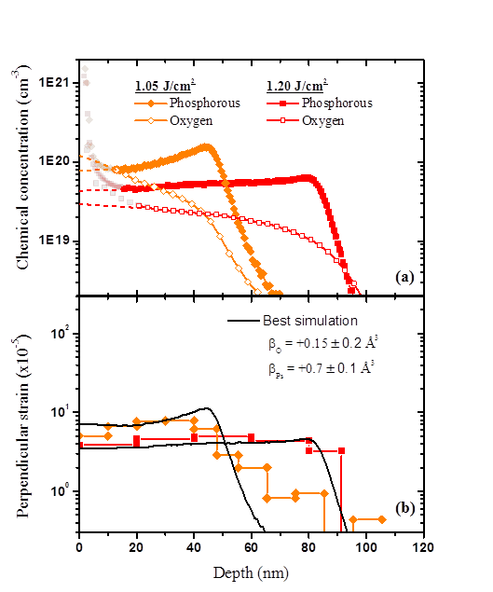
Fig SI-7 (a) P (full symbols) and O (open symbols) chemical concentrations as measured by SIMS in P-doped Ge after LTA at 1.05 (orange diamonds) and 1.20 J/cm² (red squares) vs (b) corresponding strain profiles obtained by HRXRD characterizations and their best simulation obtained by a fitting procedure assuming independent contribution of both dopant and impurity, according to . . Data are satisfactory described with a negligible contribution of O.

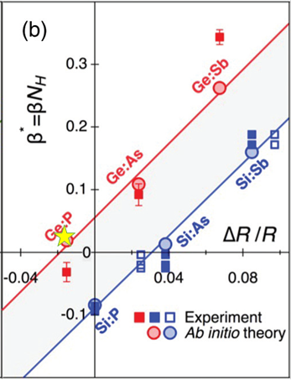

Fig. SI-8. From Ref. [8], β* values, defined as (a_{rel}-a_{Ge})N_{H}/a_{Ge} where a_{rel} is the relaxed lattice parameter, a_{Ge} is the Ge undoped latticed parameter, and N_{H} is the host atomic density, for Ge doped with P, As, and Sb (red symbols) as a function of the size mismatch ΔR/R. Ab initio theoretical values (red line) are experimentally validated in case of Sb and As in Ge (red squares), while in the case of P the experimental result was in contradiction with the theoretical predictions. The yellow star represents the β* value for Ge:P calculated from the β_{Ps} measured in this work, and is in perfect agreement with the literature ab-initio calculations, confirming that the electronic contribution to β* reverses the strain to positive values in the Ge:P system. Data published by our group for Ge doped by As by ion implantation followed by LTA (Ref. [34]) are also included (green star).

SI References

I. De Wolf ,V. Senez, R. Balboni, A. Armigliato, S. Frabboni, A. Cedola, and S. Lagomarsino, Microelectronic Engineering 2003, 70, 425-435.
M. Wihl, M. Cardona, and J. Tauc, J. of Non-Cryst. Sol., 1972, 8–10, 172-178.
G. Faraci, S. Gibilisco, and A.R. Pennisi, Phys. Rev. B, 2009, 80, 193410.
G. Gouadec and P. Colomban, Progr. in Crystal Growth and Charact. of Materials, 2007, 53, 1-73.
C.Y. Peng, C.-F. Huang, Y.-C. Fu, Y.-H. Yang, C.Y. Lai, S. T. Chang, and C. W. Liu, J. Appl. Phys. 2009, 105, 083537.
R. Carles, A.Mlayah, M.Amjoud, M.Amjoud, A.Reines, R.Morancho, Jpn.J. Appl. Phys. 1992, 31, 3511.
F. Cerdeira, T. Fjeldly, and M. Cardona, Phys. Rev. B1973, 8, 4734.

