Suplementary material
n=12
n=12
n=12
n=12
Table S1. Primers used in the study
Target |  | Probe | Primer F or R | Sequence | Product Length | TM | GC% | Intron spanning | Amplicon | Target used for primer design
Target | IFN-γ | 21 | F | atctggaggaactggcaaaa | 89 | 59 | 45 | Yes | atctggaggaactggcaaaaggatggtgacatgaaaatcctgcagagccagattatctct  ttctacctcagactctttgaagtcttgaa | NM_008337.4 Mus musculus interferon gamma (Ifng), mRNA
Target | IFN-γ | 21 | R | ttcaagacttcaaagagtctgagg | 89 | 59 | 42 | Yes |  | NM_008337.4 Mus musculus interferon gamma (Ifng), mRNA
Target | IL-1β | 38 | F | agttgacggaccccaaaag | 75 | 59 | 53 | Yes | agttgacggaccccaaaagatgaagggctgcttccaaacctttgacctgggctgtcctga  tgagagcatccagct | NM_008361.4 Mus musculus interleukin 1 beta (Il1b), mRNA
Target | IL-1β | 38 | R | agctggatgctctcatcagg | 75 | 60 | 55 | Yes |  | NM_008361.4 Mus musculus interleukin 1 beta (Il1b), mRNA
Target | Il 6 | 6 | F | gctaccaaactggatataatcagga | 78 | 59 | 40 | Yes | gctaccaaactggatataatcaggaaatttgcctattgaaaatttcctctggtcttctgg  agtaccatagctacctgg | NM_031168.2 Mus musculus interleukin 6 (Il6), transcript variant 1, mRNA
Target | Il 6 | 6 | R | ccaggtagctatggtactccagaa | 78 | 60 | 50 | Yes
Target | IL-10 | 41 | F | cagagccacatgctcctaga | 79 | 59 | 55 | Yes | cagagccacatgctcctagagctgcggactgccttcagccaggtgaagactttctttcaa  acaaaggaccagctggaca | NM_010548.2 Mus musculus interleukin 10 (Il10), mRNA
Target | IL-10 | 41 | R | tgtccagctggtcctttgtt | 79 | 60 | 50 | Yes |  | NM_010548.2 Mus musculus interleukin 10 (Il10), mRNA
Target | IL-23 alpha subunit (p19) | 19 | F | tccctactaggactcagccaac | 78 | 59 | 55 | Yes | tccctactaggactcagccaactcctccagccagaggatcacccccgggagacccaacag  atgcccagcctgagttct | NM_031252.2 Mus musculus interleukin 23, alpha subunit p19 (Il23a), mRNA
Target | IL-23 alpha subunit (p19) | 19 | R | agaactcaggctgggcatc | 78 | 60 | 58 | Yes
Target | IL-17f | 46 | F | cccaggaagacatacttagaagaaa | 113 | 59 | 40 | Yes | cccaggaagacatacttagaagaaagtacttcctgagggaagaagcagccattggagaaa  ccagcatgaagtgcacccgtgaaacagccatggtcaagtctttgctactgttg | ENSMUST00000039046.9|ENSMUSG00000041872.9 Il17f-001 interleukin 17F
Target | IL-17f | 46 | R | caacagtagcaaagacttgacca | 113 | 59 | 43 | Yes
Target | IL-18 | 46 | F | caaaccttccaaatcacttcct | 78 | 59 | 41 | Yes | caaaccttccaaatcacttcctcttggcccaggaacaatggctgccatgtcagaagactcttgcgtcaacttcaagga | NM_008360.1 Mus musculus interleukin 18 (Il18), mRNA
Target | IL-18 | 46 | R | tccttgaagttgacgcaaga | 78 | 59 | 45 | Yes |  | NM_008360.1 Mus musculus interleukin 18 (Il18), mRNA
Target | IL-12β | 82 | F6 | gcgcaagaaagaaaagatgaa | 93 | 59 | 38 | Yes | gcgcaagaaagaaaagatgaaggagacagaggaggggtgtaaccagaaaggtgcgttcctcgtagagaagacatctaccgaagtccaatgcaa | ENSMUST00000170513.2|ENSMUSG00000004296.14 Il12b-201 interleukin 12b
Target | IL-12β | 82 | R6 | ttgcattggacttcggtaga | 93 | 59 | 45 | Yes
Target | IL-12a | 27 | F2 | gtttaccactggaactacacaagaac | 113 | 59 | 42 | Yes | gtttaccactggaactacacaagaacgagagttgcctggctactagagagacttcttccacaacaagagggagctgcctgcccccacagaagacgtctttgatgatgaccctg | ENSMUST00000107816.3|ENSMUSG00000027776.12 Il12a-001 interleukin 12a
Target | IL-12a | 27 | R2 | cagggtcatcatcaaagacg | 113 | 59 | 50 | Yes
Target | IL-22 | 94 | F | tgacgaccagaacatccaga | 85 | 60 | 50 | Yes | tgacgaccagaacatccagaagaatgtcagaaggctgaaggagacagtgaaaaagcttggagagagtggagagatcaaggcgatt | NM_016971.2 Mus musculus interleukin 22 (Il22), mRNA
Target | IL-22 | 94 | R | aatcgccttgatctctccac | 85 | 59 | 50 | Yes |  | NM_016971.2 Mus musculus interleukin 22 (Il22), mRNA
Target | CXCL1 | 83 | F | acactccaacacagcaccat | 119 | 59 | 50 | Yes | acactccaacacagcaccatgatcccagccacccgctcgcttctctgtgcagcgctgctgctgctggccaccagccgcctggccacaggggcgcctatcgccaatgagctgcgctgtca | ENSMUST00000031327.8|ENSMUSG00000029380.11 Cxcl1-001 chemokine (C-X-C motif) ligand 1
Target | CXCL1 | 83 | R | tgacagcgcagctcattg | 119 | 60 | 56 | Yes
Target | TNF-α | 78 | F5 | cagcaaaccaccaagtgga | 82 | 60 | 53 | No | cagcaaaccaccaagtggaggagcagctggagtggctgagccagcgcgccaacgccctcctggccaacggcatggatctcaa | D84196.2|D84196:EMBL|60d24f1464fa67e1d8eaa780e057b0f3:MD5|ENSMUSG00000024401:Ensembl- Gn|MGP_129S1SvImJ_G0023628:Ensembl-Gn|MGP_AJ_G0023587:Ensembl-Gn|MGP_AKRJ_G0023556:Ensembl- Gn|MGP_BALBcJ_G0023594:Ensembl-Gn|MGP_C3HHeJ_G0023355:Ensembl-Gn|MGP_C57BL6NJ_G0024033:Ensembl- Gn|MGP_CASTEiJ_G0022851:Ensembl-Gn|MGP_CBAJ_G0023333:Ensembl-Gn|MGP_DBA2J_G0023461:Ensembl- Gn|MGP_FVBNJ_G0023428:Ensembl-Gn|MGP_LPJ_G0023538:Ensembl-Gn|MGP_NODShiLtJ_G0023450:EnsemblGn|MGP_NZOHlLtJ_G0024078:Ensembl-Gn|MGP_PWKPhJ_G0022599:Ensembl-Gn|MGP_WSBEiJ_G0022915:Ensembl- Gn|ENSMUST00000025263:Ensembl-Tr|MGP_129S1SvImJ_T0047387:Ensembl-Tr|MGP_AJ_T0047375:Ensembl- Tr|MGP_AKRJ_T0047324:Ensembl-Tr|MGP_BALBcJ_T0047333:Ensembl-Tr|MGP_C3HHeJ_T0047060:Ensembl- Tr|MGP_C57BL6NJ_T0047808:Ensembl-Tr|MGP_CASTEiJ_T0047142:Ensembl-Tr|MGP_CBAJ_T0046995:Ensembl- Tr|MGP_DBA2J_T0047107:Ensembl-Tr|MGP_FVBNJ_T0047068:Ensembl-Tr|MGP_LPJ_T0047211:Ensembl- Tr|MGP_NODShiLtJ_T0047066:Ensembl-Tr|MGP_NZOHlLtJ_T0047909:Ensembl-Tr|MGP_PWKPhJ_T0046732:Ensembl- Tr|MGP_WSBEiJ_T0046403:Ensembl- Tr|PMC1061546:EuropePMC|PMC148819:EuropePMC|PMC434242:EuropePMC|PMC517445:EuropePMC|PMC523004:EuropePM C|PMC538991:EuropePMC Mus musculus TNFA gene for tumor necrosis factor alpha, complete cds.
Target | TNF-α | 78 | R5 | ttgagatccatgccgttg | 82 | 59 | 50 | No
Potential norm. gene | Tbp (TATA box binding protein, NM_013684.3 | 107 | F | ggcggtttggctaggttt | 86 | 60 | 56 | Yes | ggcggtttggctaggtttctgcggtcgcgtcattttctccgcagtgcccagcatcactatttcatggtgtgtgaagataacccaga | ENSMUST00000118001.7|ENSMUSG00000014767.16 Tbp-002 TATA box binding protein
Potential norm. gene | Tbp (TATA box binding protein, NM_013684.3 | 107 | R | tctgggttatcttcacacacca | 86 | 60 | 45 | Yes
Potential norm. gene | GAPDH (glyceraldehyde-3-phosphate dehydrogenase NM_008084.3) | 33 | F | aagagggatgctgcccttac | 89 | 60 | 55 | Yes | aagagggatgctgcccttaccccggggtcccagcttaggttcatcaggtaaactcaggagagtgtttcctcgtcccgtagacaaaatgg | NM_001289726.1 Mus musculus glyceraldehyde-3-phosphate dehydrogenase (Gapdh), transcript variant 1, mRNA
Potential norm. gene | GAPDH (glyceraldehyde-3-phosphate dehydrogenase NM_008084.3) | 33 | R | ccattttgtctacgggacga | 89 | 60 | 50 | Yes

Figure S1. (A) Average C. rodentium levels shed by standard (purple) and ADR-159 (orange) fed animals dosed with C. rodentium. Average C. rodentium levels shed by standard (blue) and ADR-159 (red) fed animals dosed with PBS. Error bars represent SD; (B) infection proportions for C. rodentium dosed animals on standard (circle) or ADR-159 (square) diet (C) shedding of individual C. rodentium infected animals on standard diet; (D) shedding of individual C. rodentium infected animals on ADR-159 diet.
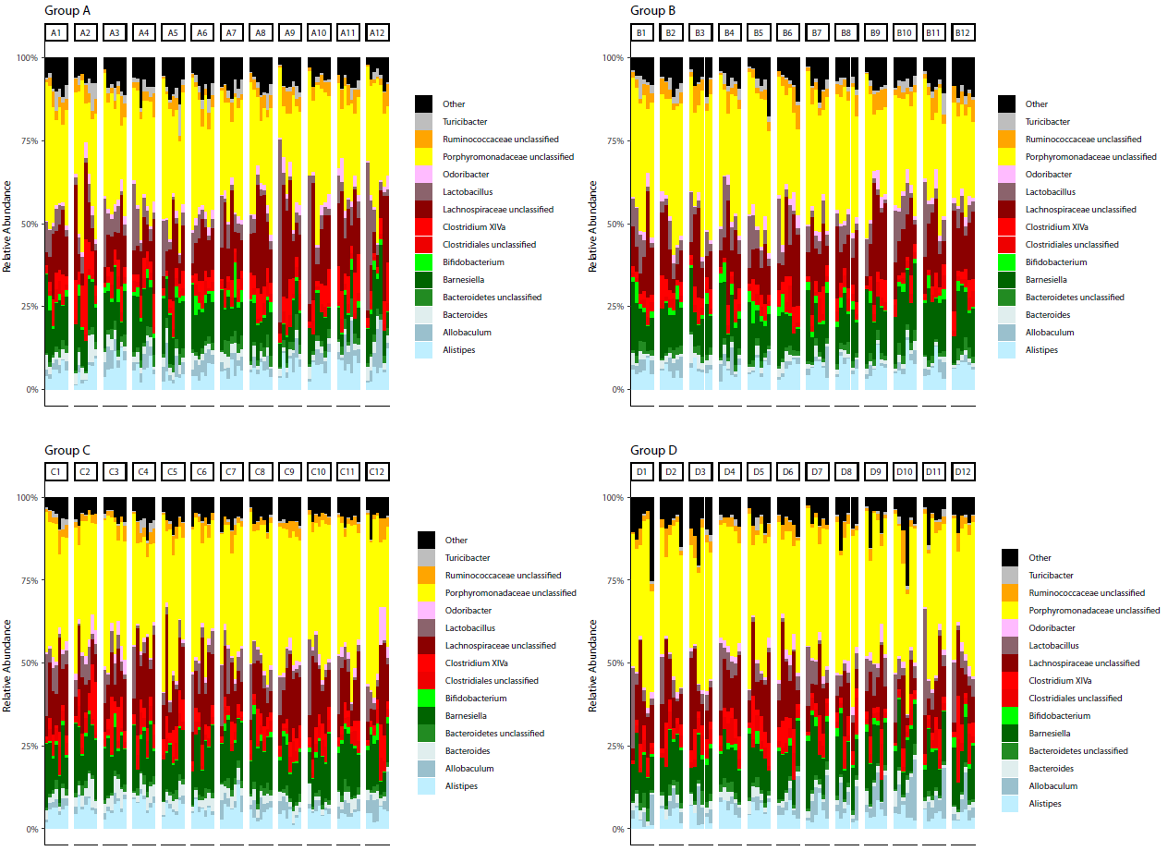
Figure S2. Relative abundance at genus level throughout the whole experiment for individual standard (A, B) and ADR-159 (C, D) fed animals dosed with C. rodentium (B, D) or PBS (A, C). Individual animals labelled 1 to 12. For each animal from left to right: week 0, week 2, week 3 (only groups A&C), week 4 (before dosing), 8 days post dosing, 12 days post dosing and 18 days post dosing (sacrifice).
Table S2. RSV differently abundant in ADR-159 fed animals compared to standard fed ones. Red indicated higher abundance; green indicates lower abundance in ADR-159 fed animals. For clarification genus and species assign to given RSV are presented.
Table S3. Supplementary genus level comparisons post dosing with PBS or Citrobacter. * indicated taxa significantly different at one of the initial 4 weeks of experiment.
Table S3. RSV differently abundant in standard and ADR-159 fed animals before and 8, 12 and 18 days post dosing with PBS or Citrobacter. For clarification genus and/or species assign to given RSV are presented.
Figure S3. Relative abundance of viral contigs throughout the whole experiment for cages of standard (A, B) and ADR-159 (C, D) fed animals dosed with C. rodentium (B, D) or PBS (A, C). Each color represents different contig, for simplicity, contigs with overall abundances below 1% were grouped together (black).
Table S4. P-values for virom alpha and beta diversity before dosing
Time point | Standard vs ADR-159 diet
Time point | Alpha diversity | Beta diversity
Week 0 | 0.3290 | 0.4645
Week 2 | 0.0152 | 0.1618
Week 4 | 0.1320 | 0.0480

Table S5. P-values for virom alpha and beta diversity after dosing

