Appendix 1 –NIR spectra data set
The dataset consists of 60 NIR spectra for ribbons produced at 24 different Roll Force/Blend combinations. For each of these Roll Force/Blend combinations, a sample of 3 ribbon sections were selected and scanned 5 times under MultiEye™ (NIR Spectrometer) using 4 probes at 29 wavelengths (1550−2110 nm in steps of 20 nm). The 3 blends differed only in the storage conditions of microcrystalline cellulose (MCC) prior to blending (low (11% RH/20ºC), ambient (41% RH/20ºC), and high (75% RH/40ºC)) relative humidity. Blends were compacted at 8 roll force settings which increased in intervals of 2 kN/cm between 2 – 16 kN/cm.
Left panel shows spectra by acquisition probes: Probe 1=Red, Probe 2=Green, Probe 3=Blue, Probe 4=Pink.
Right panels shows spectra by ribbon sample: Sample 1 = Black, Sample 2= Red, Sample 3= Green

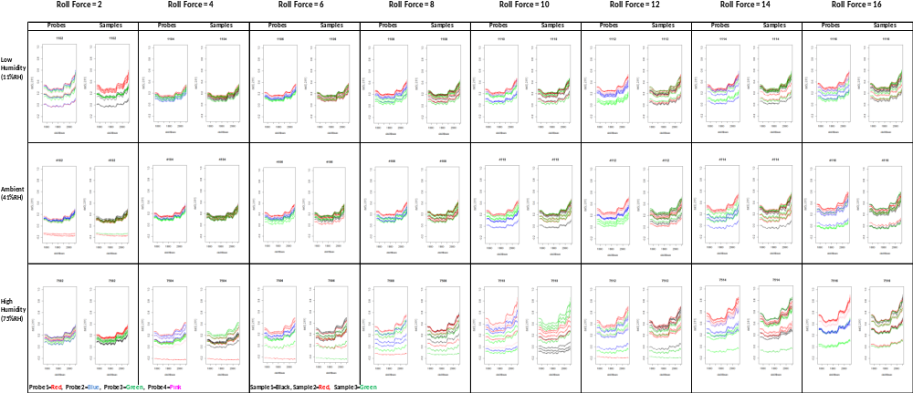

Appendix 2 Comparison of Model 1 (equation 4) and Model 2 (equation 5) using the likelihood ratio test.
