Figure list:
Fig. 1. Storage modulus (G’) of rennet gel of control (), SC (), MC () and PC () samples, under strain of 0.01 and frequency of 1 Hz.
Fig. 2. Urea-polyacrylamide gel electrophoretograms of control (C), skim milk with cream (SC), reconstituted micellar casein concentrate with cream (MC) and reconstituted low heat skim milk powder with cream (PC) cheeses at 60, 120 and 180 days of ripening. Sodium caseinate (S) was used as standard on both sides of the gel. The figure corresponds to data for one of the three cheese replicates; all replicates were similar.
Fig. 3. Ultra-performance liquid chromatograms (UPLC profiles, C₈ column) of pH 4.6-soluble extracts from control (A), SC (B), MC (C) and PC (D) cheeses at 180 days of ripening, at wavelength of 214 nm. The figure corresponds to data for one of the three cheese replicates; all replicates were similar.

Fig. 4. Individual FAA results of cheese samples at 120 (A) and 180 (B) days of ripening and total FAA results of cheese samples at 120 and 180 days of ripening (C). Control (grey bars), SC (black bars), MC (white bars) and PC (white bars filled with straight lines). Values are means of three independent trials. Error bars indicate standard deviation.
Fig. 5. Changes in TPA hardness, springiness and cohesiveness of cheese samples from 60 to 180 days of ripening. Control (grey bars), SC (black bars), MC (white bars) and PC (white bars filled with straight lines). ^{a,b,c} Means at the same time point not sharing a common superscript differ (P<0.05). Values are means of three independent trials. Error bars indicate standard deviation.
Fig. 6. Meltability (diameter increase %) of cheese samples from 60 to 180 days of ripening Control (grey bars), SC (black bars), MC (white bars) and PC (white bars filled with straight lines). ^{a,b,c,d} Means at the same time point not sharing a common superscript differ (P<0.05). Values are means of three independent trials. Error bars indicate standard deviation.
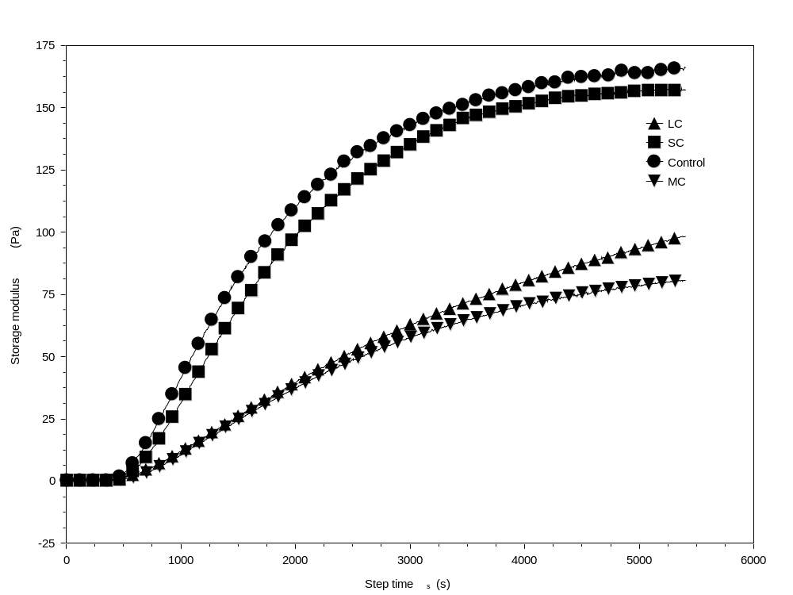
Fig. 1.
0 1000 2000 3000 4000 5000 6000
Step time (s)
175

150

125

100

75
Storage Modulus G’(Pa)
50
25
0
-25

Fig. 2.
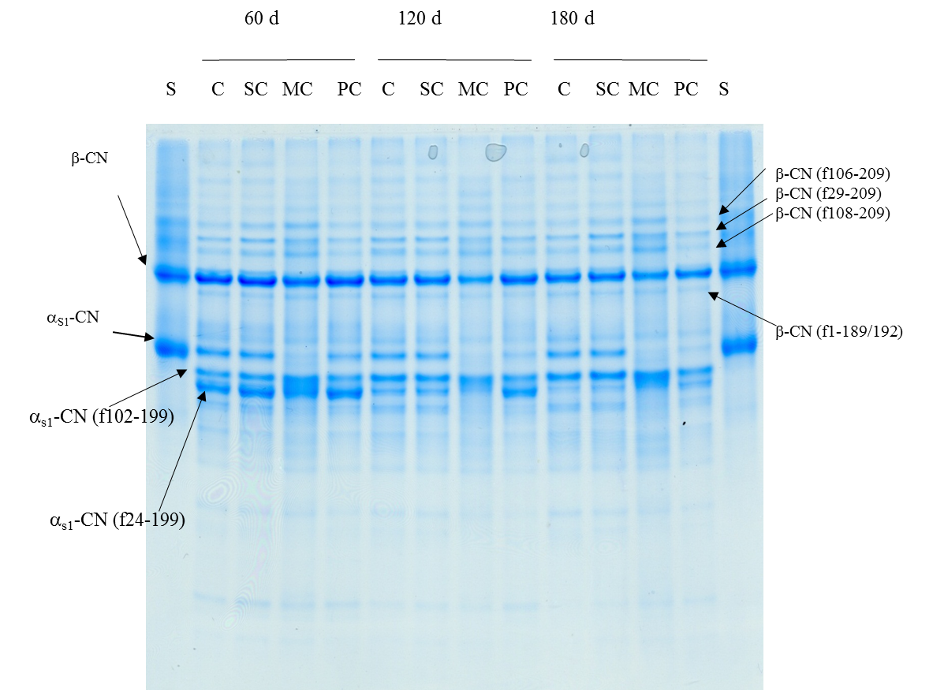

Fig. 3.
B
A
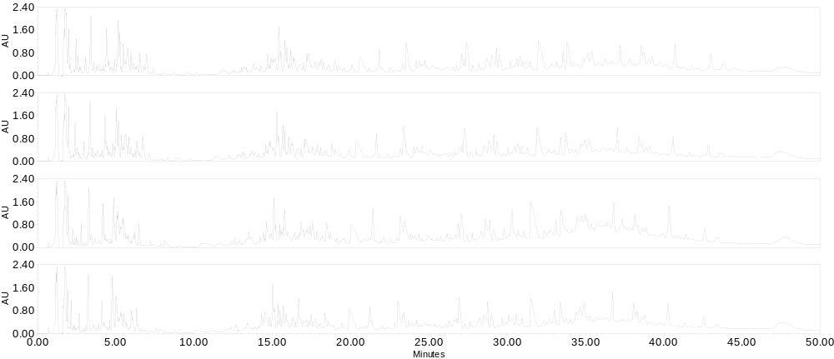
D
C

Fig. 4.
A

B
C
a
ab
bc
c

Fig. 5.
c
a
a
a
a
a
a
a
a
bc
ab
a
b
b
a a
c
c
a a
b
b
a
a
ab
a
bc
c
a
b
a
a
b
c
a
a

Fig. 6.
a
a
b
a
c
b
d
a
b
b
c
a

