Supplemental Data
a)
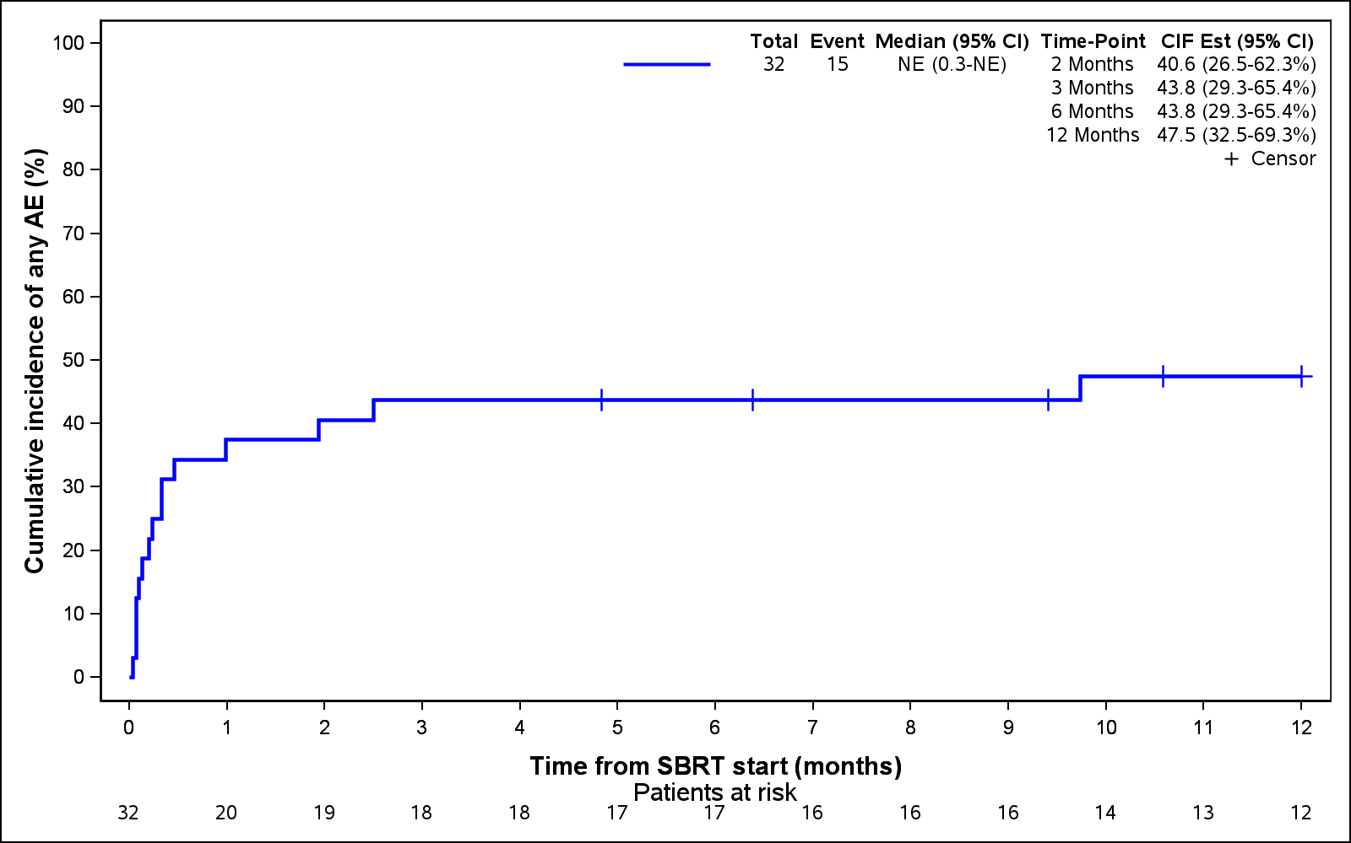
b)
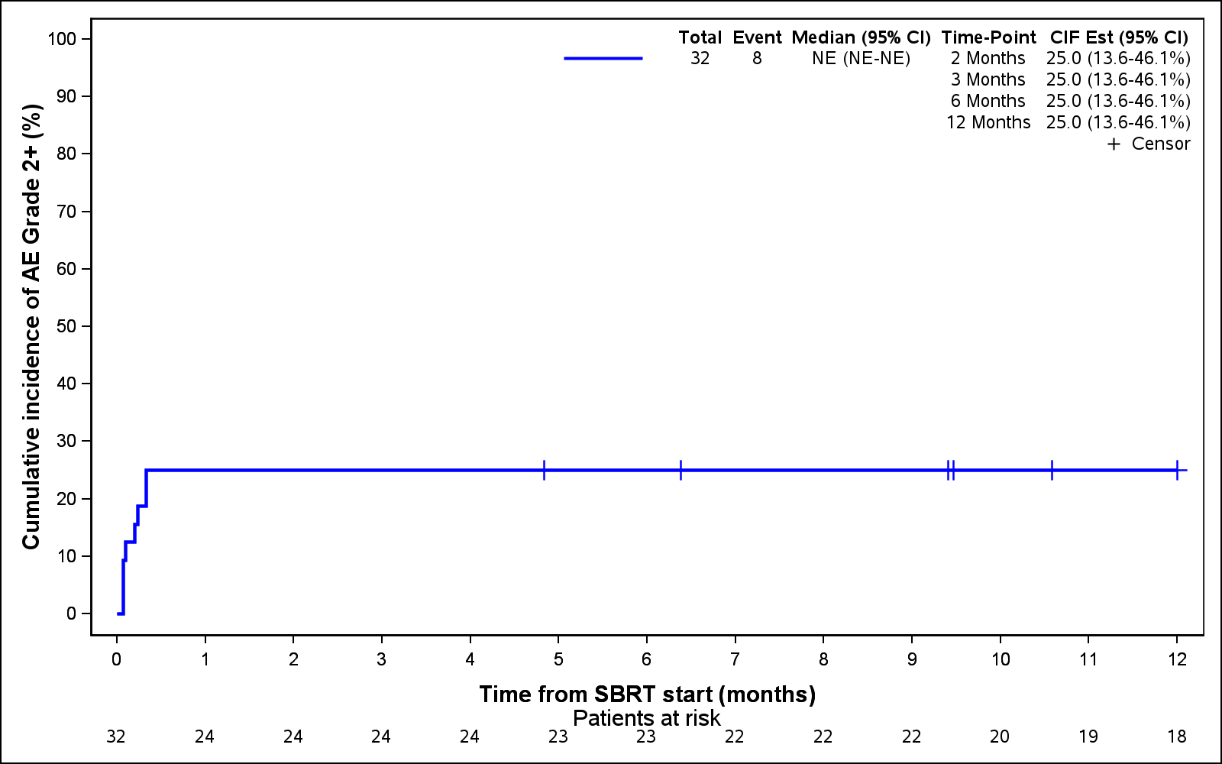
Supp. Fig. 1. Cumulative incidence of (a) any grade adverse event, and (b) adverse events of grade 2 or above.

Supp. Table 1. Accepted dose fractionation schema.

Site | Accepted dose fractionation schemas
Spine metastases | 18-24 Gy in 1-2 fractions OR 24 Gy in 3 fractions OR 30-40 Gy in 5 fractions
Non-spine bone metastases | 30-40 Gy in 5 fractions
Lung metastases | 48-60 Gy in 4 fractions OR 54-60 Gy in 3 fractions for peripheral lung tumours  50 Gy in 5 fractions OR 60 Gy in 8 fractions for central lung tumours
Liver metastases | 27.5 – 50 Gy in 5 fractions  24 – 45 Gy in 3 fractions  16-24 Gy in a single fraction  Depending on spared liver volume and proximity to adjacent organ (stomach, small bowel, large bowel or kidney).
Adrenal or kidney metastases | 30-40 Gy in 5 fractions
Lymphadenopathy | 30-40 Gy in 5 fractions

Supp. Table 2. Normal tissue constraints, for five fractions.

Serial Tissues | Volume | Volume Max (Gy) | Max Point Dose (Gy) | Endpoint (≥Gd 3)
Optic pathway | <0.5cc | 20Gy (4Gy/fr) | 25Gy (5Gy/fr) | Neuritis
Cochlea |  |  | 27.5Gy (5.5Gyfr) | Hearing loss
Brainstem | <1cc | 26Gy (5.2Gy/fr) | 31Gy(6.2Gy/fr) | Cranial neuropathy
Spinal cord | Maximum point dose |  | 22Gy (4.4Gy/fr) | Myelitis
Cauda Equina | Maximum point dose  <5cc | 30 (6Gy/fr) | 22 Gy (4.5Gy/fr)  34 (6.4Gy/fr) | Radiculopathy/cauda equina syndrome
Sacral Plexus | <3cc | 30Gy (6Gy/fr) | 32Gy (6.4Gy/fr) | Neuropathy
Esophagus* | <5cc | 27.5Gy (5.5Gy/fr) | 35Gy (6.4Gy/fr) | Stenosis/fistula
Ipsilateral brachial plexus | <3cc | 30Gy (6Gy/fr) | 32Gy (6.4Gy/fr) | Neuropathy
Heart/pericardium | <15cc | 30Gy (5Gy/fr) | 38Gy (7.6Gy/fr) | Pericarditis
Great Vessels | <10cc | 47Gy (9.4Gy/fr) | 53Gy (10.6Gy/fr) | Aneurysm
Trachea and ipsilateral bronchus* | <4cc | 18Gy (3.6Gy/fr) | 38Gy (7.6Gy/fr) | Stenosis/fistula
Skin | <10cc | 30Gy (6Gy/fr) | 32Gy (6.4Gy/fr) | Ulceration
Stomach | <10cc | 28Gy (5.6Gy/fr) | 32Gy (6.4Gy/fr) | Ulceration/fistula
Duodenum* | <5cc | 18Gy (3.6Gy/fr) | 32Gy (6.4Gy/fr) | Ulceration
Jejunum/Ileum* | <5cc | 19.5 (3.9Gy/fr) | 35Gy (7Gy/fr) | Enteritis/obstruction
Colon* | <20cc | 25 (5Gy/fr) | 38Gy (7.6Gy/fr) | Colitis/fistula
Rectum* | <20cc | 25Gy (5Gy/fr) | 38Gy (7.6Gy/fr) | Proctitis/fistula
Bladder wall | <20cc | 18.3Gy (3.65Gy/fr) | 38Gy (7.6Gy/fr) | Cystitis/fistula
Penile Bulb | <3cc | 30Gy (6Gy/fr) | 50Gy (10Gy/fr) | Impotence
Femoral Heads (R&L) | <10cc | 30Gy (6Gy/fr) |  | Necrosis
Renal hilum/vascular trunk | <2/3 volume | 23Gy (4.6Gy/fr) |  | Malignant hypertension
*Avoid circumferential irradiation

Parallel tissue | Critical Volume | Critical Volume Dose Max (Gy) | Endpoint (≥Gd 3)
Lung (R&L) | 1500cc | 12.5Gy (2.5Gy/fr) | Basic lung function
Lung (R&L) | 1000cc | 13.5Gy (2.7Gy/fr) | Pneumonitis
Liver | 700cc | 21Gy (4.2Gy/fr) | Basic liver function
Renal cortex (R&L) | 200cc | 17.5Gy (3.5Gy/fr) | Basic renal function

Supp. Table 3. Univariate analysis for change in systemic therapy, local failure, distant failure, progression-free survival and overall survival.

 | HR (95% CI) | p-value
Change in systemic therapy  Age  Number of metastases at enrollment (1 vs. >1)  Number of prior systemic lines (1 vs. >1)  Number of lesions treated (1 vs. >1)  Maximal biochemical response  BED (40 Gy-unit increase) | 1.03 (0.96 - 1.11)  0.67 (0.27 - 1.68)  0.34 (0.12 - 0.98)  1.08 (0.45 - 2.62)  0.62 (0.35 - 1.10)  1.16 (0.90 - 1.49) | 0.421  0.398  0.047  0.857  0.104  0.268
Local failure  Age  Number of metastases at enrollment (1 vs. >1)  Number of prior systemic lines (1 vs. >1)  Number of lesions treated (1 vs. >1)  Maximal biochemical response  BED (40 Gy-unit increase) | 0.93 (0.85 - 1.02)  1.41 (0.26 - 7.55)  11864667 (3569602 - 39435859)*  0.88 (0.19 - 4.11)  0.89 (0.40 - 1.98)  0.97 (0.50 - 1.89) | 0.105  0.691  <0.001  0.876  0.772  0.927
Distant failure  Age  Number of metastases at enrollment (1 vs. >1)  Number of prior systemic lines (1 vs. >1)  Number of lesions treated (1 vs. >1)  Maximal biochemical response  BED (40 Gy-unit increase) | 1.01 (0.94 - 1.08)  0.82 (0.37 - 1.82)  0.55 (0.19 - 1.62)  0.93 (0.42 - 2.06)  0.63 (0.38 - 1.04)  1.25 (1.03 - 1.52) | 0.788  0.628  0.279  0.862  0.072  0.026
Progression-free survival  Age  Number of metastases at enrollment (1 vs. >1)  Number of prior systemic lines (1 vs. >1)  Number of lesions treated (1 vs. >1)  Maximal biochemical response  BED (40 Gy-unit increase) | 0.99 (0.93 - 1.06)  0.84 (0.38 - 1.87)  0.60 (0.20 - 1.81)  0.97 (0.44 - 2.14)  0.69 (0.42 - 1.13)  1.20 (0.82 - 1.76) | 0.775  0.669  0.367  0.937  0.137  0.355
*No patients with LF/death had 1 prior line of systemic therapy

Supp. Table 4. Frequency of observed adverse events and association with SBRT delivery.

Adverse event(s) | Attributable to SBRT*  (1 - not related, 2 - unlikely related, 3 - possibly related,  4 - probably related, 5 - definitely related)
Pain (back) | 1,3,3,3,4,4,4
Pain (chest wall) | 1,2
Constipation | 1,2,3,5
Depression | 1
Dyspnea | 1,1
Pain (eye) | 1
Fatigue | 1,1,1,1,3,3,3,3,4,4,4,4,4,5,5,5
Fracture (wrist) | 1
Headache | 1
Hot flashes | 1
Joint infection | 1
Muscle weakness (upper limb) | 1,1
Pain (whole body) | 1
Pain (extremity) | 1,1,2,4,4,4
Odynophagia | 1
Pain (pelvic) | 1,1,2
Peripheral neuropathy | 1,3,3
Pruritus | 1
Thrush | 1
Upper respiratory tract infection | 1,1
Diarrhea | 2,2
Nausea | 2,3
Urinary tract infection | 2
Anorexia | 3
Pain (abdominal) | 4
Esophagitis | 5
*Scores assigned according to site treated, as well as timing in relation to SBRT delivery

