Supplementary Table 1. Oligonucleotides used in this study.
Oligo name | Sequence (5’-3’) | Target/Comment
oIT19 | ctattcccttactatatctctgcg | Fwd, 500 bp upstream of recombineering sequence site used for colony PCR check for nonsense mutation of csdA
oIT20 | gtctgtccagtagttctttctctg | Rev, 500 bp downstream of recombineering sequence site used for colony PCR check for nonsense mutation of csdA
oIT21 | cgataaaacttGAATTCG^{1,3} | Fwd oligonucleotide containing recombineering sequence used for colony PCR check for nonsense mutation of csdA
oIT22 | tttattttcgtgggtaggttataagg | Fwd, 500 bp upstream recombineering sequence site used for colony PCR check for nonsense mutation of csdB
oIT23 | gcttaatagagaaatgacaagacaaatc | Rev, 500 bp downstream of recombineering sequence site used for colony PCR check for nonsense mutation of csdB
oIT24 | agatgctcaatGAATTCG | Rev, oligonucleotide containing recombineering sequence used for colony PCR check for nonsense mutation of csdB
oIT01 | gatatcatcgtgatggattgtggc | Fwd, 500 bp upstream of recombineering sequence used for colony PCR check for nonsense mutation of csdC
oIT02 | ccacgatgtatttccggcaac | Rev, 500 bp downstream of recombineering sequence used for colony PCR check for nonsense mutation of csdC
oIT03 | gttatccgttgCGAATTC | Rev oligonucleotide containing the recombineering sequence used for colony PCR check of nonsense mutation of csdC
oIT04 | ggcgaagtttatctaactgttcac | Fwd, 500 bp upstream of recombineering sequence site used for colony PCR check for nonsense mutation of csdD
oIT05 | caatacgtatcagtgtaaggaacc | Rev, 500 bp downstream of recombineering sequence used for colony PCR check for nonsense mutation of csdD
oIT06 | gttagacaagtGAATTCG | Fwd oligonucleotide containing the inserted sequence used for colony PCR check for nonsense mutation of csdD
oIT31 | gacggaaattgtcctatac | Fwd, 500 bp upstream of recombineering sequence used for colony PCR check for nonsense mutation of csdE
oIT32 | caatctcagatttgtagcc | Rev, 500 bp downstream of recombineering sequence used for colony PCR check for nonsense mutation of csdE
oIT33 | tacgaacaatGATAACCC | Fwd oligonucleotide containing recombineering used for colony PCR check for nonsense mutation of sequence csdE
oIT34 | gcaactgtgttagcttttg | Fwd, 500 bp upstream of recombineering sequence used for colony PCR check for nonsense mutation of csdF
oIT35 | gtaagaaaccaagtgcac | Rev, 500 bp downstream of recombineering sequence used for colony PCR check for nonsense mutation of csdF
oIT36 | gcagcttattGATAACCC | Rev oligonucleotide containing recombineering used for colony PCR check for nonsense mutation of sequence csdF
oIT25 | aaaaaaccatggaatgagaataaaataatatg² | Fwd, 5’-end csdA gene for cloning in pNZ44
oIT26 | aaaaaatctagattagcctttttgctcacaat | Rev, 3’-end csdA gene for cloning in pNZ44
oIT27 | aaaaaaccatggatagaaagaaggtttgattg | Fwd, 5’-end csdB gene for cloning in pNZ44
oIT28 | aaaaaatctagactacttagatttatccatga | Rev, 3’-end csdB gene for cloning in pNZ44
oIT12 | aaaaaaactagttcagttcgactttatattgc | Rev, 3’-end csdC gene for cloning in pNZ44
oIT13 | aaaaaaccatggggtataaaaaatgaggagttg² | Fwd, 5’-end csdD gene for cloning in pNZ44
oIT37 | aaaaaaccatgggtataaaaaaagattctgtc | Fwd, 5’-end csdF gene for cloning in pNZ44
oIT38 | aaaaaatctagatcactccttaactctttttttc | Rev, 3’-end csdF gene for cloning in pNZ44
oIT39 | aaaaaaccatgggagttaaggagtgaatatg | Fwd, 5’-end csdE gene for cloning in pNZ44
oIT40 | aaaaaatctagattaatcttcgttaatgaagtc | Rev, 3’-end csdE gene for cloning in pNZ44
oIT07 | aaacaaacaccaaaaataagatatcttaccgtttg | Fwd oligonucleotide for cloning CRISPR spacer into pCRISPR targeting the mutated region of cflA
oIT08 | aaaacaaacggtaagatatcttatttttggtgttt | Rev oligonucleotide for cloning CRISPR spacer into pCRISPR targeting the mutated region of cflA
oIT09 | gattcaatgctcaactttg | Fwd, 500 bp upstream of inserted sequence used for colony PCR check for knock-out mutants of cflA
oIT10 | catgcctctattatgcca | Rev, 500 bp downstream of inserted sequence used for colony PCR check for knock-out mutants of cflA
oIT11 | aaatccgaaTAATAGGGG | Rev oligonucleotide containing the inserted sequence used for colony PCR check for anticipated knock-out mutants of cflA
oIT29 | aaaaaaggatccggcttttttatttatattcaagac | Fwd, 267 bp upstream of 5’-end csdA for cloning in pPTPL
oIT30 | aaaaaatctagaattattttattctcattttcttag | Rev, 1 bp upstream of 5’-end csdA for cloning in pPTPL
oIT14 | aaaaaaggatccgcgtctcttttggtttgaggcg | Fwd, 193 bp upstream of 5’-end csdD L. lactis for cloning in pPTPL
oIT15 | aaaaaatctagatataacaactcctcattttttatacc | Rev, 1 bp upstream of 5’-start of csdD for cloning in pPTPL
oIT41 | aaaaaaggatccgaaagacacaatcataaaaataaa | Fwd, 190 bp upstream of 5’-end csdF for cloning in pPTPL
oIT42 | aaaaaatctagataaagtaagacagaatcttttttt | Rev, 1 bp upstream of 5’-end csdF for cloning in pPTPL
Recombineering
oIT43 | t*c*a*t*t*aatgtccggtcagtagaaccatcattgacaaaataaaCGAATTCaagttttatcgagcggtaacttttctgttttatcatctact⁴ | csdA
oIT44 | t*a*t*c*a*caaaactgattggggaagaatcaaccttagaaaaccCGAATTCattgagcatctccactcatccagtcaacttttgttagcgtaa | csdB
oIT16 | t*a*t*t*a*gataactcttttataacttctaatgtgttatccgttgCGAATTCaaccatcattaataaaaaaatatgttttttctagaggtagt⁴ | csdC
oIT17 | c*a*c*a*a*cacctaccatcattgagacaatcaggccattagataCGAATTCacttgtctaaccataatattcttgattgcattgccccaatta | csdD
oIT45 | a*a*c*a*t*aaacgattctactttttggactaatgatatcattcgaaatGGGTTATCAttgttcgtatttggccttgagacgttcggaagtttc | csdE
oIT46 | g*c*a*a*a*aagtttttttgataatctaaaaatcccaataaaataGGGTTATCAataagctgctactaaaagaagatttcctaacacaagtgca | csdF
oIT18 | t*a*c*g*a*catgaaaaaactcatgaatgttttaaaatccgaaTAATAGGGGacggtaagatatcttatttttggtgtt  ttggcaactgctgtc | cflA
Footnotes:¹Capital letters: inserted sequence, ²Italics: Non-genomic nucleotide sequence, ³Underlined: Restriction site, ⁴Asterisk: phosphorothioate modification

Supplementary Table 2. Molecular masses and proposed structures of the main PSP oligosaccharides obtained by HF extraction from L. lactis NZ9000 and 3107 and derivative mutants
Figure/Panel  Strain | Proposed structures* | Calculated m/z [M+Na]⁺ | Observed m/z [M+Na]⁺
Figure 3
(A) NZ9000 | GlcNAc-Rha-(Glc)GlcNAc-Galf-Glc | 1079.37 | 1079.32
(A) NZ9000 | GlcNAc-Rha-(Glc)GlcNAc-Galf | 917.32 | 917.28
(B) NZ900-csdCD | GlcNAc-Rha-GlcNAc-Galf-Glc | 917.32 | 917.33
(B) NZ900-csdCD | GlcNAc-Rha-GlcNAc-Galf | 755.27 | 755.28
(C) NZ9000-cflA(pNZ44str) | GlcNAc-Rha-(Glc)GlcNAc-Galf-Glc | 1079.37 | 1079.34
(C) NZ9000-cflA(pNZ44str) | GlcNAc-Rha-(Glc)GlcNAc-Galf  GlcNAc-Rha-GlcNAc-Galf-Glc | 917.32 | 917.30
(C) NZ9000-cflA(pNZ44str) | GlcNAc-Rha-GlcNAc-Galf | 755.27 | 755.25
(D) NZ9000-cflA(pNZ44::cflA) | GlcNAc-Rha-(Glc)GlcNAc-Galf-Glc | 1079.37 | 1079.31
(D) NZ9000-cflA(pNZ44::cflA) | GlcNAc-Rha-(Glc)GlcNAc-Galf | 917.32 | 917.26
(E) 3107 | Glc-Galf-GlcNAc-Galf-GlcNAc | 933.32 | 933.43
(E) 3107 | Glc-Galf-GlcNAc-Galf | 730.24 | 730.22
(E) 3107 | GlcNAc-Galf-GlcNAc | 609.21 | 609.09
(E) 3107 | GlcNAc-Galf | 406.13 | 405.79
(F) 3107(pNZ44::csdCD) | Glc-Galf-(Glc)GlcNAc-Galf-GlcNAc | 1095.37 | 1095.61
(F) 3107(pNZ44::csdCD) | Glc-Galf-(Glc)GlcNAc-Galf | 892.29 | 892.44
(F) 3107(pNZ44::csdCD) | GlcNAc-(Glc)Galf-GlcNAc | 771.26 | 771.32
(F) 3107(pNZ44::csdCD) | GlcNAc-(Glc)Galf | 568.18 | 568.05
Figure S1
(A) NZ9000-csdC | GlcNAc-Rha-(Glc)GlcNAc-Galf-Glc | 1079.37 | 1079.38
(A) NZ9000-csdC | GlcNAc-Rha-(Glc)GlcNAc-Galf  GlcNAc-Rha-GlcNAc-Galf-Glc | 917.32 | 917.33
(A) NZ9000-csdC | GlcNAc-Rha-GlcNAc-Galf | 755.27 | 755.27
(B) NZ9000-csdD | GlcNAc-Rha-GlcNAc-Galf-Glc | 917.32 | 917.33
(B) NZ9000-csdD | GlcNAc-Rha-GlcNAc-Galf | 755.27 | 755.28
Figure S3
(A) NZ9000(pNZ44) | GlcNAc-Rha-(Glc)GlcNAc-Galf-Glc | 1079.37 | 1079.35
(A) NZ9000(pNZ44) | GlcNAc-Rha-(Glc)GlcNAc-Galf | 917.32 | 917.30
(B) NZ9000(pNZ44::csdA) | GlcNAc-Rha-(Glc)GlcNAc-Galf-Glc | 1079.37 | 1079.34
(B) NZ9000(pNZ44::csdA) | GlcNAc-Rha-(Glc)GlcNAc-Galf | 917.32 | 917.30
(C) NZ9000(pNZ44::csdB) | GlcNAc-Rha-(Glc)GlcNAc-Galf-Glc | 1079.37 | 1079.38
(C) NZ9000(pNZ44::csdB) | GlcNAc-Rha-(Glc)GlcNAc-Galf  GlcNAc-Rha-GlcNAc-Galf-Glc | 917.32 | 917.32
(C) NZ9000(pNZ44::csdB) | GlcNAc-Rha-GlcNAc-Galf | 755.27 | 755.27
(D) NZ9000(pNZ44::csdAB) | GlcNAc-Rha-(Glc)GlcNAc-Galf-Glc | 1079.37 | 1079.33
(D) NZ9000(pNZ44::csdAB) | GlcNAc-Rha-(Glc)GlcNAc-Galf | 917.32 | 917.28
*Proposed structures were deduced from MS analysis, methylation analysis reported in the text and previous NMR structure of the PSP (Chapot-Chartier et al., 2010; Ainsworth et al., 2014).

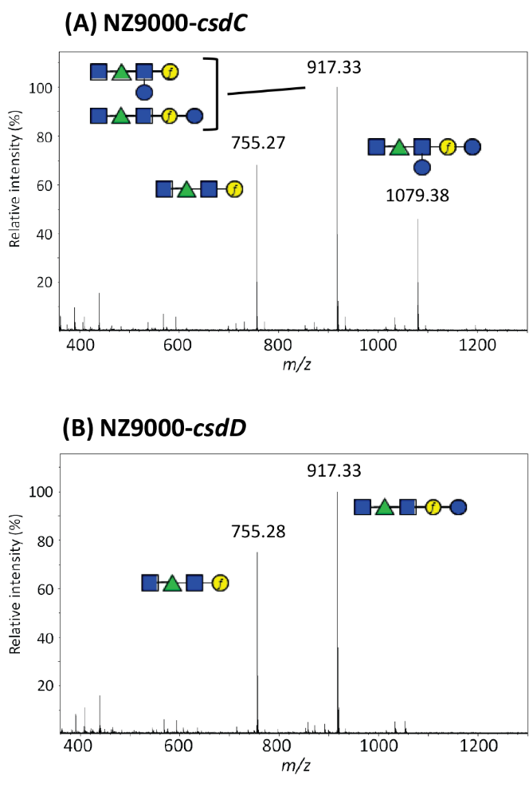

Supplementary Figure 1. Maldi-Tof MS spectra obtained on purified PSP oligosaccharides extracted by HF treatment from cell walls of (A) L. lactis NZ9000-csdC mutant and (B) L. lactis NZ9000-csdD. m/z values on spectra correspond to [M+Na]⁺ ion adducts. The polymeric PSP of L. lactis NZ9000 is cleaved during HF extraction at the level of phosphodiester bonds leading to hexasacharide (M_{calc} 1079.37) and also partially between Galf and Glc leading to a pentasaccharide (M_{calc} 917.32) as shown previously by NMR (Chapot-Chartier et al., 2010). Calculated and observed m/z values of the different oligosaccharide structures tentatively assigned to major peaks of the spectra are listed in Supplementary Table 2. Structures are drawn using the symbol nomenclature for graphical representation of glycans (SNFG). Blue square, GlcNAc; green triangle, Rha; blue circle, Glc; yellow circle, Gal: f, furanose.

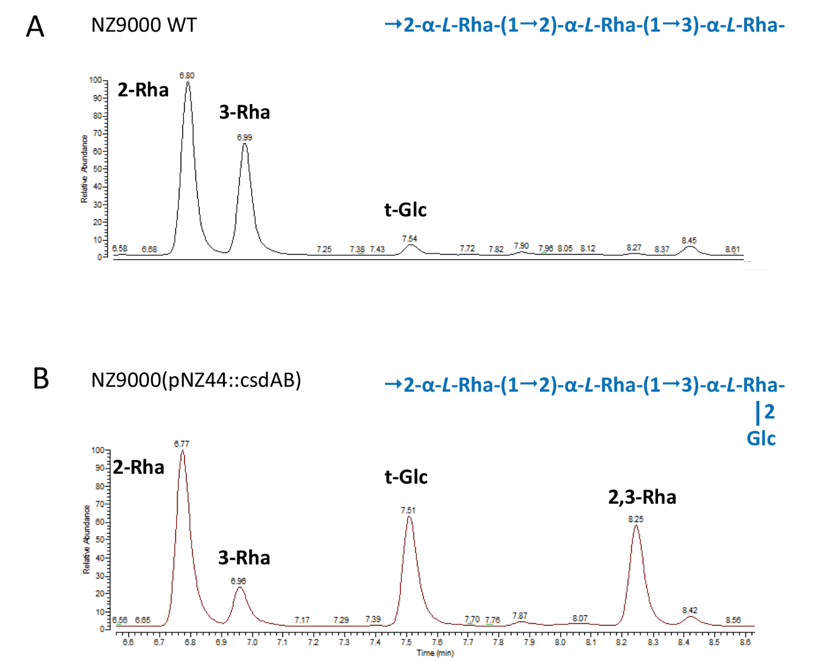

Supplementary Figure 2. Methylation analysis of SEC-HPLC purified rhamnan from L. lactis NZ9000 (A) and NZ9000(pNZ44::csdAB) (B). Samples were analysed by GC-MS. The figure was zoomed onto the region corresponding to hexoses. t-Glc = terminal glucose. In blue, (panel A) structure of the repeating unit of the major rhamnan from L. lactis NZ9000 established by NMR experiments (Sadovskaya etal., 2017) and (panel B) structure deduced from composition, MS and methylation analysis for the glucosylated rhamnan of NZ9000(pNZ44::csdAB).

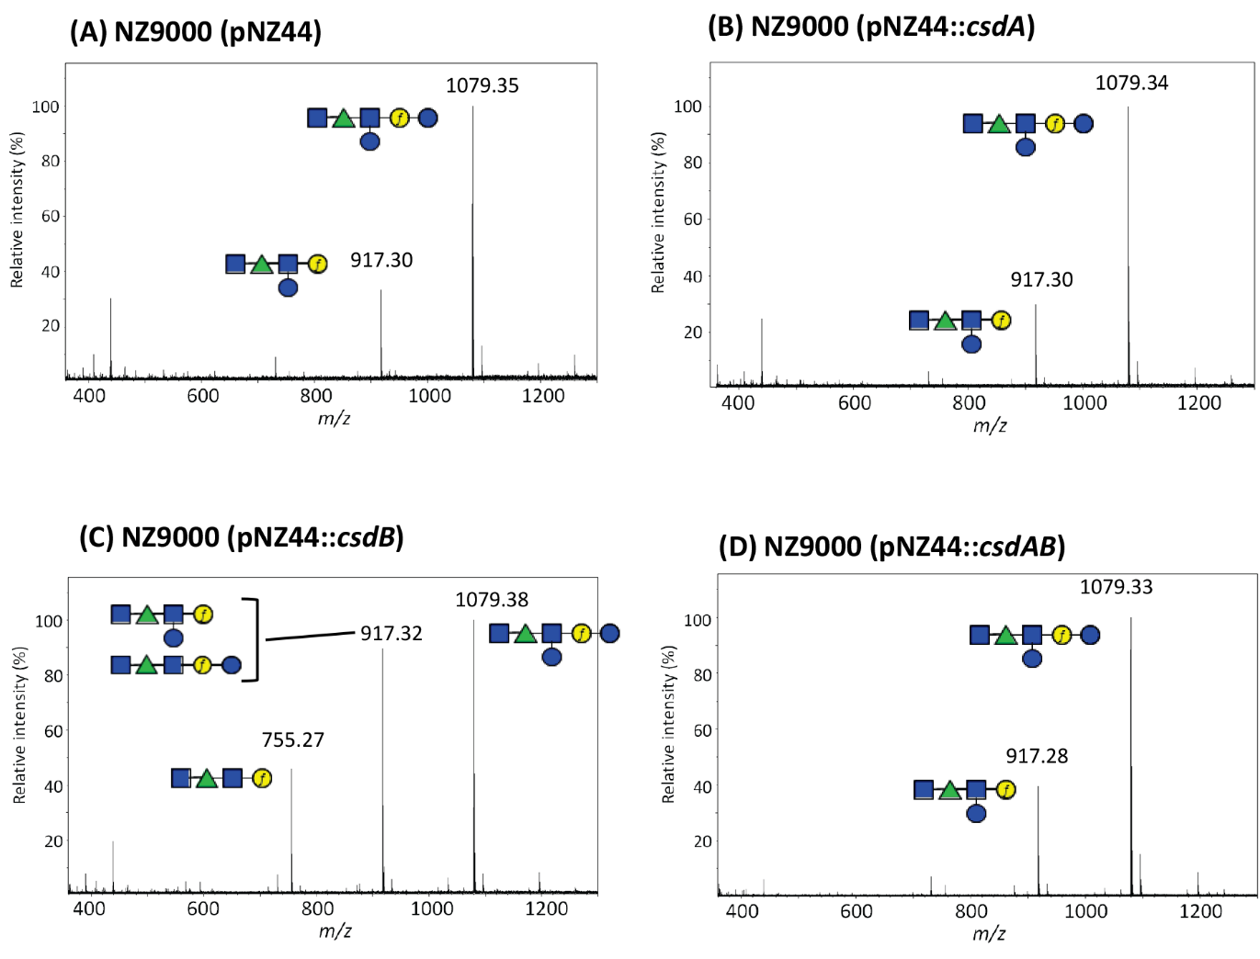

Supplementary Figure 3. Maldi-Tof MS spectra obtained on purified PSP oligosaccharides extracted by HF treatment from cell walls of (A) control L. lactis NZ9000(pNZ44); (B) L. lactis NZ9000(pNZ44::csdA) mutant; (C) NZ9000(pNZ44::csdB) mutant; (D) NZ9000(pNZ44::csdAB) mutant. m/z values on spectra correspond to [M+Na]⁺ ion adducts. The polymeric PSP of L. lactis NZ9000 is cleaved during HF extraction at the level of phosphodiester bonds leading to hexasacharide (M_{calc} 1079.37) and also partially between Galf and Glc leading to a pentasaccharide (M_{calc} 917.32) as shown previously by NMR (Chapot-Chartier et al., 2010). Calculated and observed m/z values of the different oligosaccharide structures tentatively assigned to major peaks of the spectra are listed in Supplementary Table 2. Structures are drawn using the symbol nomenclature for graphical representation of glycans (SNFG). Blue square, GlcNAc; green triangle, Rha; blue circle, Glc; yellow circle, Gal: f, furanose.
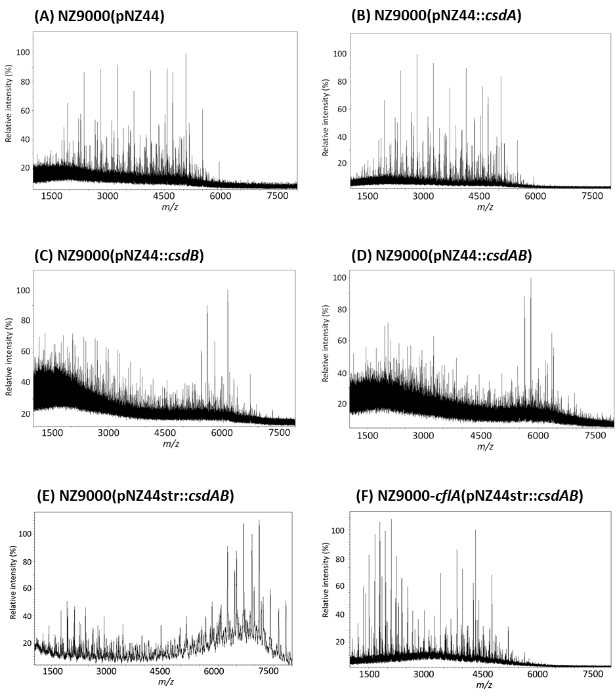

Supplementary Figure 4. Maldi-Tof MS spectra of rhamnan purified from control L. lactis NZ9000(pNZ44) (A), mutant L. lactis NZ9000 overexpressing strains NZ9000(pNZ44::csdA) (B), NZ9000(pNZ44::csdB) (C) and NZ9000(pNZ44::csdAB) (D), mutant L. lactis NZ9000 overexpressing csdAB with pNZ44str plasmid (E) and flippase cflA mutant overexpressing csdAB with pNZ44str plasmid (F). m/z values correspond to [M+Na]⁺ adducts.

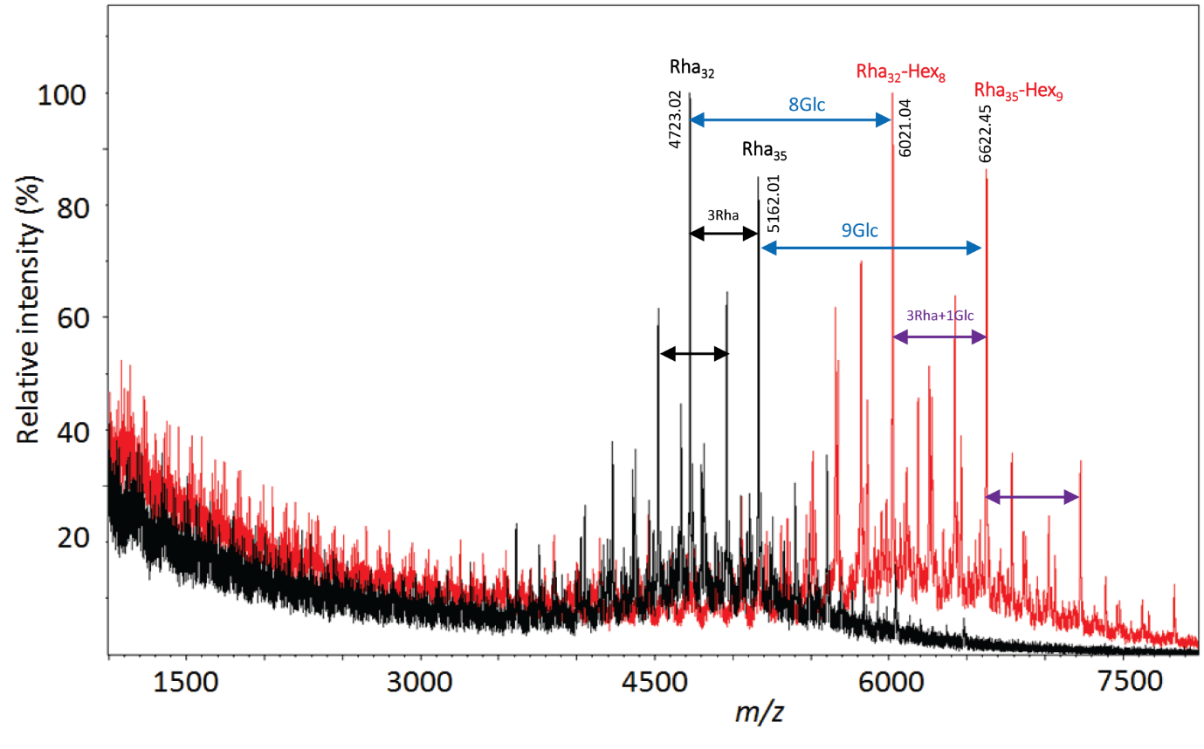

Supplementary Figure 5. Maldi-Tof MS spectra of rhamnan purified from L. lactis 3107 WT (black) and L. lactis 3107(pNZ44::csdAB) (red). All m/z values correspond to [M+Na]⁺ adducts.

Supplementary Figure 6. Methylation analysis of crude phenol extracts from (A) NZ9000 pNZStr44, (B) NZ9000-cflA pNZ44Str, and (C) NZ9000-cflA pNZ44Str::cflA. Samples were analysed by GC-MS. The figure was zoomed onto the region corresponding to hexoses. t-Glc = Terminal glucose; t-Gal = Terminal galactose; Ino = m-Inositol Standard.

Supplementary Figure 7. Growth of control strain L. lactis NZ9000 pVPL3004/pCRISPR versus L. lactis NZ9000-cflA

Supplementary Figure 8. Reversible/Irreversible adsorption assay results indicating the free-phage titres of phage p2 following adsorption to L. lactis NZ9000 and L. lactis NZ9000-csdCD. p values are indicated by stars *p<0.005

A
B

Supplementary Figure 9. Total infectivity of phages [A] LC3, 66902, 66903, and 700 against L. lactis 3107, 3107 pNZ44, and 3107pNZ44::csdAB and [B] jj50* and MCC1 against L. lactis VES5751, VES5751 pNZ44, and VES5751 pNZ44::csdAB. p values are indicated by stars *p<0.001.

