The Association between Preeclampsia and Childhood Development and Behavioural Outcomes

eTable 1: Summary of Data Collection Process
Wave (age at time of wave) | Data collected | Method of collection
Wave 1 (age 9-months) | 1. Preeclampsia  (and Preeclampsia+SGA) | Face-to-face interview with Primary Caregiver
Wave 1 (age 9-months) | 2. Potential confounding factors | Face-to-face interview with Primary Caregiver
Wave 1 (age 9-months) | 3. ASQ | Face-to-face interview with Primary Caregiver
Wave 2 (age 3 years) | SDQ | Face-to-face interview with Primary Caregiver
Wave 3 (age 5 years) | SDQ | Face-to-face interview with Primary Caregiver
Wave 3 (age 5 years) | SDQ | Postal survey completed by study child’s teacher
Wave 4 (age 7-8 years) | SDQ | Postal survey completed by Primary Caregiver
SGA, small for gestational age; ASQ, Ages and Stages Questionnaire; SDQ, Strengths and Difficulties Questionnaire.

eTable 2: Repeated Measures Analysis Examining the Association between Preeclampsia and Emotional/Behavioural Problems (by SDQ Domain) Among Singleton Live Births in Ireland
Adjusted modelª  Emotional | Mean trajectory (95% CI)  (No Preeclampsia) | Mean trajectory (95% CI) (Preeclampsia) | Mean difference in trajectory (95% CI) comparing no preeclampsia to preeclampsia
Age 3 SDQ | 1.71 (1.30, 2.12) | 1.79 (1.36, 2.21) | -0.08 (-0.19, 0.03)
Change SDQ Age 5 | -0.61 (-2.23, 1.02) | -0.44 (-2.07, 1.20) | -0.17 (-0.03, -0.31)
Change SDQ Age 7-8 | 2.93 (-0.65, 6.51) | 2.91 (-0.68, 6.49) | 0.03 (0.19, 0.24)
Age 7-8 SDQ | 4.03 (0.36, 7.70) | 4.26 (0.58, 7.94) | -0.22 (-0.01, -0.44)
Conduct
Age 3 SDQ | 2.70 (2.29, 3.11) | 2.78 (2.36, 3.21) | -0.08 (-0.21, 0.04)
Change SDQ Age 5 | -0.69 (-0.73, -0.66) | -0.61 (-0.75, -0.47) | -0.08 (-0.23, 0.06)
Change SDQ Age 7-8 | -0.09 (-0.13, -0.04) | -0.31 (-0.48, -0.14) | 0.22 (0.04, 0.40)
Age 7-8 SDQ | 1.92 (1.51, 2.33) | 1.87 (1.43, 2.31) | 0.05 (-0.12, 0.22)
Hyperactivity
Age 3 SDQ | 5.73 (5.11, 6.36) | 5.66 (5.01, 6.30) | 0.08 (-0.09, 0.25)
Change SDQ Age 5 | 0.57 (-1.68, 2.81) | 0.88 (-1.37, 3.14) | -0.32 (-0.51, -0.12)
Change SDQ Age 7-8 | 0.67 (-3.28, 4.62) | 0.48 (-3.48, 4.44) | -0.19 (-0.05, 0.43)
Age 7-8 SDQ | 6.97 (2.91, 11.03) | 7.02 (2.95, 11.09) | -0.05 (-0.30, 0.19)
Peer Problems
Age 3 SDQ | 2.36 (1.98, 2.75) | 2.39 (1.99, 2.79) | -0.03 (-0.14, 0.08)
Change SDQ Age 5 | 0.19 (-1.24, 1.63) | 0.29 (-1.15, 1.73) | -0.10 (-0.23, 0.03)
Change SDQ Age 7-8 | -0.33 (-3.15, 2.48) | -0.51 (-3.33, 2.31) | 0.17 (0.01, 0.35)
Age 7-8 SDQ | 2.22 (-0.58, 5.02) | 2.17 (-0.64, 4.98) | 0.05 (-0.11, 0.21)
Prosocial Behaviour^{b}
Age 3 SDQ | 7.39 (6.90, 7.89) | 7.49 (6.98, 7.80) | -0.09 (-0.23, 0.04)
Change SDQ Age 5 | 0.75 (-0.97, 2.47) | 0.66 (-1.07, 2.39) | 0.09 (-0.06, 0.24)
Change SDQ Age 7-8 | 1.73 (-1.46, 4.91) | 1.80 (-1.39, 4.99) | -0.07 (-0.27, 0.13)
Age 7-8 SDQ | 9.87 (6.69, 13.04) | 9.94 (6.76, 13.12) | -0.07 (-0.26, 0.11)
ªAdjusted for maternal education, maternal age, maternal ethnicity, maternal body mass index (BMI) at time of interview, family social class, gestational diabetes, and infant sex.
^{b}Prosocial Behaviour is reversed scored (i.e. higher scores indicate more positive outcomes).
Abbreviations: 95% CI, 95% confidence interval; SDQ, Strengths and Difficulties Questionnaire

eTable 3: Assessment of Repeated Measures Model Fit. Comparison of predicted values (from multilevel model) with observed values at age 3, 5 and 7-8 years.
 | Mean observed (SD) | Mean predicted (SD) | Mean difference (observed - predicted) | 95% level of agreement between observed and predicted
SDQ score
Age 3 | 7.77 (4.53) | 7.78 (2.95) | -0.01 | -4.31, 4.31
Age 5 | 7.18 (4.75) | 7.23 (3.34) | -0.05 | -4.05, 4.05
Age 7-8 | 7.10 (5.30) | 7.44 (3.72) | -0.33 | -3.63, 3.63
Abbreviations: SD, standard deviation; 95% CI, 95% confidence interval; SDQ, Strengths and Difficulties Questionnaire.

eTable 4: Sensitivity Analysis Examining Associations between Preeclampsia and Child Development and Emotional/Behavioural Problems Among Singleton Live Births in Ireland
Failure of ASQ domains (including primiparous women only) | Adjusted modelª  OR (95% CI)
Communication | 1.32 (0.80, 2.19)
Gross Motor | 1.15 (0.78, 1.71)
Fine Motor | 0.73 (0.45, 1.17)
Problem Solving | 0.74 (0.48, 1.14)
Personal Social | 1.25 (0.84, 1.86)
Abnormal SDQ age 3 years (including primiparous women only)
Emotional | 1.38 (0.74, 2.57)
Conduct | 1.06 (0.76, 1.48)
Hyperactivity | 0.93 (0.56, 1.55)
Peer Problems | 0.69 (0.42, 1.14)
Prosocial Behaviour | 1.32 (0.60, 2.91)
Abnormal SDQ age 5 years (including primiparous women only)
Emotional | 1.75 (1.09, 2.82)
Conduct | 0.78 (0.47, 1.30)
Hyperactivity | 1.64 (1.11, 2.42)
Peer Problems | 1.53 (0.90, 2.60)
Prosocial Behaviour | 1.21 (0.42, 3.55)
Abnormal SDQ age 7/8 years (including primiparous women only)
Emotional | 1.18 (0.70, 1.99)
Conduct | 0.99 (0.53, 1.89)
Hyperactivity | 0.98 (0.52, 1.84)
Peer Problems | 1.02 (0.52, 1.97)
Prosocial Behaviour | 0.30 (0.07, 1.38)
Total SDQ score age 5 years (Maternal reported) | Adjusted modelª  Coefficient (95% CI)
Preeclampsia | 0.79 (0.26, 1.31)
Total SDQ score age 5 years (Teacher reported)
Preeclampsia | 0.71 (0.12, 1.31)
ªAdjusted for maternal education, maternal age, maternal ethnicity, maternal body mass index (BMI) at time of interview, family social class, gestational diabetes and infant sex.
Abbreviations: OR, odds ratio; 95% CI, 95% confidence interval; ASQ, Ages and Stages Questionnaire; SDQ, Strengths and Difficulties Questionnaire.

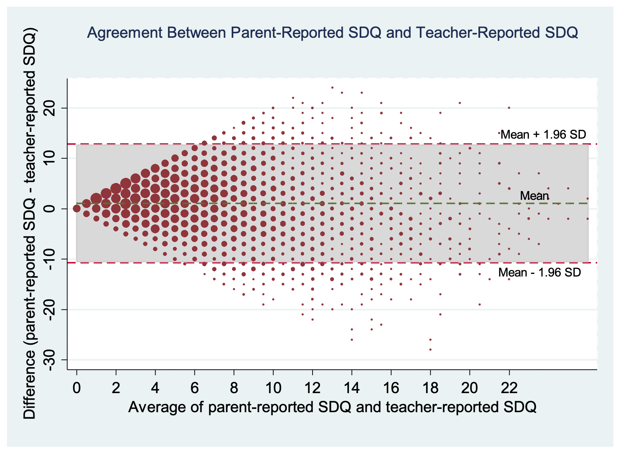

eFig. 1 Bland-Altman agreement plot

eTable 5: Repeated Measures Analysis Examining the Association between Preeclampsia/SGA and Emotional/Behavioural Problems (using Total SDQ Score) Among Singleton Live Births in Ireland (restricting study population to Irish/other white background)
Model 1ª | Mean trajectory  (95% CI)  (No Preeclampsia/No SGA) | Mean trajectory  (95% CI)  (Preeclampsia+SGA) | Mean difference in trajectory (95% CI) comparing no preeclampsia/no SGA to preeclampsia+SGA
Age 3 SDQ | 11.56 (10.05, 13.06) | 11.89 (10.09, 13.68) | -0.33 (-1.31, 0.64)
Change SDQ Age 5 | -4.16 (-10.25, 1.93) | -3.42 (-9.59, 2.75) | -0.74 (-1.78, 0.30)
Change SDQ Age 7-8 | 1.42 (-0.21, 3.05) | 0.51 (-1.66, 2.67) | 0.91 (-0.57, 2.40)
Age 7-8 SDQ | 8.81 (2.39, 15.24) | 8.98 (2.37, 15.58) | -0.16 (-1.73, 1.40)
ªAdjusted for maternal education, maternal age, maternal ethnicity, maternal body mass index (BMI) at time of interview, family social class, gestational diabetes, and infant sex.
Abbreviations: 95% CI, 95% confidence interval; SDQ, Strengths and Difficulties Questionnaire; SGA, small for gestational age.

eTable 6: Sensitivity Analysis Examining Associations between Preeclampsia with/without Preterm Birth and Child Development and Emotional/Behavioural Problems Among Singleton Live Births in Ireland
Failure of ASQ domains (Preeclampsia, born <37 weeks’ gestation)^{b} | Adjusted modelª  OR (95% CI)
Communication | 3.10 (1.49, 6.45)
Gross Motor | 2.80 (1.63, 4.85)
Fine Motor | 1.54 (0.77, 3.07)
Problem Solving | 1.74 (0.96, 3.16)
Personal Social | 1.42 (0.77, 2.61)
Failure of ASQ domains (Preeclampsia, born ≥37 weeks’ gestation)^{b}
Communication | 0.96 (0.64, 1.46)
Gross Motor | 0.93 (0.70, 1.23)
Fine Motor | 0.88 (0.63, 1.22)
Problem Solving | 0.80 (0.60, 1.08)
Personal Social | 0.92 (0.70, 1.20)
Abnormal SDQ age 3 years (Preeclampsia, born <37 weeks’ gestation)^{b}
Emotional | 1.43 (0.46, 4.49)
Conduct | 0.75 (0.40, 1.38)
Hyperactivity | 1.40 (0.64, 3.08)
Peer Problems | 1.07 (0.46, 2.49)
Prosocial Behaviour | 1.82 (0.60, 5.53)
Abnormal SDQ age 3 years (Preeclampsia, born ≥37 weeks’ gestation)^{b}
Emotional | 1.28 (0.77, 2.13)
Conduct | 1.10 (0.87, 1.40)
Hyperactivity | 0.87 (0.59, 1.29)
Peer Problems | 0.85 (0.57, 1.25)
Prosocial Behaviour | 1.06 (0.59, 1.90)
Abnormal SDQ age 5 years (Preeclampsia, born <37 weeks’ gestation)^{b}
Emotional | 2.39 (1.07, 5.37)
Conduct | 1.45 (0.69, 3.04)
Hyperactivity | 2.22 (1.12, 4.39)
Peer Problems | 2.56 (1.15, 5.69)
Prosocial Behaviour | 1.60 (0.33, 7.81)
Abnormal SDQ age 5 years (Preeclampsia, born ≥37 weeks’ gestation)^{b}
Emotional | 1.46 (0.96, 2.20)
Conduct | 1.08 (0.76, 1.54)
Hyperactivity | 1.50 (1.11, 2.03)
Peer Problems | 1.31 (0.86, 1.99)
Prosocial Behaviour | 1.42 (0.72, 2.80)
Abnormal SDQ age 7/8 years (Preeclampsia, born <37 weeks’ gestation)^{b}
Emotional | 1.52 (0.59, 3.88)
Conduct | 0.58 (0.19, 1.79)
Hyperactivity | 0.49 (0.11, 2.10)
Peer Problems | 1.14 (0.35, 3.74)
Prosocial Behaviour | -
Abnormal SDQ age 7/8 years (Preeclampsia, born ≥37 weeks’ gestation)^{b}
Emotional | 1.11 (0.73, 1.69)
Conduct | 0.90 (0.54, 1.50)
Hyperactivity | 0.87 (0.52, 1.45)
Peer Problems | 0.69 (0.39, 1.21)
Prosocial Behaviour | 0.67 (0.24, 1.89)
ªAdjusted for maternal education, maternal age, maternal ethnicity, maternal body mass index (BMI) at time of interview, family social class, gestational diabetes, and infant sex.
^{b}Reference=no preeclampsia/born ≥37 weeks’ gestation).
Abbreviations: OR, odds ratio; 95% CI, 95% confidence interval; ASQ, Ages and Stages Questionnaire; SDQ, Strengths and Difficulties Questionnaire.
Reason for empty cells: n too small to estimate.

