SUPPLEMENTARY MATERIALS:

Appendix 1: Directed Acyclic Graph of dental caries experience:
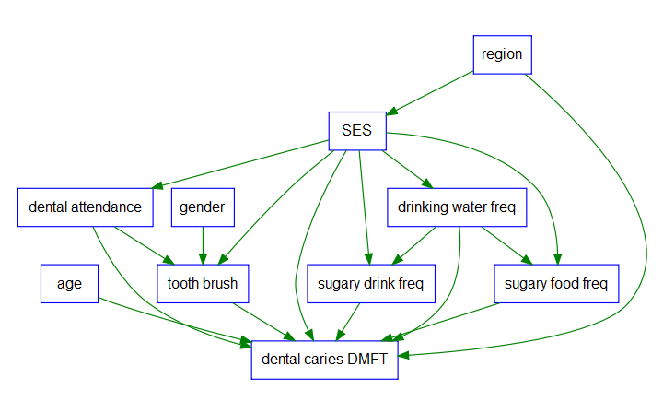
Figure S1. DAG of dental caries causal diagram based on significant causal relationships between risk factors of dental caries using Children Dental Health Survey 2013 data. Note not all significant mutual relations are shown in this DAG. Omitted associations include dental attendance vs water drinking, sugary drinking and sugary food consumption frequencies, tooth brush frequency vs water drinking and sugary drink consumption frequency, and pairwise association between water, sugary drink and sugary food consumption frequency.

Appendix 2. Model comparison between Poisson, negative binomial, zero-inflated poisson, and zero-inflated negative binomial regression:

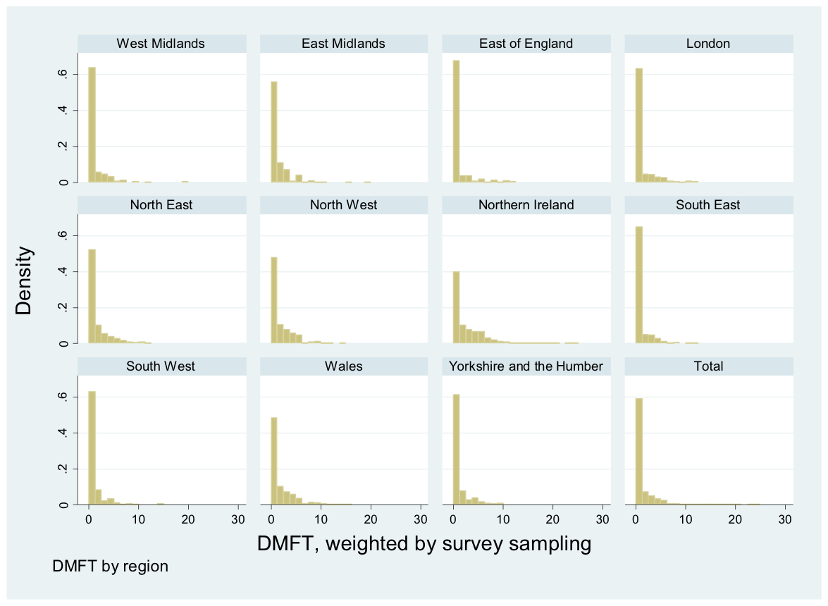
Figure S2. DMFT distribution for regions. The distribution is right skewed with excessive zeros.

DMFT scores of 12 and 15 year olds from surveyed regions as the index used for the outcome variable, and its distribution can be seen above in Figure S2. The distribution of Poisson does not fit the DMFT well because the variance of DMFT is 4.75 and the mean DMFT is 1.30 with a variance/mean ratio = 3.65 which is far above 1, while Poisson distribution would expect variance/mean ≈ 1. The weighted mean DMFT for caries-prone (DMFT>0) children is 3.3 and SD is 2.7.To choose the model that fit DMFT data, we compared four models to fit the DMFT include Poisson, NB, ZIP, and ZINB models, and after examining the residuals of each model fit. ZINB model is demonstrated to be a best fit to DMFT with the predictors (Figure S3).

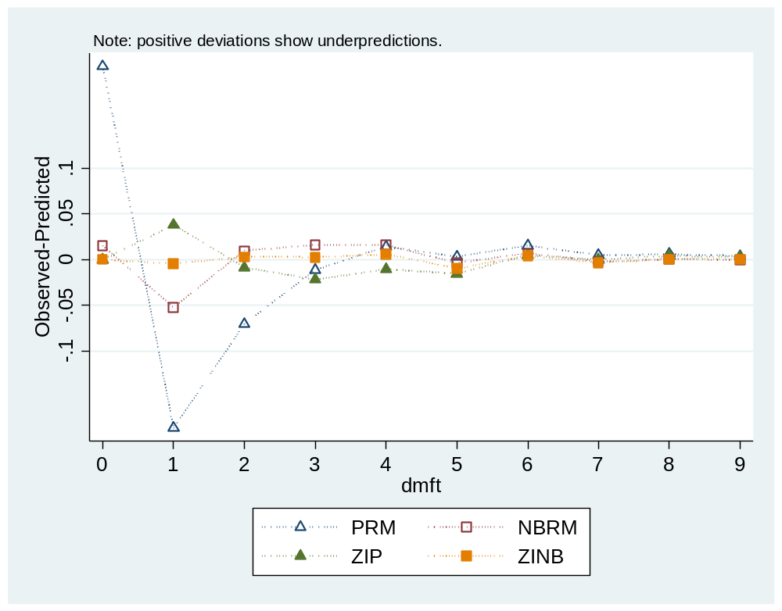
Figure S3. Count model fit: comparison between regular poisson model, regular negative binomial, zero-inflated poisson and zero-inflated negative binomial model. Result showing that zinb is the best model because the residual from all the tested models showed a close to zero residue. Small residuals are indicative of good-fitting models, so the models with lines closest to zero should be considered for our data. Zero-inflated negative binomial model behave better than zip model at any count points.

Appendix 3. Sensitivity analysis including juice as sugar-added drinks
Table S1. Daily sugar-added drinks including juice and sugar-added foods consumption frequency, and dental caries experience measured by DMFT for 12 and 15 year olds by demographic characteristics, socioeconomic status (SES), behavioural variables, in England, Wales and Northern Ireland. Difference to Table 1 in the main manuscript is presented in red.
Variable | N (%), unweighted | Daily sugar-added drinks consumption freq, n (%) |  |  |  | Daily sugar-added foods consumption freq, n (%) |  |  |  |  | DMFT
Variable | N (%), unweighted | Weighted mean (95% CI) | 0 | 1-3 | ≥ 4 |  | Weighted mean (95% CI) | ≤1 | 2-3 | ≥4 | Weighted mean DMFT (95% CI)
Age, y
12 | 2532 (51.2) | 2.9 (2.6, 3.2) | 434 (17.1) | 1124 (48.3) | 874 (34.5) |  | 2.7 (2.5, 2.8) | 866 (34.2) | 844 (33.3) | 822 (32.5) | 0.8*** (0.7, 1.0)
15 | 2418 (48.9) | 2.4 (2.2, 2.6) | 451 (18.7) | 1248 (51.6) | 719 (29.7) |  | 2.5 (2.3, 2.6) | 817 (33.8) | 800 (33.1) | 801 (33.1) | 1.4 (1.2, 1.7)
Gender
Male | 2377 (48.0) | 2.8 (2.5, 3.0) | 407 (17.1) | 1192 (50.1) | 778 (32.7) |  | 2.6 (2.4, 2.7) | 785 (33.0) | 794 (33.4) | 798 (33.6) | 1.1*** (0.9, 1.2)
Female | 2573 (52.0) | 2.5 (2.3, 2.7) | 478 (18.6) | 1280 (49.7) | 815 (31.7) |  | 2.5 (2.4, 2.6) | 898 (34.9) | 850 (33.0) | 825 (32.1) | 1.2 (1.1, 1.4)
Region |  |  | *** |  |  |  |  | ***
West Midlands | 266 (5.4) | 2.5*** (2.1, 2.9) | 51 (19.2) | 149 (56.0) | 66 (24.8) |  | 2.2*** (2.0, 2.4) | 106 (39.9) | 89 (33.5) | 71 (26.7) | 0.9*** (0.7, 1.1)
East Midlands | 199 (4.0) | 3.5 (3.4, 3.5) | 34 (17.1) | 76 (38.2) | 89 (44.7) |  | 3.0(2.9, 3.0) | 57 (28.6) | 62 (31.2) | 80 (40.2) | 1.2 (0.8, 1.7)
East England | 257 (5.2) | 2.1 (1.7, 2.5) | 59 (23.0) | 144 (56.0) | 54 (21.0) |  | 2.4 (2.1, 2.6) | 99 (38.5) | 90 (35.0) | 68 (26.5) | 0.8 (0.5, 1.1)
London | 369 (7.5) | 2.7 (2.3, 3.2) | 64 (17.3) | 166 (45.0) | 138 (37.7) |  | 2.6 (2.3, 2.8) | 138 (37.4) | 111 (30.1) | 120 (32.5) | 1.0 (0.6, 1.4)
North East | 353 (7.1) | 2.8 (2.7, 3.0) | 59 (16.7) | 164 (46.5) | 130 (36.8) |  | 2.6 (2.4, 2.9) | 117 (33.1) | 114 (32.3) | 122 (34.6) | 1.5 (1.2, 1.8)
North West | 466 (9.4) | 3.1 (2.4, 3.8) | 70 (15.0) | 216 (46.4) | 180 (38.6) |  | 3.2 (3.1, 3.4) | 128 (27.5) | 138 (29.6) | 200 (42.9) | 1.7 (1.3, 2.0)
South East | 260 (5.3) | 2.4 (2.1, 2.7) | 49 (18.8) | 129 (53.5) | 72 (27.7) |  | 2.2 (2.0, 2.3) | 107 (41.2) | 80 (30.8) | 73 (28.1) | 0.8 (0.6, 1.0)
South West | 289 (5.8) | 2.4 (1.9, 2.8) | 52 (18.0) | 168 (58.1) | 69 (23.9) |  | 2.3 (2.0, 2.6) | 118 (40.8) | 98 (33.9) | 73 (25.3) | 0.9 (0.5, 1.4)
Yorkshire and the Humber | 288 (5.8) | 2.7 (2.5, 2.9) | 53 (18.4) | 146 (50.7) | 89 (30.9) |  | 2.5 (2.5, 2.6) | 108 (37.5) | 91 (31.6) | 89 (30.9) | 1.0 (0.5, 1.5)
Wales | 1168 (23.6) | 2.7 (2.5, 3.0) | 201 (17.2) | 573 (49.1) | 394 (33.7) |  | 2.5 (2.4, 2.7) | 431 (36.9) | 394 (33.7) | 343 (29.4) | 1.8 (1.4, 2.1)
Northern Ireland | 1035 (20.9) | 2.6 (2.3, 2.8) | 193 (18.6) | 531 (51.3) | 311 (30.0) |  | 2.9 (2.8, 3.1) | 274 (26.5) | 377 (36.4) | 384 (37.1) | 2.5 (2.2, 2.9)
SES |  |  | *** |  |  |  |  | *
low | 1692 (34.2) | 3.2*** (2.9, 2.4) | 247 (14.6) | 739 (43.6) | 706 (41.7) |  | 2.7* (2.5, 2.9) | 534 (31.6) | 517 (30.6) | 641 (37.9) | 1.5*** (1.2, 1.7)
Medium | 1986 (40.1) | 2.6 (2.4, 2.8) | 381 (19.2) | 1023 (51.5) | 582 (29.3) |  | 2.5 (2.4, 2.6) | 697 (35.1) | 670 (33.7) | 619 (31.2) | 1.2 (1.0, 1.4)
High | 1064 (21.5) | 2.3 (2.0, 2.5) | 219 (20.6) | 606 (57.0) | 239 (22.5) |  | 2.4 (2.3, 2.6) | 383 (36.0) | 388 (36.5) | 293 (27.5) | 0.7 (0.5, 0.9)
Tooth-brushing/day |  |  | **
≤1 | 1104 (22.3) | 2.9** (2.6, 3.2) | 172 (15.6) | 533 (48.3) | 399 (36.1) |  | 2.8 (2.6, 3.0) | 335 (30.3) | 358 (32.4) | 411 (37.2) | 1.4*** (1..2, 1.7)
≥2 | 3760 (76.0) | 2.6 (2.4, 2.8) | 680 (18.1) | 1917 (51.0) | 1163 (30.9) |  | 2.5 (2.4, 2.7) | 1292 (34.4) | 1276 (33.9) | 1192 (31.7) | 1.1 (0.9, 1.2)
Dental Attendance |  |  | *** |  |  |  |  | *
Regular check up | 4011 (82.3) | 2.5*** (2.3, 2.6) | 749 (18.7) | 2075 (51.7) | 1187 (29.6) |  | 2.5* (2.4, 2.6) | 1390 (34.7) | 1359 (33.9) | 1262 (31.5) | 1.0*** (0.9, 1.1)
Only when in trouble/never | 860 (17.7) | 3.4 (3.0, 3.8) | 108 (12.6) | 373 (43.4) | 379 (44.1) |  | 2.9 (2.6, 3.1) | 244 (28.4) | 273 (31.7) | 343 (39.9) | 1.8 (1.5, 2.0)
Daily water consumption freq |  |  | *** |  |  |  |  | *
<1 | 766 (15.5) | 3.1*** (2.8, 3.3) | 131 (17.1) | 332 (43.3) | 303 (39.6) |  | 3.0* (2.7, 3.3) | 231 (30.2) | 236 (30.8) | 299 (39.0) | 1.5 *** (1.3, 1.8)
1-3 | 2623 (53.0) | 2.7 (2.5, 2.9) | 383 (14.6) | 1439 (54.9) | 801 (30.5) |  | 2.5 (2.3, 2.6) | 888 (33.9) | 911 (34.7) | 824 (31.4) | 1.2 (1.0, 1.3)
≥4 | 1561 (31.5) | 2.5 (2.2, 2.7) | 371 (23.8) | 701 (44.9) | 489 (31.3) |  | 2.5 (2.3, 2.7) | 564 (36.1) | 497 (31.8) | 500 (32.0) | 1.0(0.8, 1.1)
Daily sugar-added drinks consumption freq |  |  |  |  |  |  |  | ***
0 | 885 (17.9) |  |  |  |  |  | 1.6*** (1.4 1.8) | 472 (53.3) | 271 (30.6) | 142 (16.0) | 0.9 *** (0.7, 1.0)
1-3 | 2472 (49.9) |  |  |  |  |  | 2.3 (2.2, 2.4) | 922 (37.3) | 910 (36.8) | 640 (25.9) | 1.0 (0.9, 1.2)
≥4 | 1593 (32.2) |  |  |  |  |  | 3.6 (3.4, 3.8) | 289 (18.1) | 463 (29.1) | 841(52.8) | 1.6 (1.4, 1.7)
Daily sugar-added foods consumption freq |  |  | ***
≤1 | 1683 (34.0) | 1.8*** (1.7, 1.9) | 472 (28.0) | 922 (54.8) | 289 (17.2) |  |  |  |  |  | 1.0*** (0.8, 1.1)
2-3 | 1644 (33.2) | 2.5 (2.3, 2.7) | 271 (16.5) | 910 (55.4) | 463 (28.2) |  |  |  |  |  | 1.1 (0.9, 1.3)
≥4 | 1623 (32.8) | 3.8 (3.5, 4.2) | 142 (8.7) | 640 (39.4) | 841 (51.8) |  |  |  |  |  | 1.4 (1.2, 1.6)
All | 4950 | 2.7 (2.5, 2.8) | 885 (17.9) | 2472 (49.9) | 1593 (32.2) |  | 2.6 (2.4, 2.7) | 1683 (34.0) | 1644 (33.2) | 1623 (32.8) | 1.1 (1.0, 1.3)

Note: CI = confidence interval; DMFT = decayed, missing, and filled permanent teeth. P-values were obtained using ANOVA for continuous covariates, Pearson’s chi-square test for categorical variables. All weighted by survey design.
** p <0.01
*** p<0.001
┼ Mean sugar-added foods consumption frequency, mean sugar-added drinks consumption frequency, and mean DMFT is weighted by survey sample

Table S2. Zero-inflated negative binomial model versus negative regression model analysis of frequency of daily sugary drinks including juice and sugary food consumption effect on 12 and 15 year olds dental caries experience, Children Dental Health Survey, 2013. Different significance were highlighted.
 | Drinks with added sugar  consumption frequencyª |  |  | Foods with added sugar  consumption frequency^{b}
Models, adjusted for | Zero-inflated NB model |  | NB regression  model | Zero-inflated NB model |  | NB regression  model
Models, adjusted for | Negative Binomial part, IRR^{c} (95% CI) | Zero-inflated part, OR^{c} (95% CI) | IRR (95% CI) | Negative Binomial part, IRR (95% CI) | Zero-inflated part, OR (95% CI) | IRR (95% CI)
Demographic characteristics^{d}
<=3 | 1.0  (0.8, 1.4) | 0.7  (0.4, 1.2) | 1.2(0.9, 1.5)
>=4 | 1.4  (1.0, 1.8) | 0.4*  (0.2, 0.9) | 1.8***  (1.5, 2.2)
Demographics and dental behaviour^{e}
<=3 | 1.0  (0.8, 1.4) | 0.7  (0.5, 1.3) | 1.1 (.9, 1.4)
>=4 | 1.3  (1.0, 1.8) | 0.5  (0.3, 1.8) | 1.6***  (1.3, 1.9)
Demographics, dental behaviours, and water consumption frequency
<=3 | 1.0  (0.8, 1.2) | 0.6**  (0.4, 0.8) | 1.1(0.9, 1.3)
>=4 | 1.3  (1.0, 1.5) | 0.4**  (0.2, 0.8) | 1.6***  (1.3, 1.9)
Fully adjusted^{f}
<=3 | 1.1  (0.8, 1.4) | 1.0  (0.6, 1.7) | 1.1 (.9, 1.3) | 0.8  (0.7, 1.0) | 0.6*  (0.4, 0.9) | 1.0 (0.8, 1.3)
>=4 | 1.4  (1.0, 1.8) | 0.8  (0.4, 1.6) | 1.4***  (1.2, 1.7) | 1.0  (0.8, 1.2) | 0.4*** (0.3, 0.7) | 1.3**  (1.1, 1.5)

*p<0.05
**p<0.01
***p<0.001
ª Drinks with added sugar consumption frequency was represented by 3 levels (0, 1-3, and >=4). Reference category is 0.
^{b} Foods with added sugar consumption frequency was represented by 3 levels (<=1, 2-3, and >=4). Reference category is <=1.
^{c} Incidence rate ratio, IRR. Odds ratio, OR.
^{d} Demographics include age, gender, SES.
^{e} Dental behaviours include tooth-brushing frequency and dental attendance.
^{f} Adjustment for all the covariates listed above, and include both variables of drinks and foods with added sugar in the model.

Appendix 4. Table 1 continued with regional information
Table S3. Daily consumption frequency of sugar-added drinks and foods, and dental caries experience measured by DMFT in 9 English regions, Wales and Northern Ireland.
Variable | N (%), unweighted | Daily sugar-added drinks consumption freq, n (%) |  |  |  | Daily sugar-added foods consumption freq, n (%)
Variable | N (%), unweighted | Weighted mean ┼ (95% CI) | 0 | 1-3 | ≥4 | Weighted mean ┼ (95% CI) | ≤1 | 2-3 | ≥4 | Weighted mean DMFT ┼ (95% CI)
Region |  |  | *** |  |  |  | ***
West Midlands | 266 (5.4) | 1.4*** (1.0, 1.9) | 109 (41.0) | 126 (47.4) | 31 (11.7) | 2.2*** (2.0, 2.4) | 106 (39.9) | 89 (33.5) | 71 (26.7) | 0.9*** (0.7, 1.1)
East Midlands | 199 (4.0) | 2.4 (2.2, 2.5) | 63 (31.7) | 86 (43.2) | 50 (25.1) | 3.0 (2.9, 3.0) | 57 (28.6) | 62 (31.2) | 80 (40.2) | 1.2 (0.8, 1.7)
East England | 257 (5.2) | 1.2 (1.0, 1.4) | 121 (47.1) | 105 (40.9) | 31 (12.1) | 2.4 (2.1, 2.6) | 99 (38.5) | 90 (35.0) | 68 (26.5) | 0.8 (0.5, 1.1)
London | 369 (7.5) | 1.6 (1.2, 2.0) | 142 (38.5) | 155 (42.0) | 72 (19.5) | 2.6 (2.3, 2.8) | 138 (37.4) | 111 (30.1) | 120 (32.5) | 1.0 (0.6, 1.4)
North East | 353 (7.1) | 1.7 (1.4, 1.9) | 114 (32.3) | 169 (47.9) | 70 (19.8) | 2.6 (2.4, 2.9) | 117 (33.1) | 114 (32.3) | 122 (34.6) | 1.5 (1.2, 1.8)
North West | 466 (9.4) | 2.0 (1.5, 2.5) | 143 (30.7) | 214 (45.9) | 109 (23.4) | 3.2 (3.1, 3.4) | 128 (27.5) | 138 (29.6) | 200 (42.9) | 1.7 (1.3, 2.0)
South East | 260 (5.3) | 1.3 (1.1, 1.5) | 101 (38.9) | 123 (47.3) | 36 (13.9) | 2.2 (2.0, 2.3) | 107 (41.2) | 80 (30.8) | 73 (28.1) | 0.8 (0.6, 1.0)
South West | 289 (5.8) | 1. 5 (1.2, 1.8) | 97 (33.6) | 163 (56.4) | 29 (10.0) | 2.3 (2.0, 2.6) | 118 (40.8) | 98 (33.9) | 73 (25.3) | 0.9 (0.5, 1.4)
Yorkshire and the Humber | 288 (5.8) | 1.5 (1.2, 1.6) | 123 (42.7) | 127 (44.1) | 38 (13.2) | 2.5 (2.5, 2.6) | 108 (37.5) | 91 (31.6) | 89 (30.9) | 1.0 (0.5, 1.5)
Wales | 1168 (23.6) | 1.7 (1.4, 1.9) | 398 (34.1) | 548 (46.9) | 222 (19.0) | 2.5 (2.4, 2.7) | 431 (36.9) | 394 (33.7) | 343 (29.4) | 1.8 (1.4, 2.1)
Northern Ireland | 1035 (20.9) | 1.5 (1.3, 1.7) | 423 (40.9) | 443 (42.8) | 169 (16.3) | 2.9 (2.8, 3.1) | 274 (26.5) | 377 (36.4) | 384 (37.1) | 2.5 (2.2, 2.9)
Note: CI = confidence interval; DMFT = dentinal decayed, missing, and filled permanent teeth. P-values were obtained using ANOVA for continuous covariates, Pearson’s chi-square test for categorical variables. All weighted by survey design.
*p<0.05
** p <0.01
*** p<0.001
┼ Mean consumption frequency of sugar-added foods, mean consumption frequency of sugar-added drinks, and mean DMFT is weighted by survey sample

Appendix 5: The percentage of population receiving fluoridated water supply in English regions, Wales and Northern Ireland
Fluoridated water regions in England were classified as:
- Fluoridated water population percentage: 0% = London, SouthEast, SouthWest (ref)
- Fluoridated water population percentage: <5% =NorthWest, Yorkshire and the Humber, East England
- Fluoridated water population percentage: 13.63% =East Midland
- Fluoridated water population percentage: 34.57% = NorthEast
- Fluoridated water population percentage: 69.94% = WestMidlands

The appendix table listed the detailed population under each region and whether or not the water is fluoridated, and the percentage of population with fluoridated water supply.
Table S4:
English region / Wales / Northern Ireland | Strategic health authority (SHA) | SHA population | SHA population with fluoridated population water supply | Natural, adjusted or NF | Regions pop on F supplies %
London | North Central London | 1,179,151 | 0 | NF | 0.00
London | North East London | 1,498,205 | 0 | NF | 0.00
London | North West London | 1,728,941 | 0 | NF | 0.00
London | South East London | 1,490,409 | 0 | NF | 0.00
London | South West London | 1,279,580 | 0 | NF | 0.00
North West | Cumbria and Lancashire | 1,900,226 | 120,000 | Adjusted | 3.80
North West | Cheshire and Merseyside | 2,342,941 | 136,700 | Adjusted | 3.80
North West | Greater Manchester | 2,513,975 | 0 | NF | 3.80
East of England | Norfolk, Suffolk and Cambridgeshire | 2,137,986 | N/a | Naturally occurring fluoride level but hard to quantify | 3.70
East of England | Essex | 1,612,587 | 0 | Natural | 3.70
East of England | Bedfordshire and Hertfordshire | 1,597,607 | 197,961 | Partly adjusted | 3.70
West Midlands | Birmingham and the Black Country | 2,253,600 | 2,175,900 | Adjusted | 69.94
West Midlands | Shropshire and Staffordshire | 1,482,400 | 518,200 | Adjusted | 69.94
West Midlands | West Midlands South | 1,524,100 | 985,000 | Adjusted | 69.94
South West | Avon, Gloucestershire and Wiltshire | 2,149,607 | N/a | Natural | 0.00
South West | Dorset and Somerset | 1,183,606 | 0 | NF | 0.00
South West | South West Peninsula | 1,561,950 | 0 | NF | 0.00
Yorkshire and the Humber | North and East Yorkshire and Northern Lincolnshire | 1,603,635 | 135,546 | Adjusted | 2.74
Yorkshire and the Humber | West Yorkshire | 2,078,326 | 0 | NF | 2.74
Yorkshire and the Humber | South Yorkshire | 1,265,015 | 0 | NF | 2.74
East Midlands | Trent | 2,580,579 | 558,276 | Adjusted | 13.63
East Midlands | Leicestershire, Northamptonshire and Rutland | 1,514,449 | 0 | NF | 13.63
North East | Northumberland, Tyne and Wear | 1,381,728 | 647,863 | Adjusted | 34.57
North East | County Durham and Tees Valley | 1,130,907 | 220,867 | Natural & Adjusted | 34.57
South East | Thames Valley | 2,118,862 | 0 | NF | 0.00
South East | Hampshire and Isle of Wight | 1,775,406 | 0 | NF | 0.00
South East | Surrey and Sussex | 2,536,988 | 0 | NF | 0.00
South East | Kent and Medway | 1,574,483 | 0 | NF | 0.00
Wales |  | 3,063,456 | 0 | NF | 0.00
Northern Ireland |  | 1,810,863 | 0 | NF | 0.00

SHAs were part of structure of the National Health Service (NHS) England, and the NHS primary care trusts (PCTs) were under the supervision of SHAs. The SHAs were reorganised to ten NHS regions on 22 March 2006.
The natural fluoride content of supplies in some regions may reach optimal (1.0 ppm), but it is difficult to quantify the number of people affected and therefore not designated as ‘Fluoridated’.
NF=non-fluoridated.
Regions pop on F supplies % = percentage of population in English region / Wales / Northern Ireland receiving fluoridated water supply.
Naturally occurring fluoride levels around Redbridge may reach optimal (1.0 ppm), but it is difficult to quantify the number of people affected.
Naturally occurring fluoride levels in some parts of this region may reach optimal (1.0 ppm), but it is difficult to quantify the number of people affected.
Naturally occurring fluoride levels in some parts of this region varying between 0.3 ppm to 1.0 ppm. There is considerable natural variation in the level across the year. It is difficult to quantify the number of people affected.
Supply source at Ashton Keynes (Wessex Water) contains naturally elevated fluoride levels and is distributed to PCTs in Wiltshire (Kennet & North Wiltshire, Swindon, Bath & North East Somerset, West Wiltshire). It is difficult to quantify the number of people affected.
Some parts of this North Eastern Derbyshire (PCT) receive fluoridated supplies from Severn Trent Water Company.
The water fluoride level in Durham and Chester-le-Street (PCT) is artificially adjusted. Water supplies in Easington and Hartiepool (PCT) contain fluoride naturally.

