Assessing the Performance of Portable Gas-Phase Air Cleaners and Implications for Their Use in Buildings
Yiming Xiang^{1, 3*}, Kanta Amada^{1,3}, Asit Kumar Mishra^{2,3}, Shin-ichi Tanabe¹, Lei Fang³, Pawel Wargocki³
¹ Waseda University, Nishi-waseda 1-6-1, Shinjuku, Tokyo, 169-8050, Japan
² School of Public Health, University College Cork, Cork, Ireland
³ Denmark DTU SUSTAIN, Technical University of Denmark, 2800 Kongens Lyngby, Denmark
* Corresponding author

Corresponding author address: Waseda University, Nishi-waseda 1-6-1, Shinjuku, Tokyo, 169-8050, Japan
Corresponding author email address: kouekimei@ruri.waseda.jp
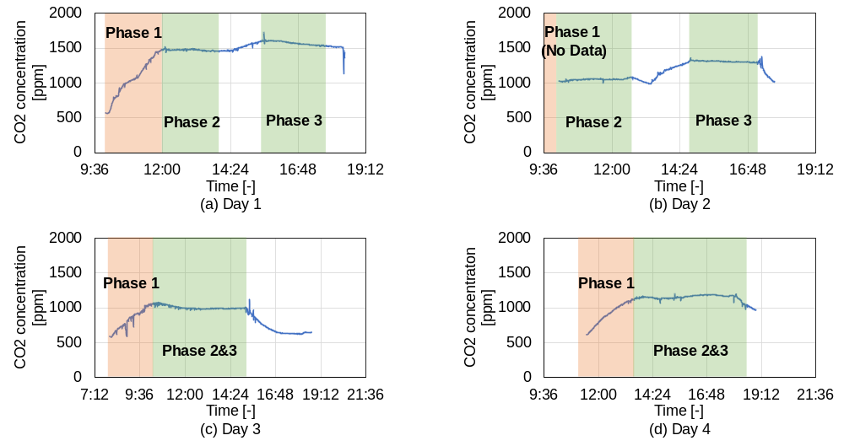
Fig.S1 CO₂ concentration during different phases and on different experimental days. The results show slight variation in outdoor air supply rate through windows but considered negligible for estimating removal effects by GPACs. They also show that one person leaving the space at the end of Phase 1 did not disturb equilibrium. Finally, they show that the operation of GPACs had an effect on some pollutants but no effect on CO2.
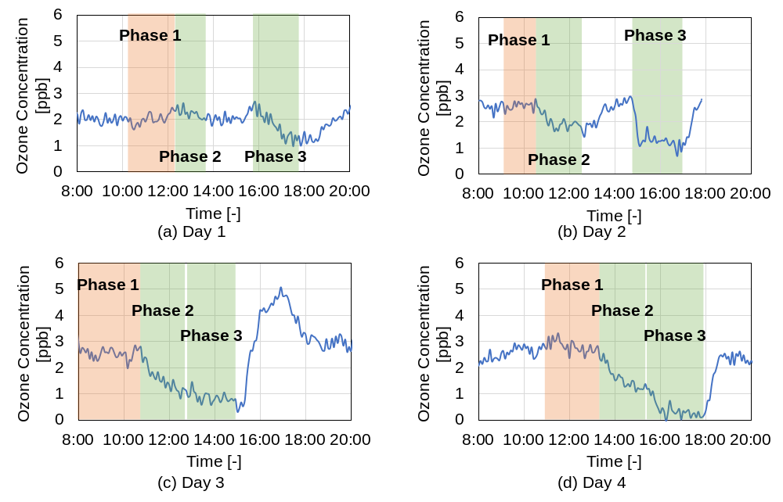
Fig.S2 Ozone concentration during different phases and on different experimental days.
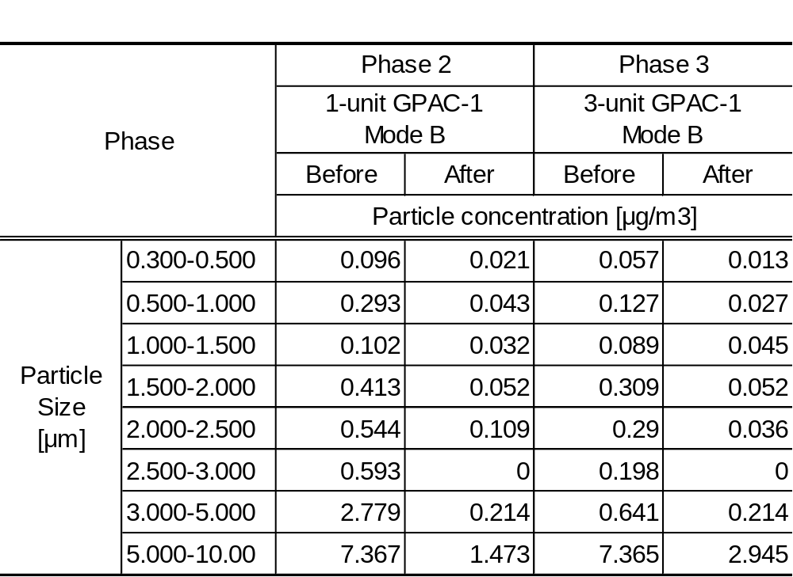
Table S1 Particle concentration during different phases and on day 1.

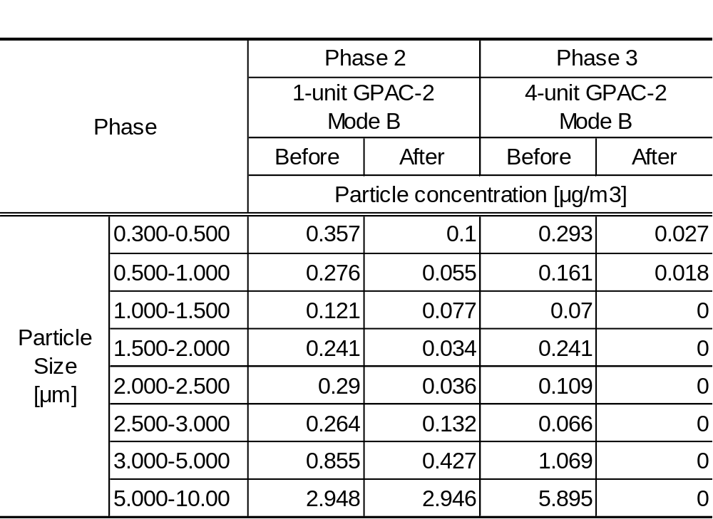
Table S2 Particle concentration during different phases and on day 2.

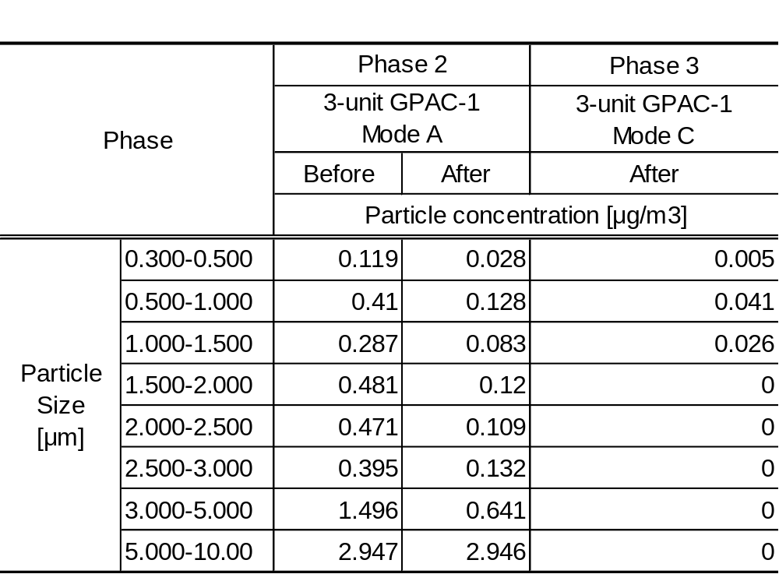
Table S3 Particle concentration during different phases and on day 3.

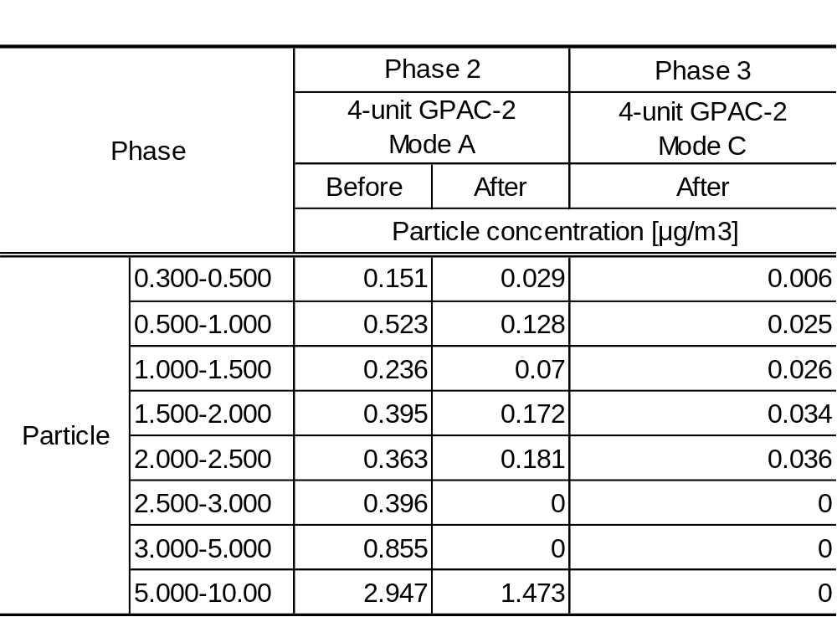
Table S4 Particle concentration during different phases and on day 4.

Theoretical Basis of PTR-MS Quantification (1)
The quantitative analysis capability of Proton Transfer Reaction Mass Spectrometry (PTR-MS) is fundamentally based on the well-defined ion-molecule reaction kinetics occurring within its drift tube. The process begins with the proton transfer reaction between a reagent hydronium ion (H₃O⁺) and an analyte molecule (M) as Eq.S1

${H_{3}O}^{+}+M→{MH}^{+}+H_{2}O$ (S1)

Under standard operating conditions, two key assumptions allow for a simplified and linear interpretation of the reaction kinetics. First, the concentration of the reagent ion, ${H_{3}O}^{+}$, is maintained in sufficient excess relative to the analyte concentration, so it can be considered constant throughout the reaction. Second, the analyte concentration, [M], is typically low enough to ensure that the term k[M]t (where k is the reaction rate coefficient and t is the reaction time) is much less than one.

Based on these conditions, the relationship between the measured ion signals and the analyte concentration can be described by the Eq.S2
$\frac{\left[{MH}^{+}\right]}{[H_{3}O^{+}]}≈k\left[M\right]t$ (S2)

where $\left[{MH}^{+}\right]$ and $[H_{3}O^{+}]$ are the signal intensities of the product and reagent ions, respectively. This equation illustrates that the product ion signal is directly proportional to the analyte concentration, forming the theoretical basis for the linear response of PTR-ToF-MS. While practical factors such as mass-dependent ion transmission and detector efficiency influence the overall sensitivity, they are typically incorporated into a constant calibration factor for a given analyte, preserving the inherent linearity of the measurement across its dynamic range. Therefore, the linear signal-concentration relationship is a direct and predictable consequence of the fundamental principles governing the PTR-ToF-MS technique.

Additional Information of Methodology
The mass balance equation during the Phase 2 and Phase 3 can be expressed as Eq.S3 (2).

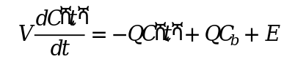 | (S3)

where C(t) (m³/m³) represents the concentration during the first period, V (m³) represents the volume of the room, Q (m³/h) represents the ventilation rate of the room, C_{b} (m³/m³) represents the background concentration, and E (m³/h) represents the VOC emission rate.

$$C\left(t\right)=\left(C\left(0\right)-C_{b}-\frac{E}{k_{decay}V}\right)e^{-k_{decay}t}+C_{b}+\frac{E}{k_{decay}V}$$ | (S4)

By solving the differential Eq S3, the concentration C(t) can be calculated by Eq S4, where $k_{decay}$ (/h) represents the first-order decay rate of the VOCs and C(0) (m³/m³) represents the concentration at the start point of the second period.

$$C\left(t\right)=ae^{-k_{decay}t}+b$$ | (S5)

All of the parameters except t in Eq S4 can be assumed as constants for a specific period. Hence, Eq S4 can be simplified to Eq S5. a and b, indicating the constants in Eq S5, can be obtained by performing a numerical curve fitting on the decay concentration as described in main article. Some examples of measured concentration data and the generated curve from the concentration are shown in Fig.4 in the main article.

The curve fit provides values, for all the constants in Eq S5, including $k_{decay}$. For VOCs, during the Phase 2 and Phase 3, $k_{decay}$ should include the removal effect provided by GPAC(s) (in air change rates, REach), by the ventilation through windows (estimated to be around 0.25 h⁻¹), and through all other losses in the space (e.g. to surfaces). We assumed that all losses except the effect of GPAC in the office space where the measurements were made were similar during different operating scenarios of GPACs, which seems to be reasonable. Hence, the removal effect (RE_{ach}, /h) of every organic compound could be expressed as Eq.S6.

${RE}_{ach}=k_{decay}-0.25$ 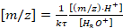 | (S6)

Then, the removal effect (RE_{m3/h}, m³/h) of every organic compound is calculated as Eq.S7.

${RE}_{m3/h}={RE}_{ach}×V$ | (S7)

Removal efficiency (RE_{ff%}) of every organic compound could be calculated as Eq.S8.

${RE}_{ff\%}={{RE}_{m3/h}/Q}_{t}×100$ | (S8)

Where ${RE}_{ff\%}$ (%) represents the removal efficiency, Q_{t} (m³/h) represents the total airflow rate of GPACs.

The energy efficiency (EER) could be calculated as Eq.S9.

$EER={RE}_{m3/h}/P$ | (S9)

Where EER (m³/Wh) represents the energy efficiency, P (W) represents the power consumption of GPACs shown in Table 1 in main article.

With two different brands and four scenarios tested per brand, a total of eight scenarios were examined. Since the study involves three variables of different scales—GPAC brand (GPAC-M and GPAC-P), number of units (1 vs. 3 or 4), and airflow rate (variable by value)—a suitable analytical approach was needed to account for these differences. To achieve this, we employed linear mixed effects models, which allowed us to interpret and compare the effects of variables across different scales as follows:

PI ~ Brand+Units+ AirflowPerDevice+(1 ┤|Compound) (S10)

Eq.S10 models the performance indicator (PI), which could be ${RE}_{m3/h}$, ${RE}_{ff\%}$, or EER. GPAC brand, number of units, and airflow per device were treated as fixed effects, while the specific organic compound was treated as a random effect.

Similarly, to analyze the differences between the four configurations tested for each brand, we used a linear mixed effects model as expressed in Eq.S11.

PI ~ Configuration+(1 ┤|Compound) (S11)

When the model indicated significant differences between scenarios, pairwise comparisons were made using the least squares means derived from the mixed effects model. This approach allowed comparisons of means for each brand while accounting for covariates and other variables in the model.

Emission and Removal of Organic Compounds
The MK test (Mann-Kendall test) is a non-parametric test used to analyze whether a time series data continuously increases or decreases(3,4). To verify the effect of GPACs in removing various organic compounds, the MK test was employed to analyze the trends in organic compounds concentrations during Phase 1, 2 and 3. Three options, decreasing, increasing, and no trend were used to show organic compounds concentrations’ trend, based on the MK test result. Table S5 shows the trend of all 44 m/z detected in Phase 1, while 3 subjects were conducting office work in the room and GPACs were off.

Since the study was conducted over 4 days, with different configurations of the GPAC operation, there were four data series of the Phase 1 taken on different days, shown in Table S5. The molecular formula was assumed based on the m/z values and possible organic compounds were identified by matching these formulas with those reported in several field studies documenting detectable organic compounds in indoor environments (5–9). However, no corresponding molecular formulas were found for m/z values of 69.029, 73.026, 77.017, and 83.041 in chemical databases or previous studies. Therefore, these m/z values were designated as "unknowns”.

The emission of organic compounds can be deduced from Table S5. It was observed that the concentrations of 28 m/z values increased on all experiment days during Phase 1. This suggests that the participants in the office were likely the primary sources of these organic compounds. For the other 16 m/z values, all three trends were observed during Phase 1, suggesting that these organic compounds originated from sources such as building materials and possible infiltration from outdoors, rather than from the occupants. Regarding emissions from humans (bioeffluents), only a fraction of them was detected by the PTR-ToF-MS, which theoretically has the capability to detect VOCs at extremely low concentrations. This indicates that the concentrations of most bioeffluents may have been below the detection limit and below the threshold for human perception in the usual office environment like the experiment room in this study.

Among the 28 organic compounds with increasing concentration, methanol, ethanol, acetone, acetic acid, isoprene, butyric acid, cyclohexanone, styrene, 6-MHO, octanal, n-nonanal, octanoic acid, and n-decanal have been reported as bioeffluents in previous studies (5–9). However, of the other 16 m/z values, compounds such as 2-butanone, 1,3,5-hexatriene, 2-pentanone, 2-furancarboxaldehyde, n-hexanal, and n-heptanal have also been reported as bioeffluents. This suggests that their concentration should have increased. The discrepancy may be attributed to emission rates being too low to counterbalance the concentration infiltration at times.

Table S6 shows the trend of all the m/z detected in Phase 2 and 3, while two occupants were conducting office work in the room and GPACs were tuned on. The molecular formula was assumed by the m/z and possible organic compounds are the organic compounds corresponding to the molecular formula. The blue blocks show a decreasing trend, the yellow blocks show no trend, and the orange blocks show an increasing trend while GPACs were tuned on.

Table S5. Trend of all the detected m/z in Phase 1 (when GPAC were idled). Blue blocks show a decreasing trend; yellow blocks show no trend and orange blocks show an increasing trend.
m/z  (protonized compounds) | Molecular  Formula | Possible  VOCs | Day1 | Day2 | Day3 | Day4
31.019 | CH₂O | Formaldehyde
33.035 | CH₄O | Methanol
41.038 | C₃H₄ | Propyne
43.018 | C₂H₂O | Ethenone
43.053 | C₃H₆ | Propene
45.033 | C₂H₄O | Acetaldehyde
47.012 | CH₂O₂ | Formic acid
47.048 | C₂H₆O | Ethanol
57.032 | C₃H₄O | Acrolein
59.048 | C₃H₆O | Acetone
61.028 | C₂H₄O₂ | Acetic acid
63.041 | C₂H₆O₂ | Ethylene glycol
69.029 | Unknown
69.067 | C₅H₈ | Isoprene
71.048 | C₄H₆O | Crotonaldehyde
71.084 | C₅H₁₀ | Cyclopentane
73.026 | Unknown
73.062 | C₄H₈O | 2-Butanone (MEK)
75.042 | C₃H₆O₂ | Propanoic acid
77.017 | Unknown
77.057 | C₃H₈O₂ | 1,2-Propanediol
79.038 | C₆H₆ | Benzene
81.068 | C₆H₈ | 1,3,5-Hexatriene
83.041 | Unknown
83.084 | C₆H₁₀ | Cyclohexene
87.044 | C₄H₆O₂ | Methyl acrylate
87.078 | C₅H₁₀O | 2-Pentanone
89.058 | C₄H₈O₂ | Butyric acid
95.01 | C₅H₂O₂ | Cyclopentadienchinon
97.028 | C₅H₄O₂ | 2-Furancarboxaldehyde
99.081 | C₆H₁₀O | Cyclohexanone
101.06 | C₅H₈O₂ | Acetylacetone
101.092 | C₆H₁₂O | n-Hexanal
105.069 | C₈H₈ | Styrene
107.051 | C₇H₆O | Benzaldehyde
115.109 | C₇H₁₄O | n-Heptanal
117.088 | C₆H₁₂O₂ | n-Butyl acetate
123.041 | C₇H₆O₂ | Benzoic acid
127.11 | C₈H₁₄O | 6-MHO
129.123 | C₈H₁₆O | Octanal
137.131 | C₁₀H₁₆O | Monoterpene
143.137 | C₉H₁₈O | n-Nonanal
145.12 | C₈H₁₆O₂ | Octanoic acid
157.153 | C₁₀H₂₀O | Decanal

Table S6. Trend of all the detected m/z in Phase 2 and Phase 3 (when GPAC were operating). Blue blocks show a decreasing trend; yellow blocks show no trend and orange blocks show an increasing trend.
Number of Units | Molecular  Formula | Possible  organic compounds | 3 | 1 | 3 | 3 | 4 | 1 | 4 | 4
Total airflow Rate [m³/h] | Molecular  Formula | Possible  organic compounds | 306 | 306 | 918 | 1530 | 240 | 290 | 1160 | 2080
Mode | Molecular  Formula | Possible  organic compounds | A | B | B | C | A | B | B | C
m/z  (protonized compounds) | Molecular  Formula | Possible  organic compounds | GPAC-1 |  |  |  | GPAC-2
31.019 | CH₂O | Formaldehyde
33.035 | CH₄O | Methanol
41.038 | C₃H₄ | Propyne
43.018 | C₂H₂O | Ethenone
43.053 | C₃H₆ | Propene
45.033 | C₂H₄O | Acetaldehyde
47.012 | CH₂O₂ | Formic acid
47.048 | C₂H₆O | Ethanol
57.032 | C₃H₄O | Acrolein
59.048 | C₃H₆O | Acetone
61.028 | C₂H₄O₂ | Acetic acid
63.041 | C₂H₆O₂ | Ethylene glycol
69.029 | Unknown
69.067 | C₅H₈ | Isoprene
71.048 | C₄H₆O | Crotonaldehyde
71.084 | C₅H₁₀ | Cyclopentane
73.026 | Unknown
73.062 | C₄H₈O | 2-Butanone (MEK)
75.042 | C₃H₆O₂ | Propanoic acid
77.017 | Unknown
77.057 | C₃H₈O₂ | 1,2-Propanediol
79.038 | C₆H₆ | Benzene
81.068 | C₆H₈ | 1,3,5-Hexatriene
83.041 | Unknown
83.084 | C₆H₁₀ | Cyclohexene
87.044 | C₄H₆O₂ | Methyl acrylate
87.078 | C₅H₁₀O | 2-Pentanone
89.058 | C₄H₈O₂ | Butyric acid
95.01 | C₅H₂O₂ | Cyclopentadienchinon
97.028 | C₅H₄O₂ | 2-Furancarboxaldehyde
99.081 | C₆H₁₀O | Cyclohexanone
101.06 | C₅H₈O₂ | Acetylacetone
101.092 | C₆H₁₂O | n-Hexanal
105.069 | C₈H₈ | Styrene
107.051 | C₇H₆O | Benzaldehyde
115.109 | C₇H₁₄O | n-Heptanal
117.088 | C₆H₁₂O₂ | n-Butyl acetate
123.041 | C₇H₆O₂ | Benzoic acid
127.11 | C₈H₁₄O | 6-MHO
129.123 | C₈H₁₆O | Octanal
137.131 | C₁₀H₁₆O | Monoterpene
143.137 | C₉H₁₈O | n-Nonanal
145.12 | C₈H₁₆O₂ | Octanoic acid
157.153 | C₁₀H₂₀O | Decanal

Table S7. Removal Efficiency (REff%) for selected m/z.
Brand | Possible  organic compounds | GPAC-1 |  |  |  | GPAC-2
Number of Units | Possible  organic compounds | 3 | 1 | 3 | 3 | 4 | 1 | 4 | 4
Total Airflow Rate [m³/h] | Possible  organic compounds | 306 | 306 | 918 | 1530 | 240 | 290 | 1160 | 2080
Operational Mode | Possible  organic compounds | A | B | B | C | A | B | B | C
m/z  (protonized compounds) | Possible  organic compounds | REff% [%]
59.048 | Acetone | 40.7 | None | 14.2 | 35.0 | 72.6 | 52.0 | 26.2 | 22.7
61.028 | Acetic acid | 47.0 | Over | 31.9 | 10.2 | 93.7 | 82.8 | 35.7 | 20.8
69.067 | Isoprene | 44.4 | 11.3 | 15.1 | 13.0 | 59.6 | 46.7 | 25.8 | 14.9
71.048 | Crotonaldehyde | 47.0 | 16.3 | 16.2 | 12.7 | 71.7 | 46.2 | 25.8 | 15.9
73.062 | 2-Butanone (MEK) | 25.1 | 13.0 | 11.4 | 14.6 | 71.3 | 48.9 | 27.9 | 15.0
75.042 | Propanoic acid | 44.6 | 53.8 | 24.4 | 9.9 | 77.8 | 62.2 | 29.6 | 16.6
79.038 | Benzene | 32.3 | 68.0 | 26.7 | 8.3 | 79.8 | 71.4 | 32.4 | 18.9
83.084 | Cyclohexene | 54.6 | 24.6 | 18.2 | 15.6 | 76.1 | 42.1 | 24.0 | 13.3
87.044 | Methyl acrylate | 61.7 | 27.6 | 20.5 | 12.7 | 86.9 | 62.0 | 27.0 | 14.2
87.078 | 2-Pentanone | 44.3 | 27.9 | 16.9 | 9.9 | 65.2 | 39.7 | 27.5 | 15.3
89.058 | Butyric acid | 65.5 | 25.0 | 21.2 | 17.6 | 99.2 | 88.3 | 27.6 | 14.2
97.028 | 2-furancarboxaldehyde | 60.6 | 30.6 | 19.4 | 14.0 | 76.7 | 56.2 | 24.2 | 12.8
101.06 | Acetylacetone | 54.8 | 33.6 | 19.5 | 18.4 | 78.6 | 63.5 | 23.5 | 13.5
101.092 | n-Hexanal | 36.4 | 30.5 | 19.1 | 10.6 | 62.8 | 36.8 | 25.5 | 16.6
107.051 | Benzaldehyde | 31.4 | 35.7 | 17.3 | 10.0 | 58.8 | 42.9 | 23.7 | 13.3
115.109 | n-Heptanal | 39.1 | 36.6 | 19.0 | 12.1 | 60.9 | 38.4 | 24.1 | 15.4
117.088 | n-Butyl acetate | 69.6 | Over | 30.6 | 8.7 | 71.7 | 60.1 | 24.0 | 10.8
127.11 | 6-MHO | 43.4 | 45.7 | 22.5 | 11.9 | 79.2 | 49.0 | 23.7 | 13.7
129.123 | Octanal | 45.3 | 35.3 | 21.3 | 10.6 | 68.6 | 45.3 | 23.7 | 13.6
137.131 | Monoterpene | None | 25.9 | 10.8 | 8.7 | 53.1 | 65.9 | 50.3 | 19.8
143.137 | n-Nonanal | 42.6 | 47.8 | 21.8 | 10.8 | 68.7 | 50.4 | 23.8 | 13.3
157.153 | n-Decanal | 44.2 | 68.8 | 24.5 | 10.9 | 75.1 | 51.3 | 23.3 | 13.0

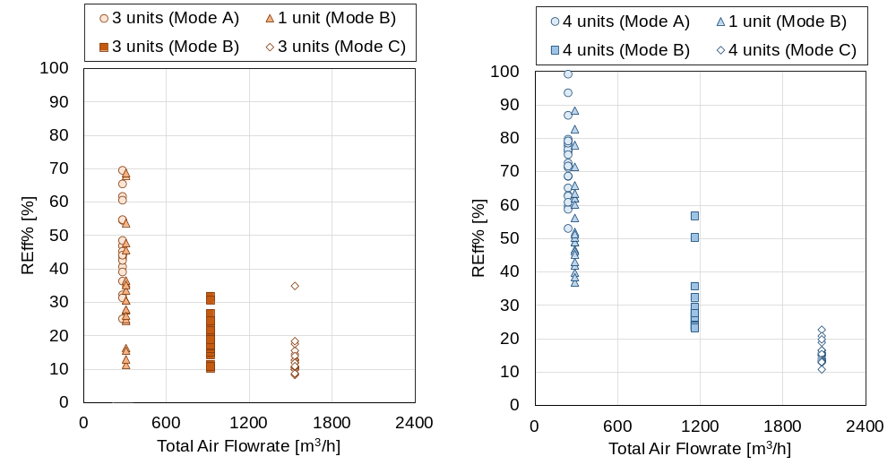
Fig.S3 REff% vs the total airflow through GPAC for GPAC-1 (left) and GPAC-2 (right), each point represents one m/z.

In Fig.S4, it is evident that removal efficiency decreased as the airflow rate through the GPACs increased. Whether using one or several units, the same total airflow through the GPACs produced similar RE_{m3/h} and EER values. Increasing the total airflow rate through GPACs reduced EER, suggesting that increases in airflow values over a certain level cannot be economically justified, as they did not yield significantly higher RE_{m3/h}.

To present the effect on energy, we made the following calculations as an example. We assumed an HVAC system with a performance coefficient of 3 and mechanical ventilation with heat recovery (MVHR) with a heat-exchanger efficiency of 0.6 in Tokyo. The approximate volume of air that can be processed with 1 kW of energy, based on the difference in specific enthalpy, was estimated without accounting for additional energy required for humidification and dehumidification. According to the Handbook of Air Conditioning(10) for Japanese HVAC System, during summer, the enthalpy difference between indoor and outdoor air is 24.3 kJ/kg, allowing for the processing of approximately 0.86 m³ of outdoor air per 1Wh of energy (indoor conditions: dry bulb temperature = 26.0°C, absolute humidity = 10.5 g/kg, relative humidity = 50.0%; outdoor conditions: dry bulb temperature = 29.8°C, absolute humidity = 18.5 g/kg, relative humidity = 70.1%). In winter, the enthalpy difference is 36.1 kJ/kg, permitting approximately 0.58 m³ of outdoor air to be processed per 1 Wh of energy (indoor conditions: dry bulb temperature = 1.3°C, absolute humidity = 1.4 g/kg, relative humidity = 50.0%; outdoor conditions: dry bulb temperature = 29.8°C, absolute humidity = 18.5 g/kg, relative humidity = 70.1%). Comparing the minimum EER of GPAC-1 (1.52 m³/Wh) and GPAC-2 (6.63 m³/Wh), as shown in Table S8 and Figure S4, to the approximately calculated values for the HVAC system (0.86 m³/Wh in summer and 0.58 m³/Wh in winter), potential energy-saving effects are evident.
Table S8 EER for selected m/z.
Brand | Possible  organic compounds | GPAC-1 |  |  |  | GPAC-2
Number of Units | Possible  organic compounds | 3 | 1 | 3 | 3 | 4 | 1 | 4 | 4
Total Airflow Rate [m³/h] | Possible  organic compounds | 306 | 306 | 918 | 1530 | 240 | 290 | 1160 | 2080
Operational Mode | Possible  organic compounds | A | B | B | C | A | B | B | C
m/z  (protonized compounds) | Possible  organic compounds | EER [m³/Wh]
59.048 | Acetone | 7.28 | None | 1.92 | 2.24 | 10.38 | 9.36 | 4.71 | 2.25
61.028 | Acetic acid | 8.41 | Over | 4.30 | 0.66 | 13.38 | 14.91 | 6.43 | 2.07
69.067 | Isoprene | 7.94 | 1.52 | 2.03 | 0.83 | 8.52 | 8.41 | 4.64 | 1.48
71.048 | Crotonaldehyde | 8.41 | 2.20 | 2.18 | 0.82 | 10.25 | 8.32 | 4.64 | 1.58
73.062 | 2-Butanone (MEK) | 4.49 | 1.75 | 1.54 | 0.93 | 10.18 | 8.80 | 5.03 | 1.49
75.042 | Propanoic acid | 7.99 | 7.25 | 3.29 | 0.63 | 11.11 | 11.20 | 5.33 | 1.64
79.038 | Benzene | 5.78 | 9.17 | 3.60 | 0.53 | 11.40 | 12.87 | 5.84 | 1.87
83.084 | Cyclohexene | 9.77 | 3.32 | 2.45 | 1.00 | 10.87 | 7.58 | 4.32 | 1.32
87.044 | Methyl acrylate | 11.05 | 3.72 | 2.76 | 0.81 | 12.42 | 11.18 | 4.86 | 1.41
87.078 | 2-Pentanone | 7.92 | 3.76 | 2.28 | 0.64 | 9.31 | 7.16 | 4.95 | 1.52
89.058 | Butyric acid | 11.72 | 3.36 | 2.86 | 1.13 | 14.18 | 15.90 | 4.98 | 1.41
97.028 | 2-furancarboxaldehyde | 10.85 | 4.12 | 2.62 | 0.90 | 10.96 | 10.12 | 4.35 | 1.27
101.06 | Acetylacetone | 9.81 | 4.53 | 2.63 | 1.18 | 11.23 | 11.45 | 4.23 | 1.34
101.092 | n-Hexanal | 6.51 | 4.11 | 2.57 | 0.68 | 8.97 | 6.63 | 4.58 | 1.64
107.051 | Benzaldehyde | 5.62 | 4.81 | 2.33 | 0.64 | 8.40 | 7.73 | 4.27 | 1.32
115.109 | n-Heptanal | 7.00 | 4.93 | 2.56 | 0.78 | 8.70 | 6.91 | 4.34 | 1.53
117.088 | n-Butyl acetate | 12.45 | Over | 4.13 | 0.56 | 10.25 | 10.83 | 4.33 | 1.07
127.11 | 6-MHO | 7.77 | 6.16 | 3.03 | 0.76 | 11.32 | 8.82 | 4.27 | 1.36
129.123 | Octanal | 8.11 | 4.76 | 2.88 | 0.68 | 9.81 | 8.16 | 4.26 | 1.35
137.131 | Monoterpene | None | 3.50 | 1.46 | 0.56 | 7.58 | 11.87 | 9.06 | 1.97
143.137 | n-Nonanal | 7.62 | 6.44 | 2.93 | 0.69 | 9.82 | 9.08 | 4.29 | 1.32
157.153 | n-Decanal | 7.91 | 9.27 | 3.30 | 0.70 | 10.73 | 9.24 | 4.19 | 1.29

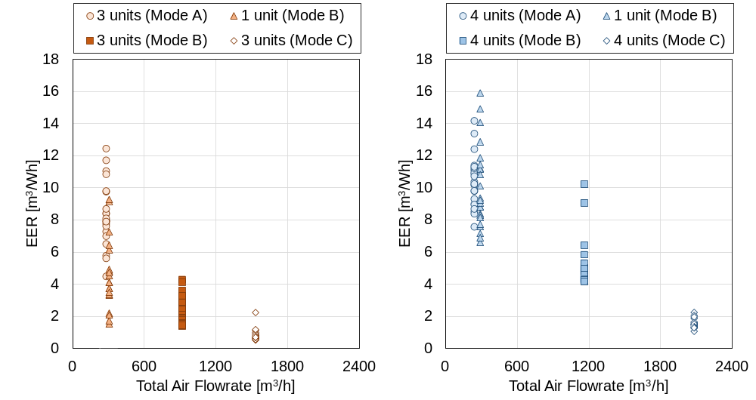
Figure S4. EER vs the total airflow through GPAC for GPAC-1 (left) and GPAC-2 (right), each point represents one m/z.

References
1. Ellis AM, Mayhew CA. Proton transfer reaction mass spectrometry: principles and applications. Chichester, West Sussex: John Wiley & Sons, Inc; 2014. 350 p.
2. Pepper DW, Carrington D. Modeling indoor air pollution. London: Imperial College Press; 2009. 1 p.
3. Hussain Md, Mahmud I. pyMannKendall: a python package for non parametric Mann Kendall family of trend tests. J Open Source Softw. 2019 Jul 25;4(39):1556.
4. Hamed KH, Ramachandra Rao A. A modified Mann-Kendall trend test for autocorrelated data. J Hydrol. 1998 Jan;204(1–4):182–96.
5. Bullock LC. Promoting Healthier Living Through Identifying the Levels of Current Volatile Compounds in University Housing Rooms and Their Relationship With Students’ Indoor Activities and Lifestyle. Honors Capstone Proj Theses. 2015;89.
6. Amada K, Fang L, Vesth S, Tanabe S ichi, Olesen BW, Wargocki P. A method for testing the gas-phase air cleaners using sensory assessments of air quality. Build Environ. 2024 Jul;259:111630.
7. Gallego E, Roca FJ, Perales JF, Guardino X. Experimental evaluation of VOC removal efficiency of a coconut shell activated carbon filter for indoor air quality enhancement. Build Environ. 2013 Sep;67:14–25.
8. Tsushima S, Wargocki P, Tanabe S. Sensory evaluation and chemical analysis of exhaled and dermally emitted bioeffluents. Indoor Air. 2018 Jan;28(1):146–63.
9. Sun X, Yang X. Volatile organic compounds in normal human exhaled breath: a long neglected pollutant source. In Rome, Italy; 2013 [cited 2024 Oct 15]. p. 773–83. Available from: http://library.witpress.com/viewpaper.asp?pcode=SAFE13-069-1
10. Inoue U. Handbook of Air Conditioning. 5th ed. Maruzen Publishing; 2008.

