9. Supplementary Material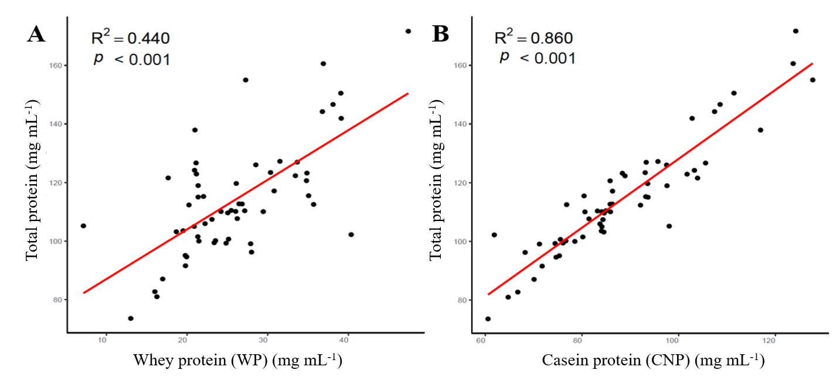
Figure 1. Relation observed between whey protein (WP) (mg mL⁻¹) and total protein (mg mL⁻¹) in colostrum (A; R² = 0.440; p< 0.001) and the relation observed between casein protein (CNP) (mg mL⁻¹) and total protein (mg mL⁻¹) in colostrum (B; R² = 0.860; p< 0.001). Red line is the trend line.

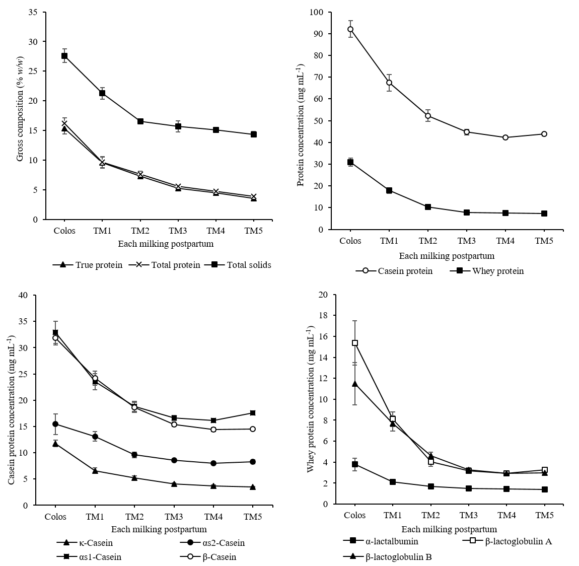
Figure 2. Effect of each milking postpartum (Colos; colostrum, transition milks one to five; TM1… TM5) on the gross composition (% (w/w); A), casein and whey concentration (mg mL⁻¹; B), individual casein proteins (mg mL⁻¹; C) and individual whey proteins (mg mL⁻¹; D). The reader is referred to Table 5; for the individual p-values for the impact each milking postpartum had on these proteins as the milk transitioned from colostrum to TM5. The error bars represent standard mean error within replicates.

