Life cycle assessment of lithium-air battery cells
Mats Zackrissonª, Kristin Fransson^{b}, Jutta Hildenbrand^{b}, Gorazd Lampic^{c} , Colm O'Dwyer^{e}
ªCorresponding author. Swerea IVF AB, Brinellvägen 68, SE-100 44 Stockholm, Sweden.
Telephone: +46 8 20 39 53. E-mail: mats.zackrisson@swerea.se.
^{b}Swerea IVF AB, Argongatan 30, SE-431 53 Mölndal, Sweden, E-mail: kristin.fransson@swerea.se; jutta.hildenbrand@swerea.se
^{c}Elaphe Ltd., Teslova 30, SI-1000, Ljubljana, Slovenia, E-mail: gorazd@elaphe-ev.com
^{e}Department of Chemistry, University College Cork, Cork T12 YN60, Ireland, E-mail: c.odwyer@ucc.ie

Abstract
Lithium-air batteries are investigated for propulsion aggregates in vehicles as they theoretically offer at least 10 times better energy density than the best battery technology (lithium-ion) of today. A possible input to guide development is expected from Life Cycle Assessment (LCA) of the manufacture, use and recycling of the lithium-air battery.
For this purpose, lithium-air cells are analyzed from cradle to grave, i.e., from raw material production, cathode manufacturing, electrolyte preparation, cell assembly, use in a typical vehicle to end-of-life treatment and recycling. The aim of this investigation is highlighting environmental hotspots of lithium-air batteries to facilitate their improvement, in addition to scrutinizing anticipated environmental benefits compared to other battery technologies. Life cycle impacts are quantified in terms of climate impact, abiotic resource depletion and toxicity. Data is partly based on assumptions and estimates guided from similar materials and processes common to lithium-ion technologies. Laboratory scale results for lithium-air systems are considered, which include expectations in their future development for efficiency gains.
At the present level of lithium-air cell performance, production-related impacts dominate all environmental impact categories. However, as the performance of the lithium-air cell develops (and less cells are needed), battery-related losses during operation become the major source of environmental impacts. The battery internal electricity losses become heat that may need considerable amounts of additional energy for its transportation out of the battery.
It is recommended that future battery cell development projects already at the design stage consider suitable methods and processes for efficient and environmentally benign cell-level recycling. LCA could provide additional arguments and a quantitative basis for lithium battery recycling. This emphasizes the need to develop LCA toxicity impact methods in order to properly assess lithium.

Keywords
LCA; Li-air battery; Li-O₂ battery; Life Cycle Assessment

Highlights
- LCA of an emerging technology: Lithium-air batteries
- At present technology level, production related impacts dominate environmental impact
- At future technology level, battery related losses dominate environmental impact
- Recycling could reduce production related environmental impact by 10-30%
List of acronyms and abbreviations
CO₂-eq | Carbon dioxide equivalents
CNT | Carbon Nanotubes
CTU | Comparative Toxic Unit
CVD | Chemical Vapour Deposition
EV | Electric Vehicle
GDL | Gas Diffusion Layer
GLO | Global
ICEV | Internal Combustion Engine Vehicle
LCA | Life Cycle Assessment
LFP | Lithium iron phosphate, LiFePO₄, battery
LMO | Lithium manganese oxide, LiMn₂O₄, battery
MWCNT | Multi Walled Carbon Nanotubes
NA | Not Applicable
NMC | Lithium nickel Manganese Cobalt oxide battery
NMP | N-Methyl-2-Pyrrolidone
PHEV | Plug-in Hybrid Electric Vehicle
PVDF | Polyvinylidenfluoride
PP | Polypropylene
RER S,U | RER = Region Europe, S=system process, U=unit process
Sb | Antimony
STABLE | STable high-capacity lithium-Air Batteries with Long cycle life for Electric Cars
TEGDME | Tetra Ethylene Glycol Dimethyl Ether
UCTE | Union for the Co-ordination of Transmission of Electricity (association of transmission system operators in continental Europe)

Introduction
Lithium-air battery cells are currently being investigated for propulsion aggregates in vehicles as they theoretically can provide a 10-fold increase in energy density compared to the best battery technology (lithium-ion) of today (Badwal et al 2014). The current state of research is however far from large scale implementation, and the technology must overcome many hurdles involving voltage stability, charge over potential, electrolyte stability, and many other physical-chemical factors that should ideally include full cell development that operates in ambient air (Bhatt et al. 2014). The purpose of this work is to highlight environmental hotspots linked with lithium-air batteries in order to guide improvement at full cell level, and to illustrate some potential benefits to the adaption of lithium-air batteries in vehicles.
Electric vehicles are seen as the main answer to the transport sector´s problems of climate impact and diminishing oil supplies. Provided that the electricity can be generated from renewable energy sources, considerable reductions of CO₂ emissions from the transport sector are possible (Notter et al. 2010). However, development of battery performance is crucial in the transition from combustion engines to electric motors in automobiles.
The LCA presented here was performed in the context of the European STABLE project aiming at STable high-capacity lithium-Air Batteries with Long cycle life for Electric cars carried out 2012-2015. LCA is generally considered very useful in the product development stage in order to identify environmental hot-spots and aid in directing development efforts in relevant areas (Rebitzer et al. 2004, Zackrisson 2009).
The LCA is targeting one of the best working lithium-air cell prototypes developed in the project. All in all, the project built five working lithium-air prototypes. The LCA was focused on prototype number four (one of the best achieved) and include a futuristic long-term scenario in which the prototype is assumed to have close to the theoretical maximum energy density of lithium-air technology.

Method
Members of the STABLE consortium have delivered detailed data about raw materials, manufacturing, use and recycling related to lithium-air batteries. Material needs were determined based on one of the best prototypes achieved in the project, using materials, methods and advancements guided by the current state of the art (Luntz & McCloskey 2014). Associated resources and emissions were found in existing databases for LCA and represent in general European or global averages. Data have mainly been drawn from the database Ecoinvent 3.1 (Ruiz et al. 2014).
With the aim of influencing the design and development of the lithium-air technology, a screening LCA was carried out early on in the project.

2.1 Functional units
In order to put the battery in the application context of a vehicle (Del Duce et al 2013), this study presents the results as environmental impact per vehicle kilometre. The vehicle context is realized via assumptions about car weight, electricity consumption and total mileage. Thereby, the results can easily be compared and classified in relation to vehicle emissions targets, e.g. the European passenger car standards of 95 g CO₂-eq/km fleet average to be reached by 2021 by all manufacturers (EC 2009). The principal functional unit of the study is one vehicle kilometre and the corresponding reference flow is battery capacity and battery power losses for one vehicle kilometre. LCA-databases typically contain vehicle emissions data per person kilometre, which can be converted to vehicle kilometre. The LCA database Ecoinvent, for example, uses 1.59 passengers per vehicle to convert from vehicle kilometre to person kilometre. It could be argued that larger vehicles carry more passengers, but occupancy rates of passenger cars in Europe fell from 2.0 in the early 1970s to 1.5 in the early 1990s, due to increasing car ownership, extended use of cars for commuting and a continued decline in household size (EEA 2016). It indicates that the actual number of passengers per car is largely decoupled from the size of the car.
It should be noted that the emissions target in a legal sense only applies to tail-pipe emissions and does not include a life cycle perspective. However, it is still a useful benchmark.
The use of vehicle kilometre as the functional unit facilitates comparisons with combustion vehicles and of different battery technologies in the same vehicle. However, it does not facilitate comparisons between different size batteries; smaller batteries, e.g. batteries for hybrid vehicles would normally have less environmental impact per vehicle kilometre. For such comparisons, the functional unit per delivered kWh over the lifetime is more appropriate.

System boundary and data
The system boundary for the study is shown in Figure 1. The vehicle itself is not present in the system, only the use of the battery cell in the vehicle. In essence, the study will include the production phase of the battery cell, those use phase losses that can be related to the cell itself and the recycling of the cell materials. In this study, we address only the battery cell including its packaging. Electronics, wiring, packaging of modules and battery casing are not included, nor are the other parts of the drive train that deliver power from plug to wheel: charger, inverter(s) and motor(s).
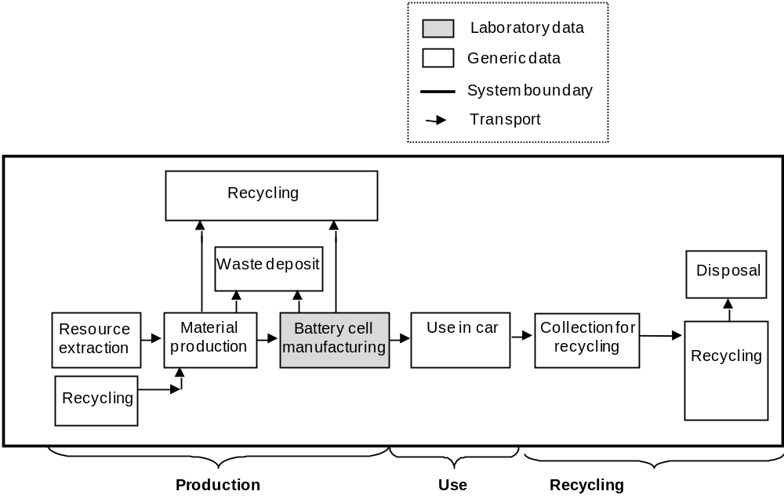
Figure 1 System boundary of the lithium-air cell LCA study
STABLE project partners in Spain and Italy provided data (material, energy, emissions) from their laboratories specific to the manufacturing of the prototype cell, which was complemented with fitting background data, e.g. for electricity.
It should be emphasized that the use phase does not include propulsion related environmental burdens, but was limited to losses that can be attributed to the battery cell. Recycling data is estimated since reliable data on recycling of lithium battery cells are exceedingly limited in scope and detail.

2.3 Life cycle impact assessment
LCA of traction batteries inevitably leads to comparisons of electric vehicles (EV) with Internal Combustion Engine Vehicles (ICEV). Such LCAs should therefore be able of assessing trade-offs between tailpipe emissions, material resource use and toxicological impacts. Thus, relevant environmental impact categories for LCA of vehicles and traction batteries in particular are: climate impact, resource depletion and toxicity. The methods used to account for these impact categories in this study are:
- Climate impact in accordance with (IPCC 2007). The unit is climate impact in grams or kilograms of carbon dioxide equivalents, CO₂-eq.
- Resource depletion, or abiotic resource depletion is calculated with the CML-IA baseline, version 3.02 as recommended by the ILCD handbook (Wolf & Pant 2012). The report is limited to depletion of mineral reserves since the climate impact indicator is considered to cover environmental impacts of fossil fuels.
- Ecotoxicity was evaluated with the method USEtox (recommended+interim) 1.04 as recommended by the ILCD handbook (Wolf & Pant 2012). The characterization factor for freshwater ecotoxicity impacts is expressed in Comparative Toxic Units (CTUe). It is an estimate of the Potentially Affected Fraction of species (PAF) integrated over time and volume, per unit mass of a chemical emitted.

Model
The production phase model is based on the bill of materials for the target prototype. According to (Matheys et al. 2005) and (Zackrisson et al. 2010), the use of the battery in the car can be modelled by considering:
- The extra power needed to carry the battery’s weight
- Extra electrical energy needed to cover charge/discharge losses
Assumptions about car weight and electricity use are needed to model the use phase. Modelling of the recycling was based on a literature survey of lithium battery recycling.

3.1 Production phase
The investigated STABLE prototype was manufactured in the laboratories of partners in Spain and Italy. The modelling aims to reflect industrial scale production in Europe.

3.1.1 Product specification
The target prototype lithium-air cell system has a controlled gas-flow cell design based on proton exchange membrane fuel cell configuration. The design and the bill of materials are shown in Figure 2 and Table 1.
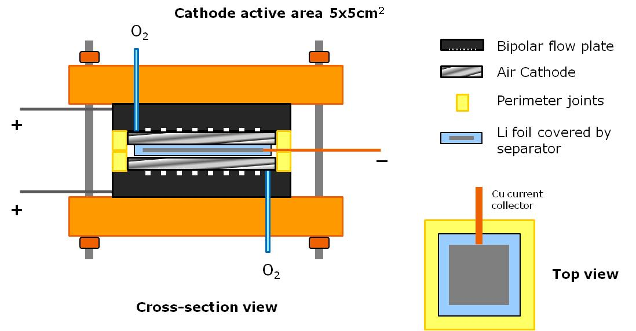
Figure 2 Target prototype lithium-air cell
The prototype in Figure 2 uses an oversized housing in stainless steel which was disregarded in the calculations and replaced by a fictitious housing in polypropylene weighing 15% of the cell components (see table below).
Table 1 Materials content of lithium-air cell
Component and material | Mass (g) | Comment
Electrolyte LiClO₄ in TEGDME | 8.902 | -
Lithium foil | 0.67 | Without hydrophobic coating or surface treatment
Separator (Celgard), polypropylene | 0.144 | -
Tab in copper | 1.537 | -
Cathode (GDL+Co₂O₃/CNT) | 0.307 | Laboratory scale manufacturing of cathode
Sealing gasket, polyester and silicone | 2.87 | -
Housing, polypropylene | 2 | Assumed to be 15% of cell components
Total mass of cell | 16.4 | -
An overview of the cell component modelling is presented in Table 2, along with the climate impact per kg of each component/material. As a rule, commercial materials were modelled with average European electricity mix. Parts made in the laboratories of the STABLE partners were modelled with the specific electricity mix of the country where the laboratory is situated.
Table 2 Overview of LCA model of lithium-air cell production
Component and material | Modelled by LCA processes | Climate impact (kg CO₂-eq/kg)
Electrolyte LiClO₄ in TEGDME | Tetra ethylene glycol dimethyl ether (TEGDME), at plant/RER System  Electricity, medium voltage, production UCTE, at grid/UCTE S  LiClO4  - Sodium perchlorate {GLO}| market for | Alloc Rec, S  - Lithium chloride {GLO}| market for | Alloc Rec, S  - Electricity, high voltage, production UCTE, at grid/UCTE S | 2.9
Lithium foil | Lithium {GLO}| market for | Alloc Rec, S | 167
Separator (Celgard), poly-propylene | Polypropylene, granulate {GLO}| market for | Alloc Rec, S  Extrusion, plastic film {GLO}| market for | Alloc Rec, S | 2.7
Tab in copper | Copper {GLO}| market for | Alloc Rec, S | 4.1
Cathode (GDL+Co₂O₃/CNT) | Cobalt oxide nanoparticles and MWCNT  - Cobalt {GLO}| market for | Alloc Rec, S  - Solvent, organic {GLO}| market for | Alloc Rec, S  - Oxygen, liquid {RER}| market for | Alloc Rec, S  - Methane, 96% by volume, from biogas, from medium pressure network, at service station {GLO}| market for | Alloc Rec, S  - Multi Walled Carbon Nanotubes, CVD, industrial scale  - Electricity, medium voltage, production UCTE, at grid/UCTE S  - Heat, light fuel oil, at industrial furnace 1MW/RER S  - Electricity, medium voltage {ES}| market for | Alloc Rec, S  PVDF binder, System  - Polyethylene, HDPE, granulate, at plant/RER S  - Tetrafluoroethylene, at plant/RER S  N-methyl-2-pyrrolidone {GLO}| market for | Alloc Rec, S  GDL24BC  - Acrylonitrile-butadiene-styrene copolymer {GLO}| market for | Alloc Rec, S  - Tetrafluoroethylene {GLO}| market for | Alloc Rec, S  - Electricity, high voltage, production UCTE, at grid/UCTE S  - Thermoforming, with calendering {GLO}| market for | Alloc Rec, S  Electricity, medium voltage {IT}| market for | Alloc Rec, S | 579
Sealing gasket, polyester and silicone | Polyester resin, unsaturated {GLO}| market for | Alloc Rec, S  Silicone product {GLO}| market for | Alloc Rec, S  Calendering, rigid sheets {GLO}| market for | Alloc Rec, S | 5.0
Housing, polypropylene | Polypropylene, granulate {GLO}| market for | Alloc Rec, S  Injection moulding {GLO}| market for | Alloc Rec, S | 3.5
Cell assembly | Electricity, medium voltage {ES}| market for | Alloc Rec, S  Heat, central or small-scale, natural gas {Europe without Switzerland}| heat production, natural gas, at boiler atm. low-NOx condensing non-modulating <100kW | Alloc Rec, S | 8.0
Below follows some more details and explanations concerning the modelling.

3.1.2 Electrolyte
The lithium perchlorate tetraethylene glycol dimethyl ether electrolyte (LiClO₄ TEGDME) is manufactured by magnetically stirring the two commercial ingredients LiClO₄ and TEGDME. It was assumed that TEGDME is produced through reaction of ethylene oxide and dimethyl ether and with energy use, emissions and waste at the same level as in production of ethylene glycol dimethylether. TEGDME is considered toxic. Precautions are needed, especially in the work environment. Exposure in the working environment to TEGDME was not modelled due to lack of data.
Lithium perchlorate, LiClO₄, can be manufactured by reaction of sodium perchlorate (NaClO₄) with lithium chloride. The reaction needs 3 kWh electric energy/kg perchlorate (Vogt & Balej 2000). The amounts were calculated by stochiometric calculation.

3.1.3 Separator
The commercial Celgard separator is made of polypropylene, presumably by film extrusion.

3.1.4 Cathode
The cathode consists of a layer of cobalt oxide (Co₃O₄ ) nanoparticles spread on a commercial gas diffusion layer. The nanoparticles were manufactured in semi-industrial scale using flame spray pyrolysis and mixed with commercial multi-walled carbon nanotubes. Production technology for the commercial multi-walled carbon nanotubes was assumed to match the floating catalyst chemical vapour deposition. Associated energy requirements were obtained from (Kushnir & Sandén 2008).
The cobalt oxide nanoparticles and the multi-walled carbon nanotubes were mixed with N-Methyl-2-pyrrolidone (NMP) into slurry and cast on a commercial gas diffusion layer, GDL24BC. The mixing and casting was done at laboratory scale in which the electricity demand for processing is time rather than mass dependent. It was assumed that the amount of product could be up-scaled by a factor of 100 using the same equipment and energy, thus reducing the overall power demands by a factor 100.
It should be noted that NMP is volatile, flammable, damaging to reproductive systems and restricted in many countries (Posner 2009). Precautions against inhalation and skin exposure are needed in the work environment. It was assumed that the NMP was burnt off. The associated CO₂ emissions were included in the model by molar calculation.
The model of the gas diffusion layer builds on information in associated product sheets and approximations.

3.1.5 Cell electronics and oxygen supply
Cell electronics and the oxygen supply were not modelled. Controlled oxygen supply is assumed not to be needed in future lithium-air cells which will take their oxygen from ambient air, though there is a growing consensus that the only practical lithium-air system will be a closed lithium-oxygen system (Gallagher et al. 2014). Electronics will certainly be needed both at cell, module and battery level, and will further add to the environmental impact of the cell.

3.1.7 Cell assembly
Energy requirements for cell assembly can vary largely, mainly depending on: 1) which share of the assembly steps require dry room/clean room conditions and 2) assembly plant throughput. Estimations and measurements vary between 1 MJ/kg battery to 400 MJ/kg battery (Dunn et al. 2014). The lithium-air cell requires most of the assembly steps to be done in dry room. An estimate derived from data in Saft’s annual report 2008 (Saft 2008) at 74 MJ/kg battery was used for the modelling of the assembly of the lithium-air cell.

Transport of materials and components
The following assumptions were made concerning the transport of materials and components in connection with lithium-air battery manufacturing, use and disposal:
- Transport from mines or recycling facilities to raw material producers. These transports are normally included in the generic data used (i.e. in the data from the Ecoinvent database).
- 11000 km transport (1000 km lorry and 10000 km boat) for both transports from raw material producers to cell manufacturer and from cell manufacturer to battery manufacturer/car assembly plant. It is expected that there will only be a few cell manufacturers in the world, so incoming and outbound transports will be relatively long. These transports are included in the Production phase.
- 6000 km transport (1000 km lorry and 5000 km boat) from car manufacturer to user. There are many car manufacturers, but customer purchases are not limited to the country of manufacture. These transports are included in the Use phase.
- Transports related to recycling and included in that phase are presented below.

Use phase
The use phase was modelled as the overall power losses in the battery during the use of the battery in the car and the extra power needed to carry the mass of the battery. In addition, the transport of the battery from the car manufacturer to the user was included in the use phase.

3.3.1 Extra power demands to accommodate battery mass
In order to calculate the extra power demands needed to carry the battery mass (M_{batt}), the total number of cells needed for the required life-long mileage (assumed to 200000 km) was calculated so that total battery weight could be put in relation to an assumption of total vehicle mass of 1600 kg (M_{vehicle}). The total weight of the battery was assumed to be double the weight of the cells. The influence of the battery mass was modelled using the assumption that 30% of energy use can be related to car mass (Zackrisson et al. 2014). Thus the mass related loss or extra power was calculated as: 0.3×M_{batt}/M_{vehicle}. This gives a dimensionless factor that can then be factored with the total delivered power.

3.3.2 Excess power requirements to accommodate charge/discharge losses
The charge/discharge efficiency, η, is defined as the relation between battery cell energy output and input. The excess power or loss is then proportional to the dimensionless factor (1- η) factored with the total delivered power. Per kilometre the dimensionless factor (1- η) is factored with the total delivered power per km which equals W_{batterytowheel}/η, i.e. the excess power per kilometre equals (1- η)×W_{batteryto wheel}/η.

3.3.3 Emissions during use phase
As mentioned earlier, the electrolyte TEGDME is considered toxic. Since emissions of TEGDME during the use of the cell are not intended they were not modelled, although they cannot be ruled out.

Recycling phase
As of 2015, industrial recycling of lithium traction batteries has only begun owing to the limited number of Li-based cells at end-of-life. However, quite a few research projects have targeted recycling of lithium batteries. Some conclusions from these studies are:
- Lithium traction batteries will be recycled in the future, inter alia, because it is mandatory in Europe, although the economics of lithium battery recycling is poor ( Dunn et al. 2012; Wang et al. 2014)
- Resource supply considerations will also be a motivation for recycling scarce materials (Speirs et al. 2014; Kushnir & Sandén 2012; Jönsson et al. 2014) used in traction batteries as the electrification of vehicles grows
- The presence of several different lithium battery chemistries will necessitate chemistry specific disassembly and treatment. Marking the batteries during manufacturing (Hall 2014; Arnberger et al. 2013) and sorting them prior to disassembly will become necessary.
- Depending on cell chemistry, recycling will use a mix of manual, mechanical, hydro- and pyrometallurgical processes (Arnberger et al. 2013; Hall 2014; Georgi-Maschler et al. 2012). The LithoRec project (Buchert 2011), for example, describes four main process steps: 1) Battery and module disassembly; 2) Cell disassembly; 3) Cathode separation; and 4) Hydrometallurgical treatment

3.4.1 Transportation
Considering the studies by (Hall 2014) and (Buchert 2011), the following recycling transportation scenario was estimated:
- 50 km from user to licensed car scrap yard. This is where the battery is removed from the vehicle and ideally sent directly to a chemistry specific disassembly and treatment plant.
- 2000 km from licensed scrap yard to chemistry specific disassembly and treatment plant. There may be intermediate transports and storage.
- 200 km from chemistry specific disassembly and treatment plant to material market (Buchert 2011). This is the same (fictitious) point at which the cell raw material producer buys precursors.
It is important to note that transportation of lithium is subject to several laws and regulations. Many of the transports outlined above require professional, dedicated transportation services. The delivery of used lithium cells to some countries is actually forbidden. The delivery from EU to Turkey is, for example, not allowed by any means of transportation.

3.4.2 Recycling and treatment processes and avoided processes
Data concerning the recycling processes is estimated based on an assumption regarding how much environmental burden can be avoided in total. It is assumed that legislation and resource supply concerns will drive recycling rate (including collection rate) to as much as 80% (Kushnir & Sandén 2012), but at the expense of energy efficiency and cost to such an extent that only 50% of environmental impacts of virgin material production is avoided. The reason for assuming only 50% of the possible avoided burdens is partly because recycled materials are often of inferior quality and cannot fully replace virgin materials, and partly because the recycling processes need resources and cause environmental burdens.
Since the cell consists mainly of electrolyte (46%) and sealing gasket (15%), both assumed to be incinerated, only 3.4 grams or 20% of the total cell weight will be recycled as material (copper, lithium, cobalt and polypropylene). The environmental impacts of lithium battery recycling are calculated as the sum of environmental impacts from the transportation and involved recycling processes and treatment processes minus environmental impacts from avoided production of virgin materials. By assuming that environmental impacts for recycling processes corresponds to 50% of Avoided virgin production, the environmental impacts of lithium battery recycling can be calculated as: Transports – 0.5×Avoided virgin production.

Parameterized model
The life cycle of the lithium-air cell was built as a parameterized model enabling variation of influencing factors. Parameters varied in the study are shown in Table 3, along with the values of the two scenarios: STABLE project achievement and Long-term lithium-air scenario. The STABLE project did not reach its objective in one single cell configuration. The number of cycle target was reached with cells with very low energy density and cells with very high energy density did not achieve that many cycles. This is reflected in the STABLE project achievement scenario. The long-term lithium-air scenario lies at least 20 years in the future.
Table 3 Model parameter settings for STABLE project scenarios
Parameter | STABLE project achievement | Long term lithium-air scenario
Charge/discharge efficiency, η | 0.66 | 0.8
Number of cycles until failure | 50 | 200
Energy density (Wh/kg) | 2700 | 10800
Share of total capacity that is cycled | 0.2 | 0.8
When comparing the energy density of the lithium-air cell to the current energy density of lithium-ion batteries (~100 Wh/kg at best) it has to be considered that the above energy densities for the lithium-air cells are calculated per kg of active component and the 100 Wh are per kg of battery system. A rough estimation, and assumption in the calculations, is that a lithium-air battery system consists of 50% non-active materials, providing an estimated energy density of 1350 Wh/kg at the battery level for the STABLE project achievement.

Results
The following description of results is intended to highlight major findings that can be used for further development of the technology. The modelling and calculations were carried out with the SimaPro software version 8.0.4.28.

Climate impact
The present “STABLE achievement” level of lithium-air cell performance comes with a large climate impact (almost 300 g CO₂-eq per km, compared with e.g. the EU 95 g CO₂-eq per km target). The production phase contributes most to climate impact. At the long-term goal level, the total climate impact is only 26 g CO₂-eq per km and dominated by losses in the use phase. Note that the presented use phase impacts only constitute battery-related losses. The vehicle operation-related (battery-to-wheel) climate impact is 89 g CO₂-eq/vehicle km with average European electricity mix (Ecoinvent 2007) at 594 g CO₂-eq per kWh and battery-to-wheel consumption of 0.15 kWh/km. Recycling avoids about 10% of production related climate impact in both scenarios.

Figure 3 Climate impact per vehicle km for the two scenarios
Detailed climate impact data per vehicle kilometre and per delivered kWh is given in Table 4. It can be seen that as performance of the cell develops, climate impact decrease altogether and is dominated by the use phase.
Table 4 Climate impact per vehicle km and per delivered kWh for the two scenarios
Scenario | Achievement |  | Long-term goal
Life cycle stage | g CO₂-eq/km | g CO₂-eq/kWh | g CO₂-eq/km | g CO₂-eq/kWh
Production | 249 | 1100 | 3.2 | 17
Use* | 69 | 296 | 23 | 124
Subtotal | 318 | 1396 | 26 | 141
End-of-life | -22 | -97 | -0.29 | -1.5
Total | 296 | 1299 | 26 | 140
*The presented use phase impacts cover only battery related losses. The operation in terms of propelling the vehicle is not included.

4.1.1 Production related climate impact
As pointed out, climate impact from the production phase is high per km or delivered kWh at the present level of development, but decreases rapidly with increasing energy density, efficiency, number of charge cycles and depth of discharge as fewer cells are needed per vehicle kilometre or delivered kWh. Production related climate impact is fairly evenly distributed among the cell components (see Figure 4): 37% from the cathode of which 34% are attributed to electrical energy; 27% from the assembly energy use; 23% from the lithium foil and 5% from the electrolyte, accounting for 92% of production related climate impact. In our model, these contributions related to the production of different components show the same ratios for both scenarios since the same materials are assumed; only the amounts of material per vehicle kilometre or delivered kWh change. Future developments would certainly need other materials, which are unknown at the time of writing, and not necessarily with larger environmental impact than the materials used for the prototype modelled here.
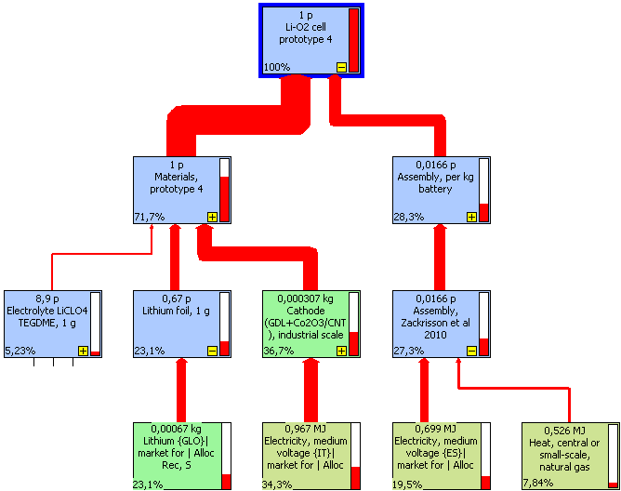
Figure 4 Relative climate impact of cell components

4.1.2 Use phase climate impact
Climate impact from the use phase is dominating more and more as the cell develops, even though in absolute terms it also decreases (as the cell develops). The use phase climate impact stems mainly from battery internal power losses, which are defined by the internal efficiency of the battery. A lot of the power passing through the battery is lost as heat: 34% and 20% respectively in the achievement and long-term goal scenarios. The extra power needed to carry the weight of the battery provides a smaller but significant contribution, especially at lower energy density levels when more cells are needed. The included transport of the battery from the car manufacturer to the user does not contribute significantly to the use phase climate impact, see Figure 5.

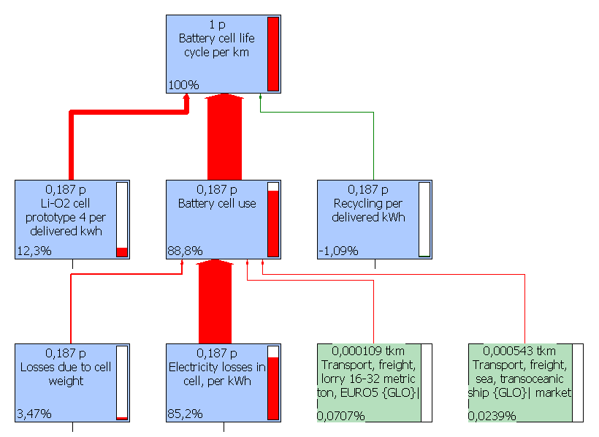
Figure 5 Relative climate impact per km at the long-term goal level

4.1.3 Recycling related climate impact
Recycling avoids about 10% of production related climate impact in both scenarios. Almost all of the avoided climate impact stems from avoided virgin production of lithium foil. The climate impact of the recycling processes was assumed to be equal to 50% of the avoided virgin production. The recycling transports give small but not insignificant contributions to climate impact.

Abiotic depletion
At the present level of lithium-air cell performance, the lithium-air cell has a relatively large abiotic depletion potential, see Figure 6. As performance of the cell develops abiotic depletion from Production and End-of-life decreases since fewer cells are needed. Use phase abiotic depletion driven by electricity use then becomes dominant. Recycling avoids about 30% of production related abiotic depletion in both scenarios.

Figure 6 Abiotic depletion, kg Sb-eq per vehicle km for the two scenarios
Detailed data about abiotic depletion per vehicle kilometre and per delivered kWh is given in Table 5.
Table 5 Abiotic depletion, kg Sb-eq per vehicle km and per delivered kWh for the two scenarios
Scenario | Achievement |  | Long-term goal
Life cycle stage | kg Sb-eq/km | kg Sb-eq/kWh | kg Sb-eq/km | kg Sb-eq/kWh
Production | 2.10E-06 | 9.3E-06 | 2.7E-08 | 1.5E-07
Use* | 1.1E-07 | 4.8E-07 | 3.6E-08 | 1.9E-07
Subtotal | 2.2E-06 | 9.7E-06 | 6.3E-08 | 3.4E-07
End-of-life | -7.7E-07 | -3.4E-06 | -1.0E-08 | -5.3E-08
Total | 1.4E-06 | 6.3E-06 | 5.3E-08 | 2.8E-07
*The presented use phase impacts cover only battery related losses. The operation in terms of propelling the vehicle is not included.

4.2.1 Production related abiotic depletion
Abiotic resource depletion from the production phase is relatively high per km or delivered kWh at the present level of development, but decreases rapidly with increasing energy density, efficiency, number of charge cycles and depth of discharge, as fewer cells are needed per vehicle kilometre or delivered kWh. Production related abiotic resource depletion stems mainly from copper, contributing 89%, see Figure 7. Lithium, the TEGDME electrolyte and electricity use (for processing) of the cathode and for assembly contribute from 5 to 1%. These relations between the production related abiotic resource depletion are the same for both scenarios since the same materials are assumed for both scenarios.

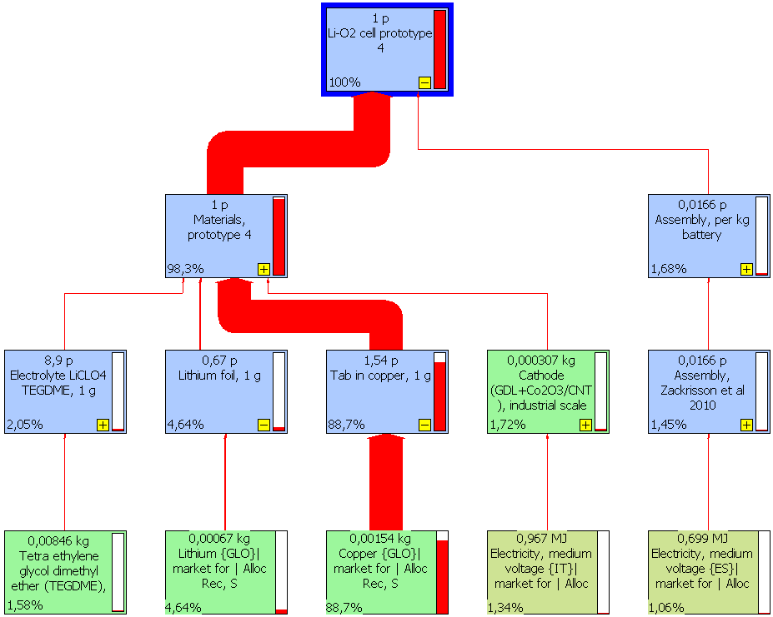
Figure 7 Relative abiotic resource depletion of cell components

4.2.2 Use phase abiotic depletion
Abiotic resource depletion from the use phase is dominating more and more as the cell develops, even though in absolute terms also the use phase abiotic resource depletion decreases as the cell develops. The use phase abiotic resource depletion stems almost completely from electricity (99%).

4.2.3 Recycling related abiotic depletion
Recycling is calculated to avoid ~30% of production related abiotic resource depletion in both scenarios. Almost all of the avoided abiotic resource depletion stems from avoided virgin production of copper. The recycling transports give insignificant contributions to abiotic resource depletion.

Ecotoxicity
At the present level of lithium-air cell performance, the cell shows relatively large ecotoxicity compared to the long-term goal. As performance of the cell develops in the future, the use phase power losses become more dominant.

Figure 8 Ecotoxicity, CTUe per vehicle km for the two scenarios
Recycling avoids about 30% of production related ecotoxicity in both scenarios. Detailed data is given in Table 6.
Table 6 Ecotoxicity, CTUe per vehicle km and per delivered kWh for the two scenarios
Scenario | Achievement |  | Long-term goal
Life cycle stage | CTUe/km | CTUe/kWh | CTUe/km | CTUe/kWh
Production | 3.6 | 16 | 0.0464 | 0.25
Use* | 0.6 | 2.8 | 0.214 | 1.1
Subtotal | 4.2 | 19 | 0.3 | 1.4
End-of-life | -1.1 | -4.8 | -0.0142 | -0.076
Total | 3.1 | 14 | 0.2 | 1.3
*The presented use phase impacts cover only battery related losses. The operation in terms of propelling the vehicle is not included.

Production related ecotoxicity
Ecotoxicity from the production phase is high per km or delivered kWh at the present level of development, but decreases rapidly with increasing energy density, efficiency, number of charge cycles and depth of discharge as fewer cells are needed per vehicle kilometre or delivered kWh. Production related ecotoxicity is fairly evenly distributed among the cell components: 67% from the copper tab; 10% from the lithium foil, 9% from the electricity used for the cathode; 8% from the assembly energy use; and 2% from the electrolyte accounts for more than 90% of production related ecotoxicity.

Use phase ecotoxicity
Ecotoxicity from the use phase is dominating more and more as the cell develops, even though in absolute terms also the use phase ecotoxicity decreases as the cell develops. The use phase ecotoxicity stems mainly from electricity during the use phase (99%).

Dominance analysis
In Table 7 can be seen that electricity, copper and lithium dominate the Production phase and electricity completely dominate the Use phase in all impact categories. Toxicity was calculated as two human toxicity scores (cancer and non-cancer related) and one ecotoxicity score. Non-cancer human toxicity was found to give around ten times higher morbidity rate than cancer-related human toxicity. In this article, only ecotoxicity is presented. From a dominance perspective, ecotoxicity represents well in particular non-cancer human toxicity, see Table 7.
Table 7 Dominance analysis
Life cycle phase  Impact category | Production | Use | End-of-life
Climate impact | Electricity (54%)  Lithium (23%)  Gas (8%)  TEGDME (4%) | Electricity (99%) | Lithium (-105%)  Copper (-6%)  Polypropylene (-4%)  Transport (15%)
Abiotic depletion | Copper (89%)  Lithium (5%) | Electricity (99%) | Copper (-96%)  Lithium (-5%)  Transport (1%)
Toxicity-cancer | Copper (35%)  Lithium (26%)  Electricity (24%) | Electricity (99%) | Copper (-59%)  Lithium (-44%)  Transport (3%)
Toxicity non-cancer | Copper (79%)  Lithium (8%)  Electricity (8%) | Electricity (99%) | Copper (-92%)  Lithium (-10%)  Transport (2%)
Ecotoxicity | Copper (67%)  Electricity (17%)  Lithium (10%) | Electricity (99%) | Copper (-88%)  Lithium (-14%)  Transport (2%)

Sensitivity calculation
The use phase climate and toxicity impacts are very dominant at the long-term goal level. This result is scrutinized with another electricity mix.
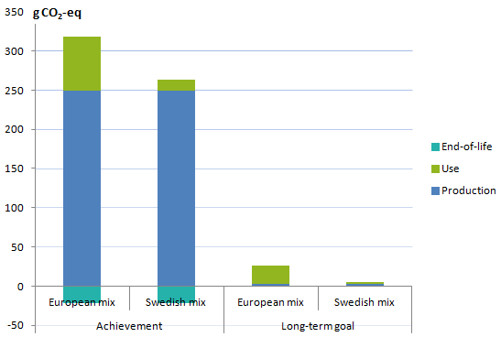
Figure 9 Climate impact per vehicle km with West European electricity mix and with Swedish electricity mix for the use phase
When the battery is using Swedish electricity mix (63 g CO₂-eq/kWh), the use phase climate impact is no longer dominant in any scenario. Note that the presented use phase impacts only cover battery related losses. The propulsion related use phase climate impact would be around 12 g CO₂-eq/vehicle km with average Swedish electricity. These 12 g CO₂-eq/vehicle km should be compared to the 95 g CO₂-eq/km tailpipe emissions limit. However, it should be noted that with carbon-rich electricity (e.g. West European electricity mix at 594 g CO₂-eq/kWh), electric cars approach the 95 g CO₂-eq/km limit if propulsion impacts are included (594 g CO₂-eq/kWh * 0.15 kWh/km= 89 g CO₂-eq/km), even if the limit does not legally apply to EVs.

Discussions and conclusions

Comparisons with other studies
In order to understand and interpret the LCA, results were compared to three other studies. The results of the comparisons are summarized in Table 8.

Table 8 Comparisons with other studies
Study  Impact category | Notter et al 2010 LCA of typical EV compared with typical ICEV | Amarakoon et al 2013 LCA of lithium chemistries for EV and PHEV batteries | Buchert 2011 LCA of recycling of lithium battery chemistries
Climate | Indicate that lithium-air cells could have potentially 4-9 times less production related climate impact than the best lithium-ion cells of today  Confirms dominance of use phase  Confirms level of avoidance by recycling (Amarakoon) |  | Confirms level of avoidance by recycling
Abiotic depletion | Reports 1000 times higher values probably caused by recent change in method |  | Confirms level of avoidance by recycling
Ecotoxicity | NA | Reports 1000 times smaller values probably caused by not using interim characterization factors. | NA

5.1.1 Climate impact
Production related climate impact around 13 g CO₂-eq/km have been reported for a LiMn₂O₄ battery for an electric vehicle by (Notter et al. 2010), and (Amarakoon et al. 2013) reports 27 g CO₂-eq/km for lithium-ion EV batteries for the production phase. At the long-term lithium-air scenario level, the production related climate impact is potentially only 3 g CO₂-eq/km for the lithium-air cell. These figures indicate that lithium-air cells could potentially reduce production related climate impact by a factor between 4-9 compared with today’s lithium-ion cells, in the long-term, but we note that the lithium-air technology is still in its infancy.
The dominance of the use phase climate impact is confirmed by (Amarakoon et al. 2013; Notter et al. 2010), and (Zackrisson et al. 2010), at least when World or West European average electricity is utilized. The use phase is accentuated in early development stages of cells since in the case of lithium-air cells, charge/discharge efficiencies from 66% at present to not more than 80% long term are assumed.
The LithoRec project (Buchert 2011) calculated net avoided climate impact to 1 g CO₂-eq/g battery and 1.7 g CO₂-eq/g battery for the recycling of NMC and LFP cells respectively, to be compared to the avoidance of 2.6 g CO₂-eq/g of lithium-air cell in this study. In contrast, (Amarakoon et al. 2013) found that recycling different EV lithium-ion cell chemistries (LiMn₂O_{4,} LiNiCoMnO₂ and LiFePO₄) potentially avoids 20% of production related climate impact, i.e. twice as much compared to this study. Being in the middle of two similar studies validates the assumption for the recycling scenario.

5.1.2 Abiotic depletion
Regarding abiotic resource depletion, only one of the studies offered comparable results. The cause is a recent change in the method to calculate abiotic resource depletion. In April 2013 Abiotic depletion was divided in two indicators: Abiotic depletion (elements, ultimate reserves) and Abiotic depletion (fossil fuels). Since (Buchert 2011) specifically lists the characterization factors used for abiotic depletion and only metals are listed this study was used for comparison. There is relatively good correlation with (Buchert 2011) who found that recycling could potentially avoid 2E-4 kg Sb/kg NMC battery and 3E-4 kg Sb/kg LFP battery. The corresponding value for the lithium-air cell is 0.9E-4 kg Sb/kg lithium-air cell.

5.1.3 Toxicity
(Amarakoon et al. 2013) reports 1.7E-3 CTUe/vehicle km for the production phase for different EV lithium-ion cell chemistries (LiMn₂O_{4,} LiNiCoMnO₂ and LiFePO₄). For the lithium-air cell, ecotoxicity values are approximately 100 times higher: 2.1E-1 CTU_{e} per vehicle kilometre for the production phase at the long-term goal level. However, these latter values are calculated using both recommended and interim characterization factors in Usetox. With only recommended characterization factors values are at the same level as (Amarakoon et al. 2013).

5.1.4 Comparability
Overall, it is important to be able to compare LCA results with other LCA studies; LCA is relative in its nature and the units are complex, thus there is a clear need for well-defined relative comparisons. To ease comparability of battery related LCA studies in the future, the following is recommended:
- Report all results per vehicle km and per delivered kWh. Per vehicle kilometre gives information on the battery/cell in a specific vehicle context. Per delivered kWh facilitates comparisons of batteries/cells of different sizes.
- Choose impact categories so that tradeoffs between tailpipe emissions, material resource use and toxicological impacts can be assessed and follow the recommendations of the ILCD handbook (Wolf & Pant 2012) concerning preferred methods.

Toxicity considerations
From the dominance analysis can be seen that toxicity stems from production of electricity, copper and lithium. There is consensus that metals are not well modelled in LCA (Hauschild et al. 2011). For example, among the recommended characterization factors in the USEtox method (used by Amarakoon) there are no characterization factors for metals. While the interim characterization factors in USEtox do include associated factors for some metals, there is still no characterization factor for lithium. The lithium process scores high in toxicity due to emissions of chromium, nickel, arsenic and mercury associated with the lithium production. On the other hand, it is not that clear where emissions of lithium would happen, thus such emissions are not modelled fully. Volatility of some lithium-containing electrolyte may provide a source of lithium contamination, but there are no dedicated reports of lithium emissions during full battery pack operation for lithium-air systems.
A recent study (Kang et al. 2013) on the potential environmental and human health impacts of lithium-ion batteries in electronic waste concludes that lithium batteries in uncontrolled landfills would leach out metals above current US regulatory limits. It was highlighted that the impact assessment methods did not take lithium and aluminium into account due to lack of toxicity data in the models, i.e. there is no data on lithium emissions from landfills nor are there characterisation factors available to translate such emissions into toxicity impacts.
The TEGDME electrolyte and the organic NMP solvent used in the manufacturing of the cathode are both considered toxic. Due to lack of data, potential emissions of these substances were not modelled in any phase. Both substances could potentially leak out in the working environment and TEGDME emissions might also occur during the use of the battery cell. Both substances lack characterization factors in USEtox.
As pointed out above, tradeoffs between tailpipe emissions, material resource use and toxicological impacts need to be assessed in LCAs of vehicles. In order to facilitate this, the following developments are recommended:
- Develop data and models for lithium emissions during the life cycle of the battery as well as for other toxic substances used in the battery cell.
- Develop characterization factors for lithium emissions and include them in the USEtox method as well as for other toxic substances used in the battery cell.
In view of above, it seems reasonable to be extra cautious when interpreting LCA toxicity scores for lithium batteries. Until the recommended developments are achieved, known toxic materials should be considered also outside of the LCA.

Use phase dominance
The dominance of the use phase is confirmed also in other studies (Zackrisson et al. 2010) and (Notter et al. 2010). The use phase dominance has many implications. If only 66-80% of the input energy is usable for propulsion, it means that 34-20% of the energy becomes heat that may need considerable amounts of additional energy for its transportation out of the battery. For all battery designs, it is therefore very important to minimize power losses (voltage drop and resistance increase) in the battery during operation.
As shown in the sensitivity calculations above, with carbon-lean Swedish electricity the use phase climate impact is no longer dominant in any scenario, from the “battery perspective” used in this study. If the associated “propulsion” emissions were to be factored into the calculations, the use phase would dominate even with carbon-lean electricity.

Potential of lithium-air cell
At the long-term goal level, production related climate impact is only 3 g CO₂-eq/km which is a factor of 4-9 lower than today’s best battery technology. The potential gains in performance are so large that a battery with lithium-air cell functioning at the long-term goal level would most probably be very competitive, even if controlled oxygen supply is needed for its proper functioning. Readers are referred to several topical reviews (Bhatt et al. 2014; Luntz & McCloskey 2014) that also outline the current technical obstacles and associated research and development underway to mitigate limited performance. The actual environmental footprint of a distant industrial scale manufacturing of lithium-air batteries will probably be higher due to intentional exclusions, like cell electronics and oxygen supply, or unintentional exclusions because of lack of knowledge and lower due to improved, up-scaled and/or different manufacturing processes. In conclusion, the currently predicted environmental impact could be higher or lower or roughly equal to that of a fully functional commercial lithium-air battery in the future.

Recycling
This study shows that by recycling the battery cell, 10-30% of production related environmental impact could be avoided. However, it is important to point out that at present there is no dedicated recycling activity for lithium traction batteries and that the economic return for recycling is quite poor (Wang et al. 2014). Thus, recycling of lithium batteries will probably not happen unless it is legally enforced worldwide, as it currently is in Europe (EC 2006). In this respect, LCA may be important in guiding policy and providing a starting basis for quantitative assessment for possible lithium battery recycling. This emphasizes the need to develop LCA toxicity impact methods in order to properly assess lithium. Resource supply considerations will also be a motivation for recycling of scarce materials used in traction batteries. In view of the above, it is recommended that future battery cell development projects already at the design stage should consider how the battery and cell should be recycled.

Conclusions
At the present level of lithium-air cell performance, production related impacts dominate all environmental impacts categories. However, as performance of the lithium-air cell develops (and less cells are needed), battery related power losses during operation become the major source of environmental impacts. This has two major implications. The battery internal power losses become heat that may need considerable amounts of additional energy for its transportation out of the battery. It is therefore very important to minimize power losses in the battery. Secondly, the dominance of the use phase (at the STABLE long-term goal level) infers that the production of cells does not carry that large environmental impact. The study indicates that lithium-air cells, in the long-term, could have 4-9 times less climate impact than today’s lithium-ion cells.
By recycling, about 10-30% of production related environmental impact could potentially be avoided. However, today no recycling of lithium based traction batteries is on-going and the economic incentive to invest in it is weak. It is therefore recommended that future battery cell development projects already at the design stage consider how the battery and cell should be recycled. LCA could provide additional arguments for lithium battery recycling. This emphasizes the need to develop LCA toxicity impact methods in order to properly assess lithium.

Acknowledgements
This research has received funding from the European Union’s Seventh Framework Programme FP7- GC.NMP.2012-1: Innovative automotive electrochemical storage applications based on nanotechnology, (Project STABLE) under grant agreement no. 314508. For further information, see www.fp7-stable.com/.
References
Amarakoon, S., Smith, J. & Segal, B., 2013. Application of Life- Cycle Assessment to Nanoscale Technology : Lithium-ion Batteries for Electric Vehicles, Available at: www.epa.gov/dfe.
Andrea Del Duce, Patricia Egede, Gerlind Öhlschläger, T.D., 2013. Guidelines for the LCA of electric vehicles,
Arnberger, A., Pomberger, R. & Curtis, A., 2013. Recycling of lithium-ion batteries taken from electric traction drive. In Wastes: Solutions, Treatments and Opportunities. 2nd International Conference. pp. 727–732.
Badwal, Sukhvinder P. S., Sarbjit S. Giddey, Christopher Munnings, A.I.B. and A.F.H., 2014. Emerging electrochemical energy conversion and storage technologies. Frontiers in Chemistry.
Bhatt, M.D. et al., 2014. Key Scientific Challenges in Current Rechargeable Non-aqueous Li-O2 Batteries: Experiment and Theory. Physical Chemistry Chemical Physics, (16), pp.12093–12130.
Buchert, M., 2011. Ökobilanz zum „Recycling von Lithium-Ionen-Batterien“ (LithoRec),
Dunn, J.B. et al., 2012. Impact of recycling on cradle-to-gate energy consumption and greenhouse gas emissions of automotive lithium-ion batteries. Environmental science & technology, 46(22), pp.12704–10. Available at: http://www.ncbi.nlm.nih.gov/pubmed/23075406.
Dunn, J.B. et al., 2014. The significance of Li-ion batteries in electric vehicle life-cycle energy and emissions and recycling’s role in its reduction. Energy Environ. Sci., 00, pp.1–11. Available at: http://xlink.rsc.org/?DOI=C4EE03029J [Accessed November 17, 2014].
EC, 2006. DIRECTIVE 2006/66/EC OF THE EUROPEAN PARLIAMENT AND OF THE COUNCIL of 6 September 2006 on batteries and accumulators and waste batteries and accumulators and repealing Directive 91/157/EEC,
EC, 2009. Regulation (EC) No 443/2009 to define the modalities for reaching the 2020 target to reduce CO2 emissions from new passenger cars,
Ecoinvent, 2007. Electricity, low voltage, production UCTE, at grid/UCTE S.
EEA, 2016. Are we moving in the right direction? Indicators on transport and environmental integration in the EU: TERM 2000 / Occupancy rates. European Environment Agency. Available at: http://www.eea.europa.eu/publications/ENVISSUENo12/page029.html [Accessed April 20, 2016].
Gallagher, K.G. et al., 2014. Quantifying the promise of lithium–air batteries for electric vehicles. Energy & Environmental Science, 7, p.1555. Available at: http://xlink.rsc.org/?DOI=c3ee43870h.
Ganter, M.J. et al., 2014. Cathode refunctionalization as a lithium ion battery recycling alternative. Journal of Power Sources, 256, pp.274–280. Available at: http://dx.doi.org/10.1016/j.jpowsour.2014.01.078.
Georgi-Maschler, T. et al., 2012. Development of a recycling process for Li-ion batteries. Journal of Power Sources, 207, pp.173–182. Available at: http://linkinghub.elsevier.com/retrieve/pii/S0378775312002984 [Accessed October 24, 2014].
Hall, B., 2014. Förstudie kring återvinningsmetoder för litiumjonbatterier och celler för fordonsapplikationer,
Hauschild, M.Z., Jolliet, O. & Huijbregts, M. a J., 2011. A bright future for addressing chemical emissions in life cycle assessment. International Journal of Life Cycle Assessment, 16(8), pp.697–700.
IPCC, 2007. Climate Change 2007: Mitigation. Summary for Policymakers. Contribution of Working Group III to the Fourth Assessment Report of the Intergovernmental Panel on Climate Change, Cambridge.
Jönsson, C. et al., 2014. Strategiska materialval. Frågeställningar ur ett livscykelperspektiv.,
Kang, D.H.P., Chen, M. & Ogunseitan, O. a, 2013. Potential environmental and human health impacts of rechargeable lithium batteries in electronic waste. Environmental science & technology, 47(10), pp.5495–503. Available at: http://www.ncbi.nlm.nih.gov/pubmed/23638841.
Kurdve, M., 2014. Development of collaborative green lean production systems. Mälardalen University.
Kushnir, D. & Sandén, B. a., 2008. Energy Requirements of Carbon Nanoparticle Production. Journal of Industrial Ecology, 12(3), pp.360–375. Available at: http://doi.wiley.com/10.1111/j.1530-9290.2008.00057.x [Accessed November 3, 2014].
Kushnir, D. & Sandén, B. a., 2012. The time dimension and lithium resource constraints for electric vehicles. Resources Policy, 37(1), pp.93–103. Available at: http://linkinghub.elsevier.com/retrieve/pii/S0301420711000754 [Accessed September 26, 2014].
Luntz, A.C. & McCloskey, B.D., 2014. Nonaqueous Li–Air Batteries: A Status Report. Chemical Reviews, 114(23), pp.11721–11750.
Matheys, J., Autenboer, W. Van & Mierlo, J. Van, 2005. SUBAT: SUSTAINABLE BATTERIES. Work package 5: Overall Assessment. Final Public Report, Vrije Universiteit Brussels - ETEC.
Notter, D. et al., 2010. Contribution of Li-Ion Batteries to the Environmental Impact of Electric Vehicles. Environmental Science &Technology.
Posner, S., 2009. Riskanalys av kemikalier vid tillverkning av litiumjonbatterier, Mölndal: Swerea IVF.
Rebitzer, G. et al., 2004. Life cycle assessment: Part 1: Framework, goal and scope definition, inventory analysis, and applications. Environment International, 30(5), pp.701–720. Available at: http://www.sciencedirect.com/science/article/B6V7X-4C4W8Y2-1/2/2f6b7df89f92f13eec398d14aea533be.
Ruiz, M. et al., 2014. Documentation of changes implemented in ecoinvent version 3.1. Ecoinvent, 1.
Speirs, J. et al., 2014. The future of lithium availability for electric vehicle batteries. Renewable and Sustainable Energy Reviews, 35, pp.183–193. Available at: http://linkinghub.elsevier.com/retrieve/pii/S1364032114002457 [Accessed December 1, 2014].
Wang, X., Gaustad, G., Babbitt, C.W., et al., 2014. Economic and environmental characterization of an evolving Li-ion battery waste stream. Journal of environmental management, 135, pp.126–34. Available at: http://www.ncbi.nlm.nih.gov/pubmed/24531384 [Accessed September 30, 2014].
Wang, X., Gaustad, G., Babbitt, C.W., et al., 2014. Economies of scale for future lithium-ion battery recycling infrastructure. Resources, Conservation and Recycling, 83, pp.53–62. Available at: http://www.sciencedirect.com/science/article/pii/S0921344913002541 [Accessed August 5, 2014].
Vogt, H. & Balej, J., 2000. Chlorine Oxides and Chlorine Oxygen Acids. ULLMANN´S Encyclopedia of Industrial Energy. Available at: http://onlinelibrary.wiley.com/doi/10.1002/14356007.a06_483/full#a06_483-sec1-0008.
Wolf, M.-A. & Pant, R., 2012. The International Reference Life Cycle Data System, Available at: http://lct.jrc.ec.europa.eu/pdf-directory/JRC Reference Report ILCD Handbook - Towards more sustainable production and consumption for a resource-efficient Europe.pdf.
Zackrisson, M. et al., 2014. Mall för miljöutredning - ett verktyg för att identifiera företagets miljöpåverkan, Mölndal: Swerea IVF.
Zackrisson, M., Avellán, L. & Orlenius, J., 2010. Life cycle assessment of lithium-ion batteries for plug-in hybrid electric vehicles - Critical issues. Journal of Cleaner Production, 18(15), pp.1517–1527. Available at: http://www.sciencedirect.com/science/article/B6VFX-50B5PJ2-1/2/294cf8e2d66a0696536eddba5a51c55b.

