In-hospital adverse drug reactions in older adults; prevalence, presentation and associated drugs. A systematic review and meta-analysis

SUPPLEMENTARY DATA
Table of Contents
Appendix 1. MOOSE Checklist for Meta-analyses of Observational Studies 4
Methods 6
Search terms 6
PubMed 6
EMBASE 7
CINAHL 8
Study Eligibility Criteria 9
Statistical analysis 9
Appendix 2. Sensitivity Analysis of ADR Presentations 11
Risk of Bias (RoB) and Quality Assessment 14
Appendix 3. Descriptive summary of RoB / Quality justification and judgements of domains of NOS of included observational Studies (provided in alphabetical order) 14
Ayub 2009, Bowman 1996 14
Calderon-Ospina 2010, Cheong 2018 14
Conforti 2012, Corsonello 2009 15
Davies 2009, Fernandez-Regueiro 2011 16
Ganeva 2016, Ganeva 2013 17
Ganeva 2007, Giardina 2018 17
Gonzalez-Martin 1997, Hailu 2020 18
Harugeri 2011, Kaur 2018 19
Lavan 2017, Leach 1986 19
Liao 2019, Mohebbi 2010 20
Mugosa 2015, O’Connor 2012 21
Onder 2010, Reichel 1965 22
Tangiisuran 2012, Tangiisuran 2014 22
Appendix 4. Summary of Observational Studies Quality Assessment 24
Appendix 5. Observational studies grouped by study quality (p=0.003) 26
Appendix 6. Forrest plot showing proportion of patients aged 65 years or older experiencing an in-hospital ADR - including Liao et al.*³¹ 27
Appendix 7. Observational studies grouped according to NOS Domain S4 - demonstration that outcome of interest (ADR) was not present at start of study 29
Appendix 8. Funnel plots of included studies 30
Funnel plot excluding Liao et al.³¹ 30
Funnel plot including Liao et al.³¹ 30
Appendix 9. Cochrane Risk of Bias (RoB) 2.0 Assessment of Randomised Control Trials (RCT). 31
Regression diagnostics 32
Subgroup Analyses 33
Appendix 10. Reported ADR events and ADR proportions for all included papers/studies, grouped by specialist service setting (p=0.051) 33
Description of ADR Identification and Assessment Methodologies Employed by all Included Papers/studies 35
Appendix 11. Description of ADR Identification and Assessment Methodologies Employed by all Included Papers/studies 35
Appendix 12. Meta-analysis of Studies Where all Participants Were ≥65 Years at Baseline (p=0.299) 43
Appendix 13. Meta-analysis of studies grouped by ADR definition (p=0.806) 44
Appendix 14. Meta-analysis of studies grouped by ADR causality (p=0.78) 45
Appendix 15. Meta-analysis of studies grouped by comparable overlapping ADR methodologies (p=0.383) 46
Appendix 16. Pooled estimates of ADR proportions grouped by ADR identification methods (p =0.31) 47
ADR Presentations 48
Appendix 17. Ranking of ADR Presentations by MedDRA-SOC® Classification 48
Appendix 18. Breakdown of ADR Presentations by ADR Detail (In Descending Frequency). 49
ADR Drugs 56
Appendix 19. Causative Drug Agents Ranked by Descending Frequency as per Therapeutic Subgroup (ATC 2nd Level). 56
Appendix 20. Reported Causative Drugs Grouped by Anatomical Group (ATC 1st Level) in Descending Order. 57
Appendix 21. Breakdown of Causative Drugs by ATC Classification in Descending Frequency – Grouped by Anatomical (ATC 1st) Level to Chemical Substance/Drug (ATC 5th); n = 2385. 58
Cardiovascular system 58
Central nervous system 60
Anti-infectives for systemic use 62
Blood and blood forming organs 64
Alimentary tract and metabolism 65
Respiratory system 67
Systemic hormonal preparations, excluding sex hormones 68
Musculoskeletal system 68
Sensory organs 68
Antineoplastic and immunomodulating agents 69
Genitourinary system and sex hormones 69
Dermatologics 69
Antiparasitic products, insecticides and repellents 70
Various 70
Appendix 22. ADR Reported Severity. 71
Appendix 23. Meta-analysis ADR Reported Severity 72
Appendix 24. Preventability 73
Appendix 25. Meta-analysis of pooled estimate of “preventable” ADRs in studies (n=4) using Hallas tool 74
Appendix 26. Reported Polypharmacy 74
Appendix 27. Reported multi-morbidity 76
Appendix 28. Reported ADR outcomes 77
References 79

Appendix 1. MOOSE Checklist for Meta-analyses of Observational Studies
Item No | Recommendation | Described | Location in document
Reporting of background should include
1 | Problem definition |  | Introduction
2 | Hypothesis statement |  | Introduction and Methods
3 | Description of study outcome(s) |  | Introduction and Methods
4 | Type of exposure or intervention used | NA | -
5 | Type of study designs used |  | Methods
6 | Study population |  | Methods
Reporting of search strategy should include
7 | Qualifications of searchers (eg, librarians and investigators) |  | Methods
8 | Search strategy, including time period included in the synthesis and key words |  | Methods and eSupplement
9 | Effort to include all available studies, including contact with authors |  | Methods
10 | Databases and registries searched |  | Methods
11 | Search software used, name and version, including special features used (eg, explosion) |  | Methods and eSupplement
12 | Use of hand searching (eg, reference lists of obtained articles) |  | Methods
13 | List of citations located and those excluded, including justification |  | Figure 1. PRISMA diagram
14 | Method of addressing articles published in languages other than English |  | Methods
15 | Method of handling abstracts and unpublished studies
16 | Description of any contact with authors |  | Methods
Reporting of methods should include
17 | Description of relevance or appropriateness of studies assembled for assessing the hypothesis to be tested |  | Methods
18 | Rationale for the selection and coding of data (eg, sound clinical principles or convenience) |  | Methods
19 | Documentation of how data were classified and coded (eg, multiple raters, blinding and interrater reliability) |  | Methods
20 | Assessment of confounding (eg, comparability of cases and controls in studies where appropriate) | NA | NA
21 | Assessment of study quality, including blinding of quality assessors, stratification or regression on possible predictors of study results |  | Methods and eSupplement
22 | Assessment of heterogeneity |  | Methods, Results and eSupplement
23 | Description of statistical methods (eg, complete description of fixed or random effects models, justification of whether the chosen models account for predictors of study results, dose-response models, or cumulative meta-analysis) in sufficient detail to be replicated |  | Methods
Item No | Recommendation | Described | Location in document
24 | Provision of appropriate tables and graphics |  | Results and eSupplements
Reporting of results should include
25 | Graphic summarizing individual study estimates and overall estimate |  | Figure 2. Overall Forest plot and eSupplement
26 | Table giving descriptive information for each study included |  | Table 1.
27 | Results of sensitivity testing (eg, subgroup analysis) |  | Results and eSupplement
28 | Indication of statistical uncertainty of findings |  | Results and discussion
Reporting of discussion should include
29 | Quantitative assessment of bias (eg, publication bias) |  | eSupplement
30 | Justification for exclusion (eg, exclusion of non-English language citations) |  | Figure 1. PRSIMA diagram and methods
31 | Assessment of quality of included studies |  | Results, Table 1. and eSupplement
Reporting of conclusions should include
32 | Consideration of alternative explanations for observed results |  | Discussion
33 | Generalization of the conclusions (ie, appropriate for the data presented and within the domain of the literature review) |  | Discussion
34 | Guidelines for future research |  | Discussion, future directions
35 | Disclosure of funding source |  | Funding
From: Stroup DF, Berlin JA, Morton SC, et al, for the Meta-analysis Of Observational Studies in Epidemiology (MOOSE) Group. Meta-analysis of Observational Studies in Epidemiology. A Proposal for Reporting. JAMA. 2000;283(15):2008-2012. doi: 10.1001/jama.283.15.2008.

Methods

Search terms
A trained biomedical academic librarian assisted with the search strategy design. Two clinically trained investigators (EJ as a senior resident in geriatric medicine and KM as a pharmacist with expertise in geriatric pharmacotherapy) screened papers identified from the search for inclusion, firstly by title and abstract, and then full-text screening of shortlisted papers.

PubMed
old* OR aged OR ageing OR aging OR elderly OR geriatric* OR "Aged"[Mesh] OR "Aged, 80 and over"[Majr] OR "Aged, 80 and over"[Mesh]
AND
Adverse drug effect OR Adverse drug effects OR Adverse drug event OR Adverse drug events OR Adverse drug reaction OR Adverse drug reactions OR Drug induced disease OR Drug induced diseases OR Drug induced morbidity OR Drug induced injury Drug related morbidity OR Drug related problem OR Drug related problems OR Medication error OR Medication errors OR Medication related problem OR Medication related injury OR Medication related disease OR Medication related toxicity OR Toxicity OR Adverse event OR adverse reaction OR drug reaction OR drug event OR adverse outcome OR adverse drug outcome OR adverse drug outcomes OR adverse medication outcome OR adverse medication outcomes OR Side effect OR unintended effect OR unintended effects OR Unintended reaction OR Unintended reactions OR Unintended outcome OR Unintended outcomes OR Unintended event OR Unintended events OR Unintended morbidity OR Unintended problem OR Unintended injury OR Adverse drug OR "Drug-Related Side Effects and Adverse Reactions"[Mesh]
AND
admis* OR admit* OR inpatient OR in-patient OR ward OR Ward-based OR hospitali* OR Hospital OR In hospital OR In-hospital OR "Inpatients"[Mesh]
AND
Multimorbid OR Multi-morbid OR Multimorbidity OR Multi-morbidity OR Multimorbid* OR Comorbid OR co-morbid OR morbid* OR co-morbid* OR "Comorbidity"[Majr] OR "Comorbidity"[Mesh]
AND
Polypharmacy OR drug combinations OR multiple drugs OR multiple medications OR multiple medication OR multiple medicines OR "Polypharmacy"[Mesh]
AND
Nosocomial OR Iatrogenic OR Hospital-acquired OR Hospital acquired OR Post-admission OR Post admission OR During admission OR During-admission OR Avoidable OR Avoided OR Avoid* OR Preventable OR prevented OR Prevent* OR "Iatrogenic Disease"[Mesh] OR "Secondary Prevention"[Mesh]

EMBASE
old OR aged OR ageing OR aging OR elderly OR geriatric OR 'aged'/exp OR Old*
AND
adverse AND ('drug'/exp OR drug) AND effect OR adverse AND drug AND effects OR adverse AND drug AND event OR adverse AND drug AND events OR adverse AND drug AND reaction OR adverse AND drug AND reactions OR drug AND induced AND disease OR drug AND induced AND diseases OR drug AND induced AND morbidity OR drug AND induced AND injury OR drug AND related AND morbidity OR drug AND related AND problem OR drug AND related AND problems OR medication AND error OR medication AND errors OR 'medication'/exp OR medication) AND related AND problem OR medication AND related AND injury OR medication AND related AND disease OR medication AND related AND toxicity OR Toxicity OR adverse AND event OR adverse AND reaction OR drug AND reaction OR drug AND event OR adverse AND outcome OR adverse AND drug AND outcome OR adverse AND drug AND outcomes OR adverse AND medication AND outcome OR adverse AND medication AND outcomes OR side AND effect OR unintended AND effect OR unintended AND effects OR unintended AND reaction OR unintended AND reactions OR unintended AND outcome OR unintended AND outcomes OR unintended AND event OR unintended AND events OR unintended AND morbidity OR unintended AND problem OR unintended AND injury OR adverse AND drug OR 'adverse event'/exp OR 'adverse drug reaction'/exp
AND
admis* OR admit* OR inpatient OR “In patient” OR Ward OR 'ward based' OR hospitali* OR Hospital OR In hospital OR 'in hospital' OR inpatient* OR 'hospital patient'/exp
AND
Multimorbid OR 'multi morbid' OR Multimorbidity OR 'multi morbidity' OR Multimorbid* OR Comorbid OR 'co morbid' OR morbid* OR 'co morbid*' OR 'multiple chronic conditions'/exp OR 'comorbidity'/exp
AND
Polypharmacy OR drug AND combinations OR multiple AND drugs OR multiple AND medications OR multiple AND medication OR multiple AND medicines OR 'polypharmacy'/exp
AND
Nosocomial OR Iatrogenic OR 'hospital acquired' OR hospital AND acquired OR 'post admission' OR post AND admission OR during AND admission OR 'during admission' OR Avoidable OR Avoided OR Avoid* OR Preventable OR prevented OR Prevent* OR 'iatrogenic disease'/exp OR 'secondary prevention'/exp

CINAHL
old* OR aged OR ageing OR aging OR elderly OR geriatric* OR (MH "Aged+")
AND
Adverse drug effect OR Adverse drug effects OR Adverse drug event OR Adverse drug events OR Adverse drug reaction OR Adverse drug reactions OR Drug induced disease OR Drug induced diseases OR Drug induced morbidity OR Drug induced injury OR Drug related morbidity OR Drug related problem OR Drug related problems OR Medication error OR Medication errors OR Medication related problem OR Medication related injury OR Medication related disease OR Medication related toxicity OR Toxicity OR Adverse event OR adverse reaction OR drug reaction OR drug event OR adverse outcome OR adverse drug outcome OR adverse drug outcomes OR adverse medication outcome OR adverse medication outcomes OR Side effect OR unintended effect OR unintended effects OR Unintended reaction OR Unintended reactions OR Unintended outcome OR Unintended outcomes OR Unintended event OR Unintended events OR Unintended morbidity OR Unintended problem OR Unintended injury OR Adverse drug OR (MH "Adverse Drug Event+")
AND
admis* OR admit* OR inpatient OR in-patient OR ward OR Ward-based OR Ward based OR hospitali* OR Hospital OR In hospital OR In-hospital OR (MH "Inpatients") OR (MH "Aged, Hospitalized")
AND
Multimorbid OR Multi-morbid OR Multimorbidity OR Multi-morbidity OR Multimorbid* OR Comorbid OR co-morbid OR morbid* OR co-morbid* OR comorbid* OR (MH "Comorbidity")
AND
Polypharmacy OR drug combinations OR multiple drugs OR multiple medications OR multiple medication OR multiple medicines OR (MH "Polypharmacy")
AND
Nosocomial OR Iatrogenic OR Hospital-acquired OR Hospital acquired OR Post-admission OR Post admission OR During admission OR During-admission OR Avoidable OR Avoided OR Avoid* OR Preventable OR prevented OR Prevent* OR (MH "Iatrogenic Disease") OR (MH "Preventive Health Care+")

Study Eligibility Criteria
Studies that examined or as a subset reported on hospital-acquired ADRs/ADEs were included. If ADR data could not be extracted or ambiguity existed regarding methodologies the author(s) were contacted for further clarification.
Studies were included if they reported on (a) human participants aged ≥ 65 years, (b) ADR occurrence during acute hospitalization, and (c) the methodology used to identify the occurrence of an ADR.
Studies were excluded if (i) all participants were under 65 years, (ii) ADRs occurred in outpatient, community or primary care settings, (iii) the setting of ADR occurrence was unclear, (iv) they described a single drug or particular ADR presentation in isolation (as not representative of our cohort), (v) they were review publications or case reports (bibliographic hand search undertaken), (vi) they related to medication errors (included if reported ADR subset), (vii) they related to intentional overdoses, or (viii) they solely related to ADRs/ADEs occurring prior to, or leading to hospitalisation.

Statistical analysis
All analysis were conducted using the R Language for Statistical Programming.¹ Meta-analysis models and plots were produced using the Metafor® package.² For meta-analysis models we used a generalized linear mixed effects model for logit transformed proportions (i.e. metafor::rms.glmm(measure = “PLO”)).
ADR Prevalence
ADR prevalence was defined as the proportion of participants aged ≥ 65 years experiencing ≥ 1 ADR during hospitalisation. Prevalence was chosen over incidence as details pertaining to the duration of each hospital admission was poorly reported in included studies i.e. prevalence is the proportion of cases in the population at a given time rather than rate of occurrence of new cases. As the admission durations were not comparable or standardised across studies (duration of hospitalisations poorly reported) we chose point prevalence as the most appropriate epidemiological measure to represent pooled proportions. Pooled prevalence estimates were calculated using the random-effects meta-analytic model implying that studies come from different populations i.e. there is no one single “true” estimate. Forest plots summarise weighted proportions and associated 95% CIs.
Culprit Drugs
Causative drugs were classified according to the WHO Anatomical Therapeutic Chemical [ATC] coding system.³ When more than one drug was accountable per ADR, each drug was counted individually. Therapeutic subgroups were reported as a proportion of the total count of all reported causative drugs. This strategy allows for comparison across studies given the lack of a common reporting system between studies.
ADR Presentation
ADR clinical presentations were classified according to the Medical Dictionary for Regulatory Activities (MedDRA) terminology⁴ using BioPortal©.^{5,6} When studies grouped ADRs involving multiple MedDRA®⁴ subgroups, equal weighting was applied to each subgroup and validated by sensitivity analysis to results when grouped ADRs were excluded (see eSupplement-eTable 2).
The absolute number of ADR presentations was indeterminable as some studies only reported ADRs when a predetermined threshold was met. Proportions of ADR presentations were calculated with the number of ADRs specific to the individual presentation as the numerator and overall number of reported ADR presentations as the denominator.

Appendix 2. Sensitivity Analysis of ADR Presentations
Rank | Sens. Rank | ADR details | Class. n | % Class. | Cumul. Class. | Sens. n | % Sens. | Cumul. sens.
1 | 1 | Electrolyte and fluid balance conditions | 461 | 19.78% | 19.78% | 561 | 17.26% | 17.26%
2 | 2 | Gastrointestinal motility and defaecation conditions | 392 | 16.82% | 36.59% | 432 | 13.29% | 30.54%
3 | 3 | Renal disorders (excl. nephropathies) | 150 | 6.44% | 43.03% | 267 | 8.21% | 38.76%
4 | 4 | Decreased and nonspecific blood pressure disorders and shock | 126 | 5.41% | 48.43% | 179 | 5.51% | 44.26%
15 | 5 | Deliria (incl. confusion) | 52 | 2.23% | 50.66% | 132 | 4.06% | 48.32%
16 | 6 | Injuries NEC | 34 | 1.46% | 52.12% | 123 | 3.78% | 52.11%
10 | 7 | Rate and rhythm disorders | 74 | 3.17% | 55.30% | 122 | 3.75% | 55.86%
11 | 8 | Epidermal and dermal conditions | 72 | 1.07% | 59.46% | 118 | 3.63% | 59.49%
19 | 9 | Neurological disorders NEC | 25 | 4.72% | 64.18% | 111 | 3.41% | 62.90%
5 | 10 | Unspecified / Unclassifiable Cardiovascular | 110 | 4.20% | 68.38% | 110 | 3.38% | 66.29%
6 | 11 | Haematology investigations - Coagulation and bleeding analyses | 98 | 3.86% | 72.24% | 98 | 3.01% | 69.30%
7 | 12 | Unspecified / unclassifiable Gastrointestinal disorders | 90 | 3.82% | 76.06% | 90 | 2.77% | 72.07%
8 | 13 | Vascular haemorrhagic disorders | 89 | 2.87% | 78.94% | 89 | 2.74% | 74.81%
13 | 14 | Gastrointestinal haemorrhages NEC | 67 | 0.47% | 79.41% | 85 | 2.61% | 77.42%
26 | 15 | unspecified / unclassifiable nervous system disorders | 11 | 3.17% | 82.58% | 80 | 2.46% | 79.88%
9 | 16 | Glucose metabolism disorders (incl. diabetes mellitus) | 74 | 2.62% | 85.20% | 74 | 2.28% | 82.16%
14 | 17 | Gastrointestinal signs and symptoms | 61 | 0.00% | 85.20% | 71 | 2.18% | 84.34%
63 | 18 | Unspecified / unclassifiable neuropsychiatric disorder | 0 | 2.87% | 88.07% | 68 | 2.09% | 86.43%
12 | 19 | Fungal infections disorders - Candida infections | 67 | 0.34% | 88.42% | 67 | 2.06% | 88.50%
29 | 20 | Allergic conditions | 8 | 1.16% | 89.58% | 54 | 1.66% | 90.16%
17 | 21 | Anaemias nonhaemolytic and marrow depression | 27 | 1.12% | 90.69% | 27 | 0.83% | 90.99%
18 | 22 | Unspecifed / unclassifiable - Metabolism and nutrition disorders | 26 | 5.41% | 48.43% | 26 | 0.80% | 91.79%
65 | 23 | "Other" | 0 | 0.00% | 90.69% | 23 | 0.71% | 92.49%
20 | 24 | Urinary tract signs and symptoms | 22 | 0.94% | 91.63% | 22 | 0.68% | 93.17%
21 | 25 | Respiratory disorders NEC | 20 | 0.86% | 92.49% | 20 | 0.62% | 93.79%
Contd.  Rank | Sens. Rank | ADR details | Class. n | % Class. | Cumul. Class. | Sens. n | % Sens. | Cumul. sens.
22 | 26 | Bacterial infectious disorders - Clostridia infections | 19 | 0.30% | 93.61% | 19 | 0.58% | 94.37%
32 | 27 | Gastrointestinal inflammatory conditions | 7 | 0.69% | 94.29% | 17 | 0.52% | 94.89%
23 | 28 | Hepatobiliary investigations - liver function analyses | 16 | 0.69% | 94.98% | 16 | 0.49% | 95.39%
24 | 29 | Platelet disorders | 16 | 0.64% | 95.62% | 16 | 0.49% | 95.88%
25 | 30 | Unspecified / Unclassifiable Blood and lymphatic system disorders | 15 | 0.43% | 96.05% | 16 | 0.49% | 96.37%
27 | 31 | Gastrointestinal stenosis and obstruction | 10 | 0.39% | 96.44% | 10 | 0.31% | 96.68%
28 | 32 | Headaches | 9 | 0.34% | 96.78% | 9 | 0.28% | 96.95%
30 | 33 | Joint disorders - Crystal arthropathic disorders | 8 | 0.34% | 97.13% | 8 | 0.25% | 97.20%
31 | 34 | Toxicity to various agents | 8 | 0.26% | 97.38% | 8 | 0.25% | 97.45%
33 | 35 | Disturbances in thinking and perception | 6 | 0.13% | 97.51% | 6 | 0.18% | 97.63%
39 | 36 | Movement disorders (incl parkinsonism) | 3 | 0.00% | 97.51% | 6 | 0.18% | 97.82%
62 | 37 | Cognitive and attention disorders and disturbances NEC | 0 | 0.21% | 97.73% | 6 | 0.18% | 98.00%
34 | 38 | Neurological signs and symptoms NEC | 5 | 0.21% | 97.94% | 5 | 0.15% | 98.15%
35 | 39 | Unspecified / unclassifiable Hepatobiliary disorders | 5 | 0.13% | 98.07% | 5 | 0.15% | 98.31%
36 | 40 | Body temperature conditions | 3 | 0.13% | 98.20% | 4 | 0.12% | 98.43%
42 | 41 | unspecified / unclassifiable respiratory system | 3 | 0.00% | 90.69% | 4 | 0.12% | 98.55%
37 | 42 | Bone disorders (excl. congenital and fractures) - metabolic bone disorders | 3 | 0.13% | 98.33% | 3 | 0.09% | 98.65%
38 | 43 | Bone, calcium, magnesium and phosphorus metabolism disorders | 3 | 0.13% | 98.46% | 3 | 0.09% | 98.74%
40 | 44 | Nephropathies | 3 | 0.13% | 98.71% | 3 | 0.09% | 98.92%
41 | 45 | Procedural related injuries and complications NEC - Cardiac and vascular procedural complications | 3 | 0.13% | 98.84% | 3 | 0.09% | 99.02%
43 | 46 | White blood cell disorders | 3 | 0.00% | 98.84% | 3 | 0.09% | 99.11%
64 | 47 | Missing | 0 | 0.09% | 98.93% | 3 | 0.06% | 99.17%
44 | 48 | Anterior eye structural change, deposit and degeneration | 2 | 0.09% | 99.01% | 2 | 0.06% | 99.23%
45 | 49 | Bone and joint injuries | 2 | 0.09% | 99.10% | 2 | 0.06% | 99.29%
46 | 50 | Cardiac failure | 2 | 0.09% | 99.18% | 2 | 0.06% | 99.35%
47 | 51 | General system disorders NEC | 2 | 0.09% | 99.27% | 2 | 0.06% | 99.42%
Contd. Rank | Sens. Rank | ADR details | Class. n | % Class. | Cumul. Class. | Sens. n | % Sens. | Cumul. sens.
48 | 52 | Glaucoma and ocular hypertension | 2 | 0.04% | 99.31% | 2 | 0.06% | 99.48%
56 | 53 | Muscle disorders | 1 | 0.09% | 99.40% | 2 | 0.06% | 99.54%
49 | 54 | Oral soft tissue conditions | 2 | 0.09% | 99.49% | 2 | 0.06% | 99.60%
50 | 55 | Seizures (incl. subtypes) | 2 | 0.09% | 99.57% | 2 | 0.06% | 99.66%
51 | 56 | Toxicology and therapeutic drug monitoring - antibiotic level | 2 | 0.04% | 99.61% | 2 | 0.03% | 99.69%
52 | 57 | Asthenic conditions | 1 | 0.04% | 99.66% | 1 | 0.03% | 99.72%
53 | 58 | Chest pain | 1 | 0.04% | 99.70% | 1 | 0.03% | 99.75%
54 | 59 | Gait disturbances | 1 | 0.04% | 99.74% | 1 | 0.03% | 99.78%
55 | 60 | Inflammations | 1 | 0.04% | 99.79% | 1 | 0.03% | 99.82%
57 | 61 | Purine and pyrimidine metabolism disorders | 1 | 0.04% | 99.83% | 1 | 0.03% | 99.85%
58 | 62 | Therapeutic and nontherapeutic effects (excl. toxicity) | 1 | 0.04% | 99.87% | 1 | 0.03% | 99.88%
59 | 63 | Vascular hypertensive disorders | 1 | 0.13% | 98.33% | 1 | 0.09% | 98.65%
60 | 64 | Viral infectious disorders - herpes viral infections | 1 | 0.04% | 99.91% | 1 | 0.03% | 99.91%
61 | 65 | Failure | 0 | 0.00% | 99.91% | 1 | 0.03% | 99.94%
61 | 66 | Exposures, chemical injuries and poisoning | 1 | 0.04% | 99.96% | 1 | 0.03% | 99.97%
62 | 67 | CNS Vascular disorder | 1 | 0.04% | 100.00% | 1 | 0.03% | 100.00%
 |  |  | 2385* | 100.00% |  | 3251 | 100.00%
Sens. – sensitivity, Class. – classifiable by MedDRA-SOC®, cumul. – Cumulative count, excl. – excluding, Incl. – including, NEC – not elsewhere classified.
*2728 ADR presentations reported in nineteen papers,⁷⁻²⁶ 397 reported by papers were not classifiable by MedDRA-SOC® classification, resulting in 2385 ADRs being accounted for in “classifiable” count. Sensitivity analysis applied equal weighting to all presentations in “grouped” reporting therefore overall 3251 presentations accounted for in sensitivity analysis count.
Green shading represents direct agreement between MedDRA-SOC® classifiable and sensitivity analysis by ranking. Yellow highlights presentation falls in top 10 ranking in either classifiable or sensitivity rankings, and red highlights top 15 in either classifiable of sensitivity rankings. The top 15 in both cases were highlighted within top 20 across two ranking systems.

Risk of Bias (RoB) and Quality Assessment

Appendix 3. Descriptive summary of RoB / Quality justification and judgements of domains of NOS of included observational Studies (provided in alphabetical order)

Ayub 2009, Bowman 1996
Domain description | Ayub ⁷  2009 Judgement | Ayub ⁷  2009  Justification | Bowman ⁸  1996 Judgement | Bowman ⁸  1996  Justification
Representativeness of the exposed cohort | 1 | Description of population, setting, duration of study, selection of participants and sample size calculation. | 1 | Description of population, setting and duration of study and selection of participants.
Selection of the non exposed cohort | 1 | Description of population, setting, duration of study and sample size calculation. | 1 | Description of population, setting and duration of study and selection of participants.
Ascertainment of exposure | 1 | Description of patient/episode review; personnel conducting review, timing of review, data sources used and data extraction method. | 1 | Description of patient/episode review; personnel conducting review, timing of review and data sources used.
Demonstration that outcome of interest was not present at start of study | 0 | Inadequate - no mention of assessment of ADRs prior to admission. | 1 | Description of review for ADR at admission.
E1 - Assessment of outcome | 1 | Description of ADR identification, collection of pertaining details, and use of Naranjo algorithm to assess. | 1 | Description of ADR identification, collection of pertaining details, and evaluation.
E2 - Was follow-up (FUP) long enough for outcomes to occur | 1 | Description of FUP from admission until discharge / deceased (Intensive Care Unit) | 1 | Description of FUP from admission, throughout hospital stay until discharge.
E3 - Adequacy of follow up of cohorts | 1 | All patients followed for duration of ICU admission  Missing data - some outcome data missing but accounted for by author | 1 | Patients adequately followed.  No evidence of loss to FUP during hospitalisation (i.e. missing data)

Calderon-Ospina 2010, Cheong 2018
Description | Calderon-Ospina ⁹  2010 Judgement | Calderon-Ospina ⁹  2010  Justification | Choeng^{10,11}  2018 Judgement | Choeng ^{10,11}  2018  Justification
S1 -Representativeness of the exposed cohort | 1 | Description of population, setting, selection of participants and sample size calculation. | ? | Inadequate – unclear as to how 150 participants were selected.
S2 - Selection of the non exposed cohort | 1 | Description of population, setting, selection of participants and sample size calculation. | ? | Inadequate – unclear as to how 150 participants were selected.
S3 - Ascertainment of exposure | 1 | Description of patient/episode review; personnel conducting review, timing of review, data sources used and data extraction method. | 0 | Inadequate - Unable to determine method of attainment of exposure
Contd.  Description | Calderon-Ospina ⁹  2010 Judgement | Calderon-Ospina ⁹  2010  Justification | Choeng^{10,11}  2018 Judgement | Choeng ^{10,11}  2018  Justification
S4 - Demonstration that outcome of interest was not present at start of study | 1 | Description of exclusion of patients hospitalized because of an ADR. | 0 | Inadequate - no mention of assessment of ADRs prior to admission.
E1 - Assessment of outcome | 1 | Description of method of ADR identification, collection of pertaining details, and independent evaluation (WHO causality). | ? | Inadequate – unclear as to the source and method of assessment of outcome.
E2 - Was follow-up (FUP) long enough for outcomes to occur | ? | Inadequate – unclear as to duration of FUP. | 0 | Inadequate - Unable to determine period of follow-up
E3 - Adequacy of follow up of cohorts | 1 | All data accounted for, no evidence of inadequate FUP. | 0 | Inadequate- insufficient information to determine adequacy of follow-up of cohorts

Conforti 2012, Corsonello 2009
Description | Conforti ¹²  2012 Judgement | Conforti ¹²  2012  Justification | Corsonello¹³ 2009 Judgement | Corsonello ¹³  2009  Justification
S1 -Representativeness of the exposed cohort | 1 | Description of population, setting, duration of study and selection of participants. | 1 | Description of population, setting, duration of study and selection of participants.
S2 - Selection of the non exposed cohort | 1 | Description of population, setting, duration of study and selection of participants. | 1 | Description of population, setting, duration of study and selection of participants.
S3 - Ascertainment of exposure | ? | Inadequate – Unclear as to where information for ADR was obtained from | 1 | Description of patient/episode review; personnel conducting review, timing of review, data sources used and data extraction method.
S4 - Demonstration that outcome of interest was not present at start of study | 1 | Description of review for ADR at admission. | 1 | Description of review for ADR at admission.
E1 - Assessment of outcome | ? | Inadequate – unclear of how outcomes were assessed. | 1 | Description of method of ADR identification, collection of pertaining details, and attending physician evaluation.
E2 - Was follow-up (FUP) long enough for outcomes to occur | 1 | Description of FUP from admission until discharge. | 1 | Description of FUP from admission until discharge, patients were followed up every 3 months for 1 year.
Contd.  Description | Conforti ¹²  2012 Judgement | Conforti ¹²  2012  Justification | Corsonello¹³ 2009 Judgement | Corsonello ¹³  2009  Justification
E3 - Adequacy of follow up of cohorts | 1 | All data accounted for, no evidence of inadequate FUP. | 1 | All patients followed for duration of admission, then up to 1 year.  Missing data - some outcome data missing but accounted for by author

Davies 2009, Fernandez-Regueiro 2011
Description | Davies ¹⁴ 2009 Judgement | Davies ¹⁴  2009  Justification | Fernandez-Regueiro ²⁷ 2011 Judgement | Fernandez-Regueiro ²⁷  2011  Justification
S1 -Representativeness of the exposed cohort | 1 | Description of population, setting, duration of study and selection of participants. | ? | Description of population, setting, duration of study. However selection of participants was unclear.
S2 - Selection of the non exposed cohort | 1 | Description of population, setting, duration of study and selection of participants. | 1 | Description of population, setting, duration of study.
S3 - Ascertainment of exposure | 1 | Description of patient/episode review; personnel conducting review, timing of review, data sources used and data extraction method. | ? | Detailed description of variables of interest. However, unclear as to how information was obtained, by whom and from which source
S4 - Demonstration that outcome of interest was not present at start of study | 1 | Description of review for ADR at admission. | 1 | Description of review for ADR at admission.
E1 - Assessment of outcome | 1 | Description of method of ADR identification, collection of pertaining details, method of assessment and independent evaluation. | 0 | Details pertaining to AR scoring systems are listed. However, there is inadequate detail as to by whom and from which source the assessment was conducted.
E2 - Was follow-up (FUP) long enough for outcomes to occur | 1 | Description of FUP from admission until discharge. | 1 | Description of FUP from admission until discharge.
E3 - Adequacy of follow up of cohorts | 1 | All data accounted for, no evidence of inadequate FUP. | 1 | All data accounted for, no evidence of inadequate FUP.

Ganeva 2016, Ganeva 2013
Description | Ganeva ¹⁶ 2016 Judgement | Ganeva ¹⁶  2016  Justification | Ganeva ¹⁷ 2013 Judgement | Ganeva ¹⁷  2013  Justification
S1 -Representativeness of the exposed cohort | 1 | Description of population, setting, duration of study and selection of participants. | 1 | Description of population, setting, duration of study and selection of participants.
S2 - Selection of the non exposed cohort | 1 | Description of population, setting, duration of study and selection of participants. | 1 | Description of population, setting, duration of study and selection of participants.
S3 - Ascertainment of exposure | 1 | Description of patient/episode review; personnel conducting review, timing of review, data sources used and data extraction method. | 1 | Description of patient/episode review; timing of review, data sources used and data extraction method.
S4 - Demonstration that outcome of interest was not present at start of study | 1 | Additional data provided to authors demonstrates differentiation between pre-hospital and in-hospital ADRs. | 1 | Additional data provided to authors demonstrates differentiation between pre-hospital and in-hospital ADRs.
E1 - Assessment of outcome | 1 | Description of method of ADR identification, collection of pertaining details, method of assessment and independent evaluation. | ? | Unclear - scoring systems are mentioned, no information in paper or the supplied additional data explains how the outcomes were assessed.
E2 - Was follow-up long enough for outcomes to occur | 1 | Description of FUP from admission until discharge. | 0 | Inadequate - no mention in methods
E3 - Adequacy of follow up of cohorts | 1 | All data accounted for, no evidence of inadequate FUP. | 1 | All data accounted for, no evidence of inadequate FUP.

Ganeva 2007, Giardina 2018
Description | Ganeva ¹⁵ 2007 Judgement | Ganeva ¹⁵  2007  Justification | Giardina ²⁸  2018 Judgement | Giardina ²⁸  2018  Justification
S1 -Representativeness of the exposed cohort | 1 | Description of population, setting, duration of study and selection of participants. | 1 | Description of population, setting, duration of study and selection of participants.
S2 - Selection of the non exposed cohort | 1 | Description of population, setting, duration of study and selection of participants. | 1 | Description of population, setting, duration of study and selection of participants.
S3 - Ascertainment of exposure | 1 | Description of patient/episode review; personnel conducting review, timing of review, data sources used and data extraction method. | 1 | Description of patient/episode review; personnel conducting review, data sources used and data extraction method.
S4 - Demonstration that outcome of interest was not present at start of study | 1 | Description of review for ADR at admission. | 1 | Description of review for ADR at admission.
Contd.  Description | Ganeva ¹⁵ 2007 Judgement | Ganeva ¹⁵  2007  Justification | Giardina ²⁸  2018 Judgement | Giardina ²⁸  2018  Justification
E1 - Assessment of outcome | 1 | Description of method of ADR identification, collection of pertaining details, method of assessment and independent evaluation. | 1 | Description of method of ADR identification, collection of pertaining details, method of assessment and independent evaluation.
E2 - Was follow-up long enough for outcomes to occur | 0 | Inadequate - no mention in methods | 1 | Description of FUP from admission until discharge.
E3 - Adequacy of follow up of cohorts | 1 | All data accounted for, no evidence of inadequate FUP. | 1 | All data accounted for, no evidence of inadequate FUP.

Gonzalez-Martin 1997, Hailu 2020
Description | Gonzalez-Martin ¹⁸ 1997 Judgement | Gonzalez-Martin ¹⁸  1997  Justification | Hailu ¹⁹  2020 Judgement | Hailu ¹⁹  2020  Justification
S1 -Representativeness of the exposed cohort | 1 | Description of population, setting, duration of study and selection of participants. | 1 | Description of population, setting, duration of study and selection of participants.
S2 - Selection of the non exposed cohort | 1 | Description of population, setting, duration of study and selection of participants. | 1 | Description of population, setting, duration of study and selection of participants.
S3 - Ascertainment of exposure | 1 | Description of patient/episode review; personnel conducting review, timing of review, data sources used and data extraction method. (source was referenced) | 1 | Description of patient/episode review; data sources used and data extraction method.
S4 - Demonstration that outcome of interest was not present at start of study | 0 | Inadequate - no mention of assessment of ADRs prior to admission. | 0 | Inadequate - no mention of assessment of ADRs prior to admission.
E1 - Assessment of outcome | 1 | Description of method of ADR identification, collection of pertaining details, method of assessment and evaluation. (source was referenced) | 1 | Description of method of ADR identification, collection of pertaining details, method of assessment and evaluation.
E2 - Was follow-up long enough for outcomes to occur | 0 | Inadequate - No description of period of follow-up reported. | 0 | Inadequate - No description of period of follow-up reported.
E3 - Adequacy of follow up of cohorts | 1 | All data accounted for, no evidence of inadequate FUP. | 1 | All data accounted for, no evidence of inadequate FUP.

Harugeri 2011, Kaur 2018
Description | Harugeri ²⁹ 2011 Judgement | Harugeri ²⁹  2011  Justification | Kaur ²⁰  2018  Judgement | Kaur ²⁰  2018  Justification
S1 -Representativeness of the exposed cohort | 1 | Description of population, setting, duration of study and selection of participants. | 1 | Description of population, setting, duration of study and selection of participants.
S2 - Selection of the non exposed cohort | 1 | Description of population, setting, duration of study and selection of participants. | 1 | Description of population, setting, duration of study and selection of participants.
S3 - Ascertainment of exposure | 1 | Description of patient/episode review; personnel conducting review, timing of review, data sources used and data extraction method. | 1 | Description of patient/episode review; personnel conducting review, timing of review, data sources used and data extraction method.
S4 - Demonstration that outcome of interest was not present at start of study | 0 | Inadequate - no mention of assessment of ADRs prior to admission. | 0 | Inadequate - no mention of assessment of ADRs prior to admission.
E1 - Assessment of outcome | 1 | Description of method of ADR identification, collection of pertaining details, method of assessment and independent evaluation. | 1 | Description of method of ADR identification, collection of pertaining details, assessment and evaluation.
E2 - Was follow-up long enough for outcomes to occur | 1 | Description of FUP from admission until discharge. | 1 | Description of FUP from admission until discharge.
E3 - Adequacy of follow up of cohorts | 1 | All data accounted for, no evidence of inadequate FUP. | 1 | All patients followed until discharge.  Missing data - some outcome data missing but accounted for by author

Lavan 2017, Leach 1986
Description | Lavan ³⁰  2017 Judgement | Lavan ³⁰  2017  Justification | Leach ²¹  1986 Judgement | Leach ²¹  1986  Justification
S1 -Representativeness of the exposed cohort | 1 | Description of population, setting, duration of study and selection of participants. | 1 | Description of population, setting, duration of study and selection of participants.
S2 - Selection of the non exposed cohort | 1 | Description of population, setting, duration of study and selection of participants. | 1 | Description of population, setting, duration of study and selection of participants.
S3 - Ascertainment of exposure | 1 | Description of patient/episode review; personnel conducting review, timing of review, data sources used and data extraction method. | 1 | Description of patient/episode review; personnel conducting review, timing of review, data sources used and data extraction method.
Contd.  Description | Lavan ³⁰  2017 Judgement | Lavan ³⁰  2017  Justification | Leach ²¹  1986 Judgement | Leach ²¹  1986  Justification
S4 - Demonstration that outcome of interest was not present at start of study | 1 | Events were classified as prevalent if they occurred prior to enrolment and as incident if they occurred after enrolment. | 0 | Inadequate - no mention of assessment of ADRs prior to admission.
E1 - Assessment of outcome | 1 | Description of method of ADR identification, collection of pertaining details, method of assessment and independent evaluation. | ? | Unclear - methods outline a definition, probability of causality and severity criteria for ADRs. However, there it is unclear as to who conducted the assessment.
E2 - Was follow-up long enough for outcomes to occur | 1 | Description of FUP from admission until discharge or within 14 days of enrolment, whichever came first. | 0 | Inadequate - No description of period of follow-up reported.
E3 - Adequacy of follow up of cohorts | 1 | All data accounted for, no evidence of inadequate FUP. | 1 | All data accounted for, no evidence of inadequate FUP.

Liao 2019, Mohebbi 2010
Description | Liao ³¹  2019 Judgement | Liao ³¹  2019  Justification | Mohebbi ³²  2010 Judgement | Mohebbi ³²  2010  Justification
S1 -Representativeness of the exposed cohort | 1 | Retrospective identification from established database* Description of population, setting, duration of study and selection of participants. | 1 | Description of population, setting, duration of study and selection of participants.
S2 - Selection of the non exposed cohort | 1 | Retrospective identification from established database. Description of population, setting, duration of study and selection of participants. | 1 | Description of population, setting, duration of study and selection of participants.
S3 - Ascertainment of exposure | 1 | Description of established mandated ADR reporting system. | 1 | Description of patient/episode review; personnel conducting review, timing of review, data sources used and data extraction method.
S4 - Demonstration that outcome of interest was not present at start of study | 0 | Inadequate - no mention of assessment of ADRs prior to admission. | 0 | Inadequate - no mention of assessment of ADRs prior to admission.
E1 - Assessment of outcome | 1 | Description of method of ADR identification, collection of pertaining details, method of assessment and independent evaluation. | ? | Unclear – methods outline ADR scoring systems. Inadequate detail as to by whom the assessment was conducted
Contd.  Description | Liao ³¹  2019 Judgement | Liao ³¹  2019  Justification | Mohebbi ³²  2010 Judgement | Mohebbi ³²  2010  Justification
E2 - Was follow-up long enough for outcomes to occur | 1 | Description of FUP from admission until discharge. | 0 | Inadequate - No description of period of follow-up reported.
E3 - Adequacy of follow up of cohorts | 1 | All data accounted for, no evidence of inadequate FUP. | 1 | All data accounted for, no evidence of inadequate FUP.
*Liao et al. was subsequently excluded from analyses based on concerns regarding potential reporting bias in the accuracy of the reported ADR rates in the database it was conducted from

Mugosa 2015, O’Connor 2012
Description | Mugosa ³³ 2015 Judgement | Mugosa ³³  2015  Justification | O'Connor ²² 2012 Judgement | O'Connor ²²  2012  Justification
S1 -Representativeness of the exposed cohort | ? | Description of population, setting, duration of study. However, selection of 200 participants is unclear. | 1 | Description of population, setting, duration of study and selection of participants.
S2 - Selection of the non exposed cohort | 1 | Description of population, setting, duration of study. | 1 | Description of population, setting, duration of study and selection of participants.
S3 - Ascertainment of exposure | 0 | Inadequate – solely patient reported ADRs. No Description of objective patient/episode review; personnel conducting review, timing of review, data sources used and data extraction method. | 1 | Description of patient/episode review; personnel conducting review, timing of review, data sources used and data extraction method.
S4 - Demonstration that outcome of interest was not present at start of study | 0 | Inadequate - no mention of assessment of ADRs prior to admission. | 0 | Inadequate - no mention of assessment of ADRs prior to admission.
E1 - Assessment of outcome | ? | Methods detail “discussion” between researcher and doctor after patient reports ADR. Unclear method of assessment and evaluation. | 1 | Description of method of ADR identification, collection of pertaining details, method of assessment and independent evaluation.
E2 - Was follow-up long enough for outcomes to occur | 0 | Inadequate - No description of period of follow-up reported. | 0 | Inadequate – FUP on day 5 and day 10. Potential for ADRs to occur after this and prior to discharge.
E3 - Adequacy of follow up of cohorts | 1 | All data accounted for, no evidence of inadequate FUP. | 1 | All data accounted for, no evidence of inadequate FUP.

Onder 2010, Reichel 1965
Description | Onder ²⁴ 2010 Judgement | Onder ²⁴  2010  Justification | Reichel ²⁶  1965 Judgement | Reichel ²⁶  1965  Justification
S1 -Representativeness of the exposed cohort | 1 | Description of population, setting, duration of study and selection of participants. | 1 | Description of population, setting, duration of study and selection of participants.
S2 - Selection of the non exposed cohort | 1 | Description of population, setting, duration of study and selection of participants. | 1 | Description of population, setting, duration of study and selection of participants.
S3 - Ascertainment of exposure | 1 | Description of patient/episode review; personnel conducting review, timing of review, data sources used and data extraction method. | 1 | Description of patient/episode review; timing of review, data sources used and data extraction method.
S4 - Demonstration that outcome of interest was not present at start of study | 1 | Description of review for ADR at admission. ADRs that were observed at hospital admission or that caused hospital admission were excluded. | 1 | Description of review for ADR at admission. “the development of a new problem that was not present at the time of admission. “
E1 - Assessment of outcome | 0 | Inadequate – methods detail ADR scoring systems. Inadequate detail as to by whom the assessment was conducted and evaluation. | 1 | Description of method of ADR identification, method of assessment and evaluation.
E2 - Was follow-up long enough for outcomes to occur | 1 | Description of FUP from admission until discharge. | 1 | Description of FUP from admission until discharge.
E3 - Adequacy of follow up of cohorts | 1 | All data accounted for, no evidence of inadequate FUP. | 1 | All data accounted for, no evidence of inadequate FUP.

Tangiisuran 2012, Tangiisuran 2014
Description | Tangiisuran³⁴  2012 Judgement | Tangiisuran ³⁴  2012  Justification | Tangiisuran ³⁵ 2014 Judgement | Tangiisuran ³⁵  2014  Justification
S1 -Representativeness of the exposed cohort | 1 | Description of population, setting, duration of study and selection of participants. | 1 | Description of population, setting, duration of study and selection of participants.
S2 - Selection of the non exposed cohort | 1 | Description of population, setting, duration of study and selection of participants. | 1 | Description of population, setting, duration of study and selection of participants.
S3 - Ascertainment of exposure | 1 | Description of patient/episode review; personnel conducting review, timing of review, data sources used and data extraction method. | 1 | Description of patient/episode review; personnel conducting review, timing of review, data sources used and data extraction method.
Contd.  Description | Tangiisuran³⁴  2012 Judgement | Tangiisuran ³⁴  2012  Justification | Tangiisuran ³⁵ 2014 Judgement | Tangiisuran ³⁵  2014  Justification
S4 - Demonstration that outcome of interest was not present at start of study | 0 | Inadequate - no mention of assessment of ADRs prior to admission. | 0 | Inadequate - no mention of assessment of ADRs prior to admission.
E1 - Assessment of outcome | 1 | Description of method of ADR identification, collection of pertaining details, method of assessment and independent evaluation. | 1 | Description of method of ADR identification, collection of pertaining details, method of assessment and independent evaluation.
E2 - Was follow-up long enough for outcomes to occur | 1 | Description of FUP from admission until discharge. | 1 | Description of FUP from admission until discharge.
E3 - Adequacy of follow up of cohorts | 1 | All data accounted for, no evidence of inadequate FUP. | 1 | All data accounted for, no evidence of inadequate FUP.

Appendix 4. Summary of Observational Studies Quality Assessment
Quality / Risk of Bias assessment based on Modified Newcastle-Ottawa Scale [NOS] domains.

 |  | NOS Domain
Author | Year | S1 -Representativeness of the exposed cohort | S2 - Selection of the non exposed cohort | S3 - Ascertainment of exposure | S4 - Demonstration that outcome of interest was not present at start of study | E1 - Assessment of outcome | E2 - Was follow-up long enough for outcomes to occur | E3 - Adequacy of follow up of cohorts | NOS Score Total | ADR proportion (95% CI)
Ayub⁷ | 2009 | + | + | + | - | + | + | + | 6 | 0.07  (0.03-0.14)
Bowman⁸ | 1996 | + | + | + | + | + | + | + | 7 | 0.30  (0.24-0.35)
Calderon-Ospina⁹ | 2010 | + | + | + | + | + | ? | + | 6 | 0.23  (0.12-0.37)
Choeng^{10,11} | 2018 | ? | + | - | - | ? | - | - | 1 | 0.69  (0.61-0.77)
Conforti¹² | 2012 | + | + | ? | + | ? | + | + | 5 | 0.25  (0.22-0.28)
Corsonello¹³ | 2009 | + | + | + | + | + | + | + | 7 | 0.11  (0.09-0.15)
Davies¹⁴ | 2009 | + | + | + | + | + | + | + | 7 | 0.18  (0.17-0.20)
Fernandez-Regueiro²⁷ | 2011 | ? | + | ? | + | - | + | + | 4 | 0.12  (0.07-0.21)
Ganeva¹⁶ | 2016 | + | + | + | + | + | + | + | 7 | 0.05  (0.02-0.09)
Ganeva¹⁷ | 2013 | + | + | + | + | ? | - | + | 5 | 0.09  (0.06-0.14)
Ganeva¹⁵ | 2007 | + | + | + | + | + | - | + | 6 | 0.06  (0.03-0.10)
Giardina²⁸ | 2018 | + | + | + | + | + | + | + | 7 | 0.03  (0.03-0.04)
Gonzalez-Martin¹⁸ | 1997 | + | + | + | - | + | - | + | 5 | 0.33  (0.24-0.43)
Hailu¹⁹ | 2020 | + | + | + | - | + | - | + | 5 | 0.02  (0.01-0.07)
Harugeri²⁹ | 2011 | + | + | + | - | + | + | + | 6 | 0.30  (0.26-0.35)
Kaur²⁰ | 2018 | + | + | + | - | + | + | + | 6 | 0.15  (0.12-0.19)
Author | Year | S1 -Representativeness of the exposed cohort | S2 - Selection of the non exposed cohort | S3 - Ascertainment of exposure | S4 - Demonstration that outcome of interest was not present at start of study | E1 - Assessment of outcome | E2 - Was follow-up long enough for outcomes to occur | E3 - Adequacy of follow up of cohorts | NOS Score Total | ADR proportion (95% CI)
Lavan³⁰ | 2017 | + | + | + | + | + | + | + | 7 | 0.22  (0.18-0.25)
Leach²¹ | 1986 | + | + | + | - | ? | - | + | 4 | 0.19  (0.15-0.23)
Liao*³¹ | 2019 | + | + | + | - | + | + | + | 6 | 0.01  (0.01-0.01)
Mohebbi³² | 2010 | + | + | + | - | ? | - | + | 4 | 0.23  (0.17-0.29)
Mugosa³³ | 2015 | ? | + | - | - | ? | - | + | 2 | 0.42  (0.30-0.55)
O'Connor²² | 2012 | + | + | + | - | + | - | + | 5 | 0.26  (0.23-0.30)
Onder²⁴ | 2010 | + | + | + | + | - | + | + | 6 | 0.07  (0.06-0.07)
Reichel²⁶ | 1965 | + | + | + | + | + | + | + | 7 | 0.11  (0.08-0.14)
Tangiisuran³⁴ | 2012 | + | + | + | - | + | + | + | 6 | 0.13  (0.11-0.16)
Tangiisuran³⁵ | 2014 | + | + | + | - | + | + | + | 6 | 0.12  (0.10-0.14)
+ green indicates study was awarded item on assessment low risk of bias; ? yellow indicates description of the item was unclear unclear risk of bias; - red - indicates the item was not described high risk of bias; italics identifies studies where all participants were ≥ 65 years.
*Liao et al. was subsequently excluded from analyses based on concerns regarding potential reporting bias in the accuracy of the reported ADR rates in the database it was conducted from i.e. retrospective study retrospective based on all reported ADR cases over 6 year period in a single medical centre. It is well established that ADRs are consistently underreported and potentially only 6% of true ADRs are recorded in reporting systems.³⁶

Appendix 5. Observational studies grouped by study quality (p=0.003)
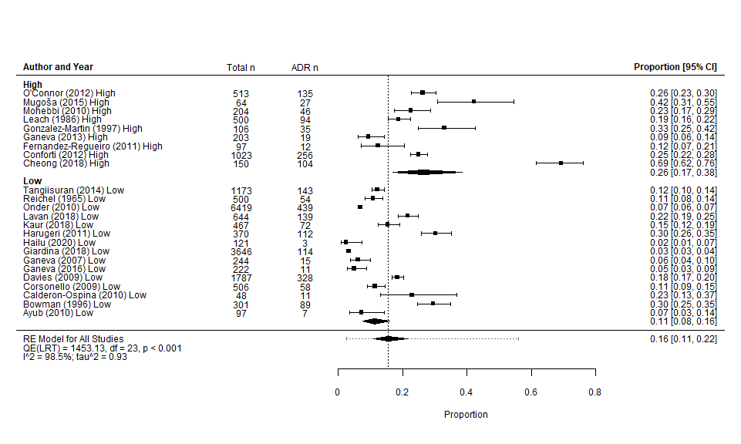
Low – low risk of bias/good quality. High – high risk of bias/poor quality

Appendix 6. Forrest plot showing proportion of patients aged 65 years or older experiencing an in-hospital ADR - including Liao et al.*³¹
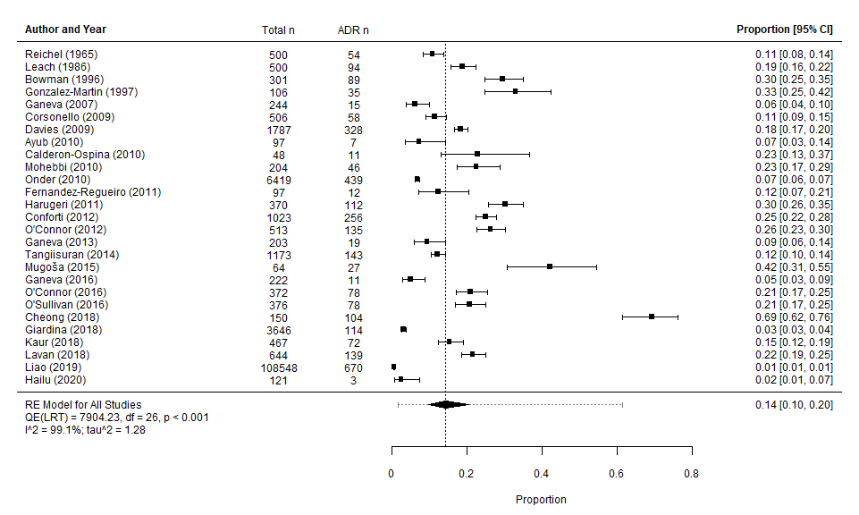
Pooled estimate by random effects (RE) model 0.1423 (0.0970-0.2039) I²=99.15% τ²=1.28
*Liao et al. was subsequently excluded from analyses based on concerns regarding potential reporting bias in the accuracy of the reported ADR rates in the database it was conducted from i.e. retrospective study retrospective based on all reported ADR cases over a 6 year period in a single medical centre. It is well established that ADRs are consistently underreported and potentially only 6% of true ADRs are recorded in reporting systems.³⁶

Appendix 7. Observational studies grouped according to NOS Domain S4 - demonstration that outcome of interest (ADR) was not present at start of study
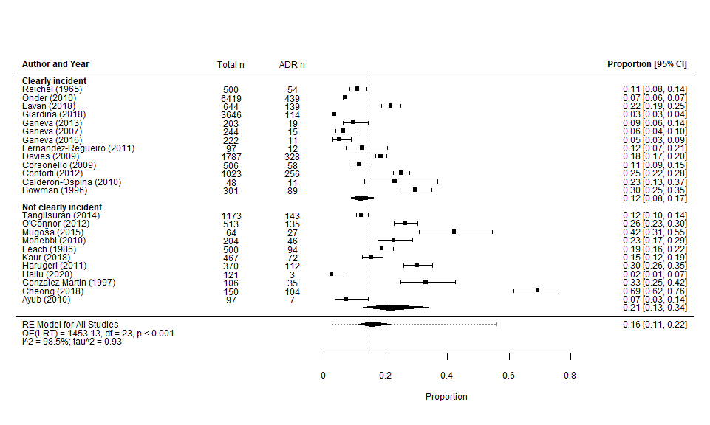
Clearly incident – study illustrated that ADRs were not present at admission/enrolment into study; Not clearly incident – study did not adequately describe if ADRs were present at admission/enrolment

Appendix 8. Funnel plots of included studies
Funnel plot excluding Liao et al.³¹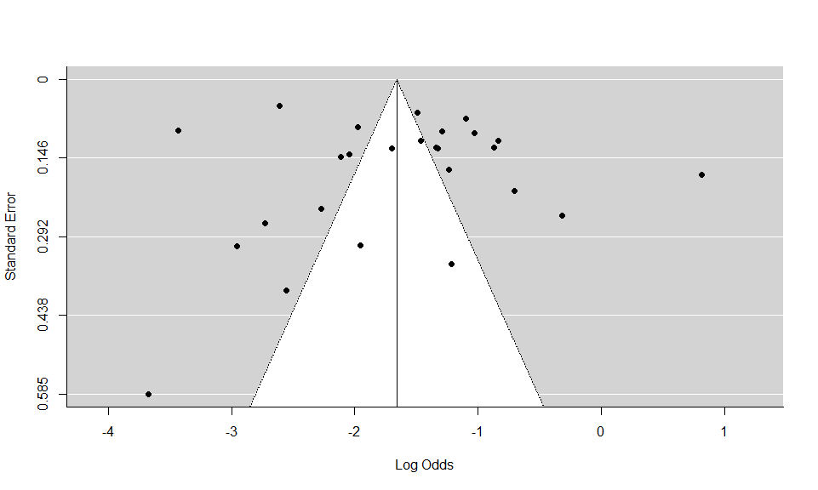

Funnel plot including Liao et al.³¹
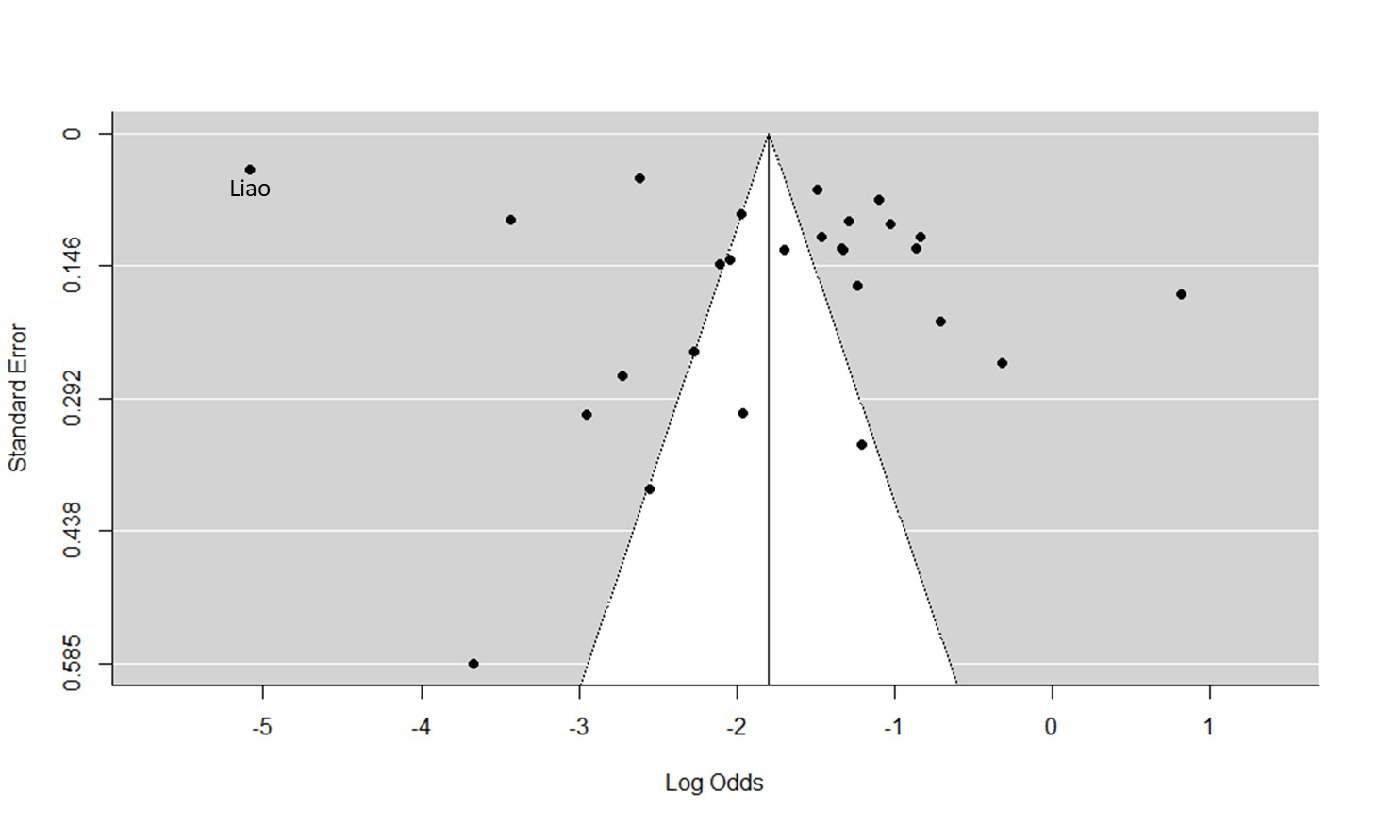

Appendix 9. Cochrane Risk of Bias (RoB) 2.0 Assessment of Randomised Control Trials (RCT).
Description | O'Connor ²³  2016 Judgement | Justification (O'Connor²³) | O'Sullivan²⁵  2016  Judgement | Justification (O'Sullivan²⁵)
Random sequence generation | Unclear risk of bias | Quote: Two lists of attending consultants were generated such that the combined rates of ADRs in these groups were known to be comparable from an ADR assessment study completed shortly before the initiation of the present clinical trial. Having finalized the composition of the lists, one list of specialist consultants was assigned as the intervention arm of the study and the other list of specialist consultants as the control arm. Comment: no evidence of random sequence generation | Unclear risk of bias | Quote: we generated two clusters of attending consultants… one group (cluster) of specialist consultants was allocated the intervention arm of the study while the other group (cluster) of specialist consultants was allocated the control arm. Comment: no evidence of random sequence generation
Allocation concealment | Low risk of bias | Quote: to avoid potentially biased selection of subjects into either arm of the study, we approached prospective trial participants in the order of their admission to the hospital Comment: | Low risk of bias | Quote: to avoid potentially biased selection of subjects into either arm of the study, the primary researcher approached prospective trial participants in the order of their admission to the hospital Comment:
Blinding of participants and personnel. Assessments should be made for each main outcome (or class of outcomes). | High risk of bias | Quote: cluster RCT design was chosen for two reasons, namely the intervention could not be double blinded (because of its nature) and the need to avoid possible "training effect". MNO'C recruited and conducted intervention and then screened for outcome. | High risk of bias | Primary researcher who recruited patients was the same researcher who carried out the intervention, so researcher was not blinded
Blinding of outcome assessment. Assessments should be made for each main outcome (or class of outcomes). | Low risk of bias | Quote: The primary researcher judged whether an ADR had occurred… and corroboration of the clinical event or observation by a second researcher who was blinded to the randomization group of the participant | Unclear risk of bias | Quote: the research pharmacist performed ADR ascertainment… a physician trained in geriatric pharmacology / therapeutics reviewed and verified all putative ADRs… subsequently two experienced pharmacists verified ADRs. Comment: unclear of blinding
Incomplete outcome data. Assessments should be made for each main outcome (or class of outcomes). | Low risk of bias | All patients included in reporting including those who died during their hospitalisation | Low risk of bias | All patients included in reporting including those who died during their hospitalisation
Selective reporting | Low risk of bias | Authors reported data on each outcome from the aims | Low risk of bias | Authors reported data on each outcome from the aims
Other sources of bias | N/A | - | N/A | -
Green – low risk of bias, yellow – unclear of risk of bias, red high risk of bias

Regression diagnostics
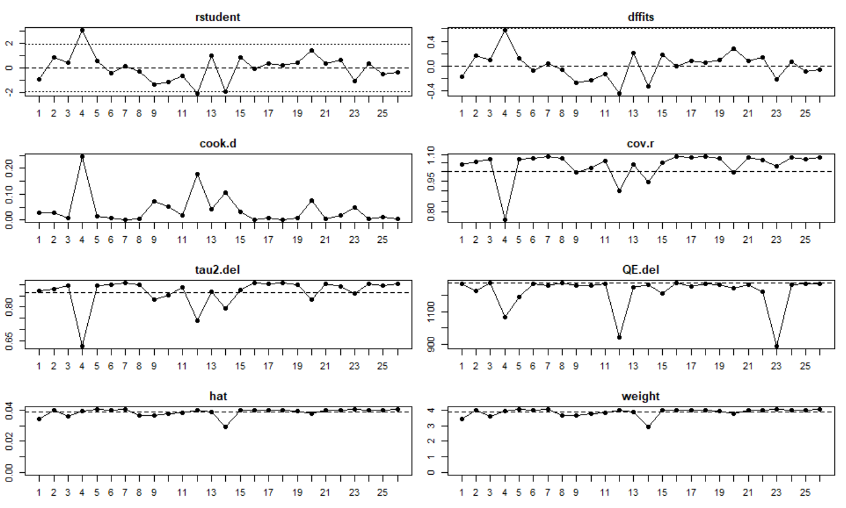
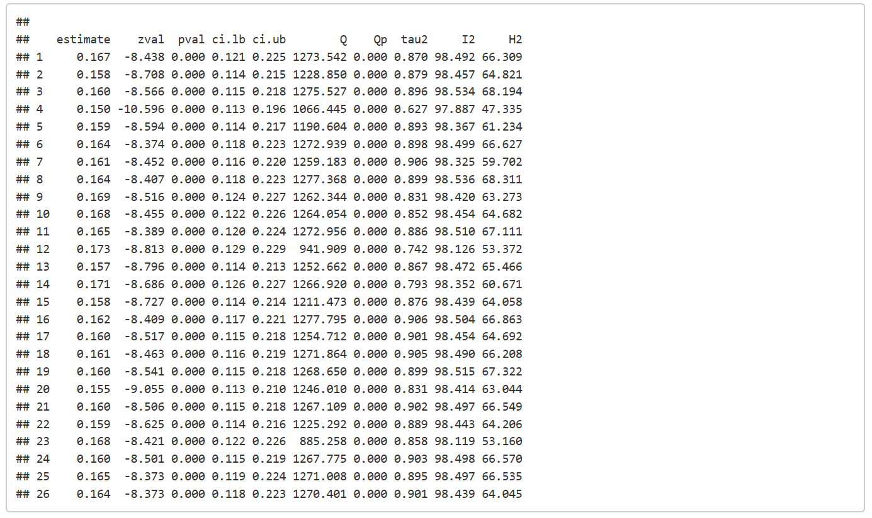
Regression diagnostics illustrating the pooled estimates when excluding one study at a time – these values do not change considerably therefore no one study is highly influential.
4 = Cheong (2018)^{10,11}, 12 = Giardina (2018)²⁸, 23 = Onder (2010)²⁴

Subgroup Analyses

Appendix 10. Reported ADR events and ADR proportions for all included papers/studies, grouped by specialist service setting (p=0.051)

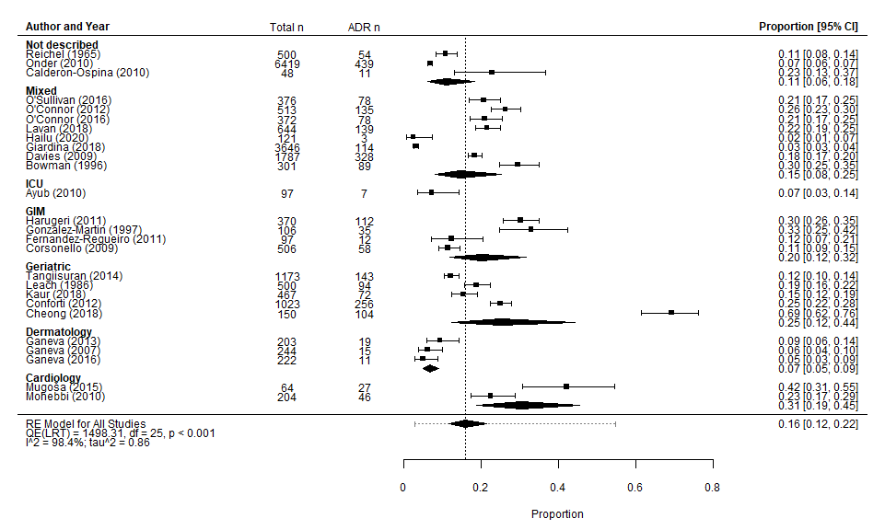

Description of ADR Identification and Assessment Methodologies Employed by all Included Papers/studies

Appendix 11. Description of ADR Identification and Assessment Methodologies Employed by all Included Papers/studies
Author | Year | ADR Definition | Identification Method | Causality | Severity | Classification | Preventability
Ayub⁷ | 2009 | WHO | Pharmacist, chart review at 3 TPs, adapted from National Health Surveillance Agency | Naranjo | Not documented | Rawlins & Thompson | Not documented
Bowman⁸ | 1996 | Local therapeutic committee | 2 x Pharmacist, chart review, ≥ 3 TPs, indicator flag list and spontaneous reporting | Naranjo | Venulet | Rawlins & Thompson | Not documented
Calderon-Ospina⁹ | 2010 | WHO | 2 x two internal physicians, daily assessment, patient questioning and panel adjudication | WHO-UMC | Author defined | DoTS | Schumock & Thornton
Cheong^{10,11} | 2018 | Not Documented | Retrospective chart review | Naranjo | Hartwig | Not documented | Not documented
Conforti¹² | 2012 | Edwards & Aronson | Nurse and Physician, "patients were monitored" | Not documented | WHO-ART | WHO-ART | Not documented
Corsonello¹³ | 2009 | WHO | Physician, daily review of chart, laboratory results, discussion with nurse and attending physician. | Not documented | Author defined | Not documented | Not documented
Davies¹⁴ | 2009 | Edwards & Aronson | Research pharmacist, daily review patients’ drug charts, medical and nursing notes. | Naranjo | Hartwig | Rawlins & Thompson | Hallas
Contd.  Author | Year | ADR Definition | Identification Method | Causality | Severity | Classification | Preventability
Fernandez-Regueiro²⁷ | 2011 | Bates reference | Not documented | Naranjo | Spanish system of pharmacovigilance | Not documented | Not documented
Ganeva¹⁵ | 2007 | WHO | 3 x Dermatologist and pharmacologist, Structured review past medical and drug history, laboratory tests, clinical description of adverse event and outcome. | Naranjo | Author defined | WHO-ART & Rawlins | Not documented
Ganeva¹⁷ | 2013 | WHO | Medical chart review | Naranjo | author defined – “clinical judgement" mild, moderate, severe" | WHO-ART | Not documented
Ganeva¹⁶ | 2016 | WHO | Screened during clinical rounds, analysis of laboratory data. | Naranjo | Hartwig | WHO-ART | Hallas
Giardina²⁸ | 2018 | Not documented | Medical records screened by pharmacist, then research team review | Naranjo | EMA | MedDRA-SOC® | Schumock & Thornton
Gonzalez-Martin¹⁸ | 1997 | Author defined - prior publication | The pharmacovigilance described by the Boston Collaborative Drug Surveillance Program | Naranjo | Author defined - lethal, severe, moderate | Not documented | Not documented
Hailu¹⁹ | 2020 | WHO | Four MSc clinical pharmacists identified and documented DRPs (patient questionnaire and chart review. | Naranjo | Hartwig | Rawlins & Thompson | Not documented
Harugeri²⁹ | 2011 | WHO | Pharmacist, daily review of chart, laboratory and nursing notes. | Naranjo | Hartwig | WHO-ART | Not documented
Contd.  Author | Year | ADR Definition | Identification Method | Causality | Severity | Classification | Preventability
Kaur²⁰ | 2018 | Edwards & Aronson’s | Spontaneous reporting, chart and laboratory results review then geriatrician physician and pharmacologist assessment | Naranjo | Hartwig | Rawlins & Thompson | Not documented
Lavan³⁰ | 2017 | WHO | Application of trigger list at recruitment and then retrospectively at D14/DC, all cases adjudicated | WHO-UMC | Hartwig | Not documented | Not documented
Leach²¹ | 1986 | WHO | Patient interview and notes review | Kramer | Hurwitz | Rawlins & Thompson | Not documented
Liao³¹ | 2019 | Edwards & Aronson’s | Interrogation of ADR reporting database (ADRs approved by senior pharmacist) | Naranjo | Not documented | Not documented | Not documented
Mohebbi³² | 2010 | WHO | Pharmacist; daily patient interview, chart and lab results review; confirmatory discussion with physicians | WHO-UMC | WHO-ART | Not documented | Not documented
Mugosa³³ | 2015 | WHO | SPC/ADR specific questionnaire and patient interview, discussion between interviewer and physician | Naranjo | WHO-ART | Meyboom, Rawlins and System organ | Not documented
O’Connor²² | 2012 | Not Documented | Physician; review of medications labs and notes at D5 & D10; patient and physician consultation | WHO-UMC | Author defined - severe, moderate, mild | Not documented | Not documented
Contd.  Author | Year | ADR Definition | Identification Method | Causality | Severity | Classification | Preventability
O’Connor²³ | 2016 | WHO | Not documented | WHO-UMC | Author defined | Not documented | Hallas
Onder²⁴ | 2010 | WHO | Physician; daily review of nursing and medical notes | Naranjo | Author defined | Not documented | Not documented
O’Sullivan²⁵ | 2016 | WHO | Pharmacist; D7-10/DC interview with patient or NOK; review of notes, labs, Kardex® and trigger list. ADRs adjudicated by geriatrician. | WHO-UMC | Hartwig | Not documented | Not documented
Reichel²⁶ | 1965 | Author defined - "new problem" | Physician; daily chart review - labs, medical and nursing notes, Kardex®, investigations, autopsy reports | Not documented | Not documented | Not documented | Not documented
Tangiisuran³⁴ | 2012 | Edwards & Aronson | 3 step process – identify, confirm and classify; daily review of labs, notes, prescriptions | Hallas | Morimoto | Rawlins & Thompson | Hallas
Tangiisuran³⁵ | 2014 | Edwards & Aronson ^{D}  Not documented ^{V} | Primary investigator trigger tool and review of medical and nursing notes, labs, drug charts and incident forms | Hallas ^{D}  Naranjo ^{V} | Not documented | Not documented | Not documented
WHO – World Health Organisation, TP – Time point WHO-UMC – World Health Organisation Uppsala Monitoring Centre, DoTs – Dose, time and susceptibility classification, WHO-ART – World Health Organisation Adverse Drug Reaction Terminology, EMA - European Medicines Agency, MedDRA-SOC® - Medical Dictionary for Regulatory Activities System Organ Classes, D – Day, DC – Discharge, SPC – Summaries of Product Characteristics, NOK – next of kin, ^{D} – development group, ^{V} – validation group, DoTs –.; DRPs – drug related problems.
Definitions
WHO³⁷ “a response to a drug which is noxious and unintended, and which occurs at doses normally used in man for the prophylaxis, diagnosis, or therapy of disease, or for the modification of physiological function.”
Edwards and Aronson³⁸ "an appreciably harmful or unpleasant reaction, resulting from an intervention related to the use of a medicinal product, which predicts hazard from future administration and warrants prevention or specific treatment, or alteration of the dosage regimen, or withdrawal of the product."
Bates³⁹ “Adverse drug event - An injury resulting from medical intervention related to a drug.”

Causality
Naranjo⁴⁰ definite, probable, possible, doubtful. Event scored across 10 questions (answers Yes, No, Don’t Know) Total scores range from -4 to +13; ≥9 indicates a definite adverse drug reaction (ADR); a score of 5 to 8 indicates a probable ADR; a score of 1 to 4 indicates a possible ADR; a score of ≤ 0 indicates that an ADR is doubtful. Q1 Are there previous conclusive reports on this reaction? (+1, 0, 0) Q2 Did the adverse event occur after the suspected drug was administered? (+2, -1, 0) Q3 Did the adverse reaction improve when the drug was discontinued or an antagonist was administered? (+1, 0, 0) Q4 Did the adverse reaction reappear when the drug was re-administered? (+2, -1, 0) Q5 Are there alternative causes (other than the drug) that could have on their own caused the reaction? (-1, +2, 0) Q6 Did the reaction reappear when a placebo was given? (-1, +1, 0) Q7 Was the drug detected in the blood (or other fluids) in concentrations known to be toxic? (+1, 0, 0) Q8 Was the reaction more severe when the drug was increased or less severe when the drug was decreased? (+1, 0, 0) Q9 Did the patient have a similar reaction to the same or similar drugs in any previous exposure? (+1, 0, 0) Q10 Was the adverse event confirmed by any objective evidence? (+1, 0, 0)
WHO-UMC⁴¹ Certain, probable, possible, unlikely, conditional/ unclassified, unassessable/ unclassifiable. Certain – event / laboratory test abnormality with plausible time relationship to intake of a drug, cannot be explained by disease or other drugs, response to withdrawal plausible, event definitive pharmacologically or phenomenologically, rechallenge satisfactory, if necessary. Probable – event or laboratory test abnormality, with reasonable time relationship to drug intake, unlikely to be attributed to disease or other drugs, response to withdrawal clinically reasonable, re-challenge not required. Possible – event or laboratory test abnormality, with reasonable time relationship to drug intake, could also be explained by disease or other drugs, information on drug withdrawal may be lacking or unclear. Unlikely – Event or laboratory test abnormality, with a time to drug intake that makes a relationship improbable Disease or other drugs provide plausible explanations. Conditional/ Unclassified – event or laboratory test abnormality, more data for proper assessment needed, or additional data under examination. Unassessable/ Unclassifiable – report suggesting an adverse reaction, cannot be judged because information is insufficient or contradictory, data cannot be supplemented or verified.
Hallas⁴² Definite (all five criteria were satisfied), probable (criteria (l), (2), (3) and (4) were satisfied), possible (criteria (1), (2) and (3) were satisfied) and unlikely/unevaluable (The relevant information required for evaluation could not be obtained, or the temporal sequence was atypical, or other conditions or dispositions were considered far more likely to have caused the symptoms); Criteria – (1) known ADR or toxic reaction: (2) a reasonable temporal relationship between commencement of drug therapy and onset of adverse reaction : (3) the adverse reaction disappeared upon dis- continuation or dose reduction: (4) the symptom or event could not be explained by any other known condition or predisposition of the patient: (5) the symptoms reappeared upon re-exposure, or laboratory tests showed toxic drug levels or drug-induced metabolic disturbances that explained the symptom.
Kramer⁴³ definite (score 6-7), probable (score 4-5), possible (0-3), unlikely (<0) based on a multi-axis algorithm, six axes are scored and the individual scores are added to get a total score, which corresponds to an overall probability that the clinical manifestation represents an ADR. The total score can range from -7 to +7.

Severity
Hartwig⁴⁴ seven level scale, mild (levels 1 & 2), moderate (levels 3 & 4) and severe (levels 5, 6 & 7); 1 An ADR occurred but no change in treatment with suspected drug 2 The ADR required that treatment with the suspected drug be held, discontinued or otherwise changes. No antidote or other treatment required. No increase in length of stay. 3 The ADR required that treatment with the suspected drug be held, discontinued or otherwise changed, or an antidote or other treatment. No increase in length of stay. 4 Any level 3 ADR which increases length of stay by at least one day or the ADR was the reason for admission. 5 Any level 4 ADR which required intensive medical care. 6 Any ADR causing permanent harm to the patient. 7a The ADR was indirectly linked to the death of the patient. 7b The ADR was directly linked to the death of the patients.
Hurwitz⁴⁵ Severe: fatal or life threatening, (2) moderate: required treatment, admission to hospital, or prolonged the stay in hospital by at least one day, (3) mild: incidental, required no treatment.
Morimoto⁴⁶ four discrete categories: (a) fatal, i.e. leading to death; (b) life threatening, i.e. prolonging hospitalization, leading to permanent defects or life-threatening complications; (c) serious, i.e. demanding a dosage reduction, therapy cessation etc.; or (d) significant, i.e. any ADR that does not meet the above criteria, not usually requiring a change in therapy.
Venulet⁴⁷ Severe: Fatal or life threatening, lowers the patient's life expectancy. A severe impairment of a vital organ-system, even if transient. Persisting for more than one month period. Moderate: Symptoms are marked but involvement of vital organ-systems is moderate. No loss of consciousness, no cardiovascular failure. Antidote drugs or hospizalization required or hospitalization prolonged by at least one day. Development of definite biochemical or structural changes could justify assigning to this category. Minor: Incidental, no antidote required, suspected drug mayor may not be stopped. Do not complicate significantly the primary disease.
WHO-ART⁴⁸ Non-serious or Serious: An adverse event or reaction that results in death; requires hospitalization or extension of hospital stay; results in persistent or significant disability or incapacity; is life-threatening.
European Medicines Agency⁴⁹ serious if fatal, life-threatening, required or prolonged hospitalization, caused serious or permanent disability, or congenital anomaly/birth defect.
Spanish system of pharmacovigilance⁵⁰ Mild (no additional measures required), moderate (motivates hospital admission), severe (threatens the patient's life) and deadly (contributes directly or indirectly to Patient's death).

Classification
DoTs⁹ three-dimensional classiﬁcation - Dose, timing and susceptibility classification; Dose – (1) supratherapeutic reactions (occurring at doses higher than are recommended), (2) collateral reactions (which usually occur at the recommended dose) or (3) hypersensitivity reactions (occurring at lower doses than are recommended); Timing - : (1) fast reactions (on administration of a drug, which is usually given intravenously), (2) the ﬁrst dose, (3) early, (4) intermediate, (5) late and (6) delayed; Susceptibility – factors of genetic susceptibility, age (paediatric and older population), gender and the presence of exogenous factors (e.g. drug interactions) or disease (e.g. hepatic or renal disease).
MedDRA-SOC®⁶ five level hierarchy from very specific (lowest level terms of which there are 70,000) to very general (system organ class).
Rawlins and Thompson⁵¹ divided into two categories: reactions that are common, predictable, and that may occur in any individual (type A); and reactions that are uncommon, not predictable, and that occur only in susceptible individuals (type B).
WHO-ART⁴⁸ four level hierarchy from general system organ classes (32), high level terms, preferred terms, and included terms (no longer actively maintained, last release WHO-UMC 2015, and superseded by MedDRA-SOC® in 2008).
Meyboom⁵² type A ("drug actions"), type B ("patients reactions") and type C ("statistical ").

Preventability
Hallas⁴² definitely avoidable, possibly avoidable, unavoidable and unclassifiable – ‘Definitely avoidable’. The drug event was due to a drug treatment procedure inconsistent with present- day knowledge of good medical practice or was clearly unrealistic, taking the known circumstances into account. ‘Possibly avoidable ’. The prescription was not erroneous, but the drug event could have been avoided by an effort exceeding the obligatory demands. ‘Not avoidable’. The drug event could not have been avoided by any reasonable means, or it was an unpredictable event in the course of a treatment fully in accordance with good medical practice. ‘Unevaluable’. The data for rating could not be obtained or the evidence was conflicting.
Schumock & Thornton⁵³ certainly preventable, probably preventable, unavoidable/not preventable; yes to any question in any category. Definitely preventable 1. Was there a history of allergy or previous reactions to the drug? 2. Was the drug involved inappropriate for the patient’s clinical condition? 3. Was the dose, route or frequency of administration inappropriate for the patient’s age, weight or disease state? 4. Was a toxic serum drug concentration (or laboratory monitoring test) documented? 5. Was there a known treatment for the Adverse Drug Reaction? Probably preventable 6. Was required Therapeutic drug monitoring or other necessary laboratory tests not performed? 7. Was a drug interaction involved in the ADR? 8. Was poor compliance involved in the ADR? 9. Were preventative measures not prescribed or administered to the patient? Unavoidable/Not preventable If all above criteria not fulfilled

Appendix 12. Meta-analysis of Studies Where all Participants Were ≥65 Years at Baseline (p=0.299)
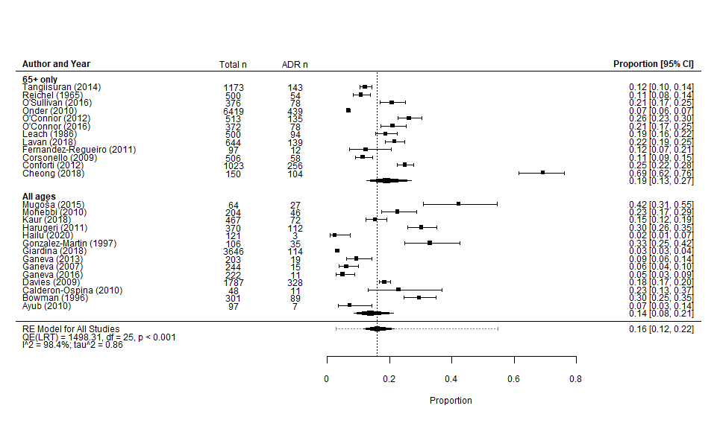
RE – Random effects model
eFigure 2: Subgroup analysis of patients experiencing at least one in-hospital ADR in studies recruiting all ages^{7-9,14-20,28,29,32,33} versus solely ≥65 years.^{10-13,21-27,30,35}
RE – Random effects model, n – number of patients aged ≥65 years, n ADR – number of patients ≥65 years experiencing at least 1 ADR during hospitalisatio

Appendix 13. Meta-analysis of studies grouped by ADR definition (p=0.806)
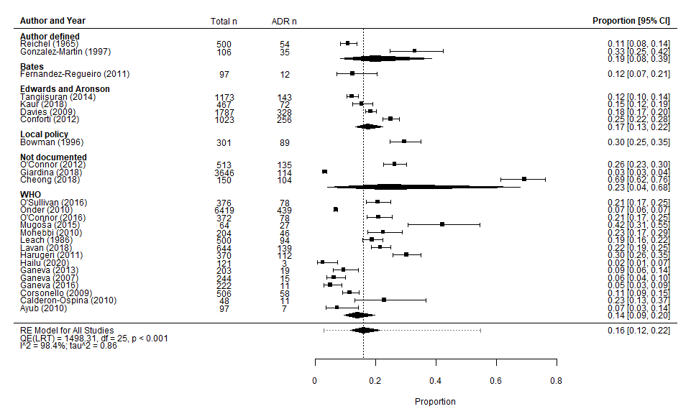

Appendix 14. Meta-analysis of studies grouped by ADR causality (p=0.78)
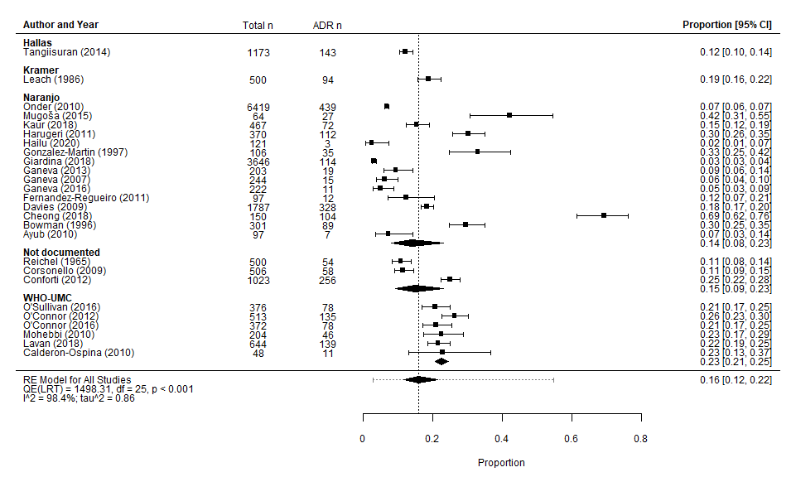

Appendix 15. Meta-analysis of studies grouped by comparable overlapping ADR methodologies (p=0.383)

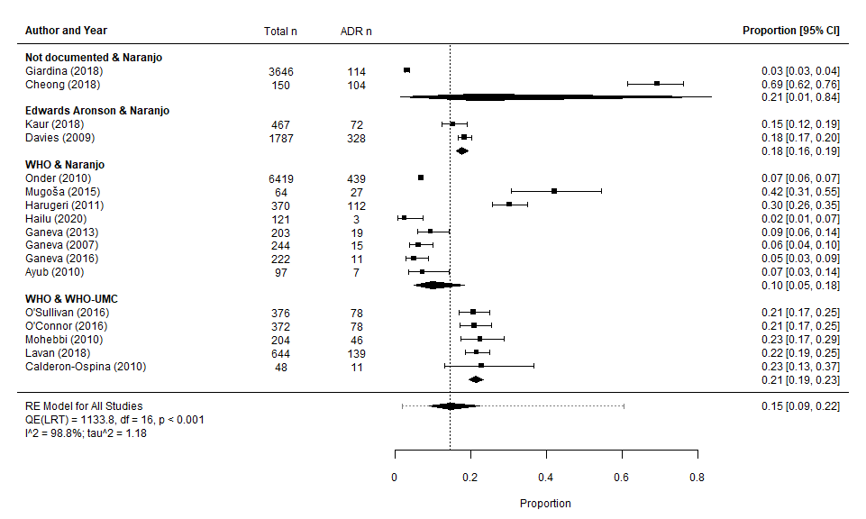
eFigure: Forest plot showing subgroup analysis of prevalence of in hospital ADRs reported by studies grouped by matching assessment methods

Appendix 16. Pooled estimates of ADR proportions grouped by ADR identification methods (p =0.31)
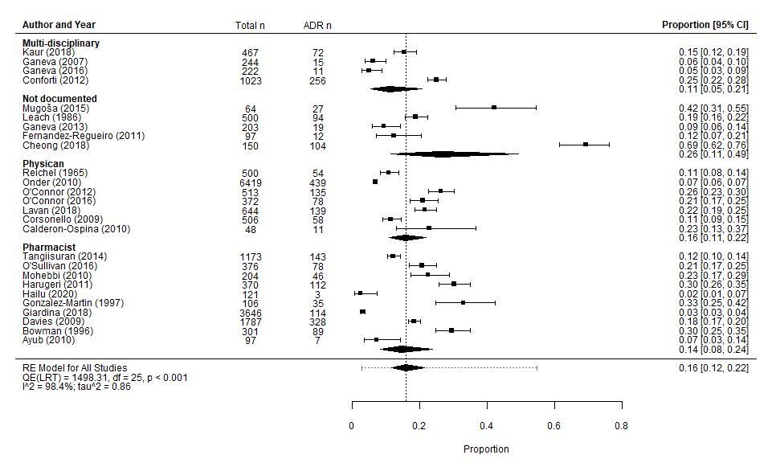

ADR Presentations

Appendix 17. Ranking of ADR Presentations by MedDRA-SOC® Classification
Rank | MedDRA® SOC Classification | n | % of 2728 | cumulative
1 | Gastrointestinal Disorders | 629 | 23.05% | 23.06%
2 | Metabolism and Nutrition Disorders | 565 | 20.73% | 43.77%
3 | Unclassifiable - Unclassifiable (Grouped Presentations / "Other") | 397 | 14.57% | 58.32%
4 | Vascular Disorders | 216 | 7.93% | 66.24%
5 | Cardiac Disorders | 187 | 6.86% | 73.09%
6 | Renal and Urinary Disorders | 175 | 6.42% | 79.51%
7 | Investigations | 116 | 4.26% | 83.76%
8 | Infections and Infestations | 87 | 3.19% | 86.95%
9 | Skin and Subcutaneous Tissue Disorders | 72 | 2.64% | 89.59%
10 | Blood and Lymphatic System Disorders | 61 | 2.24% | 91.83%
11 | Psychiatric Disorders | 58 | 2.13% | 93.95%
12 | Nervous System Disorders | 56 | 2.02% | 96.00%
13 | Injury, Poisoning and Procedural Complications | 48 | 1.72% | 97.76%
14 | Respiratory, Thoracic and Mediastinal Disorders | 23 | 0.84% | 98.61%
15 | Musculoskeletal and Connective Tissue Disorders | 12 | 0.44% | 99.05%
16 | General Disorders and Administration Site Conditions | 9 | 0.33% | 99.38%
17 | Immune System Disorders | 8 | 0.29% | 99.67%
18 | Hepatobiliary Disorders | 5 | 0.18% | 99.85%
19 | Eye Disorders | 4 | 0.15% | 100.00%
 |  | 2728 | 100.00%

Appendix 18. Breakdown of ADR Presentations by ADR Detail (In Descending Frequency).
MedDRA® SOC Classification | % (2728) | n | Description (High-Level Group Term) | n | Further ADR Description | n | Lowest Level ADR Detail (when available) | n
Gastrointestinal disorders | 23.06% | 629 | Gastrointestinal motility and defaecation conditions | 392 | Constipation | 254 | - | -
 |  |  |  |  | Diarrhoea | 138 | - | -
Gastrointestinal disorders | 23.06% | 629 | Unspecified / unclassifiable Gastrointestinal disorders | 90 | Gastrointestinal | 88 | - | -
 |  |  |  |  | Vomiting and diarrhoea | 2 | - | -
Gastrointestinal disorders | 23.06% | 629 | Gastrointestinal haemorrhages NEC | 67 | GI Bleed | 60 | - | -
 |  |  |  |  | Gastrointestinal bleeding | 7 | - | -
Gastrointestinal disorders | 23.06% | 629 | Gastrointestinal signs and symptoms | 61 | Nausea / vomiting | 59 | - | -
 |  |  |  |  | Dyspepsia | 2 | - | -
Gastrointestinal disorders | 23.06% | 629 | Gastrointestinal stenosis and obstruction | 10 | Ileus | 10 | - | -
Gastrointestinal disorders | 23.06% | 629 | Gastrointestinal inflammatory conditions | 7 | Haemorrhage / gastritis | 6 | - | -
 |  |  |  |  | Gastritis | 1 | - | -
Gastrointestinal disorders | 23.06% | 629 | Oral soft tissue conditions | 2 | Oral ulcers | 2 | - | -
Metabolism and nutrition disorders | 20.71% | 565 | Electrolyte and fluid balance conditions | 461 | Potassium imbalance | 299 | Hypokalaemia | 275
 |  |  |  |  |  |  | Hyperkalaemia | 24
 |  |  |  |  | Sodium imbalance | 29 | Hyponatraemia | 27
 |  |  |  |  |  |  | Hypernatraemia | 2
 |  |  |  |  | Total fluid volume decreased | 2 | Dehydration | 2
 |  |  |  |  | Total fluid volume increased | 3 | Oedema | 3
 |  |  |  |  | Unspecified / unclassifiable - Electrolyte and fluid balance conditions | 128 | Electrolyte disturbance | 78
 |  |  |  |  |  |  | Electrolytic | 50
Contd. MedDRA® SOC Classification | % (2728) | n | Description (High-Level Group Term) | n | Further ADR Description | n | Lowest Level ADR Detail (when available) | n
Metabolism and nutrition disorders contd. |  |  | Bone, calcium, magnesium and phosphorus metabolism disorders | 3 | Hypercalcaemia | 2 | - | -
Metabolism and nutrition disorders contd. |  |  | Bone, calcium, magnesium and phosphorus metabolism disorders | 3 | Unspecified / unclassifiable - Bone, calcium, magnesium and phosphorus metabolism disorders | 1 | Hypokalaemia / Hypocalcaemia | 1
Metabolism and nutrition disorders contd. |  |  | Unspecified / unclassifiable - Metabolism and nutrition disorders | 26 | Electrolyte / metabolic abnormality | 26 | - | -
Metabolism and nutrition disorders contd. |  |  | Glucose metabolism disorders (incl. diabetes mellitus) | 74 | Hyperglycaemic conditions NEC | 23 | Hyperglycaemia | 21
Metabolism and nutrition disorders contd. |  |  |  |  |  |  | Steroid diabetes | 2
 |  |  |  |  | Hypoglycaemic conditions NEC | 51 | Hypoglycaemia | 51
Metabolism and nutrition disorders contd. |  |  | Purine and pyrimidine metabolism disorders | 1 | Disorders of purine metabolism | 1 | Hyperuricemia | 1
Unclassifiable | 14.55% | 397 | Unclassifiable into MedDRA® SOC grouping from extractable ADR data | 397 | Multiple presentations grouped | 370 | - | -
 |  |  |  |  | Reported as "other" or "missing" | 27 | - | -
Vascular disorders | 7.92% | 216 | Decreased and nonspecific blood pressure disorders and shock | 126 | Vascular hypotensive disorders | 126 | Hypotension | 81
 |  |  |  |  |  |  | Postural hypotension | 45
Vascular disorders | 7.92% | 216 | Vascular haemorrhagic disorders | 89 | Haemorrhages NEC | 89 | Haematoma | 20
 |  |  |  |  |  |  | Bleeding | 58
 |  |  |  |  |  |  | Bleeding requiring transfusion with or without hemostasis intervention | 11
Vascular disorders | 7.92% | 216 | Vascular hypertensive disorders | 1 | Hypertension | 1 | - | -
Contd. MedDRA® SOC Classification | % (2728) | n | Description (High-Level Group Term) | n | Further ADR Description | n | Lowest Level ADR Detail (when available) | n
Cardiac disorders | 6.85% | 187 | Rate and rhythm disorders | 74 | Bradycardia | 55 | - | -
 |  |  |  |  | Tachycardia | 7 | - | -
 |  |  |  |  | AV Block | 12 | - | -
Cardiac disorders | 6.85% | 187 | Unspecified / Unclassifiable Cardiovascular | 110 | Cardiovascular and arrhythmic complications | 97 | - | -
 |  |  |  |  | Cardiovascular system | 13 | - | -
Cardiac disorders | 6.85% | 187 | Cardiac failure | 2 | Left ventricular failure / overload | 2 | - | -
Cardiac disorders | 6.85% | 187 | Chest pain | 1 | Chest pain | 1 | - | -
Renal and urinary disorders | 6.41% | 175 | Renal disorders (excl. nephropathies) | 150 | AKI | 148 | AKI | 148
 |  |  |  |  | Renal failure complications | 2 | Hyperazotaemia | 2
Renal and urinary disorders | 6.41% | 175 | Urinary tract signs and symptoms | 22 | Bladder and urethral symptoms | 22 | Haematuria | 18
 |  |  |  |  |  |  | Urine retention | 4
Renal and urinary disorders | 6.41% | 175 | Nephropathies | 3 | Nephritis | 3 | - | -
Investigations | 4.25% | 116 | Haematology investigations - Coagulation and bleeding analyses | 98 | INR increase | 97 | - | -
 |  |  |  |  | Low prothrombin time | 1 | - | -
Investigations | 4.25% | 116 | Toxicology and therapeutic drug monitoring - antibiotic level | 2 | Elevated vancomycin level | 2 | - | -
Investigations | 4.25% | 116 | Hepatobiliary investigations - liver function analyses | 16 | Elevated liver enzymes | 16 | - | -
Infections and infestations | 3.19% | 87 | Fungal infectious disorders - Candida infections | 67 | Thrush | 67 | - | -
Contd. MedDRA® SOC Classification | % (2728) | n | Description (High-Level Group Term) | n | Further ADR Description | n | Lowest Level ADR Detail (when available) | n
Infections and infestations contd. |  |  | Bacterial infectious disorders - Clostridia infections | 19 | Clostridium difficile +ve w/o diarrhoea | 7 | - | -
 |  |  |  |  | Clostridium difﬁcile diarrhoea | 5 | - | -
 |  |  |  |  | Clostridium difficile diarrhoea, vancomycin-resistant enterococci, gentamicin-induced acute kidney injury | 4 | - | -
 |  |  |  |  | C. Diff Colitis | 3 | - | -
Infections and infestations contd. |  |  | Viral infectious disorders - herpes viral infections | 1 | Herpes zoster | 1 | - | -
Skin and subcutaneous tissue disorders | 2.64% | 72 | Epidermal and dermal conditions | 72 | Rashes, eruptions and exanthems NEC | 72 | Cutaneous Rash | 60
 |  |  |  |  |  |  | Prurigo | 2
 |  |  |  |  |  |  | Urticaria | 10
Blood and lymphatic system disorders | 2.24% | 61 | Anaemias nonhaemolytic and marrow depression | 27 | Anaemia | 26 | - | -
 |  |  |  |  | Pancytopaenia | 1 | - | -
Blood and lymphatic system disorders | 2.24% | 61 | Platelet disorders | 16 | Thrombocytopaenia | 16 | - | -
Blood and lymphatic system disorders | 2.24% | 61 | Unspecified / Unclassifiable Blood and lymphatic system disorders | 15 | Haematological disturbance | 14 | - | -
 |  |  |  |  | Coagulation | 1 | - | -
Blood and lymphatic system disorders | 2.24% | 61 | White blood cell disorders | 3 | Neutropenia | 2 | - | -
 |  |  |  |  | Leukopaenia | 1 | - | -
Psychiatric disorders | 2.13% | 58 | Deliria (incl. confusion) | 52 | Confusion | 52 | - | -
Psychiatric disorders | 2.13% | 58 | Disturbances in thinking and perception | 6 | Hallucination | 6 | - | -
Contd. MedDRA® SOC Classification | % (2728) | n | Description (High-Level Group Term) | n | Further ADR Description | n | Lowest Level ADR Detail (when available) | n
Nervous system disorders | 2.05% | 56 | Neurological disorders NEC | 25 | Disturbances in consciousness NEC | 25 | Unconscious | 1
 |  |  |  |  |  |  | Drowsiness / Somnolence / sleepiness | 24
Nervous system disorders | 2.05% | 56 | Headaches | 9 | - | - | - | -
Nervous system disorders | 2.05% | 56 | Unspecified / unclassifiable nervous system disorders | 11 | Central nervous system | 11 | - | -
Nervous system disorders | 2.05% | 56 | Neurological signs and symptoms NEC | 5 | Dizziness | 5 | - | -
Nervous system disorders | 2.05% | 56 | Movement disorders (incl. parkinsonism) | 3 | Tremor | 2 | - | -
 |  |  |  |  | Extra-pyramidal SEs | 1 | - | -
Nervous system disorders | 2.05% | 56 | Seizures (incl. subtypes) | 2 | Non-convulsive epileptic crisis | 1 | - | -
 |  |  |  |  | Seizure | 1 | - | -
Nervous system disorders | 2.05% | 56 | CNS Vascular disorder | 1 | CNS Haemorrhage & cerebrovascular accident | 1 | Haemorrhagic transformation stroke | 1
Injury, poisoning and procedural complications | 1.76% | 48 | Injuries NEC | 34 | Fall | 34 | - | -
Injury, poisoning and procedural complications | 1.76% | 48 | Bone and joint injuries | 2 | Fracture | 2 | - | -
Injury, poisoning and procedural complications | 1.76% | 48 | Toxicity to various agents | 8 | Digitalis intoxication | 6 | - | -
 |  |  |  |  | Lithium toxicity | 1 | - | -
 |  |  |  |  | Opioid toxicity | 1 | - | -
Injury, poisoning and procedural complications | 1.76% | 48 | Procedural related injuries and complications NEC - Cardiac and vascular procedural complications | 3 | Phlebitis | 3 | - | -
Injury, poisoning and procedural complications | 1.76% | 48 | Exposures, chemical injuries and poisoning | 1 | Poisoning and toxicity | 1 | Toxic epidermal necrolysis | 1
Respiratory, thoracic and mediastinal disorders | 0.84% | 23 | Respiratory disorders NEC | 20 | Respiratory failures (excl. neonatal) | 16 | - | -
 |  |  |  |  | Cough | 4 | - | -
Respiratory, thoracic and mediastinal disorders | 0.84% | 23 | Unspecified / unclassifiable respiratory system | 3 | Respiratory system | 3 | - | -
Contd. MedDRA® SOC Classification | % (2728) | n | Description (High-Level Group Term) | n | Further ADR Description | n | Lowest Level ADR Detail (when available) | n
Musculoskeletal and connective tissue disorders | 0.44% | 12 | Joint disorders - Crystal arthropathic disorders | 8 | Gout | 8 | - | -
Musculoskeletal and connective tissue disorders | 0.44% | 12 | Bone disorders (excl. congenital and fractures) - metabolic bone disorders | 3 | Osteoporosis | 3 | - | -
Musculoskeletal and connective tissue disorders | 0.44% | 12 | Muscle disorders | 1 | Muscular necrosis | 1 | - | -
General disorders and administration site conditions | 0.33% | 9 | Body temperature conditions | 3 | Hyperthermia | 3 | - | -
General disorders and administration site conditions | 0.33% | 9 | General system disorders NEC | 2 | Hyperhidrosis | 2 | - | -
General disorders and administration site conditions | 0.33% | 9 | Asthenic conditions | 1 | Asthenia | 1 | - | -
General disorders and administration site conditions | 0.33% | 9 | Gait disturbances | 1 | Ataxia | 1 | - | -
General disorders and administration site conditions | 0.33% | 9 | Inflammations | 1 | Local inflammation | 1 | - | -
General disorders and administration site conditions | 0.33% | 9 | Therapeutic and nontherapeutic effects (excl. toxicity) | 1 | Signs of withdrawal | 1 | - | -
Immune system disorders | 0.29% | 8 | Allergic conditions | 8 | Allergy or drug sensitivity | 7 | - | -
 |  |  |  |  | Bronchospasm | 1 | - | -
Hepatobiliary disorders | 0.18% | 5 | Unspecified / unclassifiable Hepatobiliary disorders | 5 | Jaundice | 1 | - | -
 |  |  |  |  | Hepatic | 4 | - | -
Eye disorders | 0.15% | 4 | Glaucoma and ocular hypertension | 2 | Glaucoma | 2 | - | -
Eye disorders | 0.15% | 4 | Anterior eye structural change, deposit and degeneration | 2 | Cataract | 1 | - | -
 |  |  |  |  | Corneal deposits | 1 | - | -
NEC – Not elsewhere classified, AV – atrioventricular, AKI – Acute Kidney Injury, INR – International Normalised Ratio, +ve – positive, w/o – without, C. Diff – Clostridium Difficile, Incl. – including, SEs – Side effects, excl. – excluding

ADR Drugs

Appendix 19. Causative Drug Agents Ranked by Descending Frequency as per Therapeutic Subgroup (ATC 2nd Level).
Rank | ATC 2nd | Therapeutic subgroup | n | % of 2385
1 | C03 | Diuretics | 473 | 19.83%
2 | J01 | Antibacterials for systemic use | 354 | 14.84%
3 | B01 | Anti-thrombotic agents | 292 | 12.24%
4 | N02 | Analgesics | 260 | 10.90%
5 | R03 | Drugs for obstructive airway diseases | 113 | 4.74%
6 | C09 | Agents acting on the renin-angiotensin system | 98 | 4.11%
7 | N05 | Psycholeptics | 92 | 3.86%
8 | H02 | Corticosteroids for systemic use | 77 | 3.23%
9 | C01 | Cardiac therapy | 71 | 2.98%
10 | A10 | Drugs used in diabetes | 61 | 2.56%
11 | J04 | Anti-mycobacterials | 54 | 2.26%
12 | C02 | Anti-hypertensives | 52 | 2.18%
13 | A12 | Mineral supplements | 50 | 2.10%
14 | C08 | Calcium channel blockers | 41 | 1.72%
15 | M01 | Anti-inflammatory and anti-rheumatic products | 40 | 1.68%
16 | N03 | Antiepileptics | 30 | 1.26%
17 | A02 | Drugs for acid related disorders | 26 | 1.09%
18 | A06 | Drugs for constipation | 24 | 1.01%
19 | B03 | Antianemic preparations | 22 | 0.92%
20 | N06 | Psychoanaleptics | 20 | 0.84%
21 | C07 | Beta blocking agents | 19 | 0.80%
22 | B05 | Blood substitutes and perfusion solutions | 15 | 0.63%
23 | R01 | Nasal preparations | 15 | 0.63%
24 | S02 | Otologicals | 11 | 0.46%
25 | M04 | Antigout preparations | 10 | 0.42%
26 | C**** | Not specified by paper | 8 | 0.34%
27 | C10 | Lipid modifying agents | 7 | 0.29%
28 | M05 | Drugs for treatment of bone diseases | 6 | 0.25%
29 | N07 | Other nervous system drugs | 6 | 0.25%
30 | L01 | Antineoplastic agents | 5 | 0.21%
31 | A03 | Drugs for functional gastrointestinal disorders | 4 | 0.17%
32 | G04 | Urologicals | 3 | 0.13%
33 | N04 | Anti-parkinson drugs | 3 | 0.13%
34 | A07 | Antidiarrheals, intestinal antiinflammatory/antiinfective agents | 2 | 0.08%
35 | J02 | Antimycotics for systemic use | 2 | 0.08%
36 | M03 | Muscle relaxants | 2 | 0.08%
37 | N**** | "Psychotropics" unspecified | 2 | 0.08%
38 | N01 | Anaesthetics | 2 | 0.08%
39 | R05 | Cough and cold preparations | 2 | 0.08%
Contd. Rank | ATC 2nd | Therapeutic subgroup | n | % of 2385
40 | R06 | Antihistamines for systemic use | 2 | 0.08%
41 | A04 | Antiemetics and antinauseants | 1 | 0.04%
42 | A11 | Vitamins | 1 | 0.04%
43 | D01 | Antifungals for dermatological use | 1 | 0.04%
44 | D06 | Antibiotics and chemotherapeutics for dermatological use | 1 | 0.04%
45 | H01 | Pituitary and hypothalamic hormones and analogues | 1 | 0.04%
46 | L04 | Immunosuppressants | 1 | 0.04%
47 | P01 | Antiprotozoals | 1 | 0.04%
48 | P02 | Anthelmintics | 1 | 0.04%
49 | V04 | Diagnostic agents | 1 | 0.04%

Appendix 20. Reported Causative Drugs Grouped by Anatomical Group (ATC 1st Level) in Descending Order.
Overarching ATC Anatomical System (1st level, anatomical main group) | overall n (organ) | overall % (2385)
C – Cardiovascular System | 769 | 32.24%
N – Central nervous system | 415 | 17.40%
J – General anti-infectives, systemic | 410 | 17.19%
B – Blood and blood forming organs | 329 | 13.79%
A - Alimentary tract and metabolism | 169 | 7.09%
R – Respiratory system | 132 | 5.54%
H – Systemic hormonal preparations, excl. sex hormones | 78 | 3.27%
M – Musculo-skeletal system | 58 | 2.43%
S - Sensory organs | 11 | 0.46%
L - Antineoplastic and immunomodulating agents | 6 | 0.25%
G – Gentino-urinary system and sex hormones | 3 | 0.13%
D – Dermatologics | 2 | 0.08%
P - Antiparasitic products, insecticides and repellents | 2 | 0.08%
V – Various | 1 | 0.04%
 | 2385 | 100.00%
Excl. - excluding

Appendix 21. Breakdown of Causative Drugs by ATC Classification in Descending Frequency – Grouped by Anatomical (ATC 1st) Level to Chemical Substance/Drug (ATC 5th); n = 2385.

Cardiovascular system
Cardiovascular 769 (32.24%)
ATC 2nd | Therapeutic Subgroup | n | ATC 3rd | Pharmacological Subgroup | n | ATC 4th | Chemical Subgroup | n | ATC 5th / drug (when n ≥ 10) | n
C03 | Diuretics | 473 | C03C | High-ceiling diuretics | 234 | C03CA | Sulfonamides, plain | 232 | Furosemide | 194
 |  |  |  |  |  |  |  |  | Bumetanide | 32
C03 | Diuretics | 473 | C03D | Potassium-sparing agents | 47 | - | - | - | - | -
C03 | Diuretics | 473 | C03A | Low-ceiling diuretics, thiazides | 24 | - | - | - | - | -
C03 | Diuretics | 473 | C03B | Low-ceiling diuretics, excl. Thiazides | 13 | - | - | - | - | -
C03 | Diuretics | 473 | C03E | Diuretics and potassium-sparing agents in combination | 5 | - | - | - | - | -
C03 | Diuretics | 473 | C03* | Not specified by paper | 39 | - | - | - | - | -
C09 | Agents Acting On The Renin-Angiotensin System | 98 | C09A | ACE inhibitors, plain | 39 | C09AA | ACE inhibitors, plain (ramipril ) | 14 | Ramipril | 14
C09 | Agents Acting On The Renin-Angiotensin System | 98 | C09* | Not specified by paper | 34 | - | - | - | - | -
C09 | Agents Acting On The Renin-Angiotensin System | 98 | C09C | Angiotensin II receptor blockers (ARBs), plain | 12 | - | - | - | - | -
C09 | Agents Acting On The Renin-Angiotensin System | 98 | C09D | ARB II, combinations | 1 | - | - | - | - | -
Contd. ATC 2nd | Therapeutic Subgroup | n | ATC 3rd | Pharmacological Subgroup | n | ATC 4th | Chemical Subgroup | n | ATC 5th / drug (when n ≥ 10) | n
C01 | Cardiac Therapy | 71 | C01A | Cardiac glycosides | 44 | C01AA | Digitalis glycosides | 39 | Digoxin | 39
C01 | Cardiac Therapy | 71 | C01D | Vasodilators used in cardiac diseases | 12 | - | - | - | - | -
C01 | Cardiac Therapy | 71 | C01B | Antiarrhythmics, class I and III | 10 | C01BD | Antiarrhythmics, class III | 10 | Amiodarone | 10
C01 | Cardiac Therapy | 71 | C01* | Not specified by paper | 3 | - | - | - | - | -
C01 | Cardiac Therapy | 71 | C01E | Other cardiac preparations | 2 | C01EB | Other cardiac preparations | 2 | - | -
C02 | Antihypertensives | 52 | C02* | Not specified by paper | 52 | - | - | - | - | -
C08 | Calcium Channel Blockers | 41 | C08* | Not specified by paper | 30 | - | - | - | - | -
C08 | Calcium Channel Blockers | 41 | C08D | Selective calcium channel blockers with direct cardiac effects | 7 | - | - | - | - | -
C08 | Calcium Channel Blockers | 41 | C08C | Selective calcium channel blockers with mainly vascular effects | 4 | - | - | - | - | -
C07 | Beta Blocking Agents | 19 | C07A | Beta blocking agents | 18 | C07AB | Beta blocking agents, selective | 15 | - | -
 |  |  |  |  |  | C07AA | Beta blocking agents, non-selective | 2 | - | -
 |  |  |  |  |  | C07AG | Alpha and beta blocking agents | 1 | - | -
C07 | Beta Blocking Agents | 19 | C07C | Beta blocking agents and other diuretics | 1 | - | - | - | - | -
Contd. ATC 2nd | Therapeutic Subgroup | n | ATC 3rd | Pharmacological Subgroup | n | ATC 4th | Chemical Subgroup | n | ATC 5th / drug (when n ≥ 10) | n
C**** | Not specified by paper | 8 | - | - | - | - | - | - | - | -
C10 | Lipid Modifying Agents | 7 | C10* | Not specified by paper | 7 | - | - | - | - | -

Central nervous system
Central Nervous System 415 (17.40%)
ATC 2nd | Therapeutic subgroup | n | ATC 3rd | Pharmacological Subgroup | n | ATC 4th | Chemical Subgroup | n | ATC 5th/ drug (when n ≥ 10) | n
N02 | Analgesics | 260 | N02A | Opioids | 205 | N02A* | Unspecified "Opioids" | 123 | - | -
 |  |  |  |  |  | N02AA | Natural opium alkaloids | 44 | Morphine | 40
 |  |  |  |  |  | N02AX | Other opioids | 28 | Tramadol | 28
 |  |  |  |  |  | N02AB | Phenylpiperidine derivatives | 6 | - | -
 |  |  |  |  |  | N02AJ | Opioids in combination with non-opioid analgesics | 4 | - | -
N02 | Analgesics | 260 | N02B | Other analgesics and antipyretics | 55 | N02BE | Anilides | 34 | Co-codamol | 31
 |  |  |  |  |  | N02B* | Not specifed by the paper | 18 | - | -
N05 | Psycholeptics | 92 | N05B | Anxiolytics | 61 | N05BA | Benzodiazepine derivatives | 60 | Unspecified "benzodiazepines" | 54
 |  |  |  |  |  | N05BB | Diphenylmethane derivatives | 1 | - | -
N05 | Psycholeptics | 92 | N05A | Antipsychotics | 18 | N05A* | Unspecified "Antipsychotics" | 7 | - | -
Contd. ATC 2nd | Therapeutic subgroup | n | ATC 3rd | Pharmacological Subgroup | n | ATC 4th | Chemical Subgroup | n | ATC 5th/ drug (when n ≥ 10) | n
Contd.  N05 | Contd.  Psycholeptics |  | Contd. N05A | Contd. Antipsychotics |  | N05AD | Butyrophenone derivatives | 2 | - | -
 |  |  |  |  |  | N05AF | Thioxanthene derivatives | 2 | - | -
 |  |  |  |  |  | N05AH | Diazepines, oxazepines, thiazepines and oxepines | 2 | - | -
 |  |  |  |  |  | N05AA | Phenothiazines with aliphatic side-chain | 1 | - | -
 |  |  |  |  |  | N05AB | Phenothiazines with piperazine structure | 1 | - | -
 |  |  |  |  |  | N05AC | Phenothiazines with piperidine structure | 1 | - | -
 |  |  |  |  |  | N05AN | Lithium | 1 | - | -
 |  |  |  |  |  | N05AX | Other antipsychotics | 1 | - | -
Contd.  N05 | Contd.  Psycholeptics |  | N05C | Hypnotics and sedatives | 13 | N05C* | Unspecified "benzodiazepines" | 10 | - | -
 |  |  |  |  |  | N05CD | Benzodiazepine derivatives | 2 | - | -
 |  |  |  |  |  | N05CA | Barbiturates, plain | 1 | - | -
N03 | Antiepileptics | 30 | N03A | Antiepileptics | 30 | N03AA | Barbiturates and derivatives | 18 | phenobarbital | 18
 |  |  |  |  |  | N03AF | Carboxamide derivatives | 9 | - | -
 |  |  |  |  |  | N03AX | Other antiepileptics | 3 | - | -
Contd. ATC 2nd | Therapeutic subgroup | n | ATC 3rd | Pharmacological Subgroup | n | ATC 4th | Chemical Subgroup | n | ATC 5th/ drug (when n ≥ 10) | N
N06 | Psychoanaleptics | 20 | N06A | Antidepressants | 19 | N06AB | Selective serotonin reuptake inhibitors | 10 | - | -
 |  |  |  |  |  | N06AA | Non-selective monoamine reuptake inhibitors | 7 | - | -
 |  |  |  |  |  | N06A* | Unspecified by paper | 2 | - | -
N06 | Psychoanaleptics | 20 | N06D | Anti-dementia drugs | 1 | - | - | - | - | -
N07 | Other nervous system drugs | 6 | - | - | - | - | - | - | - | -
N**** | "Psychotropics" unspecified | 2 | - | - | - | - | - | - | - | -
N01 | Anaesthetics | 2 | - | - | - | - | - | - | - | -
N04 | Anti-parkinson drugs | 3 | - | - | - | - | - | - | - | -

Anti-infectives for systemic use
Ant-infectives for systemic use 410 (17.19%)
ATC 2nd | Therapeutic subgroup | n | ATC 3rd | Pharmacological Subgroup | n | ATC 4th | Chemical Subgroup | n | ATC 5th/ drug (when n ≥ 10) | n
J01 | Antibacterials For Systemic Use | 354 | J01C | Beta-lactam antibacterials, penicillins | 106 | J01CA | Penicillins with extended spectrum | 32 | Ampicillin | 16
 |  |  |  |  |  |  |  |  | Amoxicillin | 16
 |  |  |  |  |  | J01CR | Combinations of penicillins, incl. Beta-lactamase inhibitors | 28 | Co-amoxiclav | 28
Contd. ATC 2nd | Therapeutic subgroup | n | ATC 3rd | Pharmacological Subgroup | n | ATC 4th | Chemical Subgroup | n | ATC 5th/ drug (when n ≥ 10) | n
Contd.  J01 | Contd.  Antibacterials For Systemic Use |  | Contd. J01C | Contd.  Beta-lactam antibacterials, penicillins |  | J01CG | Beta-lactamase inhibitors | 16 | Sulbactam | 16
 |  |  |  |  |  | J01C* | Not specified by paper | 11 | - | -
 |  |  |  |  |  | J01CE | Beta-lactamase sensitive penicillins | 10 | Penicillin G | 5
 |  |  |  |  |  | J01CF | Beta-lactamase resistant penicillins | 9 | - | -
Contd.  J01 | Contd.  Antibacterials For Systemic Use |  | J01* | Not specified by paper | 63 | - | - | - | - | -
Contd.  J01 | Contd.  Antibacterials For Systemic Use |  | J01D | Other beta-lactam antibacterials | 54 | J01DD | Third-generation cephalosporins | 27 | Ceftriaxone | 26
 |  |  |  |  |  | J01DC | Second-generation cephalosporins | 20 | Cefuroxime | 15
 |  |  |  |  |  | J01DB | First-generation cephalosporins | 6 | - | -
 |  |  |  |  |  | J01DE | Fourth-generation cephalosporins | 1 | - | -
Contd.  J01 | Contd.  Antibacterials For Systemic Use |  | J01F | Macrolides, lincosamides and streptogramins | 46 | J01FA | Macrolides | 43 | Erythromycin | 24
 |  |  |  |  |  |  |  |  | Clarithromycin | 18
 |  |  |  |  |  | J01FF | Lincosamides | 3 | - | -
Contd.  J01 | Contd.  Antibacterials For Systemic Use |  | J01M | Quinolone antibacterials | 29 | J01MA | Fluoroquinolones | 29 | Ciprofloxacin | 28
Contd.  J01 | Contd.  Antibacterials For Systemic Use |  | J01X | Other antibacterials | 26 | J01XD | Imidazole derivatives | 16 | Metronidazole | 16
 |  |  |  |  |  | J01XA | Glycopeptide antibacterials | 8 | - | -
Contd. ATC 2nd | Therapeutic subgroup | n | ATC 3rd | Pharmacological Subgroup | n | ATC 4th | Chemical Subgroup | n | ATC 5th/ drug (when n ≥ 10) | n
Contd.  J01 | Contd.  Antibacterials For Systemic Use |  | Contd. J01X | Contd. Other antibacterials |  | J01XB | Polymyxins | 1 | - | -
 |  |  |  |  |  | J01XX | Other antibacterials | 1 | - | -
Contd.  J01 | Contd.  Antibacterials For Systemic Use |  | J01E | Sulfonamides and trimethoprim | 23 | J01EE | Combinations of sulfonamides and trimethoprim, incl. derivatives | 23 | Trimethoprim | 22
Contd.  J01 | Contd.  Antibacterials For Systemic Use |  | J01G | Aminoglycoside antibacterials | 6 | - | - | - | - | -
Contd.  J01 | Contd.  Antibacterials For Systemic Use |  | J01A | Tetracyclines | 1 | - | - | - | - | -
J04 | Antimycobacterials | 54 | J04A | Drugs for treatment of tuberculosis | 54 | J04AB | Drugs for treatment of tuberculosis, antibiotics | 54 | Not specified by the paper | 49
J02 | Antimycotics for systemic use | 2 | J02A | Antimycotics for systemic use | 2 | - | - | - | - | -

Blood and blood forming organs
Blood and blood forming organs 329 (13.79%)
ATC 2nd | Therapeutic subgroup | n | ATC 3rd | Pharmacological Subgroup | n | ATC 4th | Chemical Subgroup | n | ATC 5th/ drug (when n ≥ 10) | n
B01 | Antithrombotic Agents | 291 | B01A | Antithrombotic agents | 250 | B01AA | Antithrombotic agents vitamin K antagonists | 82 | Warfarin | 81
 |  |  |  |  |  | B01AB | Antithrombotic agents heparin group | 84 | Enoxaparin | 40
 |  |  |  |  |  |  |  |  | Dalteparin | 32
 |  |  |  |  |  |  |  |  | Heparin | 12
Contd. ATC 2nd | Therapeutic subgroup | n | ATC 3rd | Pharmacological Subgroup | n | ATC 4th | Chemical Subgroup | n | ATC 5th/ drug (when n ≥ 10) | n
Contd.  B01 | Contd.  Antithrombotic Agents |  | Contd.  B01A | Contd.  Antithrombotic agents |  | B01AC | Antithrombotic agents platelet aggregation inhibitors excl. heparin | 77 | Aspirin | 23
 |  |  |  |  |  |  |  |  | Unspecified antiplatelets | 36
 |  |  |  |  |  |  |  |  | Clopidogrel | 10
 |  |  |  |  |  | B01AD | Enzymes | 3 | - | -
Contd.  B01 | Contd.  Antithrombotic Agents |  | B01* | Not specified by paper | 18 | - | - | - | - | -
B03 | Antianemic Preparations | 22 | B03A | Iron preparations | 20 | B03AA | Iron bivalent, oral preparations | 16 | Ferrous sulphate | 16
 |  |  |  |  |  | B03A* | Unspecified Iron preparations | 4 | - | -
B03 | Antianemic Preparations | 22 | B03* | Not specified by paper | 1 | - | - | - | - | -
B03 | Antianemic Preparations | 22 | B03B | Vitamin B12 and folic acid | 1 | - | - | - | - | -
B05 | Blood Substitutes And Perfusion Solutions | 15 | B05B | I.V. SOLUTIONS | 8 | - | - | - | - | -

Alimentary tract and metabolism
Alimentary tract and metabolism 169 (7.09%)
ATC 2nd | Therapeutic subgroup | n | ATC 3rd | Pharmacological Subgroup | n | ATC 4th | Chemical Subgroup | n | ATC 5th/ drug (when n ≥ 10) | n
A10 | Drugs Used In Diabetes | 61 | A10A | Insulins and analogues | 39 | A10AD | Insulins and analogues for injection, intermediate- or long-acting combined with fast-acting | 27 | Unspecified insulin or analogues | 17
Contd. ATC 2nd | Therapeutic subgroup | n | ATC 3rd | Pharmacological Subgroup | n | ATC 4th | Chemical Subgroup | n | ATC 5th/ drug (when n ≥ 10) | n
Contd.  A10 | Contd.  Drugs Used In Diabetes |  | Contd. A10A | Contd.  Insulins and analogues |  | A10AB | Insulins and analogues for injection, fast-acting | 8 | - | -
 |  |  |  |  |  | A10AE | Insulins and analogues for injection, long-acting | 4 | - | -
Contd.  A10 | Contd.  Drugs Used In Diabetes |  | A10B | Blood glucose lowering drugs, excl. Insulins | 20 | - | - | - | - | -
Contd.  A10 | Contd.  Drugs Used In Diabetes |  | A10* | Not specified | 1 | - | - | - | - | -
A12 | Mineral Supplements | 50 | A12A | Potassium | 9 | - | - | - | - | -
A12 | Mineral Supplements | 50 | A12A | Calcium | 41 | A12AA | Calcium | 41 | - | -
A02 | Drugs for Acid Related Disorders | 26 | A02B | Drugs for peptic ulcer and gastro-oesophageal reflux disease (GORD) | 26 | - | - | - | - | -
A06 | Drugs for Constipation | 24 | A06A | Drugs for constipation | 24 | A06AG | Enemas | 10 | - | -
 |  |  |  |  |  | A06AD | Osmotically acting laxatives | 9 | - | -
 |  |  |  |  |  | A06AB | Contact laxatives | 4 | - | -
A03 | Drugs for Functional Gastrointestinal Disorders | 4 | - | - | - | - | - | - | - | -
A07 | Antidiarrheals, Intestinal Antiinflammatory / Antiinfective Agents | 2 | - | - | - | - | - | - | - | -
A04 | Antiemetics and Antinauseants | 1 | - | - | - | - | - | - | - | -
A11 | Vitamins | 1 | - | - | - | - | - | - | - | -

Respiratory system
Respiratory System 132 (5.53%)
ATC 2nd | Therapeutic subgroup | n | ATC 3rd | Pharmacological Subgroup | n | ATC 4th | Chemical Subgroup | n | ATC 5th / drug (when n ≥ 10) | n
R03 | Drugs For Obstructive Airway Diseases | 113 | R03A | Adrenergics, inhalants | 78 | R03AC | Selective beta-2-adrenoreceptor agonists | 62 | Salbutamol | 60
 |  |  |  |  |  | R03AK | Adrenergics in combination with corticosteroids or other drugs, excl. anticholinergics | 12 | Salmeterol/Fluticasone | 12
 |  |  |  |  |  | R03AL | Adrenergics in combination with anticholinergics incl. triple combinations with corticosteroids | 4 | - | -
R03 | Drugs For Obstructive Airway Diseases | 113 | R03D | Other systemic drugs for obstructive airway diseases | 23 | R03DA | Xanthines | 23 | Theophylline | 12
R03 | Drugs For Obstructive Airway Diseases | 113 | R03B | Other drugs for obstructive airway diseases, inhalants | 8 | - | - | - | - | -
R03 | Drugs For Obstructive Airway Diseases | 113 | R03* | Not specified by paper | 4 | - | - | - | - | -
R01 | Nasal Preparations | 15 | R01A | Decongestants and other nasal preparations for topical use | 15 | R01AD | Corticosteroids | 14 | Beclomethasone | 14
R05 | Cough And Cold Preparations | 2 | - | - | - | - | - | - | - | -
R06 | Antihistamines For Systemic Use | 2 | - | - | - | - | - | - | - | -

Systemic hormonal preparations, excluding sex hormones
Systemic hormonal preparations, excluding sex hormones 78 (3.27%)
ATC 2nd | Therapeutic subgroup | n | ATC 3rd | Pharmacological Subgroup | n | ATC 4th | Chemical Subgroup | n | ATC 5th / drug (when n ≥ 10) | n
H02 | Corticosteroids For Systemic Use | 77 | H02A | Corticosteroids for systemic use, plain | 61 | H02AB | Glucocorticoids | 60 | Prednisolone | 41
 |  |  |  |  |  | H02AA | Mineralocorticoids | 1 | - | -
H02 | Corticosteroids For Systemic Use | 77 | H02* | Not specified by paper | 16 | - | - | - | - | -
H01 | Pituitary And Hypothalamic Hormones And Analogues | 1 | - | - | - | - | - | - | - | -

Musculoskeletal system
Musculo-skeletal system 58 (2.43%)
ATC 2nd | Therapeutic subgroup | n | ATC 3rd | Pharmacological Subgroup | n | ATC 4th | Chemical Subgroup | n | ATC 5th / drug (when n ≥ 10) | n
M01 | Antiinflammatory and Antirheumatic Products | 40 | M01A | Antiinflammatory and antirheumatic products, non-steroids | 40 | M01A* | Not specified by the paper | 25 | - | -
M04 | Antigout Preparations | 10 | M04A | Antigout preparations | 10 | - | - | - | - | -
M05 | Drugs For Treatment of Bone Diseases | 6 | M05B | Drugs affecting bone structure and mineralization | 6 | M05BA | Bisphosphonates | 6 | - | -
M03 | Muscle Relaxants | 2 | - | - | - | - | - | - | - | -

Sensory organs
Sensory organs 11 (0.46%)
ATC 2nd | Therapeutic Subgroup | n | ATC 3rd | Pharmacological Subgroup | n | ATC 4th | Chemical Subgroup | n | ATC 5th / drug (when n ≥ 10) | n
S02 | Otologicals | 11 | S02B | Corticosteroids | 11 | S02BA | Corticosteroids | 11 | Dexamethasone | 11

Antineoplastic and immunomodulating agents
Antineoplastic and immunomodulating agents 6 (0.25%)
ATC 2nd | Therapeutic subgroup | n | ATC 3rd | Pharmacological Subgroup | n | ATC 4th | Chemical Subgroup | n | ATC 5th / drug (when n ≥ 10) | n
L01 | Antineoplastic Agents | 5 | - | - | - | - | - | - | - | -
L04 | Immunosuppressants | 1 | - | - | - | - | - | - | - | -

Genitourinary system and sex hormones
Genito-urinary system and sex hormones 3 (0.13%)
ATC 2nd | Therapeutic Subgroup | n | ATC 3rd | Pharmacological Subgroup | n | ATC 4th | Chemical Subgroup | n | ATC 5th / drug (when n ≥ 10) | n
G04 | Urologicals | 3 | - | - | - | - | - | - | - | -

Dermatologics
Dermatologics 2 (0.08%)
ATC 2nd | Therapeutic Subgroup | n | ATC 3rd | Pharmacological Subgroup | n | ATC 4th | Chemical Subgroup | n | ATC 5th / drug (when n ≥ 10) | n
D01 | Antifungals for Dermatological Use | 1 | - | - | - | - | - | - | - | -
D06 | Antibiotics and Chemotherapeutics for Dermatological Use | 1 | - | - | - | - | - | - | - | -

Antiparasitic products, insecticides and repellents
Antiparasitic products, insecticides and repellents 2 (0.08%)
ATC 2nd | Therapeutic Subgroup | n | ATC 3rd | Pharmacological Subgroup | n | ATC 4th | Chemical Subgroup | n | ATC 5th / drug (when n ≥ 10) | n
P01 | Antiprotozoals | 1 | - | - | - | - | - | - | - | -
P02 | Anthelmintics | 1 | - | - | - | - | - | - | - | -

Various
Various: 1 (0.04%)
ATC 2nd | Therapeutic Subgroup | N | ATC 3rd | Pharmacological Subgroup | n | ATC 4th | Chemical Subgroup | n | ATC 5th / drug (when n ≥ 10) | n
V04 | Diagnostic Agents | 1 | - | - | - | - | - | - | - | -

Appendix 22. ADR Reported Severity.
Eighteen studies reported details pertaining to ADR severity.^{8,9,12-17,19-26,31,34}
Author | Population | n ≥ 65 | # ≥ 65 ADRs | Severity Tool | n ADRs* | % Severe*
Conforti (2012)¹² | Population ≥ 65 years | 1023 | 245 | Not described | 130 | 53.30
Corsonello (2009)¹³ | Population ≥ 65 years | 506 | 99 | Not described | 22/58pts | 37.93
Leach (1986)²¹ | Population ≥ 65 years | 500 | 117 | Hurwitz | 70 | 59.83
Liao (2020)³¹ | Population ≥ 65 years | 108548 | 670 (539 reported) | Not described | 347 | 64.38
O'Connor (2016)²³ | Population ≥ 65 years | 513 | 89 | Author defined | 71 | 79.78
O'Connor (2012)²² | Population ≥ 65 years | 372 | 178 | Author defined | 43 | 24.00
Onder (2010)²⁴ | Population ≥ 65 years | 6419 | 383 | Author defined | 221 | 64.00
O'Sullivan (2016)²⁵ | Population ≥ 65 years | 376 | 91 | Hartwig Scale | 76 | 83.52
Tangiisuran (2012)³⁴ | Population ≥ 65 years | 560 | 83 | Hallas | 60 | 72.29
Kaur (2018)²⁰ | All ages author supplied | 467 | 106 | Hartwig Scale | 70 | 66.06
Davies (2009)¹⁴ | All ages author supplied | 1787 | 476 | Hartwig Scale | 385 | 80.88
Ganeva (2016)¹⁶ | All ages author supplied | 97 | 13 | Hartwig Scale | 10 | 76.92
Ganeva (2013)¹⁷ | All ages author supplied | 203 | 19 | Self-described clinical judgement | 16 | 84.21
Ganeva (2007)¹⁵ | All ages author supplied | 222 | 17 | Author defined | 6 | 54.55
Hailu¹⁹ | All ages author supplied | 121 | 3 | Hartwig Scale | 3 | 100
Bowman (1996)⁸ | All ages  (29.39% ≥ 65 years) | 301 | 89 | Venulet | 64 | 72.00
Calderon-Ospina (2010)⁹ | All ages  (48.15% ≥ 65 years) | 48 | 13 | Author defined | 13 | 100.00
Gonzalez-Martin (1997)¹⁸ | All ages  (52.74% ≥ 65 years) | 244 | 35 | Author defined - lethal, severe, moderate | 9 | 25.71
*Reporting ADRs that are moderate, severe, serious or life threatening

Appendix 23. Meta-analysis ADR Reported Severity
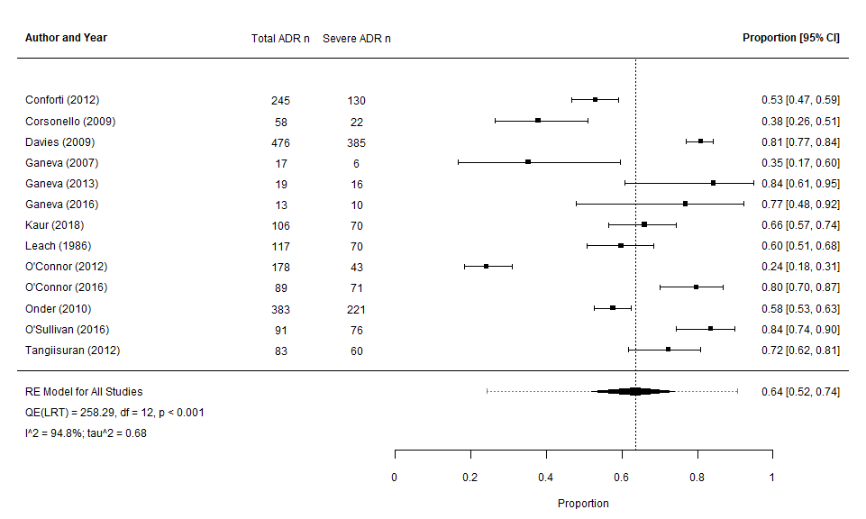
Appendix 23. Forest plot of pooled estimate (binomial-normal random effects model) of proportion of severe ADRs across eighteen studies.^{8,9,12-17,19-26,31,34}
This estimate is limited by the high level of heterogeneity and substantial variability across included studies (as evidenced by I² and τ² value). Hence, the estimate should be interpreted with caution as rather than considered as a “true” estimate.

Appendix 24. Preventability
ADRs preventability was assessed in 7 studies.^{9,14,16,19,23,28,34} Preventable in this instance is as defined by the various study methodologies. Studies did not report on the details of which ADR presentations or ADR-Drug pairs were “preventable”. Four studies^{14,16,23,28,34} had extractable data and used the same tool (Hallas).
Source | Population | Tool | Details of Preventability
O’Connor (2016)²³ | Population ≥ 65 years | Hallas | 78 patients 89 ADRs  85 ADRs (95.5%) definitely or possibly avoidable
Tangiisuran (2012)³⁴ | Population ≥ 65 years | Hallas | 74 patients 83 ADR  “69% of life-threatening or serious deemed preventable”  Life-threatening = 3  Serious = 57  41 (59%) ADRs preventable
Davies (2009)¹⁴ | All ages author supplied | Hallas | 328 patients 476 ADRs  262 (55.04%) preventable  25 definitely  237 possibly  214 unavoidable
Ganeva (2016)¹⁶ | All ages author supplied | Hallas | 11 patients ADRs  7 (63.63%) preventable  1 definitely  6 possibly  4 unavoidable
Hailu (2020)¹⁹ | All ages author supplied | Not specified | 3 patients ADRs  2 preventable
Calderon-Ospina (2010)⁹ | All ages  (48.15% ≥ 65 years) | Schumock & Thornton | 50% (33.1-66.9%) of ADRs were considered preventable (all ages)
Giardina²⁸ | All ages  (75.93%≥ 65 years) | Schumock & Thornton | Probably preventable in 69.4% (all ages)  unavoidable 24.2%  6.4% certainly preventable
Appendix 25. Meta-analysis of pooled estimate of “preventable” ADRs in studies (n=4) using Hallas tool 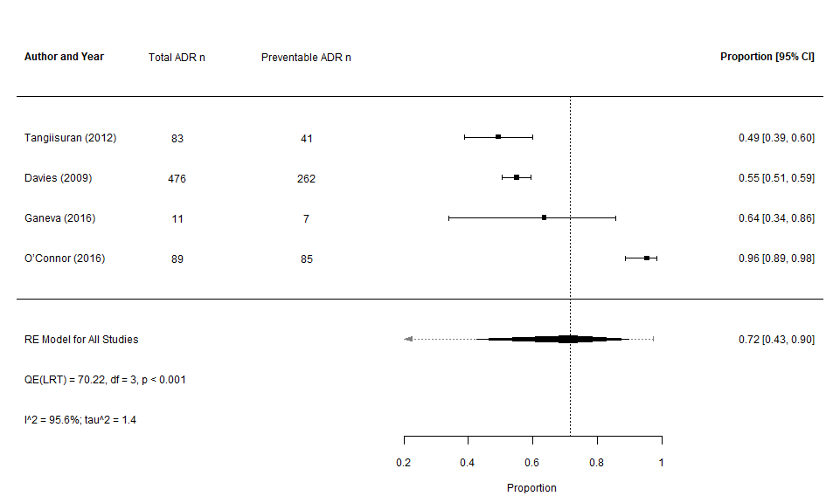
Appendix 25. Forest plot of pooled estimate (binomial-normal random effects model) of proportion of preventable ADRs across four studies using comparable reporting. ^{14,16,23,28,34}
In addition to being a small sample-size in context of overall pooled population, this estimate is limited by the high level of heterogeneity and substantial variability across included studies (as evidenced by I² and τ² value). Hence, the estimate should be interpreted with caution as rather than considered as a “true” estimate.

Appendix 26. Reported Polypharmacy
Details pertaining to medication-burden were reported in 18 studies.^{7,13,17-25,27-31,34,35} (11 whose population was ≥65 years, 6 whose population was all ages author supplied data for cohort of interest and 4 studies reported data for all ages). Polypharmacy (i.e. ≥ 5 daily medications at baseline reported as a mean/median) was present in 11 studies.^{7,13,17,21-25,27,30,34,35}

Source | Population | Medication burden | Comments/further details
Corsonello¹³ | Population ≥ 65 years | 10.6 ± 5.5 ª | # drugs per stay (excl. PIMs)  ADR group vs non-ADR 15.2±7.9 ª vs 9.9±4.8 ªp=0.001
Fernandez – Regueiro²⁷ | Population ≥ 65 years | 9 IQR 3-16^{b} | 81 patients (84%) ≥ 6 drugs
Lavan³⁰ | Population ≥ 65 years | 9.9 ± 3.8 ª | -
Leach²¹ | Population ≥ 65 years | Mean 6.1 mode 4 | Incidence ADRs increased with number of drugs 6% 1-3 drugs to 52% >8 drugs p<0.001
Contd.  Source | Population | Medication burden | Comments/further details
Liao³¹ | Population ≥ 65 years | Medications measured by number of drug classes during whole hospital stay | ADR 14.98 ± 0.43 ª  Non-ADR 14.95 ± 0.22ª  P = <0.01
O’Connor (2016)²³ | Population ≥ 65 years | 8 IQR 6-11^{b} | 291 (78%) ≥ 5 drugs
O’Connor (2012)²² | Population ≥ 65 years | 7 IQR 1-10^{b} | 345 (67%) ≥ 6 drugs  ADR median 10  Non-ADR median 7 p<0.001
Onder²⁴ | Population ≥ 65 years | 3911 (66%) GIFA study ≥ 5 drugs  425 (88%) val. Study ≥ 5 drugs | ADR group 3579 (64%) ≥ 5 drugs  Non-ADR group 332 (87%) ≥ 5 drugs  5-7 drugs OR 1.9 (1.35-2.68)  ≥8 drugs OR 4.07 (2.93-5.65)  ADR group 52 (93%) ≥ 5 drugs  Non-ADR group 373 (87%) ≥ 5 drugs  p=0.001
O’Sullivan²⁵ | Population ≥ 65 years | 8 IQR 6-11^{b} | 321 (85.4%) ≥ 5 drugs control arm
Tangiisuran (2012)³⁴ | Population ≥ 65 years | 5 IQR 3-7^{b} | Baseline, total  ADR 6 IQR 3-8 ^{b}  Non-ADR 5 IQR 3-7 ^{b}  p<0.05  On ward, total  ADR 10 (7.75-13)^{b}  Non-ADR 7 (5-10) ^{b}  P<0.05
Tangiisuran (2014)³⁵ | Population ≥ 65 years | Dev. 6 IQR 3-8^{b}  Val. 5 IQR 4-8^{b} | Dev. Range 0-18
Ayub⁷ | All ages, author supplied | 17.2 ± 2.4ª | Min 13 Max 20
Ganeva (2013)¹⁷ | All ages author supplied | 6.1 ± 2.4 ª | -
Harugeri²⁹ | Population >60 years (40% >70 years) | Overall not described | Overall medications higher in ADR group median 10 (range 3-22) non-ADR group median 9 (range 1-21) p<0.001
Giardina²⁸ | All ages  (75.93% ≥ 65 years) | Overall 48% ≥ 5 medications | -
Gonzalez-Martin¹⁸ | All ages  (52.74% ≥ 65 years) | Overall not described | Number of medications administered: A significant difference was observed between the patients > 65 years, in relation to the number of medications received during hospitalization and the frequency of ADR (9.0 ± 2.3ª medications vs. 5.5 ± 2.2 ª medications ) (t = 7.6, p <0.05).
Contd.  Source | Population | Medication burden | Comments/further details
Hailu¹⁹ | All ages  (60.5% ≥ 65 years) | Overall 3.9 ± 2.108 ª | Overall, 71 (35.5%) had polypharmacy (defined ≥5)
Kaur²⁰ | All ages  (70.97% ≥ 65 years) | 98% experiencing ADRs had polypharmacy | Population (>50 years)  Polypharmacy ≥ 3 drugs 467 (71%) ≥ 65 years
ª - Mean ± standard deviation; # - number; excl. – excluded; PIMs – potentially inappropriate medications; ^{b} - Median IQR; IQR – interquartile range; ADRs – Adverse drug reaction; GIFA – gruppo Italiano di farmacovigilanza nell’Anziano; OR – Odds Ratio; Val. – validation; Dev. – development

Appendix 27. Reported multi-morbidity
Eleven studies examined the degree of co-morbidity as an ADR-associated variable.7,13,17,19,22,24,27,30,31,34,35 Baseline multi-morbidity (defined as a mean/median of ≥ 3 chronic conditions) was reported in 10 studies.^{7,13,22,24,27,30,31,34,35}
Source | Population | Multi-morbidity | Comments/further details
Corsonello¹³ | Population ≥ 65 years | 3.7 ±1.9ª | Based on CIRS  ADR vs non ADR CIRS 4.5±1.8ª vs 3.6±1.9 ª p=0.001
Fernandez – Regueiro²⁷ | Population ≥ 65 years | 8 ± 3ª | Range 1-17
Lavan³⁰ | Population ≥ 65 years | 5.4 ± 1.9ª  5 IQR 4-6^{b} | Range 2-13  10% ≥ 8 conditions
Liao³¹ | Population ≥ 65 years | 1831 of 2393 (76%) ≥4 comorbidities | ADR 4.06 ± 1.48 ª  Non-ADR 3.53 ±1.08 ª  p = <0.001
O’Connor (2012)²² * | Population ≥ 65 years | 412 (80%) ≥ 4 comorbidities | ADR 115 (85%) ≥ 4 comorbidities  Non-ADR 301 (79.6%) ≥ 4 comorbidities  p=0.157
Onder²⁴ | Population ≥ 65 years | 2996 (50%) GIFA≥ 4 comorbidities  347 (72%) val. ≥ 4 comorbidities | ADR group 252 (66%) ≥ 4 comorbidities  Non-ADR group 2744 (49%) ≥ 4 comorbidities  p=<0.001  ADR group 49 (88%) ≥ 4 comorbidities  Non-ADR group 298 (70%) ≥ 4 comorbidities  p=0.006
Contd.  Source | Population | Multi-morbidity | Comments/further details
Tangiisuran (2012)³⁴ | Population ≥ 65 years | 8 IQR 6-10^{b} ADR  8 IQR 6-10^{b} Non-ADR | -
Tangiisuran (2014)³⁵ | Population ≥ 65 years | 8 IQR 6-10^{b} Dev.  Val. Not documented | -
Ayub⁷ | All ages author supplied | 4.71 ± 1.6ª | Range 2-7  ADR 4.8 ± 1.3ª  Non-ADR 3.6 ± 1.7ª  p=0.475
Ganeva (2013)¹⁷ | All ages author supplied | 2.7 ± 1.8ª | -
Hailu¹⁹ | All ages  (60.5% ≥ 65 years) | 2.20 ± 1.157 ª | Adjusted odds ratio (all ages) 1.588 (1.03–2.45) p = 0.04
ª - Mean ± standard deviation; CIRS – cumulative illness rating score; ADRs – Adverse drug reaction; * - identified from subsequent publication⁵¹; ^{b} - Median IQR; IQR – interquartile range; GIFA – gruppo Italiano di farmacovigilanza nell’Anziano; Dev. – development; Val. – validation

Appendix 28. Reported ADR outcomes
Clinical outcomes following ADRs were infrequently reported, only 9 papers^{12,14,17,20,22,23,25,31,34} commented on mortality and/or LOS. Pooled analysis was not feasible.
Source | Population | Outcome details
Conforti¹² | Population ≥ 65 years | ADR LOS 18.7 (95% CI 17.2-20.1)ª  Non-ADR LOS 12.6 (95% CI 11.9-12.3)ª  No comment on statistical significance.
Corsonello¹³ | Population ≥ 65 years | ADRs impact on functional decline  Increasing # ADRs = loss of ADLs 1 ADR OR 11.1(4.18-29.5) p=0.001 loss ≥1ADLs  Increasing severity of ADR = loss of ADLs  Moderate to severe ADR OR 8.11(2.67-24.6) p=<0.01
Liao³¹ | Population ≥ 65 years | ADR group had increased length of stay (days). 30.8±30.2 ª vs 16.9±14.7 ª p = <0.01  ADR group had higher total medical expenses.  US$ 9531.3±13634.5 ª vs 4108.9±5180.1 ª p=<0.01  ADR group had higher drug expenses.  US$ 2276.4±4244.1 ª vs 817.0±1806.8 ª p=<0.01
O’Connor (2016)²³ | Population ≥ 65 years | ADR LOS 10 IQR 6-17 ^{b}  Non-ADR LOS 7 IQR 4-14 ^{b}  Death 9 (control arm; unknown if ADR related)
O’Connor (2012)²² | Population ≥ 65 years | ADR LOS 12 ^{b}  Non-ADR LOS 7 ^{b}  Death 29 (5.64%)
Contd.  Source | Population | Outcome details
O’Sullivan²⁵ | Population ≥ 65 years | ADR LOS 11 IQR 7-18 ^{b}  Non-ADR LOS 8 IQR 5-13 ^{b} p<0.001  Death 17 (4.5% control arm; unknown if ADR related)
Tangiisuran (2012)³⁴ | Population ≥ 65 years | ADR LOS 14 IQR 10-26.5^{b}  Non-ADR LOS 12 IQR 7-19 ^{b}
Davies¹⁴ | All ages author supplied | ADR LOS 22 IQR 14-37^{b}  Non-ADR 10 IQR 6-17^{b}  Death 165 (11 ADR related)
Ganeva (2013)¹⁷ | All ages author supplied | ADR LOS 9.2 ± 3.4ª
Harurgeri²⁹ | Population >60 years (40% >70 years) | Overall ADR group had longer LOS  ADR LOS median 7 (range 1-43)  Non-ADR 6 (range 1-20) p=0.02
Gonzalez-Martin¹⁸ | All ages  (52.74% ≥ 65 years) | Patients> 65 years with ADRs had a longer hospital stay than those without ADRs (9.57 ± 7.55 ª days vs. 5.21 ± 3.21 ª days) p <0.05
Kaur²⁰ | All ages  (70.97% ≥ 65 years) | ADR LOS +2 days  Death 3 ≥ 65 (unknown if ADR related)
LOS – length of stay in days; CI – Confidence Interval; ª - Mean ± standard deviation; ADL – Activities of Daily Living; OR – Odds Ratio; ^{b} - Median IQR; IQR – interquartile range; ADRs – Adverse drug reaction; GIFA – gruppo Italiano di farmacovigilanza nell’Anziano; Dev. – development; Val. – validation

References

1. Team RC. R: A language and environment for statistical computing. 2013.
2. Viechtbauer W. Conducting meta-analyses in R with the metafor package. Journal of statistical software. 2010;36(3):1-48.
3. Methodology WCCfDS. ATC/DDD Index 2019. 2018; https://www.whocc.no/atc_ddd_index/. Accessed April - July, 2019.
4. The National Center for Biomedical Ontology. Medical Dictionary for Regulatory Activities Terminology (MedDRA) 2019 , April 29; http://bioportal.bioontology.org/ontologies/MEDDRA/?p=classes&conceptid=root. Accessed April-July, 2019.
5. Whetzel PL, Noy NF, Shah NH, et al. BioPortal: enhanced functionality via new Web services from the National Center for Biomedical Ontology to access and use ontologies in software applications. Nucleic acids research. 2011;39(suppl_2):W541-W545.
6. Organization MMaSS. Medical Dictionary for Regulatory Activities. 2018, September version 21.1:https://www.meddra.org/. Accessed April-July, 2019.
7. Ayub MN, Da Silva D, Martinbiancho JK, Dal-Pizzol TS. Adverse Drug Reactions in Patients Hospitalized in the Intensive Care Unit of a University Hospital in Southern Brazil. Lat Am J Pharm. 2010;29(5):688-693.
8. Bowman L, Carlstedt BC, Hancock EF, Black CD. Adverse drug reaction (ADR) occurrence and evaluation in elderly inpatients. Pharmacoepidemiology and drug safety. 1996;5(1):9-18.
9. Calderon-Ospina C, Bustamante-Rojas C. The DoTS classification is a useful way to classify adverse drug reactions: a preliminary study in hospitalized patients. Int J Pharm Pract. 2010;18(4):230-235.
10. Cheong S, Ong E, Goh W, Karim S, See L, Chong E. Do Adverse Drug Reactions Vary Between Frail and Non-Frail Hospitalized Older Adults? Paper presented at: JOURNAL OF THE AMERICAN GERIATRICS SOCIETY2018.
11. Cheong S, Ong E, Goh W, Karim S, See L, Chong E. Identifying Specific Drugs Classes That Result in Adverse Drug Reactions Between Frail and Non-Frail Hospitalized Older Adults. Paper presented at: JOURNAL OF THE AMERICAN GERIATRICS SOCIETY2018.
12. Conforti A, Costantini D, Zanetti F, Moretti U, Grezzana M, Leone R. Adverse drug reactions in older patients: an Italian observational prospective hospital study. Drug, healthcare and patient safety. 2012;4:75.
13. Corsonello A, Pedone C, Lattanzio F, et al. Potentially inappropriate medications and functional decline in elderly hospitalized patients. Journal of the American Geriatrics Society. 2009;57(6):1007-1014.
14. Davies EC, Green CF, Taylor S, Williamson PR, Mottram DR, Pirmohamed M. Adverse drug reactions in hospital in-patients: a prospective analysis of 3695 patient-episodes. PloS one. 2009;4(2):e4439.
15. Ganeva M, Gancheva T, Lazarova R, Tzvetanova Y, Hristakieva E. A prospective study of adverse drug reactions in a dermatology department. Method Find Exp Clin. 2007;29(2):107-112.
16. Ganeva M, Gancheva T, Troeva J, Gancheva D, Hristakieva E. A study of adverse drug reactions in hospitalized patients in relation to age. European journal of clinical pharmacy: atención farmacéutica. 2016;18(3):154-162.
17. Ganeva M, Gancheva T, Troeva J, Kiriyak N, Hristakieva E. Clinical relevance of drug-drug interactions in hospitalized dermatology patients. Advances in Clinical and Experimental Medicine. 2013;22(4):555-563.
18. Gonzalez-Martin G, Yanez L, Valenzuela E. [Adverse drug reactions among hospitalized elderly patients. Prospective study]. Revista medica de Chile. 1997;125(10):1129-1136.
19. Hailu BY, Berhe DF, Gudina EK, Gidey K, Getachew M. Drug related problems in admitted geriatric patients: the impact of clinical pharmacist interventions. BMC geriatrics. 2020;20(1):13.
20. Kaur U, Chakrabarti SS, Singh B, Gambhir IS. A Prospective Observational Pilot Study of Adverse Drug Reactions in Patients Admitted in the Geriatric Ward of a Tertiary Hospital in North India. Current Pharmacogenomics and Personalized Medicine (Formerly Current Pharmacogenomics). 2018;16(2):147-155.
21. Leach S, Roy SS. ADVERSE DRUG REACTIONS: AN INVESTIGATION ON AN ACUTE GERIATRIC WARD. Age and ageing. 1986;15(4):241-246.
22. O'Connor MN, Gallagher P, Byrne S, O'Mahony D. Adverse drug reactions in older patients during hospitalisation: Are they predictable? Age and ageing. 2012;41(6):771-776.
23. O'Connor MN, O'Sullivan D, Gallagher PF, Eustace J, Byrne S, O'Mahony D. Prevention of hospital‐acquired adverse drug reactions in older people using screening tool of older persons' prescriptions and screening tool to alert to right treatment criteria: A cluster randomized controlled trial. Journal of the American Geriatrics Society. 2016;64(8):1558-1566.
24. Onder G, Petrovic M, Tangiisuran B, et al. Development and validation of a score to assess risk of adverse drug reactions among in-hospital patients 65 years or older: the GerontoNet ADR risk score. Archives of internal medicine. 2010;170(13):1142-1148.
25. O'Sullivan D, O'Mahony D, O'Connor MN, et al. Prevention of Adverse Drug Reactions in Hospitalised Older Patients Using a Software-Supported Structured Pharmacist Intervention: A Cluster Randomised Controlled Trial. Drugs & aging. 2016;33(1):63-73.
26. REICHEL W. Complications in the care of five hundred elderly hospitalized patients. Journal of the American Geriatrics Society. 1965;13(11):973-981.
27. Fernandez-Regueiro R, Fonseca-Aizpuru E, Lopez-Colina G, Alvarez-Uria A, Rodriguez-Avila E, Moris-De-La-Tassa J. Inappropriate drug prescription and adverse drug effects in elderly patients. Revista Clinica Espanola. 2011;211(8):400-406.
28. Giardina C, Cutroneo PM, Mocciaro E, et al. Adverse Drug Reactions in Hospitalized Patients: Results of the FORWARD (Facilitation of Reporting in Hospital Ward) Study. Frontiers in pharmacology. 2018;9:350.
29. Harugeri A, Parthasarathi G, Ramesh M, Guido S, Basavanagowdappa H. Frequency and nature of adverse drug reactions in elderly in-patients of two Indian medical college hospitals. Journal of postgraduate medicine. 2011;57(3):189-195.
30. Lavan A, Eustace J, Dahly D, et al. Incident adverse drug reactions in geriatric inpatients: a multicentred observational study. Therapeutic advances in drug safety. 2018;9(1):13-23.
31. Liao PJ, Mao CT, Chen TL, Deng ST, Hsu KH. Factors associated with adverse drug reaction occurrence and prognosis, and their economic impacts in older inpatients in Taiwan: a nested case-control study. BMJ open. 2019;9(5):e026771.
32. Mohebbi N, Shalviri G, Salarifar M, Salamzadeh J, Gholami K. Adverse drug reactions induced by cardiovascular drugs in cardiovascular care unit patients. Pharmacoepidemiology and drug safety. 2010;19(9):889-894.
33. Mugoša S, Bukumirić Z, Kovačević A, Bošković A, Protić D, Todorović Z. Adverse drug reactions in hospitalized cardiac patients: characteristics and risk factors. Vojnosanitetski pregled. 2015;72(11):975-981.
34. Tangiisuran B, Graham Davies J, Wright JE, Rajkumar C. Adverse Drug Reactions in a Population of Hospitalized Very Elderly Patients. Drugs & aging. 2012;29(8):669-679.
35. Tangiisuran B, Scutt G, Stevenson J, et al. Development and validation of a risk model for predicting adverse drug reactions in older people during hospital stay: Brighton Adverse Drug Reactions Risk (BADRI) model. PloS one. 2014;9(10):e111254.
36. Hazell L, Shakir SA. Under-reporting of adverse drug reactions : a systematic review. Drug safety. 2006;29(5):385-396.
37. Team. WHOQAaSoM. Safety of medicines : a guide to detecting and reporting adverse drug reactions : why health professionals need to take action. . Geneva : World Health Organization 2002.
38. Edwards IR, Aronson JK. Adverse drug reactions: definitions, diagnosis, and management. Lancet (London, England). 2000;356(9237):1255-1259.
39. Bates DW, Leape LL, Petrycki S. Incidence and preventability of adverse drug events in hospitalized adults. Journal of general internal medicine. 1993;8(6):289-294.
40. Naranjo CA, Busto U, Sellers EM, et al. A method for estimating the probability of adverse drug reactions. Clin Pharmacol Ther. 1981;30(2):239-245.
41. (UMC) UMC. The use of the WHO-UMC system for standardised case causality assessment. https://www.who-umc.org/media/164200/who-umc-causality-assessment_new-logo.pdf. Accessed 19/09/2019, 2019.
42. Hallas J, Harvald B, Gram LF, et al. Drug related hospital admissions: the role of definitions and intensity of data collection, and the possibility of prevention. Journal of internal medicine. 1990;228(2):83-90.
43. Kramer MS, Leventhal JM, Hutchinson TA, Feinstein AR. An algorithm for the operational assessment of adverse drug reactions. I. Background, description, and instructions for use. Jama. 1979;242(7):623-632.
44. Hartwig SC, Siegel J, Schneider PJ. Preventability and severity assessment in reporting adverse drug reactions. American journal of hospital pharmacy. 1992;49(9):2229-2232.
45. Hurwitz N, Wade OL. Intensive hospital monitoring of adverse reactions to drugs. Br Med J. 1969;1(5643):531-536.
46. Morimoto T, Gandhi TK, Seger AC, Hsieh TC, Bates DW. Adverse drug events and medication errors: detection and classification methods. Qual Saf Health Care. 2004;13(4):306-314.
47. Stephens MDB. The detection of new adverse drug reactions. Macmillan International Higher Education; 1988.
48. Centre UM. What is WHO-ART? https://www.who-umc.org/vigibase/services/learn-more-about-who-art/. Accessed 19/09/2019, 2019.
49. Agency EM. Guideline on good pharmacovigilance practices (GVP) Annex I - Definitions (Rev 4) 2017; https://www.ema.europa.eu/en/documents/scientific-guideline/guideline-good-pharmacovigilance-practices-annex-i-definitions-rev-4_en.pdf. Accessed 19/09/2019, 2019.
50. department PaP. Spanish Agency of medicines and medical devices. http://www.aemps.gob.es/
51. Rawlins M, Thompson J. 3. Mechanisms of adverse drug reactions. 1991.
52. Meyboom RH, Lindquist M, Egberts AC. An ABC of drug-related problems. Drug safety. 2000;22(6):415-423.
53. Schumock G, Thornton J. Focusing on the preventability of adverse drug reactions. Hospital pharmacy. 1992;27(6):538.

APPENDIX 27 – Full list of references from main manuscript
1. Team. WHOQAaSoM. Safety of medicines : a guide to detecting and reporting adverse drug reactions : why health professionals need to take action. . Geneva : World Health Organization 2002.
2. Alhawassi TM, Krass I, Bajorek BV, Pont LG. A systematic review of the prevalence and risk factors for adverse drug reactions in the elderly in the acute care setting. Clinical interventions in aging. 2014;9:2079-2086.
3. Oscanoa TJ, Lizaraso F, Carvajal A. Hospital admissions due to adverse drug reactions in the elderly. A meta-analysis. European journal of clinical pharmacology. 2017;73(6):759-770.
4. Beijer HJ, de Blaey CJ. Hospitalisations caused by adverse drug reactions (ADR): a meta-analysis of observational studies. Pharm World Sci. 2002;24(2):46-54.
5. Hoonhout LH, de Bruijne MC, Wagner C, Asscheman H, van der Wal G, van Tulder MW. Nature, occurrence and consequences of medication-related adverse events during hospitalization: a retrospective chart review in the Netherlands. Drug safety. 2010;33(10):853-864.
6. Khan LM. Comparative epidemiology of hospital-acquired adverse drug reactions in adults and children and their impact on cost and hospital stay--a systematic review. European journal of clinical pharmacology. 2013;69(12):1985-1996.
7. Bates DW, Spell N, Cullen DJ, et al. The costs of adverse drug events in hospitalized patients. Jama. 1997;277(4):307-311.
8. Broyles RW, Chou AF, Mattachione S, Wild RC, Al-Assaf AF. The effect of adverse medical events on spending on inpatient care. Qual Manag Health Care. 2009;18(4):315-325.
9. Hug BL, Keohane C, Seger DL, Yoon C, Bates DW. The costs of adverse drug events in community hospitals. Jt Comm J Qual Patient Saf. 2012;38(3):120-126.
10. Lazarou J, Pomeranz BH, Corey PN. Incidence of adverse drug reactions in hospitalized patients: a meta-analysis of prospective studies. Jama. 1998;279(15):1200-1205.
11. Kanagaratnam L, Dramé M, Novella JL, et al. Risk Factors for Adverse Drug Reactions in Older Subjects Hospitalized in a Dedicated Dementia Unit. American Journal of Geriatric Psychiatry. 2017;25(3):290-296.
12. Field TS, Gilman BH, Subramanian S, Fuller JC, Bates DW, Gurwitz JH. The costs associated with adverse drug events among older adults in the ambulatory setting. Med Care. 2005;43(12):1171-1176.
13. de Boer M, Boeker EB, Ramrattan MA, et al. Adverse drug events in surgical patients: an observational multicentre study. International journal of clinical pharmacy. 2013;35(5):744-752.
14. Cullere CB, Torner MG, Ruiz JA, et al. Detecting adverse drug events during the hospital stay. Farmacia Hospitalaria (English Edition). 2009;33(6):312-323.
15. Wolfe D, Yazdi F, Kanji S, et al. Incidence, causes, and consequences of preventable adverse drug reactions occurring in inpatients: A systematic review of systematic reviews. PloS one. 2018;13(10):e0205426.
16. Gray SL, Hart LA, Perera S, Semla TP, Schmader KE, Hanlon JT. Meta-analysis of Interventions to Reduce Adverse Drug Reactions in Older Adults. Journal of the American Geriatrics Society. 2018;66(2):282-288.
17. Stevenson JM, Williams JL, Burnham TG, et al. Predicting adverse drug reactions in older adults; a systematic review of the risk prediction models. Clinical interventions in aging. 2014;9:1581.
18. Kongkaew C, Noyce PR, Ashcroft DM. Hospital admissions associated with adverse drug reactions: a systematic review of prospective observational studies. The Annals of pharmacotherapy. 2008;42(7):1017-1025.
19. Patel NS, Patel TK, Patel PB, Naik VN, Tripathi CB. Hospitalizations due to preventable adverse reactions-a systematic review. European journal of clinical pharmacology. 2017;73(4):385-398.
20. Laatikainen O, Miettunen J, Sneck S, Lehtiniemi H, Tenhunen O, Turpeinen M. The prevalence of medication-related adverse events in inpatients-a systematic review and meta-analysis. European journal of clinical pharmacology. 2017;73(12):1539-1549.
21. Emma Jennings KM, Paul Gallagher, Denis O'Mahony In-hospital adverse drug reactions in hospitalised older adults - a systematic review. 2018.
22. Moher D, Liberati A, Tetzlaff J, Altman DG, Group P. Preferred reporting items for systematic reviews and meta-analyses: the PRISMA statement. In:2010.
23. Stroup D. Berlin JA Morton SC Olkin I Williamson GD Rennie D Moher D Becker BJ Sipe TA Thacker SB. Meta-analysis of observational studies in epidemiology: a proposal for reporting. Meta-analysis of Observational Studies in Epidemiology (MOOSE) group. Journal of the American Medical Association. 2000;283:2008-2012.
24. Higgins JP, Sterne JA, Savovic J, et al. A revised tool for assessing risk of bias in randomized trials. Cochrane database of systematic reviews. 2016;10(Suppl 1):29-31.
25. Wells G, Shea B, O’connell D, et al. The Newcastle-Ottawa Scale (NOS) for assessing the quality if nonrandomized studies in meta-analyses. 2009. Epub Available from: URL: http://www ohri ca/programs/clinical_epidemiology/oxford htm [cited 2009 Oct 19]. 2016.
26. The National Center for Biomedical Ontology. Medical Dictionary for Regulatory Activities Terminology (MedDRA) 2019 , April 29; http://bioportal.bioontology.org/ontologies/MEDDRA/?p=classes&conceptid=root. Accessed April-July, 2019.
27. Whetzel PL, Noy NF, Shah NH, et al. BioPortal: enhanced functionality via new Web services from the National Center for Biomedical Ontology to access and use ontologies in software applications. Nucleic acids research. 2011;39(suppl_2):W541-W545.
28. Organization MMaSS. Medical Dictionary for Regulatory Activities. 2018, September version 21.1:https://www.meddra.org/. Accessed April-July, 2019.
29. Methodology WCCfDS. ATC/DDD Index 2019. 2018; https://www.whocc.no/atc_ddd_index/. Accessed April - July, 2019.
30. Team RC. R: A language and environment for statistical computing. 2013.
31. Viechtbauer W. Conducting meta-analyses in R with the metafor package. Journal of statistical software. 2010;36(3):1-48.
32. Ayub MN, Da Silva D, Martinbiancho JK, Dal-Pizzol TS. Adverse Drug Reactions in Patients Hospitalized in the Intensive Care Unit of a University Hospital in Southern Brazil. Lat Am J Pharm. 2010;29(5):688-693.
33. Bowman L, Carlstedt BC, Hancock EF, Black CD. Adverse drug reaction (ADR) occurrence and evaluation in elderly inpatients. Pharmacoepidemiology and drug safety. 1996;5(1):9-18.
34. Calderon-Ospina C, Bustamante-Rojas C. The DoTS classification is a useful way to classify adverse drug reactions: a preliminary study in hospitalized patients. Int J Pharm Pract. 2010;18(4):230-235.
35. Cheong S, Ong E, Goh W, Karim S, See L, Chong E. Do Adverse Drug Reactions Vary Between Frail and Non-Frail Hospitalized Older Adults? Paper presented at: JOURNAL OF THE AMERICAN GERIATRICS SOCIETY2018.
36. Cheong S, Ong E, Goh W, Karim S, See L, Chong E. Identifying Specific Drugs Classes That Result in Adverse Drug Reactions Between Frail and Non-Frail Hospitalized Older Adults. Paper presented at: JOURNAL OF THE AMERICAN GERIATRICS SOCIETY2018.
37. Conforti A, Costantini D, Zanetti F, Moretti U, Grezzana M, Leone R. Adverse drug reactions in older patients: an Italian observational prospective hospital study. Drug, healthcare and patient safety. 2012;4:75.
38. Corsonello A, Pedone C, Lattanzio F, et al. Potentially inappropriate medications and functional decline in elderly hospitalized patients. Journal of the American Geriatrics Society. 2009;57(6):1007-1014.
39. Davies EC, Green CF, Taylor S, Williamson PR, Mottram DR, Pirmohamed M. Adverse drug reactions in hospital in-patients: a prospective analysis of 3695 patient-episodes. PloS one. 2009;4(2):e4439.
40. Fernandez-Regueiro R, Fonseca-Aizpuru E, Lopez-Colina G, Alvarez-Uria A, Rodriguez-Avila E, Moris-De-La-Tassa J. Inappropriate drug prescription and adverse drug effects in elderly patients. Revista Clinica Espanola. 2011;211(8):400-406.
41. Ganeva M, Gancheva T, Lazarova R, Tzvetanova Y, Hristakieva E. A prospective study of adverse drug reactions in a dermatology department. Method Find Exp Clin. 2007;29(2):107-112.
42. Ganeva M, Gancheva T, Troeva J, Gancheva D, Hristakieva E. A study of adverse drug reactions in hospitalized patients in relation to age. European journal of clinical pharmacy: atención farmacéutica. 2016;18(3):154-162.
43. Ganeva M, Gancheva T, Troeva J, Kiriyak N, Hristakieva E. Clinical relevance of drug-drug interactions in hospitalized dermatology patients. Advances in Clinical and Experimental Medicine. 2013;22(4):555-563.
44. Giardina C, Cutroneo PM, Mocciaro E, et al. Adverse Drug Reactions in Hospitalized Patients: Results of the FORWARD (Facilitation of Reporting in Hospital Ward) Study. Frontiers in pharmacology. 2018;9:350.
45. Gonzalez-Martin G, Yanez L, Valenzuela E. [Adverse drug reactions among hospitalized elderly patients. Prospective study]. Revista medica de Chile. 1997;125(10):1129-1136.
46. Hailu BY, Berhe DF, Gudina EK, Gidey K, Getachew M. Drug related problems in admitted geriatric patients: the impact of clinical pharmacist interventions. BMC geriatrics. 2020;20(1):13.
47. Harugeri A, Parthasarathi G, Ramesh M, Guido S, Basavanagowdappa H. Frequency and nature of adverse drug reactions in elderly in-patients of two Indian medical college hospitals. Journal of postgraduate medicine. 2011;57(3):189-195.
48. Kaur U, Chakrabarti SS, Singh B, Gambhir IS. A Prospective Observational Pilot Study of Adverse Drug Reactions in Patients Admitted in the Geriatric Ward of a Tertiary Hospital in North India. Current Pharmacogenomics and Personalized Medicine (Formerly Current Pharmacogenomics). 2018;16(2):147-155.
49. Lavan A, Eustace J, Dahly D, et al. Incident adverse drug reactions in geriatric inpatients: a multicentred observational study. Therapeutic advances in drug safety. 2018;9(1):13-23.
50. Leach S, Roy SS. ADVERSE DRUG REACTIONS: AN INVESTIGATION ON AN ACUTE GERIATRIC WARD. Age and ageing. 1986;15(4):241-246.
51. Liao PJ, Mao CT, Chen TL, Deng ST, Hsu KH. Factors associated with adverse drug reaction occurrence and prognosis, and their economic impacts in older inpatients in Taiwan: a nested case-control study. BMJ open. 2019;9(5):e026771.
52. Mohebbi N, Shalviri G, Salarifar M, Salamzadeh J, Gholami K. Adverse drug reactions induced by cardiovascular drugs in cardiovascular care unit patients. Pharmacoepidemiology and drug safety. 2010;19(9):889-894.
53. Mugoša S, Bukumirić Z, Kovačević A, Bošković A, Protić D, Todorović Z. Adverse drug reactions in hospitalized cardiac patients: characteristics and risk factors. Vojnosanitetski pregled. 2015;72(11):975-981.
54. O'Connor MN, Gallagher P, Byrne S, O'Mahony D. Adverse drug reactions in older patients during hospitalisation: Are they predictable? Age and ageing. 2012;41(6):771-776.
55. O'Connor MN, O'Sullivan D, Gallagher PF, Eustace J, Byrne S, O'Mahony D. Prevention of hospital‐acquired adverse drug reactions in older people using screening tool of older persons' prescriptions and screening tool to alert to right treatment criteria: A cluster randomized controlled trial. Journal of the American Geriatrics Society. 2016;64(8):1558-1566.
56. Onder G, Petrovic M, Tangiisuran B, et al. Development and validation of a score to assess risk of adverse drug reactions among in-hospital patients 65 years or older: the GerontoNet ADR risk score. Archives of internal medicine. 2010;170(13):1142-1148.
57. O'Sullivan D, O'Mahony D, O'Connor MN, et al. Prevention of Adverse Drug Reactions in Hospitalised Older Patients Using a Software-Supported Structured Pharmacist Intervention: A Cluster Randomised Controlled Trial. Drugs & aging. 2016;33(1):63-73.
58. REICHEL W. Complications in the care of five hundred elderly hospitalized patients. Journal of the American Geriatrics Society. 1965;13(11):973-981.
59. Tangiisuran B, Graham Davies J, Wright JE, Rajkumar C. Adverse Drug Reactions in a Population of Hospitalized Very Elderly Patients. Drugs & aging. 2012;29(8):669-679.
60. Tangiisuran B, Scutt G, Stevenson J, et al. Development and validation of a risk model for predicting adverse drug reactions in older people during hospital stay: Brighton Adverse Drug Reactions Risk (BADRI) model. PloS one. 2014;9(10):e111254.
61. Hazell L, Shakir SA. Under-reporting of adverse drug reactions : a systematic review. Drug safety. 2006;29(5):385-396.
62. Miguel A, Azevedo LF, Araujo M, Pereira AC. Frequency of adverse drug reactions in hospitalized patients: a systematic review and meta-analysis. Pharmacoepidemiology and drug safety. 2012;21(11):1139-1154.
63. Mazzitello C, Esposito S, De Francesco AE, Capuano A, Russo E, De Sarro G. Pharmacovigilance in Italy: an overview. Journal of pharmacology & pharmacotherapeutics. 2013;4(Suppl1):S20.
64. Rochon PA, Gurwitz JH. The prescribing cascade revisited. Lancet (London, England). 2017;389(10081):1778-1780.
65. Wiffen P. Adverse drug reactions in hospital patients-a systematic review of the prospective and retrospective studies. Bandolier http://wwwbandolierorguk/. 2002.
66. Howard RL, Avery AJ, Slavenburg S, et al. Which drugs cause preventable admissions to hospital? A systematic review. British journal of clinical pharmacology. 2007;63(2):136-147.

