Figure S3. Dot plots of the random effects of individual and year in the final behavioural models. a-d) Results of the models assessing age and seasonal differences in the proportional occurrence of directed thermal soaring, convoluted thermal soaring, gliding and orographic soaring, respectively. f-e) Results of the models assessing sex and seasonal differences in the proportional occurrence of gliding and orographic soaring, respectively. All random effects are reported on the link scale (logit).

a)
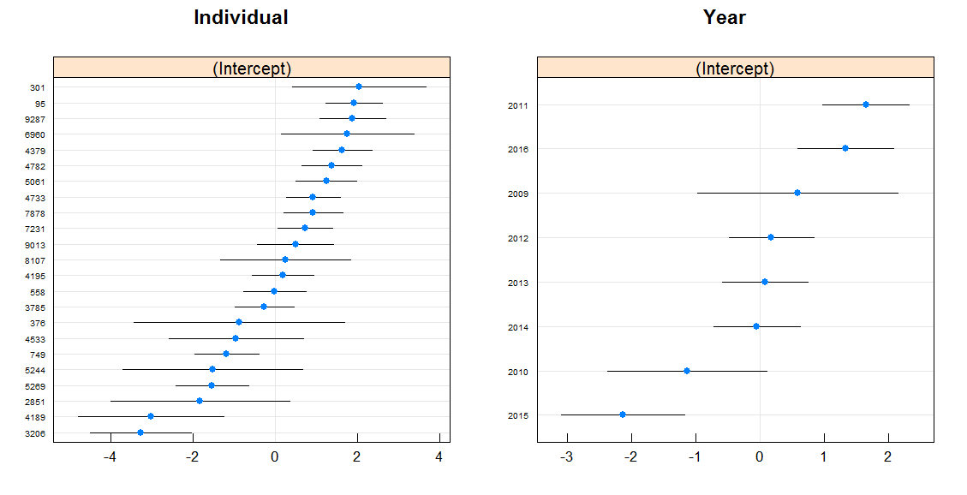

b)
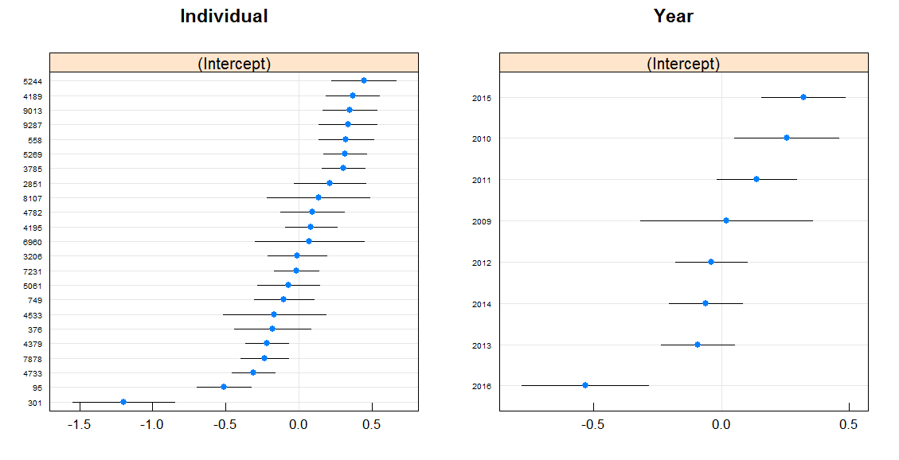

c)
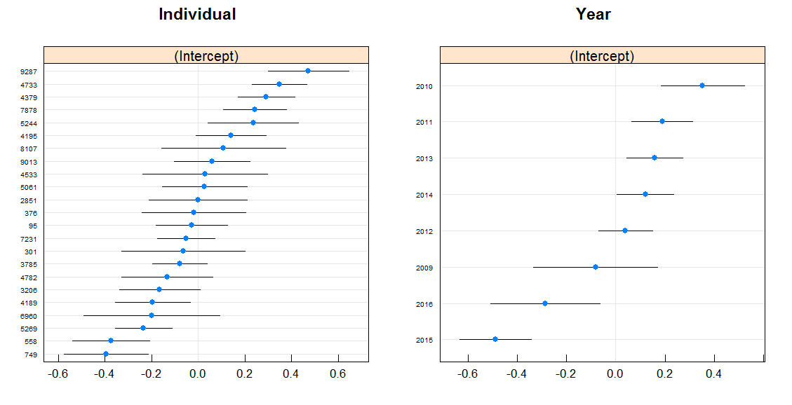

d)
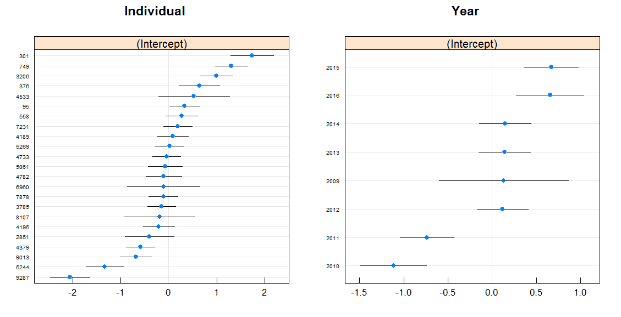

e)
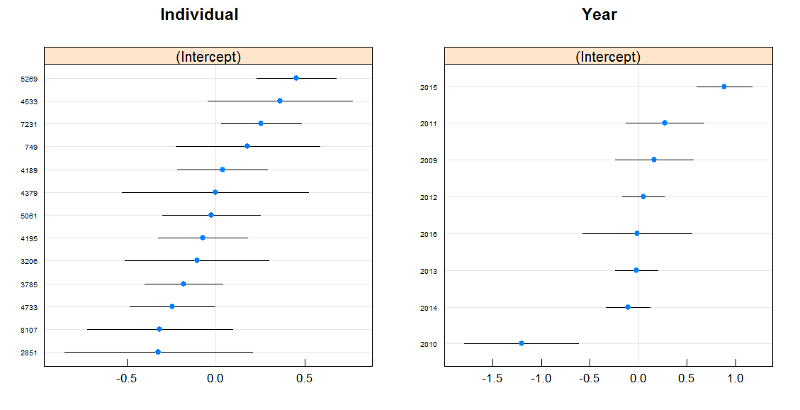

f)
