Supplementary Materials
Recruitment questionnaire (originally in Polish, translated to English)
Are you a blind person? (This implies a legal term in Polish, meaning the visual acuity less than 0.05 and visual field of less than 30 degrees)
Do you have any light perception?
Are you congenitally blind?
If not, from what age?
Have you ever learnt to read using print?
What was the cause of vision loss?
Were any of your parents blind?
Do you read Braille?
Are you right handed?
Is any of your closest family members (mother, father, siblings) left handed?
Are you diagnosed with any hearing impairment or hearing loss?
Do you have any neurological conditions?
Are you currently on any medications?
Have you ever had brain trauma needing hospitalization for more than 24 hours?
Do you wear dental braces?
Do you have any metal, irremovable elements (prosthetics, piercing) in your body?
What is your education? (PhD or Professor, Master degree, Bachelor degree, College diploma, High school diploma, Technical school diploma, Vocational Qualifications, Secondary school diploma, Primary school diploma, No education)
How many years did you spend on each educational level: (Primary school, Secondary School, Vocational School, High school, Technical school, Special high school, Collage, University, PhD studies)
Please, rate your proficiency in Braille reading. (I read Braille very poorly, I read Braille poorly, My capacity to read Braille is average, I read Braille well, I read Braille very well)

Behavioural measures
All of the subjects went through a battery of tests measuring different aspects of reading skills, phonological awareness, short-term memory, orthographic awareness, rapid naming and perceptual skills. Here we report only reading speed and accuracy measures. As no standardized tests of these skills exist for the Polish blind population the tests were created especially for the study.
Reading skills were measured using word-lists oral reading (8 lists, 6 items per list, with increasing difficulty, time and accuracy measured) and pseudoword-lists oral reading (8 lists of items with increasing difficulty, time and accuracy measured). Statistical analyses of the behavioural data were conducted in the R environment version 3.63 (R Core Team, 2017).
Results of the reading outcomes analyses are presented in Table S1. The blind and the sighted participants differed significantly on all measures of reading speed, but not accuracy (which was near-ceiling for both groups).
Table S1. Behavioural measures descriptive statistics.
Measure | Blind  Mean (SD) | Sighted  Mean (SD) | Mann-Whitney U (adjusted p value)
Word-lists reading accuracy % | 98.58 (1.67) | 99.17 (1.9) | U = 230.00 (0.06)
Word-lists reading time (s) | 65.48 (24.83) | 26.04 (5.14) | U = 609.50 (<0.001)
Words per minute | 59.00 (19.86) | 119.17 (20.57) | U = 14.00 (<0.001)
Pseudoword-lists reading accuracy % | 93.58 (6.8) | 96.83 (4.08) | U = 218.00 (0.12)
Pseudoword-lists reading time (s) | 102.48 (35.86) | 44.24 (11.38) | U = 607.00 (<0.001)
Pseudowords per minute | 39.22 (13.53) | 82.79 (19.16) | U = 18.00 (<0.001)
We report adjusted p values following Bonferroni-Holm correction. Differences that are significant at the adjusted level of p <.05 are marked with bold font.

Whole-brain results without non-congenitally blind participants.
Two subjects from the blind group lost their sight at age of two or three and were not congenitally blind. We conducted group level analyses to see if the exclusion of these two participants changed something in the results. For reading sensitive (words > baseline) and reading specific (words > non-linguistic control) contrast we observed differences only in the cluster size (slightly smaller clusters for the congenitally blind subjects only), significantly activated regions remained the same. For pseudowords reading sensitive contrast (pseudowords > baseline), with the group restricted to the congenitally blind subjects activations were present in the same regions, though we observed slightly less activation in the occipital cortex (activation in right but not left calcarine and cuneus). For pseudowords reading specific contrast (pseudowords > non-linguistic control) in the restricted sample, the right inferior frontal cluster did not reach significance (p_{cluster} = 0.052 instead of p_{cluster} = 0.007 in the whole sample). For speech sensitive contrast (words > baseline) activations were divided into more numerous clusters (five instead of three) and the activation in the right calcarine was not significant. In case of the speech specific contrast (words > non-linguistic control), the left vOT cluster did not reach significance (p_{cluster} = 0.082 instead of p_{cluster} = 0.048 in the whole sample). When it comes to speech-reading conjunction, in the restricted sample the right vOT cluster did not reach significance (p_{cluster} = 0.096 instead of p_{cluster} = 0.013 in the whole sample). We conclude that the differences between the results of the whole and restricted samples are mainly due to change in the statistical power connected to smaller sample.
Table S2. Number of subjects (percentage of the whole group) with no voxels overlapping between the reading and speech sensitive conditions in the literature based ROIs.
ROI | Sighted | Blind
left IFG/Precentral Gyrus | 16 (64%) | 10 (40%)
right STG | 2 (8%) | 5 (20%)
left IFG/Insula | 13 (52%) | 12 (48%)
left IPL | 18 (72%) | 11 (44%)
right vOT | 16 (64%) | 3 (12%)
left vOT | 12 (48%) | 2 (8%)
left MTG/STG | 0 (0%) | 3 (12%)

Table S3. Reading specific activations (words > non-linguistic control), x, y, z – cluster peak coordinates, t – value of the t-statistics from the peak, structures spanning more than 50 voxels are reported in each cluster.
Brain region | Hemisphere | x | y | z | t | # voxels | p_{cluster} FWE
Blind
Middle Occipital Gyrus, Fusiform Gyrus, Superior Occipital Gyrus, Calcarine, Inferior Occipital Gyrus, Cerebellum, Cuneus, Middle Temporal Gyrus, Inferior Temporal Gyrus, Lingual Gyrus, Superior Parietal Lobule, Inferior Parietal Lobule | L/R | -40 | -46 | -20 | 8.79 | 7254 | < 0.001
Inferior Frontal Gyrus (p. triangularis, opercularis, orbitalis), Precentral Gyrus, Insula, Postcentral Gyrus | L | -40 | -4 | 46 | 5.91 | 2169 | < 0.001
Sighted
Inferior Occipital Gyrus, Fusiform Gyrus, Middle Occipital Gyrus, Inferior Temporal Gyrus | L | -40 | -80 | -10 | 9.30 | 1424 | < 0.001
Precentral Gyrus, Postcentral Gyrus | L | -50 | -4 | 50 | 6.38 | 415 | 0.003
Blind & Sighted (conjunction)
Inferior Occipital Gyrus, Fusiform Gyrus, Middle Occipital Gyrus, Inferior Temporal Gyrus | L | -44 | -50 | -18 | 7.01 | 1109 | < 0.001
Blind > Sighted
Calcarine, Middle Occipital Gyrus, Fusiform Gyrus, Lingual Gyrus, Cerebellum, Middle Temporal Gyrus Inferior Temporal Gyrus, Superior Occipital Gyrus, Inferior Occipital Gyrus, Cuneus | L | -28 | -58 | -12 | 6.75 | 2100 | < 0.001
Inferior Frontal Gyrus (p. opercularis, triangularis), Precentral Gyrus | R | 44 | 12 | 22 | 5.09 | 317 | 0.038
Fusiform Gyrus, Cerebellum, Inferior Temporal Gyrus | R | 48 | -50 | -6 | 4.77 | 680 | 0.002
Inferior Frontal Gyrus (p. opercularis) | L | -46 | 8 | 16 | 4.41 | 338 | 0.031
Sighted > Blind
Lingual Gyrus, Calcarine, Precuneus | R | 18 | -48 | 4 | 5.48 | 388 | 0.019
Rolandic Operculum, Insula | R | 42 | -4 | 6 | 4.22 | 384 | 0.020

Individual peak analyses
Analyses of individual-level peaks of activation in the left vOT (ROI used in the voxel-count and correlation of print and speech activation analyses) were conducted. Peaks of activations were defined for the reading-specific (words > non-linguistic control) contrasts in both sighted and blind groups. Individual peaks were defined using the method described by Reich et al., (2011). The individual peaks were defined as the local maximum of activation closest to the group level peak of activation with voxelwise p < 0.01; p < 0.05 FWE cluster corrected. If finding a peak was impossible at that threshold, cluster correction was omitted or the voxel level threshold was increased to p < 0.03. Despite the lowering of the threshold it was not possible to find activation peak in the left vOT region in two sighted subjects.
Individual peaks were subjected to the k-means clustering method described by Reich et al., (2011) using an algorithm implemented in scikit-learn Python library. This method forces the division of the points given as input in two clusters, so that the distance between the points and the centre of the cluster they belong to is minimized. The distribution of the peaks belonging to each group between the resulting clusters was tested using Pearson’s chi-squared test, in order to examine whether the proportion of the peaks from different groups was different between the clusters. In addition, since the group membership of individual peaks was known, logistic regression was used with x, y and z coordinates as predictors of group identity. The results of the logistic regression models should be treated with caution as the sample size was relatively small for this kind of analysis and the linearity between the logit of outcome and the predictor assumption was not met for one of the predictors (Box-Tidwell test, interaction terms significant and level p < 0.10).
Clustering of the individual activation peaks resulted in clusters that contained peaks from both groups. Six peaks from the blind group fell into cluster one, and 19 into cluster two, whereas 10 peaks from the sighted group fell into cluster one and 13 into cluster two (Figure S1). The difference in the distribution of the peaks from the two groups between clusters one and two measured with Pearson’s chi-squared test was not significant (Χ² = 2.05, p = 0.153). In addition, logistic regression analysis showed that the reading-specific individual activation peaks did not differentiate between the sighted and the blind group (for the x coordinate, OR – odds ratio = 0.95, 95% CI: 0.812– 1.10, p = 0.168, for the y coordinate, OR – odds ratio = 0.92, 95% CI: 0.83– 1.02, p = 0.105, for the z coordinate, OR – odds ratio = 1.04, 95% CI: 0.93– 1.16, p = 0.496).
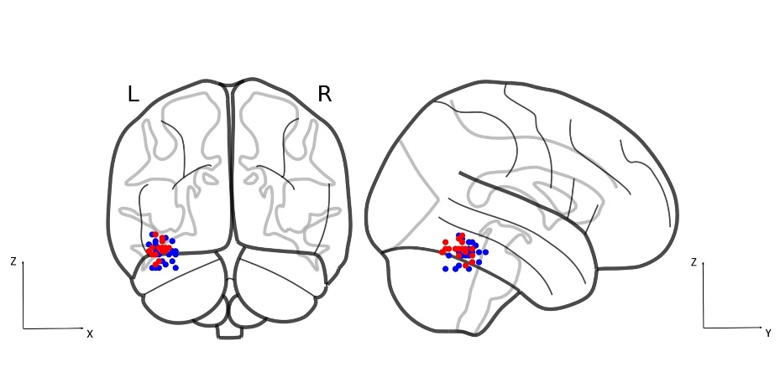
Figure S1. Individual peaks of the reading-related activations, blue – blind group, red – sighted group, L – left hemisphere, R – right hemisphere.
Automatic whole-word vs serial reading activations
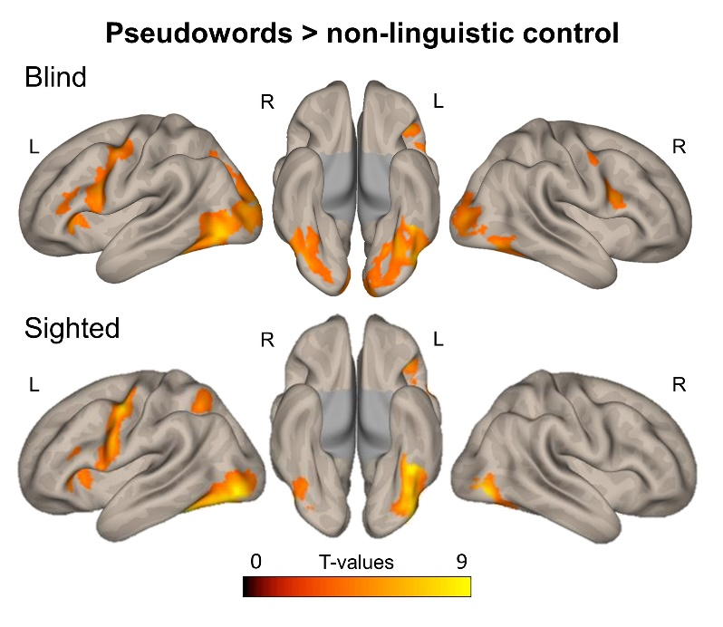
Figure S3. Pseudowords reading specific (pseudowords > non-linguistic control) activations, L – left hemisphere, R – right hemisphere. All contrasts at voxelwise p < 0.001 and clusterwise p < 0.05 FWE corrected.
Table S4. Reading specific activations (pseudowords > non-linguistic control), x, y, z – cluster peak coordinates, t – value of the t-statistics from the peak structures spanning more than 50 voxels are reported in each cluster.
Brain region | Hemisphere | x | y | z | t | # voxels | p_{cluster} FWE
Blind
Middle Occipital Gyrus, Fusiform Gyrus, Inferior Occipital Gyrus, Calcarine, Superior Occipital Gyrus, Cerebellum, Lingual Gyrus, Inferior Temporal Gyrus, Middle Temporal Gyrus, Cuneus, Superior Parietal Lobule, Inferior Parietal Lobule | L/R | -42 | -70 | -8 | 7.45 | 7418 | < 0.001
Precentral Gyrus, Inferior Frontal Gyrus (p. triangularis, opercularis, orbitalis), Insula, Postcentral Gyrus | L | -34 | 28 | 2 | 6.32 | 2113 | < 0.001
Inferior Frontal Gyrus (p. opercularis), Precentral Gyrus | R | 44 | 4 | 24 | 5.55 | 625 | 0.007
Sighted
Inferior Occipital Gyrus, Fusiform Gyrus, Middle Occipital Gyrus, Inferior Temporal Gyrus, Cerebellum | L | -40 | -80 | -8 | 8.87 | 1908 | < 0.001
Precentral Gyrus, Postcentral Gyrus, Inferior Frontal Gyrus (p.opercularis) | L | -50 | -6 | 50 | 7.53 | 1301 | < 0.001
Inferior Occipital Gyrus, Inferior Temporal Gyrus, Fusiform Gyrus | R | 46 | -74 | -6 | 7.46 | 387 | 0.004
Supplementary Motor Area | L/R | -4 | 0 | 56 | 6.16 | 255 | 0.026
Superior Parietal Gyrus, Inferior Parietal Lobule | L | -24 | -54 | 48 | 6.13 | 270 | 0.021
Inferior Frontal Gyrus (p. triangularis, orbitalis), Insula | L | -38 | 28 | 0 | 6.11 | 509 | 0.001
Blind & Sighted (conjunction)
Inferior Occipital Gyrus, Fusiform Gyrus, Middle Occipital Gyrus, Inferior Temporal Gyrus, Cerebellum | L | -44 | -72 | -12 | 6.87 | 1512 | < 0.001
Precentral Gyrus, Inferior Frontal Gyrus (p. opercularis), Postcentral Gyrus | L | -44 | -4 | 52 | 5.90 | 801 | 0.001
Inferior Frontal Gyrus (p. triangularis, orbitalis), Insula | L | -36 | 28 | 0 | 5.82 | 387 | 0.021
Blind > Sighted
Calcarine, Lingual Gyrus, Superior Occipital Gyrus, Cerebellum, Cuneus, Middle Occipital Gyrus, Fusiform Gyrus | L/R | -8 | -94 | 16 | 6.47 | 4208 | < 0.001
Sighted > Blind
No suprathreshold clusters
Sighted
Pseudowords > words
Inferior Temporal Gyrus, Inferior Occipital Gyrus, Fusiform Gyrus | L | -46 | -62 | -12 | 8.62 | 595 | < 0.001
Precentral Gyrus, Inferior Frontal Gyrus (p. opercularis) | L | -48 | 10 | 14 | 7.35 | 818 | < 0.001
Inferior Parietal Lobule, Superior Parietal Lobule | L | -36 | -56 | 56 | 6.49 | 893 | < 0.001
Inferior Parietal Lobule, Superior Parietal Lobule | R | 32 | -61 | 28 | 5.01 | 407 | 0.003

Table S5. Speech sensitive activations (words > baseline), x, y, z – cluster peak coordinates, t – value of the t-statistics from the peak, structures spanning more than 50 voxels are reported in each cluster.
Brain region | Hemisphere | x | y | z | t | # voxels | p_{cluster} FWE
Blind
Superior Temporal Gyrus, Middle Temporal Gyrus, Fusiform Gyrus, Lingual Gyrus, Calcarine, Cerebellum, Inferior Occipital Gyrus, Middle Occipital Gyrus, Rolandic Operculum, Inferior Frontal Gyrus (p. triangularis, orbitalis, opercularis), Inferior Temporal Gyrus, Insula, Heschl Gyrus, Supramarginal Gyrus, Cuneus, Postcentral Gyrus, Angular Gyrus | L | -60 | -50 | 10 | 20.48 | 9400 | < 0.001
Superior Temporal Gyrus, Middle Temporal Gyrus, Fusiform Gyrus, Rolandic Operculum, Inferior Frontal Gyrus (p. triangularis, opercularis, orbitalis), Superior Temporal Pole, Insula, Heschl Gyrus, Cerebellum, Inferior Occipital Gyrus, Inferior Temporal Gyrus, Middle Occipital Gyrus, Supramarginal Gyrus, Postcentral Gyrus | R | 62 | -12 | 0 | 18.07 | 6302 | < 0.001
Inferior Frontal Gyrus (p. triangularis, opercularis), Precentral Gyrus | R | 50 | 18 | 25 | 5.87 | 338 | 0.016
Sighted
Superior Temporal Gyrus, Middle Temporal Gyrus, Rolandic Operculum, Superior Temporal Pole, Insula, Heschl Gyrus, Supramarginal Gyrus | R | 60 | -24 | 6 | 25.17 | 5138 | < 0.001
Superior Temporal Gyrus, Middle Temporal Gyrus, Rolandic Operculum, Superior Temporal Pole, Insula, Heschl Gyrus, Supramarginal Gyrus, Postcentral Gyrus | L | -58 | -26 | 4 | 21.49 | 5445 | < 0.001
Blind & Sighted (conjunction)
Superior Temporal Gyrus, Middle Temporal Gyrus, Rolandic Operculum, Superior Temporal Pole, Insula, Heschl Gyrus, Supramarginal Gyrus | R | 58 | -26 | 4 | 16.43 | 4191 | < 0.001
Superior Temporal Gyrus, Middle Temporal Gyrus, Rolandic Operculum, Heschl Gyrus, Superior Temporal Pole, Insula, Supramarginal Gyrus | L | -60 | -24 | 2 | 15.01 | 4418 | < 0.001

Table S6. Speech specific activations (words > non-linguistic control), x, y, z – cluster peak coordinates, t – value of the t-statistics from the peak, structures spanning more than 50 voxels are reported in each cluster.
Brain region | Hemisphere | x | y | z | t | # voxels | p_{cluster} FWE
Blind
Superior Temporal Gyrus, Middle Temporal Gyrus | R | 54 | -28 | 2 | 11.39 | 1278 | < 0.001
Middle Temporal Gyrus, Superior Temporal Gyrus | L | -54 | -36 | 2 | 10.98 | 1398 | < 0.001
Fusiform Gyrus, Inferior Temporal Gyrus | L | -38 | -48 | -20 | 5.83 | 279 | 0.048
Sighted
Middle Temporal Gyrus, Superior Temporal Gyrus, Superior Temporal Pole | L | -58 | -6 | -4 | 13.71 | 2053 | < 0.001
Superior Temporal Gyrus, Middle Temporal Gyrus, Superior Temporal Pole | R | 54 | -26 | -2 | 11.91 | 1642 | < 0.001
Blind & Sighted (conjunction)
Superior Temporal Gyrus, Middle Temporal Gyrus, Superior Temporal Pole | R | 56 | -26 | 0 | 10.39 | 1089 | < 0.001
Middle Temporal Gyrus, Superior Temporal Gyrus | L | -58 | -24 | 0 | 7.82 | 1259 | < 0.001
Blind > Sighted
Fusiform Gyrus, Middle Occipital Gyrus, Inferior Occipital Gyrus, Lingual Gyrus, Inferior Temporal Gyrus | L | -40 | -78 | -2 | 5.93 | 1108 | < 0.001
Sighted > Blind
No suprathreshold clusters

Functional connectivity results
Figure S4. Task related functional connectivity between the left vOT seed (marked in red) and the whole brain during words reading and speech processing.
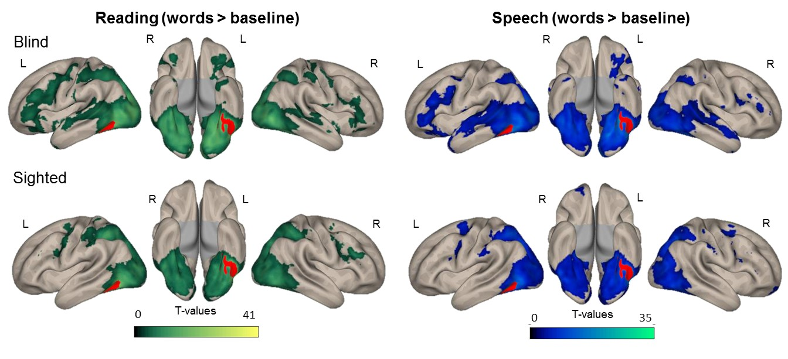
Table S7. Regions of significant correlation with the left vOT area in the blind, x, y, z – cluster peak coordinates, t – value of the t-statistics from the peak, structures spanning more than 50 voxels are reported in each cluster.
Brain region | Hemisphere | x | y | z | t | # voxels | p_{cluster} FWE
Reading > Speech processing
Superior Frontal Gyrus, Middle Frontal Gyrus | R | 36 | 60 | -8 | 7.22 | 197 | 0.002
Reading-related connectivity
Middle Occipital Gyrus, Middle Temporal Gyrus, Lingual Gyrus, Calcarine, Fusiform Gyrus, Inferior Frontal Gyrus (p. triangularis, orbitalis, opercularis), Cerebellum, Inferior Parietal Lobule, Superior Occipital Gyrus, Inferior Temporal Gyrus, Inferior Occipital Gyrus, Cuneus, Superior Parietal Gyrus, Postcentral Gyrus, Middle Frontal Gyrus, Precentral Gyrus, Superior Temporal Gyrus, Superior Temporal Pole, Hippocampus, Parahippocampal Gyrus, Amygdala, Putamen, Thalamus, Pallidum, Insula, Middle Temporal Pole, Precuneus, Supramarginal Gyrus | L/R | -36 | -54 | -10 | 44.77 | 58 682 | < 0.001
Postcentral Gyrus | L | -52 | -12 | 16 | 5.88 | 159 | 0.022
Precentral Gyrus | R | 10 | -30 | 68 | 4.80 | 203 | 0.006
Speech processing related connectivity
Middle Temporal Gyrus, Middle Occipital Gyrus, Lingual Gyrus, Fusiform Gyrus, Calcarine, Inferior Frontal Gyrus (p. triangularis, orbitalis, opercularis), Cerebellum, Superior Temporal Gyrus, Inferior Temporal Gyrus, Superior Occipital Gyrus, Superior Temporal Gyrus, Inferior Occipital Gyrus, Cuneus, Hippocampus, Superior Parietal Gyrus, Superior Temporal Pole, Parahippocampal Gyrus, Middle Frontal Gyrus, Inferior Parietal Lobule, Precentral Gyrus, Angular Gyrus, Amygdala, Precuneus, Middle Temporal Pole, Insula, Putamen, Supramarginal Gyrus, Thalamus, Postcentral Gyrus, Rolandic Operculum, Heschl Gyrus, Pallidum | L/R | -36 | -56 | -14 | 36.68 | 44 113 | < 0.001
Inferior Frontal Gyrus (p. triangularis, opercularis) | R | 52 | 38 | 18 | 5.85 | 822 | < 0.001
Precentral Gyrus, Middle Frontal Gyrus | L | -38 | -2 | 64 | 5.66 | 353 | < 0.001

Table S8. Regions of significant correlation with the left vOT area in the sighted, x, y, z – cluster peak coordinates, t – value of the t-statistics from the peak, structures spanning more than 50 voxels are reported in each cluster.
Brain region | Hemisphere | x | y | z | t | # voxels | p_{cluster} FWE
Speech processing > Reading
Lingual Gyrus, Precuneus | L | -14 | -40 | -2 | 5.40 | 116 | 0.009
Reading-related connectivity
Middle Occipital Gyrus, Fusiform Gyrus, Inferior Parietal Lobule, Lingual Gyrus, Superior Occipital Gyrus, Superior Parietal Lobule, Cerebellum, Inferior Temporal Gyrus, Inferior Occipital Gyrus, Middle Temporal Gyrus, Calcarine, Cuneus, Postcentral Gyrus, Precuneus, Cuneus, Angular Gyrus, Supramarginal Gyrus, Postcentral Byrus, Parahippocampal Gyrus | L/R | -38 | -58 | -10 | 41.02 | 30 333 | < 0.001
Middle Frontal Gyrus, Inferior Frontal Gyrus (p. opercularis, triangularis), Precentral Gyrus | R | 56 | 14 | 38 | 9.42 | 1729 | < 0.001
Superior Frontal Gyrus, Precentral Gyrus | L | -24 | -12 | 44 | 7.20 | 246 | < 0.001
Inferior Frontal Gyrus (p. triangularis), Middle Frontal Gyrus | L | -48 | 48 | 12 | 6.60 | 376 | < 0.001
Precentral Gyrus, Inferior Frontal Gyrus (p. opercularis) | L | -52 | 0 | 42 | 5.80 | 663 | < 0.001
Superior Frontal Gyrus | R | 30 | -2 | 64 | 5.09 | 197 | 0.001
Speech processing related connectivity
Middle Occipital Gyrus, Fusiform Gyrus, Lingual Gyrus, Superior Parietal Gyrus, Superior Occipital Gyrus, Inferior Occipital Gyrus, Cerebellum, Calcarine, Inferior Parietal Lobule, Inferior Temporal Gyrus, Middle Temporal Gyrus, Cuneus, Precuneus, Parahippocampal Gyrus, Supramarginal Gyrus, Angular Gyrus, Postcentral Gyrus | L/R | -38 | -58 | -10 | 33.20 | 26 673 | < 0.001
Superior Frontal Gyrus, Precentral Gyrus, Middle Frontal Gyrus | L | -28 | -2 | 52 | 7.80 | 610 | < 0.001
Superior Frontal Gyrus, Middle Frontal Gyrus, Precentral Gyrus | R | 32 | -2 | 52 | 7.53 | 758 | < 0.001
Inferior Frontal Gyrus (p. triangularis) | R | 54 | 38 | 8 | 7.03 | 166 | 0.002
Inferior Frontal Gyrus (p.opercularis), Precentral Gyrus | R | 44 | 12 | 28 | 5.95 | 369 | < 0.001
Precentral Gyrus, Inferior Frontal Gyrus (p. opercularis) | L | -42 | 0 | 30 | 5.72 | 352 | < 0.001
Anterior Orbital Gyrus | R | 24 | 62 | -16 | 5.34 | 173 | 0.001

Table S9. Group differences in functional connectivity with the left vOT area, x, y, z – cluster peak coordinates, t – value of the t-statistics from the peak, structures spanning more than 50 voxels are reported in each cluster.
Brain region | Hemisphere | x | y | z | t | # voxels | p_{cluster} FWE
Reading-related connectivity
Blind > Sighted
Lingual Gyrus, Calcarine, Fusiform Gyrus, Middle Occipital Gyrus, Superior Occipital Gyrus, Cerebellum, Cuneus, Inferior Occipital Gyrus, Middle Temporal Gyrus, Hippocampus, Middle Occipital Gyrus, Precuneus, Thalamus | L/R | -36 | -52 | -10 | 7.69 | 8945 | < 0.001
Cerebellum | R | 14 | -74 | -26 | 4.75 | 362 | < 0.001
Reading-related connectivity
Sighted > Blind
Superior Parietal Lobule, Precuneus | R | 24 | -64 | 64 | 5.87 | 679 | < 0.001
Middle Frontal Gyrus, Superior Frontal Gyrus | L | -32 | 32 | 32 | 5.36 | 242 | 0.001
Middle Frontal Gyrus | R | 30 | 34 | 30 | 4.63 | 203 | 0.004
Speech processing related
Blind > Sighted
Lingual Gyrus, Calcarine, Fusiform Gyrus, Middle Occipital Gyrus, Cerebellum, Inferior Occipital Gyrus, Superior Occipital Gyrus, Cuneus | L | -36 | -56 | -14 | 6.27 | 3109 | < 0.001
Middle Temporal Gyrus | L | -48 | -36 | 2 | 5.88 | 1125 | < 0.001
Cerebellum | R | 12 | -80 | -24 | 5.23 | 186 | 0.004
Inferior Frontal Gyrus (p. triangularis, orbitalis) | L | -46 | 44 | 0 | 5.19 | 326 | < 0.001
Superior Temporal Gyrus, Middle Temporal Gyrus | R | 52 | -40 | 12 | 5.12 | 439 | < 0.001
Middle Temporal Gyrus | L | -64 | -16 | -8 | 5.01 | 244 | 0.001
Cerebellum | R | 16 | -60 | -32 | 4.49 | 134 | 0.024
Calcarine, Superior Occipital Gyrus | R | 20 | -86 | 10 | 4.30 | 141 | 0.019
Speech processing related
Sighted > Blind
Superior Frontal Gyrus | R | 28 | 62 | -8 | 5.29 | 275 | < 0.001
Precuneus, Superior Parietal Lobule | R | 12 | -64 | 64 | 4.94 | 308 | < 0.001
Superior Frontal Gyrus | R | 28 | -2 | 52 | 4.71 | 212 | 0.002
Superior Frontal Gyrus | L | -22 | -8 | 62 | 4.60 | 166 | 0.008

Table S10. Speech-reading convergence of the language specific contrasts (words > non-linguistic control), x,y,z – cluster peak coordinates, t – value of the t-statistics from the peak.
Brain region | Hemisphere | x | y | z | t | # voxels | p_{cluster} FWE
Blind
Fusiform Gyrus, Inferior Temporal Gyrus, Inferior Occipital Gyrus | L | -40 | -46 | -20 | 6.14 | 311 | 0.061
Fusiform Gyrus, Inferior Temporal Gyrus, Cerebellum | R | 42 | -52 | -16 | 5.25 | 85 | 0.505
Middle Occipital Gyrus, Inferior Occipital Gyrus | L | -46 | -78 | 4 | 3.57 | 52 | 0.683
Middle Temporal Gyrus | L | -50 | -54 | 2 | 3.81 | 51 | 0.689
Inferior Occipital Gyrus | R | 46 | -76 | -4 | 3.31 | 2 | 0.970
Sighted
Precentral Gyrus, Postcentral Gyrus | L | -48 | -4 | 52 | 6.05 | 164 | 0.105
Supplementary Motor Area | L/R | -4 | -2 | 62 | 4.01 | 118 | 0.228

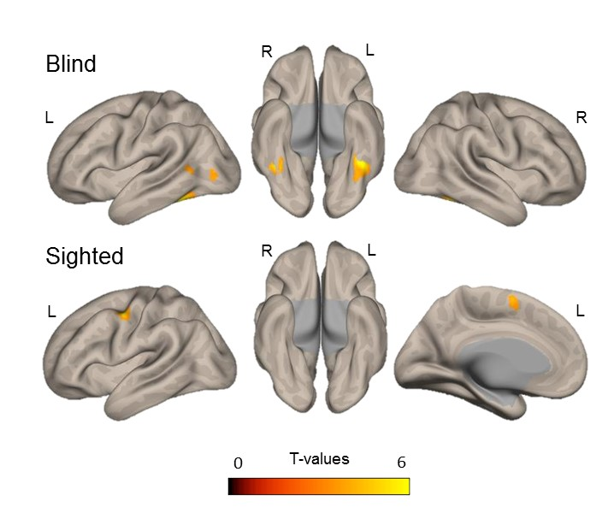
Figure S5. Speech-reading convergence of the language specific contrasts (words > non-linguistic control), in blind and sighted participants, L – left hemisphere, R – right hemisphere. All contrasts at voxelwise p < 0.001 uncorrected.

