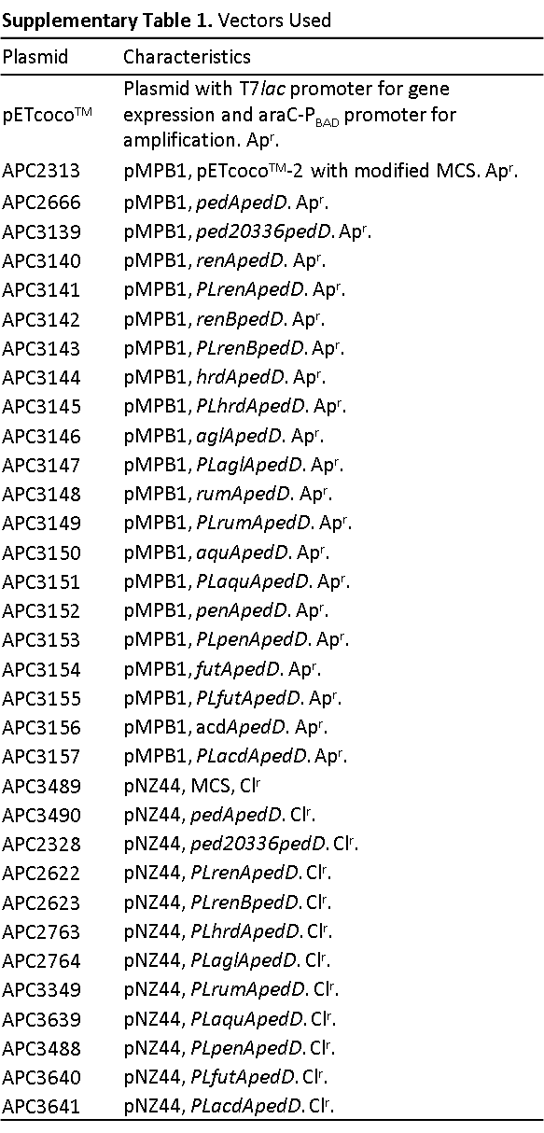
*MCS, multiple cloning site. Ap^{r}, ampicillin resistant. Cl^{r}, chloramphenicol resistance. PL, pediocin PA-1 leader sequence fusion gene.

