Title
Risk to the supply of ecosystem services across aquatic ecosystems

Authors
Fiona Culhane*, Heliana Teixeira, Antonio J A Nogueira, Florian Borgwardt, Daniel Trauner, Ana Lillebø, GerJan Piet, Mathias Kuemmerlen, Hugh McDonald, Tim O’Higgins, Ana Luisa Barbosa, Jan Tjalling van der Wal, Alejandro Iglesias-Campos, Juan Arevalo –Torres, Julian Barbière and Leonie A. Robinson
*Corresponding author

Appendix

Table A1 Ecosystem Component Classification used in the study from EUNIS (Davies et al., 2004) and (Teixeira et al., 2019, this issue)
Realm | Component (Biotic Group or Lowest EUNIS Level Available) | Description
Biotic Group (Mobile) | Amphibian | Adults and juveniles
Biotic Group (Mobile) | Birds | Adults and juveniles
Biotic Group (Mobile) | Fish & Cephalopods | Adults and juveniles
Biotic Group (Mobile) | Insects | Adult insects
Biotic Group (Mobile) | Mammals | Adults and juveniles
Biotic Group (Mobile) | Reptiles | Adults and juveniles
Coastal | A1 | Littoral rock and other hard substrata
Coastal | A2 | Littoral sediment
Coastal | A2.2 | Littoral sand and muddy sand
Coastal | A3 | Infralittoral rock and other hard substrata
Coastal | A4 | Circalittoral rock and other hard substrata
Coastal | A5 | Sublittoral sediment
Coastal | A5.2 | Sublittoral sand
Coastal | A5.4 | Sublittoral mixed sediments
Coastal | A6 | Deep-sea bed
Coastal | A7 | Pelagic water column
Coastal-Terrestrial  (CoastalTerr) | B | Coastal habitats
Coastal-Terrestrial  (CoastalTerr) | B1 | Coastal dunes and sandy shores
Coastal-Terrestrial  (CoastalTerr) | B1.3 | Shifting coastal dunes
Coastal-Terrestrial  (CoastalTerr) | B1.4 | Coastal stable dune grassland (grey dunes)
Coastal-Terrestrial  (CoastalTerr) | B1.6 | Coastal dune scrub
Coastal-Terrestrial  (CoastalTerr) | B1.7 | Coastal dune woods
Coastal-Terrestrial  (CoastalTerr) | B1.8 | Moist and wet dune slacks
Coastal-Terrestrial  (CoastalTerr) | B2 | Coastal shingle
Coastal-Terrestrial  (CoastalTerr) | B3 | Rock cliffs, ledges and shores, including the supralittoral
Inlets Transitional | A1 | Littoral rock and other hard substrata
Inlets Transitional | A2 | Littoral sediment
Inlets Transitional | A2.2 | Littoral sand and muddy sand
Inlets Transitional | A2.3 | Littoral mud
Inlets Transitional | A2.5 | Coastal saltmarshes and saline reedbeds
Inlets Transitional | A2.6 | Littoral sediments dominated by aquatic angiosperms
Inlets Transitional | A3 | Infralittoral rock and other hard substrata
Inlets Transitional | A4 | Circalittoral rock and other hard substrata
Inlets Transitional | A5 | Sublittoral sediment
Inlets Transitional | A5.2 | Sublittoral sand
Inlets Transitional | A5.3 | Sublittoral mud
Inlets Transitional | A6 | Deep-sea bed
Inlets Transitional | A7 | Pelagic water column
Inlets Transitional | J5 | Highly artificial man-made waters and associated structures
Inlets Transitional | J5.1 | Highly artificial saline and brackish standing waters
Inlets Transitional | X01 | Estuaries
Lakes | C1 | Surface standing waters
Lakes | C1.1 | Permanent oligotrophic lakes, ponds and pools
Lakes | C1.2 | Permanent mesotrophic lakes, ponds and pools
Lakes | C1.3 | Permanent eutrophic lakes, ponds and pools
Oceanic | A6 | Deep-sea bed
Oceanic | A7 | Pelagic water column
Other (Agricultural, Terrestrial-Natural, Urban) | F | Heathland, scrub and tundra
Other (Agricultural, Terrestrial-Natural, Urban) | F5 | Maquis, arborescent matorral and thermo-Mediterranean brushes
Other (Agricultural, Terrestrial-Natural, Urban) | F7 | Spiny Mediterranean heaths (phrygana, hedgehog-heaths and related coastal cliff vegetation)
Other (Agricultural, Terrestrial-Natural, Urban) | FB | Shrub plantations
Other (Agricultural, Terrestrial-Natural, Urban) | G1.7 | Thermophilous deciduous woodland
Other (Agricultural, Terrestrial-Natural, Urban) | G5 | Lines of trees, small anthropogenic woodlands, recently felled woodland, early-stage woodland and coppice
Other (Agricultural, Terrestrial-Natural, Urban) | G5.1 | Lines of trees
Other (Agricultural, Terrestrial-Natural, Urban) | G5.4 | Small coniferous anthropogenic woodlands
Other (Agricultural, Terrestrial-Natural, Urban) | I | Regularly or recently cultivated agricultural horticultural or domestic habitats
Other (Agricultural, Terrestrial-Natural, Urban) | I1 | Arable land and market gardens
Other (Agricultural, Terrestrial-Natural, Urban) | I1.1 | Intensive unmixed crops
Other (Agricultural, Terrestrial-Natural, Urban) | I1.4 | Inundated or inundatable croplands including rice fields
Other (Agricultural, Terrestrial-Natural, Urban) | I1.5 | Bare tilled fallow or recently ab
Other (Agricultural, Terrestrial-Natural, Urban) | J | Constructed, industrial and other artifical habitats
Other (Agricultural, Terrestrial-Natural, Urban) | J1 | Buildings of cities towns and villages
Other (Agricultural, Terrestrial-Natural, Urban) | J2 | Low density buildings
Other (Agricultural, Terrestrial-Natural, Urban) | X10 | Mosaic landscapes with a woodland element bocages
Riparian | E | Grasslands and lands dominated by forbs, mosses or lichens
Riparian | E1 | Dry grasslands
Riparian | E2 | Mesic grasslands
Riparian | E3 | Seasonally wet and wet grasslands
Riparian | E5 | Woodland, forest and other wooded land
Riparian | E5.4 | Moist or wet tall-herb and fern fringes and meadows
Riparian | E6 | Inland salt steppes
Riparian | E7 | Sparsely wooded grasslands
Riparian | G | Woodland, forest and other wooded land
Riparian | G1 | Broadleaved deciduous woodland
Riparian | G1.1 | Riparian and gallery woodland, with dominant alder, birch, poplar or willow
Riparian | G1.2 | Mixed riparian floodplain and gallery woodland
Riparian | G1.3 | Mediterranean riparian woodland
Riparian | G2 | Broadleaved evergreen woodland
Riparian | G3 | Coniferous woodland
Riparian | G4 | Mixed deciduous and coniferous woodland
Riparian | G5 | Lines of trees, small anthropogenic woodlands, recently felled woodland, early-stage woodland and coppice
Riparian | Riparian | Riparian
Rivers | C2 | Surface running waters
Rivers | C2.2 | Permanent non-tidal, fast, turbulent watercourses
Rivers | C2.3 | Permanent non-tidal, smooth-flowing watercourses
Shelf | A3 | Infralittoral rock and other hard substrata
Shelf | A4 | Circalittoral rock and other hard substrata
Shelf | A5 | Sublittoral sediment
Shelf | A5.2 | Sublittoral sand
Shelf | A7 | Pelagic water column
Wetlands | C3 | Littoral zone of inland surface waterbodies
Wetlands | C3.1 | Species rich helophyte beds
Wetlands | C3.2 | Water-fringing reedbeds and tall helophytes other than canes
Wetlands | C3.4 | Species-poor beds of low-growing water-fringing or amphibious vegetation
Wetlands | C3.5 | Periodically inundated shores with pioneer and ephemeral vegetation
Wetlands | C3.6 | Unvegetated or sparsely vegetated shores with soft or mobile sediments
Wetlands | C3.7 | Unvegetated or sparsely vegetated shores with non-mobile substrates
Wetlands | D5 | Sedge and reedbeds, normally without free-standing water
Wetlands | E3 | Seasonally wet and wet grasslands

Table A2 Ecosystem components and realms found in each case study
Realm | Component (Biotic Group or Lowest Eunis Level Available) | North Sea | Ria de Aveiro | Azores | Swiss Plateau | Lough Erne | Danube | Andalucía/Morocco
Mobile Group | Amphibian |  | x |  | x | x | x | x
Mobile Group | Birds | x | x | x | x | x | x | x
Mobile Group | Fish & Cephalopods | x | x | x | x | x | x | x
Mobile Group | Insects |  | x |  | x | x | x | x
Mobile Group | Mammals | x | x | x | x | x | x | x
Mobile Group | Reptiles | x | x | x | x |  | x | x
Coastal | A1 | x |  | x |  |  |  | x
Coastal | A2 | x |  | x
Coastal | A2.2 |  | x
Coastal | A3 | x |  | x
Coastal | A4 | x |  | x
Coastal | A5 | x |  | x
Coastal | A5.2 |  | x
Coastal | A5.4 |  | x
Coastal | A6 | x |  | x
Coastal | A7 | x | x | x
Coastal-Terrestrial  (CoastalTerr) | B |  |  |  |  |  |  | x
Coastal-Terrestrial  (CoastalTerr) | B1 | x |  |  |  |  |  | x
Coastal-Terrestrial  (CoastalTerr) | B1.3 |  | x
Coastal-Terrestrial  (CoastalTerr) | B1.4 |  | x
Coastal-Terrestrial  (CoastalTerr) | B1.6 |  | x
Coastal-Terrestrial  (CoastalTerr) | B1.7 |  | x
Coastal-Terrestrial  (CoastalTerr) | B1.8 |  | x
Coastal-Terrestrial  (CoastalTerr) | B2 | x
Coastal-Terrestrial  (CoastalTerr) | B3 | x |  |  |  |  |  | x
Inlets Transitional | A1 | x
Inlets Transitional | A2 | x |  |  |  |  |  | x
Inlets Transitional | A2.2 |  | x
Inlets Transitional | A2.3 |  | x
Inlets Transitional | A2.5 |  | x
Inlets Transitional | A2.6 |  | x
Inlets Transitional | A3 | x
Inlets Transitional | A4 | x
Inlets Transitional | A5 | x
Inlets Transitional | A5.2
Inlets Transitional | A5.3 |  | x
Inlets Transitional | A6 | x
Inlets Transitional | A7 | x | x
Inlets Transitional | J5 |  |  |  |  |  |  | x
Inlets Transitional | J5.1 |  | x
Inlets Transitional | X01 |  |  |  |  |  |  | x
Lakes | C1 |  | x |  |  |  |  | x
Lakes | C1.1 |  |  |  |  |  | x
Lakes | C1.2 |  |  |  |  |  | x
Lakes | C1.3 |  | x |  |  | x | x
Oceanic | A6 | x |  | x |  |  |  | x
Oceanic | A7 | x |  | x |  |  |  | x
Other (Agricultural, Terrestrial-Natural, Urban) | F |  |  |  |  |  |  | x
Other (Agricultural, Terrestrial-Natural, Urban) | F5 |  |  |  |  |  |  | x
Other (Agricultural, Terrestrial-Natural, Urban) | F7 |  |  |  |  |  |  | x
Other (Agricultural, Terrestrial-Natural, Urban) | FB |  |  |  |  |  |  | x
Other (Agricultural, Terrestrial-Natural, Urban) | G1.7 |  | x
Other (Agricultural, Terrestrial-Natural, Urban) | G5 |  |  |  |  | x
Other (Agricultural, Terrestrial-Natural, Urban) | G5.1 |  | x |  |  |  | x
Other (Agricultural, Terrestrial-Natural, Urban) | G5.4
Other (Agricultural, Terrestrial-Natural, Urban) | I |  |  |  |  |  |  | x
Other (Agricultural, Terrestrial-Natural, Urban) | I1 |  |  |  | x | x | x | x
Other (Agricultural, Terrestrial-Natural, Urban) | I1.1 |  | x |  |  |  | x
Other (Agricultural, Terrestrial-Natural, Urban) | I1.4 |  | x
Other (Agricultural, Terrestrial-Natural, Urban) | I1.5 |  | x |  |  |  | x
Other (Agricultural, Terrestrial-Natural, Urban) | J |  |  |  |  |  |  | x
Other (Agricultural, Terrestrial-Natural, Urban) | J1 |  |  |  |  | x | x
Other (Agricultural, Terrestrial-Natural, Urban) | J2 |  | x |  |  | x | x | x
Other (Agricultural, Terrestrial-Natural, Urban) | X10 |  | x |  |  |  | x
Riparian | E |  |  |  |  |  |  | x
Riparian | E1 |  |  |  |  |  | x | x
Riparian | E2 |  |  |  | x | x | x | x
Riparian | E3 |  |  |  | x |  |  | x
Riparian | E5 |  |  |  | x |  | x
Riparian | E5.4 |  | x
Riparian | E6 |  |  |  |  |  |  | x
Riparian | E7 |  |  |  | x |  | x | x
Riparian | G |  |  |  |  |  |  | x
Riparian | G1 |  | x |  | x | x | x | x
Riparian | G1.1 |  | x
Riparian | G1.2 |  | x
Riparian | G1.3 |  | x
Riparian | G2 |  |  |  |  |  |  | x
Riparian | G3 |  |  |  | x | x | x | x
Riparian | G4 |  |  |  | x |  | x | x
Riparian | G5 |  |  |  | x |  |  | x
Riparian | Riparian |  | x
Rivers | C2 |  |  |  |  |  |  | x
Rivers | C2.2 |  |  |  | x |  | x
Rivers | C2.3 |  | x |  | x | x | x
Shelf | A3 |  |  |  |  |  |  | x
Shelf | A4 | x |  |  |  |  |  | x
Shelf | A5 | x |  |  |  |  |  | x
Shelf | A5.2 |  | x
Shelf | A7 | x | x |  |  |  |  | x
Wetlands | C3 |  |  |  |  |  |  | x
Wetlands | C3.1 |  |  |  |  |  | x
Wetlands | C3.2 |  | x |  |  |  | x
Wetlands | C3.4 |  |  |  |  |  | x
Wetlands | C3.5 |  |  |  |  |  | x
Wetlands | C3.6 |  |  |  |  |  | x
Wetlands | C3.7 |  |  |  |  |  | x
Wetlands | D5 |  |  |  |  | x |  | x
Wetlands | E3 |  |  |  |  | x | x | x

Table A3 List of primary activities considered in the impact risk assessment. From Borgwardt et al. (2019, this issue) and adapted from (EC, 1992, EC, 2006, White et al., 2013, Connor, 2015, Smith et al., 2016)
Type of Activity | Primary Activity | Activity Description (not exhaustive)
Agriculture & Forestry | Agriculture | Cultivation of crops, maintenance of pasture, and keeping of livestock (Irrigation, drainage, change of riparian habitat, alteration of channels, atmospheric emissions, runoff of nutrients).
Agriculture & Forestry | Forestry | Cultivation of forestry (Irrigation, drainage, change of riparian habitat, alteration of channels).
Aquaculture | Aquaculture | Both ex-situ and in-situ aquaculture. Fin-fish, macro-algae, shellfish, and freshwater aquaculture (water abstraction, waste discharge, waste products, anti-fouling, predator control, disease and disease control, infrastructure effects on local hydrography, escapees, litter, anchoring/mooring of boats, interaction with seafloor during set-up of infrastructure, loss of gear).
Environmental Management | Flood and coastline management | Hydro-morphological alterations to the system: Marine coastal defences like sea walls, breakwaters, groynes, and artificial reefs. Beach replenishment. Freshwater flood protection - both artificial and natural measures. Levees, dykes, artificial flood retention areas, morphological changes, erosion control and improved infiltration, restoration/reconnection of floodplains and wetlands.
Environmental Management | Dredging | Capital and maintenance dredging - extraction of substrate and spoil/waste disposal.
Environmental Management | Land claim or conversion | Land claim or conversion - construction and operation (habitat change, smothering, increased turbidity, noise, atmospheric emissions, changes in hydrography).
Environmental Management | Watercourse management | Waterway construction, alteration of water levels, culverting lagoons, transversal instream structures (weirs, culverts, other).
Environmental Management | Species Management | Species control: Removal/control of invasive species, stocking and moving fish for conservational purposes.
Fishing | Fishing - benthic towed gears | Benthic trawls and dredges, suction/hydraulic dredges, and demersal fishing (interaction with seafloor, catch, bycatch, waste products, anti-fouling, ballast water, litter, lost gear, atmospheric emissions, collisions).
Fishing | Fishing - fixed gears | Gillnets/other nets/lines, potting and creeling (catch, bycatch, waste products, interaction with seafloor, atmospheric emissions, litter, lost gear, antifoulants)
Fishing | Fishing - pelagic towed gears | Pelagic trawls (catch, bycatch, waste products, atmospheric emissions, collisions, anti-fouling, ballast water, litter, lost gear).
Manufacturing (land-based) - operations | Land -based manufacturing | Industry with effluent discharge and abstraction of water.
Mining, extraction of materials | Mining - other non-renewable | Sand/gravel/rocks/mineral/maerl/inorganic mine and particular waste - extraction and spoil/waste disposal (habitat change, interaction with sediment, contaminant release, smothering, removal of habitat-structuring species). Extraction of peat (sedimentation).
Non-Renewable Energy | Oil and Gas - offshore | Exploration (seismic surveys, exploratory drilling and anchoring, oil spills), construction (drilling, anchoring, construction of wellheads, laying pipelines, oil spills), decommissioning (anchoring, oil spills, removal of infrastructure).
Non-Renewable Energy | Power stations | Land-based power stations - construction and operation. Habitat change, sealing, increased turbidity, noise, atmospheric emissions, abstraction of water, thermal discharge of cooling water, localised effects on hydrography, waste.
Renewable Energy | Tidal and wave energy | Construction and operation of tidal barrages, sluices and wave energy (interaction with seafloor, habitat change (upstream and downstream) and localised sealing of habitat, barrier to movement for migratory anadromous or catadromous species, change in tidal (and emergence) regime, barrier to movement for migratory anadromous or catadromous species, localised changes in hydrography, cable laying - localised habitat change, noise, localised electro-magnetic changes around cables, localised change in flow of water).
Renewable Energy | Wind energy | Construction and operation of wind farms (installation of turbines on seafloor includes interaction with seafloor, habitat change and sealing, laying cables, active cables on seafloor - electromagnetic changes, moving turbines - collisions, boats servicing and maintaining farms, interference with birds, visual disturbance).
Renewable Energy | Hydropower | Construction and operation of run-of-the-river and hydro-peaking power stations (interruption of river continuity, morphological alteration, disconnection of riparian area, altered water levels and hydrology, water abstraction, residual flow, hydro-peaking, dams, impoundments, other infrastructure, changes in sedimentation pattern, water and sediment retention, thermal change).
Research | Research | Specific to activity (study design & equipment) but can include: interaction with sediment, biota, catch, bycatch, atmospheric emissions, collisions, anti-fouling, ballast water exchange, litter, oils leaching, Mooring/anchoring/beaching/launching.
Residential & Commercial Development | Ports and marinas | Construction and operation of marinas and dock/port facilities (habitat change, sealing, interaction with sediment, smothering, increased turbidity, noise, atmospheric emissions, litter, light, noise, waste disposal).
Residential & Commercial Development | Urban developments | Urban development (habitat change, sealing, interaction with sediment, smothering, increased turbidity, noise, atmospheric emissions, contaminants, commercial developments, litter)
Services | Military | Military operations specific to activity (Marine dumped munitions, seismic activities, sonar, anti-fouling, ballast water exchange, litter, mooring/anchoring/beaching/launching, atmospheric emissions, collisions).
Services | Shipping | Shipping operations (anti-fouling, ballast water exchange, litter, mooring/anchoring/beaching/launching, atmospheric emissions, collisions, disturbance of river bottom, wave action along river banks).
Services | Telecoms and Electricity | Laying cables and operating telecoms and electricity (localised habitat change and smothering, interaction with seafloor, atmospheric emissions from ships laying cables, localised electro-magnetic changes)
Services | Transport | Transport - run off from roads, emissions, etc., construction
Services | Water Supply | Abstraction of water, reservoir construction and operation
Tourism/ Recreation and Non-Commercial Harvesting | Cruise ships and ferries (large) | Operation of cruise ships and river cruises (anti-fouling, ballast water exchange, litter, mooring/anchoring/beaching/launching, atmospheric emissions, collisions, disturbance of river bottom, wave action along river banks).
Tourism/ Recreation and Non-Commercial Harvesting | Recreational boating and water sports | Recreational boating, yachting, diving and other water sports including a raft (anti-fouling, ballast water exchange, litter, mooring/anchoring/beaching/launching, atmospheric emissions, collisions, disturbance of sediment, wave action along river banks).
Tourism/ Recreation and Non-Commercial Harvesting | Recreational hunting, fishing and angling | Recreational hunting, fishing and angling, bait digging, collecting bird eggs/shell fish, wildfowling (catch, bycatch, fish stocking, interaction with sediment + atmospheric emissions + antifoulants if using boats, trampling, interaction with sediment, removal of individuals, )
Tourism/ Recreation and Non-Commercial Harvesting | Shore-based recreation and tourism | Water sports/terrestrial sports, public beaches and tourist resorts (trampling, litter, disturbance, habitat change, sealing, smothering, increased turbidity, noise effluent discharge, abstraction of water)
Waste Management | Waste management | Operating water management (effluent discharge, thermal discharge) due to disposal of waste or other material and/or due to sewage treatment and storm overflows

Table A4 List of pressures considered in the impact risk assessment as introduced by activities to aquatic ecosystems. From Borgwardt et al. (2019, this issue) and adapted from (EC, 1992, EC, 2000, EC, 2008, White et al., 2013, Connor, 2015, Smith et al., 2016)
Pressure Type | Pressure
Biological Disturbance | 1. Introduction of Microbial Pathogens Introduction of microbial pathogens into aquatic ecosystems by human activities
Biological Disturbance | 2. Introduction of Non-Indigenous Species Introduction of non-indigenous species by the activities of a particular sector (e.g. through exchange of ballast waters by shipping, or from release of individuals from the aquaria trade or aquaculture). This specifically refers to the introduction of a new species to the area.
Biological Disturbance | 3. Translocations of species (native or non-native) Movement from one location to another of individuals from a species by the activities of a particular sector (e.g. through exchange of ballast waters by shipping or from release of individuals from aquaculture). Does not include new additions of non-native species (see pressure 2). Does not include additions of microbial pathogens which are dealt with separately (see pressure 1)
Biological Disturbance | 4. Extraction of flora and/or fauna Extraction (and subsequent mortality) of any aquatic fauna (vertebrate or invertebrate) and/or flora (plants and algae) from their natural habitat, including incidental non-target catch (e.g. by commercial fishing, recreational angling and collecting/harvesting). Note that extraction of cultivated fauna is not considered here.
Biological Disturbance | 5. Introduction of genetically modified species Release of genetically modified species through the activities of a particular sector. A specific example includes through the release of individuals of genetically modified fish or shellfish species from aquaculture.
Chemical changes, chemicals and other pollutants | 6. pH changes Change in pH (average, range or variability) e.g. due to run off from land-based industry (localised, not climate change)
Chemical changes, chemicals and other pollutants | 7. Salinity changes Change in salinity (average, range or variability), e.g. due to outfalls from industrial plants or alterations in coastal structures affecting mixing (localised, not climate change)
Chemical changes, chemicals and other pollutants | 8. Introduction of Non-Synthetic compounds Introduction of heavy metals and hydrocarbons into aquatic ecosystems by human activities; can include new additions and/or release of compounds previously held in sediments following disturbance.
Chemical changes, chemicals and other pollutants | 9. Introduction of Radionuclides Introduction of radionuclides into aquatic ecosystems by human activities; can include new additions and/or release of compounds previously held in sediments following disturbance
Chemical changes, chemicals and other pollutants | 10. Introduction of Synthetic compounds Introduction of man-made compounds (e.g. pharmaceuticals, industrial compounds, etc.) into aquatic ecosystems by human activities; can include new additions and/or release of compounds previously held in sediments following disturbance
Chemical changes, chemicals and other pollutants | 11. Litter Litter originating from numerous sources but entering aquatic ecosystems and consisting of different materials including: plastics, metal, glass, rubber, wood and cloth
Chemical changes, chemicals and other pollutants | 12. N&P Enrichment Input of fertilisers, and other Nitrogen and Phosphorous rich substances, elevated above the background levels, including any subsequent associated deoxygenation
Chemical changes, chemicals and other pollutants | 13. Change in input of Organic Matter Organic enrichment and any subsequent deoxygenation, e.g. from industrial and sewage effluent into aquatic ecosystems, or from the waste from aquaculture or from fishing discards. Changes in organic input may also come from changes to riparian vegetation and loss of allochthonous input into rivers and lakes.
Physical | 14. Water abstraction Removal of freshwater or seawater for e.g. drinking water, irrigation, cooling industrial plants or for desalination, directly reducing the availability of habitats and causing hydrological changes.
Physical | 15. Water flow rate change Change in currents (speed, direction or variability) due to barrages or other manmade structures such as coastal defences or hydropower structures (localised, not climate change)
Physical | 16. Death or Injury by Collision Death or injury of fauna due to impact with moving parts of a human activity, e.g. marine mammals with ships/jet skis, seabirds with wind turbines, fish in hydroelectric turbines, etc.
Physical | 17. Emergence Regime changes Change to natural sea level regime (average, range or variability) of natural shore areas due to barrages or other manmade structures such as coastal defences, or changes to the regime of emergence (e.g. timing, extent) of lakes, rivers or floodplains due to human activities such as alteration of water levels for hydropower (localised, not climate change)
Physical | 18. Abrasion/Damage Physical interaction of human activities with the seafloor, riverbed or lake bottom, riparian/coastal terrestrial/wetland habitats and with the benthic fauna/flora causing physical damage and/or mortality (e.g. from trawling, dredging, or anchoring).
Physical | 19. Barrier to species movement Preventing the natural movement of motile fauna along a key route of travel (e.g. a migration route) due to dams, barrages, causeways, wind turbines, and other manmade structures. This can take place laterally across a flood plain due to e.g. flood defences.
Physical | 20. Changes in wave exposure Change in the size, number, distribution, and/or periodicity of waves along a coast due to installation of coastal structures (localised, not climate change, see 33); change in wave exposure along a shoreline due to shipping/boating activity
Physical | 21. Changes in Siltation Change in the concentration and/or distribution of suspended sediments in the water column from runoff, dredging etc.
Physical | 22. Total habitat loss (physical) Loss of natural habitat from sealing by permanent manmade construction (e.g. Coastal defences, wind turbines, bridges, river walls) or due to land conversion (e.g. intertidal/littoral habitats lost through land claim). Can include change in habitat type at Eunis Level 3 or above (e.g. Littoral mixed sediments to Littoral sand, or Broadleaf deciduous woodland to Arable land).
Physical | 23. Selective Extraction of non-living resources: substrate Includes sand and gravel (aggregates) extraction, removal of surface substrates for exploration of seabed, river bed, lake bottom, and subsoil. This pressure involves reducing the amount of physical habitat.
Physical | 24. Smothering Cover habitat surface with materials falling to the seafloor, riverbed or lake bottom or other relevant aquatic habitats from activities in the water column (e.g. waste substances from aquaculture cages), on land (e.g. in runoff or effluent), or around activities (e.g. around trawling gear), or from disposal of materials (e.g. disposal of materials from dredging onto the seafloor). Smothering may lead to reduced functioning (e.g. feeding) or mortality of benthic animals living on, or in, the seafloor, river bed or lake bottom.
Physical | 25. Disturbance (visual) of species Physical structures, which may affect the behaviour of fauna, e.g. wind farms and seabirds.
Physical | 26. Artificialisation of habitat The addition of artificial habitat or manmade structures to an aquatic environment e.g. artificial reefs, wind turbines. This could provide stepping stones for invasive species.
Physical | 27. Change of habitat structure/morphology Change of benthic habitat or substrate without total habitat loss (22) e.g. alteration of river channels, loss of habitat complexity such as leaves, dead wood. Broad habitat type remains the same but quality/structure changes.
Energy | 28. Electromagnetic changes Change in the amount and/or distribution and/or periodicity of electromagnetic energy emitted in a marine or freshwater area (e.g. from electrical sources such as underwater cables)
Energy | 29. Thermal changes Change in temperature of the water (average, range or variability) e.g. due to outfalls from industrial plants (localised, not climate change)
Energy | 30. Noise (underwater and other) Introduction of underwater noise that is outside normal background levels, and originates from activities such as shipping, acoustic surveys, pile driving during construction etc. Other noise can refer to noise elsewhere in the environment that could affect aquatic species such as birds.
Energy | 31. Input of light Addition of light from artificial sources e.g. due to urbanisation around a littoral area

Table A5 CICES classification of ecosystem services and abiotic outputs. 33 ecosystem services at the Group level were used in this study. From (Teixeira et al., 2019, this issue) and adapted from (Haines-Young and Potschin, 2018)
Service Section | Service Division | Service Group (including the classes)
Provisioning (Biotic) | Energy | Biomass  Plants and fauna
Provisioning (Biotic) | Energy | Mechanical Energy
Provisioning (Biotic) | Materials | Biomass  Fibres and other materials from all biota for direct use or processing; genetic materials (DNA) from all biota
Provisioning (Biotic) | Nutrition | Biomass  Wild plants and fauna; plants and animals from in situ aquaculture
Provisioning (Abiotic) | Energy | Renewable Abiotic Energy Sources
Provisioning (Abiotic) | Energy | Non-renewable Abiotic Energy Sources
Provisioning (Abiotic) | Materials | Water  Surface or groundwater for non-drinking purposes
Provisioning (Abiotic) | Materials | Metallic
Provisioning (Abiotic) | Materials | Non metallic
Provisioning (Abiotic) | Nutrition | Water  Surface or groundwater for drinking purposes
Provisioning (Abiotic) | Nutrition | Mineral
Provisioning (Abiotic) | Nutrition | Non mineral
Regulating and Maintenance (Biotic) | Maintenance of Physical, Chemical and Biological Conditions | Lifecycle Maintenance, Habitat and Gene Pool Protection
Regulating and Maintenance (Biotic) | Maintenance of Physical, Chemical and Biological Conditions | Pest and Disease Control
Regulating and Maintenance (Biotic) | Maintenance of Physical, Chemical and Biological Conditions | Soil Formation and Composition
Regulating and Maintenance (Biotic) | Maintenance of Physical, Chemical and Biological Conditions | Water Conditions
Regulating and Maintenance (Biotic) | Maintenance of Physical, Chemical and Biological Conditions | Atmospheric Composition and Climate Regulation
Regulating and Maintenance (Biotic) | Mediation of Flows | Mass Flows
Regulating and Maintenance (Biotic) | Mediation of Flows | Liquid Flows
Regulating and Maintenance (Biotic) | Mediation of Flows | Gaseous/Air Flows
Regulating and Maintenance (Biotic) | Mediation of Waste, Toxins and Other Nuisances | Mediation by Biota
Regulating and Maintenance (Biotic) | Mediation of Waste, Toxins and Other Nuisances | Mediation by Ecosystems  Combination of biotic and abiotic factors
Regulating and Maintenance (Abiotic) | Maintenance of Physical, Chemical and Biological Conditions | By natural chemical and physical processes
Regulating and Maintenance (Abiotic) | Mediation of flows by natural abiotic structures | Solid (mass), liquid and gaseous (air) flows
Regulating and Maintenance (Abiotic) | Mediation of Waste, Toxins and Other Nuisances | By natural chemical and physical processes
Cultural (Biotic) | Physical and Intellectual Interactions with biota, ecosystems, and seascapes [environmental settings] | Experiential use of biota and seascapes; physical use of seascapes in different environmental settings
Cultural (Biotic) |  | Intellectual and Representative Interactions  Scientific, education, heritage, aesthetic, entertainment
Cultural (Biotic) | Spiritual, Symbolic and other Interactions with biota, ecosystems, and seascapes [environmental settings] | Spiritual and/or emblematic  Symbolic, sacred and/or religious
Cultural (Biotic) |  | Other Cultural Outputs  Existence, bequest
Cultural (Abiotic) | Physical and Intellectual | Experiential use of seascapes; physical use of seascapes in different physical settings
Cultural (Abiotic) | Physical and Intellectual | Intellectual and Representative Interactions  Scientific, education, heritage, aesthetic, entertainment
Cultural (Abiotic) | Spiritual and Symbolic | Spiritual and/or emblematic  Symbolic, sacred and/or religious
Cultural (Abiotic) | Spiritual and Symbolic | Other Cultural Outputs  Existence, bequest

Explanatory Variables included in the linear model

Area of Case Study: the actual area of the case study considered where habitats were mapped and linkages with ecosystem services were identified, as identified by each case study team.
Catchment Area: Used to calculate the population density, GDP and land cover relevant for each case study. Note values are based on land area for marine case studies but includes water bodies in freshwater case studies.
Population Density: calculated from NUTS Eurostat data or other. Adjusted where necessary to account for differences across regions within a case study.
GDP: calculated from NUTS Eurostat data or other. Adjusted where necessary to account for differences across regions within a case study.
Land Cover: ‘artificial’ land cover here was made up of the broad ‘artificial’ and ‘agricultural’ land cover types as given in the CORINE land cover data layers in the case study catchment.
Table A6 Case study explanatory variables
Case Study | Area of Case Study area (km²) (and area of catchment (km²) relevant for population density, GDP and land cover) | Population Density in the Catchment (inhabitants per km²) (from Eurostat* NUTS 3 regions except where stated) | Gross Domestic Product (GDP) per capita in the catchment (€) (2014 data from Eurostat* NUTS 3 regions except where stated) | Proportion of Artificial and Agricultural Land Cover in the catchment (%) (found using CORINE⁺ Land Cover except where stated)
North Sea | 547,224  (737,612) | 223ª | 34,226 ª | 55.45
Andalucía/Morocco | 47,937  (same as case study area) | 194  From Global Human Settlement Data 2015^{b}, sub catchment L12 | 14,767^{C} | 27.07^{d}
River Danube | 19522  (801,463) | 99e | 14,896e | 56.03 (Ukraine and Moldovia missing)
Lough Erne | 48  (3,737) | 69  (NUTS 3 UKN05) | 22,500  (NUTS 3 UKN05) | 79.23
Ria de Aveiro Natura 2000 from catchment to coast | 512  (3,682) | 396 (average three NUTS regions) | 14,433  (average three NUTS regions) | 36.47
Swiss Plateau | 312  (11,171) | 511^{f} | 54,967^{g} | 67.92
Azores: Faial-Pico Channel | 237  (231,999)^{h} | 107  (NUTS 3 PT200) | 15,000  (NUTS 3 PT200) | 60.10
* Eurostat http://ec.europa.eu/eurostat
⁺ CORINE Land cover (CLC 2012) https://land.copernicus.eu/pan-european/corine-land-cover
ª 552 NUTS 3 regions where pressures would drain into the North Sea were identified and mapped using NUTS 3 region data from GISCO - Eurostat (European Commission), Administrative boundaries: © EuroGeographics © UN-FAO © Turkstat. Population density and GDP were then found for each relevant region in Eurostat (with missing GDP data imputed from World Bank), and these values were weighted according to the proportion each region made up of the total catchment area.
^{b} Global Human Settlement Data http://ghsl.jrc.ec.europa.eu/
^{c} Information for Spain from Eurostat (2 NUTS regions), information for Morocco from COMPTES REGIONAUX PRODUIT INTERIEUR BRUT ET DEPENSES DE CONSOMMATION FINALE DES MENAGES 2013 Septembre 2015 REGIONAL ACCOUNTS GROSS DOMESTIC PRODUCT AND FINAL CONSUMPTION EXPENDITURE OF HOUSEHOLDS – 2013 From Moroccan High Commission of Planning. GDP from each region was then weighted according to the proportion each region made up of the area of the case study.
^{d} Land cover for Morocco from Copernicus Africa 100m; Land cover for Spain from regional land cover maps
^{e} Mean population density across all Danube countries taken from ICPDR (2015a). The Danube River Basin District Management Plan 2015, https://www.icpdr.org/main/sites/default/files/DRBM_Plan_2009.pdf. GDP 2013 for each Danube country taken from Danube River Basin Management Plan and weighted by the population living in each country http://www.icpdr.org/main/sites/default/files/nodes/documents/drbmp-update2015.pdf
^{f} Based on a total population of 5,711,449 inhabitants in a 11,168.5km² area. Data from BFS GEOSTAT (YEAR), STATPOP2014, Bundesamt für Statistik, CH-2010 Neuchâtel
^{g}GDP per capita data comes from Swiss Statistics (Bruttoinlandsprodukt (BIP) nach Grossregion und Kanton 2014, Bundesamt für Statistik, CH-2010 Neuchâtel). Weighted average is calculated by weighting by size of each of the 20 cantons that make up the Swiss Plateau.
^{h} Catchment is taken as area encompassing all nine islands of the Azores

Interaction plots of significant interactions in the linear models
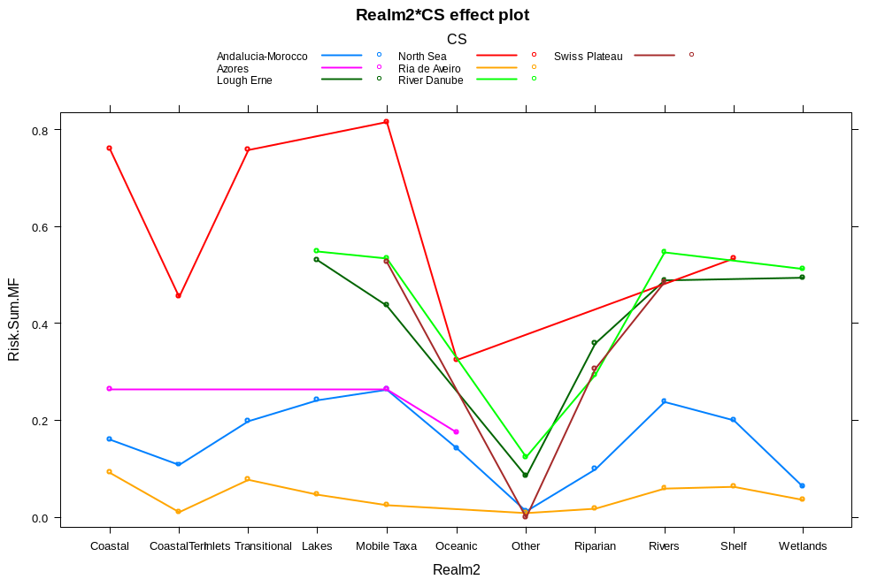
Figure A1 Interaction plot of significant interaction between the IR with realm and case study. Related to Table 3 Model 1: Impact Risk~Realm*Case Study

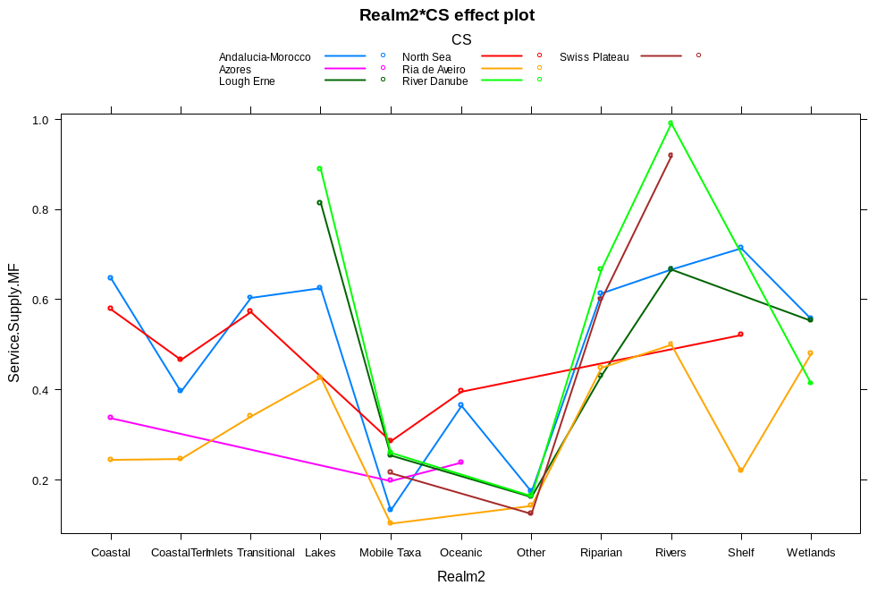Figure A2 Interaction plot of significant interaction between the SSP with realm and case study. Related to Table 3 Model 2: Service Supply Potential~Realm*Case Study
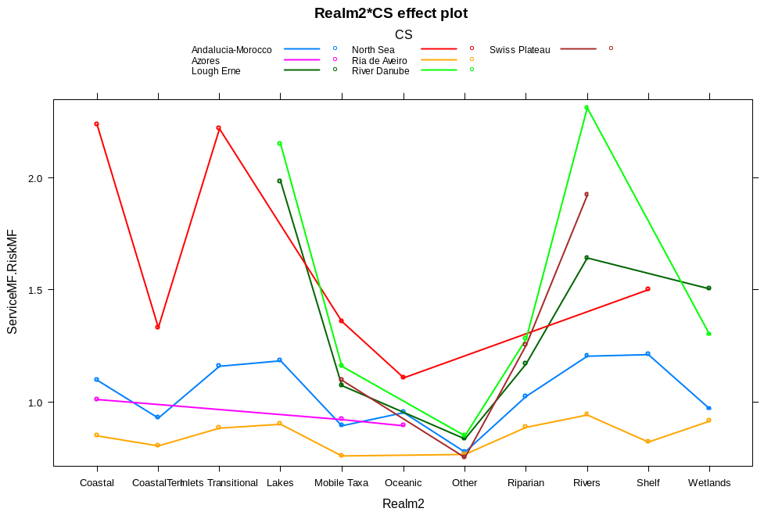
Figure A3 Interaction plot of significant interaction between the RESS with realm and case study. Related to Table 3 Model 3: Risk to Ecosystem Service Supply~Realm*Case Study
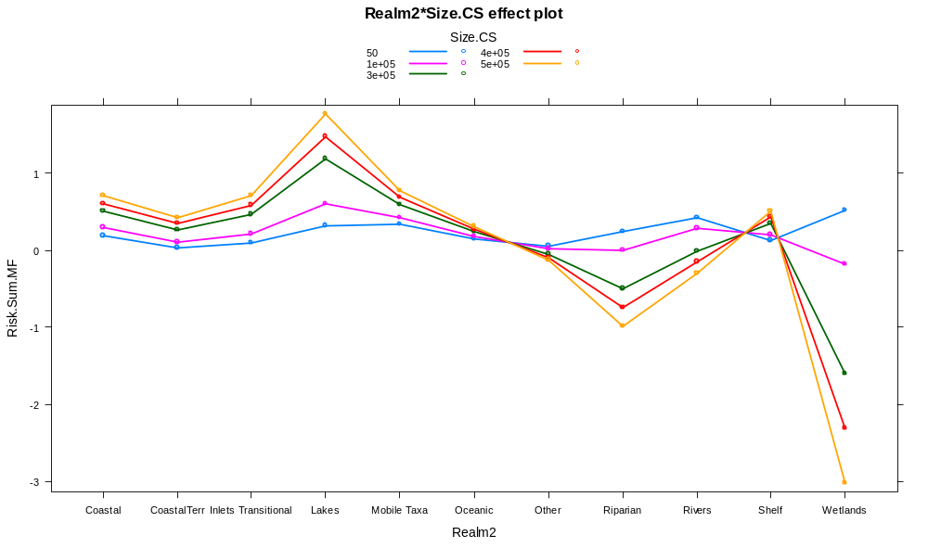
Figure A4 Interaction plot of significant interaction between the IR with realm and area of case study. Related to Table 4 Model 1: Impact risk~Realm + Area of Case Study + Population density + GDP + Land cover + Realm*Area of Case Study + Realm*Population density + Realm*GDP + Realm*Land cover + Area of Case Study*Population density + Area of Case Study*GDP

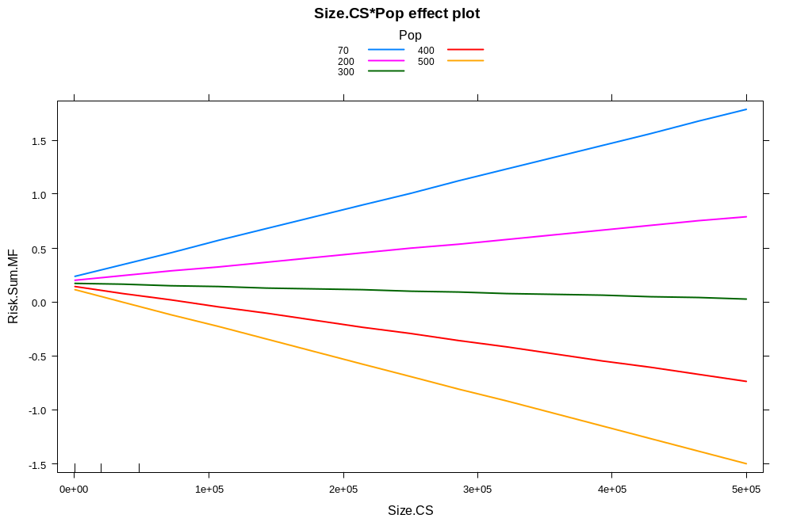
Figure A5 Interaction plot of significant interaction between the IR with area of case study and population density. Related to Table 4 Model 1: Impact risk~Realm + Area of Case Study + Population density + GDP + Land cover + Realm*Area of Case Study + Realm*Population density + Realm*GDP + Realm*Land cover + Area of Case Study*Population density + Area of Case Study*GDP
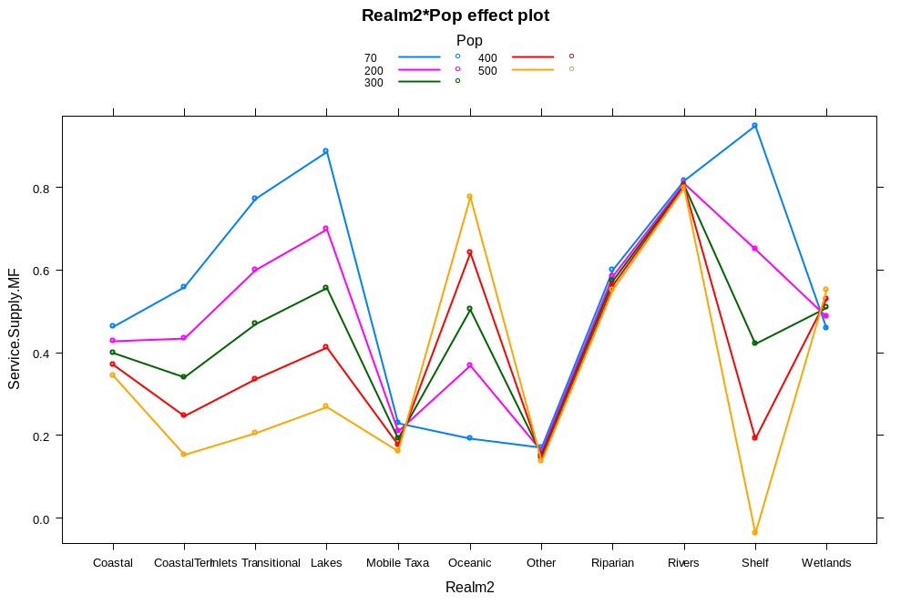
Figure A6 Interaction plot of significant interaction between the SSP with realm and population density. Related to Table 4 Model 2: Service Supply Potential~Realm + Area of Case Study + Population density + GDP + Land cover + Realm*Area of Case Study + Realm*Population density + Realm*GDP + Realm*Land cover + Area of Case Study*Population density + Area of Case Study*GDP
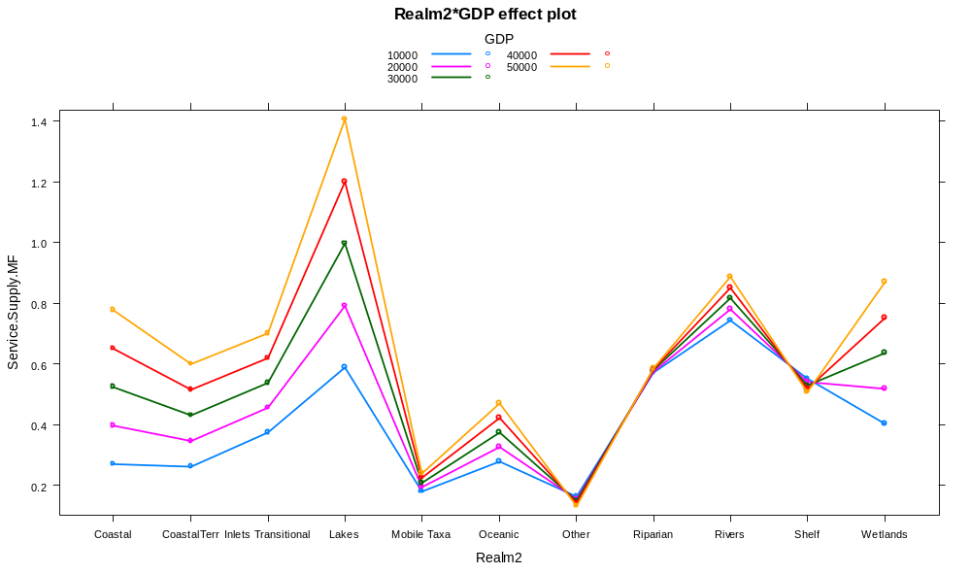
Figure A7 Interaction plot of significant interaction between the SSP with realm and GDP. Related to Table 4 Model 2: Service Supply Potential~Realm + Area of Case Study + Population density + GDP + Land cover + Realm*Area of Case Study + Realm*Population density + Realm*GDP + Realm*Land cover + Area of Case Study*Population density + Area of Case Study*GDP
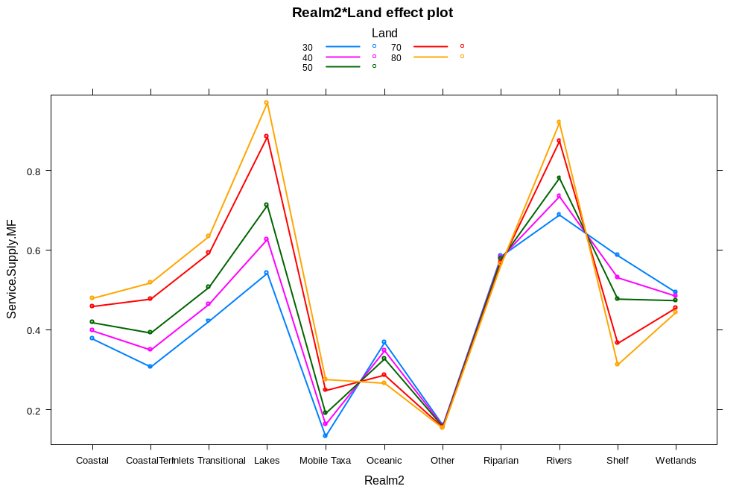
Figure A8 Interaction plot of significant interaction between the SSP with realm and land cover. Related to Table 4 Model 2: Service Supply Potential~Realm + Area of Case Study + Population density + GDP + Land cover + Realm*Area of Case Study + Realm*Population density + Realm*GDP + Realm*Land cover + Area of Case Study*Population density + Area of Case Study*GDP
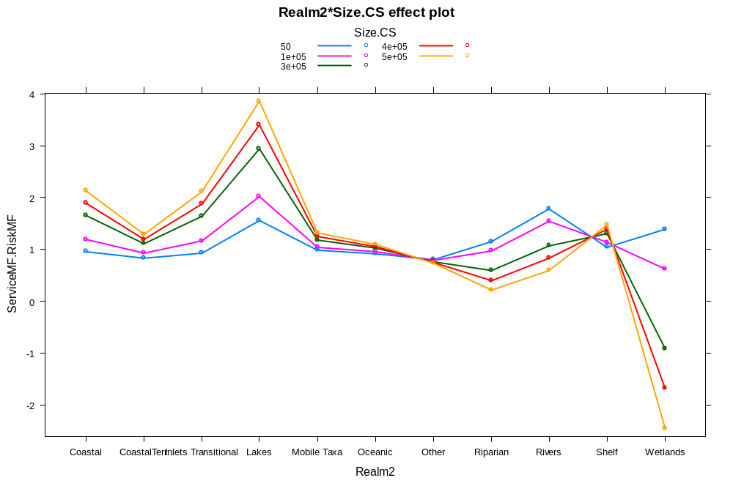
Figure A9 Interaction plot of significant interaction between the RESS with realm and area of case study. Related to Table 4 Model 3: Risk to Service Supply~Realm + Area of Case Study + Population density + GDP + Land cover + Realm*Area of Case Study + Realm*Population density + Realm*GDP + Realm*Land cover + Area of Case Study*Population density + Area of Case Study*GDP
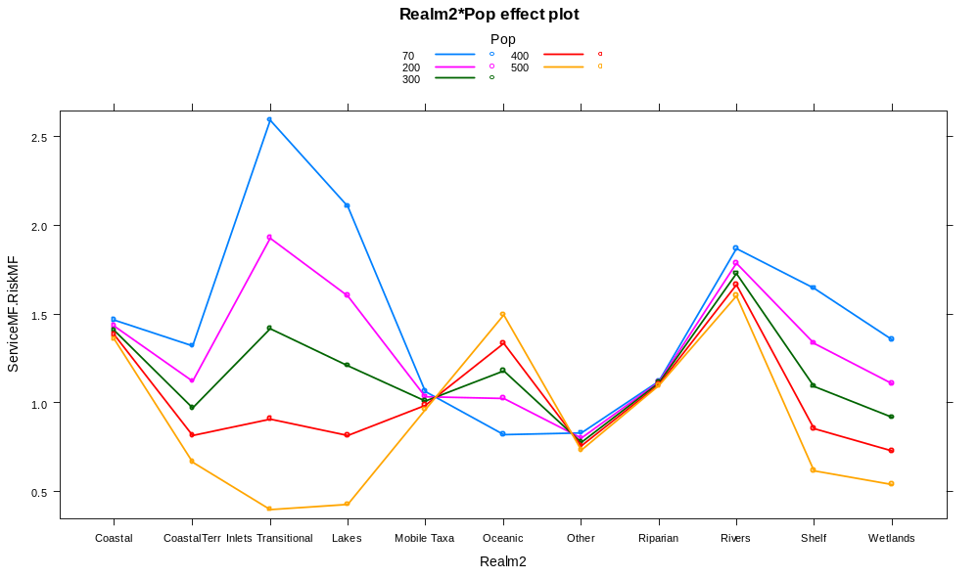
Figure A10 Interaction plot of significant interaction between the RESS with realm and population density. Related to Table 4 Model 3: Risk to Ecosystem Service Supply~Realm + Area of Case Study + Population density + GDP + Land cover + Realm*Area of Case Study + Realm*Population density + Realm*GDP + Realm*Land cover + Area of Case Study*Population density + Area of Case Study*GDP
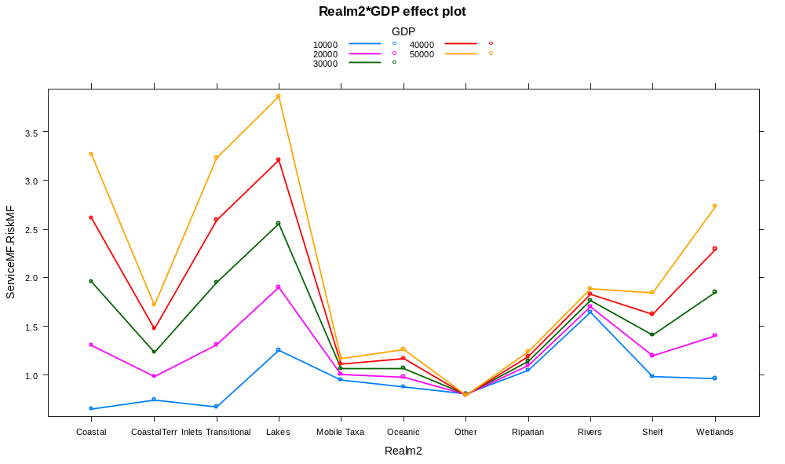
Figure A11 Interaction plot of significant interaction between the RESS with realm and GDP. Related to Table 4 Model 3: Risk to Ecosystem Service Supply~Realm + Area of Case Study + Population density + GDP + Land cover + Realm*Area of Case Study + Realm*Population density + Realm*GDP + Realm*Land cover + Area of Case Study*Population density + Area of Case Study*GDP

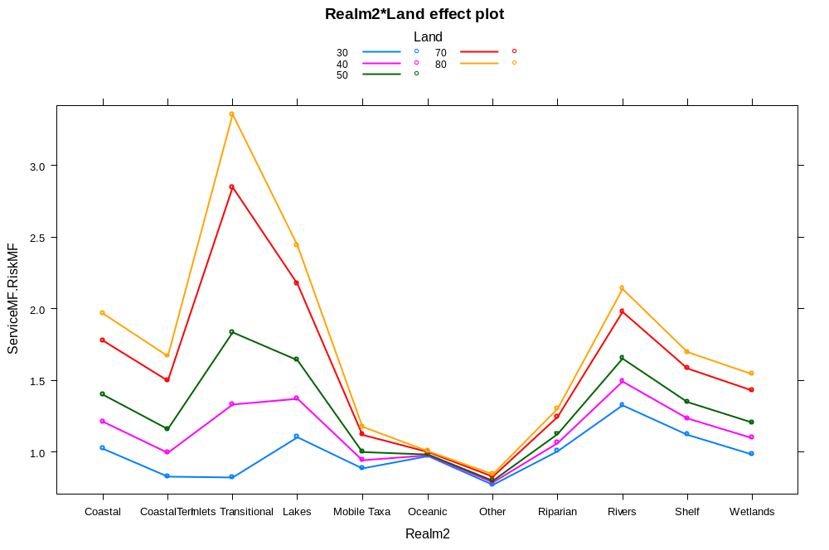
Figure A12 Interaction plot of significant interaction between the RESS with realm and land cover. Related to Table 4 Model 3: Risk to Service Supply~Realm + Area of Case Study + Population density + GDP + Land cover + Realm*Area of Case Study + Realm*Population density + Realm*GDP + Realm*Land cover + Area of Case Study*Population density + Area of Case Study*GDP

References

BORGWARDT, F., ROBINSON, L., TRAUNER, D., TEIXEIRA, H., NOGUEIRA, A. J. A., LILLEBØ, A. I., PIET, G., KUEMMERLEN, M., O'HIGGINS, T., MCDONALD, H., AREVALO-TORRES, J., BARBOSA, A. L., IGLESIAS-CAMPOS, A., HEIN, T. & CULHANE, F. 2019, this issue. Exploring variability in environmental impact risk from human activities across aquatic ecosystems. Science of The Total Environment, 652, 1396-1408.
CONNOR, D. 2015. A generic framework of activities, pressures and impacts relevant to the marine environment. DG Environment. Revised 12 June 2015.
DAVIES, C. E., MOSS, D. & HILL, M. O. 2004. EUNIS Habitat Classification Revised 2004. European Environment Agency European Topic Centre On Nature Protection And Biodiversity. Available from <http://www.eea.europa.eu/themes/biodiversity/eunis/eunis-habitat-classification#tab-documents>.
EC 1992. Council Directive 92/43/EEC of 21 May 1992 on the conservation of natural habitats and of wild fauna and flora. L 206/7.
EC 2000. Establishing a framework for Community action in the field of water policy. Directive 2000/60/EC of the European Parliament and of the Council. . Official Journal of the European Communities, L327, 1-72.
EC 2006. Regulation (EC) No 1893/2006 of the European Parliament and of the Council of 20 December 2006 establishing the statistical classification of economic activities NACE Revision 2 and amending Council Regulation (EEC) No 3037/90 as well as certain EC Regulations on specific statistical domains. Official Journal of the European Union, L393/1.
EC 2008. Establishing a framework for community action in the field of marine environmental policy (Marine Strategy Framework Directive). Directive 2008/56/EC of the European Parliament and of the Council. Official Journal of the European Communities, L164, 19-40.
HAINES-YOUNG, R. & POTSCHIN, M. 2018. Common Internation Classification of Ecosystem Services (CICES) V5.1 and guidance on the Application of the Revised Structure. Available from www.cices.eu.
SMITH, C. J., PAPADOPOULOU, K.-N., BARNARD, S., MAZIK, K., ELLIOTT, M., PATRÍCIO, J., SOLAUN, O., LITTLE, S., BHATIA, N. & BORJA, A. 2016. Managing the Marine Environment, Conceptual Models and Assessment Considerations for the European Marine Strategy Framework Directive. Frontiers in Marine Science, 3.
TEIXEIRA, H., LILLEBO, A., CULHANE, F., ROBINSON, L., TRAUNER, D., BORGWARDT, F., KUMMERLEN, M., BARBOSA, A. L., MCDONALD, H., FUNK, A., O'HIGGINS, T., VAN DER WAL, J. T., PIET, G., HEIN, T., AREVALO-TORRES, J., IGLESIAS-CAMPOS, A., BARBIERE, J. & NOGUEIRA, A. 2019, this issue. Flow linkages from biodiversity to ecosystem services supply: integrating across aquatic ecosystems. Science of the Total Environment.
WHITE, L. J., KOSS, R., ERIKSSON, A. & ROBINSON, L. A. 2013. ODEMM Linkage Framework Userguide (Version 2). ODEMM Guidance Document Series No. 3. EC FP7 project (244273) 'Options for Delivering Ecosystem-based Marine Management'. University of Liverpool. ISBN: 978-0-906370: 14 pp.

