Supplementary file 1: Outcomes
Table S1. Outcome prioritization by GDG
Critical: exacerbations, asthma control (ACQ, ACT), quality of life (AQLQ, EQ5D), safety (drug-related adverse events and serious adverse events)
Important: lung function (FEV₁), decrease in ICS dose and OCS dose, healthcare resource utilization, rescue medication use, FeNO

Table S2: Search Strategies

Search strategy for evidence of efficacy and safety
MEDLINE  PubMed  30/01/2019 | #12 Add Search #5 OR #8 OR #11 770 07:35:20  #11 Add Search #9 AND #10 13 07:34:32  #10 Add Search “Vaccines”[Mesh] OR vaccin*[ti] 248570 07:34:22  #9 Add Search #6 NOT #8 2676 07:34:07  #8 Add Search #6 AND #7 680 07:33:51  #7 Add Search (“clinical trials as topic”[mesh: noexp] OR “randomized controlled trial”[pt] OR “controlled clinical trial”[pt] OR randomized[tiab] OR placebo[tiab] OR randomly[tiab] OR trial[ti]) NOT (“animals”[Mesh] NOT “humans”[Mesh]) 1107735 07:33:45  #6 Add Search #3 NOT #5 3356 07:33:37  #5 Add Search #3 AND #4 77 07:33:22  #4 Add Search systematic[sb] 126175 07:33:11  #3 Add Search #1 AND #2 3433 07:32:42  #2 Add Search “Antibodies, Monoclonal, Humanized”[Mesh] OR “Omalizumab”[Mesh] OR "mepolizumab"[Supplementary Concept] OR "reslizumab"[Supplementary Concept] OR “benralizumab”[Supplementary Concept] OR “SAR231893”[Supplementary Concept] OR "tezepelumab"[Supplementary Concept] OR “lebrikizumab”[Supplementary Concept] OR “tralokinumab”[Supplementary Concept] OR “brodalumab”[Supplementary Concept] OR “ligelizumab”[Supplementary Concept] OR mepolizumab [tiab] OR reslizumab[tiab] OR benralizumab[tiab] OR dupilumab[tiab] OR omalizumab[tiab] OR lebrikizumab[tiab] OR tralokinumab[tiab] OR tezepelumab[tiab] OR brodalumab[tiab] OR ligelizumab[tiab] 47689 07:32:25  #1 Add Search “Hypersensitivity, Immediate”[Mesh] OR “Asthma”[Mesh] OR “Rhinitis, Allergic”[Mesh] OR “Rhinitis”[Majr] OR “Sinusitis”[Mesh] OR “Nasal Polyps”[Majr] OR “Dermatitis, Atopic”[Mesh] OR “Dermatitis”[Majr] OR “Urticaria”[Mesh] OR “Eosinophilic Esophagitis”[Mesh] OR “Food Hypersensitivity”[Mesh] OR allergy[tiab] OR allergic[tiab] OR asthma*[tiab] OR atopic dermatitis[tiab] OR dermatitis[ti] OR urticaria[tiab] OR erythema[ti] OR rhinosinusitis[tiab] OR allergic rhinitis[tiab] OR (food[ti] AND allerg*[ti]) OR (food[ti] AND react*[ti]) OR food allerg*[tiab] OR food reaction*[tiab] OR eosinophilic esophagitis[tiab] OR esophagitis[ti] OR eosinophil*[ti] 447588 07:32:11
EMBASE  Ovid Embase <1974 to 2019 January 29>  30/01/2019 | Ovid Embase  1 exp asthma/ (237991)  2 exp allergic rhinitis/ (36816)  3 *rhinitis/ (5649)  4 exp sinusitis/ (39314)  5 *nose polyp/ (5041)  6 exp atopic dermatitis/ (38417)  7 *dermatitis/ (9465)  8 exp urticaria/ (40115)  9 exp eosinophilic esophagitis/ (5319)  10 exp food allergy/ (31742)  11 allergy.ti,ab. (92943)  12 allergic.ti,ab. (146253)  13 asthma*.ti,ab. (206208)  14 atopic dermatitis.ti,ab. (28752)  15 dermatitis.ti. (36058)  16 urticaria.ti. (8720)  17 erythema.ti. (7091)  18 rhinosinusitis.ti. (5540)  19 allergic rhinitis.ti,ab. (24674)  20 (food adj5 (allerg* or react*)).ti,ab. (23811)  21 eosinophilic esophagitis.ti,ab. (4268)  22 esophagitis.ti. (7426)  23 eosinophil*.ti. (30459)  24 1 or 2 or 3 or 4 or 5 or 6 or 7 or 8 or 9 or 10 or 11 or 12 or 13 or 14 or 15 or 16 or 17 or 18 or 19 or 20 or 21 or 22 or 23 (548337)  25 mepolizumab.ti,ab. (677)  26 reslizumab.ti,ab. (226)  27 benralizumab.ti,ab. (194)  28 dupilumab.ti,ab. (396)  29 omalizumab.ti,ab. (3891)  30 lebrikizumab.ti,ab. (103)  31 tralokinumab.ti,ab. (69)  32 tezepelumab.ti,ab. (12)  33 brodalumab.ti,ab. (275)  34 ligelizumab.ti,ab. (13)  35 25 or 26 or 27 or 28 or 29 or 30 or 31 or 32 or 33 or 34 (5365)  36 limit 35 to "systematic review" (175)  37 35 not 36 (5190)  38 limit 37 to "therapy (best balance of sensitivity and specificity)" (1491)
The Cochrane Library  30/01/2019  Cochrane Central Register of Controlled Trials Issue 1 of 12, January 2019 [1180 hits] | #1 MeSH descriptor: [Asthma] explode all trees 10851  #2 MeSH descriptor: [Rhinitis, Allergic] explode all trees 2786  #3 MeSH descriptor: [Rhinitis] explode all trees 3553  #4 MeSH descriptor: [Sinusitis] explode all trees 888  #5 MeSH descriptor: [Nasal Polyps] explode all trees 319  #6 MeSH descriptor: [Dermatitis, Atopic] explode all trees 1518  #7 MeSH descriptor: [Dermatitis] explode all trees 3660  #8 MeSH descriptor: [Urticaria] explode all trees 674  #9 MeSH descriptor: [Eosinophilic Esophagitis] explode all trees 57  #10 MeSH descriptor: [Food Hypersensitivity] explode all trees 825  #11 allerg*:ti,ab 17766  #12 asthma*:ti,ab 26324  #13 (atopic NEXT dermatitis):ti,ab 2555  #14 dermatitis:ti,ab 4394  #15 urticaria:ti,ab 1357  #16 erythema:ti,ab 4071  #17 rhinosinusitis:ti,ab 950  #18 (allergic NEXT rhinitis):ti,ab 5127  #19 (food NEAR5 react*):ti,ab 80023  #20 (eosinophilic NEXT esophagitis):ti,ab 152  #21 esophagitis:ti 997  #22 eosinophil*:ti 1029  #23 #1 OR #2 OR #3 OR #4 OR #5 OR #6 OR #7 OR #8 OR #9 OR #10 OR #11 OR #12 OR #13 OR #14 OR #15 OR #16 OR #17 OR #18 OR #19 OR #20 OR #21 OR #22 124342  #24 mepolizumab:ti,ab 172  #25 reslizumab:ti,ab 70  #26 benralizumab:ti,ab 94  #27 dupilumab:ti,ab 141  #28 omalizumab:ti,ab 637  #29 lebrikizumab:ti,ab 49  #30 tralokinumab:ti,ab 41  #31 tezepelumab:ti,ab 8  #32 brodalumab:ti,ab 70  #33 ligelizumab:ti,ab 14  #34 #24 OR #25 OR #26 OR #27 OR #28 OR #29 OR #30 OR #31 OR #32 OR #33 1466  #35 #23 AND #34 1180

Search strategy for economic evidence
MEDLINE  PubMed  27/08/2019 | #1 Add Search (“Hypersensitivity, Immediate”[Mesh]) OR “Asthma”[Mesh]) OR “Rhinitis, Allergic”[Mesh]) OR “Rhinitis”[Majr]) OR “Sinusitis”[Mesh]) OR “Nasal Polyps”[Majr]) OR “Dermatitis, Atopic”[Mesh]) OR “Dermatitis”[Majr]) OR “Urticaria”[Mesh]) OR “Eosinophilic Esophagitis”[Mesh]) OR “Food Hypersensitivity”[Mesh]) OR allergy[tiab]) OR allergic[tiab]) OR asthma*[tiab]) OR atopic dermatitis[tiab]) OR dermatitis[ti]) OR urticaria[tiab]) OR erythema[ti]) OR rhinosinusitis[tiab]) OR allergic rhinitis[tiab])) OR ((food[ti]) AND AND allerg*[ti])) OR ((food[ti]) AND react*[ti])) OR food allerg*[tiab]) OR food reaction*[tiab]) OR eosinophilic esophagitis[tiab]) OR esophagitis[ti]) OR OR eosinophil*[ti] 457361 12:53:56  #2 Add Search (“Antibodies, Monoclonal, Humanized”[Mesh] OR “Omalizumab”[Mesh] OR "mepolizumab"[Supplementary Concept] OR "reslizumab"[Supplementary Concept] OR “benralizumab”[Supplementary Concept] OR “SAR231893”[Supplementary Concept] OR "tezepelumab"[Supplementary Concept] OR “lebrikizumab”[Supplementary Concept] OR “tralokinumab”[Supplementary Concept] OR “brodalumab”[Supplementary Concept] OR “ligelizumab”[Supplementary Concept] OR mepolizumab [tiab] OR reslizumab[tiab] OR benralizumab[tiab] OR dupilumab[tiab] OR omalizumab[tiab] OR lebrikizumab[tiab] OR tralokinumab[tiab] OR tezepelumab[tiab] OR brodalumab[tiab] OR ligelizumab[tiab]) 51477 12:57:47  #3 Add Search #1 AND #2 3851 12:59:59  #4 Add Search (((((((((((“Costs and Cost Analysis”[Mesh]))) OR “Health Care Costs”[Mesh]) OR economic*[tiab]) OR ((cost*[ti] OR cost[tiab] OR costs[tiab] OR cost effect*[tiab] OR cost utility*[tiab]))) OR ((price[tiab] OR prices[tiab] OR pricing[tiab]))) OR pharmacoeconomic*[tiab]) OR budget*[tiab]))) 850194 13:03:29  #5 Add Search #3 AND #4 270 13:06:48
EMBASE  Ovid Embase <1974 to 2019 January 29>  30/01/2018 | Ovid Embase  1 exp asthma/ (237991)  2 exp allergic rhinitis/ (36816)  3 *rhinitis/ (5649)  4 exp sinusitis/ (39314)  5 *nose polyp/ (5041)  6 exp atopic dermatitis/ (38417)  7 *dermatitis/ (9465)  8 exp urticaria/ (40115)  9 exp eosinophilic esophagitis/ (5319)  10 exp food allergy/ (31742)  11 allergy.ti,ab. (92943)  12 allergic.ti,ab. (146253)  13 asthma*.ti,ab. (206208)  14 atopic dermatitis.ti,ab. (28752)  15 dermatitis.ti. (36058)  16 urticaria.ti. (8720)  17 erythema.ti. (7091)  18 rhinosinusitis.ti. (5540)  19 allergic rhinitis.ti,ab. (24674)  20 (food adj5 (allerg* or react*)).ti,ab. (23811)  21 eosinophilic esophagitis.ti,ab. (4268)  22 esophagitis.ti. (7426)  23 eosinophil*.ti. (30459)  24 1 or 2 or 3 or 4 or 5 or 6 or 7 or 8 or 9 or 10 or 11 or 12 or 13 or 14 or 15 or 16 or 17 or 18 or 19 or 20 or 21 or 22 or 23 (548337)  25 mepolizumab.ti,ab. (677)  26 reslizumab.ti,ab. (226)  27 benralizumab.ti,ab. (194)  28 dupilumab.ti,ab. (396)  29 omalizumab.ti,ab. (3891)  30 lebrikizumab.ti,ab. (103)  31 tralokinumab.ti,ab. (69)  32 tezepelumab.ti,ab. (12)  33 brodalumab.ti,ab. (275)  34 ligelizumab.ti,ab. (13)  35 25 or 26 or 27 or 28 or 29 or 30 or 31 or 32 or 33 or 34 (5365)  36 limit 35 to "systematic review" (175)  37 35 not 36 (5190)  38 limit 37 to "therapy (best balance of sensitivity and specificity)" (1491)
The Cochrane Library  27/08/2019  Cochrane Central Register of Controlled Trials Issue 8 of 12, August 2019 | #1 MeSH descriptor: [Asthma] explode all trees 10992  #2 MeSH descriptor: [Rhinitis, Allergic] explode all trees 2837  #3 MeSH descriptor: [Rhinitis] explode all trees 3627  #4 MeSH descriptor: [Sinusitis] explode all trees 925  #5 MeSH descriptor: [Nasal Polyps] explode all trees 335  #6 MeSH descriptor: [Dermatitis, Atopic] explode all trees 1613  #7 MeSH descriptor: [Dermatitis] explode all trees 3808  #8 MeSH descriptor: [Urticaria] explode all trees 698  #9 MeSH descriptor: [Eosinophilic Esophagitis] explode all trees 62  #10 MeSH descriptor: [Food Hypersensitivity] explode all trees 869  #11 allerg*:ti,ab 23024  #12 asthma*:ti,ab 30618  #13 (atopic NEXT dermatitis):ti,ab 3409  #14 dermatitis:ti,ab 5674  #15 urticaria:ti,ab 1624  #16 erythema:ti,ab 5107  #17 rhinosinusitis:ti,ab 1155  #18 (allergic NEXT rhinitis):ti,ab 5852  #19 (food NEAR5 react*):ti,ab 99337  #20 (eosinophilic NEXT esophagitis):ti,ab 199  #21 esophagitis:ti 1138  #22 eosinophil*:ti 1199  #23 #1 OR #2 OR #3 OR #4 OR #5 OR #6 OR #7 OR #8 OR #9 OR #10 OR #11 OR #12 OR #13 OR #14 OR #15 OR #16 OR #17 OR #18 OR #19 OR #20 OR #21 OR #22 152516  #24 MeSH descriptor: [Antibodies, Monoclonal, Humanized] explode all trees 6142  #25 mepolizumab:ti,ab 230  #26 reslizumab:ti,ab 96  #27 benralizumab:ti,ab 131  #28 dupilumab:ti,ab 221  #29 omalizumab:ti,ab 792  #30 lebrikizumab:ti,ab 67  #31 tralokinumab:ti,ab 64  #32 tezepelumab:ti,ab 18  #33 brodalumab:ti,ab 97  #34 ligelizumab:ti,ab 21  #35 #24 OR #25 OR #26 OR #27 OR #28 OR #29 OR #30 OR #31 OR #32 OR #33 OR #34 7538  #36 #23 AND #35 1986  #37 MeSH descriptor: [Costs and Cost Analysis] explode all trees 9937  #38 MeSH descriptor: [Health Care Costs] explode all trees 3299  #39 economic*:ti,ab 16322  #40 cost*:ti 12210  #41 cost:ti,ab 45833  #42 costs:ti,ab 25393  #43 cost effect*:ti,ab 41337  #44 cost utility:ti,ab 2787  #45 #37 OR #38 OR #39 OR #40 OR #41 OR #42 OR #43 OR #44 70316  #46 #36 AND #45 69

Table S3: Excluded studies (evidence of effects)
Author/Year |  | Reasons of exclusion
Dupilumab
Busse 2014 |  | Study protocol
Corren 2018 |  | Post-hoc from Wenzel 2016, no subgroup analysis for eosinophilic asthma
Iftikhar 2018 |  | NMA comparing IL-4, IL-5, IL-13
Weinstein 2017 |  | Congress abstract
Weinstein 2018 |  | Post-hoc from Wenzel 2016, no subgroup analysis for eosinophilic asthma
Wenzel 2013 |  | Dupilumab not given at approved dose
Zayed 2018 |  | Systematic review and meta-analysis
Omalizumab
Baena-cagnani 2015 |  | Not RCT
Bang 2004 |  | Not RCT
Brodlie 2012 |  | Not RCT, Not interested population
Corren 2007 |  | No comparison
Gevaert 2013 |  | Different disease
Hanf 2006 |  | No interested outcome
Humbert 2005 |  | Only Abstract
Johansson 2009 |  | No interested outcome
Lupinek 2017 |  | Different intervention
Luskin 2005 |  | Only Pooled data
Noga 2006 |  | No interested outcome
Ohta 2010 |  | No comparison
Schroeder 2009 |  | Different objective, no interested outcome
Wahn 2009 |  | No interested outcome
Zielen 2013 |  | Not FDA approved doses
Nct 2016 |  | Different intervention
Baker 2014 |  | Different objective
Bousquet 2005 |  | Pooled analysis, original RCT have already been included
Bousquet 2007 |  | Pooled analysis, original RCT have already been included
Bousquet 2004 |  | Pooled analysis, original RCT have already been included
Busse 2007 |  | Meeting abstract
Corren 2003 |  | Pooled analysis, original RCT have already been included
Harris 2011 |  | Pooled analysis, original RCT have already been included; Different objective
Humbert 2008 |  | Pooled analysis, original RCT have already been included; Different objective
Humbert 2009 |  | Different objective
Iribarren 2017 |  | Letter to editor
Karpel 2010 |  | Meeting abstract
Lowe 2011 |  | Pooled analysis, original RCT have already been included
Massanari 2010b |  | Pooled analysis, original RCT have already been included
Massanari 2009a |  | Pooled analysis, original RCT have already been included
Massanari 2009b |  | Pooled analysis, original RCT have already been included
Maykut 2008 |  | Pooled analysis, original RCT have already been included
Milgrom 2011 |  | Pooled analysis, original RCT have already been included
Boulet 1997 |  | Different objective
Boulet 2003 |  | No full text detected
Reslizumab
Bourdin 2018 |  | Different design (ITC)  Indirect comparison with reslizumab could not be performed because of insufficient effective sample size
Nct 2015 (MEMORY) |  | Different phenomenon/intervention of interest  Study terminated 2017
Busse 2019 |  | Different design (ITC)
Cabon 2017 |  | Different design (ITC)
Casale 2019 |  | Different design (ITC)
Deeks 2017 |  | Different design (review)
Emma 2018 |  | Different design (review)
Farne 2017 |  | Different design (systematic review)
He 2018 |  | Different design (systematic review and NMA)
Henriksen 2018 |  | Different design (systematic review)
Iftikhar 2018 |  | Different design (systematic review and NMA)
Li 2017 |  | Different design (systematic review)
Milosavljevic 2018 |  | Different design (systematic review)
Mukherjee 2018 |  | Different design (not randomized)
NCT 2015 |  | Different design
Sharma 2016 |  | Different design (systematic review and NMA)
Wang 2016 |  | Different design (systematic review)
Benralizumab
Author/Year | Reasons of exclusion
Brightling 2014 | Different disease (COPD in general)
DuBuske 2018 | Duplicate data included: pooled data from included RCTs
Busse 2019 | No comparison
Castro 2014 | NO FDA approved doses
Ferguson 2017 | NO FDA approved doses
Laviolette 2013 | NO FDA approved doses
Nowak 2015 | NO FDA approved doses
Ohta 2018 | Duplicate data included: pooled data from included RCTs
Park 2016 | NO FDA approved doses
Pham 2016 | NO FDA approved doses
Wang 2014 | NO FDA approved doses
Zeitlin 2018 | Different disease and no relevant outcomes
Mepolizumab
Ayars 2009 | Different outcome of interest/ Different intervention (750 mg)
Busse 2019 | Indirect treatment comparison (ITC)
Buttner 2003 | Dose not approved by FDA (250 mg, 750 mg)
Cockle 2017 | Indirect treatment comparison
Flood-Page 2003a | Dose not approved by FDA (750mg)
Flood-Page 2003b | Dose not approved by FDA (750mg)
Flood-Page 2007 | Dose not approved by FDA (250 mg, 750 mg)
Gunsoy 2018a | Different phenomenon/intervention of interest
Gunsoy 2018b | Different design (Case study- Cost utility)
Haldar 2009 | Dose not approved by FDA (750mg) /Different intervention
Katz 2014 | Dose not approved by FDA
Leckie 2000 | Dose not approved by FDA (2·5 mg/kg and 10 mg/kg) Different intervention
Liao 2017 | Different outcome
Lukaszyk 2016 | Review in Polish
Menzies-Gow 2003 | Dose not approved by FDA (750 mg)/ Different intervention
Mukherjee 2018 | Different phenomenon/intervention of interest (Reslizumab)
Nair 2009 | Dose not approved by FDA
Pavord 2012 (DREAM) | Dose not approved by FDA (75 mg, 250 mg, or 750 mg)/ Different intervention
Pouliquen 2015 | Dose not approved by FDA (12.5, 125, or 250 mg SC or 75 mg IV)
Prazma 2019 | Different design (Research letter)
Robinson 2013 | Different design (Expert opinion)
Sabogal Pineros 2018 | Dose not approved by FDA (750mg)
Sehmi 2016 | Different design (Cross-sectional study)

Table S4: Excluded studies (economic evidence)

Author | Reason for exclusion
Basu 2017 | Did not report health consequences of each alternative. Reported direct costs associated with an asthma related exacerbation
Bermejo 2017 | No economic evaluation
Brown 2007 | Did not evaluate eosinophilic patients
Campbell 2010 | Did not evaluate eosinophilic patients
Cooper 2018 | No economic evaluation
Dal Negro 2011 | Did not evaluate eosinophilic patients
Dal Negro 2012 | Did not evaluate eosinophilic patients
Dewilde 2006 | Did not evaluate eosinophilic patients
Entrenas 2019 | Did not evaluate eosinophilic patients
Faria 2014 | Did not evaluate eosinophilic patients
Jahnz-Różyk 2018 | Did not evaluate eosinophilic patients
Kolbin 2016 | Conference abstract
Kolbin, A, Namazova-Baranova, L 2016 | Conference abstract
Likhar 2016 | Conference abstract
Levy 2014 | Did not evaluate eosinophilic patients
Martínez-Moragón 2019 | Not published in English. Available full text only in Spanish.
McQueen 2018 | Systematic review used as source of primary studies.
Menzella 2012 | Did not evaluate eosinophilic patients
Morishima 2013 | Did not evaluate eosinophilic patients
Norman 2013 | Did not evaluate eosinophilic patients
Oba 2014 | Did not evaluate eosinophilic patients
Rodriguez-Martinez 2018 | Systematic review used as source of primary studies
Suzuki 2017 | Did not evaluate eosinophilic patients
Tadrous 2017 | Only reported costs. Did not report health consequences of each alternative. Mentioned that there were not significant differences in clinically relevant outcomes
Van Nooten 2012 | Did not evaluate eosinophilic patients
Vennera 2016 | Did not evaluate eosinophilic patients
Yoshikawa 2016 | Did not report health consequences of each alternative. Reported the cost saving due to hospital-free days
Wu 2007 | Did not evaluate eosinophilic patients
Zafari 2016 | Did not evaluate eosinophilic patients
Zafari 2018 | Did not evaluate eosinophilic patients
Zhou 2018 | Did not evaluate eosinophilic patients

Table S5: Direct unitary cost per each type of biologic treatment
Mepolizumab | Unitary cost
Direct unitary cost
Mepolizumab 100 mg, 1 vial | 2,500 $ ª
Asthma-related hospital stay | 9,960 $ ª
Asthma-related emergency department visit | 684 $ ª
Asthma-related outpatients visit | 195 $ ª
Direct cost per patient
Annual cost of long-term oral corticosteroid use and adverse events | 857 $ ª
Annual average cost of the standard therapy | 5,738 $ ª
Annual average cost of the intervention with Mepolizumab | 32,500 $ ª
Reslizumab
Reslizumab drug and administration per cycle, 75 kg patient | 2,000 $ ^{b}
Chronic asthma management per cycle | 92 $ ^{b}
Mild exacerbation per cycle | 110 $ ^{b}
Moderate exacerbation (outpatient) per cycle | 202 $ ^{b}
Moderate exacerbation (emergency department) per cycle | 2,160 $ ^{b}
Severe exacerbation | 6,688 $ ^{b}
Severe exacerbation (no intubation) | 5,489 $ ^{b}
Severe exacerbation (intubation) | 21,556 $ ^{b}
Short-acting beta-agonist per puff | 0.14 $ ^{b}
Managing adverse events (anaphylaxis) | 3,143 $ ^{b}
Dupilumab
Dupilumab 200 mg or 300 mg by subcutaneous injection once every 2 weeks | 2,774.65 ^{c}
Benralizumab
Benralizumab 30 mg by subcutaneous injection once every 4 weeks for 3 doses; then every 8 weeks | 4,728.23 ^{c}
- Reported in 2014 US Dollars by Whittington et al (Whittington 2017).
- Reported in 2018 US Dollars by Lam et al (Lam 2019).
- Reported in 2018 US Dollars by ICER (ICER 2018).

Table S6: Evidence profiles of the economic evidence

Mepolizumab in addition to standard therapy vs. standard therapy
Quality assessment |  |  |  |  |  |  | Summary of resources and costs |  |  | Quality
Nº. of studies | Study design | Limitations | Inconsistency | Indirectness | Imprecision | Publication bias | Incremental cost per patient* | Incremental effect per patient* | ICER | Quality
ICER per QALY (high quality study - not funded by Industry)
1ª | Cost-utility,  Markov model | Not serious¹ | Not serious | Serious² | Serious³ | Not serious | 589,941 $  (Lifetime horizon) | 1.53 QALY  (Lifetime horizon) | 385,546 $ / QALY | ⨁⨁◯◯  LOW
*Incremental cost and effect due to the addition of Mepolizumab.
ICER: Incremental cost-effectiveness ratio. QALY: Quality adjusted life years. $: US Dollar.
- Markov model study with low risk of bias. CHEC (consensus on health economics criteria checklist) score 16 out of 20.
- One single study performed in the USAª. The results might not be directly applicable to European countries.
- The ICER varied from 385,546 $ to 160,000 $ in the group of responder patients. However, the ICERs obtained from the sensitivity analyses were not lower than 30,000 € (the willingness to pay threshold in most European countries).
References
- Whittington, M. D. et al. Assessing the value of mepolizumab for severe eosinophilic asthma: a cost-effectiveness analysis. Ann Allergy Asthma Immunol. 2017; 118 (2): 220-225.

Reslizumab in addition to standard therapy vs. standard therapy
Quality assessment |  |  |  |  |  |  | Summary of resources and costs |  |  | Quality
Nº. of studies | Study design | Limitations | Inconsistency | Indirectness | Imprecision | Publication bias | Incremental cost per patient* | Incremental effect per patient* | ICER | Quality
ICER per QALY (high quality study - not funded by Industry)
1ª | Cost-utility,  Markov model | Not serious¹ | Not serious | Serious² | Serious³ | Not serious | 24,404 $  (5-year horizon) | 0.035 QALYs  (5-year horizon) | 697,403 $ / QALY | ⨁⨁⨁◯  MODERATE
ICER per QALY (high quality study - funded by Industry)
1^{b} | Cost-utility,  Markov model | Not serious¹ | Not serious | Serious⁴ | Not serious⁵ | Serious⁶ | 119,394 $  (lifetime horizon) | 5.17 QALYs  (lifetime horizon) | 23,081 $ / QALY | ⨁⨁◯◯  LOW
*Incremental cost and effect due to the addition of Reslizumab.
ICER: Incremental cost-effectiveness ratio. QALY: Quality adjusted life years. $: US Dollar.
- Markov model studies with low risk of bias (CHEC score 13 or higher).
- One single study performed in the USA. The results may not be applicable to other countries.
- The sensitivity analysis showed large variations in the ICER value. However, all of them were higher than 100,000 $, which is the willingness to pay threshold in most countries. Increasing 20% the quality of life with reslizumab would drop the ICER to 154,352 $, and it was 467,010 $ where non-responders had the same quality of life and exacerbations rates as the standard therapy group. Furthermore, in 95% of the iterations the ICER varied between 378,534 $ and 2,082,379 $.
- One single study performed in South Korea. The results may not be applicable to other countries.
- The ICER varied from 18,465 $ to 30,005 $. In the deterministic sensitivity analysis. Also, the ICER had 99% probability of being cost-effective at a 38,275 $ threshold.
- Teva-Handok Pharma financed the study.
References
- Lam, J. et al. A cost-effectiveness analysis of reslizumab in the treatment of poorly controlled eosinophilic asthma. J Asthma. 2019; 56 (8): 872-881.
- Han, S. et al. Cost–utility analysis of reslizumab for patients with severe eosinophilic asthma inadequately controlled with high-dose inhaled corticosteroids and long-acting β2-agonists in South Korea. Current medical research and opinion. 2019; 10.1080/03007995.2019.1605159.

Dupilumab in addition to standard therapy vs. standard therapy
Quality assessment |  |  |  |  |  |  | Summary of resources and costs |  |  | Quality
Nº. of studies | Study design | Limitations | Inconsistency | Indirectness | Imprecision | Publication bias | Incremental cost per patient* | Incremental effect per patient* | ICER | Quality
ICER per QALY (high quality study - not funded by Industry)
1ª | Cost-utility,  Markov model | Not serious¹ | Not serious | Serious² | Serious³ | Not serious | 704,000 $  (lifetime horizon) | 1.51 QALYs  (lifetime horizon) | 464,000 $ / QALY | ⨁⨁⨁◯  MODERATE
*Incremental cost and effect due to the addition of Dupilumab.
ICER: Incremental cost-effectiveness ratio. QALY: Quality adjusted life years. $: US Dollar.
- Markov model study with low risk of bias (CHEC score 13 or higher).
- One single study performed in the USA. The results may not be applicable to other countries.
- The deterministic sensitivity analysis showed large variations in the ICER value from 300,000 $ to 1,000,000 $ (0.85 to 0.81 utilities gained, respectively). Furthermore, at a threshold of 50,000, the probability for Dupilumab to be cost-effective was 0%.
References
- ICER. Institute for Clinical and Economic Review. Biologic Therapies for Treatment of Asthma Associated with Type 2 Inflammation: Effectiveness, Value, and Value-Based Price Benchmarks. Available at: https://icer-review.org/material/asthma-final-evidence-report/. Accessed Sept, 2019.

Benralizumab in addition to standard therapy vs. standard therapy
Quality assessment |  |  |  |  |  |  | Summary of resources and costs |  |  | Quality
Nº. of studies | Study design | Limitations | Inconsistency | Indirectness | Imprecision | Publication bias | Incremental cost per patient* | Incremental effect per patient* | ICER | Quality
ICER per QALY (high quality study - not funded by Industry)
1ª | Cost-utility,  Markov model | Not serious¹ | Not serious | Serious² | Serious³ | Not serious | 581,000 $  (lifetime horizon) | 1.41 QALYs  (lifetime horizon) | 412,000 $ / QALY | ⨁⨁⨁◯  MODERATE
ICER per QALY (high quality study - funded by Industry)
1^{b} | Cost-utility,  Markov model | Not serious⁴ | Not serious | Serious⁵ | Serious⁶ | Not serious | NR £  (lifetime horizon) | NR QALYs  (lifetime horizon) | 39,135 £ / QALY | ⨁⨁◯◯  LOW
*Incremental cost and effect due to the addition of Benralizumab.
ICER: Incremental cost-effectiveness ratio. QALY: Quality adjusted life years. $: US Dollar. £: British pounds. NR: Not reported.
- Markov model study with low risk of bias (CHEC score 13 or higher).
- One single study performed in the USA. The results may not be applicable to other countries.
- The deterministic sensitivity analysis showed large variations in the ICER value from 250,000 $ to 950,000 $ (0.85 to 0.81 utilities gained, respectively). Furthermore, at a threshold of 50,000, the probability for benralizumab to be cost-effective was 0%.
- One single study performed in the UK. The results may not be applicable to other countries.
- The ICER varied from 34,270 £ reported by AstraZeneca to 73,560 £ found by the University of Exter in the deterministic sensitivity analysis (zero asthma related mortality).
- AstraZeneca financed the original model critiqued by the University of Exeter. The University explored ICER sensitivity through changes in the age-stratified probabilities for hospitalised patients, oral corticosteroids use at baseline (42%), administration cost of benralizumab, and treatment discontinuation rate (0.0041/cycle).
References
- ICER. Institute for Clinical and Economic Review. Biologic Therapies for Treatment of Asthma Associated with Type 2 inflammation: Effectiveness, Value, and Value-Based Price Benchmarks. Available at: https://icer-review.org/material/asthma-final-evidence-report/. Accessed Sept, 2019.
- Tikhonova I, et al. Benralizumab for treating severe asthma: A Single Technology Appraisal. Peninsula Technology Assessment Group (PenTAG), 2018.

Supplementary files: metanalysis plots and risk of bias

Mepolizumab
Exacerbation rate ratio (overall)* †
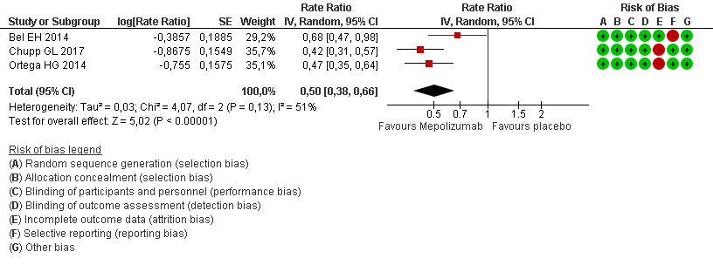
*Outcome definitions used in the included trials: Bel 2014: annualized rates of asthma exacerbations. A clinically significant exacerbation was defined as worsening of asthma leading to at least the doubling of the existing maintenance dose of oral glucocorticoids for 3 or more days or hospital admission or an emergency department visit for asthma treatment; Chupp 2017: annual rate of clinically significant exacerbations, defined as worsening of asthma requiring systemic corticosteroids administered intravenously or orally for ≥3 days or as a single intramuscular dose, or an emergency room visit or admission to hospital; Ortega 2014: annualized frequency of clinically significant exacerbations, defined as worsening of asthma. For example administration of systemic glucocorticoids for at least 3 days by the treating physician, the patient visiting an emergency department or being hospitalized.
† Exacerbation rate ratio was not reported in Ortega 2014, it was extracted from results reported in clinical trial.gov, defined as the number of exacerbations per year in the mepolizumab 100 mg SC arm divided by the number of exacerbations per year in the placebo arm (Source: https://clinicaltrials.gov/ct2/show/results/NCT01691521).

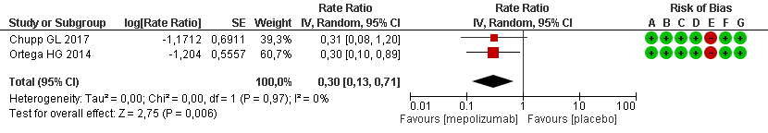
Exacerbation leading to hospitalization

Exacerbation rate ratio (subgroup: blood eosinophil’s counts at baseline)
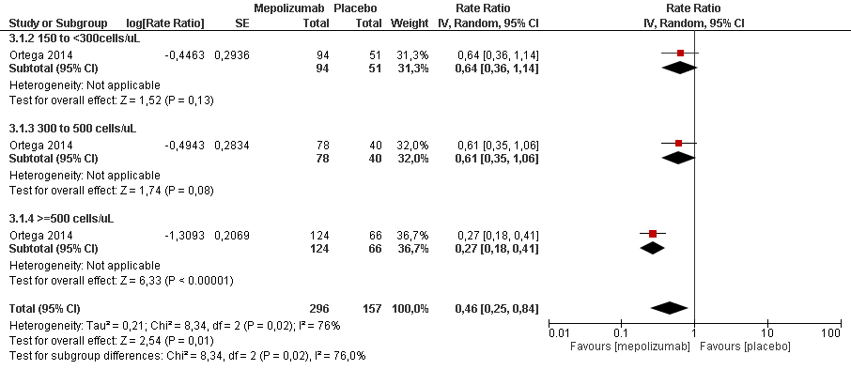
Pre-bronchodilator Forced Expiratory Volume in 1 s (FEV1) (overall)* †
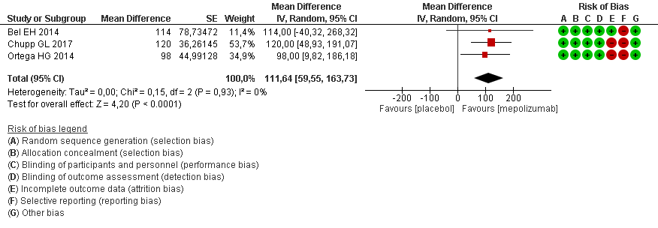
*Outcome definitions used in the included trials: Bel 2014: mean change from baseline in the FEV1 before bronchodilator: Between-group difference: 114 (-44 - 273)¹; p =0.15 at week 24; Chupp 2017: mean change from baseline in pre-bronchodilator FEV1 at week 24: Between-group difference: 120 (47-192); p =0.001 at week 24; Ortega 2014: mean change from baseline in FEV1 (ml) before bronchodilator: Between-group difference: 98 (11-84); p =0.03 at week 32.
†95%CI data was not reported in Bel 2014. It was extracted from the FDA in the product statistical review (https://www.accessdata.fda.gov/drugsatfda_docs/nda/2015/125526Orig1s000StatR.pdf).

Morning peak expiratory flow rate (PEF) *
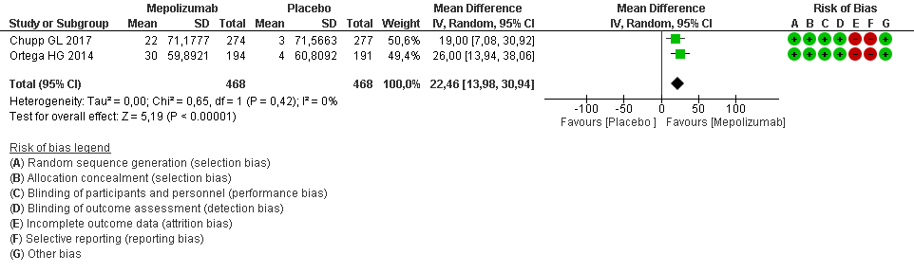
*Post Hoc analysis of MENSA and MUSCA trials from Ortega 2018.

Asthma Control Questionnaire (ACQ-5)*
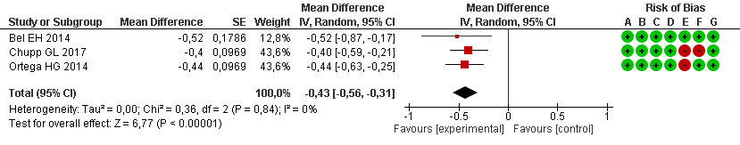
*Outcome definitions used in the included trials: Bel 2014: mean change from baseline in the ACQ-5 score: Between-group difference: -0.52 (-0.87 to -0.17); p =0.004 at week 24; Chupp 2017: mean change from baseline in the ACQ-5 score: between-group difference: -0.4 (-0.6 to -0.2); p <0.0001 at week 24; Ortega 2014: mean change from baseline in the ACQ-5 score: Between-group difference: -0.44 (-0.63 to -0.25); p <0.0001 at week 32.
†Score from 0 to 6 (higher scores indicate poorer control. Minimal important difference: 0.5 points (Juniper EF et al. 2005))

St. George's Respiratory Questionnaire (SGRQ)*†

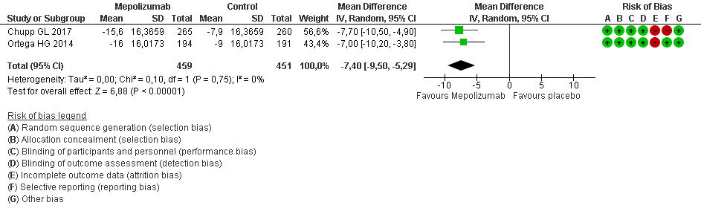
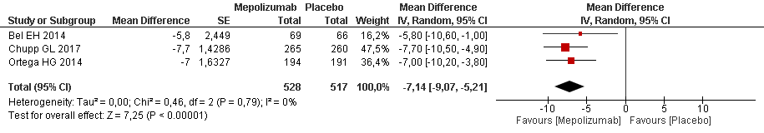
*Outcome definitions used in the included trials: Bel 2014: mean change from baseline in the SGRQ score: Between-group difference: -5.8 (-10.6 to -1.0); p =0.02 at week 24); Chupp 2017: mean change from baseline in the SGRQ score: between-group difference: -7.7 (-10.5 to –4.9); p <0.0001 at week 24); Ortega 2014: mean change from baseline in the SGRQ score: Between-group difference: -7.0 (-10.2 to -3.8); p <0.0001 at week 32).
† Minimal important difference: > -0.4 points which corresponds to a slightly effective change (Jones PW. 2002).

Treatment related adverse events
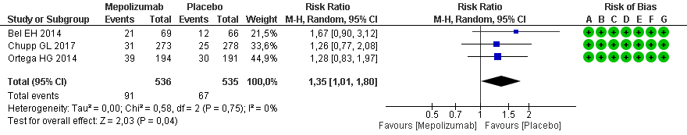

Treatment related serious adverse events (SAE)
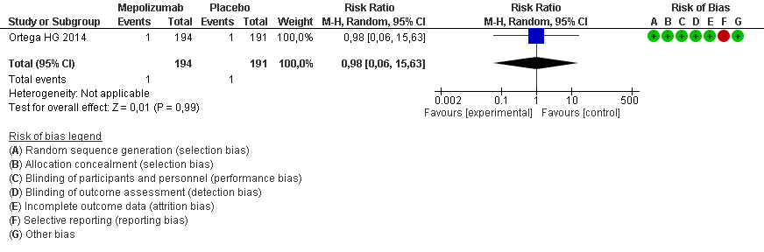

Reduction of glucocorticoids use*†
Outcome | Mepolizumab (n=69) | Placebo (n=66) | RR*  (95% CI) | P value
Reduction in oral glucocorticoid dose of ≥ 50%, n (%) | 37 (54) | 22 (33) | 1.61 (1.07-2.41) | 0.02
Reduction in daily oral glucocorticoid dose to a level ≤5mg, n(%) | 37 (54) | 21 (32) | 1.69 (1.11-2.55) | 0.01
Reduction in oral glucocorticoid dose of 100%, n(%) | 10 (14) | 5 (8) | 1.91 (0.69-5.30) | 0.2
*Calculated crude RR.
† Only Bel 2014 assessed this outcome

Rescue medication use*†
Daily brochodilator use at week 21-24 | Placebo  (n=277) | Mepolizumab  (n=247) | Mean difference  (between groups)  MD (95% CI)
Change from baseline, mean (SD) | -0.4 (1.5) | -0.5 (1.4) | -0.10 (-0.35 to 0.15)

*Chupp 2017 assessed with puffs/day.
†Minimal important difference -0.81 puffs/day (Santanello 1999).

Benralizumab
Annual asthma exacerbation rate (Overall)*
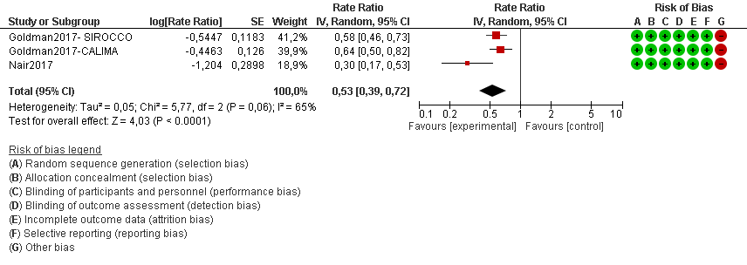
*Nair 2017 reported the annual exacerbation rate at 28 weeks, and Goldman 2017 reported a pooled analysis from SIROCCO (week 48) and CALIMA (week 56), both in patients with blood eosinophil count of ≥150 cells/lL.
Goldman 2017 defined the annual asthma exacerbation rate as the total number of exacerbations multiply by 365.25 and devided by the total duration of follow-up within the treatment group (days); An exacerbation was defined as a worsening of asthma that led to one of the following: (1) use of systemic corticosteroids (or a temporary increase in a stable oral corticosteroids background dosage) for at least 3 days or a single, injected dose of corticosteroids, (2) emergency department (ED)/urgent care visit (<24 hours) related to asthma that required systemic corticosteroids, or (3) inpatient hospitalization (24 hours) related to asthma. Nair 2017 did not report the definition of the annual exacerbation rate.

Change of Asthma Control Questionnaire-6 (ACQ-6) from baseline to End of treatment (EOT) (Overall)*
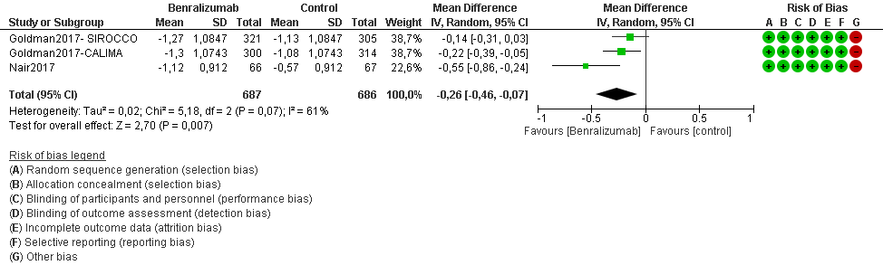

*Nair 2017 reported the change of ACQ-6 at 28 weeks, and Goldman 2017 reported a pooled analysis from SIROCCO (week 48) and CALIMA (week 56) studies, both in patients with blood eosinophil count of ≥150 cells/lL.
For ACQ-6, lower score indicate better control of symptoms.

Asthma Quality of Life Questionnaire for age ≥ 12 years old (AQLQ) from baseline to EOT (Overall)*
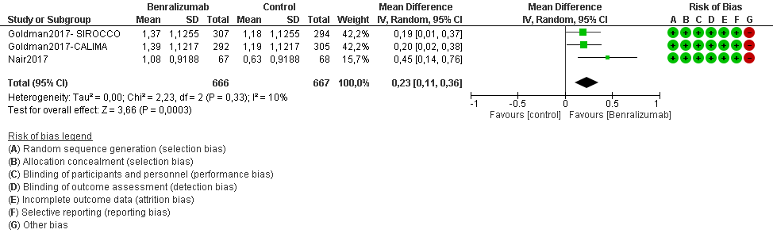
*Nair 2017 reported the change of AQLQ from baseline at 28 weeks, and Goldman 2017 reported a pooled analysis from SIROCCO (week 48) and CALIMA (week 56) studies, both in patients with blood eosinophil count of ≥150 cells/lL.
For AQLQ, higher scores indicate better quality of life.
Change of Prebronchodilator Forced Expiratory Volume in 1 s (FEV1, L) from baseline to EOT (Overall)*
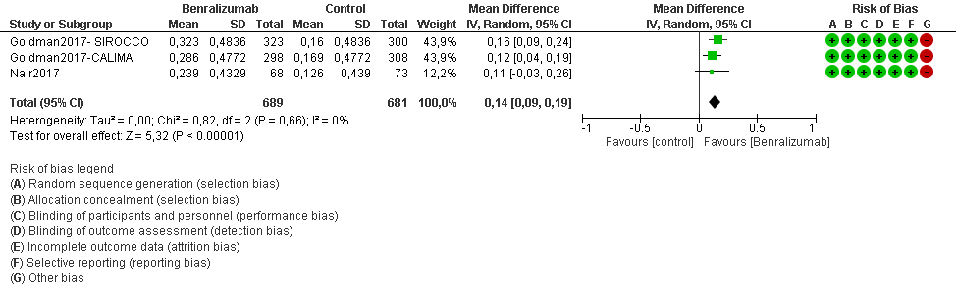
*Nair 2017 reported the annual exacerbation rate at 28 weeks, and Goldman 2017 reported a pooled analysis from SIROCCO (week 48) and CALIMA (week 56) studies, both in patients with blood eosinophil count of ≥150 cells/lL.

The reduction (%) of OCS from baseline (Overall)*
Outcome | Benralizumab vs. Placebo* | P value
Reduction from baseline in final oral glucocorticoid dose ≥50% | 1.76 (1.26 to 2.47) | 0.0005
Reduction from baseline in final oral glucocorticoid dose 100% | 2.75 (1.38 to 5.47) | 0.0014
Final oral glucocorticoid dose of ≤5.0 mg/day¹ | 1.77 (1.22 to 2.57) | 0.0018
*Crude risk ratio (95% CI) was calculated by Revman
1 All patients with a final oral glucocorticoid dose of 5.0 mg or less per day also had a reduction of at least 25% from baseline in the final oral glucocorticoid dose.

Any drug-related adverse events (AE)*
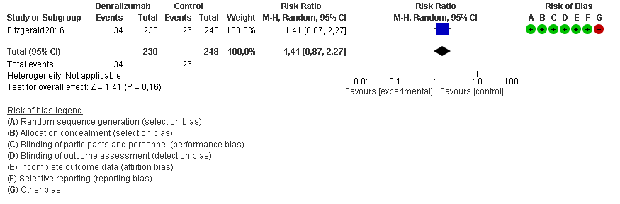
*Fitzgerald 2018 reported pooled data analysis from SIROCCO (week 48) and CALIMA (week 56) studies.
Any serious adverse event (SAE) unrelated to asthma exacerbation*
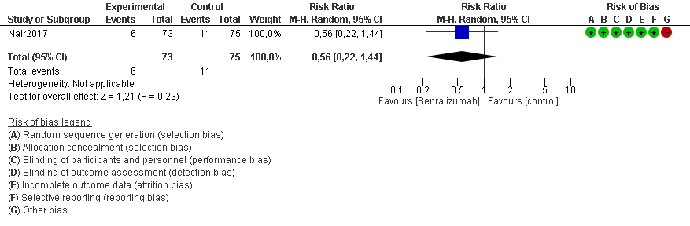
*Nair 2017 reported the annual exacerbation rate at 28 weeks in patients receiving high-dosage inhaled corticosteroids plus long-acting β2-agonists and blood eosinophil count ≥150 cells/µL.

Reslizumab
Clinically significant exacerbation rate ratio (Overall)* †
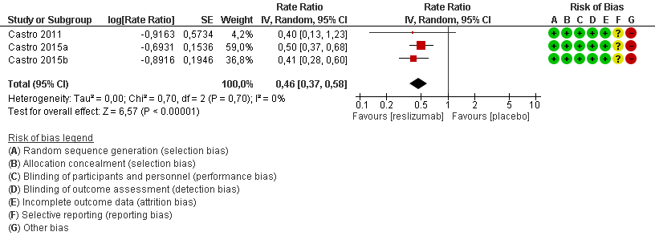
* Castro 2015a and Castro 2015b (reported results from two trials, see table 1) assessed exacerbation rates at 52 weeks and Castro 2011 at 15 weeks.
†Castro 2015a, b defined annual rate of clinical asthma exacerbations (number of exacerbations per person year), defined as worsening of asthma that resulted in use of systemic corticosteroids in patients not already receiving treatment, or a two-times increase in the dose of either inhaled corticosteroids or systemic corticosteroids for 3 or more days, or the need for asthma-related emergency treatment. Castro et al. 2011 defined a clinical asthma exacerbation as a 20% or more decrease from baseline in FEV1 or worsening of asthma requiring emergency treatment, hospital admission, or three or more days of oral corticosteroid treatment. In this study exacerbations where reported as “percentage of patients with clinical asthma exacerbations” at week 15, and the effect was estimated as a risk ratio.

Forced Expiratory Volume (FEV1) change (mL) (Overall)*
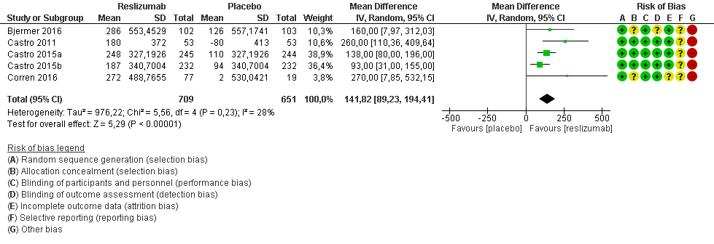
* FEV1 is considered a surrogate outcome of asthma control of symptoms, with a variable correlation with asthma symptoms (Aburuz 2005); included studies evaluated eosinophil patients with blood eosinophil counts ≥400cells/ul.
Castro 2015 also assessed FEV1 at 52 weeks, the mean difference from baseline was 122.28 (45.54, 199.02).
Bjermer 2016, Castro 2015 a/b and Corren 2016 assessed change in FEV₁ at 16 weeks and Castro 2011 at week 15.

Change from baseline of Asthma Control Questionnaire (ACQ-7) (Overall)*
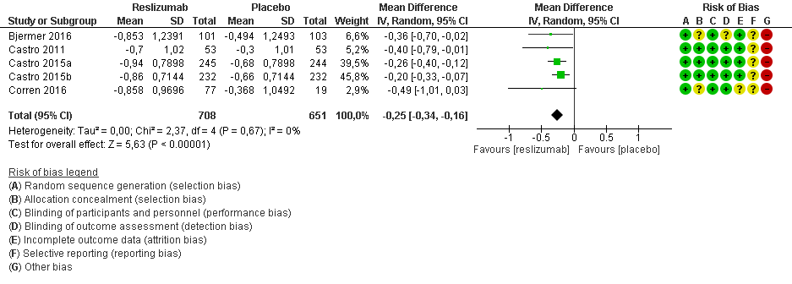
*Higher scores indicate poorer control. Minimal important difference: 0.5 points)
Bjermer 2016, Castro 2015 a/b and Corren 2016 assessed change in ACQ-7 at 16 weeks and Castro 2011 at week 15.
Castro 2015 a/b also assessed ACQ-7 at 52 weeks, the mean difference from baseline of ACQ-7 was -0.25 (-0.34, -0.16)

AQLQ Changes from baseline (Overall)
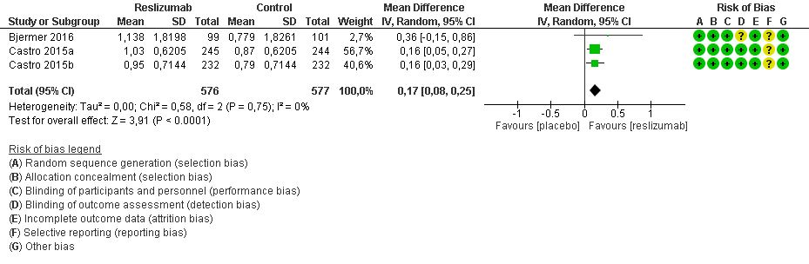
Bjermer 2016 assessed change in AQLQ at 16 weeks and Castro 2015 a/b at 15 weeks.
Castro 2015 a/b also assessed AQLQ at 52 weeks, the mean difference from baseline was 0.29 (0.18, 0.41), see full text report.

Rescue medication use (puffs/day) between-group-difference at week 16(Overall)
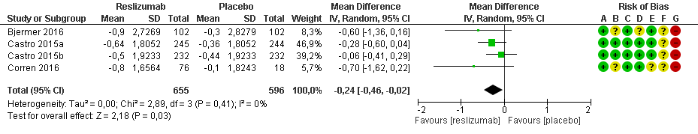
Outcome definitions used in the included trials:
Bjermer 2016: Change in SABA (short acting ß-agonist) use from baseline (puffs/day). Rescue inhaler use was assessed via patient recall of the number of inhalations over the preceding 3 days.
Castro 2015a/b: Change in SABA use from baseline (puffs/day). Rescue inhaler use was assessed via patient recall of the number of inhalations over the preceding 3 days.
Corren 2016: Change in SABA use from baseline (puffs/day). Rescue inhaler use was assessed via patient recall of the number of inhalations over the preceding 3 days.
Treatment-related adverse events (AE) at 15 to 52 weeks (Overall)*
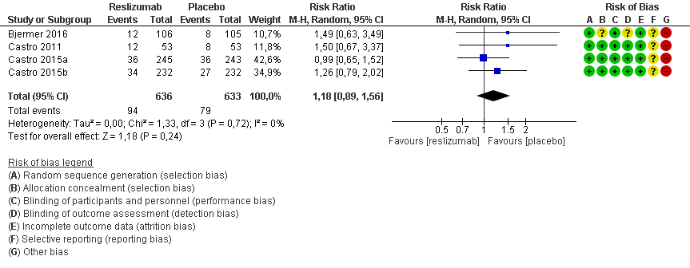*Data extracted from clinicaltrials.gov
Treatment-related serious adverse events (SAE) at 15 to 52 weeks (Overall)
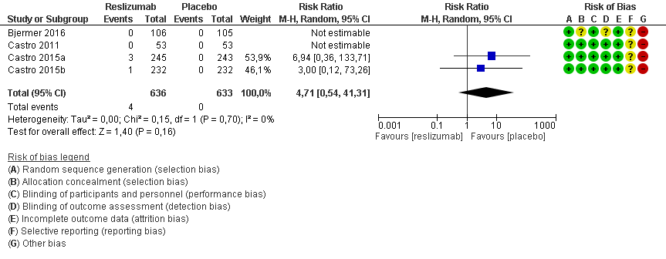
*Data extracted from clinicaltrials.gov

Omalizumab
Exacerbation rate (Overall)*
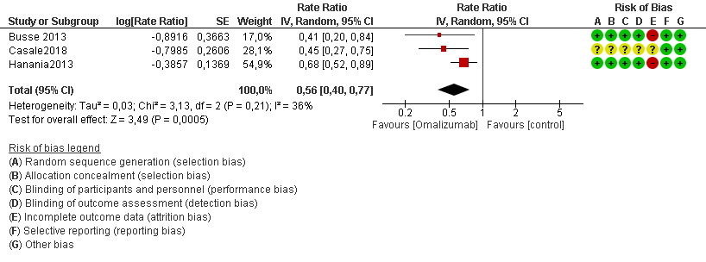
*Casale 2018 included patients with high eosinophil counts ≥ 200/µl, Busse 2013 with atopy and high blood eosinophil counts ≥ 300/µl and Hanania 2013 also with atopy and high blood eosinophil counts ≥ 260/µl.
Sorkness 2013 reported the exacerbation at 48 weeks for patients with FeNO ≥20 ppb and aged 6-20 years, OR: 2.57 (CI 95% 1.46-4.54).

Total Asthma Symptoms Score (TASS)*
TASS – patients with Blood eosinophil counts ≥ 260/ul*

Measure (Hanania 2013) | Omalizumab  (n=214) | Placebo  (n=200)
LS mean change | -1.63 | -1.47
LS mean difference change vs placebo (95% CI) | -0.16 (-0.51 to 0.19) | -

* Hanania 2013 assessed change of TASS for patients with eosinophil counts ≥260/µl at 48 weeks.
LS: least square

Predicted Forced Expiratory Volume in 1s (FEV1%) Change from baseline *
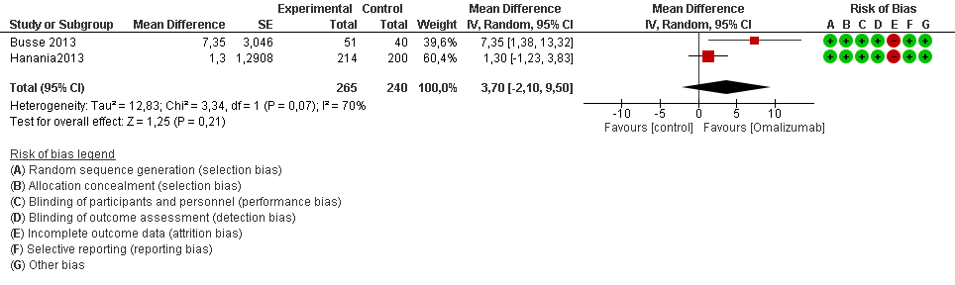
* Hanania 2013 assessed change of FEV1% for patients with eosinophil counts ≥260/µl at 48 weeks and Busse 2013 assessed patients with blood eosinophil counts ≥ 300 /µl at 24 weeks.
Hanania 2013 also assessed an overlapping subgroup with FeNO≥24 ppb, the LSMD for FEV1% was 3.20 (CI 95% -0.74 to 7.14).

Asthma Quality of Life Questionnaire(S) + 12 score (AQLQ)
Measure (Hanania2013) | Omalizumab vs. Placebo (CI 95%)
LS mean difference (eosinophil counts ≥ 260/ul) | 0.13 (-0.11 to 0.37)
LS mean difference (FeNO >24 ppb) | 0.37 (0.01 to 0.73).
*Hanania 2013 assessed AQLQ at 48 weeks f in patients with eosinophil counts ≥260/µl and FeNO >24 ppb.

Rescue medication use (Albuterol, puffs/day)*
Measure (Hanania2013) | Omalizumab vs. Placebo (CI 95%)
LS mean difference (eosinophil counts ≥ 260/ul) | -0.34 (-0.83 to 0.15)
LS mean difference (FeNO >24 ppb) | -0.49 (-0.88 to -0.11).
*Hanania 2013 assessed rescue medication use at 48 weeks in patients with eosinophil counts ≥260/µl and FeNO >24 ppb.

Inhaled corticosteroid (ICS) taken (Budesonide, μg/day)*
Outcome (Sorkness 2013) | Omalizumab vs. Placebo | P value
LS mean difference (FeNO ≥ 20 ppb) | -164.2 μg/day | 0.03
*Sorkness 2013 assessed reduction of Budesonide at 48 weeks in patients with FeNO≥20 ppb and aged 6-20 years old.

Drug related adverse events
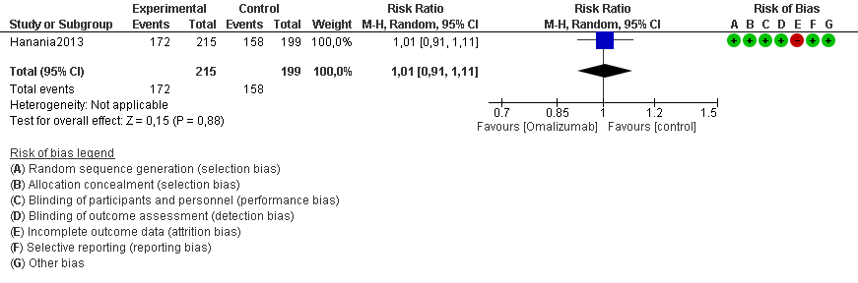
*Hanania 2013 evaluated subgroup population with blood eosinophil counts ≥ 260/µl.

Dupilumab
Exacerbation rate ratio* ɫ†
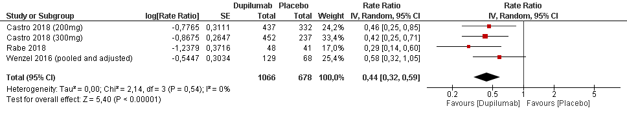
* Annualized rate of severe exacerbation was defined as number of severe exacerbations per person year. Severe exacerbation was defined as a deterioration of asthma requiring: 1) the use of systemic corticosteroids for ≥3 days and or 2) hospitalization/emergency room visit because of asthma, requiring systemic corticosteroids. Outcome assessment timepoints ranges from week 24 (Rabe 2018), week 40 (Wenzel 2016) to week 52 (Castro 2018).

ɫ Castro 2018 assessed patients with ≥ 150 eosinophils/µL count; Wenzel 2016 and Rabe 2018 assessed patients with ≥ 300 eosinophils/µL count.

† Wenzel 2016 reported multiple treatment arms compared to the same control arm, thus, we corrected the standard errors to take into account the data correlation in each comparison (unit of analysis errors) (Rucker 2017).
Asthma Control Questionnaire-5 (AQC-5) (Subgroup: dosage)*

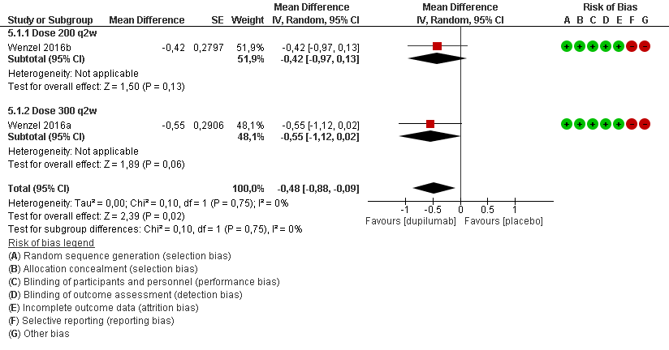
†

†

*Wenzel 2016 assessed ACQ in patients with eosinophil count ≥300 cells/mm³ at 24 weeks. Higher ACQ-5 scores indicate poorer control: scale from 0 (no impairment) to 6 (maximum impairment). Minimal important difference: 0.5 points.
†Wenzel 2016 reported multiple treatment arms compared to the same control arm, thus, we corrected the standard errors to take into account the data correlation in each comparison (unit of analysis errors) (Rucker 2017).

AQLQ change from baseline (Subgroup: dose)*

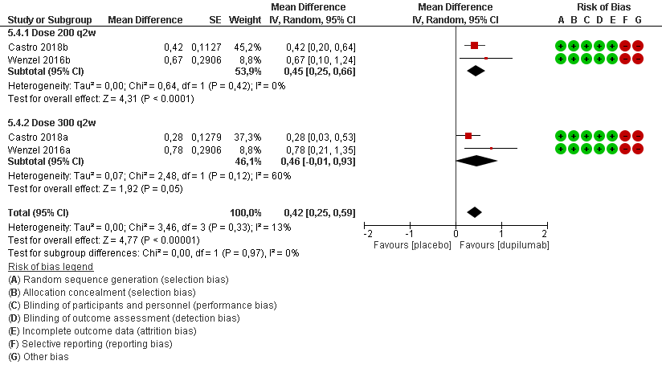
†

†

*Included studies assessed AQLQ in patients with eosinophils count ≥ 300 cells/mm³ at 24 weeks. Higher AQLQ scores indicate better quality of life. Minimal important difference: 0.5 points.
†Wenzel 2016 reported multiple treatment arms compared to the same control arm, thus, we corrected the standard errors to take into account the data correlation in each comparison (unit of analysis errors) (Rucker 2017).
Any treatment-emergent Adverse Events (AE) (Overall)*

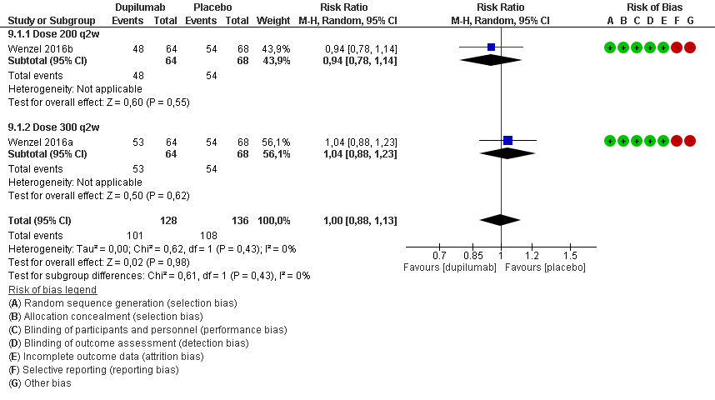
*Wenzel 2016 assessed AE in patients with eosinophil’s count ≥300 cells/mm³ at 24 weeks.

Any treatment-emergent serious adverse events (SAE)*

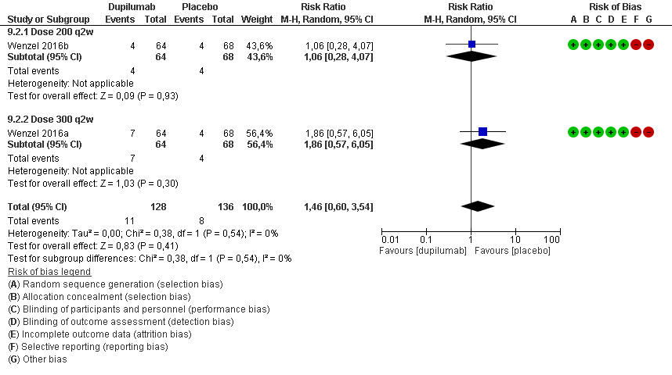
*Included studies evaluated patients with eosinophils count ≥ 300/mm³ at 24 weeks.
FEV 1 (L) – eosinophil count ≥ 150 cells/mm³ (Overall)*

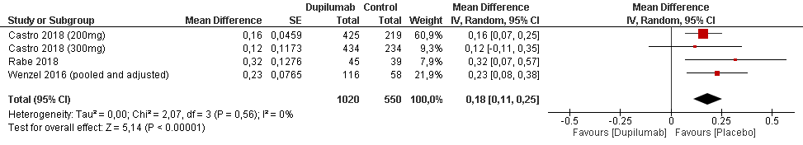
†

†

*All studies assessed patients with eosinophils count ≥ 150 cells/mm³
† Wenzel 2016 reported multiple treatment arms compared to the same control arm, thus, we corrected the standard errors to take into account the data correlation in each comparison (unit of analysis errors) (Rucker 2017).

Fractional exhaled nitric oxide (FeNO)
FeNO (ppb) (Subgroup: dose)*

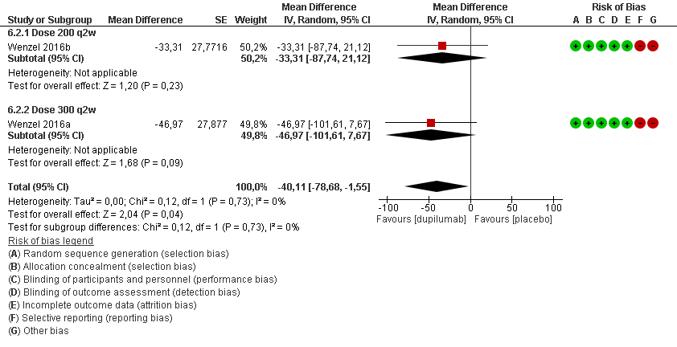
†

†

*Wenzel 2016 assessed FeNO in patients with eosinophil count ≥300 cells/mm³ at 24 weeks. Outcome defined as percentage change from baseline.
†Wenzel 2016 reported multiple treatment arms compared to the same control arm, thus, we corrected the standard errors to take into account the data correlation in each comparison (unit of analysis errors) (Rucker 2017).
Rescue medication use - eosinophil count ≥300 cells/mm³ (puffs/day)*

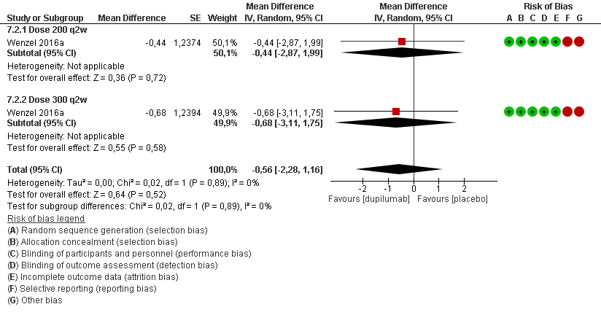
†

†

*Wenzel 2016 assessed rescue medication use in patients with eosinophil’s count ≥300 cell/mm³ at 24 weeks. Rescue medication use was defined as number of salbutamol/albuterol or levosalbutamol/levalbuterol inhalations recorded daily by the patients.
†Wenzel 2016 reported multiple treatment arms compared to the same control arm, thus, we corrected the standard errors to take into account the data correlation in each comparison (unit of analysis errors) (Rucker 2017).
Oral corticosteroid use % (Subgroup: Eosinophilic counts)* ɫ
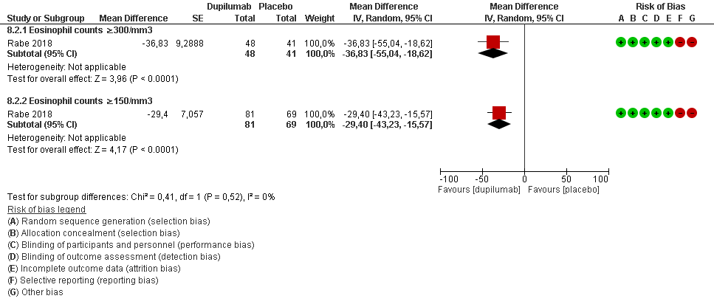
* We will use eosinophil counts ≥ 150 cell/mm³ as an overall population (as defined by protocol).
ɫ Systemic corticosteroid use defined as percentage of reduction in systemic corticosteroid use at 24 weeks. Overall estimate not shown given the overlapping between the subgroups.

