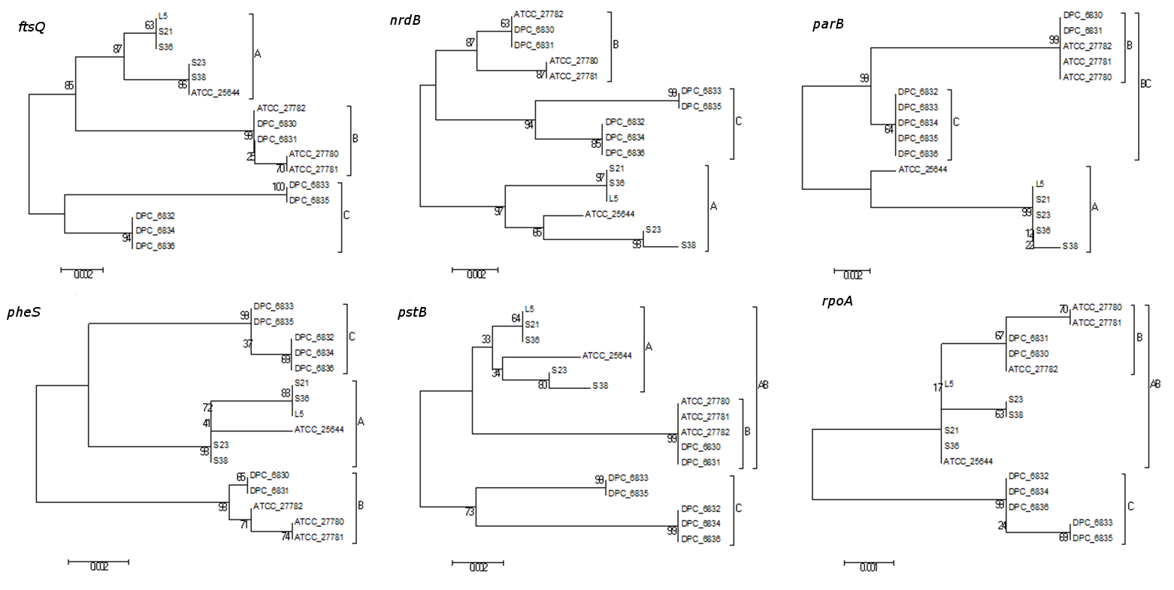
Additional file 4 Neighbour-joining phylogenetic trees for the MLST loci indicated.

