Supporting Information for

A folate-targeted PEGylated cyclodextrin-based nanoformulation achieves co-delivery of docetaxel and siRNA for colorectal cancer

Yifang Zou ^{a #} , Fang Xiao ^{b #}, Liu Song ª, Bingxue Sun ª, Dandan Sun ª, Di Chu ª, Limei Wang ^{c}, Shulan Han ª, Zhuo Yu ^{d}, Caitriona M O’Driscoll ^{e} *, Jianfeng Guo ª *

ªSchool of Pharmaceutical Sciences, Jilin University, Changchun 130021, China
^{b}Department of Pharmacy, the Second Hospital of Jilin University, Changchun 130041, China
^{c}Department of Pharmacy, the General Hospital of FAW, Changchun 130011, China
^{d}Department of Hepatopathy, Shuguang Hospital, Affiliated to Shanghai University of Traditional Chinese Medicine, Shanghai 201203, China
^{e}Pharmacodelivery Group, School of Pharmacy, University College Cork, Cork T12 YT20, Ireland

#These authors are joint first authors.

*Corresponding authors:
Email: jguo@jlu.edu.cn (J Guo), caitriona.odriscoll@ucc.ie (CM O’Driscoll).

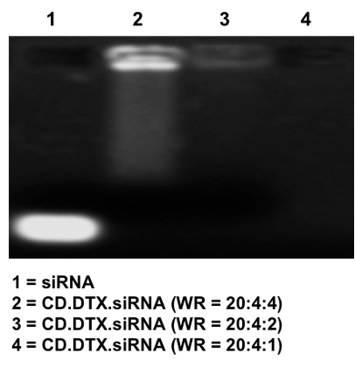
Figure S1. The binding efficiency of siRNA (0.5 μg) by CD.DTX at different weight ratios.

Figure S2. TEM images of CD.DTX.siRNA, CD.DTX.siRNA.PEG, and CD.DTX.siRNA.PEG-FA (bar = 100 nm).

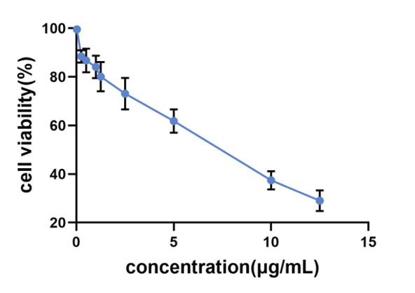
Figure S3. Cell viability (%) of CT26 cells following treatment of DTX at different concentrations (n = 3). IC₅₀ (~ 6.5 μg/mL) and IC₂₀ (~ 1.33 μg/mL) were calculated using the GraphPad Prism software.

Figure S4. The viability (%) of CT26 cells following treatment of DTX (1.33 μg/mL), CD.DTX.PEG and CD.DTX.PEG-FA (n = 3, * p < 0.05 and NS = no significance).

Figure S5. The viability (%) of CT26 cells following treatment of CD.siRelA.PEG (50 nM of siRNA), CD.siNC.PEG-FA and CD.siRelA.PEG-FA (n = 3, * p < 0.05 and NS = no significance).

Figure S6. Fluorescence intensity (%) shown in Fig. 2A (n = 3, * p < 0.05).

Figure S7. The competitive uptake of FA-targeted co-formulation into CT26 cells. The FACS assay was performed as described in Fig. 2A, except that CT26 cells were incubated with or without 2.5 mM of folic acid for 12 h prior to the addition of CD.DTX.siFAM.PEG-FA. Fluorescence intensity (%) (n = 3, * p < 0.05).

Figure S8. Apoptosis (%) caused by CD.siRelA.PEG-FA, CD.DTX.PEG-FA and CD.DTX.siRelA.PEG-FA (~ 1.33 μg/mL DTX and ~ 25 nM siRelA) as shown in Fig. 2D (n = 3, * p < 0.05 and ** p < 0.01).

Figure S9. Qualification of protein bands shown in Fig. 2F (n = 3, * p < 0.05 and NS = no significance).

Figure S10. Tumor growth of CRC following three treatments of saline, CD.siRelA.PEG-FA (~ 1 mg/kg siRelA), CD.DTX.PEG-FA (~ 4 mg/kg DTX) and CD.DTX.siRelA.PEG-FA (~ 4 mg/kg DTX and ~ 1 mg/kg siRelA) over a 25-day period (n = 4, * p < 0.05).

Figure S11. Qualification of protein bands shown in Fig. 4D (n = 3, * p < 0.05 and NS = no significance).

Figure S12. The body weight over 25 days following i.v. treatment of “DTX+siRelA” and folate-targeted co-formulation (~ 4 mg/kg DTX and ~ 1 mg/kg siRelA) on Day 1, 3 and 5 (n = 4).

Table S1. Primers used in this study.
Primer | Sequence
RelA | Forward: 5′-GCC TCA TCC ACA TGA ACT TGT GGG-3′  Reverse: 5′-ACC ATG GTC TGG GCA AGG ACT GGG-3′
GAPDH | Forward: 5′-ACC ACA GTC CAT GCC ATC AC-3′  Reverse: 5′-TCC ACC ACC CCC TGT TGC TGT A-3′

Table S2. Antibodies used in the study.
Antibody | Company | Catalog No. | Experiment | Dilution
Anti-RelA | Affinity | AF5006 | WB | 1:2000
Anti-β-actin | Affinity | AF7018 | WB | 1:2000
Goat Anti-Rabbit IgG (H+L) HRP | Affinity | S0001 | WB | 1:2000

Table S3. Physicochemical profiles of CD.DTX at different weight ratios (n = 3).

Table S4. Physicochemical profiles of CD.DTX.PEG and CD.DTX.PEG-GA (n = 3).

