SUPPORTING INFORMATION

Green Nanosilicas for monoaromatic hydrocarbons removal from air

Abdunaser M. Ewlad-Ahmed, Michael A. Morris, Justin Holmes, David J. Belton, Siddharth V. Patwardhan* and Lorraine T. Gibson.*

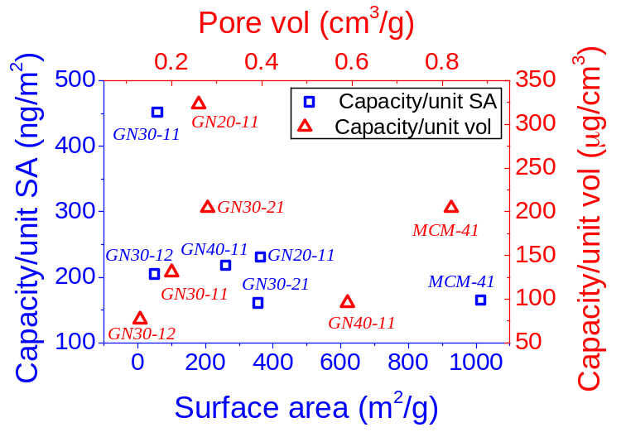
Fig S1 Normalised capacities of MCM-41 and GN.

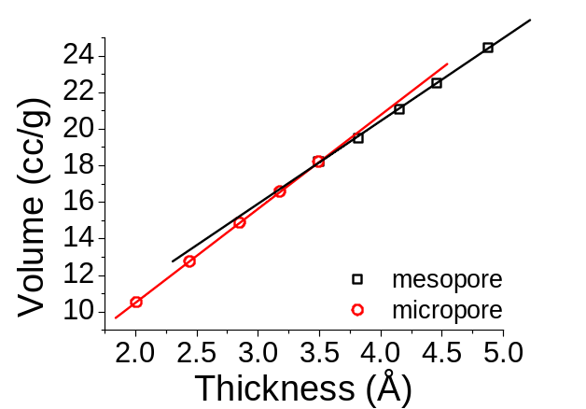

Fig S2 V-t plot for the nitrogen gas adsorption analysis used for micropore measurement of GN30-11.

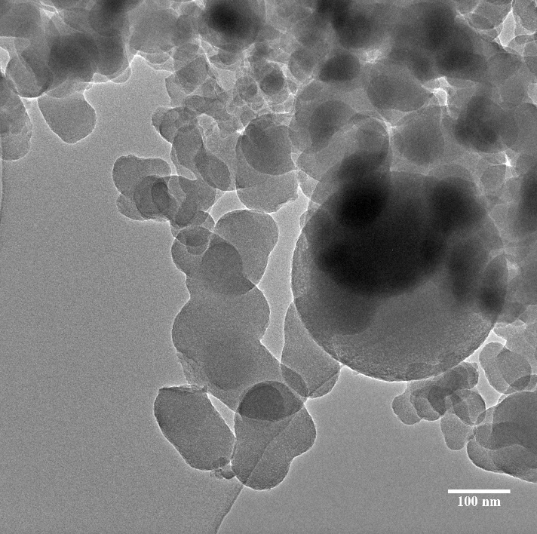
Fig S3 Representative TEM image of GN30-11. Scale bar = 100 nm

