Evolving Radiographic Practice: A Comprehensive Analysis of Skill Requirements for Radiographers in the United Arab Emirates
Authors: Dr. Leena R David*, Dr. Wiam Elshami, Dr. Olanrewaju Lawal, Dr. Mohamed Abuzaid, Ms. Nitika Panakkal, Mr. Visakh T, Dr. Andrew England, Prof. Mark McEntee, Mr. T. Somasundaram, Dr. Suresh Sukumar, Ms. Sneha Ravichandran,

Abstract
Aim: This study aims to identify the prospective skill requirements for future radiographers practising in the United Arab Emirates (UAE). Such information will inform educational institutions, healthcare organisations, and policymakers in developing effective strategies.
Methods: A cross-sectional study was conducted involving currently practising radiographers, nuclear medicine technologists, sonographers, and radiation therapists in the UAE. A comprehensive survey questionnaire was developed and validated through piloting and expert consultations. Ethical approval was obtained, and data were collected through purposive sampling. Descriptive statistics, reliability analysis, Chi-square tests, and factor analysis were employed in the data analysis.
Results:
Conclusion: This study sheds light on the CPD requirements and aspirations of radiographers in the UAE, offering insights into their preferences and challenges. These findings can inform strategies for improving CPD opportunities and ensuring that radiographers are equipped to meet the evolving healthcare demands in the UAE, including performing enhanced practice.
Implications for practice: Development of flexible and comprehensive CPD programmes tailored to radiographers' career interests is required. Employers should provide financial support and flexibility in training options. Regulatory bodies should continue to mandate CPD, fostering a culture of lifelong learning. Supportive work environments, interdisciplinary collaboration, and technological fluency are crucial. Emphasising patient-centred care, research opportunities, and continuous assessment further enhances radiography practice.
Keywords:
Radiography; Radiographer; CPD; Continuing Professional Development; Education; UAE

Introduction
Radiography holds a central position in modern healthcare, driven by substantial technological advancements that have unfolded in recent years. These advancements have ushered in a new era, enabling accurate diagnosis and treatment of diverse medical conditions through the adept utilization of medical imaging technologies (Keshavarz-Motamed, 2022). In the United Arab Emirates (UAE), much like in other countries, the practice of radiography remains in a state of constant evolution, prompted by the momentum of medical technology progress, evolving healthcare needs, and the burgeoning diversity of the patient demographic (Elshami, 2022). In light of these transformative dynamics, the imperative emerges to ensure that radiographers in the UAE remain equipped with the necessary skills to adeptly navigate these evolving demands.
The contemporary healthcare landscape has shifted towards a more patient-centred orientation, emphasizing effective communication, empathy, and overall patient satisfaction (Fox, 2015). Radiographers are no longer solely responsible for capturing images but also play a more holistic role in nurturing a positive patient experience throughout the imaging process (Hillergård, 2013). Therefore, the possession of robust interpersonal and communication skills is imperative for radiographers to proficiently engage with patients, alleviate their anxieties, and explain procedures clearly (Lawal, Regelous & Omiyi, 2023; 2024).
It is of importance to tackle the incorporation of Artificial Intelligence (AI) into radiography as it has initiated a transformative journey within the realm of modern healthcare. In recent years, AI has emerged as a disruptive force, redefining the landscape of medical imaging and revolutionizing the role of radiographers (David et al., 2022). The paradigm shift is not confined to clinical outcomes alone. Radiographers, traditionally focused on image acquisition and processing, are now becoming orchestrators of AI-enhanced workflows. The evolving role of radiographers, from image capture to AI collaborators, mandates skill diversification, fostering a generation adept in both technological fluency and compassionate care (Hamd et al., 2023).
Furthermore, given the involvement of ionizing radiation, the paramount significance of patient safety and minimisation of radiation exposure is apparent. In addition, proficiency in radiation safety protocols, quality control measures, and adherence to regulatory guidelines are critical skills that radiographers must possess (Amis, 2007). Continuous education and training in radiation protection practices are prerequisites for upholding the highest standards of patient care and staff well-being. Continuing professional development (CPD) is a systematic, holistic commitment and ongoing process of education undertaken by health professionals to maintain up-to-date knowledge and develop professional competency (Friedman, 2004). Healthcare, especially medical diagnostic and treatment services, is constantly revolutionising; therefore, those working in this field should possess updated knowledge and training. The Society and College of Radiographers define CPD as “An ongoing professional activity in which the practitioner identifies, undertakes, and evaluates learning appropriate to the maintenance and development of the highest standards of practice within an evolving scope of practice” (SCOR, 2021). In many countries, it is mandatory to have CPDs for professional body registrations by radiology professionals (Henwood, 2013).
By identifying future skill requirements and providing targeted training and education programs, organisations can help to ensure that radiographers are prepared to meet the changing demands of the healthcare industry and provide the best possible care to their patients. However, due to the lack of intrinsic motivation, time, financial, and limited resources, feeling that the topics are irrelevant, lack of awareness about CPD learning opportunities, shortage of staff, and lack of support from the management were found to be some barriers for the CPD learning activities among radiographers (Bwanga, 2020). While the concept of continuing professional development is well-recognized, there exists a dearth of evidence concerning the specific requirements and barriers to obtaining CPD among radiographers in the UAE. Additionally, little attention has been directed towards discerning the areas of radiography that radiographers aspire to develop. This study aims to identify and report the CPD requirements and aspirations of radiographers in the UAE.

Materials and Methods
Study Design
A cross-sectional design was adopted to investigate the future skill requirements among radiography professionals in the UAE, with a specific focus on their current demands for continuous professional development. Currently practising radiographers, nuclear medicine technologists, sonographers, and radiation therapists with a license for practising or interns from the UAE were included in the study. Those who are not currently practising and radiography students were excluded.
Questionnaire Development and Validation
A comprehensive survey questionnaire (see Supplementary Material) was developed by the research team and underwent validation through piloting and expert consultations. Ethical approval was provided by **** (REC ***). Data was collected using Google Forms (Google Inc, Mountain View, CA). The survey questionnaire was disseminated via purposive sampling; three investigators of this research shared the questionnaire with potential participants through social media as well as during a Radiography conference held at the study institution in March 2023. Participation was voluntary and responses were anonymised.
Data Analysis
Descriptive statistics were employed to present the baseline characteristics of the study participants. In a bid to ensure result, a reliability analysis was conducted utilising Cronbach’s alpha coefficient with a threshold of 0.7 is considered as acceptable reliable. Association between categorical variables was investigated through Chi Square Analysis. The variables examined for association included the relevance of the training program, working within specific Emirates, and mandatory requirements for CPD are the variables used to test their association. Furthermore, Factor analysis was conducted to discern underlying factors that resonated with a larger set of observed variables. The aim was to extract the maximum shared variance from these variables and put them into a unified score, thereby shedding light on the latent structure of the data.

Results
The questionnaire was sent to 119 potential participants and completed by 74 participants indicating a 62% response rate. The outcomes of the reliability test encompassing data from 74 respondents, revealed a Cronbach’s alpha coefficient of 0.943 for 45 variables confirming consistency and reliability of the data (threshold 0.7)
Participant Demographics
Table 1 summarises of the demographic characteristics of the 74 respondents, 63.5% were female and 36.5% male. Age distribution reveals that the majority (35.1%) of respondents fell within the age range of 26–30 years. Experience in the field varied, over half had between 0 and 10 years’ experience. Qualification-wise, the majority 64.9% held a Bachelor’s degree and worked (63.5%) in Dubai.

Table 1: Demographic Profile of Respondents (n=74).
Variables | Frequency | Percentage
Gender  Male  Female | 27  47 | 36.5  63.5
Age  Less than 25 years  26 – 30 years  31 – 40 years  41 years and Above | 10  26  19  19 | 13.5  35.1  25.7  25.7
Years of Experience  0 – 5 years  6 – 10 years  11 – 15 years  16 and above years | 27  22  5  20 | 36.5  29.7  6.8  27.0
Qualification  Diploma  Bachelor’s Degree  Master’s Degree  Doctor of Philosophy | 10  48  14  2 | 13.5  64.9  18.9  2.7
Region of employment  Abu Dhabi  Dubai  Sharjah  Ajman | 10  47  15  2 | 13.5  63.5  20.3  2.7

Clinical Practice Modalities
Figure 1 illustrates the distribution of participants across various clinical practice modalities. Most (75.7%) worked in general X-ray, followed by 50 to 60.8% in CT and DEXA. A smaller percentage, less than 7% of participants practised in nuclear medicine, operating theatre and CBCT. Notably, participants often engaged in multiple modalities simultaneously, a minimum 2 to 3 multiple devices at the same time.
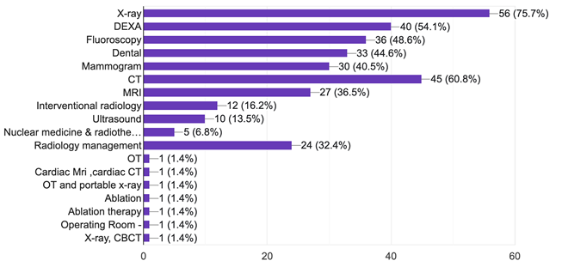
Figure 1. Participant’s current specialty of practice
CPD Opportunities and Preferences
Survey results indicated that most radiographers (86.5%) had a compulsory requirement for CPD mandated by the professional regulatory body or workplace; 71.9% of respondents were monitored annually. Most participants (86%) reported having CPD opportunities at their workplace, of which 65% were satisfied with the opportunities available. Reason for their dissatisfaction or satisfaction were not sought in this study. Survey data indicated that a majority (55.9%) were able to obtain financial support from their workplace to attend CPD activities and 73.7 % were provided financial support annually.
Figure 2 CPD opportunities available for the participants and their satisfaction
Mode of delivery for CPDs
Figure 2 illustrates the preference of participants for various CPD sessions. The majority (39.2%) preferred to attend conferences. Around 81% preferred face-to-face CPD activities conducted outside workplace followed by face-to-face sessions in their workplace (73.8%). The present survey also confirmed that most respondents (62.2%) preferred journal club/case presentations to help improve their clinical competency.

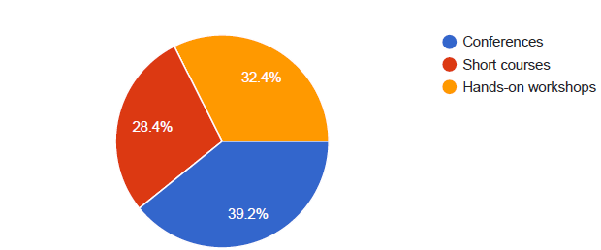


Figure 2. Pie charts illustrating the respondent preferences for CPD activities.

Areas of Interest for Career Development
Figure 3 describes the participants' areas of interest for career development. Notably, 73% of participants were keen on enhancing their expertise in ‘safety’ in the Radiology department (patient safety, infection control and radiation protection). Further, 47.3% of the participants displayed equal interested in image interpretation, post-processing, artifact correction, patient care and communication. Other fields of interest included interprofessional and interpersonal skills (43.2%), research and managerial skills (40.5%), Picture Archiving and Communication System (PACS) administration and AI (39.2%). Clinical supervision and assessment of students were found to be of interest to 33.8% of the participants.

Figure 3. Bar chart illustrating the participants’ areas of interest that they are looking forward to developing into a practice.
With reference to the choice of modality preferred for CPD training, the majority of participants (55.4%) chose CT as the area of interest.
Preferred CPD Timing
The preferred day and time for attending CPD training was considered. Weekends were preferred by 57% of participants, while 43% of participants preferred weekdays. Regarding the time, 47% of the participants preferred morning (am) sessions, while 46% preferred afternoon (pm) sessions and 7% of the participants conveyed that they can be available for either morning or afternoon sessions.

Table 3: Chi- Square analysis for identifying the relevance of the training program with the respect to the geographical region of work.
 | Chi-Square Value | df | Asymp. Sig. (2-sided)
Safety in Radiology (patient safety, infection control and radiation protection) | 2.505ª | 3 | .474
Clinical supervision and assessment of students | 6.960 | 6 | .241
Patient care and Communication | 14.645ª | 6 | .781
Image interpretation, post-processing, artifact correction | 11.086ª | 6 | .086
Interprofessional and Interpersonal skills | 10.757ª | 6 | .096
PACS Administration and Artificial Intelligence | 8.609ª | 6 | .197
Research and Managerial skills | 5.105ª | 6 | .530
a. 6 cells (50.0%) have expected count less than 5. The minimum expected count is .17.

Table 4 presents the results of hypothesis testing concerning the association between the relevance of the training program and the participants' geographical location. Analysis indicated that the relevance of the training program was not associated with the Emirates (location) where the participants were working in.

Table No: 4 Chi – Square Analysis showing the mandatory requirement of CPD by the licensing authority body.
Test Statistics
 | Mandatory requirement by a professional regulatory body for CPD
Chi-Square | 39.405ª
df | 1
Asymp. Sig. | .000
a. 0 cells (.0%) have expected frequencies less than 5. The minimum expected cell frequency is 37.0.

Table 4 encapsulates the outcomes of the hypothesis testing regarding the necessity of mandatory requirement for CPD by a professional regulatory body (. The alternate hypothesis (Ha) was accepted as all significance values were less than 0.05, signifying the essential need for mandatory CPD requirements.

Factor Analysis:
Results from the Kaiser-Meyer-Olkin (KMO) test attests to the adequacy of sampling. A value of 0.811 surpassing the threshold of 0.6 and confirmed study data for data reduction techniques. Additionally, the significance level of Barlett’s test was <0.001 indicating a high level of correlation between variables, thus confirming the adequacy of study data for factor analysis.

Rotated Component Matrix
Table X, provides insight into the rotated component matrix of each factor considered for CPD training accompanied by Eigen value and factor loading. Eigen values exceeding 1 were deemed significant.

Table X.
Factor | Variables | Rotated Factor Loading | % of Variance | Eigen Value
Training Setting | Improve learning ability in CPD Session | .805 | 52.1 | 15.12
Training Setting | Supports interaction between trainer and learner | .802 | 52.1 | 15.12
Training Setting | Encourage participation | .751 | 52.1 | 15.12
Training Setting | It provides flexibility to learn | .727 | 52.1 | 15.12
Training Setting | Influence on exposure the talent and skills | .725 | 52.1 | 15.12
Training Setting | Provide sufficient time for learning from CPD session | .724 | 52.1 | 15.12
Training Setting | Helps to meet the programme objectives | .660 | 52.1 | 15.12
Training Setting | Influence them to show their participation | .594 | 52.1 | 15.12
Training Setting | It is important in deciding interest level of radiographers in attending the CPD session | .542 | 52.1 | 15.12
Training Topics | Beneficial insight into trends in radiography | .730 | 6.5 | 1.88
Training Topics | Relevant to the practice | .721 | 6.5 | 1.88
Training Topics | Opportunities to acquire new knowledge | .682 | 6.5 | 1.88
Training Topics | Creates interest among radiographers to learn new techniques | .652 | 6.5 | 1.88
Training Topics | Relevant to my practice | .602 | 6.5 | 1.88
Training Topics | Makes everyone feels comfortable in attending CPD session | .577 | 6.5 | 1.88
Training Topics | Flexibility to attend the CPD session | .569 | 6.5 | 1.88
Training Topics | motivate them to attend the CPD session | .551 | 6.5 | 1.88
Training Topics | Interest level in attending the CPD training | .550 | 6.5 | 1.88
CPD Credits | CPD Credits helps to improve further in practice level | .757 | 5.9 | 1.72
CPD Credits | Supports them to understand their existing level | .702 | 5.9 | 1.72
CPD Credits | Motivates them to learn many things in their practice | .665 | 5.9 | 1.72
CPD Credits | Supports them in measuring the performance level | .643 | 5.9 | 1.72
CPD Credits | Helps to renew my clinical practice license | .611 | 5.9 | 1.72
Presenter and Expenses | Realize the importance of CPD session | .768 | 5.2 | 1.49
Presenter and Expenses | Participation level regarding CPD session | .766 | 5.2 | 1.49
Presenter and Expenses | Cost associated with training topic relevant to topic | .751 | 5.2 | 1.49
Presenter and Expenses | Cost provides flexibility to attend the CPD session | .642 | 5.2 | 1.49
Presenter and Expenses | Vital role in deciding to attend the CPD session | .614 | 5.2 | 1.49

Interpretation:
Factor 1 (Training settings):
Eigen value of 15.12 accounted for 52.1% of the variance. The variables are related to venue-related variables and showcased factor loading on variables like improve learning ability (0.805), support interaction level between trainer and learner (0.802), encourage trainer’s participation (0.751), flexibility to learn (0.727), exposure to talent and skills (0.725), and provide sufficient time for learning (0.724)
Factor 2 (Training topics):
Eigen value of 1.88 accounting for 6.5% of the variance. The variables are related to training topics and it has factor loading on variables like beneficial insight into trends in radiography (0.730), and relevance to practice (0.721).
Factor 3 (CPD Credits):
Eigen value of 1.72 accounting for 5.9% of variance. The variables are related to CPD points, and it has factor loading on improving further practice (0.757), and support understanding existing level (0.702).
Factor 4 (Presenter and Expenses):
Eigen value of 1.49 accounting for 5.2% of variance. The variables are related to speaker, and it has factor loading on realizing the importance of CPD session (0.768), participation in activity (0.766), and cost associated with training topic are relevant (0.751), flexibility (0.642) and role (0.614). Analysis of the factor analysis indicated that four factors influenced radiographers attending CPD namely; training setting, training topics, CPD credits and speaker (Figure 5).
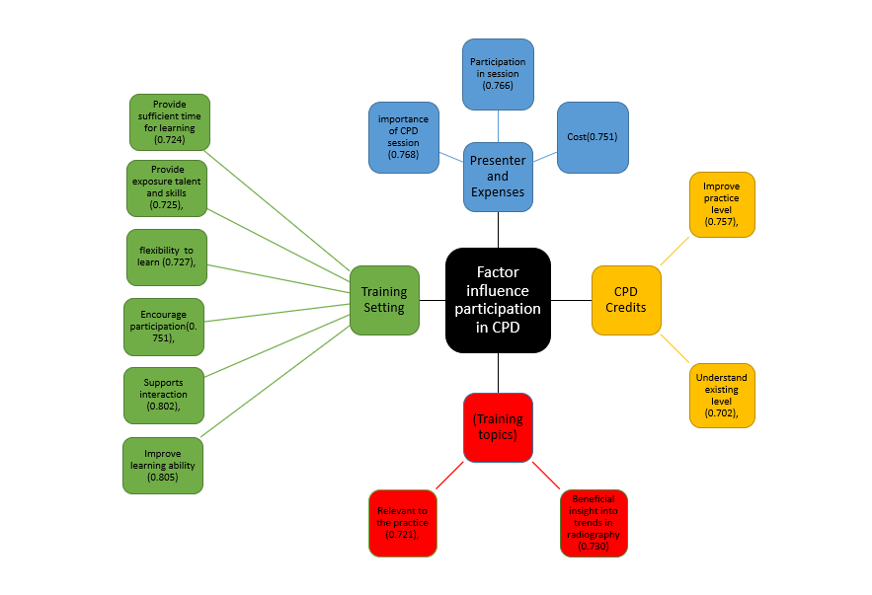

Discussion
CPD in radiography ensures that all radiology professionals remain up to date on the various changes and technological advancements (Wareing, 2017). Participation in CPD is generally voluntary and remains voluntary in many countries. However, some countries have mandatory CPD for radiology professionals. Our findings indicate that most radiographers (86.5 %) had a compulsory requirement for CPD credit points by a professional regulatory body or workplace and 71.9 % were monitored annually. The Australian Society of Medical Imaging and Radiotherapy started making their CPD programme mandatory in 2005, whereas the CPD programmes in New Zealand were made mandatory in 2004 (Henwood, 2010; Lee, 2010).
Many professional bodies, from various countries, encourage their radiology professionals to participate in various CPD activities. Unfortunately, many barriers exist, including cost, time, feasibility and lack of incentives that prevent radiographers from engaging in CPD activities (James, 2011). In the UAE, mainly depending on the different Emirate region, there are different regulatory bodies and requirements for CPD.
CPD mode of delivery
Around 39.2% of respondents preferred to attend conferences, whereas 32.4% preferred hands-on workshops and 28.4% chose short-term courses to improve and maintain professional competency. A similar study conducted by Mohamed Afif (YEAR) showed that workshops were the most preferred CPD activity selected as they provide a more hands-on experience for the participants. However, the study also demonstrated online sessions as the second most preferred mode of delivery. Our study indicated that the majority of the respondents (81%) preferred CPD activities conducted face-to-face learning outside the workplace, whereas around 73.8% preferred face-to-face sessions at their workplace and online sessions. Online sessions can be beneficial and convenient for a radiographer working shifts (Moreira, 2019; Shanahan, 2010). A survey conducted by Marshall and colleagues (2008) in Europe reported that a majority preferred a mix of e-learning, paper based and internet learning for CPD. The present survey also demonstrated that a majority of respondents (62.2%) preferred journal club/case presentations to help improve their clinical competency (Figure 5). However, individual learning preferences may affect the choice of type of delivery (Fowler, 2002).
Cost factor
Studies have demonstrated that one of the major barriers that kept individuals from attending CPD activities is the financial aspect (Haywood, 2012; Power, 2011). A study conducted in Sudan reported only 28% of participants were financially supported by their institution which was found to be the major cause of low participation of radiographers (Elshami, 2016). A study conducted in Singapore (Mohamed Afif; 2021) showed that 75.8 % participants were supported by their institution. The present study showed that a majority (55.9%) were able to obtain financial support from their workplace to attend CPD activities and 73.7% were provided financial support annually. Around 63.2% were provided financial support of around 25-140 USD to attend CPD activities by their employers. A survey conducted in Australia reported that respondents spent an average of $1000 per annum on CPD which was similar to the employer contributions.
Choice of topic
The present research demonstrated that “Clinical supervision and assessment of students” was the most preferred area to be developed followed by “research and managerial skills”. In contrast to the present study, a survey conducted in Singapore reported “clinical supervision” was of interest to only 6.3% of participants and a majority of them chose “image interpretation” as the most preferred area of interest (Mohamed Afif, 2021). This could be because the majority of the participants were in the clinical field. Their study also reported a lower score for research interests as only a few radiographers are involved in research. With reference to the choice of modality preferred for CPD training, a majority of participants (55.4%) chose CT as the area of interest (Figure 6). This could be due to the fact that the majority of the respondents were working in CT. It can also be due to the rapid developments in technology seen in these areas. A survey conducted in Europe also showed CT as one of the most preferred areas of interest followed by MRI and digital imaging (Marshall, 2008). Nevertheless, the current study showed that 32% of participants would like to participate in AI. Previous studies showed that it is imperative for radiographers to improve their understanding and abilities in AI. Acquiring knowledge in the field of AI enables radiographers to remain abreast of the ever-changing technological advancements and actively engage in collaborative decision-making processes. Moreover, it presents new avenues for research within the domain of medical imaging.
CPD opportunities
In literature, it has been reported that management can be responsible for providing and withholding opportunities (Gould, 2007; Ellis, 2005; Hughes,2005). Lack of support can also be considered one of the barriers with respect to CPD participation. Most respondents in the present survey (63.5%) considered the workplace responsible for CPD training. Around 64.9% of respondents had CPD opportunities available in their workplace and 52.1% reported that CPDs would be conducted annually at their workplace. One survey conducted in New Zealand and the UK reported that study days allotted for attending CPD activities can be beneficial to the staff (Henwood, 2010). The present study demonstrated that 53.1% of respondents were provided with paid leave to attend CPD activities. Around 55.9% were allowed to avail two days of paid leave to attend CPD activities (Figure 7). Employer support is crucial to overcome barriers of CPD participation (James, 2011).
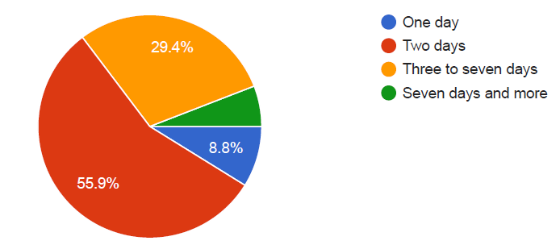
Figure 7. Pie chart demonstrating percentage of paid leave that can be availed for attending CPD.
Timing preferences
The present survey reported that a majority of respondents (56.8%) preferred to attend CPD training on weekends. This was comparable to a survey conducted in Singapore that reported that a majority of the respondents preferred to attend CPD activities on Fridays and after hours (Mohamed Afif, 2021). However, the survey conducted in the UK and New Zealand reported that the participants preferred to attend CPD activities during working hours (Henwood, 2010]. The opinion in this matter is reported to be mixed in literature. Some prefer to attend CPD activities after working hours, whereas some object the use of their free time in attending CPD activities and would prefer attending them during their working hours (Gould, 2007).
CPD points
The CPD program has already been made mandatory in countries like the UK, Australia and New Zealand (Henwood, 2010; Lee, 2010). The present study reported that a majority of them strongly agreed that CPD points can motivate individuals, helps in assessing the existing level of practice, improves performance and knowledge and clinical practice. However, a professional body may be required to supervise CPD activities to ensure learning has taken place.

Conclusions
This study highlights the significance of ongoing CPD in radiography and the need for financial and logistical support to make participation feasible. The study also shows that preferences for CPD delivery methods differ, indicating the importance of providing flexible training options. Factors such as cost, time, and incentives must be addressed to promote CPD participation. Additionally, the diverse interests of radiographers in CPD topics reflect the dynamic nature of their profession. Future research might evaluate the perspectives of departmental managers on the facilitators and barriers to supporting staff for CPD programmes. Furthermore, a longitudinal study is needed to track evolving trends and attitudes of radiographers in the UAE. This type of research could help determine if there are shifts in CPD participation and identify any factors influencing these changes.

Funding statement
There was no funding available for this research.
Author Contributions
Conceptualization, LRD, OL; methodology, LRD, WE, MA; statistical analysis T.S; writing of original draft LRD, WE, MA, NP, VT; review and editing AE, WE, MA, OL, SS, SR. All authors have read and agreed to the published version of the manuscript.
Informed Consent Statement
Informed consent was obtained from all subjects involved in the study.
Data Availability Statement
Data is available with LRD, the first author.
Conflicts of Interest
The authors declare no conflict of interest.

References

Amis Jr, E. S., Butler, P. F., Applegate, K. E., Birnbaum, S. B., Brateman, L. F., Hevezi, J. M., ... and Zeman, R. K. (2007). American College of Radiology white paper on radiation dose in medicine. Journal of the american college of radiology, 4(5), 272-284.

Bwanga O. Barriers to Continuing Professional Development (CPD) in radiography: a review of literature from Africa. Health Professions Education. 2020 Dec 1;6(4):472-80.

David, L. R., Elshami, W., Alshuweihi, A., Obaideen, A., Issa, B. A., & Shetty, S. R. (2022). Comparison of diagnostic accuracy of the artificial intelligence system with human readers in the diagnosis of portable chest x-rays during the COVID-19 pandemic. Advances in Biomedical and Health Sciences, 2(1), 4.

Elshami, W., Abuzaid, M. M., McConnell, J., and Baird, M. (2022). Changing the model of radiography practice: Challenges of role advancement and future needs for radiographers working in the UAE. Radiography, 28(4), 949-954.

Elshami W, Elamrdi A, Alyafie S, Abuzaid M. Continuing professional development in radiography: practice, attitude and barriers. Int J Med Res Health Sci 2016;5(1):68e73.
https://doi.org/10.5958/2319-5886.2016.00015.1.

Ellis E, Nolan M. Illuminating continuing professional education: unpacking the black box. Int J of Nurg Studies 2005; 42: 97–106
Friedman, A., and Phillips, M. (2004). Continuing professional development: Developing a vision. Journal of education and work, 17(3), 361-376.
Fowler P. Learning styles of radiographers. Radiography 2002; 8:3e11.
Fox, A., and Reeves, S. (2015). Interprofessional collaborative patient-centred care: a critical exploration of two related discourses. Journal of interprofessional care, 29(2), 113-118.
Gould D, Dery N, Berridge E. Nurses’ experiences of continuing professional development. Nurs Ed Today 2007; 27: 602–9
Hamd, Z., Elshami, W., Al Kawas, S., Aljuaid, H., & Abuzaid, M. M. (2023). A closer look at the current knowledge and prospects of artificial intelligence integration in dentistry practice: A cross-sectional study. Heliyon.
Henwood SM, Yielder J, Flinton D. Exploring radiographers' attitudes to mandatory CPD in the United Kingdom and New Zealand. Radiographer. 2010 Apr;57(1):25-32.
(https://onlinelibrary.wiley.com/doi/10.1002/j.2051-3909.2010.tb00117.x)

Haywood H, Pain H, Ryan S, et al. Engagement with continuing professional development: development of a service model. J Allied Health 2012;41(2):83e9.

Hughes E. Nurses’ perceptions of continuing professional development. Nurs Standard 2005; 19: 41–9
Keshavarz-Motamed, Z., Del Alamo, J. C., Bluestein, D., Edelman, E. R., and Wentzel, J. J. (2022). Novel methods to advance diagnostic and treatment value of medical imaging for cardiovascular disease. Frontiers in Bioengineering and Biotechnology, 10, 1501.
James N.K. Gawugah, Hansa Jadva-Patel, Marcus T. Jackson, The uptake of Continuing Professional Development (CPD) by Ghanaian radiographers, Radiography, Volume 17, Issue 4,2011, Pages 332-344,
Power A, Grammatiki A, Bates I, et al. Factors affecting the views and attitudes of Scottish pharmacists to continuing professional development. Int J Pharm Pract 2011;19(6):424e30.
Lawal O, Regelous P, Omiyi D. Supporting claustrophobic patients during Magnetic Resonance Imaging examination–the patient perspective. Radiography. 2023 Oct 1;29(6):1108-14.
Lawal O, Regelous P, Omiyi D. Supporting claustrophobic patients during magnetic resonance imaging examination–the radiographer perspective. Radiography. 2024 Jan 1;30(1):80-6.

Lee SHE, Read W, Poulos A. Continuing professional development: the perceptions of radiographers in New South Wales. Radiographer 2010;57:33e9.

Mohamed Afif A, Goh MZH, Lin YJ, Ho GD, Anwar T, Chong CM, Sim J. An analysis of the continuing professional development needs of radiographers and radiation therapists in Singapore. Radiography (Lond). 2021 Aug;27(3):927-934. doi: 10.1016/j.radi.2021.03.002. Epub 2021 Mar 26. PMID: 33775519.
Moreira IC, Ramos I, Rua Ventura S, Pereira Rodrigues P. Learner's perception, knowledge and behaviour assessment within a breast imaging E-Learning course for radiographers. Eur J Radiol 2019;111:47e55.

Shanahan M. Radiographers and the internet: an Australian perspective. Radiol
Technol 2010;81(3):223e32.
Society and College of Radiographers. Using CPD Now for
HCPC Audit. 2021; retrieved from https://www.sor.org/getattachment/ae898486-3e67-4ceb-a69c-0b859d8d30c8/Using-CPD-Now-for-HCPC-Audit-pdf.pdf?lang=en-GB (retrieved on 13 June 2023 ).

Hillergård, K. (2013). Radiographic quality workflow: in the digitized healthcare environment. Inst för klinisk vetenskap, intervention och teknik/Dept of Clinical Science, Intervention and Technology.
A. Wareing, C. Buissink, D. Harper, M. Gellert Olesen, M. Soto, S. Braico, P. Van Laer, I. Gremion, L. Rainford,Continuing professional development (CPD) in radiography: A collaborative European meta-ethnography literature review,Radiography,Volume 23, Supplement 1,2017,Pages S58-S63,

