Supplementary material for:
No reproductive fitness benefits of dear enemy behaviour in a territorial songbird
Behavioral Ecology and Sociobiology
Michael S. Reichert*, Jodie M.S. Crane, Gabrielle L. Davidson, Eileen Dillane, Ipek G. Kulahci, James O’Neill, Kees van Oers, Ciara Sexton, John L. Quinn

*Correspondence:
Michael Reichert
501 Life Sciences West, Department of Integrative Biology, Oklahoma State University, Stillwater, OK 74078 USA
email: michael.reichert@okstate.edu

Table S1. Study site locations and summary statistics.

Site Name | Coordinates | N DE behaviour/N tested | Clutch Size | N Fledged | Average Mass (g)
Ballinphellic (BP) | 51.840546, −8.630297 | 0/1 | 6 | 5 | 16.8
Castle Bernard (CB) | 51.741568, −8.767775 | 2/9 | 5.0 (1.3) | 1.4 (1.8) | 14.4 (3.1)
Dukes Wood (DW) | 51.785965, −8.751366 | 2/9 | 4.4 (1.1) | 1.7 (1.7) | 16.6 (1.9)
Dunderrow (DD) | 51.719555, −8.600512 | 0/4* | 5 | 0 | 15.3
Garrettstown (GT) | 51.655159, −8.616456 | 0/1 | 6 | 6 | 18.0
Innishannon (IN) | 51.763415, −8.664943 | 2/9 | 5.9 (1.5) | 1.0 (1.6) | 15.4 (1.6)
Kilbrittain (KB) | 51.671290, −8.682011 | 8/16** | 4.9 (1.3) | 2.2 (2.0) | 15.9 (1.6)
Shippool (SP) | 51.737780, −8.630792 | 1/2 | 4.5 (0.7) | 0.5 (0.7) | 17.6

Site names and coordinates as in O’Shea 2017. See also Figure S1. Values for the reproductive success variables are means (±standard deviation, not reported when only one individual was sampled at a site). Clutch size includes all eggs whether or not they were identified as extrapair; number fledged and average mass were calculated excluding any young identified as extrapair. Initials for the site name are given that correspond to the site variable in the raw data file. N DE behaviour refers to the number of individuals exhibiting dear enemy behaviour under the standard criterion.

*Three of these individuals at Dunderrow were excluded from the analyses of reproductive success variables because of widespread stoat predation of nests at the site in 2018. The numbers reported here are from the one nest that was included.
**One individual from Kilbrittain that had no eggs in the nest was excluded from the calculations of reproductive success variables.

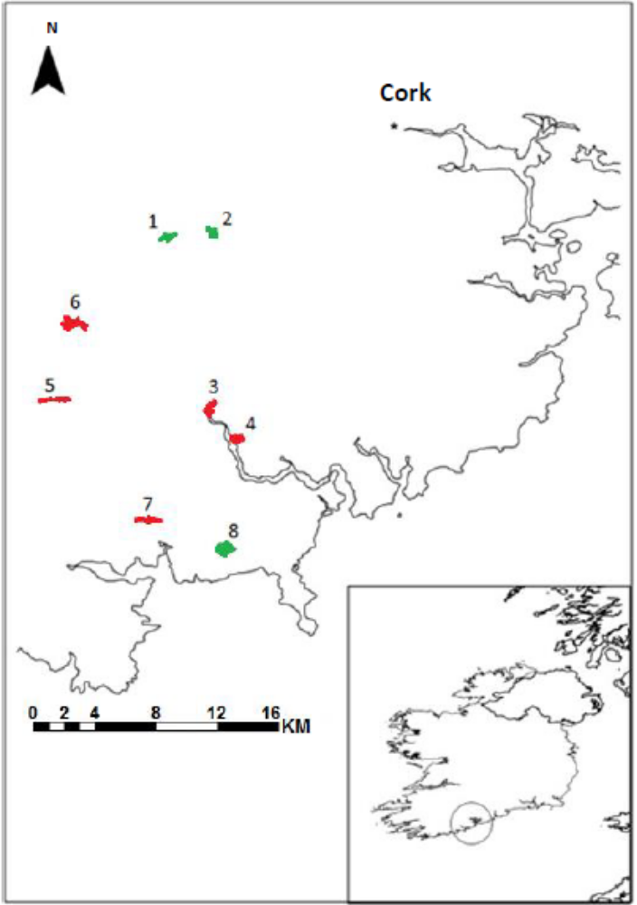
1

Figure S1. Map of the study sites, modified from O’Shea (2017). Numbers correspond to the individual sites (see also Table S1): 1. Innishannon, 2. Ballinphellic, 3. Shippool, 4. Dunderrow, 5. Castle Bernard, 6. Dukes Wood, 7. Kilbrittain, 8. Garrettstown.

Table S2. Response on last neighbour trial versus response on stranger trial

 | Responded stranger trial | Did not respond stranger trial
Responded last neighbour trial | 15 | 0
Did not respond last neighbour trial | 15 | 21

The table shows the number of individuals for each combination of responding or not responding to the last neighbour trial and to the subsequent stranger trial.

Table S3. Effects of context on dear enemy behaviour.

Dear enemy criterion | Factor | Estimate | SE | Test statistic | P
Standard criterion | Intercept | 1049 | 1668 | 0.63 | 0.53
 | Year | −0.52 | 0.83 | −0.63 | 0.53
 | Date | 0.07 | 0.05 | 1.33 | 0.18
 | Stimulus rate (high) | 0.58 | 0.70 | 0.82 | 0.41
 | Date relative to first egg | −0.01 | 0.06 | −0.18 | 0.86
 | Average song number | −0.07 | 0.06 | −1.13 | 0.26
Standard without nonresponders | Intercept | 5701 | 3478 | 1.64 | 0.10
 | Year | −2.83 | 1.73 | −1.64 | 0.10
 | Date | 0.15 | 0.10 | 1.52 | 0.13
 | Stimulus rate (high) | 0.87 | 1.08 | 0.81 | 0.42
 | Date relative to first egg | −0.02 | 0.08 | −0.26 | 0.80
 | Average song number | −0.25 | 0.12 | −2.09 | 0.04
Response slope | Intercept | 12.37 | 73.49 | 0.17 | 0.87
 | Year | −0.01 | 0.04 | −0.17 | 0.87
 | Date | 0.001 | 0.002 | 0.46 | 0.65
 | Stimulus rate (high) | 0.01 | 0.03 | 0.29 | 0.77
 | Date relative to first egg | 0.002 | 0.002 | 1.05 | 0.3
 | Average song number | 0.002 | 0.002 | 1.00 | 0.33
Song slope | Intercept | 485 | 2262 | 0.21 | 0.83
 | Year | −0.24 | 1.12 | −0.22 | 0.83
 | Date | 0.08 | 0.07 | 1.13 | 0.27
 | Stimulus rate (high) | −0.70 | 0.81 | −0.86 | 0.40
 | Date relative to first egg | 0.01 | 0.06 | 0.12 | 0.91
 | Average song number | 0.05 | 0.05 | 0.96 | 0.35

Results are from a generalized linear model of whether or not the individual met the standard criterion for expressing dear enemy behaviour (where the test statistic is z), or from linear models for the slope variables (where the test statistic is t). The reference category for stimulus rate is the low rate stimulus. The variable “average song number” refers to the average number of songs produced by the bird over the nine total neighbour trials. Date is coded as the day number of the year on which the first playback was performed for that bird, with 1 March being day 1. Date relative to first egg refers to which day the first playback was performed for that bird relative to when the first egg was laid in the nest (so day zero would indicate that the first playback was performed on the same day that the first egg was laid in the nest). N = 50 individuals for the standard criterion (one individual not included because there was never an egg laid at the nest), 29 individuals for standard without nonresponders, and 25 individuals for the slope variables.

Table S4. Full models of dear enemy behaviour and reproductive success, including brood size effects when included in models.

Reproductive measure | Dear enemy behaviour measure | Estimate(SE) | test statistic | P | N
Clutch size | Standard criterion | −0.14 (0.15) | −0.98 | 0.33 | 47
 | Standard without nonresponders | −0.15 (0.17) | −0.85 | 0.40 | 28
 | Response slope | 0.59 (1.29) | 0.46 | 0.65 | 28
 | Song slope | 0.008 (0.043) | 0.19 | 0.85 | 28
Number fledged | Standard criterion | −0.42 (0.35) | −1.22 | 0.22 | 47
 | Standard without nonresponders | −0.33 (0.37) | −0.90 | 0.37 | 28
 | Response slope | 3.12 (2.13) | 1.47 | 0.14 | 28
 | Song slope | 0.04 (0.07) | 0.58 | 0.56 | 28
Fledged offspring yes/no | Standard criterion | −0.85 (0.65) | −1.30 | 0.19 | 47
 | Standard without nonresponders | −0.58 (0.76) | −0.75 | 0.45 | 28
 | Response slope | −1.48 (5.73) | −0.26 | 0.80 | 28
 | Song slope | 0.04 (0.19) | 0.19 | 0.85 | 28
Average offspring biomass (g) | Standard criterion | −0.78 (0.94) | −0.83 | 0.41 | 30
 | Brood size | 0.28 (0.27) | 1.06 | 0.30
 | Standard without nonresponders | 0.69 (1.11) | 0.62 | 0.55 | 16
 | Brood size | 0.46 (0.34) | 1.35 | 0.2
 | Response slope | −7.00 (9.64) | −0.73 | 0.48 | 16
 | Brood size | 0.62 (0.46) | 1.36 | 0.2
 | Song slope | 0.09 (0.33) | 0.27 | 0.79 | 16
 | Brood size | 0.28 (0.49) | 0.58 | 0.57
Individual offspring mass (g) | Standard criterion | −0.70 (0.92) | −0.76 | 0.45 | 95/30
 | Brood size | 0.20 (0.26) | 0.75 | 0.46
 | Standard without nonresponders | 0.77 (0.99) | 0.78 | 0.45 | 49/16
 | Brood size | 0.38 (0.31) | 1.24 | 0.24
 | Response slope | −7.00 (8.81) | −0.79 | 0.44 | 49/16
 | Brood size | 0.57 (0.44) | 1.28 | 0.22
 | Song slope | 0.01 (0.30) | 0.05 | 0.96 | 49/16
 | Brood size | 0.29 (0.47) | 0.62 | 0.55

Output is from models with the reproductive measure as the dependent variable (all measures except for clutch size include only within−pair young), and the dear enemy behaviour measure as a factor. Models for average and individual offspring mass included brood size as an additional factor (brood size never had a significant effect; results reported in Table S3). Test statistic is z for analyses of clutch size and number fledged, and t for the remaining reproductive measures. Sample sizes refer to the number of subject males included (for the analyses of individual offspring mass they refer to the number of individual offspring/number of subject males) and vary because some variables excluded individuals that failed to respond to both the final neighbour playback and the stranger playback (“nonresponders”), and because for many nests all offspring died before weighing on day 15. For the standard criteria, the reference category was individuals that did not show dear enemy behaviour. Statistically significant effects are shown in bold.

Table S5. Full models of dear enemy behaviour and reproductive success. Unlike Table S4, these analyses include both within-pair and extra-pair young.

Reproductive measure | Dear enemy behaviour measure | Estimate(SE) | test statistic | P | N
Number fledged | Standard criterion | −0.45 (0.30) | −1.50 | 0.13 | 47
 | Standard without nonresponders | −0.36 (0.33) | −1.08 | 0.28 | 28
 | Response slope | 2.75 (2.02) | 1.36 | 0.17 | 28
 | Song slope | 0.06 (0.07) | 0.80 | 0.42 | 28
Fledged offspring yes/no | Standard criterion | −0.69 (0.65) | −1.07 | 0.29 | 47
 | Standard without nonresponders | −0.59 (0.77) | −0.76 | 0.45 | 28
 | Response slope | −2.75 (5.84) | −0.47 | 0.64 | 28
 | Song slope | 0.04 (0.19) | 0.23 | 0.82 | 28
Average offspring biomass (g) | Standard criterion | −0.77 (0.86) | −0.89 | 0.38 | 31
 | Brood size | 0.31 (0.26) | 1.19 | 0.25
 | Standard without nonresponders | 0.69 (1.00) | 0.69 | 0.50 | 17
 | Brood size | 0.47 (0.31) | 1.52 | 0.15
 | Response slope | −5.89 (8.62) | −0.68 | 0.51 | 17
 | Brood size | 0.57 (0.40) | 1.45 | 0.17
 | Song slope | 0.11 (0.29) | 0.38 | 0.71 | 17
 | Brood size | 0.28 (0.41) | 0.67 | 0.51
Individual offspring mass (g) | Standard criterion | −0.70 (0.83) | −0.85 | 0.41 | 111/31
 | Brood size | 0.22 (0.25) | 0.89 | 0.38
 | Standard without nonresponders | 0.75 (0.91) | 0.83 | 0.42 | 59/17
 | Brood size | 0.38 (0.29) | 1.33 | 0.21
 | Response slope | −5.68 (7.99) | −0.71 | 0.49 | 59/17
 | Brood size | 0.48 (0.38) | 1.26 | 0.23
 | Song slope | 0.06 (0.26) | 0.23 | 0.82 | 59/17
 | Brood size | 0.23 (0.38) | 0.59 | 0.56

Output is from models with the reproductive measure as the dependent variable (all measures include both extra-pair and within−pair young), and the dear enemy behaviour measure as a factor. Results for clutch size are not reported here because the identical analysis is already presented in Table S4 (we did not remove extra-pair young from the measure of clutch size). Models for average and individual offspring mass included brood size as an additional factor (brood size never had a significant effect; results reported in Table S3). Test statistic is z for analyses of clutch size and number fledged, and t for the remaining reproductive measures. Sample sizes refer to the number of subject males included (for the analyses of individual offspring mass they refer to the number of individual offspring/number of subject males) and vary because some variables excluded individuals that failed to respond to both the final neighbour playback and the stranger playback (“nonresponders”), and because for many nests all offspring died before weighing on day 15. For the standard criteria, the reference category was individuals that did not show dear enemy behaviour. Statistically significant effects are shown in bold.

Supplementary References

O’Shea, W. 2017. The evolutionary ecology of personality and life history variation in an anthropogenic heterogeneous landscape. PhD Thesis, University College Cork.

