Supporting Information for
Dynamic Kinetic Resolution of 2-Methyl-2-nitrocyclohexanol: Combining the Intramolecular Nitroaldol (Henry) Reaction & Lipase Catalysed Resolution.
Aoife M. Foley,ª Declan P. Gavin,ª Rebecca E. Deasy,^{b} Sinéad E. Milner,^{b} Thomas S. Moody,^{c} Kevin S. Eccles,^{b} Simon E. Lawrence,^{d} and Anita R. Maguire*^{d}
^{c}School of Chemistry, Analytical and Biological Chemistry Research Facility, Synthesis and Solid-State Pharmaceutical Centre, University College Cork, Cork, Ireland
^{b}School of Chemistry, Analytical and Biological Chemistry Research Facility, University College Cork, Cork, Ireland
^{c}Department of Biocatalysis & Isotope Chemistry, Almac, Craigavon, BT63 5QD, Northern Ireland, United Kingdom; Arran Chemical Company Limited, Unit 1, Monksland Industrial Estate, Athlone, Co. Roscommon, Ireland.
^{d}School of Chemistry & School of Pharmacy, Analytical and Biological Chemistry Research Facility, Synthesis and Solid-State Pharmaceutical Centre, University College Cork, Cork, Ireland
E-mail: a.maguire@ucc.ie; Fax: +353 21 4901770; Tel: +353 21 490 1694/2125/3501

Table of Contents
Spectroscopic and Chromatographic Data 3
Chiral HPLC conditions and spectra for 2a, 2b, 3a and 3b 3
cis-2-Methyl-2-nitrocyclohexyl acetate 3a (¹H, ¹³C NMR) 4
trans-2-Methyl-2-nitrocyclohexyl acetate 3b (¹H, ¹³C NMR) 6
6-Nitroheptan-1-ol (¹H, ¹³C NMR) 8
6-Nitroheptanal 1 (¹H, ¹³C NMR) 10
Supplementary Information 12
Lipase-mediated transesterification of 2-methyl-2-nitrocyclohexanol 2a or 2b with vinyl acetate as both acetylating agent and solvent 12
Preparative scale CAL-B (immob)-mediated transesterification of cis-2-methyl-2-nitro cyclohexanol 2a 14
Preparative scale P. stutzeri-mediated transesterification of trans-2-methyl-2-nitro cyclohexanol 2b 15
Variation of Acyl Source 16
Ethyl Acetate as Acylating agent and solvent 17
Base Mediated cyclisation of 6-nitroheptanal 1 with vinyl acetate as solvent 18
Evidence for dynamic interconversion − 2-methyl-2-nitrocyclohexanol 2 and base in CDCl₃ 20
Base Mediated Interconversion of 2-methyl-2-nitrocylcohexanol 2 with vinyl acetate as solvent 22
Exploration of alternative bases using ethyl acetate as solvent 23
Sequential “two-pot” lipase-mediated dynamic resolution screens 25
Solvent Screen – towards a one-pot reaction 27
Temperature Studies 28
One Pot Reactions 29

Spectroscopic and Chromatographic Data

Chiral HPLC conditions and spectra for 2a, 2b, 3a and 3b

HPLC profile of cyclisation of 6-nitroheptanal 1 with P. stutzeri catalysed transesterification to 2-methyl-2-nitrocyclohexyl acetate 3 in vinyl acetate with TMG (2.0 eq.) as catalyst
Trace I Racemic
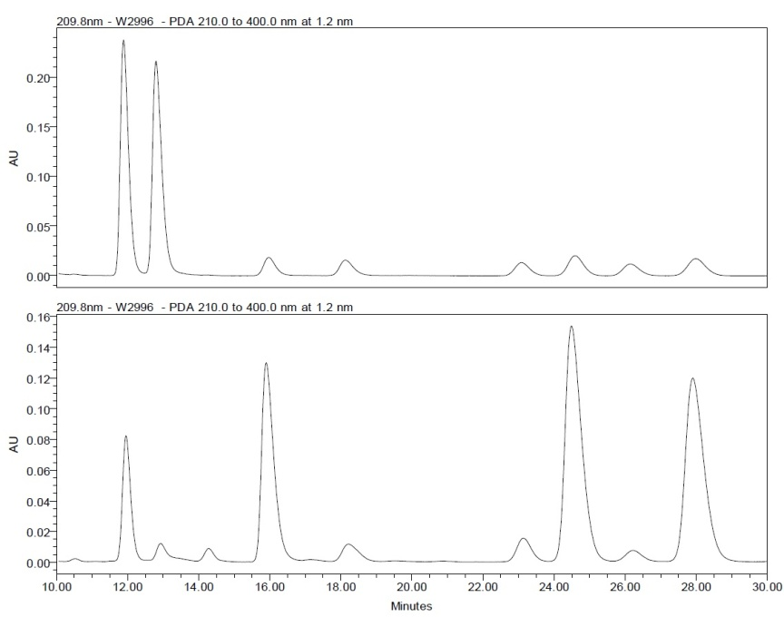
(±)-3b

(±)-3a
(±)-2a
(±)-2b

Trace II

Figure 1. HPLC Trace I: A racemic mixture of (±)-trans-2-methyl-2-nitrocyclohexyl acetate (±)-3b, (±)-cis-2-methyl-2-nitrocyclohexyl acetate (±)-3a, (±)-cis-2-methyl-2-nitrocyclohexanol (±)-2a and (±)-trans-2-methyl-2-nitrocyclohexanol (±)-2b. Trace II: Pseudomonas stutzeri and TMG (2.0 eq.) mediated dynamic resolution process, (1R,2R)-trans-2-methyl-2-nitrocyclohexyl acetate (1R,2R)-3b, 75% ee, (1R,2S)-cis-2-methyl-2-nitrocyclohexyl acetate (1R,2S)-3a, 80% ee, (1S,2R)-cis-2-methyl-2-nitrocyclohexanol (1S,2R)-2a, 35% ee and (1S,2S)-trans-2-methyl-2-nitrocyclohexanol (1S,2S)-2b, 6% ee.

HPLC conditions. Daicel Chiralcel OJ-H, hexane/i-PrOH = 97:3, flow rate 0.75 mL/min, ambient temperature, injection volume 10 μL, λ = 209.8 nm.

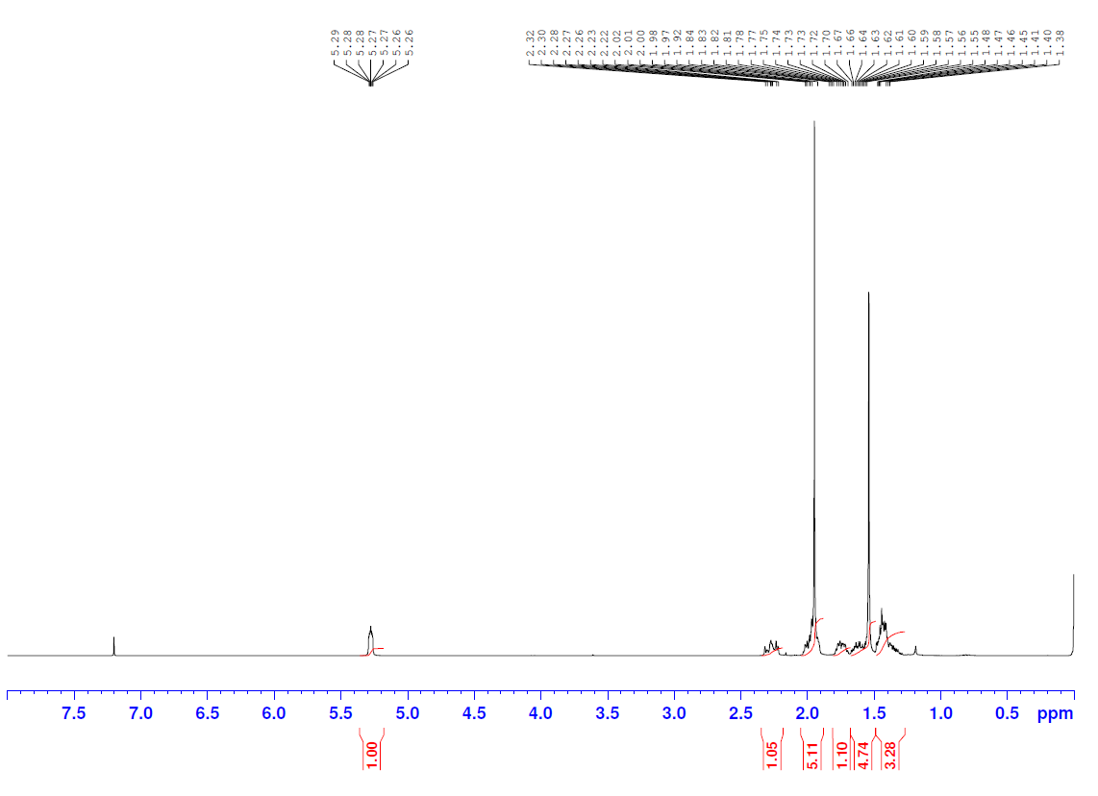
cis-2-Methyl-2-nitrocyclohexyl acetate 3a (¹H, ¹³C NMR)

(±)-3a

(±)-3a

trans-2-Methyl-2-nitrocyclohexyl acetate 3b (¹H, ¹³C NMR)
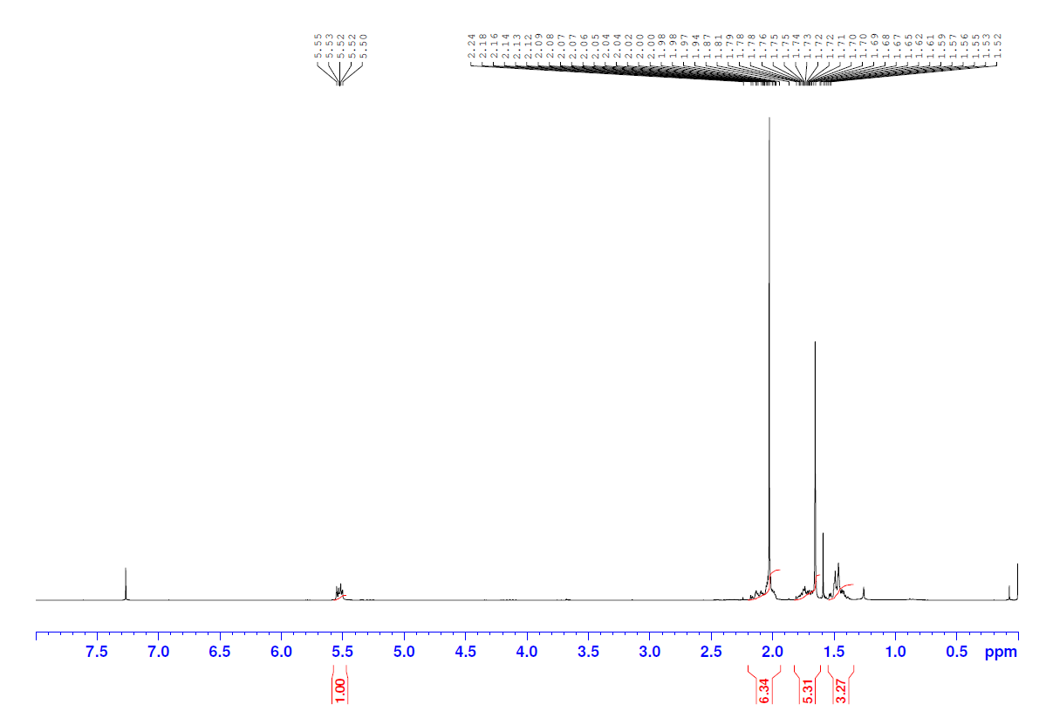

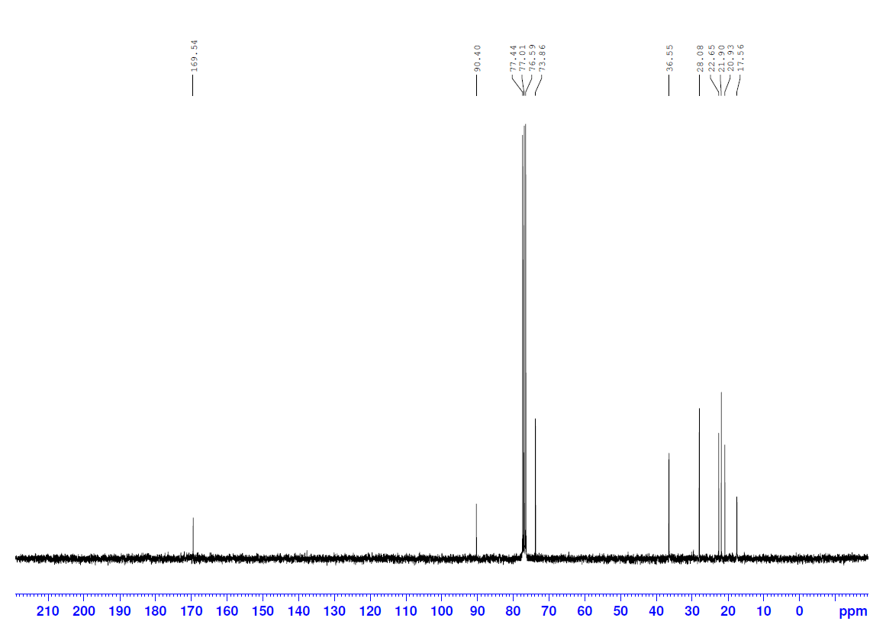

(±)-3b

6-Nitroheptan-1-ol (¹H, ¹³C NMR)
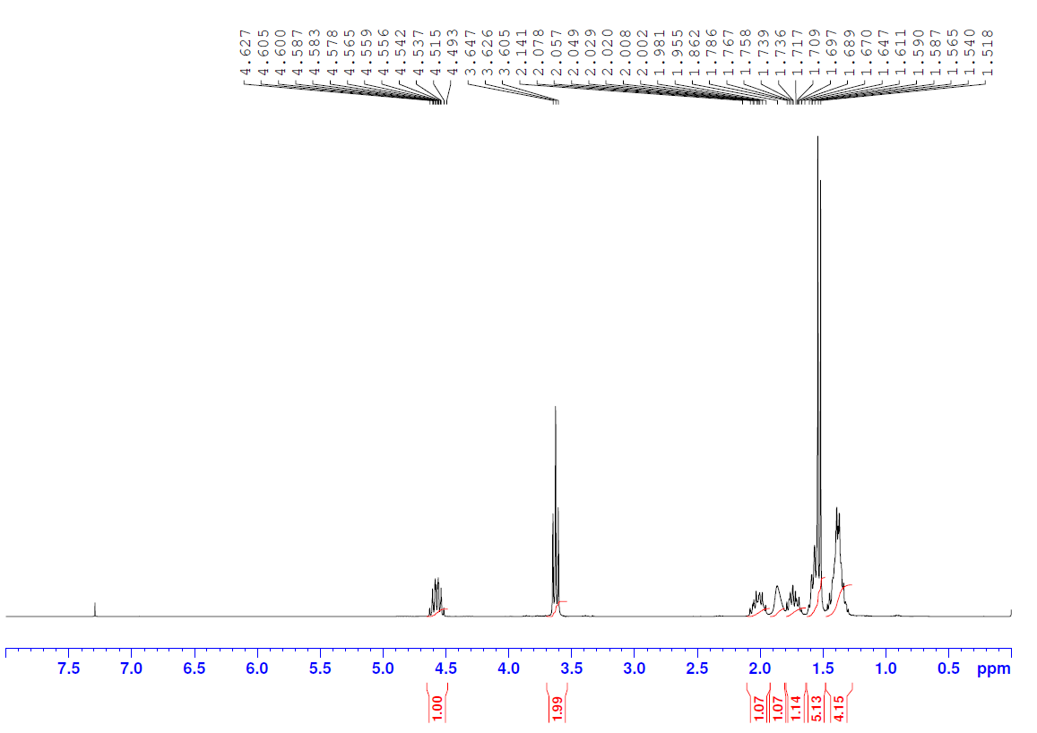

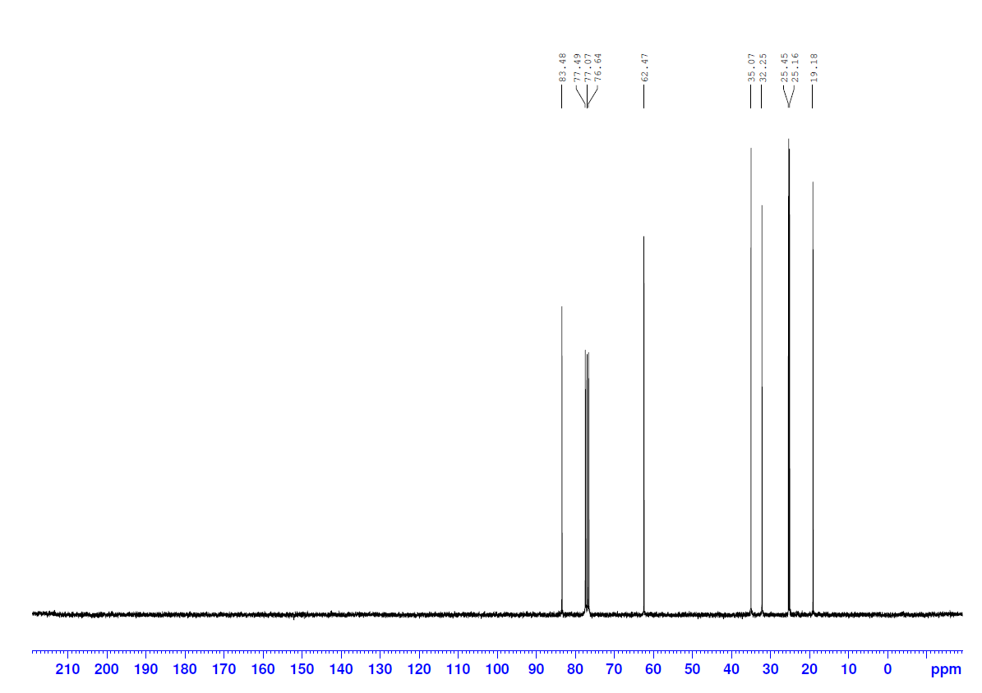

6-Nitroheptanal 1 (¹H, ¹³C NMR)
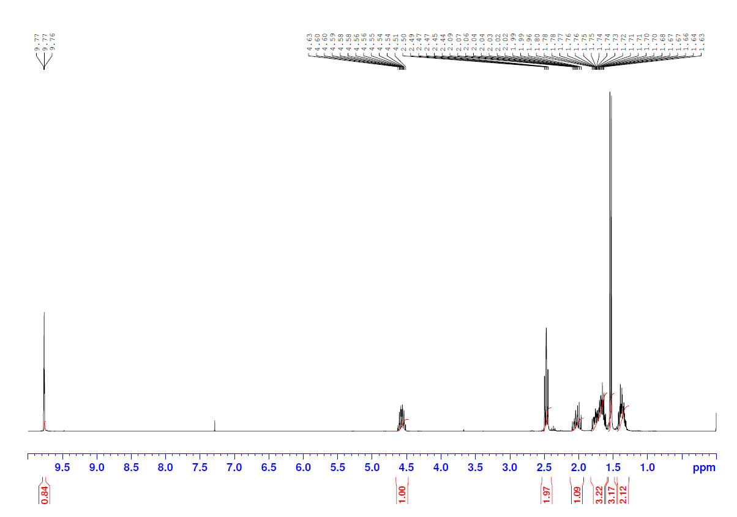

1

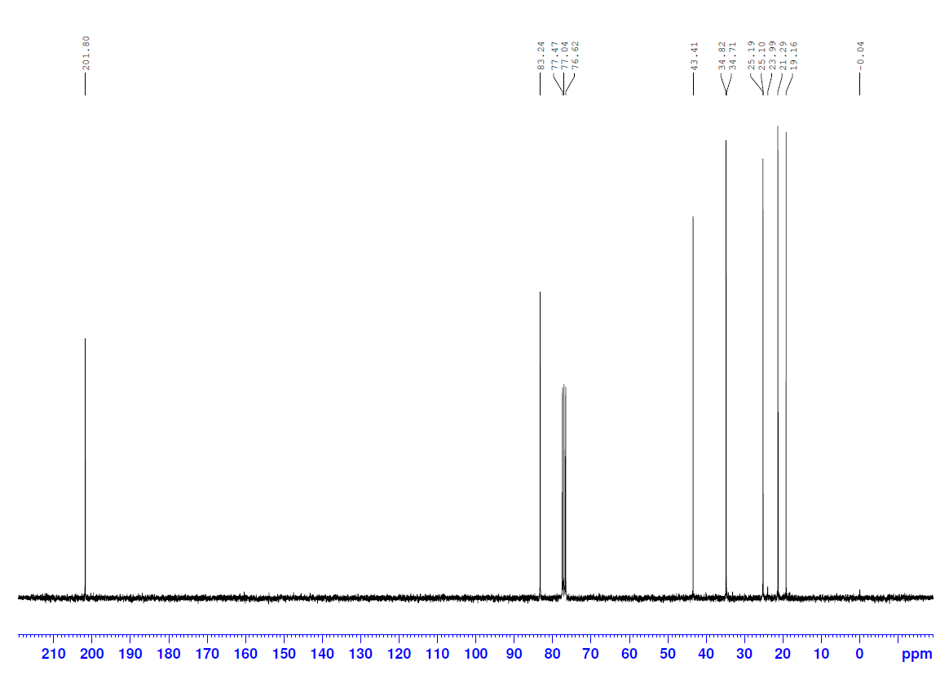
1

Supplementary Information

Lipase-mediated transesterification of 2-methyl-2-nitrocyclohexanol 2a or 2b with vinyl acetate as both acetylating agent and solvent

Table 1 & Table 2 show that a lipase which provided both the cis-2-methyl-2-nitrocyclohexyl acetate (1R,2S)-3a and cis-2-methyl-2-nitrocyclohexanol (1S,2R)-2a, and the trans-2-methyl-2-nitrocyclohexyl acetate (1R,2R)-3b and trans-2-methyl-2-nitrocyclohexanol (1S,2S)-2b with high enantioselectivity was not identified. However, this was due to low extent of acylation. This is not particularly important when applied to the one-pot system, or to a mixture of nitroalcohols 2, what is more important is the diastereomeric discrimination.
Significantly, on comparison of the efficiency and enantioselectivity of the resolution of the trans-2-methyl-2-nitrocyclohexanol 2b with that of the cis-diastereomer 2a, CAL-B (immob) demonstrated potential diastereoselectivity. Excellent enantioselectivity in the resolution of the trans-alcohol 2b was observed (Table 2, Entry 3), and crucially, a slightly higher rate of transesterification was evident relative to the cis-isomer 2a (Table 1, Entry 2) (49% vs. 33%). While P. stutzeri also demonstrated excellent enantioselectivity in the transesterification of trans-2b (Table 2, Entry 4), the high rate of conversion (78%) and lack of discrimination of the enantiomers of cis-2a (Table 1, Entry 3) meant this lipase was much less attractive.
Further investigation of the potential diastereoselectivity of CAL-B (immob) was warranted. Thus, an equimolar mixture of the diastereomeric alcohols 2a and 2b was dissolved in vinyl acetate and CAL-B (immob) charged to the reaction vessel. Reaction monitoring by ¹H NMR spectroscopy was conducted throughout the incubation period and the relative conversions of the cis- and trans-alcohols 2a and 2b to their respective cis- and trans-acetates 3a and 3b was determined. The final extraction, in addition to ¹H NMR spectroscopy, was also analysed by chiral HPLC. As an efficient and convenient chiral HPLC method has been developed, enantiopurities of all four enantiomeric pairs 2a and 2b and 3a and 3b could be determined on a single trace, thus negating the requirement for prior separation of the acetates 3a and 3b and alcohols 2a and 2b by column chromatography.

Table 1 Lipase-mediated transesterification of cis-2-methyl-2-nitrocyclohexanol 2a in vinyl acetate
Entry |  | Enzyme Source |  | Reaction Time |  | Conversion (%) |  | ee (%)^{[a]} |  |  |  | E value^{[b]}
 |  |  |  |  |  |  |  | Alcohol  cis-2a  (1S,2R) |  | Acetate  cis-3a  (1R,2S) |  | E value^{[b]}
1 |  | Pseudomonas cepacia P2 |  | 48 h |  | <10^{[c]} |  | − |  | − |  | −
2 |  | CAL-B (immob) |  | 72 h |  | 33^{[b]} |  | 49 |  | >98 |  | 159
3 |  | Pseudomonas stutzeri |  | 48 h |  | 78^{[b]} |  | >98 |  | 27 |  | 6.4
4 |  | Pseudomonas fluorescens |  | 113.5 h |  | 40^{[b]} |  | 64 |  | 96 |  | 95
^{[a]}Enantiomeric excess [ee (%)] was determined by chiral HPLC analysis [Daicel Chiralcel OJ-H, hexane/i-PrOH = 96:4, flow rate 0.9 mL/min, ambient temperature, injection volume 10 μL, λ = 209.8 nm]. ^{[b]}Conversion and the enantiomeric ratio (E value) were calculated from the enantiomeric excess of substrate alcohol 2a (ee_{s}) and product acetate 3a (ee_{p}).^{15 [c]}Conversion was estimated by ¹H NMR spectroscopy of the crude products to be <10%, chiral HPLC analysis was not conducted.
Table 2 Lipase-mediated transesterification of trans-2-methyl-2-nitrocyclohexanol 2b in vinyl acetate

Entry | Enzyme Source |  | Reaction Time |  | Conversion (%) |  | ee (%)^{[a]} |  |  |  | E value^{[b]}
 |  |  |  |  |  |  | Alcohol  trans-2b  (1S,2S) |  | Acetate  trans-3b  (1R,2R)
1 | Candida cylindracea C1 |  | 48 h |  | 33^{[b]} |  | 61 |  | >98 |  | 185
2 | Pseudomonas cepacia P2 |  | 48 h |  | <10^{[c]} |  | − |  | − |  | −
3 | CAL-B (immob) |  | 72 h |  | 49^{[b]} |  | 96 |  | >98 |  | >200
4 | Pseudomonas stutzeri |  | 48 h |  | 50^{[b]} |  | 97 |  | >98 |  | >200
5 | Pseudomonas fluorescens |  | 113.5 h |  | <10^{[c]} |  | − |  | − |  | −
^{[a]}Enantiomeric excess [ee (%)] was determined by chiral HPLC analysis [Daicel Chiralcel OJ-H, hexane/i-PrOH = 97:3, flow rate 0.5 mL/min, ambient temperature, injection volume 2 μL, λ = 209.8 nm]. ^{[b]}Conversion and the enantiomeric ratio (E value) were calculated from the enantiomeric excess of substrate alcohol 2b (ee_{s}) and product acetate 3b (ee_{p}).^{15 [c]}Conversion was determined by ¹H NMR spectroscopy of the crude products to be <10%, chiral HPLC analysis was not conducted.

Experimental
A spatula tip of enzyme (~5-10 mg, amount not critical) was added to the alcohol substrate 2a or 2b (~20 mg) dissolved in vinyl acetate (1 mL). The small test tubes were sealed and agitated at 750 rpm for the appropriate length of time at room temperature. The solution was filtered through Celite®, washed with ethyl acetate and concentrated under reduced pressure. The sample was analysed by ¹H NMR spectroscopy, reconcentrated and dissolved in a mixture of isopropanol/hexane [10:90 (HPLC grade)] and enantioselectivity determined by chiral HPLC. The results of the screens are summarised in Tables 1 and 2.

Preparative scale CAL-B (immob)-mediated transesterification of cis-2-methyl-2-nitro cyclohexanol 2a
This section corresponds to the section “Diastereoselective lipase-mediated Transesterification” in the manuscript
The preparative-scale (0.51 mmol) CAL-B (immob) mediated transesterification of 2a was subsequently investigated. The enantioselectivity of the synthetic-scale bioresolution reflected very closely that of the analytical scale (Table 1, Entry 2). While the isolated (1R,2S)-3a was obtained in excellent enantiopurity (>98% ee, 30% yield), the enantiopurity of the alcohol (1S,2R)-2a was low (45% ee, 33% yield) due to the poor conversion rate (31%). The absolute stereochemical assignment of the isolated enantiopure cis-2-methyl-2-nitrocyclohexyl acetate 3a was determined by single crystal X-ray diffraction to be (1R,2S)-3a, in agreement with Kazlauskas’s rule (Figure 1). The enantioenriched untransformed alcohol was therefore assigned as (1S,2R)-2a.
Experimental
CAL-B (immob) (70.0 mg) was added to 2a (80.5 mg, 0.51 mmol) in vinyl acetate (3 mL). The reaction mixture was shaken at 750 rpm at 24 °C. An aliquot of reaction mixture (0.25 mL) was withdrawn at 72 h. Following a mini work-up, chiral HPLC analysis was conducted. The solution was filtered at 79 h to produce a clear oil (91.1 mg). Purification by column chromatography on silica gel using hexane/ethyl acetate 97/3 as eluent gave the pure acetate (1R,2S)-3a (30.9 mg, 30%) as a clear oil $[{α]}_{D}^{20}$ −46.2 (c 0.5, CHCl₃), >98% ee, and the pure alcohol (1S,2R)-2a (26.7 mg, 33%) as a clear oil $[{α]}_{D}^{20}$ +0.7 (c 0.5, CHCl₃), 45% ee. Conversion estimated by E-value calculator at 31%.¹⁵ ¹H NMR spectra were identical to those for the racemic materials previously prepared.
A sample of (1R,2S)-3a was recrystallised by slow evaporation of acetonitrile (HPLC grade) and the absolute stereochemistry determined by single crystal X-ray diffraction.
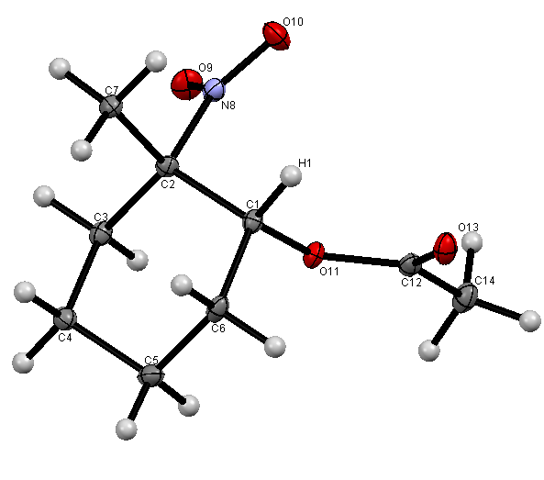

Figure 1 A view of (1R,2S)-cis-2-methyl-2-nitrocclohexyl acetate (1R,2S)-3a showing the structure and relative stereochemistry. The model has chirality C! (R) and C2 (S). Anisotropic displacement parameters are drawn at the 30% probability level

Preparative scale P. stutzeri-mediated transesterification of trans-2-methyl-2-nitro cyclohexanol 2b
This section corresponds to the section “Diastereoselective lipase-mediated transesterification” in the manuscript
To demonstrate the practical viability of this process P. stutzeri was selected as the most suitable lipase for preparative scale (1.30 mmol) mediated transesterification of trans-2-methyl-2-nitrocyclohexanol 2b. The conversion and enantiopurity of the alcohol (1S,2S)-2b and acetate (1R,2R)-3b were analysed utilising chiral HPLC and optimum 50% conversion was achieved after 52.5 h, with both enantiomers produced in ≥98% ee. The enantiopure acetate (1R,2R)-3b was obtained in 36% yield after column chromatography and the enantiopure alcohol (1S,2S)-2b was isolated in 35% yield. The absolute stereochemistry of the trans-acetate 3b and trans-alcohol 2b could not be determined by single crystal X-ray diffraction as both enantiopure products were obtained as oils. Therefore, while stereochemical assignment of 2b and 3b has not been confirmed, it has been assigned by analogy to the results obtained with the cis-2a isomer and is consistent with the anticipated stereochemical outcome.
Experimental
Pseudomonas stutzeri (60.0 mg) was added to 2b (207.6 mg, 1.30 mmol) in vinyl acetate (7 mL). The reaction mixture was shaken at 750 rpm at room temperature. An aliquot of reaction mixture (0.5 mL) was withdrawn at 48 h. Following a mini work-up, ¹H NMR and chiral HPLC analysis was conducted. The solution was filtered at 52.5 h to produce a clear oil (156.3 mg). Purification by column chromatography on silica gel using hexane/ethyl acetate as eluent (gradient elution 3-25% ethyl acetate) gave the pure acetate (1R,2R)-3b (95.5 mg, 36%) as a clear oil $[{α]}_{D}^{20}$ −32.6 (c 1.0, CHCl₃), >98% ee, and the pure alcohol (1S,2S)-2b (72.1 mg, 35%) as a clear oil $[{α]}_{D}^{20}$ +42.0 (c 1.0, CHCl₃), 98% ee. Conversion estimated by E-value calculator at 50%.¹⁴ ¹H NMR spectra were identical to those for the racemic materials previously prepared.

Variation of Acyl Source
This section corresponds to the section “Diastereoselective lipase-mediated Transesterification” in the manuscript.
Ramström et al.⁸ reported success in a related one-pot reaction using phenyl acetate. Various acylating agents were screened, all furnishing the acetate products (±)-3a and (±)-3b with excellent enantioselectivity, albeit, some with very limited conversion. Isopropenyl acetate, and isopropyl acetate, both gave similar results, but with conversion <5% for (±)-2a and <15% for (±)-2b, after 12 hours. Ethyl acetate, similarly, showed low extent of acylation of (±)-2a, but showed high diastereoselectivity (1:8, favouring (±)-3b) when used as the acyl source.
We compared various acylating agents, including ethyl acetate, which could potentially be used as the solvent and the acylating agent. For these screens, we used 50 eq. of the acylating agent as the acyl source and the solvent.
Table 3 Variation of acyl source
Entry | Acyl Source | Reaction time (h) | Acetate 3^{[a][b]}
Entry | Acyl Source | Reaction time (h) | cis-3a | trans-3b
1 | Vinyl Acetate | 12 | 5 (>98) | 35 (>98)
2 | Vinyl Acetate | 48 | 12 (>98) | 46 (>98)
3 | Isopropenyl Acetate | 12 | 3 (>98) | 14 (>98)
4 | Isopropyl Acetate | 12 | 3 (>98) | 13 (>98)
5 | Phenyl Acetate | 12 | 6 (>98) | 34 (>98)
6 | Phenyl Acetate | 48 | 14 (>98) | 48 (>98)
7 | Ethyl Acetate | 12 | 2 (>98) | 16 (>98)
^{[a]}Relative conversions, determined from ee values of the substrate alcohols (ee_{s}) and product acetates (ee_{p}). ^{[b]}Numbers in parenthesis are % ee values, which were determined by chiral HPLC analysis [Daicel OJ-H, hexane/i-PrOH = 98.5:1.5, flow rate 0.5 ml/min, ambient temperature, injection volume = 10 µL, λ = 209.8 nm]¹⁵

Ethyl Acetate as Acylating agent and solvent
The reaction was carried out again, this time with ethyl acetate as acylating agent, as it is not strong enough to undergo chemical acylation. The reaction time was extended to 120 hours and the agitation was increased to 750 rpm, extra lipase was added after 48 hours. The reaction carried out without lipase (i.e. only the interconversion process) showed that the interconversion worked under these conditions. However, when the lipase was present, the interconversion was not observed. The acylation proceeded very slowly, giving us <10% of the enantiopure acetate trans-3a even after extended reaction times.
Although the material recovered here was enantioenriched, the extent of conversion was too low to be useful, even after 5 days. As well as this, the interconversion was sluggish in the polar solvent.

Base Mediated cyclisation of 6-nitroheptanal 1 with vinyl acetate as solvent
This corresponds to the Dynamic Interconversion Process
Table 4 Base-mediated cyclisation of 6-nitroheptanal 1 with vinyl acetate as solvent
Entry | Base | Eq. | Temp (°C) | Reaction Time | Aldehyde 1  (%)^{[a]} | Alcohol 2 |  | Acetate 3
 |  |  |  |  |  | cis-2a  (%)^{[a]} | trans-2b  (%)^{[a]} | cis-3a  (%)^{[a]} | trans-3b  (%)^{[a]}
1 | Piperidine | 2.0 | rt | 48 h | 100 | − | − | − | −
2 | NaOH (1M) | − | rt | 48 h | 100 | − | − | − | −
3 | DEA | 2.0 | rt | 48 h | 82 | 8 | 10 | − | −
4 | Hünigs Base | 2.0 | rt | 48 h | 85 | 5 | 10 | − | −
5 | NEt₃ | 2.0 | 40 | 72 h | 9 | 24 | 67 | − | −
6 | DABCO | 2.0 | rt | 48 h | − | 40 | 60 | − | −
7 | DBU | 0.1 | rt | 24 h | − | 11 | 52 | 22 | 15
8 | DBU | 0.1 | rt | 48 h | − | − | 30 | 37 | 33
9 | DBU | 0.05 | rt | 48 h | 50 | 16 | 31 | 2 | 1
10 | TMG | 0.1 | rt | 24 h | 69 | 10 | 21 | − | −
11 | TMG | 0.1-2.1^{[b]} | rt | 48 h | 6 | 30 | 57 | 5 | −
^{[a]}Conversions were estimated by ¹H NMR spectroscopy and were derived from integration of the ¹H NMR spectrum of the mixture of the crude material. ^{[b]}At 24 h after analysis by ¹H NMR spectroscopy an additional 2.0 equivalents of TMG (2.0 eq., 95 μL, 86.8 mg, 0.75 mmol) were added to the reaction vessel and stirred at room temperature for a further 24 h.

Limited or no cyclisation to the β-nitroalcohols (±)-2a and (±)-2b was observed after 48 h employing sodium hydroxide, piperidine, diethylamine (DEA) and N,N-diisopropylethylamine (Hünigs base) (Table 4). As the aforementioned bases were unsuccessful in catalysing the intramolecular nitroaldol reaction, further investigation into their use in the base-mediated dynamic interconversion process was not pursued.
Both triethylamine and DABCO successfully catalysed the nitroaldol reaction in the presence of vinyl acetate, notably without competing chemical acetylation (See SI). In these screens the trans-2-methyl-2-nitrocyclohexanol (±)-2b was clearly the preferred diastereomer, formed to a greater extent than the cis-diastereomer (±)-2a in all cases. The dynamic interconversion process between (±)-2a and (±)-2b via ring opening and closing of 1 was subsequently explored employing the optimum reaction conditions identified for the triethylamine and DABCO mediated intramolecular nitroaldol reaction.
While triethylamine and DABCO successfully catalyse the Henry reaction of 1, there is no evidence of interconversion between the diastereomeric alcohols (±)-2a and (±)-2b on exposure to triethylamine in vinyl acetate or DABCO in CDCl₃, which represents a significant challenge to the objective of a DKR process. Interconversion of the stereocentres at C1 and C2 in situ is an intrinsic requirement of the process, thus both triethylamine and DABCO were no longer explored as viable bases.
The TMG-mediated dynamic interconversion process was also explored. The more stable diastereomer, (±)-2b, and TMG (2.0 eq.) were dissolved in CDCl₃ allowing efficient analysis by ¹H NMR spectroscopy. The cis-diastereomer (±)-2a was evident within 50 min of the initial addition of TMG and a thermodynamic ratio of cis-alcohol (±)-2a:trans-alcohol (±)-2b, 28:72 was observed after 3 days, similar to the ratio observed after only 5 hours (26:74) (Table 4).

The TMG mediated intramolecular nitroaldol reaction was also investigated. Initial studies explored 0.1 equivalent of TMG and limited cyclisation of 6-nitroheptanal 1 was observed by ¹H NMR analysis after 24 h, unreacted 1 comprising 69% of the mixture. Thus, additional base (2.0 equivalents) was added at this point in the study to promote the intramolecular nitroaldol reaction. Favourably, at 48 h with the increased concentration of base only 6% of the aldehyde 1 remained and significantly, chemical acetylation was evident only in trace amounts (≤ 5%). As both DBU and TMG were effective in mediating the intramolecular nitroaldol reaction in the presence of vinyl acetate, they were further investigated in the development of the dynamic interconversion of cis- and trans-2-methyl-2-nitrocyclohexanol (±)-2a and (±)-2b via 6-nitroheptanal 1.
Diastereomerically pure samples of (±)-2a and (±)-2b were dissolved in CDCl₃ and 0.1 equivalent of DBU was added to the NMR tube (Table 5 & Table 6). Significantly in each of the experiments conversion to the opposite diastereomer was observed immediately. The thermodynamic ratio of ~34:66 (±)-2a:(±)-2b was attained within 24 h irrespective of whether the experiment was conducted starting from the cis- or trans-diastereomer (±)-2a or (±)-2b. This is the first time the dynamic interconversion of β-nitrocyclohexanols (±)-2a and (±)-2b exclusively via the reversible intramolecular nitroaldol reaction has been observed – a key milestone towards the development of the dynamic lipase-mediated process.
Notably however, when the DBU (0.1 eq.) mediated dynamic interconversion process was conducted in the presence of vinyl acetate, chemical acetylation to form the racemic acetates (±)-3a and (±)-3b competes efficiently with the ring opening and closing process.

Experimental
A standard solution of 6-nitroheptanal 1 (0.54 g, 3.39 mmol) in vinyl acetate (27 mL, 292.93 mmol) was prepared and aliquots (3 mL) were dispensed into nine round bottom flasks. The following bases were added to the appropriate round bottom flask and stirred at room temperature or 40 °C; piperidine (2.0 eq., 74 μL, 64.2 mg, 0.75 mmol), aqueous sodium hydroxide (1M, 1 mL), DEA (2.0 eq., 78 μL, 55.1 mg, 0.75 mmol), Hünigs base (2.0 eq., 131 μL, 97.4 mg, 0.75 mmol), triethylamine (2.0 eq., 105 μL, 76.3 mg, 0.75 mmol), DABCO (2.0 eq., 84.6 mg, 0.75 mmol), DBU (0.1 eq., 6 μL, 5.7 mg, 0.04 mmol), (0.05 eq., 3 μL, 2.9 mg, 0.02 mmol) and TMG (0.1 eq., 5 μL, 4.3 mg, 0.04 mmol). At various time intervals, an aliquot of reaction mixture was removed. In the case of the 1M NaOH trial the layers were separated and the aqueous phase was extracted with diethyl ether (3 × 1 mL) and then concentrated under reduced pressure. In all other experiments, the reaction aliquot was concentrated under reduced pressure with no work-up. The samples were analysed by ¹H NMR spectroscopy and the results summarised above.

Evidence for dynamic interconversion − 2-methyl-2-nitrocyclohexanol 2 and base in CDCl₃
This corresponds to the “Dynamic Interconversion Process” in the main text.
Table 5 Evidence for dynamic interconversion - cis-2-methyl-2-nitrocyclohexanol 2a and DBU (0.1 eq) in CDCl₃
Reaction Time (h) | 2a (%)^{[a]} | 2b (%)^{[a]}
0 | 100 | −
0.6 | 93 | 7
1.1 | 87 | 13
4.9 | 63 | 37
9.0 | 48 | 52
24.8 | 35 | 65
^{[a]}6-Nitroheptanal 1 was not detected in the ¹H NMR spectra.

Table 6 Evidence for dynamic interconversion - trans-2-methyl-2-nitrocyclohexanol 2b and DBU (0.1 eq.) in CDCl₃
Reaction Time (h) | 2a (%)^{[a]} | 2b (%)^{[a]}
0 | − | 100
0.4 | 5 | 95
1.2 | 11 | 89
4.3 | 24 | 76
5.9 | 28 | 72
21.9 | 33 | 67
^{[a]}6-Nitroheptanal 1 was not detected in the ¹H NMR spectra.

Table 7 Evidence for dynamic interconversion - trans-2-methyl-2-nitrocyclohexanol 2b and TMG (2.0 eq.) in CDCl₃
Reaction Time (h) | 2a (%)^{[a]} | 2b (%)^{[a]}
0 | - | 100
0.8 | 14 | 88
5.1 | 26 | 74
72 | 28 | 72
^{[a]}6-Nitroheptanal 1 was not detected in the ¹H NMR spectra.
The cyclisation of 6-nitroheptanal 1 was more efficient with the stronger bases DBU and TMG relative to triethylamine and DABCO. After 24 h complete cyclisation of 1 was observed with 0.1 equivalents of DBU (see SI for more details). Notably both the cis- and trans-alcohols (±)-2a and (±)-2b and cis- and trans-acetates (±)-3a and (±)-3b were evident in the ¹H NMR spectrum after 24 h. However, as the reaction proceeded, the cis- and trans-alcohols (±)-2a and (±)-2b were slowly acetylated over time (see SI for more details). Thus, in the absence of a lipase, chemical acetylation occurs with 0.1 equivalents of DBU, leading to racemic acetates (±)-3a and (±)-3b, the backround reaction. This result highlights a significant hurdle in the development of a DBU-mediated one-pot DKR process to a single stereoisomer of 2-methyl-2-nitrocyclohexyl acetate 3.
Notably, only trace evidence of the cis- and trans-2-methyl-2-nitrocyclohexyl acetates (±)-3a and (±)-3b (<5% total) was observed in the precence of a reduced amount of DBU (0.05 eq.). Conversely, at this lower concentration of DBU the efficiency of the desired cyclisation of 6-nitroheptanal 1 via the intramolecular nitroaldol reaction was limited. Nevertheless, these results indicate that the cyclisation to form (±)-2a and (±)-2b can be effected under these conditions which reduce the background reaction.
A less active acyl transfer agent e.g. ethyl acetate and the introduction of a solvent in the kinetic resolution of 2, thereby decreasing the concentration of vinyl acetate required, were both investigated in order to inhibit chemical acetylation. While the DBU mediated intramolecular nitroaldol cyclisation of 6-nitroheptanal 1 occurs readily in the presence of ethyl acetate without any evidence of chemical acetylation, the lipase-mediated resolution of 2 in ethyl acetate in place of vinyl acetate resulted in poor conversions and enantiopurity. Likewise the employment of a solvent with vinyl acetate in the lipase-mediated resolution reduced the efficiency of the transesterification and accordingly the enantiopurity.
Experimental
Three ¹H NMR samples of diastereomerically pure 2a or 2b (20.0 mg, 0.13 mmol) in deuterated chloroform, CDCl₃ (0.6 mL) were prepared. The appropriate base; DBU (0.1 eq., 2 μL, 1.9 mg, 0.01 mmol) or TMG (2.0 eq., 32 μL, 28.9 mg, 0.25 mmol) was dispensed where appropriate to the NMR tube, agitated and analysed by ¹H NMR spectroscopy at regular time intervals. The results of the spectroscopic analysis are summarised in Table 5, Table 6 & Table 7.

Base Mediated Interconversion of 2-methyl-2-nitrocylcohexanol 2 with vinyl acetate as solvent
This section is relevant to the section “Dynamic Interconversion Process” in the main text
Triethylamine
Diastereomerically pure trans-2-methyl-2-nitrocyclohexanol 2b was dissolved in vinyl acetate with triethylamine (2.0 eq.) at 40 °C and the ratio of the β-nitroalcohols 2a and 2b monitored over time by ¹H NMR spectroscopy. No interconversion to the cis-diastereomer 2a was observed even after 3 days. The dynamic interconversion process was briefly explored with a higher loading of triethylamine (8.0 eq.); however, this did not result in the reversible intramolecular nitroaldol reaction.
DABCO
The dynamic interconversion process was subsequently explored with DABCO. A ¹H NMR sample was prepared with diastereomerically pure cis-2-methyl-2-nitrocyclohexanol 2a and DABCO (2.0 eq.) in CDCl₃ enabling direct analysis of the ratios of the β-nitroalcohols 2a and 2b. While this base successfully mediated the ring closure of 6-nitroheptanal 1 (Table 4, Entry 6), significantly in this study, no dynamic interconversion to the trans-diastereomer 2b was observed over an extended reaction period of 10 days.

Exploration of alternative bases using ethyl acetate as solvent
This section is relevant to the section “Dynamic Interconversion Process” in the main text
The dynamic one-pot kinetic resolution process was investigated with DBU and TMG, as both bases are clearly capable of effecting the interconversion of 2a and 2b via the reversible intramolecular nitroaldol reaction. The lipases CAL-B (immob) and P. stutzeri lipase were examined in the one-pot dynamic resolution of the nitroaldol reaction (details included in SI). In particular CAL-B (immob) had demonstrated good diastereoselectivity in the kinetic resolution of 2. Vinyl acetate was used as both solvent and acyl source.
When DBU (0.1 eq.) was combined with CAL-B (immob), the intramolecular cyclisation did not proceed, returning only starting material after 72 h (Table 8, Entry 1). The use of P. stutzeri lipase with this base effectively mediated the ring-closing, however, poor enantioselectivity in the resolution meant this was not a viable one-pot system (Table 8, Entry 2 & 3). When the base was changed to TMG, the ring-closing proceeded sluggishly, with aldehyde 1 (15%) still evident after 48 hours; and the low extent of conversion to the products (±)-3a and (±)-3b, was disappointing (Table 8, Entry 4).
Based on a recent report of the use of immobilised DMAP for the Henry reaction,¹⁷ investigation of DMAP was next explored. Ethyl acetate was selected as solvent due to the excellent diastereoselectivity in the lipase-mediated resolution. DMAP performed poorly when only 1 equivalent was used, but when the amount of DMAP was increased, up to 5 equivalents, the interconversion was very successful, outperforming DBU (immob) in this solvent. Most importantly here, even with 10 equivalents of DMAP, there was no chemical acylation evident even using 50 equivalents of vinyl acetate in ethyl acetate as solvent. Use of immobilised DMAP proved to be poorly effective for the interconversion and led to background acylation in the presence of vinyl acetate. Interconversion of the diastereomers was not seen when using related bases (2 equivalents), lutidine, and pyridine, while chemical acylation was evident with lutidine under these conditions.

Table 8 Cyclisation of 6-nitroheptanal 1 with lipase-catalysed transesterification to 2-methyl-2-nitrocyclohexyl acetate 3 in vinyl acetate with DBU or TMG as catalyst
Entry | DBU  (eq.) | TMG (eq.) | Lipase  Source | Reaction  Time | Aldehyde  1 (%)^{[a]} | Alcohol 2 |  | Acetate 3
 |  |  |  |  |  | cis-2a  (%)^{[a]}  [ee (%)]^{[b],[c]} | trans-2b  (%)^{[a]}  [ee (%)]^{[b],[d]} | cis-3a  (%)^{[a]}  [ee (%)]^{[b],[e]} | trans-3b  (%)^{[a]}  [ee (%)]^{[b],[f]}
1 | 0.1 | − | CAL-B | 72 h | 100 | − | − | − | −
2 | 0.5 | − | P. stutzeri | 48 h | − | 6  [>98]^{[g]} | 4  [>98]^{[g]} | 37  [1] | 53  [1]
3 | 1.0 | − | P. stutzeri | 48 h | − | 6  [>98]^{[g]} | 3  [>98]^{[g]} | 53  [1] | 38  [0]
4 | − | 2.0 | P. stutzeri | 48 h | 15 | 22  [35] | 50  [6] | 9  [80] | 4  [75]
^{[a]}Conversions were estimated by ¹H NMR spectroscopy and were derived from integration of the ¹H NMR spectrum of the mixture of the crude material. ^{[b]}Enantiomeric excess [ee (%)] was determined by chiral HPLC analysis [Daicel Chiralcel OJ-H, hexane/i-PrOH = 99.5:0.5, flow rate 0.5 mL/min, ambient temperature, injection volume 10 μL, λ = 209.8 nm] or [Daicel Chiralcel OJ-H, hexane/i-PrOH = 97:3, flow rate 0.75 mL/min, ambient temperature, injection volume 10 μL, λ = 209.8 nm]. ^{[c]}The principal enantiomer was (1S,2R)-cis-2-methyl-2-nitrocyclohexanol (1S,2R)-2a. ^{[d]}The principal enantiomer was (1S,2S)-trans-2-methyl-2-nitrocyclohexanol (1S,2S)-2b. ^{[e]}The principal enantiomer was (1R,2S)-cis-2-methyl-2-nitrocyclohexyl acetate (1R,2S)-3a. ^{[f]}The principal enantiomer was (1R,2R)-trans-2-methyl-2-nitrocyclohexyl acetate (1R,2R)-3b. ^{[g]}While chiral HPLC indicates high enantiomeric excess for the recovered alcohols (1S,2R)-2a and (1S,2S)-2b, the very low levels present mean the enantiopurity should be interpreted with caution.

Cyclisation of 6-nitroheptanal 1 with lipase-catalysed transesterification to 2-methyl-2-nitrocyclohexylacetate 2 in vinyl acetate with DBU or TMG as catalyst
A standard solution of 6-nitroheptanal (0.80 mg, 0.50 mmol) in vinyl acetate (4 mL, 43.40 mmol) was prepared and aliquots (1 mL) were dispensed into four test tubes. DBU (0.1 eq., 2 μL, 1.9 mg, 0.01 mmol), (0.5 eq., 9 μL, 9.6 mg, 0.06 mmol), (1.0 eq., 19 μL, 19.1 mg, 0.13 mmol) or TMG (2.0 eq., 32 μL, 28.9 mg, 0.25 mmol) and a spatula tip (~5-10 mg) of lipase (CAL-B or P. stutzeri lipase) were added to the appropriate test tube and the mixture was agitated for the required length of time at room temperature. Water (1 mL) was added, the layers were separated and the organic layer was filtered and concentrated under reduced pressure. All samples were analysed by ¹H NMR spectroscopy and chiral HPLC.

Sequential “two-pot” lipase-mediated dynamic resolution screens
This section is relevant to Scheme 5 – “Two-Pot Process” in the manuscript
The intramolecular nitroaldol reaction and associated dynamic interconversion process was first examined with DBU as base in methyl tert-butyl ether (MTBE) (Table 9, Step A). Notably, vinyl acetate was not employed thus no chemical acetylation was observed. In addition, base inhibition was not an issue due to the absence of a lipase. Complete cyclisation of 6-nitroheptanal 1 to 2a and 2b was achieved with a thermodynamic ratio of 30:70. The DBU was removed by aqueous work up and the crude β-nitroalcohols 2a and 2b were dissolved in vinyl acetate and treated with CAL-B (immob) (Table 9, Step B). In this study, as anticipated, the lipase-mediated transesterification of trans-2-methyl-2-nitrocyclohexanol 2b was the dominant kinetic resolution process, with the trans-acetate (1R,2R)-3b accounting for 33% of the overall product ratio. High diastereoselectivity was also observed with limited transformation of cis-2-methyl-2-nitrocylohexanol 2a. The two individual steps, A and B, were then continuously repeated. Significantly in the dynamic interconversion process, step A, the ratio of the trans-alcohol 2b was observed to increase relative to the ratio determined in the kinetic resolution protocol, step B, due to DBU mediated ring opening and closing of 1 to form the more thermodynamically favoured trans-diastereomer 2b.
It is evident from Table 9, that the efficiency of both steps, the dynamic interconversion and kinetic resolution process, was hindered as the reaction progressed with minimal change in conversion observed between the last two steps in the sequence. Notably, the trans-acetate (1R,2R)-3b was the dominant product observed in the dynamic interconversion process prior to work-up (57%), highlighting the significant potential of this dynamic process to provide a single stereoisomer of (1R,2R)-3b.
Because the DBU-mediated cyclisation and interconversion were carried out prior to the resolution, with a work-up to remove the catalysts and solvent, this furnished products cis-3a and trans-3b in excellent enantiopurity (both >98% ee). Significantly excellent enantioselectivity (>98% ee) was achieved for the acetates 3a and 3b demonstrating the major potential of this process for the development of a formal DKR of the intramolecular nitroaldol reaction of 6-nitroheptanal 1 through CAL-B (immob) catalysis. The cycle was repeated three times, followed by exposure of the reaction mixture to the interconversion conditions. As a result of the last step being the base mediated interconversion, this meant that the alcohols cis-2a and trans-2b were returned in poor enantiopurity (10% ee, 37% ee, respectively).
While the cycling of the material through the two steps is tedious, development of this protocol through engineering of a flow system can be envisaged to provide an efficient process.
Table 9 Sequential "two-pot" DKR of the intramolecular nitroaldol reaction through lipase catalysis
Step | DBU (eq.) | Vinyl Acetate (eq.) | CAL-B (immob)  (% w/w) | Alcohol 2 |  | Acetate 3
 |  |  |  | cis-2a (%)^{[a]} | trans-2b (%)^{[a]} | cis-3a (%)^{[a]} | trans-3b (%)^{[a]}
A | 0.2 | − | − | 30 (±) | 70 (±) | − | −
B | − | 138 | 18 | 25 | 37 | 5 | 33
A | 0.2 | − | − | 19 | 41 | 6 | 34
B | − | 138 | 18 | 16 | 29 | 8 | 47
A | 0.2 | − | − | 13 | 30 | 8 | 49
B | − | 138 | 18 | 11 | 22 | 10 | 57
A | 0.2 | − | − | 10  10% ee^{[b],[c]} | 22  37% ee^{[b],[d]} | 10  >98% ee^{[b],[e]} | 57  >98% ee^{[b],[f]}
^{[a]}Conversions were determined by ¹H NMR spectroscopy and were derived from integration of the ¹H NMR spectrum of the mixture of the crude material. ^{[b]}Enantiomeric excess [ee (%)] was determined by chiral HPLC – cis-2a and trans-2b [Daicel Chiralcel OJ-H, hexane/i-PrOH = 99.5:0.5, flow rate 0.5 mL/min, ambient temperature, injection volume 5 μL, λ = 209.8 nm] - cis-3a and trans-3b [Daicel Chiralcel OJ-H, hexane/i-PrOH = 97:3, flow rate 0.5 mL/min, ambient temperature, injection volume 2 μL, λ = 209.8 nm]. ^{[c]}The principal enantiomer was (1S,2R)-cis-2-methyl-2-nitrocyclohexanol (1S,2R)-2a. ^{[d]}The principal enantiomer was (1S,2S)-trans-2-methyl-2-nitrocyclohexanol (1S,2S)-2b. ^{[e]}The principal enantiomer was (1R,2S)-cis-2-methyl-2-nitrocyclohexyl acetate (1R,2S)-3a. ^{[f]}The principal enantiomer was (1R,2R)-trans-2-methyl-2-nitrocyclohexyl acetate (1R,2R)-3b.
Experimental
Step A: DBU mediated dynamic interconversion
DBU (0.2 eq., 55 μL, 55.8 mg, 0.37 mmol) was added to a solution of 6-nitroheptanal 1 (291.5 mg, 1.83 mmol) in MTBE (3 mL) and stirred at room temperature overnight. The reaction mixture was washed with water (3 × 2 mL), dried, filtered and concentrated under reduced pressure to give a crude mixture (258.0 mg, 89%) of nitroalcohols 2a and 2b as a clear oil. The sample was analysed by ¹H NMR spectroscopy and conversions to 2a and 2b determined by integration of the crude material.
Step B: CAL-B (immob) mediated kinetic resolution.
CAL-B (immob) (228.0 mg, 88% w/w) was added to a solution of the crude nitroalcohols 2a and 2b (258.0 mg, 1.62 mmol) in vinyl acetate (12.9 mL, 139.95 mmol) and shaken at 750 rpm at room temperature for 18 h. The solution was filtered through Celite®, washed with ethyl acetate and concentrated under reduced pressure to give a crude mixture (274.6 mg) of nitroalcohols 2a, 2b and nitroacetates 3a, 3b as a clear oil. The sample was analysed by ¹H NMR spectroscopy and conversions to 3a and 3b determined by integration of the crude material.
The DBU mediated dynamic interconversion procedure followed by CAL-B (immob) mediated kinetic resolution was repeated as per Table 9 to give a final crude mixture of nitroalcohols 2a, 2b and nitroacetates 3a, 3b (88.5 mg) as a clear oil. The final crude mixture following ¹H NMR spectroscopy was dissolved in a mixture of isopropanol/hexane [10:90 (HPLC grade)] and enantioselectivity determined by chiral HPLC.

Solvent Screen – towards a one-pot reaction
This is relevant to the section “Move Towards a One-Pot Dynamic System” in the manuscript
Table 10 Solvent screen for resolution
Entry | Solvent | Acetate 3^{[a][b]}
Entry | Solvent | cis-3a | trans-3b
1 | Toluene | 4 (>98) | 22 (>98)
2 | Hexane | 9 (>98) | 38 (>98)
3 | MTBE | 10 (>98) | 33 (>98)
4 | IPA | -^{[c]} | 4 (>98)
5 | 1-octanol | 2 (>98) | 11 (33)
6 | Ethyl Acetate | 2 (>98) | 23 (>98)
^{[a]}Relative conversions, determined from ee values of the substrate alcohols (ee_{s}) and product acetates (ee_{p}), as the presence of some solvents made interpretation of the ¹H NMR spectrum difficult. ^{[b]}Numbers in parenthesis are % ee values, which were determined by chiral HPLC analysis [Daicel OJ-H, hexane/i-PrOH = 98.5:1.5, flow rate 0.5 ml/min, ambient temperature, injection volume = 10 µL, λ = 209.8 nm]. ^{[c]} No cis-3a was detected by ¹H NMR.

Table 11 Solvent screen for the interconversion catalysed by immobilised DBU
Entry | Solvent | Alcohol 2^{[a]}
Entry | Solvent | cis-2a | trans-2b
1 | Toluene | 68 | 32
2 | Hexane | 87 | 13
3 | MTBE | 87 | 13
4 | IPA | 70 | 30
5 | 1-octanol | -^{[b]} | -^{[b]}
6 | Ethyl Acetate | 84 | 16
^{[a]} Values determined by ¹H NMR ^{[b]} Values could not be determined by ¹H NMR due to the presence of the solvent.

Temperature Studies

Table 12 Temperature effect on the interconversion process
Entry | Eq. Vinyl Acetate | 30 °C^{[a]} |  |  | 40 °C^{[a]} |  |  | 50 °C^{[a]}
Entry | Eq. Vinyl Acetate | cis-2a | trans-2b | Acetate 3^{[a]} | cis-2a | trans-2b | Acetate 3^{[a]} | cis-2a | trans-2b | Acetate 3^{[a]}
1 | 0 | 68 | 32 | 0 | 66 | 34 | 0 | 52 | 48 | 0
2 | 5 | 68 | 28 | 4 | 70 | 28 | 3 | 59 | 37 | 4
3 | 10 | 66 | 28 | 6 | 71 | 25 | 4 | 49 | 42 | 9
4 | 20 | 69 | 24 | 8 | 69 | 24 | 8 | 55 | 33 | 12
Starting material was a mixture of cis-2a & trans-2b in the ratio 87:13 ^{[a]}% of mixture, determined by ¹H NMR by comparison of the areas of the integrals for to relevant alcohols and acetates.

Table 13 The effect of temperature on resolution
Entry | Eq. Vinyl Acetate | 30 °C^{[a][b]} |  | 40 °C^{[a][b]} |  | 50 °C^{[a][b]}
Entry | Eq. Vinyl Acetate | cis-3a | trans-3b | cis-3a | trans-3b | cis-3a | trans-3b
1 | 5 | 7 (>98) | 34 (>98) | 9 (>98) | 38 (>98) | 16 (>98) | 43 (>98)
2 | 10 | 9 (>98) | 38 (>98) | 14 (>98) | 43 (>98) | 16 (>98) | 40 (>98)
3 | 20 | 6 (>98) | 27 (>98) | 10 (>98) | 37 (>98) | 15 (>98) | 35 (>98)
^{[a]}Relative conversions, determined by ¹H NMR by comparison of the areas of the integrals for to relevant alcohol and acetate ^{[b]}Numbers in parenthesis are % ee values, which were determined by chiral HPLC analysis [Daicel OJ-H, hexane/i-PrOH = 98.5:1.5, flow rate 0.5 ml/min, ambient temperature, injection volume = 10 µL, λ = 209.8 nm]¹⁴

One Pot Reactions
This is relevant to the section “Move Towards a One-Pot Dynamic System” in the manuscript
Table 14 A selection of one-pot and two-pot reactions
Entry^{[a]} | Step |  | Temp  (°C) | Alcohol^{[a]} |  | Acetate^{[a]}
Entry^{[a]} |  |  | Temp  (°C) | cis-2a | trans-2b | cis-3a | trans-3b
1 | A  B |  | 50 | 52  33 (41) | 48  18 (87) | -  17 (>98) | -  32 (>98)
2^{[b]} | A  B |  | 50 | 52  41 (26) | 48  26 (80) | -  11 (>98) | -  22 (>98)
3 | A & B |  | 50 | 64 (29) | 9 (81) | 22 (>98) | 6 (>98)
4^{[c]} | A & B |  | 50 | 5 (28) | 46 (87) | 2 (>98) | 46 (>98)
5 | A & B |  | 50 | 58 (33) | 9 (85) | 25 (>98) | 8 (>98)
6^{[c]} | A & B |  | 30 | 8 (3) | 79 (13) | 1 (ND) | 12 (12)
7 | A & B |  | 30 | 72 (16) | 9 (73) | 13 (>98) | 6 (>98)
8^{[c]} | A & B |  | 30 | 63 (10) | 18 (56) | 8 (>98) | 11 (>98)
9 | A & B |  | 30 | 72 (15) | 9 (77) | 13 (>98) | 6 (>98)
10^{[d]} | A & B |  | 30 | 37 (88) | 8 (52) | 48 (>98) | 7 (>98)
^{[a]}Numbers in parenthesis are % ee values, which were determined by chiral HPLC analysis [Daicel OJ-H, hexane/i-PrOH = 98.5:1.5, flow rate 0.5 ml/min, ambient temperature, injection volume = 10 µL, λ = 209.8 nm]. ^{[b]}Entry 2 included a filtration to remove the DBU (immob) before addition of the lipase. ^{[c]}Starting material for each reaction was cis-2a:trans-2b 87:13 except for Entry 4 (4:96), Entry 6 (4:96), and Entry 8 (70:30). ^{[d]}Entry 10 included molecular sieves.

Here, Entries 1-2 were 24 hours (2x 12h) and the rest of the Entries were 12 hour total, with the reagents added at the same time (one-pot).
Entry 1 shows evidence of a dynamic system, as the DBU (immob) was not removed prior to CAL-B (immob) addition. In the case of Entry 2, the DBU (immob) was removed by filtration before the addition of the CAL-B (immob), which resulted in a static system, as expected.
Entries 3 & 4 are identical except for the ratio of starting material, with Entry 3 having cis-2a:trans-2b 87:13 and Entry 4 having cis-2a:trans-2b 4:96. Using predominantly trans-2b starting material, Entry 4, we saw a much greater conversion, with the conversion essentially approaching the kinetic limit with some evidence of a dynamic process, as there are equal amounts of trans-2b & trans-3b but the % ee of trans-2b is not >98%, as would be expected from a static system.
Entries 5 has starting material cis-2a:trans-2b 87:13, and is carried out at 50°C and Entry 6 has cis-2a:trans-2b 4:96 and is carried out at 30 °C. For Entry 5, which was cis-2a enriched, the trans diastereomers were close to the kinetic limit, but the ee values indicated a static system.
The one-pot procedure, where both the catalysts were added in at the same time, was repeated at lower temperature, 30°C, using both trans-2b and cis-2a enriched material (Entry 7 and Entry 8, respectively). The conversions in this case were poor compared to the higher temperature but still retained high stereoselectivity, as expected.
The effect of water was also investigated at this temperature (Entries 9 & 10). The reaction was run with (Entry 10) or without (Entry 9) molecular sieves, again with both the catalysts introduced at the same time. Interestingly, the presence of molecular sieves reversed the diastereoselectivity of the reaction, with the cis-3a diastereomer being preferred here, but no change in the interconversion efficiency, showing that the presence of small amounts of water is not affecting the DBU (immob) efficiency.

Table 15 One Pot reaction - removal of each catalyst before addition of the next
Entry | Step | Temperature  (°C) | Alcohol 2^{[a]} |  | Acetate 3^{[a]}
Entry | Step | Temperature  (°C) | cis-2a | trans-2b | cis-3a | trans-3b
1 | 1a  1b  2a  2b  3a  3b | All steps carried out at 50°C | 56 (-)  56 (23)  35 (18)  30 (42)  23 (30)  21 (79) | 44 (-)  17 (58)  34 (22)  25 (76)  25 (40)  23 (>98) | 0 (-)  13 (>98)  15 (>98)  20 (>98)  23 (>98)  26 (>98) | 0 (-)  14 (>98)  16 (>98)  25 (>98)  29 (>98)  30 (>98)
2 | 1a  1b  2a  2b  3a  3b | 50  30  50  30  50  30 | 34 (4)  38 (10)  28 (4)  25 (14)  20 (8)  28 (14) | 66 (5)  42 (31)  41 (16)  27 (70)  24 (2)  13 (66) | 0 (-)  4 (>98)  6 (>98)  8 (>98)  10 (>98)  11 (>98) | 0 (-)  16 (>98)  25 (>98)  40 (>98)  47 (>98)  47 (>98)
3 | 1a  1b  2a  2b  3a  3b | 50  30  50  30  50  30 | 36 (1)  36 (9)  27 (6)  25 (20)  25 (21)  25 (24) | 64 (3)  39 (46)  32 (33)  25 (78)  17 (70)  19 (78) | 0 (-)  4 (>98)  8 (>98)  10 (>98)  13 (>98)  12 (>98) | 0 (-)  20 (>98)  33 (97)  40 (>98)  45 (96)  43 (97)
^{[a]}Expressed as a % ,estimated by integration of the relevant ¹H NMR signals. Numbers in parenthesis are % ee values, which were determined by chiral HPLC analysis [Daicel OJ-H, hexane/i-PrOH = 98.5:1.5, flow rate 0.5 ml/min, ambient temperature, injection volume = 10 µL, λ = 209.8 nm].
Step A, interconversion: DBU (immob) (0.5 eq.), toluene (1ml/10mg substrate). Step B, resolution: CAL-B (immob), vinyl acetate (3 eq.), toluene (1mL/10mg). Each step was carried out for 12 hours, except step 1A for Entry 2 & Entry 3 which were 18h.
Entry 1 involved a filtration through Celite® & MgSO₄ after each step A and B, to remove the catalyst. The solution was concentrated under vacuum after each step B to remove the solvent and the acylating agent. Both steps were carried out at 50 °C. Starting material was cis-2a:trans-2b 87:13.
Signals for impurities (which can be removed by chromatography) are very close to some of the signals of interest in the NMR, especially for the reactions conducted at higher temperatures, resulting in limitations in the accuracy of estimation of the % composition of the material by 1H NMR. In some instances, the % of acetate in the mixtures are slightly overestimated as a result.

Entry 2 was identical to entry 1, except step B was carried out at 30°C. This returned the highest % of the major product of all 3 entries, with 47% acetate trans-3b.
Entry 3 was identical to Entry 2 except the vacuum step after step B was not carried out. As a result of the low loading of vinyl acetate, the extent of chemical acylation is low here, with the ee at the end of 3 cycles only falling to 97%, but with a lowered overall product ratio.
As a result of the sustained excellent enantioselectivity, the reactions were carried out again, this time omitting the evaporation step, resulting in the DBU (immob) being exposed to vinyl acetate but giving us an overall simpler process from a work-up point of view (Table 15, Entry 3). The kinetic limit was reached after 2 cycles. Only a modest decrease in enantiopurity was observed suggesting that the omission of the evaporation step was well tolerated. At the end of 3 cycles the ¹H NMR and HPLC showed 43% of the reaction mixture made up of the acetate trans-3b (97% ee), and 12% acetate cis-3a (>98% ee).
Encouraged by these results, a series of cycling reactions were carried out, similar to the “two-pot” procedure albeit without a workup between. In the first reaction cycle (Table 15, Entry 1), the material was cycled through the two steps, removing the catalyst by a simple filtration prior to addition of the next, and removal of the vinyl acetate by rotary evaporation at the end of the resolution, before addition of toluene and DBU (immob) to start the cycle again. Here, the equivalents of vinyl acetate were reduced to 3, to minimise the amount of chemical acylation.
For the initial cycles, the first procedure performed both the interconversion and the resolution at 50 °C. While this system reached the kinetic limit after two cycles, ((±)-2b: (±)-3b = 1:1), there was evidence of a dynamic system (76% ee, >98% ee, respectively). The diastereoselectivity was poor, giving equal amounts of the acetates (±)-3a and (±)-3b at the end of the third cycle, with, overall, a poor conversion for a dynamic system (acetate 3 making up just over 50% of the mixture).
Following these results, the same cycling system was maintained, this time with the resolution being carried out at the lower temperature of 30 °C (Table 15, Entry 2 & 3), and the initial interconversion step being extended from 12 hours to 18 hours, which gave a greater proportion of alcohol (±)-2b present for the first resolution step (34:66, compared to 56:44 after 12h). Again, before the addition of each catalyst, the previous catalyst was removed by filtration, and the vinyl acetate was removed by rotary evaporation at the end of the cycle. Throughout three cycles the enantioselectivity remained consistently high, with enantiopure (±)-3a and (±)-3b observed by HPLC analysis. In this case, acetate 3 again made up over 50% of the reaction mixture, but the product trans-3b was strongly preferred (47% trans-3b, 11% cis-3a, >98% ee for both). Here, there was no evidence that the reaction was complete (alcohol (±)-2b ee << 98%), but when it was continued through another cycle the product started to hydrolyse, and the formation of removable by-products made the spectra more difficult to interpret. Here, it was shown that the resolution worked much better at the lower temperature, and thus, it was decided to continue under these conditions.
When no evaporation step was carried out (Table 16, Entry 1) the overall enantiopurity of the products cis-3a and trans-3b were reduced (95% ee, 90% ee, respectively), as well as reduced conversion overall. When both the filtration and the evaporaton steps were removed, the overall product ratios were reduced (Table 16, Entry 4). In this case, extra catalyst was added to the reaction mixture after each step, but without the removal of the previous catalysts. This resulted in hydrolysis of the product acetates cis-3a and trans-3b after each racemisation step, as well as evidence of chemical acylation.
Table 16 One-pot reactions
(Entry 2 here is Entry 1 for Table 2 in the manuscript)
Entry | Step | Alcohol 2^{[a]} |  | Acetate 3^{[a]}
Entry | Step | cis-2a | trans-2b | cis-3a | trans-3b
1 | 1a  1b  2a  2b  3a  3b | 36 (4)  20 (28)  16 (13)  18 (28)  18 (24)  19 (39) | 64 (0)  26 (96)  26 (32)  22 (85)  14 (62)  19 (95) | 0 (-)  14 (>98)  15 (94)  15 (96)  20 (96)  19 (95) | 0 (-)  41 (>98)  42 (>98)  46 (97)  48 (96)  42 (90)
2 | 1a  1b  2a  2b  3a  3b | 36 (4)  18 (39)  16 (16)  17 (16)  9 (7)  11 (55) | 64 (0)  27 (>98)  27 (7)  25 (62)  21 (13)  17 (87) | 0 (-)  14 (>98)  17 (92)  16 (97)  19 (94)  18 (97) | 0 (-)  41 (>98)  40 (97)  43 (98)  51 (97)  53 (96)
3 | 1a  1b  2a  2b  3a  3b | 33 (7)  20 (41)  17 (89)  26 (80)  23 (57)  26 (52) | 67 (0)  25 (93)  30 (>98)  34 (55)  44 (37)  45 (31) | 0 (-)  16 (94)  19 (98)  17 (98)  15 (96)  15 (96) | 0 (-)  40 (>98)  34 (98)  23 (97)  17 (96)  15 (95)
4 | 1a  1b  2a  2b  3a  3b | 33 (4)  19 (35)  19 (71)  20 (64)  28 (32)  28 (31) | 67 (1)  26 (>98)  43 (36)  41 (38)  53 (11)  48 (17) | 0 (-)  14 (>98)  18 (98)  17 (98)  13 (95)  13 (94) | 0 (-)  41 (>98)  20 (>98)  22 (>98)  6 (85)  11 (63)
^{[a]}Expressed as a % estimated by integrating of the relevant ¹H NMR signals. Numbers in parenthesis are % ee values, which were determined by chiral HPLC analysis [Daicel OJ-H, hexane/i-PrOH = 98.5:1.5, flow rate 0.5 ml/min, ambient temperature, injection volume = 10 µL, λ = 209.8 nm].

Step A, interconversion: DBU (immob) (0.5 eq.), toluene (1ml/10mg substrate), 50°C, 500 rpm. Step B, resolution: CAL-B (immob), vinyl acetate (3 eq.), toluene (1mL/10mg), 30°C, 400 rpm. Each step was carried out for 12 hours, except step 1A for which was 32h.
Entry 1 involved a filtration through Celite® after Step B, to remove the catalysts. The acylating agent was not removed by using a vacuum step, and only 1 eq. of vinyl acetate was added with CAL-B (immob), except for step 1B, which was 3 eq. Starting material was cis-2a:trans-2b 87:13. We see loss of stereochemical selectivity.
Entry 2 was identical to Entry 1 except the acylating agent was removed by rotary evaporation, and 3 eq. of vinyl acetate were added with CAL-B (immob). Comparing this to Entry 1, we see that the vacuum step at the end of the cycle 9after step B) gives ~10% more of major product trans-3b than without the vacuum step, with higher ee. This is identical to the data given in Table 2 of the main manuscript.
Entry 3 had no filtration or vacuum step, and no additional catalyst was added after step 1B. 1 eq. of vinyl acetate was added at the start of steps 2B and 3B. We see the amount of the product acetates cis-3a and trans-3b decreasing when no fresh catalyst is added. Showing that the exposure to older catalyst is detrimental to the reaction.
Entry 4 was similar to Entry 3, except that fresh catalyst was added at each step, no steps were carried out to remove the previous catalyst. Here, the outcome is different to when no fresh catalyst is added but shows that the older catalyst needs to be removed, as it is having an undesired effect.
Both Entry 3 & Entry 4 resulted in poor overall product distribution, and hydrolysis was evident.

Yield may be reduced due to sample being withdrawn during reaction monitoring at 72 h.
Yield may be reduced due to sample being withdrawn during reaction monitoring at 48 h.

