Supporting Information
Table S1. Primer sequences designed to amplify short fragments of the mitochondrial DNA control region of North Atlantic killer whales (Orcinus orca) and Atlantic mackerel (Scomber scombrus).
Name | Species | Primer Forward (5’-3’) | Primer Reverse (5’-3’) | Amplicon  length (bp)
Orca_01 | Orcinus orca | GCC GGC GTA TCT TCA ATC CT | TTC CGG CTG CTA AAA CAG GT | 120
Orca_02 | Orcinus orca | TCT GGG ATA CCT CGC CGA TA | CAC CGC TAA CAC CTC TCG TT | 116
Orca_03 | Orcinus orca | TTT TTG GCC ACC CCG AAG TA | CGA TGA AGC CCA GGA AAC CA | 110
Orca_04 | Orcinus orca | CGC CTG AGC GGG AAT AGT AG | GCT ATG TCA GGG GCT CCA AT | 170
Orca_05 | Orcinus orca | GAC TGG CAA CAC TTC ACG GA | GAC GAA GCC CCC TAT GAT GG | 175
Scom_01 | Scomber scombrus | ACA TCG GCA CCC TCT ACC TA | AAT GAA GGC ATG GGC CGT AA | 112
Scom_02 | Scomber scombrus | GAG CCC CCG ATA TAG CGT TC | ACA CCT GCT AGG TGA AGG GA | 162
Scom_03 | Scomber scombrus | CCA CTT TCT TTG ACC CCG GA | ATA CCA TGC CCA TGT AGC CG | 134
Scom_04 | Scomber scombrus | ATG GAC GTA GAC ACA CGA GC | GGG CGT CCC ATT TTA GGT CA | 81
Scom_05 | Scomber scombrus | CTT ACT GGG ATC GTC CTC GC | GAA CGA ACC CGC CAA GAA TG | 87

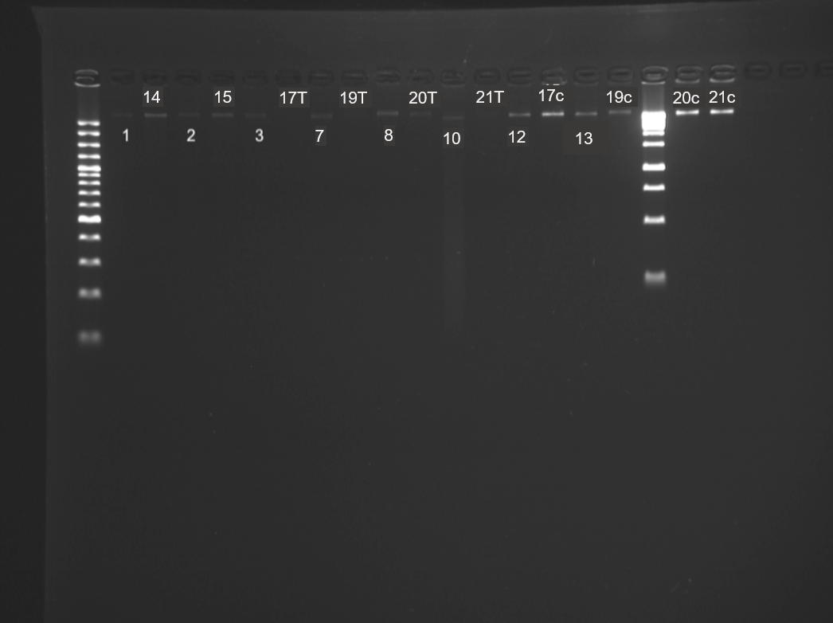
Figure S1. Unamplified eDNA extracts ran on an electrophoresis gel with a 100 bp and 1 kb ladder to determine the fragment size of the DNA captured. Bright bands appear in several samples at >10 kb length. Two extractions were carried out on each of the Icelandic samples (17 – 21); an extraction from the filter within the capsule after removal of Longmire’s storage buffer (indicated by a ‘c’), and an extraction from the removed buffer (indicated by a ‘T’). Details of samples are provided in Table 1.

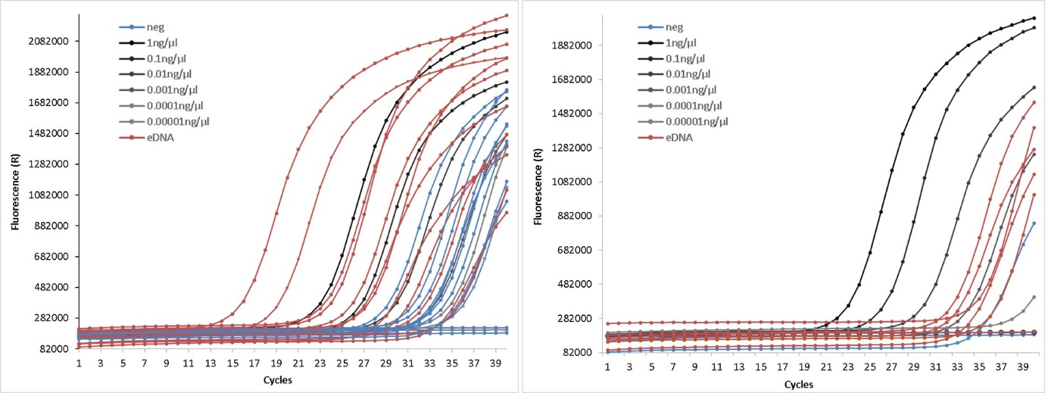
(b)
(a)

Figure S2. Quantitative PCRs (qPCRs) to target short fragments (112 bp) of Atlantic mackerel DNA in eDNA samples taken during the Northeast Atlantic mackerel fishery and around Vestmannaeyjar, Iceland in 2017. Each qPCR includes a serial dilution of a positive control of Atlantic mackerel DNA extract. (a) Samples 1 – 17, 7 field-negatives and 3 laboratory-negatives. (b) Samples 19 – 21 and 1 field negative. See Table S2 for sample results.

Table S2. Results of quantitative PCR analysis for Atlantic mackerel DNA in eDNA samples collected during the Northeast Atlantic mackerel fishery (NEAM) and around Vestmannaeyjar, Iceland in 2017. Cycle threshold (C_{t}) for each technical replicate and average C_{t} across replicates are included.
Sample | Site | Results | C_{t}1 | C_{t}2 | C_{t}3 | Avg. C_{t}
1 | NEAM fishery | + | 24.5 | 24.2 | 24.2 | 24.3
2 | NEAM fishery | + | 19.0 | 18.8 | 19.0 | 18.9
3 | NEAM fishery | - | 32.1 | 32.7 | 32.4 | 32.4
N1 (lab neg) | - | - | 33.6 | 34.2 | 33.8 | 33.9
4 (field neg) | NEAM fishery | - | UD | UD | UD | UD
5 (field neg) | NEAM fishery | - | 36.1 | UD | UD | 36.1
6 (field neg) | NEAM fishery | - | 32.4 | 32.1 | 32.9 | 32.5
7 | NEAM fishery | + | 27.3 | 27.5 | 27.7 | 27.5
8 | NEAM fishery | + | 26.0 | 25.9 | 26.0 | 25.9
9 (field neg) | NEAM fishery | - | 34.3 | UD | 35.2 | 34.8
N2 (lab neg) | - | - | 34.2 | 33.2 | 32.6 | 33.3
10 | NEAM fishery | + | 16.1 | 15.9 | 16.0 | 16.0
11 (field neg) | NEAM fishery | + | 29.1 | 29.2 | 29.0 | 29.1
12 | NEAM fishery | + | 23.9 | 24.0 | 23.8 | 23.9
13 | NEAM fishery | + | 28.9 | 28.7 | 28.8 | 28.8
14 | NEAM fishery | - | 30.5 | 30.5 | 30.3 | 30.4
15 | NEAM fishery | + | 27.0 | 27.1 | 27.0 | 27.0
N3 (lab neg) | - | - | 31.8 | 31.6 | 31.2 | 31.5
16c (field neg) | Vestmannaeyjar | - | 35.4 | 35.4 | 36.2 | 35.7
16T (field neg) | Vestmannaeyjar | - | 33.8 | 33.0 | 32.9 | 33.2
17c | Vestmannaeyjar | - | 35.3 | 33.3 | 36.5 | 35.0
17T | Vestmannaeyjar | - | 34.9 | 34.3 | 34.6 | 34.6
18c (field neg) | Vestmannaeyjar | - | 34.7 | 34.9 | 35.6 | 35.1
18T (field neg) | Vestmannaeyjar | - | 31.2 | 32.7 | 34.6 | 32.8
19c | Vestmannaeyjar | + | 32.5 | 30.2 | 30.0 | 30.9
19T | Vestmannaeyjar | + | 29.7 | 28.8 | 29.7 | 29.4
20c | Vestmannaeyjar | - | 32.7 | UD | 32.8 | 32.8
20T | Vestmannaeyjar | - | UD | 33.5 | 33.2 | 33.3
21c | Vestmannaeyjar | - | UD | UD | UD | UD
21T | Vestmannaeyjar | - | 30.5 | 31.6 | 33.3 | 31.8
lab neg = laboratory negative; field neg = field negative; ‘+’ = positive; ‘-‘ = negative; ‘c’ = extraction from filter; ‘T’ = extraction from buffer; UD = undetermined

Table S3. Comparison of eDNA sampling and laboratory methodology carried out by Baker et al. (2018) and the study described herein.
Baker et al. 2018 | This study
Field sample collection
Sampled 200m directly behind whales | Sampled ≤20m of whales
Sampled inshore in Puget Sound, a sheltered semi-enclosed estuary | Sampled both inshore (Vestmannaeyjar) and offshore (NE Atlantic), both in non-sheltered areas
Sampled using 1L Nalgene bottle 50-80cm below surface using bilge pump and then changed to 1L samples taken at air/surface interface | 5 x 180ml (rope & bucket) or 1L Nalgene bottle ≤1m below surface (eDNA sampler) from fishing vessels.  Water samples taken at air/surface in Iceland; 6 X 180ml samples.
Samples collected in pairs (2L per site) and stored on ice onboard | 900ml, 1000ml (fishing vessels) frozen onboard at -20°C on fishing vessels.  Kept with ice packs in Iceland until back on land then stored in fridge or freezer (-20°C) depending on when filtration could take place
Filtration and Extraction
Filtered that evening using a Nalgene filter unit and vacuum pump. Filters stored in Longmire’s buffer and kept on ice for transportation back to laboratory | Fishing vessel’s samples thawed and filtered through Sterivex filters using Luer lock syringe. Iceland: samples filtered in the same manner but Sterivex capsules were stored in Longmire’s buffer in a 20ml sterile container for transportation back to Ireland. Samples frozen when back in Ireland.
Used a laboratory negative control | Used a laboratory negative control and a field negative control
Extracted DNA from filters using phenol/chloroform methods. DNA was re-suspended in 50 μL of TE. | Extracted DNA using the DNeasy® Blood & Tissue kit (QIAGEN, CA, USA) and MinElute spin columns (QIAGEN), with slight modifications to the standard protocol as described in Spens et al. (2017). DNA was eluted with 70 µl of molecular grade water
PCR and sequencing
Designed a set of PCR primers using available reference sequences for the mtDNA control region of known killer whale ecotypes in the North Pacific | Designed a set of PCR primers using available reference sequences for the mtDNA control region of known killer whale types in the Northeast Atlantic
Primers tested positive for family Delphinidae | Primers tested positive for family Delphinidae
Primers: 139 – 246bp in length | Primers: ≤ 175 bp (killer whale)  ≤ 162 bp (mackerel)
ddPCR with specific TaqMan molecular probe | qPCR with dilution series of a positive control (killer whale blood DNA extract). Followed by whole genome enrichment capture and shotgun sequencing for a subset of samples.
All samples were run in duplicate or triplicate, with negative controls and positive controls (1 µL of 1/1,000 dilution of Hector’s dolphin skin DNA extract) included in each ddPCR run | All samples were run in triplicate alongside a positive control dilution series, the field and laboratory negative controls and two negative PCR controls (UV-treated laboratory-grade water) within each qPCR run.
Positive control: Hector’s dolphin DNA extracted from skin biopsy | Positive control: killer whale DNA extracted from blood sample from a captive individual
ddPCR limits of detection conducted using an 8-fold series of 2x dilutions. The series included 6 replicates of each dilution. | 5-fold series of 10x dilutions within each qPCR reaction.

