Supplementary Material

Energy retrofit: factors affecting a just transition to better indoor environmental quality

A1: Characteristics of dwellings that participated in the IAQ Surveys
Table A1: Characteristics of dwellings that participated in the IAQ Surveys
Home ID | Property type | Year of Construction | Pre-retrofit BER rating | Social / Private housing | Pre-retrofit sampling | Post-retrofit sampling | Radon Sampling
HAVEN  01 | Detached, two storey | 2006 | D1 | Private | Yes | Yes | Yes
HAVEN  02 | Detached bungalow | 2003 | D2 | Private | Yes | Yes | Yes
HAVEN  03 | Detached two storey | 2001 | C2 | Private | Yes | Yes | Yes
HAVEN  04 | Semi-detached Bungalow | 1997 | E2 | Social | Yes | Yes | Yes
HAVEN  05 | Detached bungalow | 2006 | C1 | Social | No | Yes | Yes
HAVEN 07 | Semi-detached Bungalow | 1998 | C3 | Social | Yes | Yes | Yes
HAVEN  08 | Semi-detached bungalow | 1998 | G | Social | Yes | No | Yes
HAVEN  09 | End of Terrace | 1950 | E2 | Social | Yes | No | Yes
HAVEN  10 | Semi-detached bungalow | 1998 | G | Social | Yes | No | Yes
HAVEN  11 | Terraced | 2001 | C2 | Social | Yes | Yes | Yes
HAVEN  12 | Terraced | 2001 | C2 | Social | Yes | No | Yes
HAVEN  13 | Terraced | 2001 | C2 | Social | Yes | Yes | Yes
HAVEN  14 | Semi-detached | 2001 | C3 | Social | Yes | Yes | Yes
HAVEN  15 | Terraced | 1970’s | F | Social | Yes | No | Yes
HAVEN  16 | Semi-detached | 1970’s | G | Social | Yes | Yes | Yes
HAVEN  17 | Terraced | 1970’s | F | Social | Yes | Yes | Yes
HAVEN  18 | Semi-detached two storey | 2008 | C2 | Social | Yes | No | Yes
HAVEN  19 | Semi-detached bungalow | 2000 | E2 | Social | Yes | Yes | Yes
HAVEN  21 | Bungalow | 1990 | E1 | Social | Yes | Yes | Yes
HAVEN  22 | Bungalow | 1992 | E2 | Social | Yes | Yes | Yes
INTERREG23 | Detached, two storey | 2003 | C2 | Social | Yes | No | No
INTERREG24 | Terraced, two storey | 2003 | C2 | Social | Yes | No | No

A.2 Building Energy rating (BER)
A Building Energy Rating (BER) certificate allows for the comparison of the energy performance of dwellings. It is calculated following the Domestic Energy Assessment Procedure (DEAP) calculation framework, which is based on IS EN 13790 [1], and is compliant with the methodology framework in the EU Energy Performance of Buildings Directive (EPBD). The BER is based on the building itself, the fabric and systems installed, it is not based on its operational performance. It rates the dwelling on a scale of A to G, with A-rated homes being the most energy efficient while G-rated are the least energy efficient. There are three subdivisions of the A, B and C grade, two for D and E grade. A dwelling with an A3 rating has a calculated energy consumption >50 kWh/m2/yr and ≤ 75 kWh/m2/yr. A dwelling with a B” rating has a calculated energy consumption >100 kWh/m2/yr and ≤ 125 kWh/m2/yr [2].

A.3 Summary of indoor air quality pollutant/thermal parameters monitored, and sampling methodology employed
Table A3. Summary of indoor air quality pollutant/thermal parameters monitored, and sampling methodology employed.
Parameter | Sampling Method | Accuracy/Uncertainty | Sampling interval and duration
PM_{2.5} | 90◦ light scattering, laser diode TSI SidePak™ Personal Aerosol Monitor (AM520) | Range 0.001 to 100 mg/ m³  Minimum resolution 1 µg/m³ | Every 1 min over 48 h -72 h
CO₂ | Gray Wolf DirectSense II probe with smart °C/°F, %RH sensors | Range: 0 – 10,000 ppm  Accuracy ± 35 ppm  Sensor LOD: 1.0 ppm | Every 5 min over 48 h -72 h
CO₂ | Aranet 4 monitor | Range: 0 - 9999 ppm  Resolution - 1ppm  Accuracy: ± 30 ppm  ± 3 % of reading | 5 minutes  (historic data availability 7 days)
TVOC | Gray Wolf DirectSense II probe with photoionization detector 10.6 eV lamp smart °C/°F, %RH sensors | Range 0 – 20000 ppm  Sensor LOD 0.005 ppm  Resolution 0.001 ppm | Every 5 min over 48 h -72 h
CO | Gray Wolf DirectSense II probe with smart Electrochemical sensor | Range: 0.0 to 500 ppm  Accuracy ±2%rdg ±1ppm | Every 5 min over 48 h -72 h
Temperature | Gray Wolf DirectSense II probe with smart °C/°F, Pt100 | Range -25°C to 70°C  Accuracy ± 0.3°C | Every 5 min over 48 h -72 h
Temperature | Aranet 4 monitor with  SHT3x-DIS CMOSens® Sensor Chip, | Range: 0 - 85 %  Accuracy: ± 3 % | 5 minutes  (historic data availability 7 days)
Relative humidity | Gray Wolf DirectSense II Capacitive | Range 0 – 100%  Accuracy ± 2%RH<80%RH (± 3 %RH>80%RH) | Every 5 min over 48 h -72 h
Relative humidity | Aranet 4 monitor with  SHT3x-DIS CMOSens® Sensor Chip, | Resolution RH: 1%  Accuracy RH: ± 3 % | 5 minutes  (historic data availability 7 days)
Formaldehyde | UMEX 500-100 passive badges | 7-day LOD: 0.2 ppb (2 µg/m³⁾ | Mass collected over 72 h
Radon | Closed alpha-track detector (Radtrak) | ±15% rdg | 3-9 months
Ventilation flow rates | Kimo MP50 Manometer by Sauermann | Range: -1000 to +1000 Pa  Accuracy: ±0.5 % of reading ±2 Pa | Measured once or twice at the time on sampling

A.4 Bedroom ventilation calculations using carbon dioxide concentration data
The Steady state method assumes that CO₂ concentrations increase as occupants sleep until the influence of ventilation leads to a plateau. Recorded CO₂ levels are influenced by the number of occupants, their age, gender, and the volume of the room. These factors are accounted for in this method. Ventilation capabilities are presented in terms of building air exchange rates (h⁻¹) and litres/per second/per person [3]. Only night-time CO₂ data recorded whilst occupants were sleeping was utilised to calculate ventilation rates.
The steady-state method was preferred over the decay method since the decay method would be highly sensitive to occupant behaviour after waking up, such as opening doors and/or windows. The steady state method uses the following formula to estimate outdoor air ventilation:

$V \left(\frac{L}{s}\right)= \frac{G (\frac{L}{s})}{C_{ss}- C_{o}}$,

where V is the outdoor air ventilation rate in litres per second, G is carbon dioxide generation rate from all the occupants in the bedroom (litres per second), C_{ss} is the steady-state CO₂ levels reached in the bedroom, and C_{o} is the outdoor CO₂ level, both CO₂ levels expressed in parts per million. We assume that the bedrooms did not have any other sources of CO₂, apart from the occupants, during the nighttime, which is a logical assumption for these homes.
The associated uncertainty with this formula is,

$\frac{δV}{V}= \sqrt{{\left(\frac{δG}{G}\right)}^{2}+ {\left(\frac{δC_{SS}}{C_{SS}}\right)}^{2}{+ \left(\frac{δC_{O}}{C_{O}}\right)}^{2} }$

Where δG is the uncertainty associated with the occupants’ CO₂ generation, δC_{ss} and δC_{o} are the uncertainties associated with the indoor and outdoor CO₂ levels. For occupant CO2 generation, a 10% uncertainty is assumed, deriving from occupants’ self-reported height and weight (age and sex are determined without any uncertainty). The met rate, while occupants slept, was estimated at 1 met, assumed to be determined without any uncertainty. δC_{ss} and δC_{o} are respectively taken at 35 and 50 ppm. Using these values, the average uncertainty of bedroom ventilation estimates post-retrofit was found to be 22.4% and for pre-retrofit estimates, the average uncertainty was 22.8%.
Apart from the uncertainty associated with the measurements, the process also relied on assuming the bedrooms (in some cases, the bedroom-ensuite combination) as a single zone, with negligible interzone transport of CO₂ – between the bedroom and the rest of the home. Considering that living room CO₂ levels were consistently lower than bedroom values, there is a likelihood of air from the rest of home leaking into the bedroom or vice versa. The implication would be the estimated bedroom ventilation levels are conservative values.

A.5 Thermal comfort questionnaire survey
The questionnaire survey examined: thermal comfort and temperature satisfaction (8 questions), sources of thermal discomfort (5 questions), perceived indoor air quality (1 question), odour perception and response (2 questions), observance of mould and/or condensation (2 questions), and noise disturbance (1 question). Five-point Likert scale response formats ranging from ‘satisfied’ to ‘unsatisfied’ were employed for satisfaction questions e.g., “how satisfied are you with the temperature in your home”. Multiple response options where participants could check all the items that applied, were used to explore aspects of thermal comfort in more depth e.g., sources of thermal discomfort, causes of draughts, locations of mould, window opening behaviour, sources of odours, noise disturbance sources, etc. Some yes/no response options were also employed, e.g. “Are there any unpleasant odours present in your house that bother you?”
A copy of the survey is provided below:

HAVEN STUDY - THERMAL COMFORT QUESTIONS

(Note: The thermal comfort questions have been extracted from a larger questionnaire instrument, the results of which are reported elsewhere)

Section 2: This section asks about your home
- Have you noticed mould on walls / ceilings in your house?
YES ☐ NO ☐
- How much of a problem would you say that you have with condensation in your house? Please tick one only.
Not a problem ☐ Minor problem ☐ Moderate problem ☐
Severe problem ☐ Very severe problem ☐

Section 4: This section asks about your Thermal Comfort
Thermal comfort is very difficult to define, but aims to describe a person’s state of mind in terms of whether they feel too hot or too cold. Your thermal comfort can be influenced by environmental factors such as air temperature, air movement, or relative humidity but also personal factors such as your clothing and also your activity. In this questionnaire we ask you a number of questions about the thermal environment in your home so that we can try and evaluate the impact of your energy renovation on your thermal comfort.
- How would you rate your thermal comfort in general? (Check the one that is most appropriate)
Hot | ☐
Warm | ☐
Slightly warm | ☐
Neutral | ☐
Slightly cool | ☐
Cool | ☐
Cold | ☐

- How satisfied are you with the temperature in your home? (Check the one that is most appropriate)
Satisfied ☐ Fairly satisfied ☐ No opinion/Cannot tell ☐ Rather unsatisfied ☐ Unsatisfied ☐

- Overall, how satisfied are you with the heating in your home? (Please tick one only)
Satisfied ☐ Fairly satisfied ☐ No opinion/Cannot tell ☐ Rather unsatisfied ☐ Unsatisfied ☐

- In warm/hot weather, how would you describe the temperature in your home: (Check the one that is most appropriate)
Always too hot ☐ Often too hot ☐ Occasionally too hot ☐ Occasionally too cold ☐ Often too cold ☐

- In cool/cold weather, how would you describe the temperature in your home: (Check the one that is most appropriate)
Often too hot ☐ Occasionally too hot ☐ Occasionally too cold ☐ Often too cold ☐ Always too cold ☐

- On cooler days, would you consider the thermal comfort of your home to be a problem? (Check all that apply)
Morning (before 11am) | ☐ | No particular time | ☐
Midday (11am-2pm) | ☐ | Always | ☐
Afternoon (2-5pm) | ☐ | Never | ☐
Evening (after 5pm) | ☐ | Other | ☐

- Following on from question 6, on cooler days how would you best describe the source of thermal discomfort in your home? (Check all that apply)
Humidity too high (damp) | ☐ | Glare incoming from sun | ☐
Humidity too low (dry) | ☐ | Draughts from windows | ☐
Air movement too high | ☐ | Draughts from vents | ☐
Air movement too low | ☐ | Some areas are hotter/cooler than others | ☐
Thermostat is inaccessible | ☐ | Heating/cooling system does not respond quickly enough to the thermostat | ☐
Thermostat is not adjustable | ☐ | Hot/cold surrounding surfaces (floor, ceiling, walls, windows) | ☐
Temperature changes between rooms | ☐ | Deficient window (not operable) | ☐
Other: | ☐ |  | ☐

- Within your home, are any of the following a source of discomfort causing air movement or draughts (Please tick all that apply)
 | Summer | Winter
Leaky windows | ☐ | ☐
Cold window panes | ☐ | ☐
Mechanical ventilation (extract ducts (bathroom) or cooker hood (kitchen)) | ☐ | ☐
Doors to the outside | ☐ | ☐
Doors within the house | ☐ | ☐
Stairways or landing | ☐ | ☐
Wall vents | ☐ | ☐
Other places (please specify) | ☐ | ☐

- How satisfied are you with your indoor air quality within your house? (please tick one only)
Satisfied ☐ Fairly satisfied ☐ No opinion/Cannot tell ☐ Rather unsatisfied ☐ Unsatisfied ☐

- How often do you need to open your windows in the following rooms in winter to be comfortable? (Please tick all that apply)
 | Daily | Weekly | From time to time | Never
Kitchen | ☐ | ☐ | ☐ | ☐
Bedroom(s) | ☐ | ☐ | ☐ | ☐
Living room | ☐ | ☐ | ☐ | ☐
Bathroom | ☐ | ☐ | ☐ | ☐
Other areas | ☐ | ☐ | ☐ | ☐

- How often do you open your windows in the following rooms in summer to be comfortable? (Please tick all that apply)
 | Daily | Weekly | From time to time | Never
Kitchen | ☐ | ☐ | ☐ | ☐
Bedroom(s) | ☐ | ☐ | ☐ | ☐
Living room | ☐ | ☐ | ☐ | ☐
Bathroom | ☐ | ☐ | ☐ | ☐
Other areas | ☐ | ☐ | ☐ | ☐

- Over the last 3 months did you suffer at any time at home from dry eyes?
Daily ☐ Weekly ☐ From time to time ☐ Never ☐

- Over the last 3 months did you suffer at nay time at home from a dry throat?
Daily ☐ Weekly ☐ From time to time ☐ Never ☐

- Over the last 3 months did you suffer at any time at home from a headache?
Daily ☐ Weekly ☐ From time to time ☐ Never ☐

- During the past month, how would you rate your sleep quality overall?
Very good ☐ Fairly good ☐ Fairly bad ☐ Very bad☐

- Are there any unpleasant odours present in your house that bother you?
Yes ☐ No ☐
If yes, what type? (please tick all that apply)
Food odours | ☐ | General stuffiness | ☐
Cigarette smoke | ☐ | Sewer odour | ☐
Mould odour | ☐ | Smoke odour | ☐
Construction materials | ☐ | Odours from traffic | ☐

- Following on from question 16, what do you do if you notice any unpleasant odours?
Open windows | ☐ | Spray air freshener (Febreze, etc.) | ☐
Open inside doors | ☐ | Turn on electric air diffuser | ☐
Open outside doors | ☐ | Aroma diffuser (oils, etc.) | ☐
Light scented candles | ☐ | Nothing | ☐

- Do you experience noise disturbances from the following sources? (Please tick all that apply)
 | Daily / almost daily | Weekly | From time to time | Never
Inside the house (from different rooms) | ☐ | ☐ | ☐ | ☐
Building ventilation, plumbing, etc. | ☐ | ☐ | ☐ | ☐
Immediate surroundings (e.g. neighbours, yard) | ☐ | ☐ | ☐ | ☐
Surrounding areas (traffic, industry, etc.) | ☐ | ☐ | ☐ | ☐

- Have you noticed any mould in your house
Yes ☐ No ☐
If yes, location of mould?
Around the windows | ☐
At cornice level (ceiling) | ☐
Middle of ceiling | ☐
At skirting level | ☐
Middle of the wall | ☐

- Do any of the following cause you discomfort? (Please tick all that apply)
 | Summer | Winter
Natural light (daylight from outside) (too bright) | ☐ | ☐
Natural light (daylight from outside) (too dark) | ☐ | ☐
Lighting overall (too bright) | ☐ | ☐
Lighting overall (too dark) | ☐ | ☐
Vibration from inside the building (appliances, etc.) | ☐ | ☐
Vibration from outside the building (traffic, etc.) | ☐ | ☐

A.6 Linear mixed effects models for indoor parameters
Linear mixed effects models (LMEs) were chosen for analysing the impact of retrofits on the indoor air quality and thermal environmental parameters that were recorded as time series. We also used LMEs to examine the impact of different occupant behaviours on these parameters. Since multiple data points corresponded to the same homes, to account for non-independence of data (data from the same home) LMEs were the appropriate choice, with HomeID being modelled as a random effect. The LMEs allowed us to explicitly specify the impact of occupant behaviour and retrofit status in the model, along with outdoor weather data (temperature, humidity, wind speed, and PM2.5). Since participating homes may often drop out of such long-term studies or even withdraw consent regarding use of their data, it is further advantageous to use LMEs. These models do not depend on having the exact same population before and after intervention.
Separate linear mixed effect were developed for living rooms and bedrooms. For bedrooms, data between 10 pm and 7 am was used and for living rooms, data between 7 am and 10 pm was used. A model (Eq. A.1) without the Retrofit Status as one of the predictor variables was compared to a model (Eq. A.2) with retrofit status added to the list of predictors.

𝑃𝑟𝑒𝑑𝑖𝑐𝑡𝑒𝑑 𝑃𝑎𝑟𝑎𝑚𝑒𝑡𝑒𝑟 ~ 𝑇𝑒𝑚𝑝.𝑂𝑢𝑡+𝑅𝐻.𝑂𝑢𝑡+𝑊𝑖𝑛𝑑.𝑂𝑢𝑡+𝑃𝑀2.5.𝑂𝑢𝑡+ 1 𝐻𝑜𝑚𝑒𝐼𝐷)
(Eq A.1)

𝑃𝑟𝑒𝑑𝑖𝑐𝑡𝑒𝑑 𝑃𝑎𝑟𝑎𝑚𝑒𝑡𝑒𝑟 ~ 𝑇𝑒𝑚𝑝.𝑂𝑢𝑡+𝑅𝐻.𝑂𝑢𝑡+𝑊𝑖𝑛𝑑.𝑂𝑢𝑡+𝑃𝑀2.5.𝑂𝑢𝑡+𝑅𝑒𝑡𝑟𝑜𝑓𝑖𝑡 𝑆𝑡𝑎𝑡𝑢𝑠+1 𝐻𝑜𝑚𝑒𝐼𝐷)
(Eq A. 2)

If addition of retrofit status significantly improved the model, it meant the energy retrofit had a significant effect on the indoor environmental parameter. If a difference was found, we proceeded to pairwise comparisons using the “lsmeans” package in R, computing contrasts between pre- and post-retrofit values.
To address non-uniform residuals, we log-transformed PM2.5 and CO2 parameters before fitting the model. For temperature data, no transformation was required.
To examine the impact of occupant behaviour on CO₂, window opening percentage (as gathered from the participant activity diary, percentage) and blocking of vents (Yes or No) was added to the model. For PM2.5 model, window opening, blocking of vents, smoking (Yes or No), and burning of wood fire or incense/candles (Yes or No) were added. The occupant behaviour models were examined to see if addition of these behaviours significantly improved the model over the model with retrofit (Eq,A.2). If the model with behaviours was significantly better then we examined which behaviours had the leading contribution to the model, using standardized coefficients.

A.7 Summary of the Retrofit measures completed across the 14 participant homes
Five homes (HAVEN 01-03, 21, 22) received extra cavity wall insulation, five homes (HAVEN 04, 5, 21 and 22) received 100 - 160 mm external wall insulation (U value 0.12 -0.13 W/m²K). Eight of the homes received extra attic insulation (300 – 400 mm fibre glass wool, typical U value of 0.13 W/m²K), and nine received new windows and doors (both double and triple glazed). All homes had their fossil fuel-based heating systems (stoves or fireplace) replaced with a heat pump, and chimneys and flues were filled. Three homes (HAVEN 5, 21 and 22) had solar PV installations (»2kW), resulting in a higher post retrofit BER rating (A3 and A2). The three private dwellings (HAVEN 1-3) had wood burning stoves installed as secondary heating sources post retrofit.

Table A.7.1 Deep retrofit measures completed in participating dwellings.
Home ID | Construction year | Floor area (m²) | Wall insulation | Roof insulation | Windows/Doors  (U-values, Wm².K) | Post ventilation system | Heat pump | Wood burning/ Room heater
HAVEN01 | 2006 | 270.1 | 300mm CW, 0.36 W/m²K | 300mm FG,  0.13 W/m²K | 2.3/1.2 | DCV | A2W350% | Yes
HAVEN02 | 2003 | 178.8 | 300mm CW, 0.31 W/m²K | 300mm FG, 0.13 W/m²K | 0.7/0.9 | DCV | A2W350% | Yes
HAVEN03 | 2001 | 173.7 | 300mm CW, 0.30 W/m²K | 300mm FG, 0.13 W/m²K | 0.7/3.0 | DCV | A2W350% | Yes
HAVEN04 | 1997 | 48.8 | 150mm EWI, 0.12 W/m²K | 400mm FGW, 0.26 W/m²K | 0.8/1.8 | NV | A2W6kW 350% | No
HAVEN05 | 2006 | 97.5 | 160mm EWI + 50mm CW, 0.13 W/m²K | 300mm FG, 0.13 W/m²K | 1.2/1.2 | NV | A2W6kW 350% | No
HAVEN07 | 1998 | 73.0 | - | - | -/- | NV | A2W350% | No
HAVEN11 | 2001 | 76.0 | - | - | -/- | NV | A2W350% | No
HAVEN13 | 2001 | 76.0 | - | - | -/- | NV | A2W350% | No
HAVEN14 | 2001 | 76.0 | - | - | -/- | NV | A2W350% | No
HAVEN16 | 1970’s | 76.0 | - | - | 1.2*/1.0 | NV | A2W175% | No
HAVEN17 | 1970’s | 76.0 | - | - | 1.2*/1.0 | NV | A2W175% | No
HAVEN19 | 2000 | 55.0 | - | 400mm MWI, 0.11 W/m²K | 0.7*/- | NV – RH controlled | A2W | No
HAVEN21 | 1990 | 74.2 | 100mm EWI, 0.25 W/m²K + 50mm CW | 300mm FG | 1.1*/1.2 | NV | A2W8kW 350% | No
HAVEN22 | 1992 | 77.0 | 100mm EWI, 0.25 W/m²K + 50mm CW | 300mm FG | 1.1*/1.2 | DCV | A2W8kW 350% | No
Note. *=triple glaze windows (double glaze otherwise), CW = cavity wall insulation, EWI = external wall insulation, FG = fibre glass, FGW = fibre glass wool, MWI = mineral wool insulation, DCV = demand control ventilation, NV = natural ventilation, A2W = air to water.

Table A7.2. Retrofit measures for houses participating in the thermal comfort survey questionnaire.
Retrofit measures | Number of houses
Heat pump | 56
New doors | 36
New windows | 31
Insulation added within the roof space | 18
External wall insulation | 11
Wall cavity insulation | 11
Hot water tank/Internal pipework insulated | 6
Internal wall insulation | 5
Demand control ventilation | 12*
Floor insulation added | 2*
*These measures were only applied in private homes

A.8 Indoor air pollutant profiles showing the impact of occupant behaviours, blocking wall vents and smoking on concentrations of carbon dioxide and PM2.5 respectively

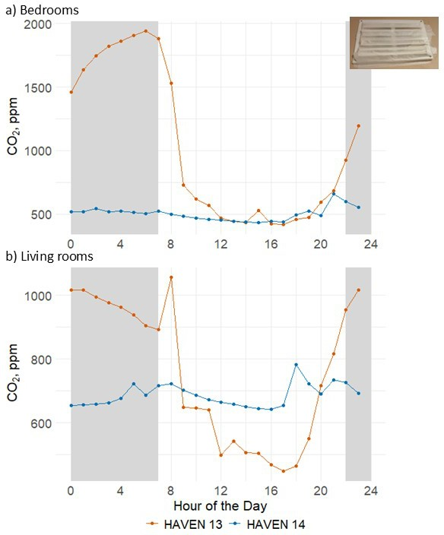
Figure A.8.1 Hourly bedroom CO₂ concentration profile for HAVEN 13, compared to HAVEN 14, showing the impact of blocked wall vents on (a) bedroom and (b) living room concentrations post retrofit. Both dwellings have the same construction style. At the time of the surveys two adults occupied the bedroom in both homes. Both dwellings were monitored at the same time period.
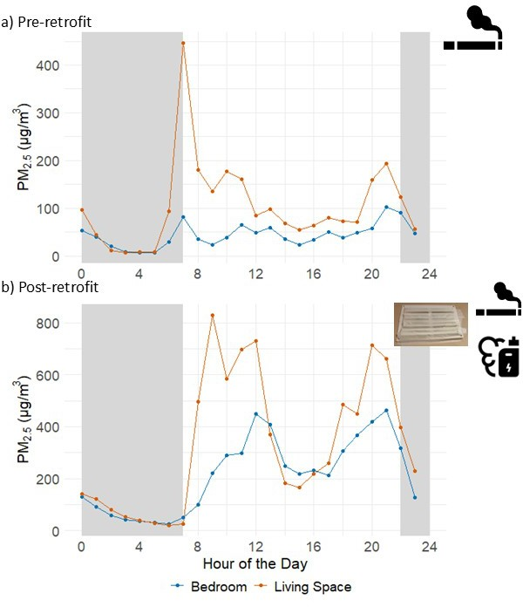

Figure A8.2 Hourly bedroom PM_{2.5} concentrations (a) pre-retrofit and (b) post-retrofit in HAVEN 16, showing the impact of tobacco smoking in the living area (pre- and post-retrofit), and vaping in the bedroom (post-retrofit only) on nighttime and daytime concentrations. Occupants had blocked the wall vents in this dwelling post retrofit.

A.8.1 Ventilation in indoor environments

Figure A8.1. Pre/post-retrofit nighttime ventilation rates (night time, L/s/p)

A.9 Distribution of indoor air quality and thermal environment parameters across sampled houses.
We present stacked plots of distribution for indoor air quality and thermal environment data for the homes pre- and post-retrofit. These plots present “paired” data, that is, only homes for which we had data both pre- and post-retrofit for a given parameter have been included in the plots.

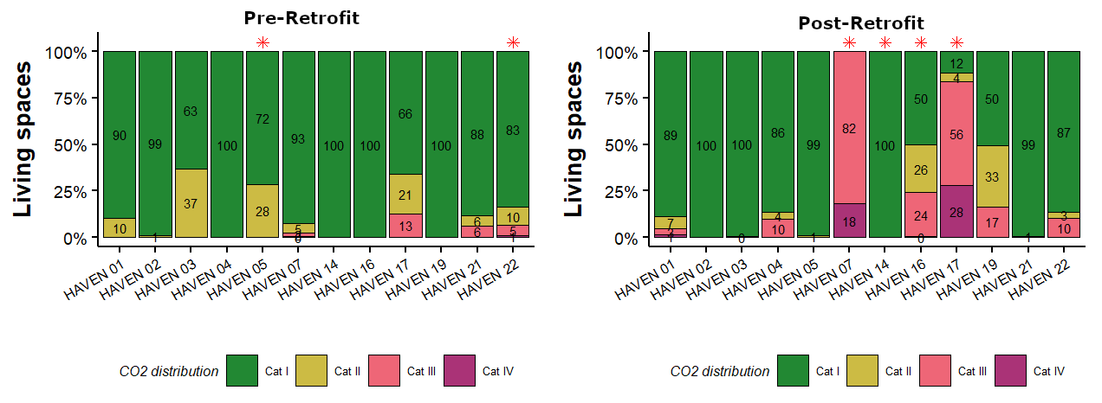
Figure A9.1. CO₂ distribution in living rooms pre- and post-retrofit (* marked homes had blocked vents).

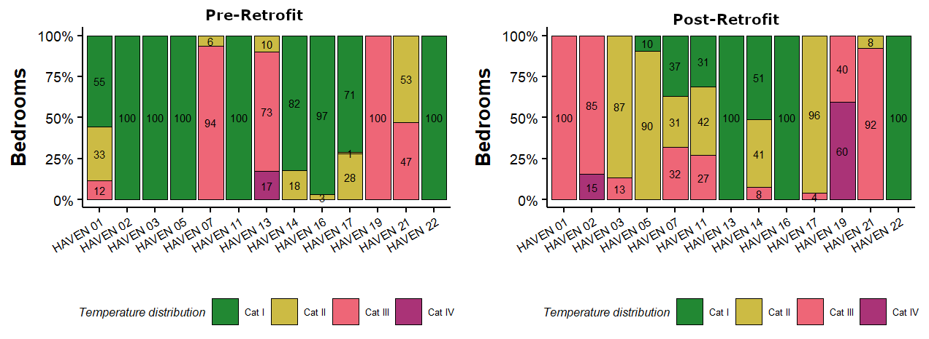
Figure A9.2. Temperature distribution in bedrooms pre- and post-retrofit.
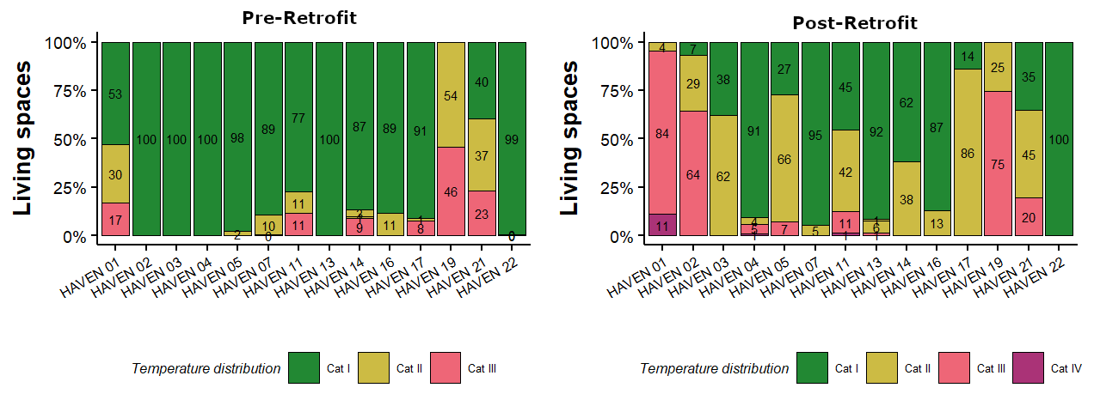
Figure A9.3. Temperature distribution in living rooms pre- and post-retrofit.
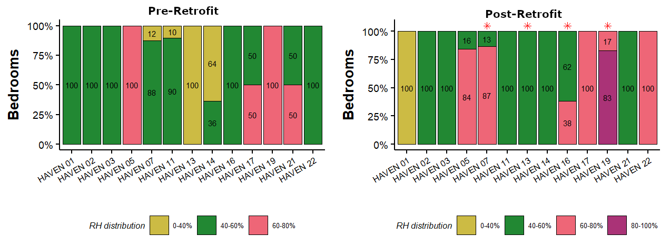
Figure A9.4. Relative humidity distribution in bedrooms pre- and post-retrofit. (* marked homes had visible mould issues)

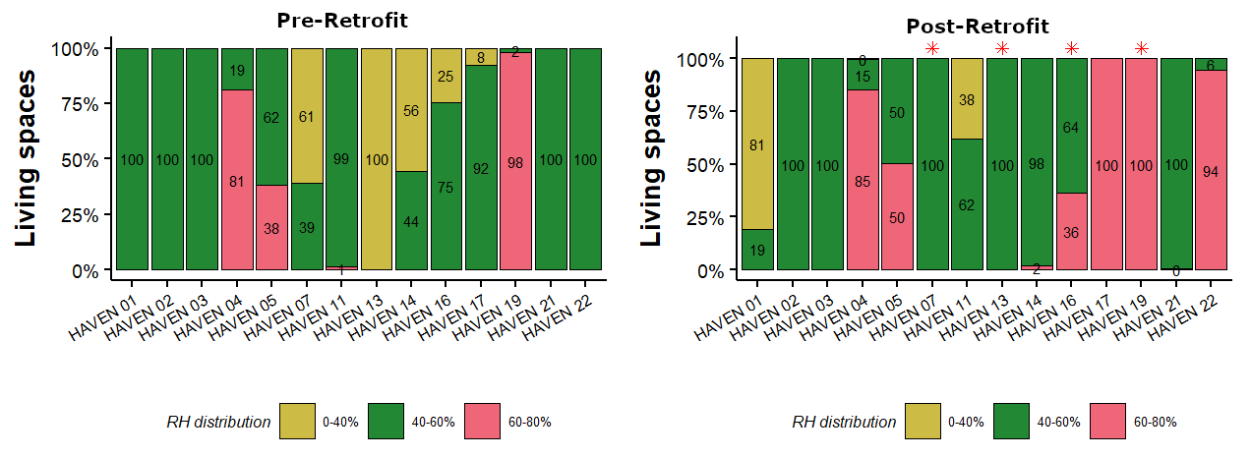
Figure A9.5. Relative humidity distribution in living rooms pre- and post-retrofit. (* marked homes had visible mould issues)

References
[1] SEAI, ISEN 13790: Energy performance of buildings - Calculation of energy use for space heating and cooling.
[2] SEAI, Building Energy Rating Certificate (BER). 2024 (accessed May 2024).
[3] S. Batterman, Review and Extension of CO2-Based Methods to Determine Ventilation Rates with Application to School Classrooms, Int. J. Environ. Res. Public Health 14(2) (2017) 145.

