Supplementary Material to “Adapting to the Little Ice Age in pastoral regions: an interdisciplinary approach to climate history in north-west Europe”
By Eugene Costello, Kevin Kearney and Benjamin Gearey
Corresponding author: Eugene Costello
eugene.costello@arklab.su.se

This supplementary material document contains:
- Information on Bayesian modelling approach
- Supplementary Table 1. Posterior density estimates for arable-relared pollen values in BAR L1
- Supplementary Figure 1. BAR L1 P_Sequence
- Supplementary Table 2. Posterior density estimates for cereal pollen values in Camban
- Supplementary Figure 2. Camban P_Sequence
- Supplementary Table 3. Posterior density estimates for cereal pollen values in Carnach Mór
- Supplementary Figure 3. Carnach Mór P_Sequence
- References

Information on Bayesian modelling approach
In order to better refine the chronology of palynological ‘events’ and to extend the chronological framework to ‘events’ which fall between dated horizons in the stratigraphic sequence, a Bayesian approach was employed (Buck et al. 1992). The minimum threshold for Bayesian analysis is five radiocarbon determinations, and sequences passing this threshold were modelled using the programme OxCal v4.4 (Bronk Ramsey 1995; 1998; 2008; 2009a; 2017) and IntCal20 (Reimer et al. 2020). A general introduction to the application of the Bayesian approach has been widely discussed in the literature (e.g. Blaauw and Christen 2005; Blaauw et al. 2007a; Blaauw et al. 2007b; Bronk Ramsey 2008), with the application Bayesian modelling to palaeoenvironmental sequences reviewed in Parnell et al. (2011).
For each of the accepted sequences a model was produced assuming a ‘Poisson’ process which treated the sediment accumulation process as being random (see P_Sequence models in supplementary material). Deposition models were constructed to allow for flexibility in the estimation of sediment accumulation rates, by averaging the values of the rigidity of the model (k value) of between 0.01 and 100cm⁻¹ (Bronk Ramsey and Lee 2013). The k factor is estimated based on the relationship between the number of depositional events and the overall stratigraphic process. The value used was estimated from the radiocarbon dates following the approach outlined in Blockley et al. (2007; 2008).
Where there were age inversions in the sequences, formal outlier analysis was undertaken to identify any radiocarbon dates which were statistically defined as outliers, at a 0.05 probability (1 in 20). These were removed from the models (Bronk Ramsey 2009b) and are indicated by the ‘?’ symbol (see supplementary material). The ranges quoted in italics are posterior density estimates, derived from this Bayesian mathematical modelling of the radiocarbon chronology (Bayliss et al. 2007), while conventional calibrated radiocarbon ages are quoted in accordance with the international standard established by the Trondheim Convention (Stuiver and Kra 1986) and are not italicised. The calibrated date/posterior density estimate are quoted in the form recommended by Mook (1986), with the end points rounded outward to 10 years and are cited at two sigma, (95.4% confidence) unless stated otherwise.
The Date () parameter was used to extrapolate a posterior density estimate for palynological features from the resulting P_Sequence. The statistical probability of an ‘event’ being before, after or contemporaneous with another ‘event’ was estimated by using the Order() parameter, which builds up a matrix of the relative order of all pairs of ‘events’. This approach to palaeoenvironmental and archaeological chronologies has been discussed in Gearey et al. (2009) and an examples of its application can be found in Schmid et al. (2018) and Kearney and Gearey (2020). The posterior density estimates of palynological evidence for cereal cultivation were statistically assessed, within a Bayesian framework, to determine the percentage probability of each ‘event’ occurring before, contemporary with or after changes in climate proxy datasets.

 | 1δ 68.2% probability | 2δ 95.4% probability
Arable indicators 44cm | 1540-1680 cal AD | 1488-1765 cal AD
Arable indicators 48cm | 1501-1626 cal AD | 1466-1712 cal AD
Peak arable indicators 52cm | 1467-1565 cal AD | 1450-1656 cal AD
Arable indicators 56cm | 1450-1506 cal AD | 1437-1619 cal AD
Arable indicators 60cm | 1365-1490 cal AD | 1260-1596 cal AD
Arable indicators 64cm | 1266-1445 cal AD | 1124-1516 cal AD

Supplementary Table 1. Posterior density estimates for arable-relared pollen values in BAR L1 (pollen data from Overland and O’Connell 2008, Fig. 11)
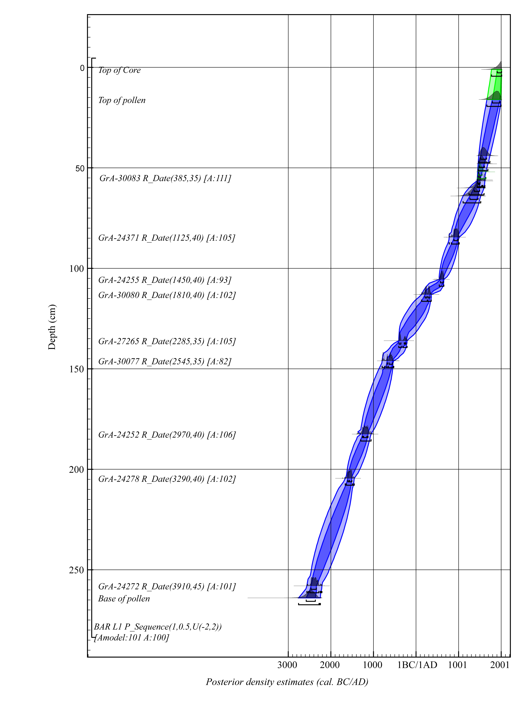
Supplementary Figure 1. BAR L1 P_Sequence (a remodelling of radiocarbon dates originally published in Overland and O’Connell 2008, Fig. 9)

 | 1δ 68.2% probability | 2δ 95.4% probability
End low cereal 4cm | 1615-1855 cal AD | 1574-1997 cal AD
Start low cereal 9cm | 1592-1797 cal AD | 1516-1945 cal AD
High cereal 12cm | 1580-1759 cal AD | 1493-1904 cal AD
Low cereal 16cm | 1564-1705 cal AD | 1471-1840 cal AD
End high/moderate cereal 18cm | 1559-1675 cal AD | 1464-1799 cal AD
Start high/moderate cereal 32cm | 1528-1624 cal AD | 1447-1635 cal AD
End low cereal 36cm | 1510-1615 cal AD | 1436-1631 cal AD
Start low cereal 76cm | 1364-1480 cal AD | 1321-1536 cal AD
End moderate/low cereal 80cm | 1350-1465 cal AD | 1313-1521 cal AD
Start moderate/low cereal 112cm | 1277-1370 cal AD | 1249-1395 cal AD
End low cereal 114cm | 1271-1363 cal AD | 1237-1391 cal AD
Start low cereal 134cm | 1188-1280 cal AD | 1066-1334 cal AD
No cereal 136cm | 1183-1272 cal AD | 1056-1314 cal AD
1st cereal of period 140cm | 1176-1261 cal AD | 1054-1276 cal AD

Supplementary Table 2. Posterior density estimates for cereal pollen values in Camban (original pollen data from Davies 1999, Table 25)
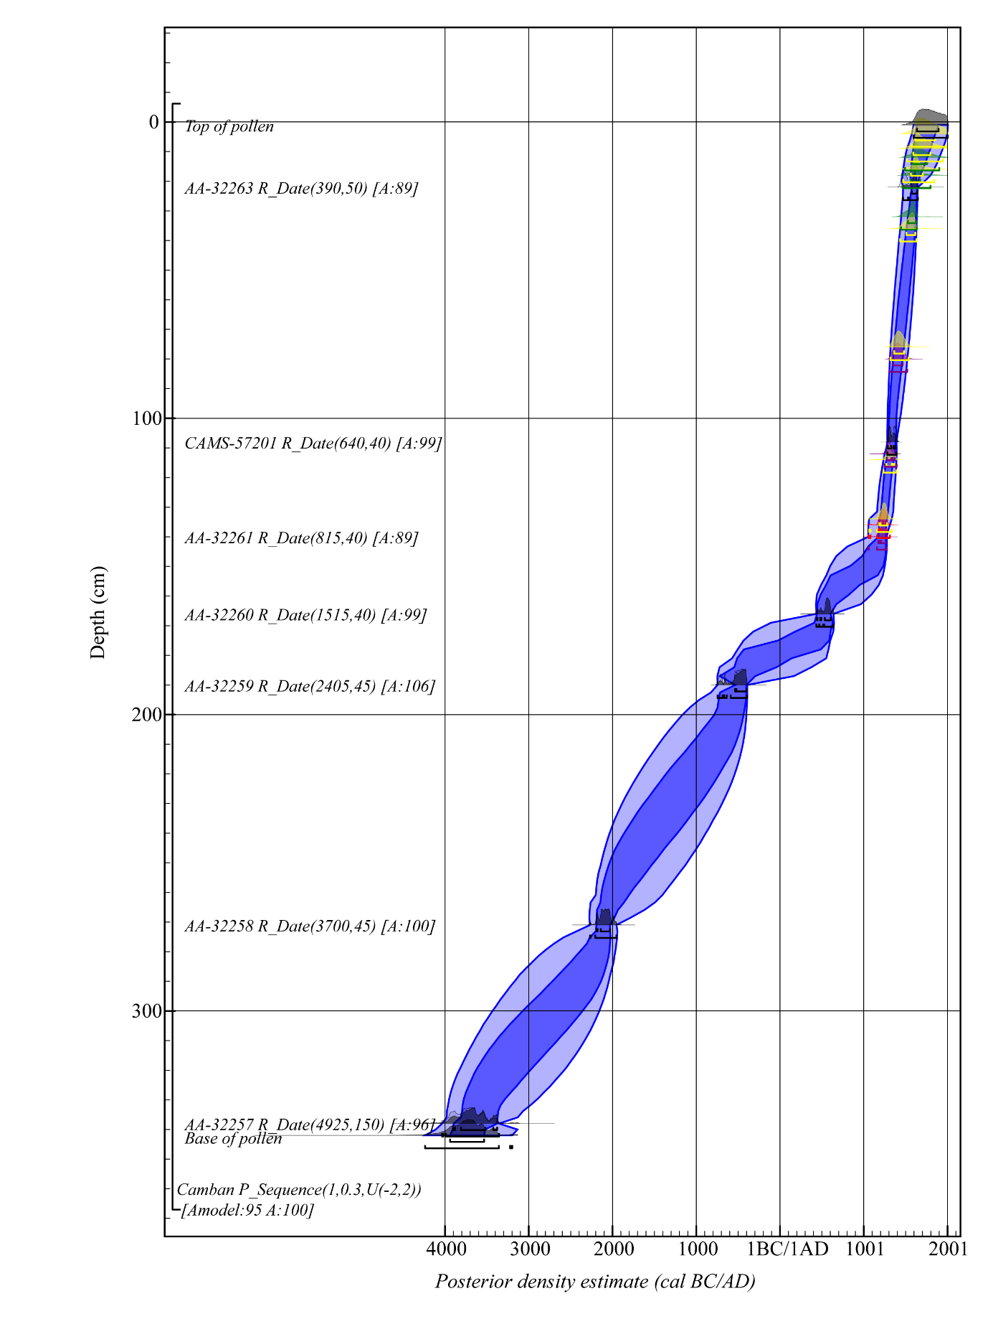
Supplementary Figure 2. Camban P_Sequence (a remodelling of radiocarbon dates originally presented in Davies 1999, Table 22)

 | 1δ 68.2% probability | 2δ 95.4% probability
End low/no cereal 28cm | 1545-1760 cal AD | 1480-1860 cal AD
Start low/no cereal 32cm | 1510-1710 cal AD | 1464-1824 cal AD
High cereal values 34cm | 1497-1687 cal AD | 1455-1805 cal AD
End moderate/low cereal 36cm | 1485-1665 cal AD | 1450-1783 cal AD
Start moderate/low cereal 40cm | 1467-1627 cal AD | 1441-1739 cal AD
End very high cereal 42cm | 1456-1625 cal AD | 1436-1714 cal AD
Start very high cereal 52cm | 1405-1603 cal AD | 1340-1625 cal AD
Low cereal 54cm | 1373-1515 cal AD | 1299-1618 cal AD
No cereal 56cm | 1349-1504 cal AD | 1266-1609 cal AD
Moderate cereal 58cm | 1325-1490 cal AD | 1239-1597 cal AD
High cereal 60cm | 1303-1475 cal AD | 1208-1578 cal AD
End moderate/low cereal 62cm | 1280-1455 cal AD | 1184-1559 cal AD
Start moderate/low cereal 74cm | 1173-1304 cal AD | 1054-1386 cal AD
Very high cereal 76cm | 1172-1281 cal AD | 1047-1339 cal AD
Supplementary Table 3. Posterior density estimates for cereal pollen values in Carnach Mór (original pollen data from Davies 1999, Table 18)

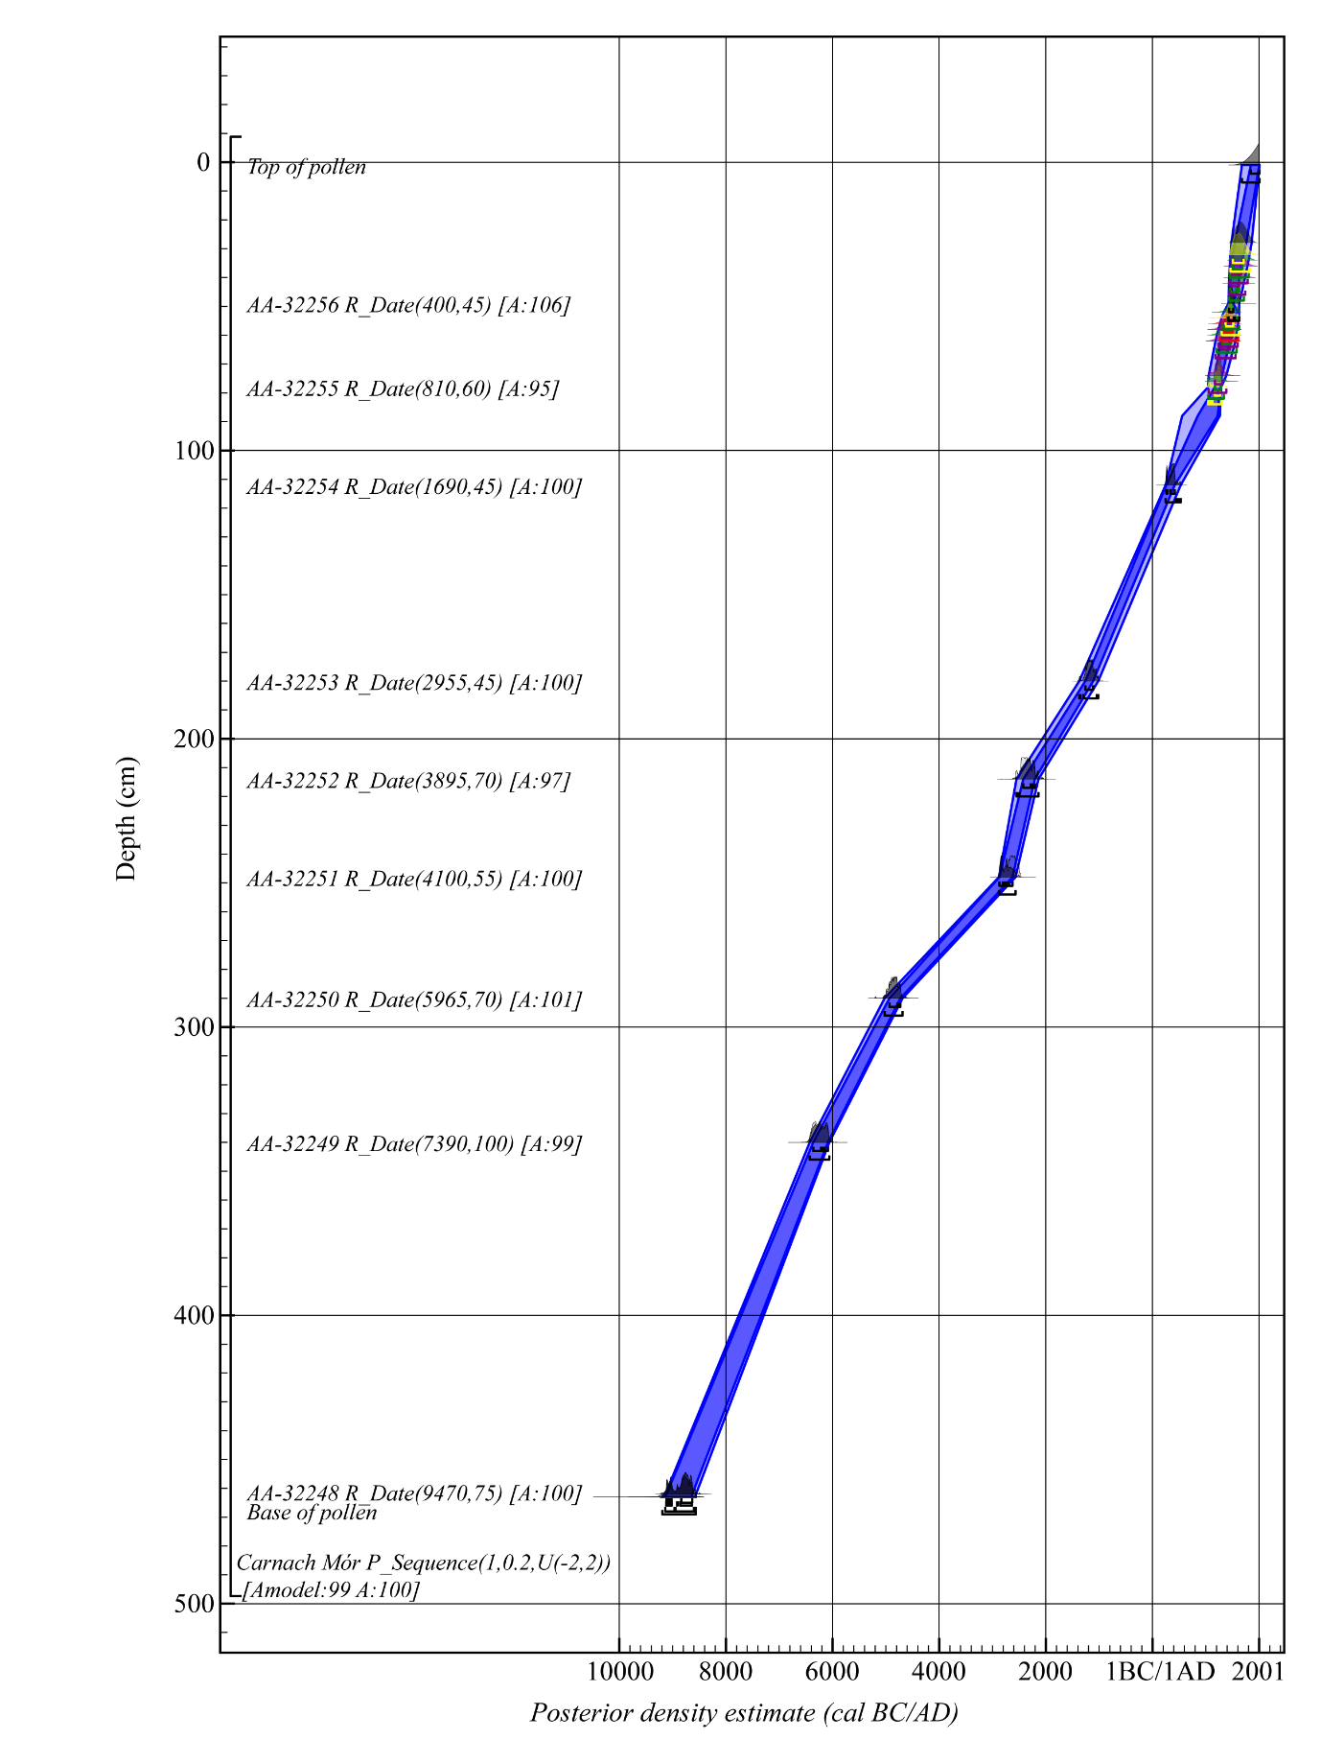
Supplementary Figure 3. Carnach Mór P_Sequence (a remodelling of radiocarbon dates originally presented in Davies 1999, Table 16)
References
Blaauw, M., Bakker, R., Christen, J.A., Hall, V.A. and J. van der Plicht. 2007a. A Bayesian framework for age modeling of radiocarbon-dated peat deposits: case studies from the Netherlands. Radiocarbon 49:357-367.
Blaauw, M. and J.A. Christen. 2005. Radiocarbon peat chronologies and environmental change. Journal of the Royal Statistical Society Series C-Applied Statistics 54:805-816.
Blaauw, M., Christen, J.A., Mauquoy, D., van der Plicht, J. and K.D. Bennett. 2007b. Testing the timing of radiocarbon-dated events between proxy archives. The Holocene 17:283-288.
Blockley, S.P.E., Blaauw, M., Bronk Ramsey, C. and J. van der Plicht. 2007. Building and testing age models for radiocarbon dates in Late Glacial and Early Holocene sediments. Quaternary Science Reviews 26:1915-1926.
Blockley, S.P.E., Ramsey, C.B., Lane, C.S. and A.F. Lotter. 2008. Improved age modelling approaches as exemplified by the revised chronology for the Central European varved lake Soppensee. Quaternary Science Reviews 27:61-71.
Bronk Ramsey, C. 1995. Radiocarbon calibration and analysis of stratigraphy: the OxCal program. Radiocarbon 37:425-430.
Bronk Ramsey, C. 1998. Probability and dating. Radiocarbon 40:461-474.
Bronk Ramsey, C. 2008. Deposition models for chronological records. Quaternary Science Reviews 27:42-60.
Bronk Ramsey, C. 2009a. Bayesian analysis of radiocarbon dates. Radiocarbon 51:337-360.
Bronk Ramsey, C. 2009b. Dealing with Outliers and Offsets in Radiocarbon Dating. Radiocarbon 51:1023-1045.
Bronk Ramsey, C. 2017. Methods for Summarizing Radiocarbon Datasets. Radiocarbon 59:1809-1833.
Bronk Ramsey, C. and S. Lee. 2013. Recent and Planned Developments of the Program OxCal. Radiocarbon 55:720-730.
Buck, C.E., Litton, C.D. and A.F. Smith. 1992. Calibration of radiocarbon results pertaining to related archaeological events. Journal of Archaeological Science 19(5):497-512.
Davies, A.L. 1999. High spatial resolution Holocene vegetation and land-use history in West Glen Affric and Kintail, Northern Scotland. Unpublished Doctoral Thesis, University of Stirling.
Gearey, B.R., Marshall, P. and D. Hamilton. 2009. Correlating archaeological and palaeoenvironmental records using a Bayesian approach: a case study from Sutton Common, South Yorkshire, England. Journal of Archaeological Science 36:1477-1487.
Kearney, K. and B.R. Gearey. 2020. The Elm Decline is dead! Long live declines in elm: revisiting the chronology of the Elm Decline in Ireland and its association with the Mesolithic/Neolithic transition. Environmental Archaeology. 10.1080/14614103.2020.1721694.
Mook, W.G. 1986. Business meeting: Recommendations/resolutions adopted by the twelfth International Radiocarbon Conference. Radiocarbon 28:799.
Overland, A. and M. O'Connell. 2008. Fine-spatial paleoecological investigations towards reconstructing late Holocene environmental change, landscape evolution, and farming activity in Barrees, Beara peninsula, southwestern Ireland. Journal of the North Atlantic 1(1):37-73.
Parnell, A.C., Buck, C.E. and T.K. Doan. 2011. A review of statistical chronology models for high-resolution, proxy-based Holocene palaeoenvironmental reconstruction. Quaternary Science Reviews 30:2948-2960.
Reimer, P.J., Austin, W.E., Bard, E., Bayliss, A., Blackwell, P.G., Ramsey, C.B., Butzin, M., Cheng, H., Edwards, R.L., Friedrich, M. and P.M. Grootes. 2020. The IntCal20 Northern Hemisphere radiocarbon age calibration curve (0–55 cal kBP). Radiocarbon 62(4):725-757.
Schmid, M.M.E., Zori, D., Erlendsson, E., Batt, C., Damiata, B.N. and J. Byock. 2018. A Bayesian approach to linking archaeological, paleoenvironmental and documentary datasets relating to the settlement of Iceland (Landnám). The Holocene 28:19-33.
Stuiver, M. and R.S. Kra. 1986. Editorial comment. Radiocarbon 28:ii.

