**Supplementary Materials for**

**An essential role for sulfur in sulfide-silicate melt partitioning of gold and magmatic gold transport at subduction settings**

**Yuan Li1,2*[1]\**, Lu Feng1, Ekaterina S. Kiseeva3, 4, Zenghao Gao1, Haihao Guo2, Zhixue Du1, Fangyue Wang5, Lanlan Shi1**

1State Key Laboratory of Isotope Geochemistry, Guangzhou Institute of Geochemistry, Chinese Academy of Sciences, Guangzhou 510640, China

2Bayerisches Geoinstitut, Universität Bayreuth, 95440 Bayreuth, Germany

3Department of Earth Sciences, University of Oxford, Oxford OX1 3AN, UK

4School of Biological, Earth and Environmental Sciences, University College Cork, Cork, Ireland

5School of Resources and Environmental Engineering, Hefei University of Technology, Hefei 230009，China

**Supplementary Materials include:**

1. **High-pressure equipment**
2. **Analytical methods**
3. **Estimation of sample fO2 using S6+/Stot in silicate melts**
4. **The sulfur content in sulfide- and/or anhydrite-saturated silicate melts**
5. **Estimation of sample *f*S2**
6. **Attainment of equilibrium**
7. **Supplementary Figures 1-5**
8. **Supplementary Tables 1-3**
9. **References**

***1. High-pressure equipment***

All experiments were conducted in an end-loaded, solid-media piston cylinder apparatus, using 0.5-inch diameter MgO-NaCl assemblies with stepped graphite heaters. A friction correction of 5% was applied to the nominal pressure based on a bracketing of the quartz–coesite transition at 790 °C and using the data of Bose and Ganguly (1995) as  
reference. The hot piston-in method was used to pressurize the assembly. The total pressure uncertainty is less than 0.1 GPa. The experimental temperatures were monitored by S-type thermocouples with an uncertainty of ~10 °C. All experiments were quenched to below 100 °C within 10-20 s by switching off the electric power to the graphite heaters. The recovered sample capsules were sectioned longitudinally into two halves and mounted in epoxy for polishing.

***2. Analytical methods***

***2.1. Electron microprobe***

Major element compositions of the quenched silicate melts and sulfides (MSS) were measured with a JEOL JXA-8200 electron microprobe. The analyses were performed in wavelength-dispersive mode, and a PAP matrix correction was applied to the raw data. Sulfides were analyzed with 20 kV acceleration voltage and 20 nA beam current, whereas quenched silicate melts were analyzed with 15 kV/10 nA. Natural and synthetic standards were used to calibrate the instrument. For sulfide analysis, Fe and S were calibrated on a synthetic pyrrhotite with a well-known Fe:S ratio, while Ni and Cu were calibrated on pure metals, and O was calibrated on magnetite. For silicate melts, Na was calibrated on albite, Ca on wollastonite, K on orthoclase, Ti and Mn on ilmenite, Si on enstatite, Mg on forsterite, Al on spinel, P on GaP, and Fe on metallic Fe. Sulfur in the quenched silicate melt was analyzed with a 50 nA beam current and 60 s peak counting time using a pyrrhotite/barite standard. A defocused beam of 20 µm diameter was used for all of the standardizations and sample measurements. The measured major elements of silicate melts and sulfides are given in Tables S2 and S3.

The oxidation state of sulfur in silicate melts was determined based on the shift of the $SK_{α}$ lines with respect to the BaSO4 (S6+) and the ZnS (S2-) standards (Carroll and Rutherford, 1988). The S6+/Stot in silicate melts is given by

$\frac{S^{6+}}{S_{tot}}=\frac{∆λ{(SK_{α})}_{sample}}{∆λ{(SK_{α})}_{sulfate}} ×100\%$**(S1)**

in which $∆λ{(SK_{α})}_{sample}$ is the wavelength shift of the measured sample glass relative to ZnS, and $∆λ{(SK_{α})}_{sulfate}$ is the wavelength shift of BaSO4 relative to the same reference. Measurements of the $SK_{α}$ position were conducted on a PETJ spectrometer, which was moved over a range of ~3.12 * 10-2 Å in 100–200 steps, using a 500 ms counting time for each step (the total acquisition time was between 50 s and 100 s). The acquisition time is thought to be sufficiently short to reduce the oxidation effect of the electron beam (Masotta and Keppler, 2015).

***2.2. Laser-ablation ICP-MS***

Trace element analyses of Au, Cu, Ni, Co, and Ag in the quenched silicate melts and MSS were conducted on an Agilent 7900 Quadrupole ICP-MS coupled to a Photon Machines Analyte HE 193-nm ArF Excimer Laser Ablation system. Helium was applied as the carrier gas (0.9 L/min) and mixed with the Ar carrier gas (0.85 L/min) via a T-connector before entering the ICP. After measuring the gas blank for 20 s, each analysis was performed by a laser beam of 30-50 µm diameter, at 8 Hz with an energy of ~2 J/cm2 for 40 s for the silicate melts and at 6 Hz with an energy of ~1.5 J/cm2 for 40 s for MSS. A squid signal smoothing device is included in this laser ablation system. NIST SRM 610 glass was used as an external standard for all analyses, whereas Si and Fe determined by electron microprobe were used as an internal standard for the silicate melts and MSS, respectively. The detection limit of Au in the silicate melts was ~0.01 ppm. Tests on Au-bearing MSS and pyrrhotite standards revealed an agreement between LA-ICP-MS measurements and certified Au concentrations within 3-15%, demonstrating the valid use of NIST SRM 610 glass as the standard for the measurements of Au in sulfides (Li and Audétat, 2012). The measured Au contents in the silicate melts and MSS are provided in Table 1.

The time-resolved Au signals of the LA-ICP-MS analyses are smooth and constant for most of the experiments with a relatively high sulfur content in the silicate melts; hence, Au is fully dissolved in these silicate melts. However, for some experiments that have a low melt sulfur content or are only anhydrite-saturated, Au nuggets are present in the quenched silicate melts, and the LA-ICP-MS signals of Au dissolved in these silicate melts were contaminated by signals from Au nuggets. In this case, as has been done in previous studies (Jégo and Pichavant, 2012; Jégo et al., 2010; Zajacz et al., 2013; Zajacz et al., 2012), for each sample that contains Au nuggets, we either increased the number of analytical spots and only chose those analyses that were not contaminated by Au nuggets, or only integrated the LA-ICP-MS signals that are clearly derived from the Au dissolved in the silicate melts. For a few experiments (runs Da-3A, Da-3B, and Rh-2B), we completely discarded the measured Au solubility values due to the very narrow integration range of LA-ICP-MS signals from the Au dissolved in the silicate melts. In addition, tests on a few sample glasses show that the Au signal was not affected, regardless of whether the squid signal smoothing device was used or not, the reason for which could be due to the high He and Ar flow rates, high cleaning efficiency, fast signal response (<1 s), and short washout time (<1.5 s). The measured Au solubility in the silicate melts varies from 0.012 to 55.3 ppm, which is strongly correlated with the sulfur content in the only sulfide-saturated silicate melts (see the main text).

***3. Estimation of sample fO2 using S6+/Stot in silicate melts***

The *f*O2 of most of our experiments was not buffered by any *f*O2 buffer. However, the relationship between *f*O2 and S6+/Stot in the quenched silicate melts provides an approach to estimate the *f*O2 prevailing in our experiments. Several studies have calibrated S6+/Stot in the quenched silicate melts as a function of *f*O2 varying from FMQ-2 to FMQ+6 (Carroll and Rutherford, 1988; Jugo et al., 2005; Wallace and Carmichael, 1994) (see (Wilke et al., 2011) for a review), and these calibrations have been used to estimate the *f*O2 of natural samples of different compositions by determining S6+/Stot in the sample glasses (Metrich and Clocchiatti, 1996; Rowe et al., 2007; Rowe et al., 2009). For example, Metrich and Clocchiatti (1996) used this S6+/Stot-approach to estimate the *f*O2 of melt inclusions that correspond to potassic and shoshonitic primary melts to tholeiitic and hawaiitic primitive melts. These authors found that their estimated *f*O2 values are consistent with the *f*O2 values estimated from the Cr-spinel-silicate melt equilibria within 0-0.5 log units. Rowe et al. (2009) compared the *f*O2 values of Cascade volcanic arc basalts, that were estimated from the S6+/Stot approach and the chromite-olivine pairs. They found that the *f*O2 values estimated from these two approaches match within 0-0.5 log units when the *f*O2, estimated using the S6+/Stot approach, is 0.3 log units above the FMQ buffer. However, when the *f*O2 is below the FMQ buffer, the *f*O2 values estimated from the S6+/Stot approach are ~0.4-1.3 log units lower than the *f*O2 values estimated from the chromite-olivine pairs. The authors thought that the discrepancy could be caused by the inaccurate measurements of S6+/Stot at low S6+ fraction and the inaccurate measurements of Fe3+ content in spinel from microprobe analysis. In this study, we used a model from Jugo et al. (2005), which was calibrated based on a large number of natural and synthetic samples of basaltic to dacitic compositions:

S6+/Stot = 1 / (1 + 10A-BΔFMQ) **(S2)**

in which A equals 1.22, B equals 0.95, and ΔFMQ is *f*O2 relative to the FMQ buffer. Eq. (S2) was also used to estimate *f*O2 for a few rhyolitic samples (run Rh-1B, Rh-2A, Rh-3A, and Rh-3B from Set-3 experiments; Table 1), which yielded *f*O2 values of FMQ+1.5 to FMQ+1.9. This approach could potentially introduce a large error for the estimated *f*O2 values, because the calibration of Eq. (S2) does not include data from very felsic samples. However, our estimated *f*O2 values for the sulfide-anhydrite-saturated rhyolitic samples are generally consistent with previous *f*O2 values that were determined for the stabilization of both sulfide and anhydrite in the rhyolitic melts (Parat et al., 2011).

Thermodynamic calculations show that the pressure, melt composition, and melt water content, all could change the *f*O2 range for the sulfide-sulfate transition in silicate melts (Baker and Moretti, 2011). A recent experimental study shows that for andesitic melt at 850-950 °C, the pressure variation from 0.5 to 1.5 GPa shifts the *f*O2 for the sulfide-sulfate transition from a range of FMQ to FMQ+1 to a range of FMQ+1 to FMQ+2.5 (Matjuschkin et al., 2016). However, a most recent experimental study shows that the temperature, rather than the pressure, plays the most important role in determining the *f*O2 range for the sulfide-sulfate transition in the basaltic to dacitic melts (Nash et al., 2019). The temperature of our experiments ranges from 950 to 1040 °C, which is well in the temperature range of the experimental study of Carroll and Rutherford (1988). Wilke et al. (2011) show that both models of Jugo et al. (2005) and Wallace and Carmichael (1994) can well reproduce the data of Carroll and Rutherford (1988) with an *f*O2 uncertainty of less than 0.5 log units. We therefore believe that the model of Eq. (S2) from Jugo et al. (2005) is valid to estimate our sample *f*O2.

In this section, two additional things deserve to be further clarified. (1) Although the S6+/Stot determined by $∆λ(S$) of the electron microprobe is less precise than the S6+/Stot determined by sulfur K-edge XANES (Jugo et al., 2010), our estimated *f*O2 values are valid because the calibration of Eq. (S2) was based on the S6+/Stot determined by $∆λ(S$) of the electron microprobe. (2) The variation of the *f*O2 values (FMQ+0.6 to FMQ+1.6) estimated for the unbuffered experiments does not mean that the *f*O2 of our unbuffered experiments varied indefinitely with the run duration. This is because the starting materials together with the solid-medium assembly used for the high-pressure experiments imposed an *f*O2 on the sample, although the *f*O2 imposed may vary by more than two log units between each individual experiment because of the difference in compositions of the starting materials (Prouteau and Scaillet, 2012).

***4. Estimation of sample fS2***

Sample sulfur fugacity log*f*S2 was calculated based on the major element compositions of MSS, using an experimental calibration (Toulmin and Barton, 1964):

NFeS = FeS / (FeS﹢S2)  **(4)**

log*f*S2 = (70.0﹣85.83 NFeS) × (1000/T﹣1) + 39.30 √(1﹣0.9981 NFeS)﹣11.91 **(5)**

in which NFeS is the mole fraction of FeS in the FeS-S2 system, and T is the temperature in K. For all log*f*S2 calculations, the measured oxygen in MSS was assumed to be present in the form of FeO, and NFeS was replaced by $N_{FeS+NiS+{Cu}_{2}S}$ for the Ni-Cu-bearing MSS (Mengason et al., 2010). The calculated log*f*S2 for all of the samples ranges from -2.17 to 2.08 (Table 1).

Sample log*f*S2 was also calculated using a calibration in which the pressure effect was considered (Froese and Gunter, 1976). The results show that for experiments at 1-3 GPa, the log*f*S2 values calculated using this calibration are systematically 1-3 log units higher than the log*f*S2 values calculated using the calibration of Toulmin and Barton (1964). Fitting the Au solubility in MSS ($C_{Au}^{MSS}$) as a function of the log*f*S2 calculated using the calibration of Froese and Gunter (1976) yielded (R2=0.32). Considering that the correlation between $log{(C}_{Au}^{MSS}, ppm)$ and the log*f*S2 calculated using the calibration of Toulmin and Barton (1964) is stronger and closer to the theoretical prediction of Eq. (11) (see Fig. 3), we chose to use the log*f*S2 values calculated using the calibration of Toulmin and Barton (1964).

***5. The sulfur content in sulfide- and/or anhydrite-saturated silicate melts***

The sulfur content in the silicate melts at only sulfide-saturation (SCSS), at sulfide-anhydrite-saturation (SCSAS), and at only anhydrite-saturation (SCAS) is a multiple function of the temperature, pressure, *f*O2, melt composition, and melt water content (D'Souza and Canil, 2018; Jugo et al., 2005; Jugo et al., 2010; Mavrogenes and O’Neill, 1999; Smythe et al., 2017). For a given sulfide±anhydrite and silicate melt system, our measured sulfur content in the silicate melts, in general, increases with increasing S6+/Stot (Fig. S2A), except for the Set-4 experiments. In the Set-4 experiments, the sulfur content in the silicate melts appears to be positively correlated with the Na2O content (Fig. S2B), which is consistent with the strongly positive effect of Na2O on SCSS (D'Souza and Canil, 2018). Several empirical parameterization models of SCSS as a function of temperature, pressure, melt composition, and melt water content have been developed at *f*O2≤FMQ, to predict SCSS in the silicate melts (D'Souza and Canil, 2018; Fortin et al., 2015; Li and Ripley, 2005; Smythe et al., 2017). The transition from the relatively insoluble sulfide (S2-) species to more soluble sulfate (S6+) species in the silicate melts strongly depends on *f*O2, and normally occurs at *f*O2s between FMQ and FMQ+2 (Jugo et al., 2005, 2010). In Fig. S3, we compared our measured SCSS and SCSAS values with the predicted SCSS values using a comprehensive parameterization of Smythe et al. (2017). Note that the SCSS values predicted by the model of Smythe et al. (2017) are the S2- contents in the silicate melts at only sulfide-saturation. It can be seen from Fig. S3 that our measured SCSS and SCSAS values are, in general, higher than those predicted SCSS values, which indicates the presence of oxidized sulfur species in our silicate melts, as measured by $λ(SK_{a})$ of the electron microprobe (Fig. S2A). Fig. S3 also implies that the *f*O2 of most of our unbuffered, only sulfide-saturated experiments is well within the *f*O2 range required for the sulfide-sulfate transition in the silicate melts.

Studies on the sulfur content in slab melts at the saturation of sulfide and/or anhydrite are sparse (Jégo and Dasgupta, 2013, 2014; Prouteau and Scaillet, 2012). In Fig. S4, we compared our slab melt SCSS and SCSAS values with literature values obtained at 2-3 GPa. As can be seen from Fig. S4, the SCSS in slab melts at *f*O2 below FMQ is rather low (< 200 ppm), but in the *f*O2 range of sulfide-sulfate transition, the SCSS is between 100 and 1000 ppm. When the slab melts are saturated with both sulfide and anhydrite, the sulfur content (SCSAS) appears to reach a maximum, but it then starts to decrease as *f*O2 increases to the point of only anhydrite-saturation.

***6. Attainment of equilibrium***

Our experimental durations are 43-48 hours for experiments at 1000 °C, 35-168 hours for experiments at 1040 °C, and 96-312 hours for experiments at 950-975 °C. These experimental durations are much longer than those of previous experiments performed at similar temperatures, in which equilibrium dissolution and partitioning of Au were attained (Botcharnikov et al., 2011; Zajacz et al., 2013). For example, Zajacz et al. (2013) showed that their experiments for studying Au solubility and partitioning in basaltic to rhyolitic melt can reach equilibrium within 24 hours at 1000 °C, 48 hours at 900 °C, and 72 hours at 800 °C. Additional lines of evidence that support equilibrium dissolution and partitioning of Au in this study are as follows: (1) both silicate melts and MSS are compositionally homogeneous with respect to major elements, Au, and S (Table 1; Tables S2 and S3); (2) although the run duration of the only MSS-saturated experiments varies from 35 to 312 hours, the measured Au solubility and SCSS in the silicate melts of these experiments are strongly correlated (Fig. 2), which cannot be obtained if equilibrium were not approached; and (3) at a given SCSS in the silicate melts and at a given *f*S2, the presently obtained Au solubility in the silicate melts and MSS, and the presently obtained $D_{Au}^{MSS/SM}$ are in good agreement with the results obtained in previous studies (Figs. 2-4).

***7. Supplementary Figures***

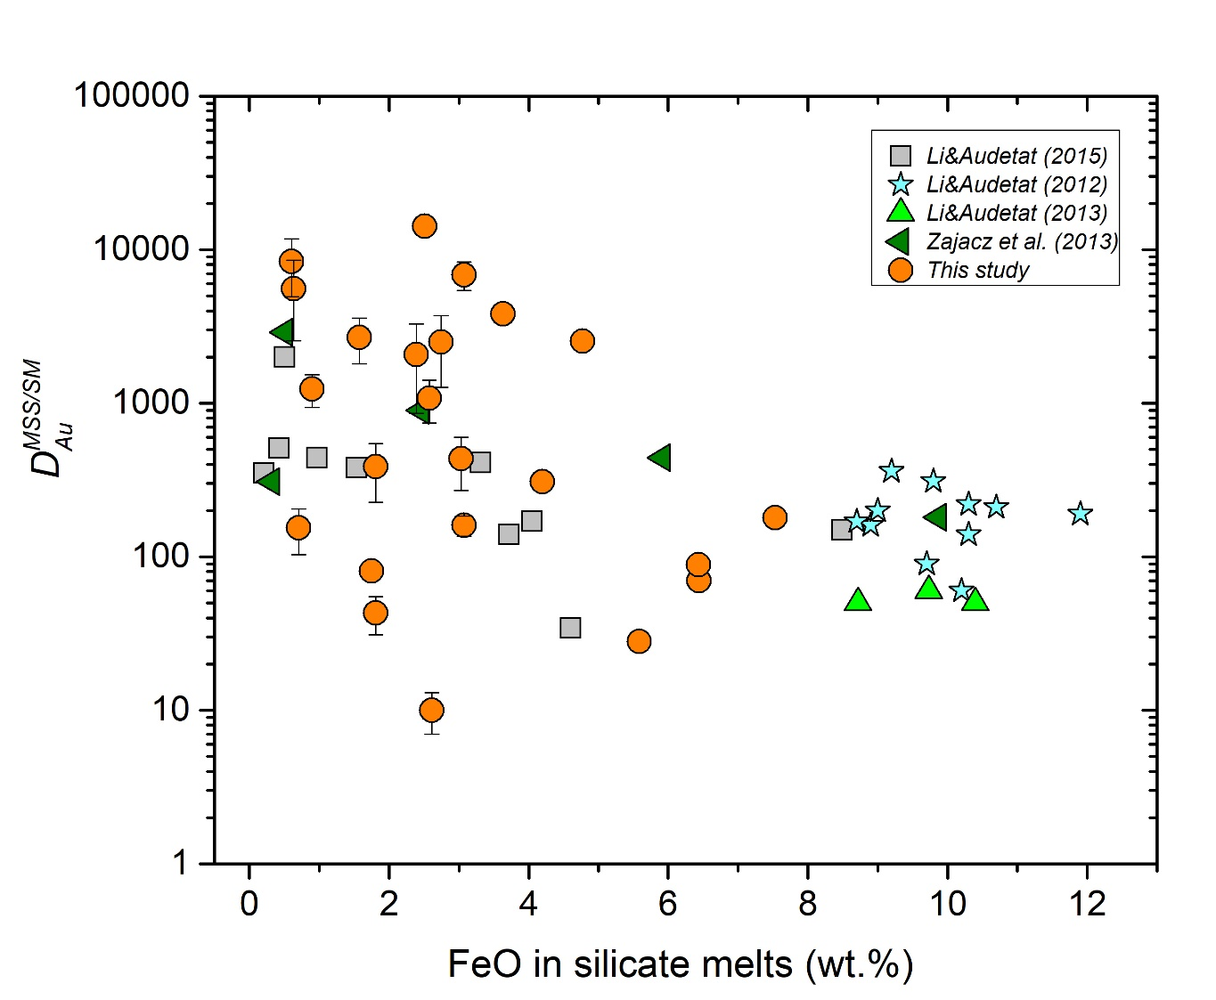

**Fig. S1.** The plot of all available $D_{Au}^{MSS/SM}$ data as a function of the FeO content in silicate melt. Fitting these data into Eqs. (1) and (2) in the main text yielded log $D_{Au}^{MSS/SM}=1.9\left(1.5\right)+1.3\left(1.8\right)×\frac{{10}^{3}}{T}-0.54\left(0.23\right)\log\left(FeO, wt.\%\right)(R^{2}=0.16)$, and log $D_{Au}^{MSS/SM}=1.0\left(1.6\right)+2.2\left(2.0\right)×\frac{{10}^{3}}{T}-0.32\left(0.26\right)\log\left(FeO, wt.\%\right)-0.045\left(0.074\right) ∆FMQ(R^{2}=0.11)$. The poor correlation between $D_{Au}^{MSS/SM}$ and the FeO (and *f*O2) content of the silicate melt, indicate that the melt FeO content and *f*O2 alonecannot sufficiently describe the MSS-silicate melt partitioning of Au, although for a number of other chalcophile elements, such as Re, Mo, and Pb, the correlation with the FeO does not require correction for additional parameters (e.g. T, oxygen content of sulfide, silicate melt composition).

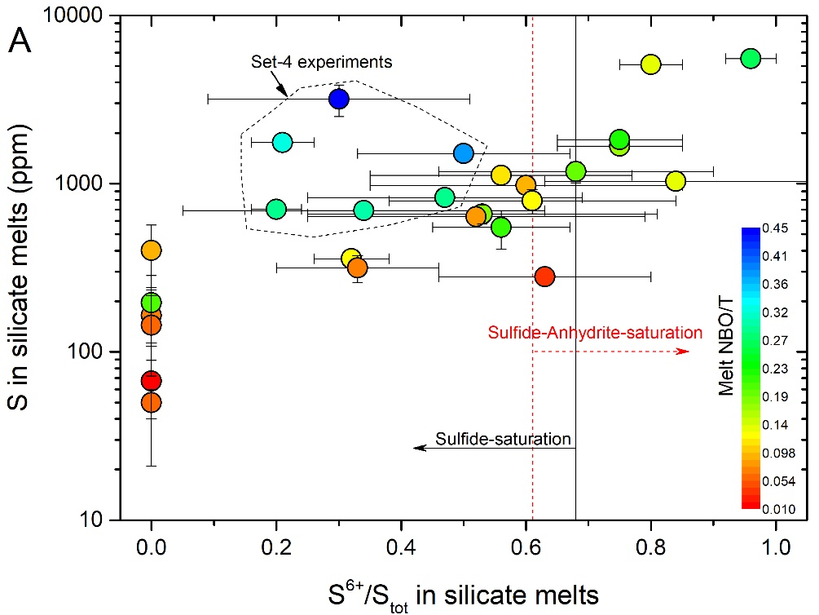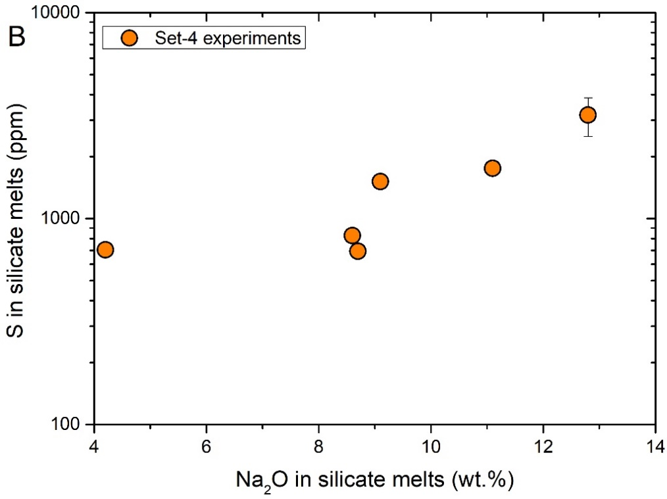

**Fig. S2.** Sulfur content in silicate melts of the only sulfide-saturated and sulfide-anhydrite-saturated experiments. (A) For the silicate melts with similar compositions, the sulfur content, in general, increases with increasing S6+/Stot, except for the Set-4 experiments. (B) The sulfur content in silicate melts of the Set-4 experiments appears to be correlated with the melt Na2O content, consistent with the study of D'Souza and Canil (2018) that shows a strongly positive effect of Na2O on the melt sulfur content at sulfide-saturation.

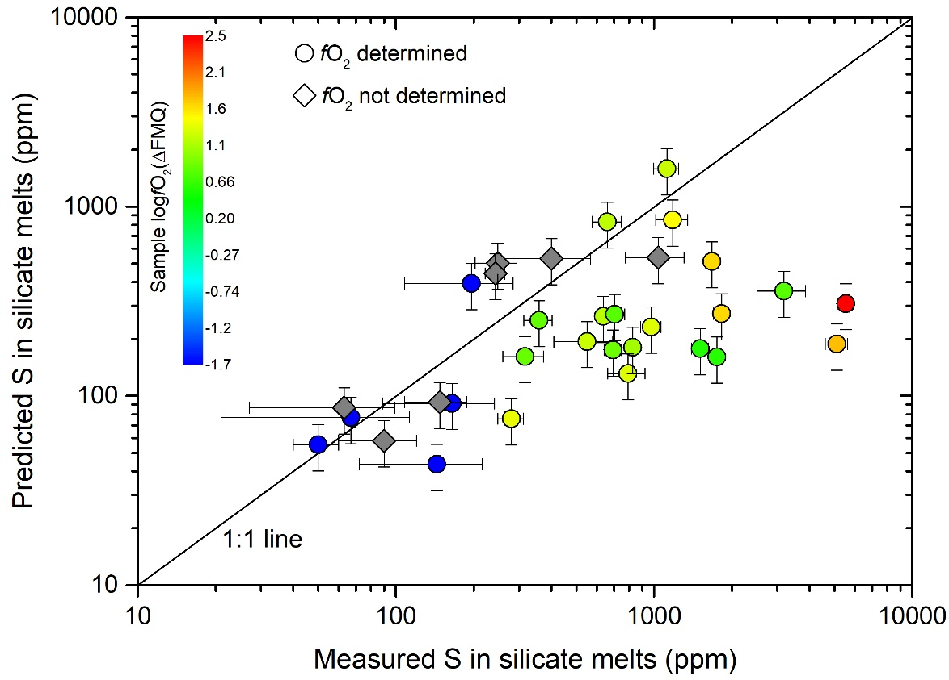

**Fig. S3.** Comparison between our measured sulfur contents in the only sulfide-saturated and sulfide-anhydrite-saturated experiments with those predicted using the SCSS model of Smythe et al. (2017). Note that our measured sulfur contents are higher than those predicted, which indicates the presence of oxidized sulfur species in our silicate melts. This observation is consistent with our measured S6+/Stot in the silicate melts by $∆λ(SK_{α}$) of the electron microprobe.

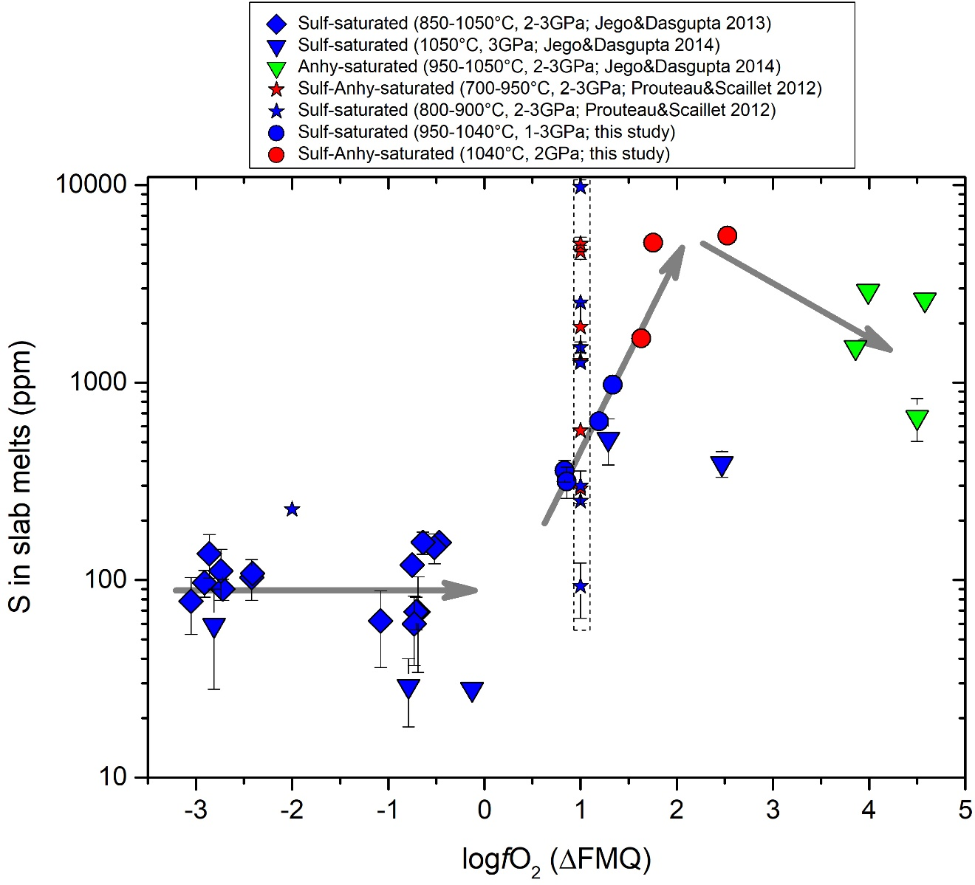

**Fig. S4.** Sulfur content in slab melts at only sulfide-saturation, at sulfide-anhydrite-saturation, and at only anhydrite-saturation. Note that the *f*O2 in the study of Prouteau and Scaillet (2012) is not well constrained. This figure shows that the sulfur content in the sulfide-saturated slab melts is below 200 ppm at *f*O2 below FMQ, but it increases with increasing *f*O2. A maximum sulfur content is obtained when the slab melt is saturated with both sulfide and anhydrite, but when the slab melt is saturated with only anhydrite, the sulfur content drops moderately.

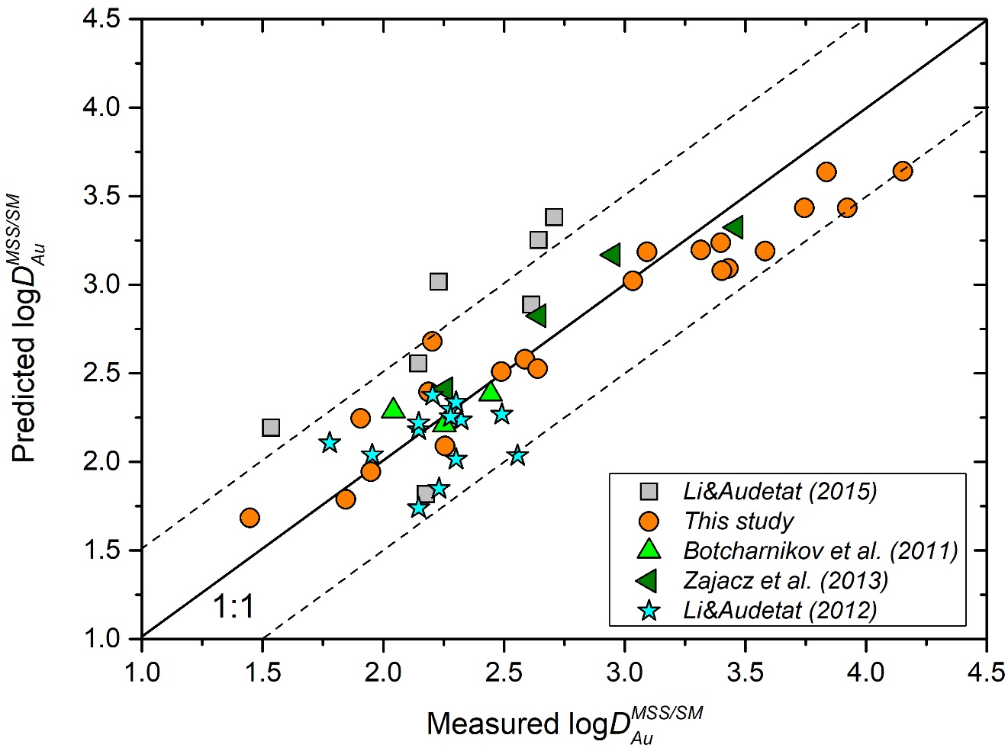

**Fig. S5.** Comparison of the experimentally measured and predicted log $D_{Au}^{MSS/SM}$ using Eq. (16). Note that log $D_{Au}^{MSS/SM}$ can be predicted within 0.5 log units for 90% of the data points, as indicated by the dashed lines.

***8. Supplementary Tables***







***9. References:***

Baker, D.R., Moretti, R., 2011. Modeling the Solubility of Sulfur in Magmas: A 50-Year Old Geochemical Challenge. Reviews in Mineralogy and Geochemistry 73, 167-213.

Botcharnikov, R.E., Linnen, R.L., Wilke, M., Holtz, F., Jugo, P.J., Berndt, J., 2011. High gold concentrations in sulphide-bearing magma under oxidizing conditions. Nature Geoscience 4, 112-115.

Carroll, M., Rutherford, M.J., 1988. Sulfur speciation in hydrous experimental glasses of varying oxidation state--results from measured wavelength shifts of sulfur X-rays. American Mineralogist 73, 845-849.

D'Souza, R., Canil, D., 2018. Effect of alkalinity on sulfur concentration at sulfide saturation in hydrous basaltic andesite to shoshonite melt at 1270 °C and 1 GPa. American Mineralogist 103, 1030-1043.

Fortin, M.-A., Riddle, J., Desjardins-Langlais, Y., Baker, D.R., 2015. The effect of water on the sulfur concentration at sulfide saturation (SCSS) in natural melts. Geochimica et Cosmochimica Acta 160, 100-116.

Froese, E., Gunter, A.E., 1976. A note on the pyrrhotite-sulfur vapor equilibrium. Economic Geology 71, 1589-1594.

Jégo, S., Dasgupta, R., 2013. Fluid-present melting of sulfide-bearing ocean-crust: Experimental constraints on the transport of sulfur from subducting slab to mantle wedge. Geochimica et Cosmochimica Acta 110, 106-134.

Jégo, S., Dasgupta, R., 2014. The Fate of Sulfur During Fluid-Present Melting of Subducting Basaltic Crust at Variable Oxygen Fugacity. J Petrol 55, 1019-1050.

Jégo, S., Pichavant, M., 2012. Gold solubility in arc magmas: Experimental determination of the effect of sulfur at 1000°C and 0.4GPa. Geochimica et Cosmochimica Acta 84, 560-592.

Jégo, S., Pichavant, M., Mavrogenes, J.A., 2010. Controls on gold solubility in arc magmas: An experimental study at 1000° C and 4kbar. Geochimica et Cosmochimica Acta 74, 2165-2189.

Jugo, P.J., Luth, R.W., Richards, J.P., 2005. Experimental data on the speciation of sulfur as a function of oxygen fugacity in basaltic melts. Geochimica et Cosmochimica Acta 69, 497-503.

Jugo, P.J., Wilke, M., Botcharnikov, R.E., 2010. Sulfur K-edge XANES analysis of natural and synthetic basaltic glasses: Implications for S speciation and S content as function of oxygen fugacity. Geochimica et Cosmochimica Acta 74, 5926-5938.

Li, C., Ripley, E.M., 2005. Empirical equations to predict the sulfur content of mafic magmas at sulfide saturation and applications to magmatic sulfide deposits. Miner Deposita 40, 218-230.

Li, Y., Audétat, A., 2012. Partitioning of V, Mn, Co, Ni, Cu, Zn, As, Mo, Ag, Sn, Sb, W, Au, Pb, and Bi between sulfide phases and hydrous basanite melt at upper mantle conditions. Earth and Planetary Science Letters 355, 327-340.

Masotta, M., Keppler, H., 2015. Anhydrite solubility in differentiated arc magmas. Geochimica et Cosmochimica Acta 158, 79-102.

Matjuschkin, V., Blundy, J.D., Brooker, R.A., 2016. The effect of pressure on sulphur speciation in mid- to deep-crustal arc magmas and implications for the formation of porphyry copper deposits. Contributions to Mineralogy and Petrology 171.

Mavrogenes, J.A., O’Neill, H.S.C., 1999. The relative effects of pressure, temperature and oxygen fugacity on the solubility of sulfide in mafic magmas. Geochimica et Cosmochimica Acta 63, 1173-1180.

Mengason, M.J., Piccoli, P.M., Candela, P., 2010. An evaluation of the effect of copper on the estimation of sulfur fugacity (fS2) from pyrrhotite composition. Econ. Geol. 105, 1163-1169.

Metrich, N., Clocchiatti, R., 1996. Sulfur abundance and its speciation in oxidized alkaline melts. Geochimica et Cosmochimica Acta 60, 4151-4160.

Nash, W.M., Smythe, D.J., Wood, B.J., 2019. Compositional and temperature effects on sulfur speciation and solubility in silicate melts. Earth and Planetary Science Letters 507, 187-198.

Parat, F., Holtz, F., Streck, M.J., 2011. Sulfur-bearing Magmatic Accessory Minerals. Reviews in Mineralogy and Geochemistry 73, 285-314.

Prouteau, G., Scaillet, B., 2012. Experimental Constraints on Sulphur Behaviour in Subduction Zones: Implications for TTG and Adakite Production and the Global Sulphur Cycle since the Archean. J Petrol 54, 183-213.

Rowe, M.C., Kent, A.J.R., Nielsen, R.L., 2007. Determination of sulfur speciation and oxidation state of olivine hosted melt inclusions. Chemical Geology 236, 303-322.

Rowe, M.C., Kent, A.J.R., Nielsen, R.L., 2009. Subduction Influence on Oxygen Fugacity and Trace and Volatile Elements in Basalts Across the Cascade Volcanic Arc. J Petrol 50, 61-91.

Smythe, D.J., Wood, B.J., Kiseeva, E.S., 2017. The S content of silicate melts at sulfide saturation: New experiments and a model incorporating the effects of sulfide composition. American Mineralogist 102, 795-803.

Toulmin, P., Barton, P.B., 1964. A thermodynamic study of pyrite and pyrrhotite. Geochimica et Cosmochimica Acta 28, 641-671.

Wallace, P.J., Carmichael, I.S.E., 1994. S speciation in submarine basaltic glasses as determined by measurements of SKa X-ray wavelength shifts. Amer. Mineral. 79, 161-167.

Wilke, M., Klimm, K., Kohn, S.C., 2011. Spectroscopic Studies on Sulfur Speciation in Synthetic and Natural Glasses. Reviews in Mineralogy and Geochemistry 73, 41-78.

Zajacz, Z., Candela, P.A., Piccoli, P.M., Sanchez-Valle, C., Wälle, M., 2013. Solubility and partitioning behavior of Au, Cu, Ag and reduced S in magmas. Geochimica et Cosmochimica Acta 112, 288-304.

Zajacz, Z., Candela, P.A., Piccoli, P.M., Wälle, M., Sanchez-Valle, C., 2012. Gold and copper in volatile saturated mafic to intermediate magmas: Solubilities, partitioning, and implications for ore deposit formation. Geochimica et Cosmochimica Acta 91, 140-159.

1. * Email address: Yuan.Li@gig.ac.cn