Supplementary Information

Functional Genomic Insights into Floricoccus penangensis ML061-4 Isolated from Leaf Surface of Assam Tea

Patthanasak Rungsirivanich, Elvina Parlindungan, Jennifer Mahony, Witsanu Supandee, Narumol Thongwai & Douwe van Sinderen
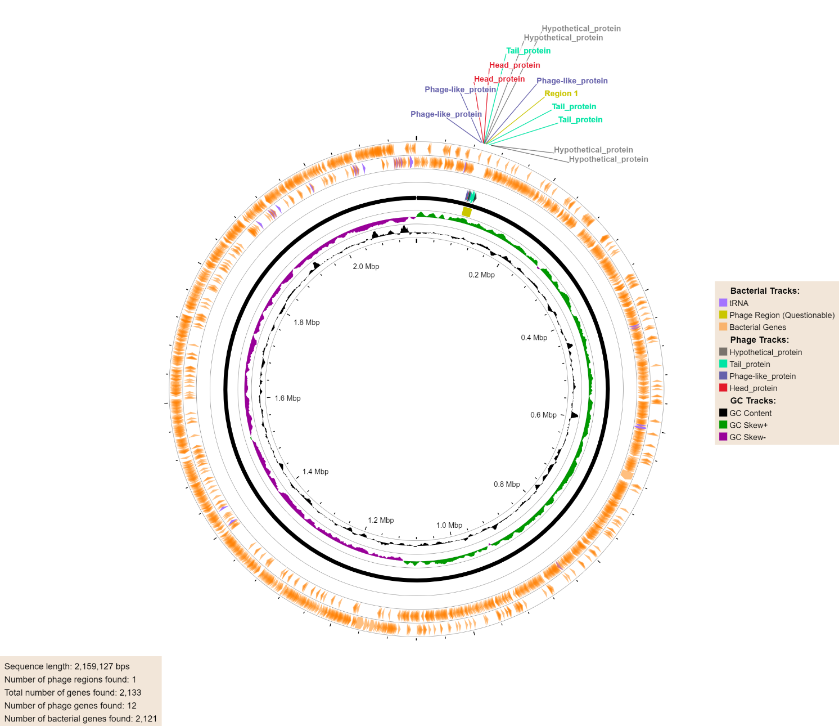
Supplementary Fig. S1. The region of proghage elements in the F. penangensis ML061-4 genome using PHASTEST.
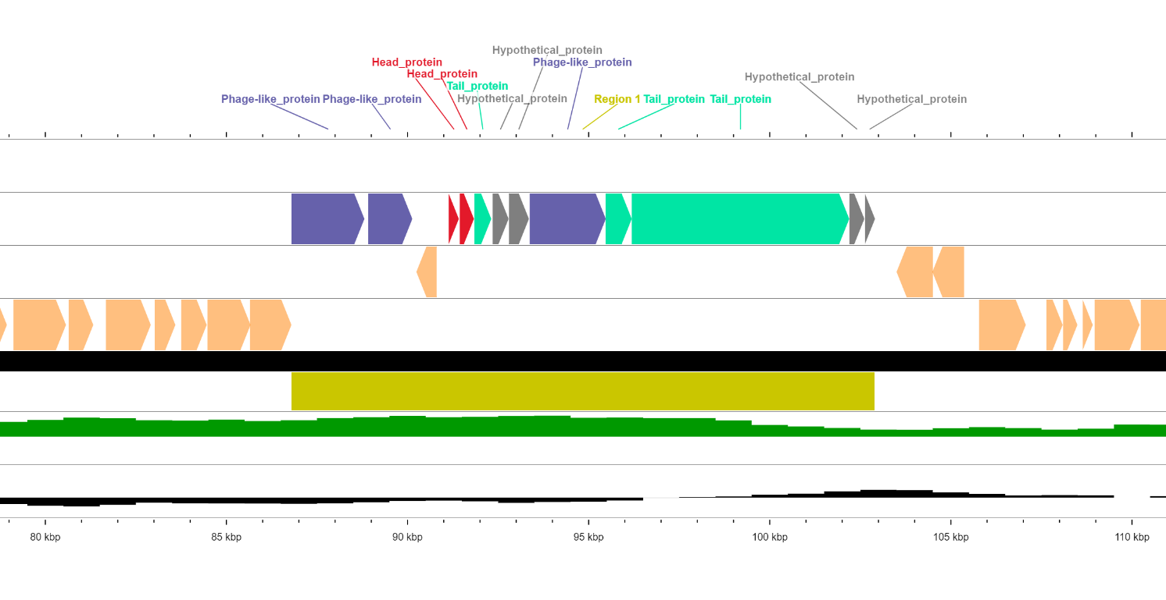
Supplementary Fig. S2. Proghage region in the F. penangensis ML061-4 genome.

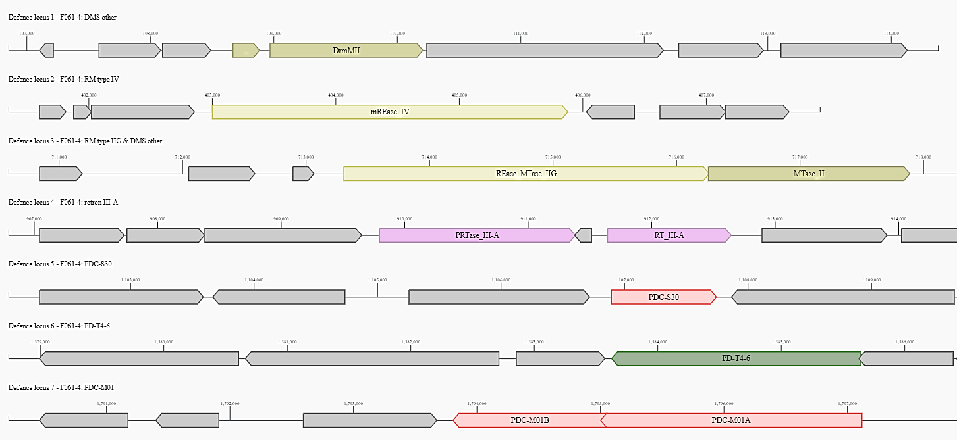
Supplementary Fig. S3. Antiviral defence systems detected in the genome of F. penangensis ML061-4

