Supplementary Material

Interlaboratory Comparison with a Reference Measurement Procedure (RMP) for Determining 24,25-Dihydroxyvitamin D₃ in Human Serum using Liquid Chromatography - Tandem Mass Spectrometry (LC-MS/MS)

Stephen A. Wiseª, Ekaterina Mineva^{b}, Christine M. Pfeiffer^{b}, Hubert Vesper^{b}, Étienne Cavalier^{c}, Stephanie Peeters^{c}, Karen Galvin^{d}, Kevin D. Cashman^{d}, Andrew N. Hoofnagle^{e}, Emma L. Williams^{f}, Laura E. Briggs^{f}, Megan E. Souness^{f}, Adam J. Kuszak^{g}, Grace Hahm^{h}, and Johanna E. Camara^{h}

ª IFC contractor in support of the Office of Dietary Supplements (ODS), National Institutes of Health (NIH), Bethesda, MD 20817, USA
^{b} Centers for Disease Control and Prevention (CDC), Division of Laboratory Sciences, Atlanta, GA 30341, USA
^{c} University of Liège, Department of Clinical Chemistry, CIRM, CHU de Liège, 4000 Liège, BE
^{d} University College Cork, Cork Centre for Vitamin D and Nutrition Research, School of Food and Nutritional Sciences, Cork T12 YT20, IE
^{e} University of Washington, Department of Laboratory Medicine and Pathology, Seattle, WA 98185, USA
^{f} Imperial College Healthcare NHS Trust, London W6 8RF, UK
^{g} National Institutes of Health (NIH), Office of Dietary Supplements (ODS), Bethesda, MD 20817, USA
^{h} National Institute of Standards and Technology (NIST), Chemical Sciences Division, Gaithersburg, MD 20899, USA

Table of Contents

Supplementary Tables
Table S1. Ordinary Deming regression and Bland-Altman mean difference of laboratory results compared to NIST RMP results for 30 DEQAS samples and SRM in 2017 24,25(OH)₂D₃ intercomparison study……………………………………………. 3
Table S2. Publications reporting the use of SRMs to validate 24,25(OH)₂D₃ measurements 4

Using SRMs for validation of 24,25(OH)₂D₃ methods…………………………………………... 5
Supplementary Figures
Figure S1. Bar graph of the concentration of 24,25(OH)₂D₃ in 50 single-donor samples (purple) and four SRMs (textured purple) ordered from lowest to highest concentration………………………………………………………………………6
Figure S2. Percent bias of laboratory results for the concentration of 24,25(OH)₂D₃ for the 50 single-donor samples and four SRMs compared with results from the NIST RMP……………………………………………………………………………….7
Figure S3. Ordinary Deming regression analysis for (A) UCC, (B) ICHT and (C) U of WA versus NIST RMP results for the determination of 24,25(OH)₂D₃ in 30 DEQAS samples from 2017 interlaboratory comparison study……………………………………………………………………………….8
Figure S4. Bland-Altman plots showing the difference in the laboratory mean and the NIST mean for the 30 DEQAS samples for three laboratories in a 2017 intercomparison study for the determination of 24,25(OH)₂D₃ [1]: (A) ICHT (B) UCC, and (C) U of WA.……………………………………………………………………………..9
Figure S5. Comparison of results from four laboratories for determination of 24,25(OH)₂D₃ in SRM 2969 and SRM 2970………………………………………………………..10

References………………………………………………………………………………………..11

Table S1. Ordinary Deming regression and Bland-Altman mean difference of laboratory results compared to NIST RMP results for 30 DEQAS samples and SRM in 2017 24,25(OH)₂D₃ intercomparison study [1]
Laboratory | N | Ordinary Deming Regression |  |  |  |  |  | Bland-Altman^{b}
Laboratory | N | Regression Line |  |  | Prediction Interval (PI) 24,25(OH)₂D₃ (nmol/L)
Laboratory | N | Slope | Int. | R² | Minª | Maxª | Width | Mean Difference | Lower 95 % LoA^{b} | Upper 95 % LoA^{b} | Width
Imperial College Healthcare | 14^{c} | 1.481 | -2.39 | 0.812 | -6.98 | 2.21 | 9.19 | 0.445 | -2.11 | 0.59 | 2.70
University College Cork | 30 | 1.164 | -0.052 | 0.982 | -0.77 | 0.66 | 1.43 | 0.615 | -0.36 | 1.58 | 1.94
University of Washington | 30 | 1.083 | -0.041 | 0.998 | -0.27 | 0.19 | 0.46 | 0.298 | -0.12 | 0.71 | 0.83
ª Min = minimum value at which x = 0 on the y-scale; Max = maximum value at which x = 0 on y-scale; width = distance from Min to Max
^{b} LoA = 95% Limits of Agreement; width = distance from lower to upper LoA on y-axis
^{c} For ICHT, only 14 of the 30 samples were above the LoQ for the method used in this study

Table S2. Publications reporting the use of SRMs to validate 24,25(OH)₂D₃ measurements
Authors | Year | SRM(s) used | n, SRM analysis | SRM in Abstractª | Bias, % | Mean bias, % | Comments
K.G. Dowling et al. [2] | 2017 | 972a L1-L4, 2973 | 3 | no | 8.4 % to 19.2% | 11.9%
S.L. Yu et al. [3] | 2019 | 972a L1-L4 | 2 | yes | -7.7% to -3.9% | -5.6%
B.C. DeFelice et al. [4] | 2020 | 972a | 10 | yes | - | 14.9% | 10 metabolites measured
D.H. Ko et al. [5] | 2021 | 972a, 2973 | 24 | no | - | - | 15% acceptance criterion
Jenkinson et al. [6] | 2021 | 972a L1-L4 | 14 | no | -1.9% to 6.3% | 2.6%
Jenkinson et al. [7] | 2022 | 972a | 23 | yes | - | <0.06% | 13 metabolites measured
K. Kandler et al. [8] | 2025 | 972a L1, L2, 2973 | 6 | no | - | -2.4% (L1) ,-3.7% (L2)
CDC | 2026 | 972a L1-L4 | 3 | n.a. | -3.1% to -1.9% | -2.5% | See this paper for details
ª SRM is mentioned in the abstract of the paper
n.a. = not applicable
Note: A dash in a cell indicates no data was available

Using SRMs for validation of 24,25(OH)₂D₃ methods
Papers describing the use of SRMs for the determination of 24,25(OH)₂D3 are summarized in Table S2. Dowling et al. [2] reported using SRM 972a to validate 24,25(OH)₂D₃ measurements using their ID LC-MS/MS method with a mean bias of 12% for five SRM levels ranging from 9.4% to 19.2% [1]. Yu et al. [3] developed an ID LC-MS/MS method for multiple vitamin D metabolites including 24,25(OH)₂D₂, 24,25(OH)₂D₃, 25(OH)D₂, and 25(OH)D₃ using SRM 972a for validation. They reported bias of -6.4%, -3.9%, -7.7%, and -4.6% for 24,25(OH)₂D₃ in SRM 972a levels 1 through 4, respectively (mean bias of -5.6%) [3]. Using a multi-metabolite method, DeFelice et al. [4] reported bias of 14.9% for 24,25(OH)₂D₃ measurements for SRM 972a. Ko et al. [5] used multiple SRMs for vitamin D metabolites (SRM 972a, SRM 2973, SRM 1949 and SRM 1950) to validate a multiplex LC-MS/MS method for simultaneous determination of 25(OH)D, 24,25(OH)₂D₃, albumin, and vitamin D binding protein (VDBP) isoforms with an accuracy acceptance criterion of ±15%. Jenkinson et al. [6] developed an LC-MS/MS method for simultaneously measurement of 13 vitamin D₂ and D₃ monohydroxy and dihydroxy metabolites and assessed the accuracy by analyzing SRM 972a. The authors found good agreement of their measurements for the four levels of SRM 972a (n = 23) with the NIST certified values with a mean difference of 0.06% [6]. Later, Jenkinson et al. [7] investigated the hydrolysis step in a method for determining circulating conjugated and unconjugated vitamin D metabolites using all four levels of SRM 972a and demonstrated a mean bias of 0.06% for 23 measurements of the four SRM levels.

Figure S1. Bar graph of the concentration of 24,25(OH)₂D₃ in 50 single-donor samples (purple) and four SRMs (textured purple) ordered from lowest to highest concentration. Error bars on each sample concentration are ±SD of duplicate measurements for each of the 50 single-donor samples and for the SRM samples by the NIST RMP (n = 6 for SRM 2969 and SRM 2970 and n = 12 for SRM 972a L2 and SRM 2973).

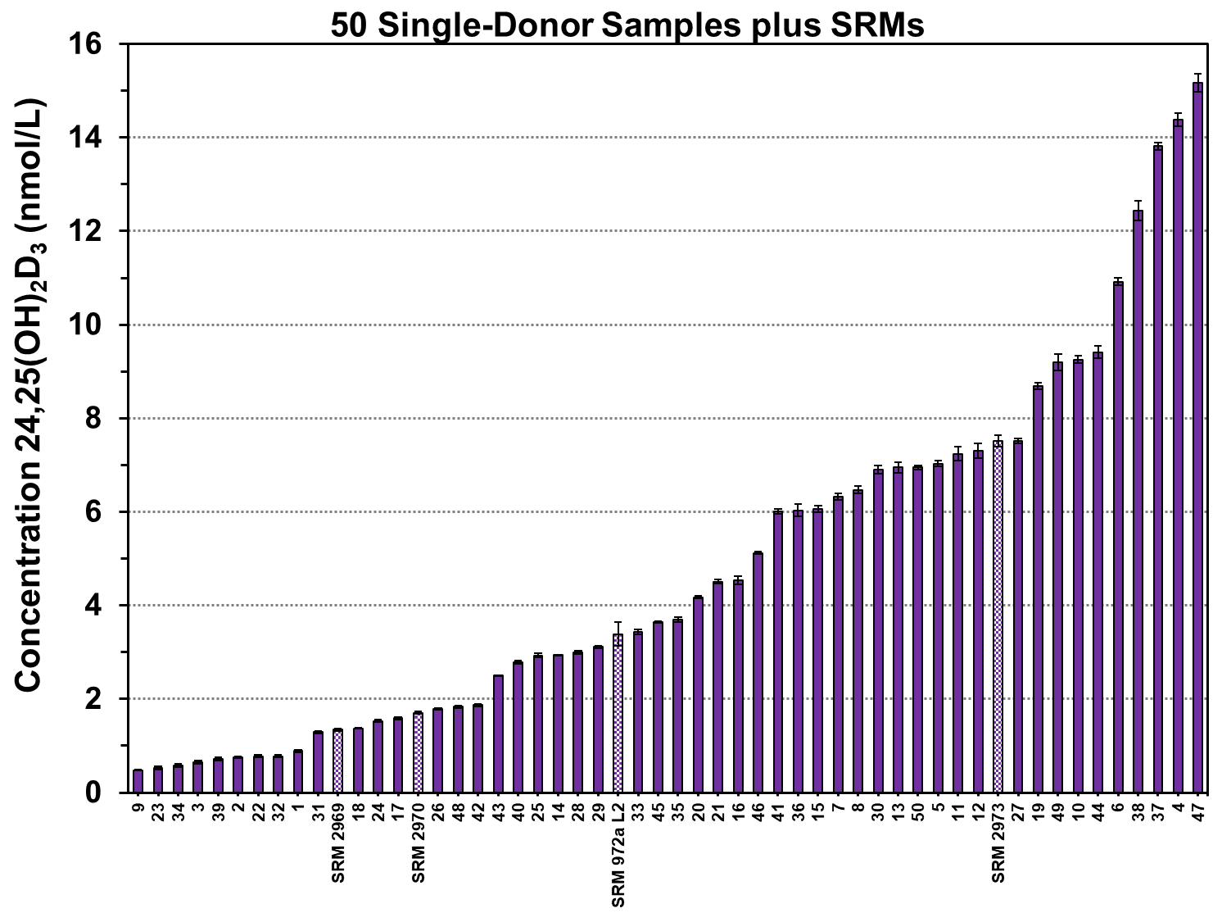
Figure S2. Percent bias of laboratory results for the concentration of 24,25(OH)₂D₃ for the 50 single-donor samples and four SRMs compared with results from the NIST RMP. Laboratories: (1) CDC – black solid line with black circles, (2) University of Washington – red dotted line with red triangles, (3) University of Liège – green solid line with green diamonds, (4) University of Cork – blue dashed line with blue squares, and (5) Imperial College Healthcare NHS Trust – purple solid line with purple circles.

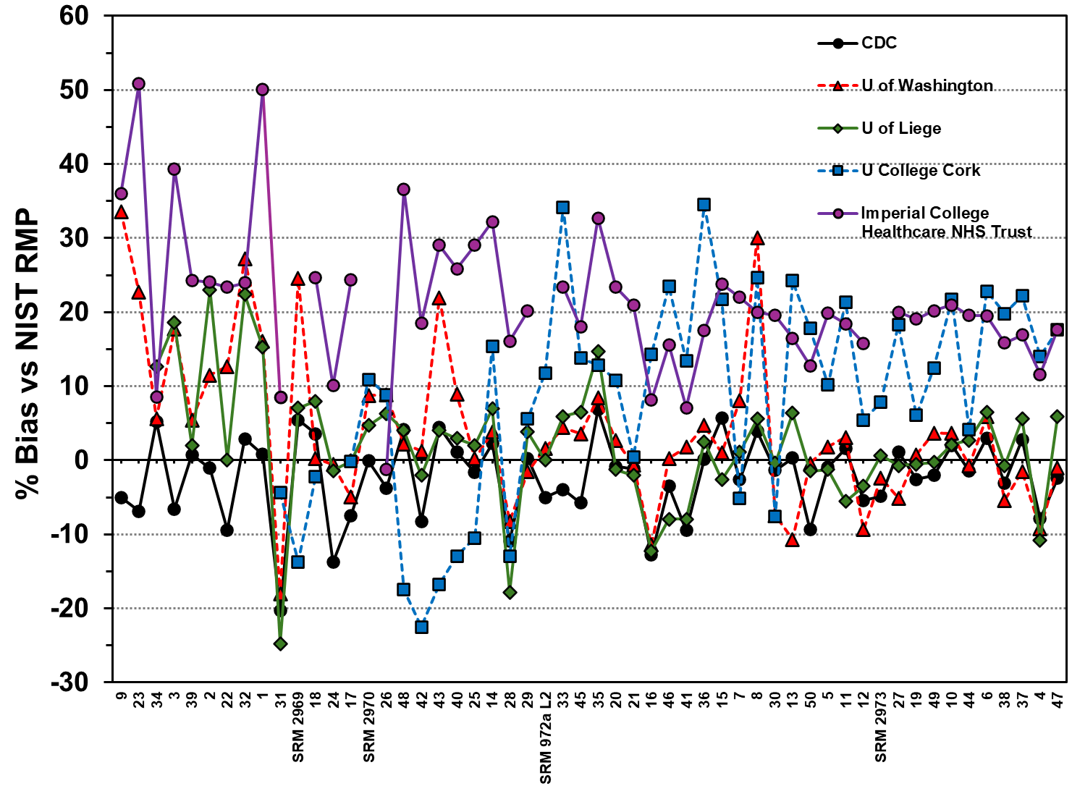

Figure S3. Ordinary Deming regression analysis for (A) UCC, (B) ICHT and (C) U of WA versus NIST RMP results for the determination of 24,25(OH)₂D₃ in 30 DEQAS samples from 2017 interlaboratory comparison study. Red circles are the DEQAS samples (mean of duplicates). Black solid line is the Ordinary Deming regression line; blue dotted line is the identity line (x = y), and red dashed lines are the 95% prediction interval.
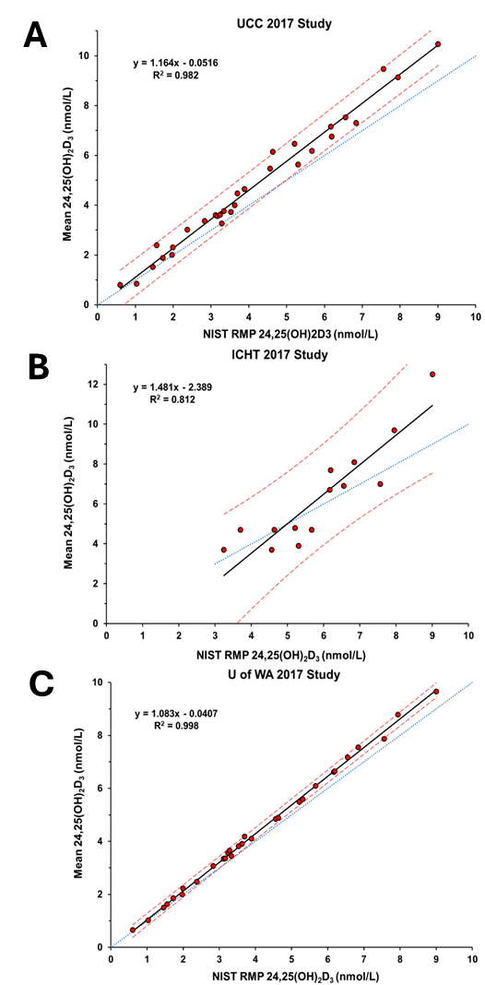
Figure S4. Bland-Altman plots showing the difference in the laboratory mean and the NIST mean for the 30 DEQAS samples for three laboratories in a 2017 intercomparison study for the determination of 24,25(OH)₂D₃ [1]: (A) ICHT (B) UCC, and (C) U of WA. Red circles are the DEQAS samples. Black solid line is the mean bias; dashed blue line is the 95 % Limits of Agreement.
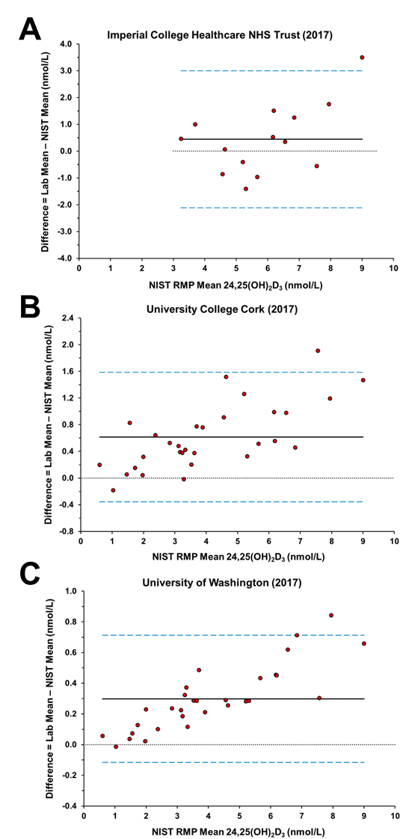

Figure S5. Comparison of results from four laboratories for determination of 24,25(OH)₂D₃ in SRM 2969 and SRM 2970. Yellow squares are the results for SRM 2969 and red circles are results for SRM 2970. Error bars on the laboratory results, laboratory means, and NIST RMP results are ±SD. Lab mean (n = 5) (black square for SRM 2969 and black circle for SRM 2970) are the results for four laboratories and the NIST RMP. NIST RMP values for SRM 2969 and SRM 2970 are based on six samples.

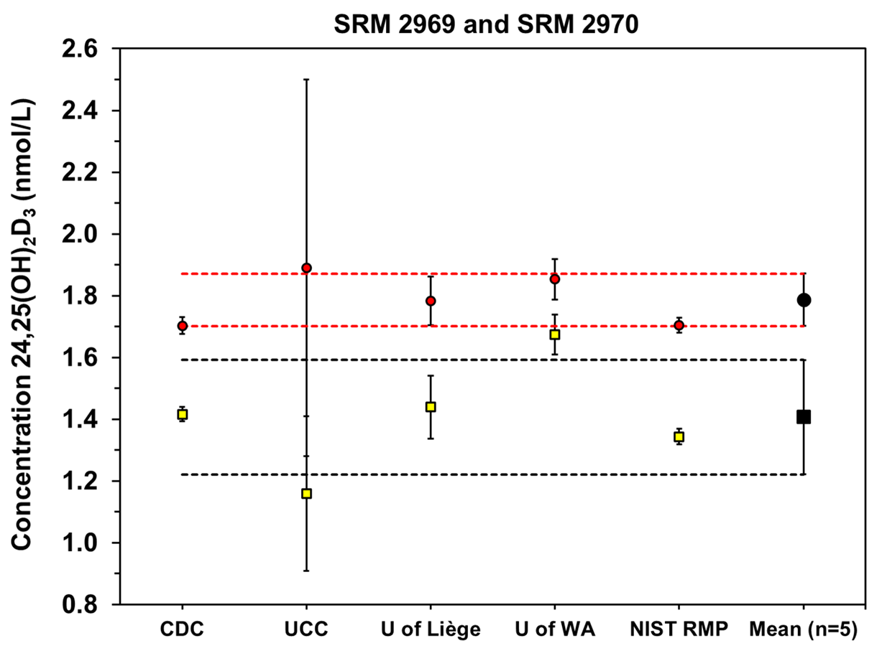

References

1. Wise SA, Tai SSC, Nelson MA, Burdette CQ, Camara JE, Hoofnagle AN, Laha TJ, Carter GD, Jones J, Williams EL, Barclay ZJ, Jones G, Kaufmann M, Binkley N, Kapoor A, Ziegler T, Cashman KD, Dowling KG, Sempos CT (2017) Interlaboratory comparison for the determination of 24,25-dihydroxyvitamin D-3 in human serum using liquid chromatography with tandem mass spectrometry. J AOAC Int 100 (5):1308–1317. doi:https://doi.org/10.5740/jaoacint.17-0183
2. Dowling KG, Hull G, Sundvall J, Lamberg-Allardt C, Cashman KD (2017) Improved accuracy of an tandem liquid chromatography-mass spectrometry method measuring 24R,25-dihydroxyvitamin D-3 and 25-hydroxyvitamin D metabolites in serum using unspiked controls and its application to determining cross-reactivity of a chemiluminescent microparticle immunoassay. J Chromatogr A 1497:102–109. doi:https://doi.org/10.1016/j.chroma.2017.03.058
3. Yu SL, Zhou WY, Wang DC, Yin YC, Cheng Q, Xie SW, Sun DD, Li HL, Cheng XQ, Qiu L (2019) Rapid liquid chromatography-tandem mass spectrometry method for determination of 24,25(OH)2D and 25OHD with efficient separation of 3-epi analogs. J Steroid Biochem Mol Biol 187:146–151. doi:https://doi.org/10.1016/j.jsbmb.2018.11.012
4. DeFelice BC, Pedersen TL, Shorrosh H, Johnson RK, Seifert JA, Norris JM, Fiehn O (2020) Utilizing cooled liquid chromatography and chemical derivatization to separate and quantify C3-epimers of 25-hydroxy vitamin D and low abundant 1 alpha,25(OH)(2)D3: Application in a pediatric population. J Steroid Biochem Mol Biol 197. doi:https://doi.org/10.1016/j.jsbmb.2019.105519
5. Ko DH, Jun SH, Nam Y, Song SH, Han M, Yun YM, Lee K, Song J (2021) Multiplex LC-MS/MS for simultaneous determination of 25-hydroxyvitamin D, 24,25-dihydroxyvitamin D3, albumin, and vitamin D-binding protein with its isoforms: One-step estimation of bioavailable vitamin D and vitamin D metabolite ratio. J Steroid Biochem Mol Biol 206. doi:https://doi.org/10.1016/j.jsbmb.2020.105796
6. Jenkinson C, Desai R, Slominski AT, Tuckey RC, Hewison M, Handelsman DJ (2021) Simultaneous measurement of 13 circulating vitamin D3 and D2 mono and dihydroxy metabolites using liquid chromatography mass spectrometry. Clin Chem Lab Med 59 (10):1642–1652. doi:https://doi.org/10.1515/cclm-2021-0441
7. Jenkinson C, Desai R, McLeod MD, Mueller JW, Hewison M, Handelsman DJ (2022) Circulating conjugated and unconjugated Vitamin D metabolite measurements by liquid chromatography mass spectrometry. J Clin Endocrinol Metab 107 (2):435–449. doi:https://doi.org/10.1210/clinem/dgab708
8. Kandler K, Stadlmeier M, Singh N, Bauland F, Geistanger A, Geletneky C, Taibon J (2025) Isotope dilution-liquid chromatography-tandem mass spectrometry-based candidate reference measurement procedures for the quantification of 24(R),25-dihydroxyvitamin D2 and 24(R),25-dihydroxyvitamin D3 in human serum and plasma. Clin Chem Lab Med. doi:https://doi.org/10.1515/cclm-2024-1139

