Appendix

The details for the calculations of the metrics and more detail from the sensitivity tests and results etc. are presented.

UN SDGs
It is not straightforward to apply the SDGs to individual situations because they were originally aimed at global / national sustainability goals rather than the goals of an individual project (Zeug, Bezama and Thrän, 2020). It is however possible to extract indicators from them which are useful for the purposes of this investigation. The following metrics in Table 5 are derived from the UN SDGs and their indicators (IAEG-SDGs, 2016), they find support from the literature (Van Schoubroeck et al., 2019).
Table 5 Rationale of selecting the SDGs and Metrics used in this research study.
SDG | Metric (s) | Rationale
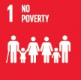 | Salary  Hours of Work | Can be addressed by generating an income from the end-of-life alternatives.
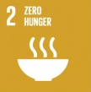 | Salary  Hours of work | May be addressed via the economic benefits of the alternatives.
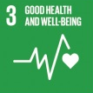 | Salary | Is also linked to having an adequate income, in line with this, Salary has been suggested as a metric above in SDGs 1 and 2.
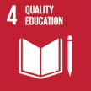 | Education Level | Seeks to “promote lifelong learning opportunities for all”. This is not merely learning the techniques for working with GFRP but may include training for new entrepreneurs and business managers.  4.6.1 and 4.3.1 (IAEG-SDGs, 2016)
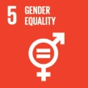 | - | Would not seem to be a direct consequence of the alternatives; any prediction of a measure of gender equality between the five alternatives would be subject to a wide margin of error. It is therefore unlikely that a metric for gender equality would be useful discriminating among the alternatives.  5.5.2 (IAEG-SDGs, 2016)
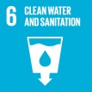 | Human Health, Ecosystem Quality | May be affected by a risk that fibres and dust would be released when the blades are cut as would be required for all of the alternatives. In addition, there may well be problems with the resin which forms the composite, being leached.  6.3.1 (IAEG-SDGs, 2016)
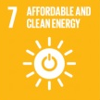 | GHG  Resources | This was one of the motivations for building windfarms. The responsible decommissioning of blades can produce some energy by incineration with heat recovery and avoidance of the extraction of new materials.
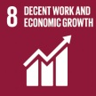 | Salary  Hours of Work  Accident Rate  Commercial Potential | These are essential economic drivers of many of the SDGs. The International Labour Organization (ILO), an agency of the UN, characterises decent work as providing a fair income and prospects for personal development (Burchell et al., 2014), (ILO, 2020). This extends to opportunities offered to workers for their education, promotion and self-employment (Burchell et al., 2014). On the negative side, the Accident Rate of a workplace would suggest using occupational deaths and accidents, as a way to measure decency of work. Examining the economic growth aspect of SDG 8, we may consider the benefits for the local economy (Salary and Hours of Work) and the future Commercial Potential of a business as metrics.  8.5.1, 8.5.2, 8.6.1 and 8.8.1(IAEG-SDGs, 2016)
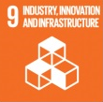 | Commercial Potential  R&D Value | These are essential to economic development. The first issue to consider is what size and depth of market there might be for such goods. This will be measured in terms of the future Commercial Potential from the alternatives. The amount spent on R&D is an indicator of innovation in industry.  9.5.1(IAEG-SDGs, 2016)
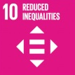 | Salary | Wind blades are located almost exclusively in rural areas, and it is typical that rural areas have less opportunity for employment, more difficult access to education and lower prosperity than urban areas. The provision of new jobs in rural areas would help to reduce the gap between urban and rural employment opportunities.  10.1.1 and 10.2.1 (IAEG-SDGs, 2016)
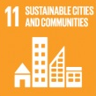 | Community Support | Community involvement in and support for the choice of alternatives is suggested by this SDG.  11.3.2 (IAEG-SDGs, 2016)
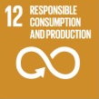 | Ecosystem Quality  Human Health  Resources | This has the aim of developing sustainable practices in businesses, and encouraging sustainable consumption. The LCA damage indicator Ecosystem Quality includes aquatic eco-toxicity, acidification, and eutrophication, as well as terrestrial eco-toxicity and acidification, which is caused by mismanagement of chemical waste. A second LCA damage category Human Health includes human toxicity and respiratory effects. A reduction in newly mined or extracted material as one way to measure how a production system has become more sustainable. LCA damage indicator Resources does this.  SDG Targets 12.4 and 12.5(IAEG-SDGs, 2016)
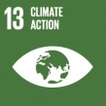 | GHG | This is most clearly measured by the emission of greenhouse gasses.  13.2.1 (IAEG-SDGs, 2016)
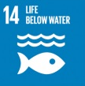 | Ecosystem Quality | This aims to reduce, among other things, marine pollution and ocean acidification. This would be particularly relevant for alternatives which involve cutting the blades on site rather than in a controlled environment since surface run off would carry any pollution into a water course. LCA damage indicator Ecosystem Quality includes aquatic eco-toxicity, acidification, and eutrophication, as well as water withdrawal and water consumption.
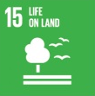 | Human Health  Ecosystem Quality | As with the previous SDG, avoidance of pollution is relevant for all the end-of-life alternatives. Life on Land will be affected by pollution measured in the same ways.
 | - | Peace and Justice are essential to support success of the various alternatives for the end-of-life for wind blades. It is however unclear how considerations of peace, justice or strong institutions would be useful to discriminate between the alternatives.
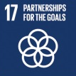 | Community Support | Partnerships for the SDGs might include the possible cooperation between a local community and a wind blade recycling processor. This Community Support for a sustainable path for end-of-life wind blades may be chosen as a metrics.

Questionnaires for Main Delphi Study
Participants were asked to compare the criteria in questions 1 to 4 by allocating scores of 1 to 9 for pairwise comparisons (Table 10). Q1 compared the economy, society and environment in three pairs, Q2 compared salary, commercial potential and R&D value in six pairs, Q3 compared hours of work, education level, community support and accident rate in six pairs and Q4 compared ecosystem quality, human health, resources and GHG.
Participants were given the following description of the scoring system (Satty, 2008).
Table 6 Description of AHP Scoring from 1 to 9.
Intensity of importance | Definition | Explanation
1 | Equal importance | Two activities contribute equally to the objective
2 | Weak or slight
3 | Moderate importance | Opinion slightly favours one activity over another
4 | Moderate plus
5 | Strong importance | Opinion strongly favour one activity over another
6 | Strong plus
7 | Very strong demonstrated importance | An activity is favoured very strongly over another
8 | Very, very strong
9 | Extreme importance | The highest possible order of affirmation

Assumptions for Estimating the R&D value
The R&D valuation method is based on Deeney et al., (2021) in which an R&D project aims to reduce the cost and improve the income from each alternative, this will be implemented at a specific cost and will last for a number of years. The scenario is that there is a two-year period for initial research during which the results of the R&D are not implemented. This R&D plan is typical of university-based research which has a fixed period in which to report its findings, but which does not aim at a commercial launch of a new product. The initial stage is followed by a period of up to three years where the research continues and may be implemented as soon as it is considered commercially opportune. It is reasonable to assume that there will be a supply of waste GFRP for the next 25 years due to blade decommissioning of existing blades. This allows for this 5-year R&D phase followed by a 20-year operational life. Indications of the income and expenditure are given in Table 7.
Table 7 Assumptions for Real Option Valuation of the five alternative end-of-life wind turbine.
 | Income | Expenditure | Technology Readiness
Landfill | Gate fees  Possible R&D cost reduction 20% | Labour costs and regulatory compliance | Well established
Incineration with Heat Recovery | Value of the primary energy which is displaced by the heat recovery. There may be an improvement to this of the order of 20% due to R&D. | Labour, processing costs and EU Emission Allowances | Well established
Co-Processing | Cement sale price, possible cost reduction 30% | Labour, processing costs and EU Emission Allowances | Quite advanced
Furniture Making | Furniture sales. As systems automate, and the niche market is abandoned for the mass market, there may be a cost reduction 50% | Labour and processing costs | Existing Tech
Bridge Fabrication | Bridge sales. This is a new product, R&D needed now to greatly improve output. Currently unprofitable.  Possible cost reduction 75% | Labour and processing costs | New

Landfill is an established technology, and it is considered that there is relatively little scope for a large cost reduction, perhaps of the order of 20%, because of the relatively straightforward way in which the business is conducted. R&D might reduce the labour required or make monitoring easier. This may produce some cost savings. The income to landfill businesses will probably be fixed with little change in the next years until the use of landfill for GFRP is phased out.
Incineration with heat recovery is already in use and may benefit from some R&D to improve the process, either by improving the efficiency of heat extraction or power generation, or by decreasing the compliance and monitoring costs. This may amount to a possible reduction of 20% in production costs. Similar to landfill this business does not depend on blade decommissioning to any great extent. Incineration is liable for the EU Emissions Trading Scheme (EUETS) and so this business is liable to either the cost of emission allowances (EUAs) or the cost of carbon capture, whichever is the lesser. Income would be the value of coal at a substitution of 60%, so that 1 tonne of GFRP would be worth 600kg of coal which costs approx. €225 (Nagle et al., 2020). Coal is chosen as it is the cheapest fuel source per heat generated and therefore will produce the most conservative estimate for the calculations.
Co-Processing involves shredding the blade waste to pieces less than 4cm, then burning this waste with solid recovered fuel in a cement kiln to make cement (Nagle et al., 2020). There is space for improvement in the manner in which blade waste is mixed with other materials to make cement. Co-Processing as a method to recycle composite waste is a relatively new technology which is currently the subject of a great deal of research and as such will benefit from R&D (Schmidl and Hinrichs, 2010; Oliveux, Dandy and Leeke, 2015; Hall, 2016; Job et al., 2016). This may produce a 30% reduction in production costs as the process is quite complex and relatively new. A commercial price for a tonne of cement is €192.69. Given the ready market for cement, it is reasonable to assume this alternative could potentially use all the blade waste available to it.
Furniture made from blade waste is a niche market product at present which is highly labour-intensive, there are a great many possible savings from R&D for automation and new fixings, designing and cutting technologies. It may be realistic to propose a 50% reduction in production costs due to R&D. Given the size of the furniture market it is possible for this technology to absorb all of the blade waste available in Ireland. Estimates for the income generated by a tonne of GFRP are based on the cost per tonne of furniture from IKEA. An online search for “Table” was conducted on 10th July 2020 and the top 30 items were used to produce an average price. Tables were chosen as they are a relatively simple product which would reflect the possible uses of large pieces of GFRP.
Bridge fabrication will require considerable R&D as it is a new process and has yet to pass certification from civil engineers or gain public trust. Present costs for fabricating a modest 8.5m span bridge incorporating blades might be estimated to be of the order of €20,000. This cost could be reduced by 75% with sufficient R&D and commercial scale production. There is a possibility that the market for bridges may increase as more infrastructure for walking and cycling is being considered.

Hours of Work and Salary
The data for the calculation for the hours of work per tonne of GFRP are given in Table 8

Table 8 Hours of Work and Salary Calculations
 | Load Size in tonnes | Prep. h | Distance km | Lorry Speed km/h | Work time | Hours Transport per tonne | Labour Hours per tonne | Total Salaries per tonne | Total Hours of work per tonne
Landfill | 6 | 2 | 296 | 60 | 1 | 0.82 | 0.50 | 31.83 | 1.32
Incineration with Heat Recovery | 6 | 2 | 457 | 60 | 1.5 | 1.27 | 0.58 | 44.40 | 1.85
Co-Processing | 6 | 2 | 729 | 60 | 7.8 | 2.03 | 1.63 | 88.62 | 3.66
Furniture making | 4 | 2 | 59 | 60 | 74 | 0.25 | 19.00 | 486.24 | 19.25
Bridge fabrication | 4 | 3 | 59 | 30 | 74 | 0.49 | 19.25 | 498.29 | 19.74

Prep.: Time in hours includes onsite cutting or chopping as well as loading and unloading. Bridge fabrication takes longer as the pieces of blade used are much longer and slower to move by road.
Distance: Distance is in km, by lorry includes travel to location of work and travel to and from a local town where a lorry may be expected to be based. For Furniture making and Bridge fabrication it is assumed that the same local town is where the work is done and where the lorry is kept. Distances are estimated from GIS.
Work: Work time in hours includes the time spent on the substantial work as well as administration for the facility where the work is carried out.
Salaries: Salary in Euro per tonne use the information from the CSO (CSO, 2020a).

Education Level
Based on the Irish Census of 2016 with the scoring of 1 for primary, 2 lower secondary, 3 upper secondary, 4 Technical / Vocational qualification, 5 Advanced Certificate, 6 Higher Certificate, 7 Ordinary Bachelor Degree, 8 Honours Degree, 9 Post graduate degree, 10 Doctoral degree, the calculations for mean Educational Levels weighted by population within each employment category are presented in Table 9 and Table 10 (CSO, 2020b).
Table 9 Education Levels
Education Level. | 0 |  | 1 | 2 | 3 | 4 | 5 |  | 6 | 7 |  | 8 | 9 | 10 |  | Total | No. People. | Mean Educ
Transport and mobile machine drivers and operatives | 768 |  | 7,146 | 21,371 | 16,718 | 6,466 | 4,221 |  | 1,973 | 1,674 |  | 996 | 557 | 20 |  | 183,748 | 61,910 | 3.0
Process, plant and machine operatives | 516 |  | 3,929 | 14,114 | 21,238 | 8,560 | 5,524 |  | 3,312 | 3,702 |  | 3,520 | 2,245 | 210 |  | 253,982 | 66,870 | 3.8
Skilled metal, electrical and electronic trades | 207 |  | 1,951 | 10,797 | 12,169 | 9,270 | 24,871 |  | 4,293 | 4,116 |  | 3,444 | 1,867 | 115 |  | 321,562 | 73,100 | 4.4
Textiles, printing and other skilled trades | 329 |  | 2,483 | 8,170 | 11,624 | 6,816 | 8,032 |  | 3,590 | 3,487 |  | 2,154 | 977 | 28 |  | 193,373 | 47,690 | 4.1
Skilled construction and building trades | 400 |  | 3,332 | 15,458 | 12,198 | 6,672 | 14,080 |  | 1,977 | 1,569 |  | 1,072 | 396 | 14 |  | 203,055 | 57,168 | 3.6

Table 10 Worker Compatible Education Level
 | Education Level | Comparable Position
Landfill | 3.0 | Transport and mobile machine drivers and operatives
Incineration with Heat Recovery | 3.8 | Process, plant and machine operatives
Co-Processing | 4.4 | Skilled metal, electrical and electronic trades
Furniture making | 4.1 | Textiles, printing and other skilled trades
Bridge fabrication | 3.6 | Skilled construction and building trades

Ternary Plots for the Economic Dimension
It is possible to use a ternary plot within the Economic Dimension as it has three metrics. It is seen from the normalized metrics in Table 11 that the sequence of rankings has the possibility of placing bridge fabrication in first place ahead of furniture making in the AHP Economic Sustainability Index, if the weight given to Salary is large enough, and also that incineration may be placed ahead of co-processing if the weight given to R&D Value is large enough. These are illustrated in Figure 6 and Figure 7.
The situation becomes more complex for the Social and Environmental weights as both of these dimensions have four metrics, and so the illustration of a triangle needs to be replaced with a tetrahedron (for which Viviani’s Theorem still applies). This is not illustrated here.
Table 11 Economic Metrics Normalized Values
 | Salary | Commercial Potential | R&D  Value
Weights of the Metrics | 25% | 48% | 27%
Normalised
Values of the Metrics
Landfill | 0.00 | 0.00 | 0.00
Incineration | 0.03 | 0.39 | 0.04
Co-Processing | 0.12 | 0.64 | 0.03
Furniture Making | 0.97 | 1.00 | 1.00
Bridge Fabrication | 1.00 | 0.56 | 0.30

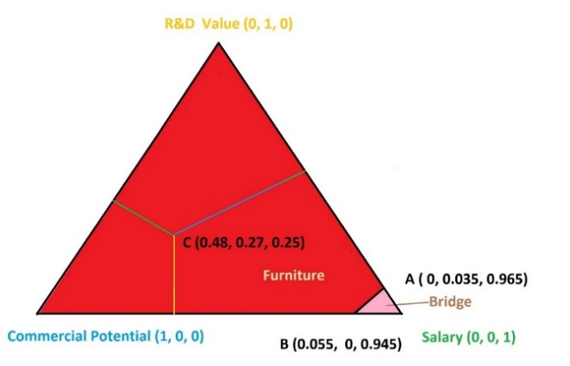
Figure 6 Ternary Plot of Economic Weights for Furniture Making and Bridge Fabrication showing areas where furniture making or bridge building are in first position using the Economic AHP score ranking.

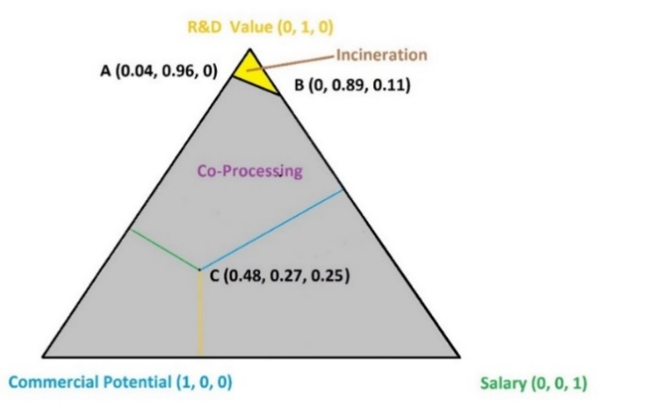
Figure 7 Ternary Plot of Economic Weights for Co-Processing and Incineration showing areas where co-processing or incineration with heat recovery are in third position using the Economic AHP score ranking.

Technical Details on the Ternary Plots of the Three Dimensions
Viviani’s Theorem (Ken-Ichiroh Kawasaki, 2005) states that the sum of the perpendicular distances of a point inside an equilateral triangle is equal to the height of the triangle, which in this case is 1. Hence, any combination of the weights for Economy, Society and Environment, can be described as a point in or on the triangle. Given that height of the triangle is 1, and hence the side of the triangle is $2/\sqrt{3}$ , it can be calculated that on a standard Cartesian plane with origin at the Economy vertex and x axis in the direction towards the Environment vertex, that the Cartesian coordinates of C, the weight triplet chosen by the Delphi Study are (0.74, 0.28). The point D is taken from Table 4 and is the weight triplet (31%, 22%, 47%) which is a 10% or 0.10 increase in the Economic weight, this corresponds to the position (0.67, 0.22) in Cartesian coordinates and is in the red zone where furniture is in first place. E is also from Table 4 and represents a 15% decrease in Environmental weight giving the weight triplet (28.5%, 34.5%, 37%) with Cartesian coordinates (0.63, 0.35), it is also in the red zone. The line AB in Figure 4, has gradient -10.5 and an intercept on the y-axis of 7.5 (recall the origin is at the Economy vertex and the x-axis is to the right). The shortest distance from C to the boundary is 0.047, meaning that a reasonably small change in the weights will change the selection of first and second places, the direction of this change is mostly towards Economy but also towards Society (which explains why the 5% increase in the Economy weight in Table 4 did not result in a changed outcome).
This method of visualising the weights for Economy, Society and Environment is used in Section 3.4 to illustrate the sensitivity of the results for the end-of-life choices for wind blades, to the values of the weights. This will also be applied to the three economic weights given to Salary, Commercial Potential and R&D Value below. Application to four weights for the Social and Environmental dimensions, will require illustrations using tetrahedrons; these are not presented here.

First Round Delphi Results
The dimension weights from the first Delphi were (0.21, 0.27, 0.52) as illustrated in Figure 5. In the second round the point C moved a distance of 0.018 from its earlier position, indicating that the change between the rounds is very small.
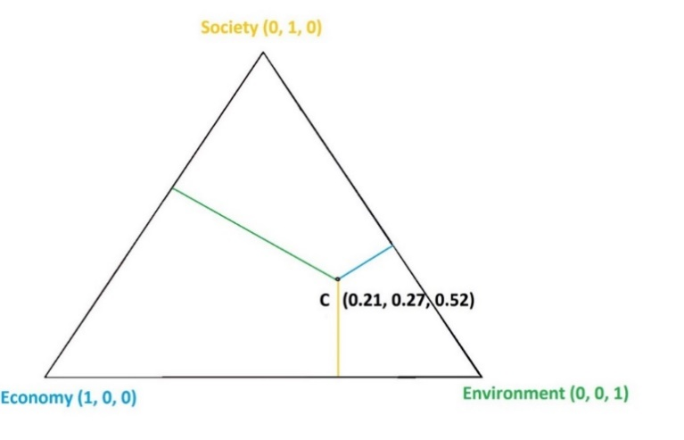
Figure 5 First Delphi Results.

Community Support
In order to assess the level of community support for the five alternatives a Delphi study was conducted among an expert group of 10 sociologists and academics with experience in community work in an Irish context, following (Revez et al., 2020). A summary of the results is presented in Table 9. Details of the methods used in the study are the same as those used for the weights Delphi study as described in Section 2.2. The study required two rounds and was in line with standard practice (Diamond et al., 2014). On the first round Kendall’s W had a score of 0.89 indicating a high degree of consensus, this increased to 0.95 for the second and final round. The Saaty consistency ratio for the first round was 0.068 and 0.085 for the second round both of which are less than the acceptable limit of 0.1. The distance between the two vectors is 0.025 indicating an acceptable level of convergence. These measures of consensus, consistency and convergence indicate that the stopping condition of Section 2.2 has been fulfilled. It is interesting to note that although furniture making was marginally ahead on the first round, bridge fabrication moved into first position as a result of changes made by the respondents.
Table 12 Delphi Results for Community Support
 | Round 1 Weight | Round 2 Weight | Change | Change Squared | Distance d₁
Landfill | 0.032 | 0.031 | -0.001 | 0.000001 | 0.02509
Incineration with Heat Recovery | 0.051 | 0.052 | 0.001 | 0.000002
Co Processing | 0.110 | 0.118 | 0.009 | 0.000074
Furniture Making | 0.407 | 0.387 | -0.020 | 0.000419
Bridge Fabrication | 0.400 | 0.412 | 0.012 | 0.000133
Kendall's W | 0.89 | 0.95
CI | 0.075 | 0.095
CI/CR | 0.068 | 0.085
Table 13: Statistics of two round Delphi study.
 | Round 1 |  | Round 2 |  |  | Consensus | Convergence
 | Consensus | Consistency Ratio |  | Consensus | Consistency Ratio | Change | Gap Filled | d _{i}
Dimensions | 0.22 | 0.03 |  | 0.29 | 0.05 | 0.07 | 9% | 0.01
Economy | 0.03 | 0.01 |  | 0.17 | 0.01 | 0.13 | 14% | 0.047
Society | 0.11 | 0.04 |  | 0.18 | 0.03 | 0.07 | 8% | 0.01
Environment | 0.23 | 0.01 |  | 0.35 | 0.003 | 0.12 | 15% | 0.02

Description of the LCA assumptions and the LCI
The assumption made for the LCA, the material inputs, and the life cycle inventory (LCI) are described in Table 14. Numbers with a negative (-) sign indicate that environmental gains were made through material substitution or recycling.
Table 14: Life Cycle Inventory for LCA data of five scenarios
Scenario | Inputs and Life Cycle Inventories
Landfill | EcoInvent 3.6 LCI: Inert Waste, Europe without Switzerland
Incineration | -4.16 GJ (EcoInvent 3.6 LCI: Electricity, high voltage, Ireland) (Liu, Meng and Barlow, 2019)  559 kg inert waste goes to landfill (EcoInvent 3.6 LCI: Inert Waste, Europe without Switzerland)  171 MJ of electricity (EcoInvent 3.6 LCI: Electricity, high voltage, Ireland) is used to shred the blade waste
Co-Processing | -271 kg silica sand (EcoInvent 3.6 LCI: Silica Sand, Germany, production), -27 kg Aluminium Oxide (EcoInvent 3.6 LCI: Aluminium oxide, metallurgical, Europe)  -291 kg bituminous coal (EcoInvent 3.6 LCI: Bituminous coal, in industrial boiler, US).  -48 kg steel (EcoInvent 3.6 LCI: Steel and Iron, waste treatment, Global) was recycled  171 MJ of Irish energy was used to shred the blade material (EcoInvent 3.6 LCI: Electricity, high voltage, Ireland)
Furniture | Half of the blade waste was assumed to be converted into outdoor garden furniture, and half as indoor furniture. The outdoor furniture use would substite an amount of Eucalyptus based on a common material utilized in IKEA outdoor tables, and the indoor furniture would substitute an amount of fibreboard based on a common material used in indoor IKEA furniture.  -0.925 m³ of Eucalyptus (EcoInvent 3.6 LCI: Roundwood, eucalyptus from sustainable forest management, under bark, Global Production)  -0.925 m³ of fibreboard (EcoInvent 3.6 LCI: medium density fibre board production, uncoated).  End of life disposal of furniture into landfill (EcoInvent 3.6 LCI: Inert Waste, Europe without Switzerland)
Bridge | One tonne of blade waste was assumed to replace the steel girders, including transport, for a short span pedestrian bridge  -430 kg of steel (EcoInvent 3.6 LCI: hot dip galvanized, including recycling, blast furnace route, production mix, Global Production)  -173 tonne-km of transport (EcoInvent 3.6 LCI: Container ship ocean, technology mix, 27.5 dry weight tonne pay load capacity, European Region).  No end of life disposal was considered.

Bibliography
Burchell, B. et al. (2014) ‘The quality of employment and decent work: Definitions, Methodologies, and ongoing debates’, Cambridge Journal of Economics, 38(2), pp. 459–477. doi: 10.1093/cje/bet067.
CSO (2020a) Earnings and Labour Costs Quarterly: Q4 2019 (Final) Q1 2020 (Preliminary Estimates), Central Statistics Office (Ireland). Available at: https://www.cso.ie/en/releasesandpublications/er/elcq/earningsandlabourcostsq42019finalq12020preliminaryestimates/ (Accessed: 1 June 2020).
CSO (2020b) EB049: Population Aged 15 Years and Over in the Labour Force 2011 to 2016 by County and City, Detailed Occupational Group and CensusYear, Central Statistics Office (Ireland). Available at: https://statbank.cso.ie/px/pxeirestat/Statire/SelectVarVal/Define.asp?maintable=EB049&PLanguage=0 (Accessed: 1 June 2020).
Deeney, P. et al. (2021) ‘A real options based decision support tool for R&D investment: Application to CO2 recycling technology’, European Journal of Operational Research, 289(2), pp. 696–711. doi: 10.1016/j.ejor.2020.07.015.
Diamond, I. R. et al. (2014) ‘Defining consensus: A systematic review recommends methodologic criteria for reporting of Delphi studies’, Journal of Clinical Epidemiology, 67(4), pp. 401–409. doi: 10.1016/j.jclinepi.2013.12.002.
Hall, S. (2016) ‘End-of-life recycling options for glass fibre reinforced polymers’, The Plymouth Student Scientist, 9(2), pp. 68–94.
IAEG-SDGs (2016) ‘Final list of proposed Sustainable Development Goal indicators’, Report of the Inter-Agency and Expert Group on Sustainable Development Goal Indicators, p. Annex IV. doi: ISBN 978 92 4 150848 3.
ILO (2020) Decent Work, International Labour Organization. Available at: https://www.ilo.org/global/topics/decent-work/lang--en/index.htm (Accessed: 8 June 2020).
Job, S. et al. (2016) Composites Recycling, Where are we now? Composites UK.
Ken-Ichiroh Kawasaki, Y. Y. and K. Y. (2005) ‘On Viviani’s Theorem in Three Dimensions’, The Mathematical Gazette, 89(515), pp. 283–287.
Oliveux, G., Dandy, L. O. and Leeke, G. A. (2015) ‘Current status of recycling of fibre reinforced polymers: Review of technologies, reuse and resulting properties’, Progress in Materials Science. Pergamon, 72, pp. 61–99. doi: 10.1016/J.PMATSCI.2015.01.004.
Revez, A. et al. (2020) ‘Beyond Forecasting: Using a Modified Delphi Method to Build Upon Participatory Action Research in Developing Principles for a Just and Inclusive Energy Transition’, International Journal of Qualitative Methods, 19, pp. 1–12. doi: 10.1177/1609406920903218.
Schmidl, E. and Hinrichs, S. (2010) ‘Geocycle Provides Sustainable Recycling of Rotor Blades in Wenn es darauf ankommt . Werbung’, DEWI Magazin. Holcim (Deutschland), 36(February), pp. 6–14.
Van Schoubroeck, S. et al. (2019) ‘Sustainability indicators for biobased chemicals: A Delphi study using Multi-Criteria Decision Analysis’, Resources, Conservation and Recycling. Elsevier, 144(December 2018), pp. 198–208. doi: 10.1016/j.resconrec.2018.12.024.
Zeug, W. ;, Bezama, A. ; and Thrän, D. (2020) Towards a Holistic and Integrated Life Cycle Sustainability Assessment of the Bioeconomy-Background on Concepts, Visions and Measurements, UFZ Discussion Papers. doi: 10.13140/RG.2.2.16912.02564.

Commercial prices ex VAT: £165 from http://www.strataireland.com/pages/view/bulk-coal-bagged---trade based on a delivery of at 30 tonnes, loose
Based on a local supplier to the university https://www.mdoshea.ie/irish-cement-per-tonne-cork-kerry-killarney-ballincollig.
This is based on an estimate by Lawrence C. Bank.

