Video is part of this manuscript

The first report of putaminal cysts in the familial series of dystonia associated with Salla Disease-the phenotype expanded.

Authors:

Esther Macken, MD ¹ ; Antoinette O’Connor MD, PhD. ¹ ; Noel Fanning, MD, FRCSI, FRCR, FFR RCSI ; ² Brian J. Sweeney, MB, BCh, BAO, FRCPI, FRCP ¹*; Diana A. Olszewska, MD, PhD. ^{1,3} *
*authors contributed equally

Affiliations

- Department of Neurology, National Neuroscience Centre, Cork University Hospital, Cork,

Ireland

- Department of Radiology, National Neuroscience Centre, Cork University Hospital, Cork,

Ireland.

3. Department of Medicine, University College Cork, Cork, Ireland

Corresponding author
Dr. Diana Angelika Olszewska
Email: diana.angelika.olszewska@gmail.com

Word count 920

Running title: Movement disorders in Salla disease

Key words (up to 5): myoclonus, familial dystonia, putaminal cysts, Salla disease, first Irish report

Salla disease (SD) is an autosomal recessive, lysosomal storage disorder first

described in 1979 and named after a small municipality in Finland.¹ SD is caused by

mutations in the SLC17A5 gene encoding sialin a protein responsible for sialic

acid transport across lysosomal membranes and CNS myelination.² Individuals

typically present after six months of age with hypotonia, ataxia, developmental

delay, and hypomyelination, followed by slowly progressive neurological

deterioration and nearly normal lifespan.³ Despite over 200 reported cases, many

aspects remain poorly understood due to its rarity and limited geographic

diversity.

Case report

We report the first Irish family with genetic confirmation of Salla disease. The family

consists of six siblings born to non-consanguineous parents, five symptomatic.

The proband, a 48-year-old man (III-4, Video 1), had poor head control

and impaired balance in infancy. He did not crawl until age two or walk until six.

Myoclonus, dystonia and ataxia were prominent from five years. Speech

was limited (short phrases), and he required special schooling. He remained stable

until his mid-30s, when cognitive and motor decline emerged.

By age 48 he had spasticity of the lower limbs, gait ataxia, pyramidal weakness, tremor (head

upper limbs), bilateral foot dystonia, dysarthria, dysphagia, and impaired

executive and social function.

Extensive investigations, including metabolic screening (in particular, lysosomal storage

disorders, aminoacidopathies, and mitochondrial diseases), cerebrospinal fluid analysis,

muscle and skin biopsy (for mitochondrial disease and Lafora disease) were unrevealing.

MR imaging showed hypomyelination (proband’s imaging

was performed >20 years ago and is not available). Whole exome sequencing revealed

homozygous SLC17A5 p.K136E (c.406A>G) pathogenic variant confirming Salla

disease.

Four siblings developed similar phenotype (Figure 1, Video 1 and 2), one remained

asymptomatic (III-2). All affected siblings were born at a normal gestation without

complications and had infantile hypotonia, delayed milestones,

psychomotor impairment requiring special schooling. Motor regression requiring walking

aids in the third to fifth decades was noted in four of the five patients (III-1, III-3, III-4,

III-5, and III-6). Speech development was impaired with spastic dysarthria and regression in

subsequent years. Facial coarsening and hypertelorism were present. Two developed

epilepsy in their 20s. Four had stimulus sensitive myoclonus with age of onset in early

childhood, most pronounced in their 20s and 30s.

Bedside examination confirmed spasticity, executive dysfunction and impaired social

cognition. Two of the five patients (III-1 aged 43; III-5 aged 47) died from aspiration

pneumonia secondary to impaired bulbar function in the fifth decade of life.

Genetic testing confirmed homozygous SLC17A5 p.K136E (c.406A>G) pathogenic variant in

all five affected, with parents as asymptomatic carriers (normal examination),

MRI brain showed hypomyelination in all, and putaminal cysts in two siblings (Fig 2, III-3,

III-5).

Discussion

We present the first Irish report of Salla disease and describe the novel radiological

feature of putaminal cysts. The predominant phenotype in our family included ataxia,

spasticity, and dystonia.

While ataxia and spasticity are well-documented in Salla disease, dystonia is rarely reported,

with only ten cases described worldwide including in one sibling pair. ^{4,5}

With five affected siblings, our series represents one of the largest familial clusters of

dystonia associated with Salla disease.

We additionally report myoclonus in four siblings, an observation not previously documented

to our knowledge. This was noted consistently during 25 years of follow-up (BS), particularly

in early adulthood (ages 20-30s), and partially remitted in later years. The longitudinal nature

of this observation strengthens its validity despite retrospective assessment and lack of video

documentation.

The genetic mutation identified in our patients (p.K136E) has only been reported in four

other homozygous cases.^{3,4}

Clinical features in those cases overlapped with our patients, including early-onset ataxia,

hypotonia, and developmental delay in a 3-year-old girl, and a 5-year old boy who also

exhibited nystagmus and intention tremor. In contrast, two other reported patients

—a 19-year-old man and a 12-year-old girl—had intellectual disability but,

showed no movement disorders or seizures.^{3,4}

By contrast, the majority of Finnish patients carry the founder R39C mutation, reflecting a

strong geographic concentration (carrier frequency of 1:100) in northeastern Finland.^{6,7}

Only 35 out of the 204 documented cases of intermediate severe Salla disease worldwide

have detailed MRI findings. Among these, hypomyelination and corpus callosum hypoplasia

remain the hallmark of Salla disease ^{8,9} Our identification of putaminal cysts expands the

imaging phenotype^{. 9,10} While symmetrical putaminal necrosis as seen in Leigh

syndrome cannot be entirely excluded, the well-circumscribed (unlike in Leigh syndrome),

CSF-like signal of the lesions without diffusion restriction, gliosis, or edema, and stability

across serial MRIs four years apart in III-5 strongly favor cystic nature rather than necrosis.

We hypothesize that sialic acid accumulation in Salla disease leads to impaired lysosomal

homeostasis, disrupted autophagy, progressive neuronal and glial dysfunction, and

hypomyelination further weakening deep gray and white matter, predisposing to cystic

degeneration in vulnerable regions such as the basal ganglia. In this slowly

progressive leukodystrophy, the lesions therefore reflect structural vulnerability rather than

acute necrosis. Although putaminal cysts could contribute to dystonia, none have been

reported among the 10 published cases of dystonia in Salla disease.

Although we were unable to capture myoclonus, prior to this study, only ten patients with

Salla disease have been published with clinical images (no videos).

Although rare, Salla disease should be considered in patients with progressive developmental

delay and hypomyelination on MRI. By describing familial dystonia in siblings, and

reporting putaminal cysts on MRI for the first time, this report broadens the clinical and

radiological phenotype of Salla disease.

These findings emphasise the need for heightened clinical suspicion and comprehensive

evaluation in patients presenting with developmental delay and movement disorders,

regardless of geographic background.

Author roles:

- Research project: A. Conception, B. Organization, C. Execution;

- Statistical Analysis: A. Design, B. Execution, C. Review and Critique;

- Manuscript Preparation: A. Writing of the first draft, B. Review and Critique;

EM 1B, 1C, 3A,3B AOC 1C, 3B
NF 3C
BS 1A, 1C, 3B
DAO 1A, 1B, 1C, 3B

Disclosures:

Funding Sources and Conflict of Interest:

No specific funding was received for this work.

The authors declare that there are no conflicts of interest relevant to this work.

Financial Disclosures for the previous 12 months:

Ethical compliance statement

We confirm that we have read the Journal’s position on issues involved in ethical

publication and affirm that this work is consistent with those guidelines. Written, informed consent was obtained from all participants of the study

EM declares no financial support

AOC acknowledges funding from the Health Research Board and previous support from

Rosetrees Trust and Alzheimer’s Society.

NF declares no financial support

BS declares no financial support
DAO is supported by MJFox foundation

Ethical Compliance Statement

The authors confirm that the approval of an institutional review board was not required for

this work.

Informed, written consent was obtained from all participants and the next of kin.

We confirm that we have read the Journal’s position on issues involved in ethical publication

and affirm that this work is consistent with those guidelines.

References

- Aula P, Autio S, Raivio KO, et al. "Salla disease": a new lysosomal storage disorder. Arch

Neurol 1979;36:88-94.

- Aula P, Gahl W. Disorders of free sialic acid storage. In: Scriver CR BA, Sly WS, Valle D,

eds. The metabolic and molecular basis of inherited disease. New York: McGraw-Hill,

2001:5109-20

- Barmherzig R, Bullivant G, Cordeiro D, Sinasac DS, Blaser S, Mercimek-Mahmutoglu S.

A New Patient With Intermediate Severe Salla Disease With Hypomyelination: A Literature

Review for Salla Disease. Pediatr Neurol. 2017 Sep;74:87-91.e2. doi:

10.1016/j.pediatrneurol.2017.05.022.

- Ebrahimi-Fakhari D, Hildebrandt C, Davis PE, Rodan LH, Anselm I, Bodamer O. The

Spectrum of Movement Disorders in Childhood-Onset Lysosomal Storage Diseases. Mov

Disord Clin Pract. 2018 Mar-Apr;5(2):149-155. doi: 10.1002/mdc3.12573.

- Chapleau A, Mirchi A, Tran LT, Poulin C, Bernard G. Longitudinal Characterization of the

Clinical Course of Intermediate-Severe Salla Disease. Pediatr Neurol. 2023 Aug 19;148:133-

137. doi: 10.1016/j.pediatrneurol.2023.08.013.

- Verheijen FW, Verbeek E, Aula N, Beerens CEMT, Havelaar AC, Joosse M, et al. A new

gene, encoding an anion transporter is mutated in sialic acid storage diseases. Nat Genet.

1999;23(4):462–5.

- Paavola LE, Remes AM, Harila MJ, Varho TT, Korhonen TT, Majamaa K. A 13-year

follow-up of Finnish patients with Salla disease. J Neurodev Disord. 2015;7(1):20. doi:

10.1186/s11689-015-9116-7.

- Matsuura R, Hamano SI, Iwamoto T, Shimizu K, Ohashi H. First Patient With Salla
Disease Confirmed by Genomic Analysis in Japan. Pediatr Neurol. 2018 Apr;81:52-53. doi:
10.1016/j.pediatrneurol.2018.01.002.

- Tarailo-Graovac M, Drögemöller BI, Wasserman WW, Ross CJ, van den Ouweland AM,

Darin N, Kollberg G, van Karnebeek CD, Blomqvist M. Identification of a large intronic

transposal insertion in SLC17A5 causing sialic acid storage disease. Orphanet J Rare Dis.

2017 Feb 10;12(1):28. doi: 10.1186/s13023-017-0584-6.

- Gupta J, Reddy N, Mankad K, Kabra U, Bhandari A, Bagarhatta M, Gupta A. Teaching

NeuroImage: A New Imaging Finding in a Boy With Salla Disease Caused by a Pathogenic

Variant in the SLC17A5 Gene. Neurology. 2023 Aug 1:10.1212/WNL.0000000000207546.

doi: 10.1212/WNL.0000000000207546.

Figure 1 legend

Family pedigree

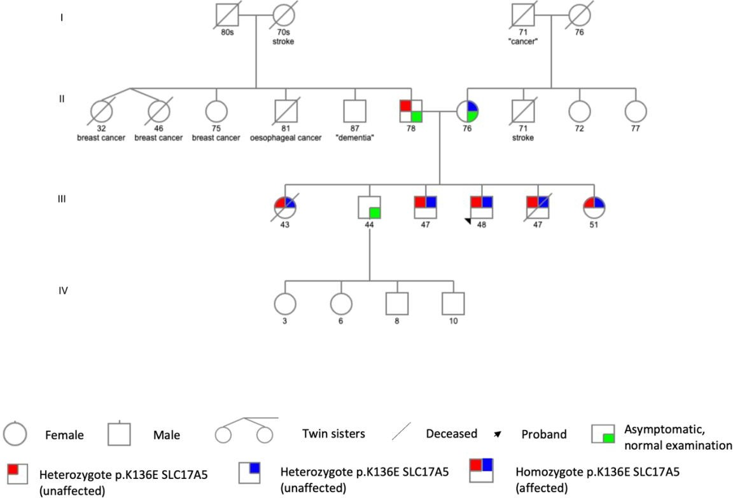

Figure 2 legend

MRI of his four siblings, III-5 (A-D), III-3 (E-H), III-1 (I-L) and III-6 (M-P). All four siblings

show signs of hypomyelination with homogeneous moderately elevated signal in the cerebral

white matter on the T2-weighted images (first two columns). There is bilateral posterior

putaminal hypointense signal on the susceptibility weighted imaging in all four siblings (C, G,

K, O) (dotted arrow) with putaminal cyst formation in III.5 (B) and sibling III-3 (F) (arrows).

There is significant global atrophy with prominent involvement of the corpus callosum and

vermis in all siblings (fourth column).

Video 1 legend

Video 1 demonstrates two of three alive and affected siblings. Limited examination due to

severe cognitive disability. Video III-3 shows the absence of tremor during drawing spirals,

slight dystonic posturing of the hands, normal tone, past pointing on right finger-nose, ataxic

gait, III-3 (proband) dystonic tremor of the head and hands, hypersalivation, normal tone, ataxic

gait.

Video 2 legend

Video 2 demonstrates the third affected sibling. Video III-6 shows writing attempt, normal tone,

dystonic tremor of the hands, slight kinetic tremor of the right hand, left hand past pointing

possibly related to comprehension difficulties, spastic gait.

