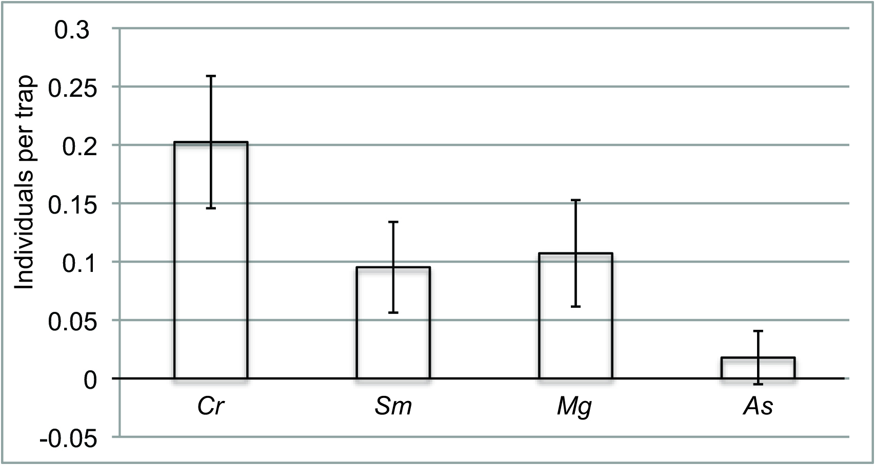

Figure S1. Mean relative abundance (±SD) of the same four small mammal species from this study (Cr: Crocidura russula; Sm: Sorex minutus; Mg: Myodes glareolus; As: Apodemus sylvaticus) trapped at four sites in Belle Île, France in October 2006 [27].

