SUPPORTING INFORMATION

Pen direct writing of Multiplex-LFIA for detection of thiamphenicol and tylosin in milk
Alida Russo ª, Simone Cavalera ^{b}, Richard Murray ª, Aidan J. Quinn ª, Laura Anfossi^{b} , Daniela Iacopino ^{a*}
ª Tyndall National Institute, University College Cork, Dyke Parade, Cork, Ireland
^{b} Department of Chemistry, University of Turin, Via P. Giuria 5, 10125, Turin, Italy
*Corresponding author: daniela.iacopino@tyndall.ie

Synthesis of the antigen Thiam-HS-BSA
Some molecules, like the antibiotics, are too small to generate an immune response, therefore it is necessary to couple them to a carrier protein such as bovine serum albumin (BSA) to obtain antigenic conjugates. Similarly, small molecules-protein antigenic conjugates are needed in competitive immunoassays, to be deposited in the nitrocellulose membranes [1].
For this research, the antigen was produced by conjugation of the thiamphenicol hemisuccinate (Thiam-HS) to bovine serum albumin (BSA). The Thiam-HS was synthesized starting from the thiamphenicol (Figure SI1a) through the reaction with succinic anhydride and the formation of the hemisuccinate derivative (Figure SI1b). Briefly, 25 mg of thiamphenicol (0.07 mmol, 1 eq) were dissolved in 1.5 mL of anhydrous pyridine into a dark glass vial. After complete dissolving, 1.12 mL of a 10 mg mL⁻¹ solution of succinic anhydride in pyridine, supplemented by 1 mg ml⁻¹ of 4-dimethylaminopyridine (dmap) (0.112 mmol, 1.6 eq) were added and the solution was let reacting for 72 h at room temperature under stirring. Then, 10 mL of milliQ water were added to the solution containing the synthesized Thiam-HS and was acidified by adding HCl dropwise until pH 2-3. Rapidly, the solution was extracted three times with ethyl acetate, reduced into few millilitres with rotary evaporator, and transferred into a glass vial for exhaustive drying under vacuum. 36mg were recovered after drying. Subsequently, the Thiam-HS was activated transforming it into a N-hydroxy succinimide ester (Figure SI1c). Briefly, 31.2 mg of Thiam-HS were dissolved in 840.6 µL of anhydrous dimethylformamide (DMF) (0.068 mmol, 1 eq). Then, 286.7 µL of a freshly prepared 30 mg mL⁻¹ solution in anhydrous DMF of N-hydroxy succinimide (NHS) (0.075 mmol, 1.1 eq), and 11.7 µL of N,N'-diisopropylcarbodiimide (DIC) (0.075 mmol, 1.1 eq), were added and the solution was let reacting at 4 °C for 2 h. The so-obtained hapten Thiam-HS-NHS was conjugated to BSA with a molar excess ratio of 200 (Figure SI1d). To this purpose, 5 mg of BSA were dissolved into a dark glass vial with 2.5 ml of bicarbonate buffer 150 mM, pH 8.5. Then 151.6 µL of Thiam-HS-NHS active solution was added and the mixture was let reacting at room temperature under stirring overnight. Finally, the solution was purified through size exclusion chromatography by means of a Sephadex G26 (MWCO 6000 Da) eluting with PBS [2].

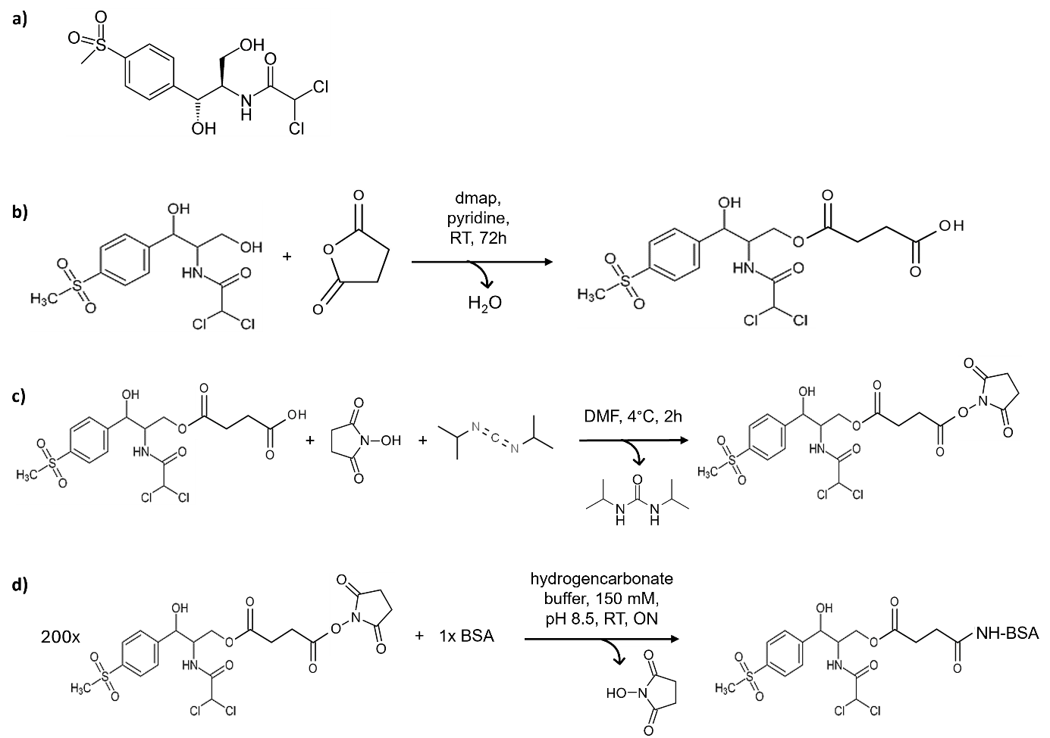
Figure SI1: a) Chemical structures of Thiamphenicol; b) scheme of the synthesis of the hapten Thiam-HS; c) activation of the Thiam-HS hapten to Thiam-HS-NHS; d) synthesis of the antigen Thiam-HS-BSA.

ELISA evaluation of the antigen-antibody pair
The antigens (Thiam-HS-BSA, Spi-BSA) were preliminary tested for their binding and competition capacity by means of a screening indirect competitive ELISA (cELISA). Briefly, this cELISA format was carried out with the immobilized antigen and indirect antibody detection. Microplate wells were coated with 150 µL per well of antigen solution in coating buffer by overnight incubation at 4°C. Plates were rinsed three times with washing solution (milliQ water with 0.05% v/v Tween 20) after each incubation step. The wells were coated with 300 µL per well of buffer solution supplemented of 0.5% w/v BSA by 1 h incubation at room temperature (RT). The competitive immunochemical reaction was performed by mixing 100 µL per well of antibiotic solution in PBS with 100 µL per well of the antibody solution in PBS-T (PBS containing 0.05% v/v Tween 20). The mixture was incubated for 1 h at RT and, after that, the plates were washed. The fraction of bound antibody was detected by adding 200 µL per well of a 1/5000 dilution in PBS-T of peroxidase labelled rabbit anti-sheep immunoglobulin polyclonal antibody (RAS-HRP). The plates were incubated at RT for 1 h, and after washing as before, the signal was generated by adding 200 mL per well of N,N,N’N’-tetramethylbenzidine/substrate solution. The enzymatic reaction was stopped after 30 min at RT in the dark by adding 50 µL of 2 M H₂SO₄ per well. The absorbance was immediately read at 450 nm. For both the pairs, Thiam-HS-BSA/antiThiam antibody and Spi-BSA/antiTyl antibody, the binding and competition was verified (Figure SI2).
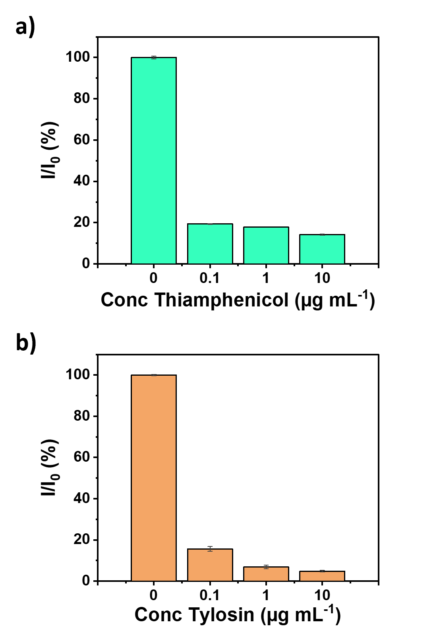
Figure SI2: cELISA binding and competition results for the antibody-antigen pairs: a) Thiam-HS-BSA/antiThiam; b) Spi-BSA/antiTyl.
Fabrication of multiplex LFIA strips
In Figure SI3 we have reported the digital picture of our assembled multiplex-LFIA strip with its 4 main components: (from left to right) adsorbent pad, membrane, conjugate pad, sample pad. The strip has been inserted into a plastic cassette which helps maintain pressure points between the overlapping components.

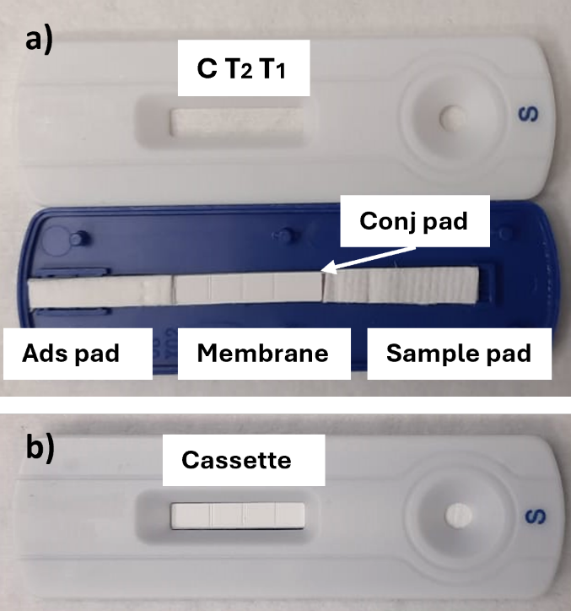
Figure SI3: a) Image of assembled LFIA strip; b) Plastic cassette used for our multiplex-LFIA.

Comparison conventional instruments-fountain pen
The conventional instrument for dispensation of the reagents requires the use of 500-800 μL to fill the entire tube (Figure SI4a). The fountain pen used has a cartridge (Figure SI4b) holding a maximum total volume of 640 μL. However, successful deposition of reagents was obtained with a minimum volume of 250 μL in the cartridge.

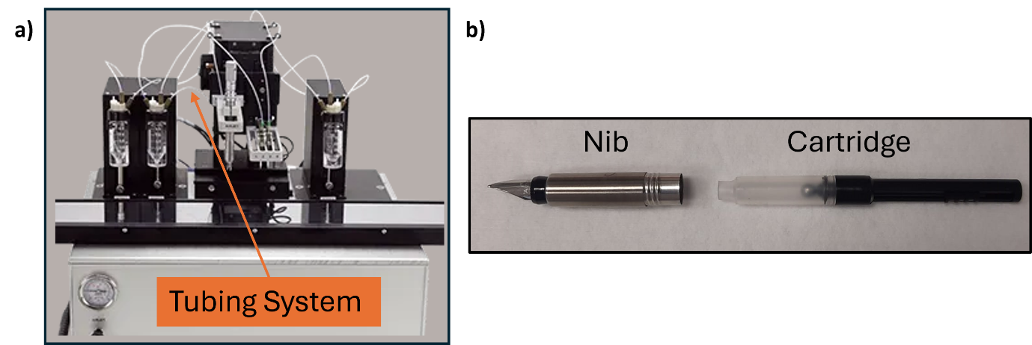
Figure SI4: a) Example of conventional dispensing instruments for LFIA; b) Nib and cartridge used for dispensing the multiplex-LFIA developed.

Flocculation stress test

Table SI1: Results obtained through the flocculation stress test for determining the optimal pH and amount of antibodies for the conjugation Au NPs-Ab anti-Thiam.
Au NPs pH 6
 | Ab anti-Thiam (µg) | 0 | 2 | 4 | 6 | 8 | 10
Abs | λ: 540 nm | 0.1702 | 0.2012 | 0.2295 | 0.2306 | 0.2321 | 0.2351
Abs | λ: 620 nm | 0.1871 | 0.2198 | 0.0595 | 0.0613 | 0.0596 | 0.0616
Abs₅₄₀/Abs₆₂₀ |  | 0.910 | 0.915 | 3.857 | 3.762 | 3.894 | 3.817
Au NPs pH 7
 | Ab anti-Thiam (µg) | 0 | 2 | 4 | 6 | 8 | 10
Abs | λ: 540 nm | 0.1347 | 0.2391 | 0.2333 | 0.236 | 0.2367 | 0.2395
 | λ: 620 nm | 0.1508 | 0.1061 | 0.0583 | 0.0577 | 0.0567 | 0.0596
Abs₅₄₀/Abs₆₂₀ |  | 0.893 | 2.254 | 4.002 | 4.090 | 4.175 | 4.018
Au NPs pH 8
 | Ab anti-Thiam (µg) | 0 | 2 | 4 | 6 | 8 | 10
Abs | λ: 540 nm | 0.1408 | 0.2313 | 0.2318 | 0.2383 | 0.2333 | 0.2334
 | λ: 620 nm | 0.1405 | 0.1238 | 0.0601 | 0.0601 | 0.0569 | 0.0571
Abs₅₄₀/Abs₆₂₀ |  | 1.002 | 1.868 | 3.857 | 3.965 | 4.100 | 4.088

Table SI2: Results obtained through the flocculation stress test for determining the optimal pH and amount of antibodies for the conjugation Au NPs-Ab anti-Tyl.
 | Au NPs pH 6
 |  | Ab anti-Tyl (µg) | 0 | 2 | 4 | 6 | 8 | 10
 | Abs | λ: 540 nm | 0.1717 | 0.1944 | 0.2426 | 0.2364 | 0.2453 | 0.2441
 | Abs | λ: 620 nm | 0.1806 | 0.2195 | 0.1028 | 0.0597 | 0.0677 | 0.0647
 | Abs₅₄₀/Abs₆₂₀ |  | 0.951 | 0.886 | 2.360 | 3.960 | 3.623 | 3.773
 | Au NPs pH 7
 |  | Ab anti-Tyl (µg) | 0 | 2 | 4 | 6 | 8 | 10
 | Abs | λ: 540 nm | 0.1483 | 0.1879 | 0.2379 | 0.2355 | 0.2453 | 0.2322
 |  | λ: 620 nm | 0.1643 | 0.2071 | 0.0767 | 0.0626 | 0.0692 | 0.0561
 | Abs₅₄₀/Abs₆₂₀ |  | 0.903 | 0.907 | 3.102 | 3.762 | 3.545 | 4.139
Au NPs pH 8
 |  | Ab anti-Tyl (µg) | 0 | 2 | 4 | 6 | 8 | 10
Abs |  | λ: 540 nm | 0.1252 | 0.1766 | 0.2256 | 0.2274 | 0.2304 | 0.2306
 |  | λ: 620 nm | 0.1364 | 0.1912 | 0.0635 | 0.0588 | 0.0587 | 0.0573
Abs₅₄₀/Abs₆₂₀ |  |  | 0.918 | 0.924 | 3.553 | 3.867 | 3.925 | 4.024

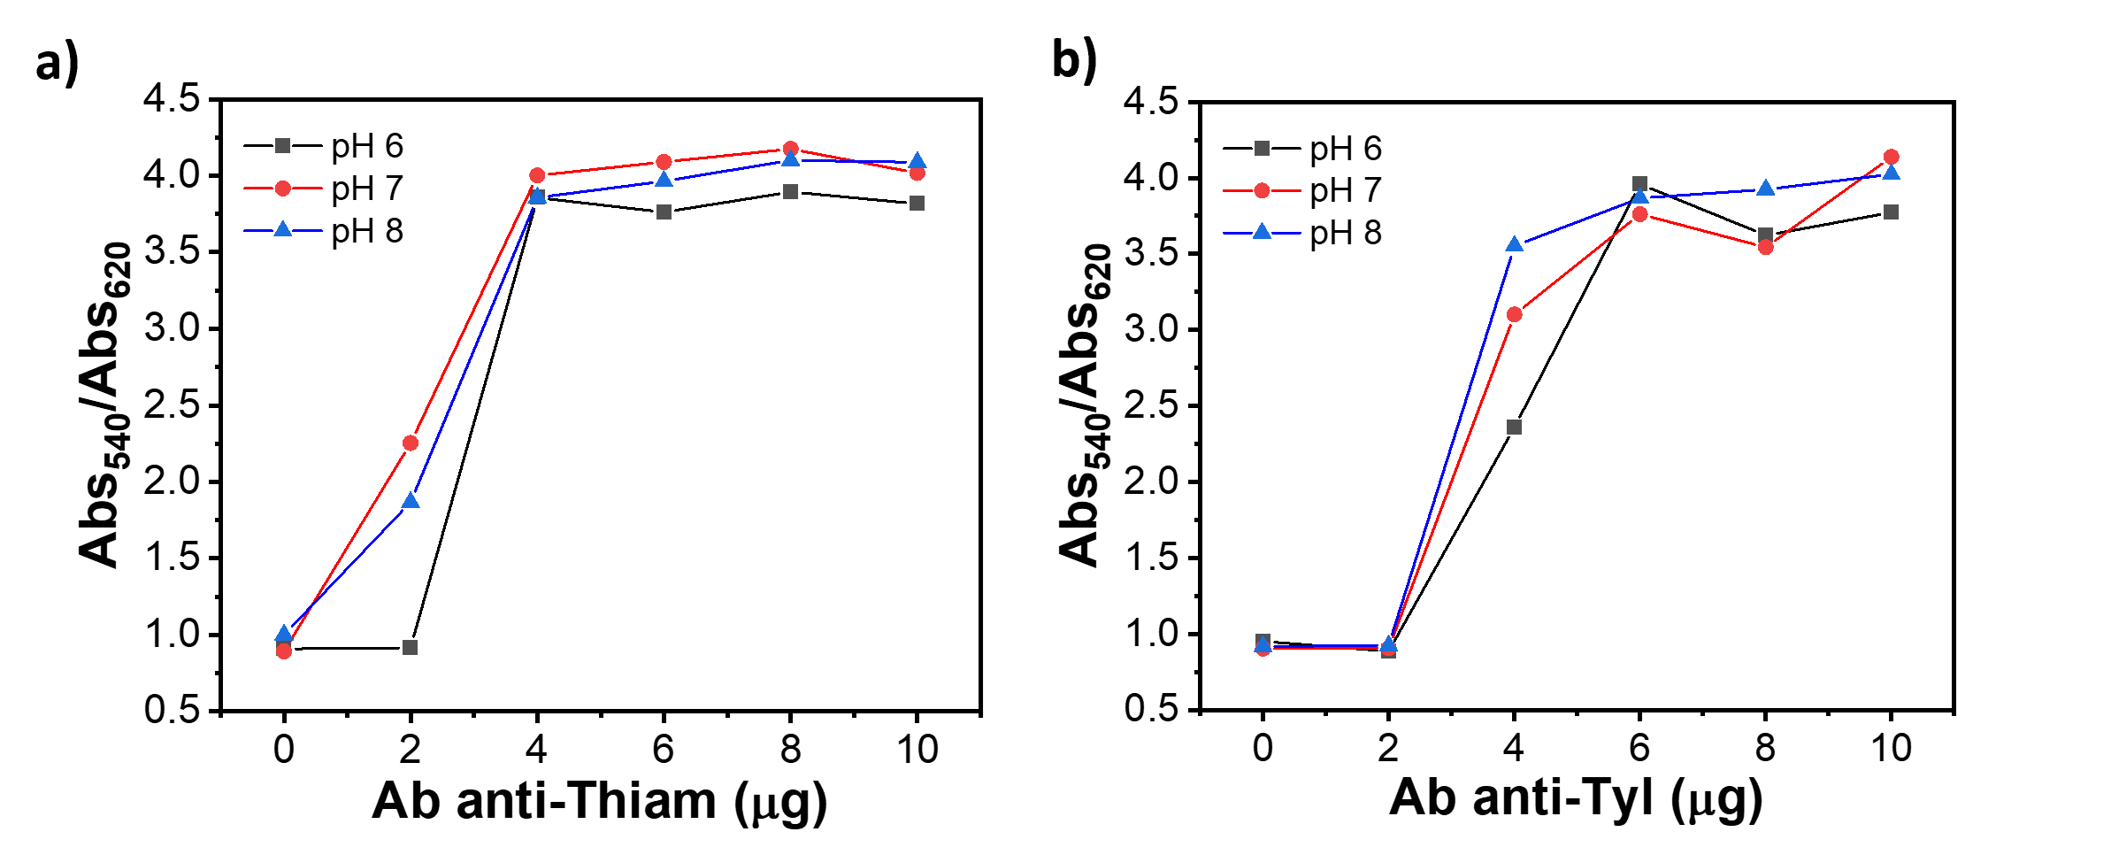
Figure SI5: Graphical results of the flocculation stress test for a) Ab anti-Thiam and b) Ab anti-Tyl.

Optimization of LFIA parameters
In Figure SI6 we have reported same pictures as example for the optimization of different parameters. Specifically, for the nitrocellulose membrane two different ones have been tested and it was noticed how the Hi-Flow Plus 180 was giving a stronger intensity than the other membrane. In Figure SI6a we can see this result on the two strips having all the same conditions except for the membrane used (the strips had T_{dot} as Thiam-HS-BSA and C_{dot} as secondary antibody.
Regarding the sample pad, in Figure SI6b there is the comparison of the labelled NPs flowing along the strips, using two different sample pad. The sample was flowing more homogenously using the glass fiber pad instead of the cellulose one. In particular, glass fiber sample pad used has a thickness of 0.35 mm, while the cellulose 0.83 mm, so the contact between the sample pad and the conjugate pad, helped by the pressure points of the cassette, is more direct in the first case.
Instead, Figure SI6c shows the comparison of two strips with dots for the detection of Tylosin, obtained with same condition but absence or presence of NaCl as additive in the running buffer. Since, we notice no difference in the intensities, it was decided not to add it in the final buffer.
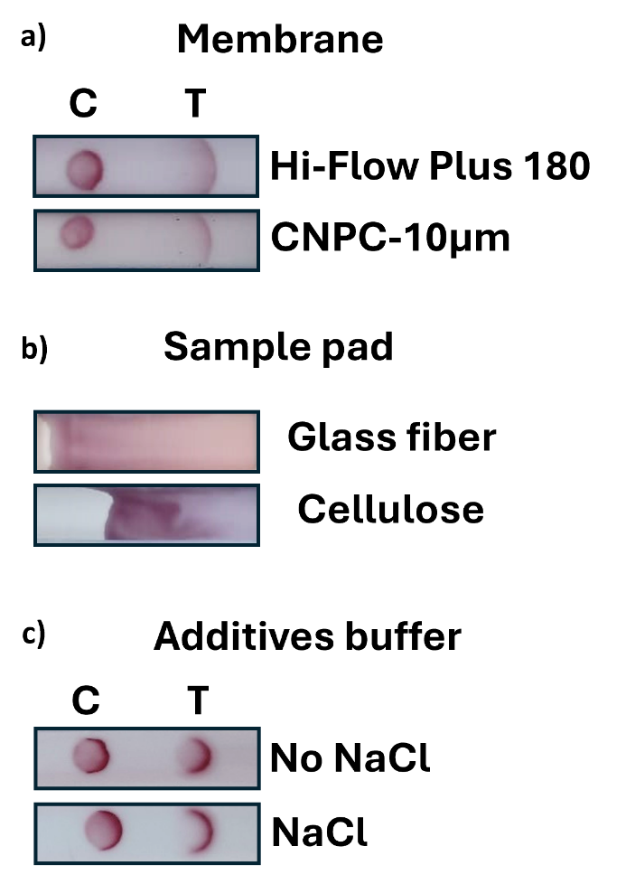
Figure SI6: Pictures of LFIA strips as examples for different parameters optimization: a) comparison for the two types of membrane tested; b) comparison related to the use of different sample pad; c) comparison on use/not use of NaCl in the running buffer.

LFIAs for detection of Thiamphenicol and Tylosin
Prior to the development of the multiplex-LFIA the two antibiotics were tested separately. Figure SI7 and SI8 show results obtained in buffer and milk for the detection of thiamphenicol and tylosin, respectively. The two antibiotics were tested at increasing concentrations both in buffer (PB in presence of 0.2% v/v Tween20) and spiked in milk.
For the development of the LFIA for detection of thiamphenicol, the test and control line were written onto the nitrocellulose with 0.3 mg mL⁻¹ Thiam-HS-BSA and 0.2 mg mL⁻¹ secondary antibody, respectively. The conjugate pad was dispensed per saturation with Au NPs-antiThiam OD 3.
For the detection of tylosin, test and control line were written using 0.25 mg mL⁻¹ of both Spi-BSA and secondary antibody, respectively. The conjugate pad was dispensed with Au NPs-antiTyl OD 3 per saturation.
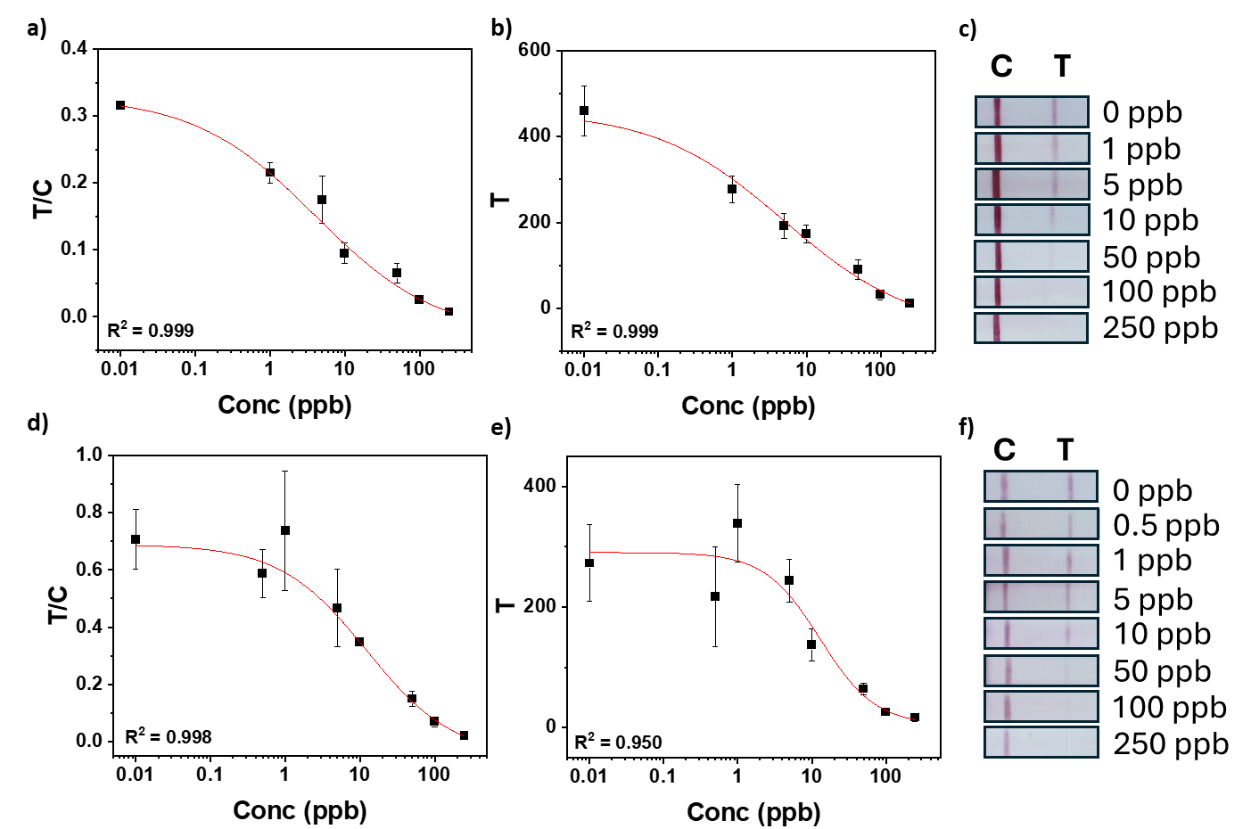
Figure SI7: a) Calibration curve obtained considering the ratio between the intensities of the lines T and C as a function of thiamphenicol concentration in buffer; b) calibration curve obtained considering the intensity of the T line as function of thiamphenicol concentration in buffer; c) visual readout of the strips at different levels of thiamphenicol in buffer; d) calibration curve got from the ratio of the T and C line intensities as function of thiamphenicol concentration in milk; e) calibration curve obtained considering the intensity of the T line as function of thiamphenicol concentration in milk; f) visual readout of the strips at different levels of thiamphenicol in milk. The measurements in buffer were obtained with two replicates, the measurements in milk were in three replicates.
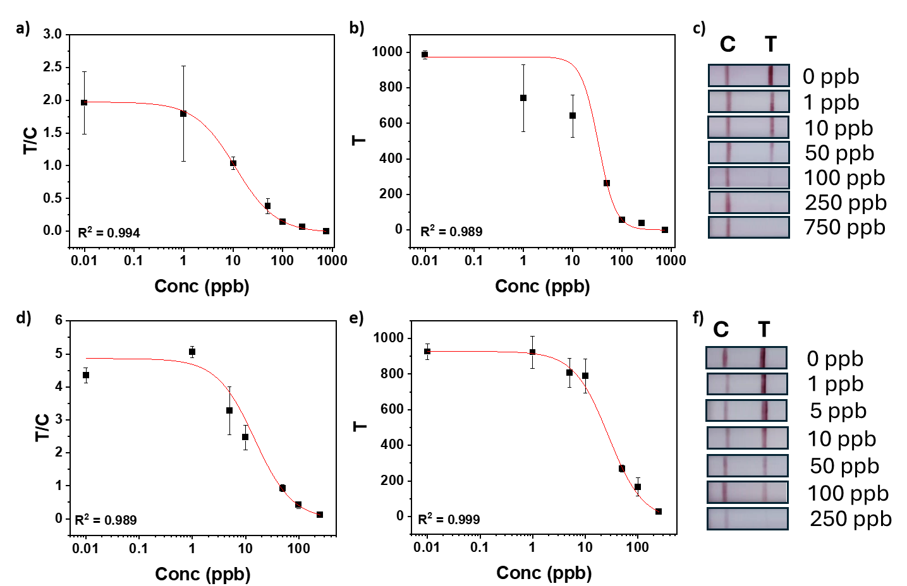
Figure SI8: a) Calibration curve obtained considering the ratio between the intensities of the lines T and C as a function of tylosin concentration in buffer; b) calibration curve obtained considering the intensity of the T line as function of tylosin concentration in buffer; c) visual readout of the strips at different levels of tylosin in buffer; d) calibration curve got from the ratio of the T and C line intensities as function of tylosin concentration in milk; e) calibration curve attained considering the intensity of the T line as function of tylosin concentration in milk; f) visual readout of the strips at different levels of tylosin in milk. The measurements in buffer were done two replicates, the ones in milk three replicates.

Cross-reactivity measurements
For the development of a selective multiplex-LFIA, it was necessary to prove that antibodies and antibiotics did not interact with each other. Therefore, two sets of experiments were designed to investigate the cross-reactivity of the two target antibiotics. The first experiment consisted in using the single-test line sensor of one antibiotic in presence of the other antibiotic spiked in milk (Figure SI9a,c), which needed to give the same result as a negative test. The second experiment consisted of using non-spiked milk samples into single-test line sensors using opposite conjugate pads (Figure SI9b,d). The aim was to investigate the interaction between the antigen of one antibiotic and the antibodies against the other, which should result in just a coloured control line. The results excluded a possible cross-reactivity among the two antibiotics.
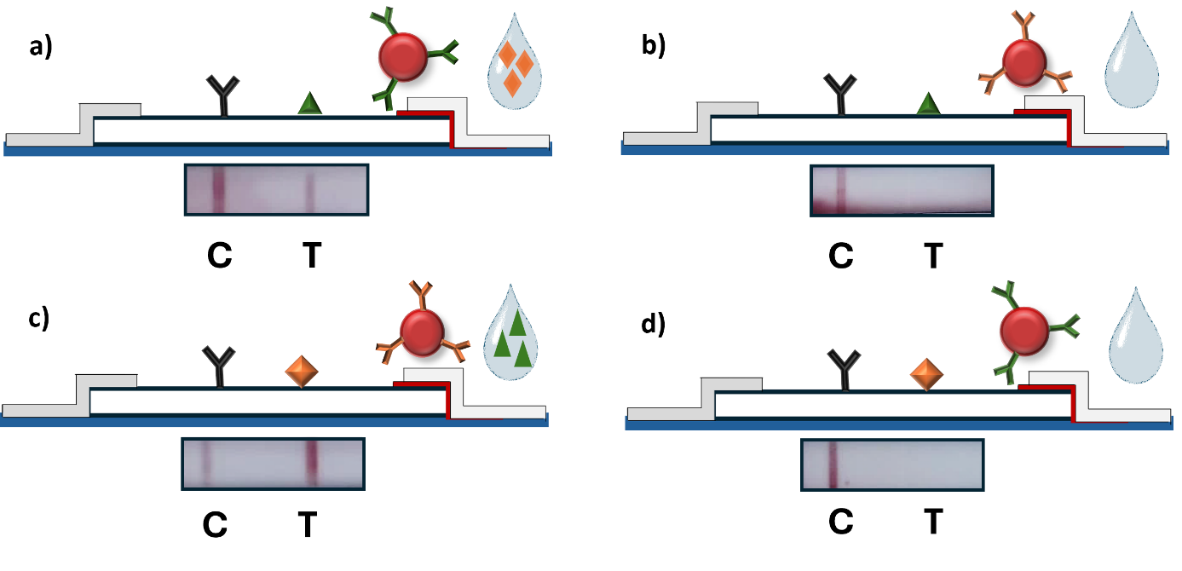
Figure SI9: Schematic and digital picture results of cross-reactivity tests on single-test line assays: a) thiamphenicol-LFIA using conjugate Au NPs-antiThiam OD 3 in presence of tylosin in milk; b) thiamphenicol-LFIA using conjugate Au NPs-antiTyl OD 3 in milk; c) tylosin-LFIA using conjugate Au NPs-antiTyl OD 3 in presence of thiamphenicol in milk; d) tylosin-LFIA using conjugate Au NPs-antiThiam OD 3 in milk.

Double conjugate test
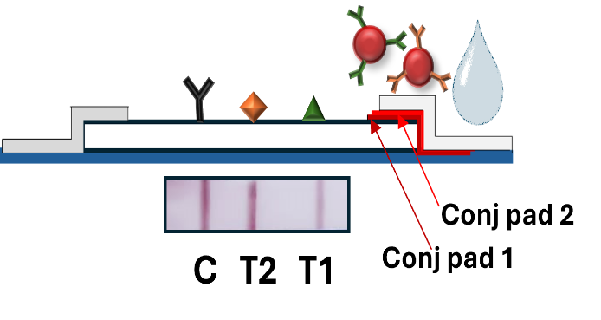
Figure SI10: Schematic and digital picture of the negative result (1+1: milk + running buffer) obtained using two separate conjugate pads for the two-types modified nanoparticles. In particular, ‘conj pad 1’ is referred to Au NPs-antiThiam OD 3, while ‘conj pad 2’ is referred to Au NPs-antiTyl OD 3. All the rest of the components were maintained constant.

Calibration curves for Thiamphenicol and Tylosin
Table SI3: Calibration curves parameters for Figure 5 and 6.
Intensity | Curve | IC₅₀ | Dynamic range  (IC₁₀-IC₉₀)
Thiamphenicol T₁/C | Fig. 5b | 2.8 ± 2.7 | 0.2-46.2
Thiamphenicol T₁ | Fig. 5c | 5.0 ± 4.4 | 0.3-86.9
Tylosin T₂/C | Fig. 5e | 5.2 ± 6.1 | 0.3-90.6
Tylosin T₂ | Fig. 5f | 13.1 ± 7.7 | 0.9-186.4
Thiamphenicol T₁/C | Fig. 6b | 8.1 ± 4.7 | 0.3-254.4
Thiamphenicol T₁ | Fig. 6c | 10.8 ± 1.3 | 0.7-167.7
Tylosin T₂/C | Fig. 6d | 7.9 ± 2.0 | 1.5-41.1
Tylosin T₂ | Fig. 6e | 6.9 ± 1.0 | 1.5-31.6

Comparison with literature
Table SI4: Comparison of limits of detection (LODs) for detection of thiamphenicol and tylosin antibiotics in literature with different methodologies.
Antibiotics | Method | LOD | Reference
Thiamphenicol | HPLC | 30 ppb | [3]
Thiamphenicol | FPSE-HPLC diode array | 52.49 μg kg⁻¹ | [4]
Thiamphenicol | Optical biosensor | 0.5 μg kg⁻¹ | [5]
Chloramphenicol,  Thiamphenicol, florfenicol | LFIA-SERS | 0.36 ng/mL, 0.20 ng/mL, and 0.78 ng/mL | [6]
Tylosin | HPLC | 7 ng/mL | [7]
Tylosin | Bio-SA-HCR-ELISA | 4.9 ng/mL | [8]
Tylosin | SMM-FIA | 6.37 ng/mL | [9]
Tylosin | CG-LFIA, LM-LFIA, TrFM-LFIA | 8 ng/mL, 4 ng/mL, 2 ng/mL | [10]
Thiamphenicol, Tylosin | Multiplex-LFIA | vLOD: 100 ppb  IC₅₀: 13.1 ± 7.7, 10.8 ± 1.3 (respectively)* | Our work
*The highest IC₅₀ obtained for both antibiotics with the calibration curves reported in the manuscript

Stability
The stability of the multiplex-LFIA was evaluated at room temperature in a month time in three different days (day 1-7-30) at three different concentration levels (0-10-100 ppb) for both antibiotics: thiamphenicol (Figure SI11a) and tylosin (Figure SI11b).
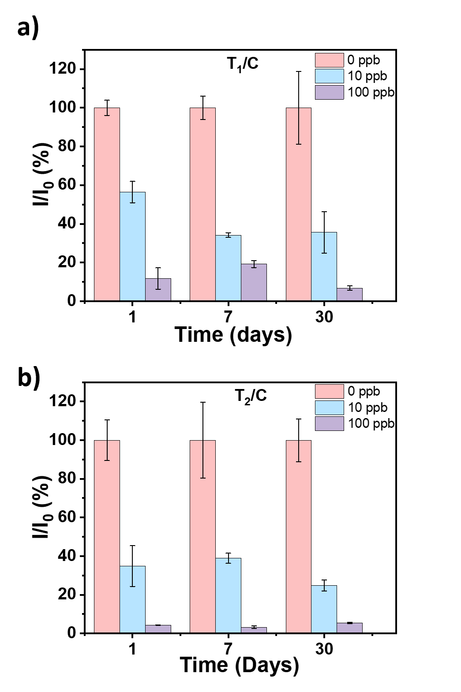
Figure SI11: Stability of the multiplex-LFIA developed at room temperature at three concentrations of antibiotics: a) thiamphenicol; b) tylosin. The measurements were done in milk on two replicates at day 1, day 7 and day 30.

Specificity
The multiplex-LFIA tests have been performed in spiked milk with three different antibiotics: tetracycline, penicillin g and streptomycin. These have been chosen among the classes of most used antibiotics as veterinary drugs. The milk has been spiked with 500 ppb of each antibiotic, a quantity that for thiamphenicol and tylosin would leave the test lines completely uncoloured. The results obtained have been compared with a negative test, so performing it on a milk sample that was not spiked with any antibiotics, as reported in Figure SI12.
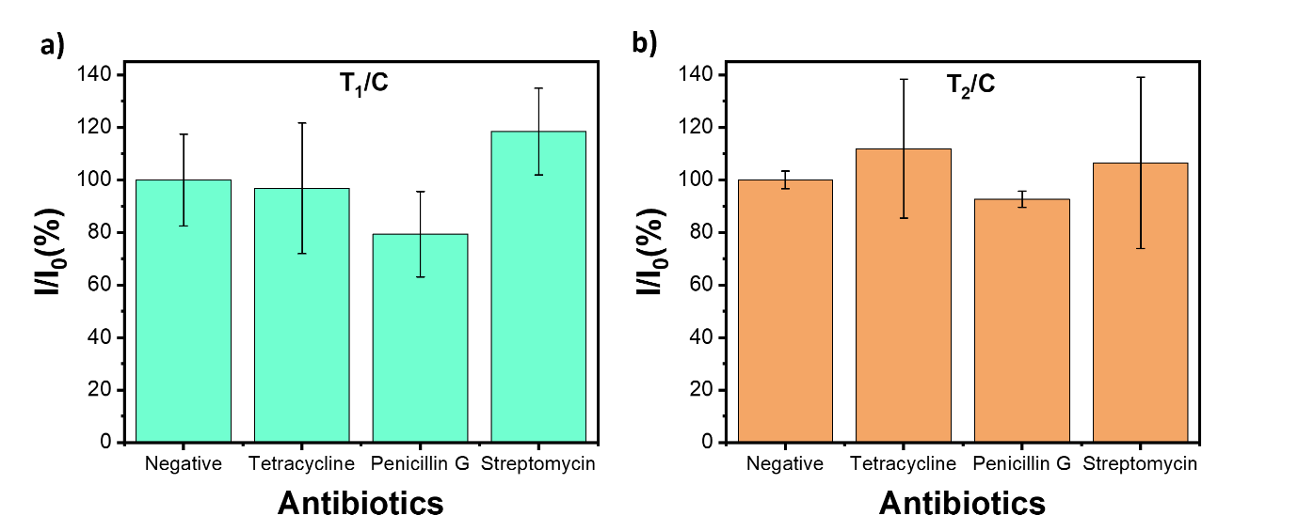
Figure SI12: Comparison between the response of negative sample and the one obtained spiking milk samples with tetracycline, penicillin g or streptomycin for the two lines: a) T1/C ; b) T2/C. The measurements have been performed in two replicates.

References

[1] S. Thompson, ‘Small-Molecule-Protein Conjugation Procedures’, in Molecular Diagnosis of Infectious Diseases, J. Decler and U. Reischl, Eds., Totowa, NJ: Humana Press, 2004, pp. 255–265. doi: 10.1385/1-59259-679-7:255.
[2] G. T. Hermanson, Bioconjugate Techniques. Academic Press, 2010.
[3] E. G. Iosifidou and J. E. Psomas, ‘Liquid Chromatographic Analysis of Thiamphenicol Residues in Milk’, Journal of Liquid Chromatography, vol. 18, no. 9, pp. 1863–1870, May 1995, doi: 10.1080/10826079508010012.
[4] V. Samanidou, L.-D. Galanopoulos, A. Kabir, and K. G. Furton, ‘Fast extraction of amphenicols residues from raw milk using novel fabric phase sorptive extraction followed by high-performance liquid chromatography-diode array detection’, Analytica Chimica Acta, vol. 855, pp. 41–50, Jan. 2015, doi: 10.1016/j.aca.2014.11.036.
[5] C. S. Thompson, I. M. Traynor, T. L. Fodey, P. Barnes, D. V. Faulkner, and S. R. H. Crooks, ‘Screening method for the detection of residues of amphenicol antibiotics in bovine milk by optical biosensor’, Food Additives & Contaminants: Part A, vol. 37, no. 11, pp. 1854–1864, Nov. 2020, doi: 10.1080/19440049.2020.1809718.
[6] Y. Pan et al., ‘Surface-Enhanced Raman Scattering–Based Lateral Flow Immunoassay for the Detection of Chloramphenicol Antibiotics Using Au@Ag Nanoparticles’, Food Anal. Methods, vol. 14, no. 12, pp. 2642–2650, Dec. 2021, doi: 10.1007/s12161-021-02091-4.
[7] S. Şanli, İ. M. Palabiyik, N. Şanli, Z. B. Guzel-Seydim, and G. Alsancak, ‘Optimization of the experimental conditions for macrolide antibiotics in high performance liquid chromatography by using response surface methodology and determination of tylosin in milk samples’, J Anal Chem, vol. 66, no. 9, pp. 838–847, Sep. 2011, doi: 10.1134/S1061934811090152.
[8] S. Shan et al., ‘Integrated double signal amplification systems with ELISA assay for sensitive detection of tylosin in food’, Food and Agricultural Immunology, vol. 35, no. 1, p. 2292971, Dec. 2024, doi: 10.1080/09540105.2023.2292971.
[9] Y. Bang-Ce, L. Songyang, Z. Peng, and L. Xiao-hong, ‘Simultaneous detection of sulfamethazine, streptomycin, and tylosin in milk by microplate-array based SMM–FIA’, Food Chemistry, vol. 106, no. 2, pp. 797–803, Jan. 2008, doi: 10.1016/j.foodchem.2007.06.006.
[10] X. Li et al., ‘Three lateral flow immunochromatographic assays based on different nanoparticle probes for on-site detection of tylosin and tilmicosin in milk and pork’, Sensors and Actuators B: Chemical, vol. 301, p. 127059, Dec. 2019, doi: 10.1016/j.snb.2019.127059.

