Supplementary Material

Dual-Gate MoS₂ Transistors with sub-10 nm Top-Gate High-k Dielectrics

Pavel Bolshakov⁽¹⁾, Ava Khosravi⁽¹⁾, Peng Zhao⁽¹⁾, Paul K. Hurley⁽²⁾, Christopher L. Hinkle⁽¹⁾, Robert M. Wallace⁽¹⁾, and Chadwin D. Young⁽¹⁾

¹Department of Materials Science and Engineering, The University of Texas at Dallas,
800 West Campbell Road, Richardson, Texas 75080, USA
²Tyndall National Institute, University College Cork,
Lee Maltings Complex, Dyke Parade, Mardyke, Cork, Ireland

Back-Gate Device Structures:
(a)
Exposed MoS₂ Surface
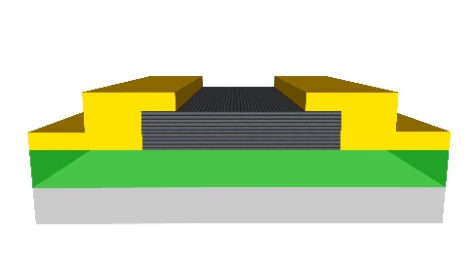
Ti/Au Ti/Au

HfO₂ (9nm)

HfO₂ (6nm)
Al₂O₃
(3nm)
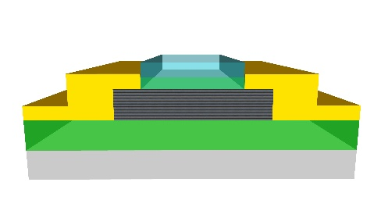
Al₂O₃
p++ Si

(c)
(b)
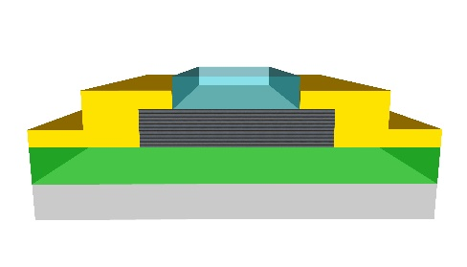

Figure S1. (a) Cross-section graphic of p⁺⁺Si/Al₂O₃/MoS₂ stack with the top MoS₂ surface exposed to air. (b) Cross-section of the p⁺⁺Si/Al₂O₃/MoS₂ stack after HfO₂ deposition and (c) after the bilayer deposition (Al₂O₃/HfO₂).

Dual-Gate Sweeping:

In order to have dual-gate (DG) sweeping, the back-gate (BG) – the highly doped Si wafer and the top-gate (TG) – the Pd/Au metal gate have the same voltage sweep bias applied to them at the same time as shown in Fig. S2 below.
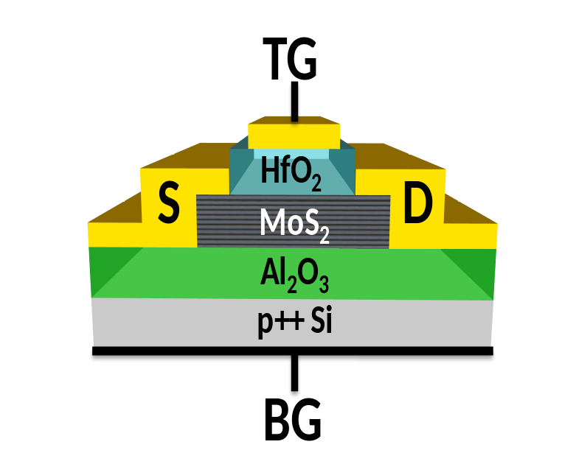
(a)
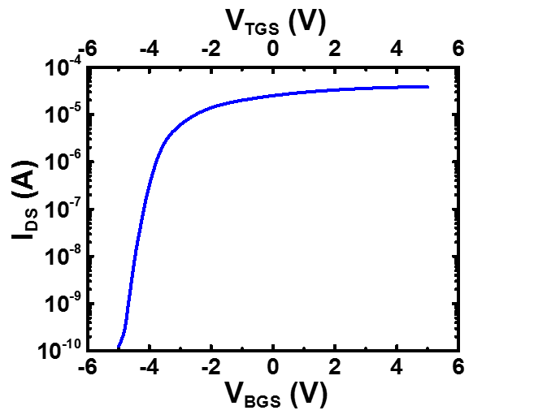
(b)

Figure S2. (a) Dual-gate structure cross-section graphic of the p⁺⁺Si/Al₂O₃/MoS₂/HfO₂/Pd/Au stack and (b) the DG sweep transfer curve where V_{BGS} represents the back-gate voltage and V_{TGS} the top-gate voltage.

Dual-Gate Mobility Extraction:

For the mobility (µ_{FE}) extraction, the total capacitance (C_{OX}) was calculated from the top-gate oxide (C_{TOX}) and bottom-gate oxide (C_{BOX}) for each gate stack (C_{OX} = C_{TOX} + C_{BOX})¹. The observed trend shows ~10x increase in µ_{FE} for the Al₂O₃/MoS₂/Al₂O₃/HfO₂ stack compared to the Al₂O₃/MoS₂/HfO₂ stack.

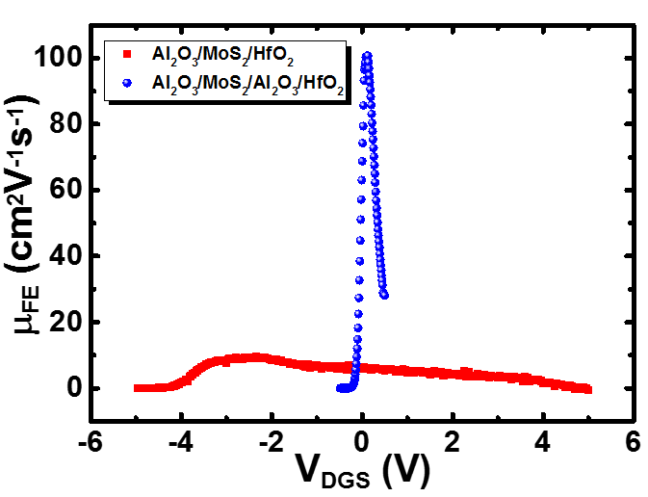
Figure S3. Dual-gate MoS₂ FET mobility comparison of the Al₂O₃/MoS₂/Al₂O₃/HfO₂ stack compared to the Al₂O₃/MoS₂/HfO₂ stack demonstrating ~10x increase in µ_{FE}.

Gate Leakage After HfO₂ Deposition:

For the back-gate MoS₂ FET with HfO₂ deposition in Fig. 1a of the main text, the high off current is not due to gate injection at negative bias as shown in Fig. S4 below.

Figure S4. The transfer curve of a back-gate MoS₂ FET after HfO₂ deposition demonstrating a high off current and low gate leakage at negative gate bias.

Impact of Contact Resistance on Evaluated Subthreshold Swing:

Contact resistance (R_{C}) between metal electrodes and MoS₂ can vary over orders of magnitude^{2,3} and can also be influenced by defects in the MoS₂⁴. As a consequence, it is important to consider the possibility that the value of R_{C} could impact on the evaluation of the subthreshold swing.

Taking into account the R_{C}, determined using the Y-function method, the voltage drop across the source and drain resistance (I_{DS}*2R_{C} ) is subtracted from the applied drain voltage (V_{DS}) to estimate the channel voltage, which is ~V_{DS}-I_{DS}*2R_{C.} The results are plotted on a triple Y-axis in the figure below, and indicates that for our samples there is a negligible impact of R_{C} on the evaluation of the subthreshold swing in the subthreshold regime of the I_{DS}-V_{DGS} characteristics.
.

Figure S5. The transfer curve of dual-gated Al₂O₃/MoS₂/Al₂O₃/HfO₂ stack along with the extracted SS and the corresponding channel voltage (~V_{DS}-I_{DS}*2R_{C}).

References

¹ J.S. Kim, P.J. Jeon, J. Lee, K. Choi, H.S. Lee, Y. Cho, Y.T. Lee, D.K. Hwang, and S. Im, Nano Lett. 15, 5778 (2015).
² C.D. English, G. Shine, V.E. Dorgan, K.C. Saraswat, and E. Pop, Nano Lett. 16, 3824 (2016).
³ G. Mirabelli, M. Schmidt, B. Sheehan, K. Cherkaoui, S. Monaghan, I. Povey, M. McCarthy, A.P. Bell, R. Nagle, F. Crupi, P.K. Hurley, and R. Duffy, AIP Adv. 6, 025323 (2016).
⁴ S. McDonnell, R. Addou, C. Buie, R.M. Wallace, and C.L. Hinkle, ACS Nano 8, 2880 (2014).

