TITLE: Multi-generational dispersal and dynamic patch occupancy reveals spatial and temporal stability of seascapes

AUTHORS
Charlotte H. Clubley ^{a,b}, Tiago A. M. Silva ^{c}, Louisa E. Wood ^{d,e}, Louise B. Firth ^{a,f}, David T. Bilton ^{a,g}, Enda O’Dea ^{h,i}, Antony M. Knights ^{a,f}

AFFILIATIONS
ª School of Biological and Marine Sciences, University of Plymouth, Plymouth, PL4 8AA, United Kingdom
^{b} Aarhus University, Department of Ecoscience, Frederiksborgvej 399, PO Box 358, 4000 Roskilde, Denmark
^{c} Lowestoft Laboratory, Centre for Environment, Fisheries and Aquaculture Science, NR33 0HT, Lowestoft, United Kingdom
^{d} Centre for Blue Governance, Department of Economics and Finance, University of Portsmouth, Portsmouth, Hampshire, PO1 3DE, United Kingdom
^{e} Department of Biology, University of Fribourg, Chemin du Musée 15, CH-1700 Fribourg, Switzerland
^{f} School of Biological, Earth and Environmental Sciences, University College Cork, North Mall, Cork, Ireland
^{g} Department of Zoology, University of Johannesburg, PO Box 524, Auckland Park, Johannesburg 2006, South Africa
^{h} Met Éireann, 65/67 Glasnevin Hill, Dublin 9, D09 Y921, Ireland
^{i} Met Office, FitzRoy Road, Exeter, Devon, EX1 3PB, United Kingdom

Table S1. The environmental parameters used to identify areas of suitable habitat for spawning and settlement of the Pacific oyster, Magallana gigas, and the sources of raster data used in the creation of the ‘environmental raster’ and ‘habitat grid’.
Environmental parameter | Suitable range/type | Reference | Data
Temperature (°C) | 3 – 35 | Mann et al. (1991)^{[2]};  Ruiz et al. (1992)^{[5]};  Robins et al. (2017)^{[4]};  Wood et al. (2021)^{[6]} | https://www.lifewatch.be/sdmpredictors/MS_sst07_5m_lonlat.tif https://www.lifewatch.be/sdmpredictors/MS_sst08_5m_lonlat.tif https://www.lifewatch.be/sdmpredictors/MS_sst09_5m_lonlat.tif
Salinity (ppt) | 11 – 34 | Mann et al. (1991)^{[2]};  Ruiz et al. (1992)^{[5]};  Wood et al. (2021)^{[4]} | https://bio-oracle.org/data/2.2/Present.Surface.Salinity.Mean.BOv2_2.tif.zip
Depth (m) | 0 – 40 | FAO (2016)^{[1]} | https://www.lifewatch.be/sdmpredictors/MS_bathy_5m_lonlat.tif
Substrate type | Rock and hard  Sand  Coarse  Mixed sediment  Fine mud  Sandy mud  Seabed  Muddy sand  Biogenic reefs  Sediment | FAO (2016)^{[1]};  Padilla (2010)^{[3]};  Wood et al. (2021)^{[6]} | https://emodnet.ec.europa.eu/geoviewer/
^{[1]} FAO. (2016). Species fact sheets: Crassostrea gigas (Thunberg, 1793) Retrieved 01 Jan 2023 from http://www.fao.org/fishery/species/3514/en
^{[2]} Mann, R. L., Burreson, E. M., & Baker, P. K. (1991). The decline of the Virginia Oyster fishery in Chesapeake Bay considerations for introduction of a non-endemic species, Crassostrea gigas (Thunberg, 1793). Journal of Shellfish Research, 10(s), 379-388.
^{[3]} Padilla, D. K. (2010). Context-dependent impacts of a non-native ecosystem engineer, the Pacific oyster Crassostrea gigas. Integrative and Comparative Biology, 50(2), 213-225. https://doi.org/10.1093/icb/icq080
^{[4]} Robins, P. E., Tita, A., King, J. W., & Jenkins, S. R. (2017). Predicting the dispersal of wild Pacific oysters Crassostrea gigas (Thunberg, 1793) from an existing frontier population – a numerical study. Aquatic Invasions, 12(2), 117-131. https://doi.org/10.3391/ai.2017.12.2.01
^{[5]} Ruiz, C., Abad, M., Sedano, F., Garcia-Martin, L. O., & Sánchez López, J. L. (1992). Influence of seasonal environmental changes on the gamete production and biochemical composition of Crassostrea gigas (Thunberg) in suspended culture in El Grove, Galicia, Spain. Journal of Experimental Marine Biology and Ecology, 155(2), 249-262. https://doi.org/10.1016/0022-0981(92)90066-J
^{[6]} Wood, L. E., Silva, T. A., Heal, R., Kennerley, A., Stebbing, P., Fernand, L., & Tidbury, H. J. (2021). Unaided dispersal risk of Magallana gigas into and around the UK: combining particle tracking modelling and environmental suitability scoring. Biological Invasions, 23, 1719-1738. https://doi.org/10.1007/s10530-021-02467-x

Supplementary methods, Figure S1:
To test the effect that the particle time step of 5 minutes used in the models in this manuscript may have had on dispersal predictions, a sensitivity analysis was conducted using hydrodynamic data and model parameters for the year 2000. Four models were run, using a particle time step of 5 minutes, 1 minute, 30 seconds and 1 second respectively. These models used a reduced particle number of 100 particles per spawning location to minimize computational expense. When Kolmogorov-Smirnov tests were carried out on the resulting distance distribution of particles from each model, convergence was found for all time steps (Figure S1). Therefore, the longer time step of 5 minutes used in the models in this manuscript likely had no significant effect on dispersal predictions.
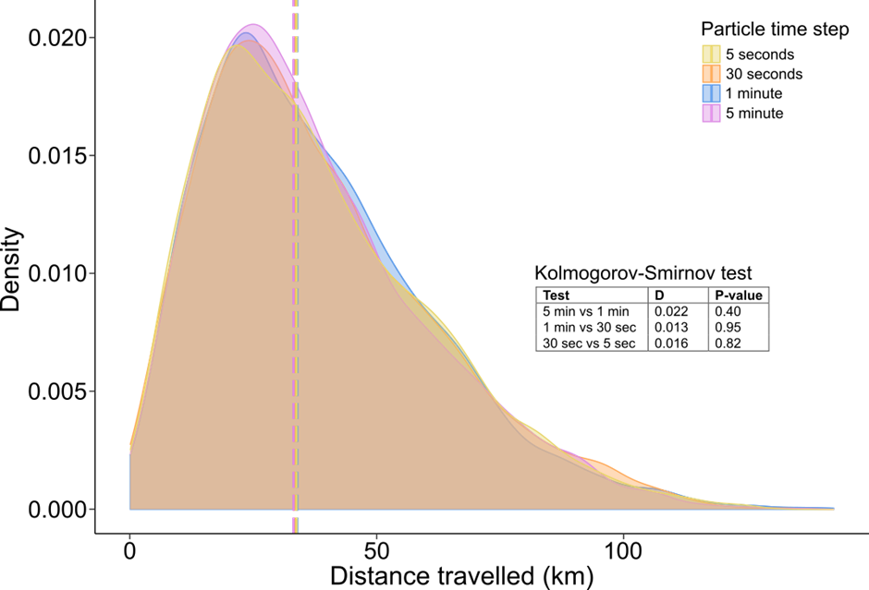 Figure S1. Results of the sensitivity analysis to determine the effect of particle time step on dispersal predictions. Graph shows the distance distribution of particles from four model scenarios: (i) 5 minute time step; (ii) 1 minute time step, (iii) 30 second time step; or (iv) 5 second time step. Dashed lines show the median value for each scenario. Table inset shows the results of Kolmogorov-Smirnov tests between subsequent time steps.

Supplementary methods, Figure S2:
A sensitivity analysis was conducted to determine the optimal number of particles to be released from each spawning location using hydrodynamic data and model parameters for the year 2000. Four models were run, releasing 100, 1,000, 10,000 and 100,000 particles from each location respectively. When Kolmogorov-Smirnov tests were carried out on the resulting distance distribution of particles from each model, convergence was found for 100, 1,000 and 10,000 particles (Figure S1). The distance distributions of 10,000 particles and 100,000 particles were significantly different, and therefore a quantity of 100,000 particles was selected for release from each spawning location. Due to practical constraints of computational feasibility, particle quantities greater than 100,000 were not tested.

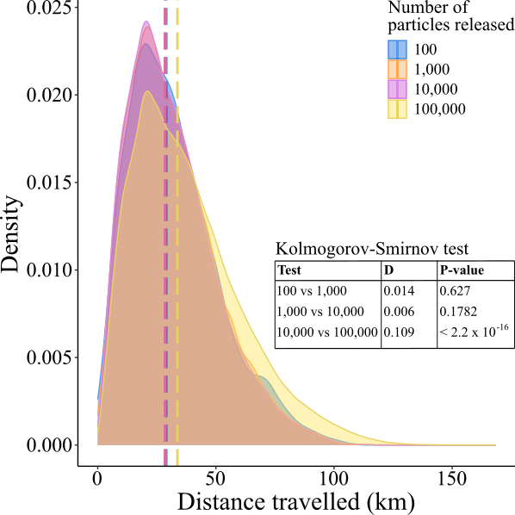
Figure S2. Results of the sensitivity analysis to determine particle release number. Graph shows the distance distribution of particles from four model scenarios: (i) 100 particles released from each location; (ii) 1,000 particles released from each location, (iii) 10,000 particles released from each location; or (iv) 100,000 particles released from each location. Dashed lines show the median value for each scenario. Table inset shows the results of Kolmogorov-Smirnov tests between subsequent particle sizes.

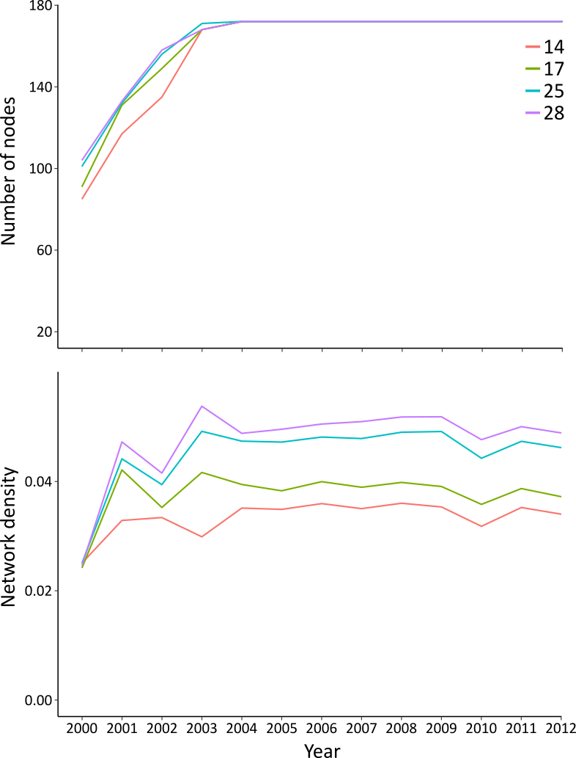
Figure S3. The number of nodes contained within (top) and network density of (bottom) graph networks created from the outputs of dispersal models using a planktonic larval duration of 14, 17, 25 or 28 days.

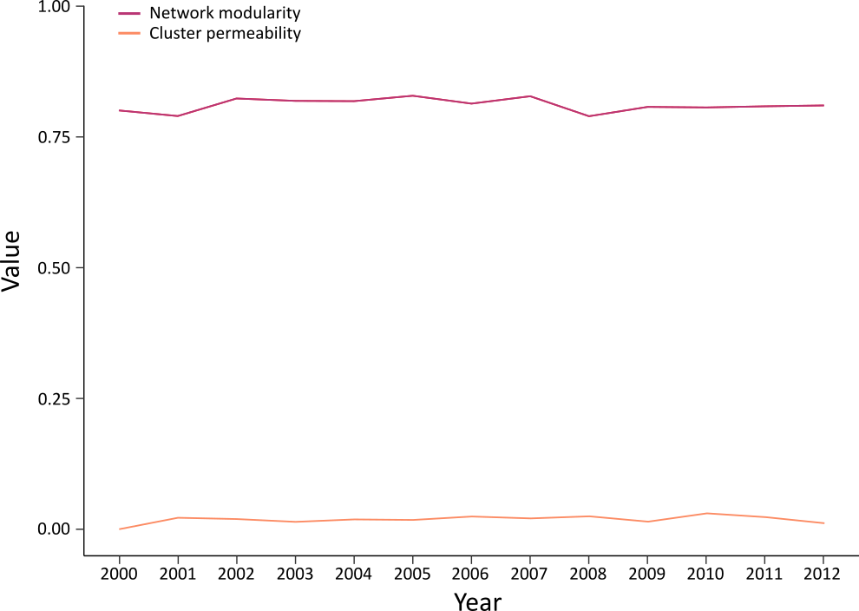
Figure S4. Network modularity (orange) and cluster permeability (purple) of clusters identified for each of the 13 modelled years. Both values are constrained between 0 and 1.

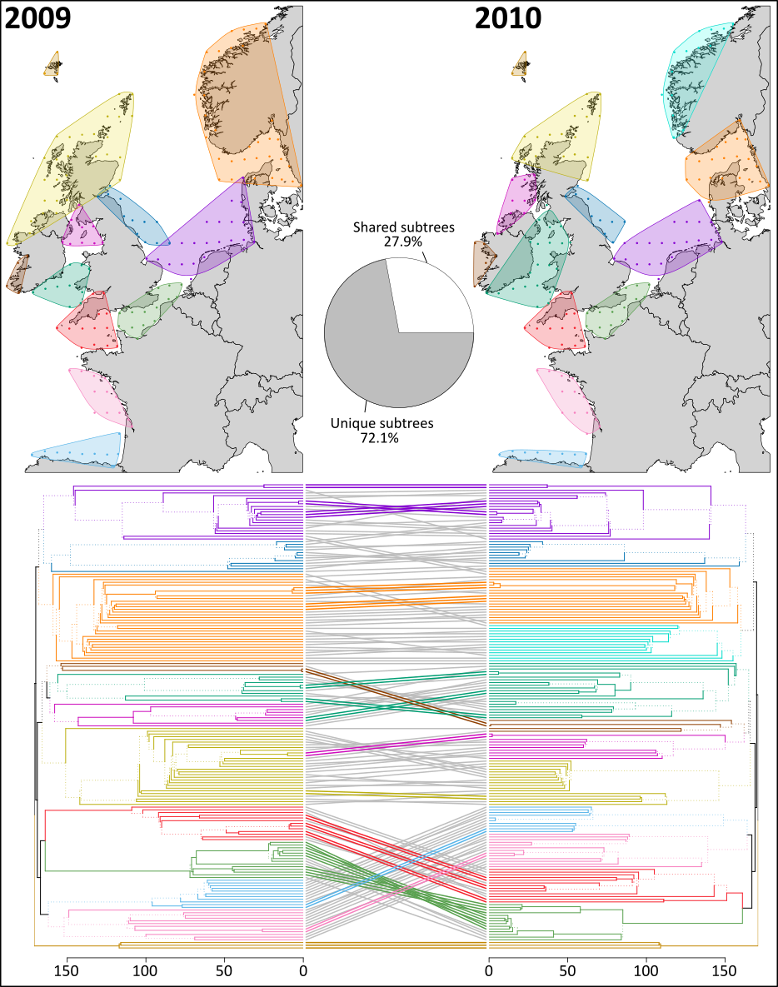
Figure S5. A comparison of the two years with the highest value of Baker’s Gamma Index, and therefore the most similar node clustering: 2009 and 2010. The spatial arrangement of clusters is shown in maps. Hierarchical clustering of the nodes from both years are compared through the use of a tanglegram, where each leaf indicates an individual node. Dashed lines indicate branches that are not shared between the two trees. Branch and leaf colours correspond to the colour of the cluster on the map to which that node belongs. Coloured lines connecting the two trees indicate shared subtrees and are coloured corresponding to the cluster within which the node belongs in the year 2010. Grey lines indicate unique subtrees. Also shown is a pie chart indicating the percentage of subtrees that are common or unique.

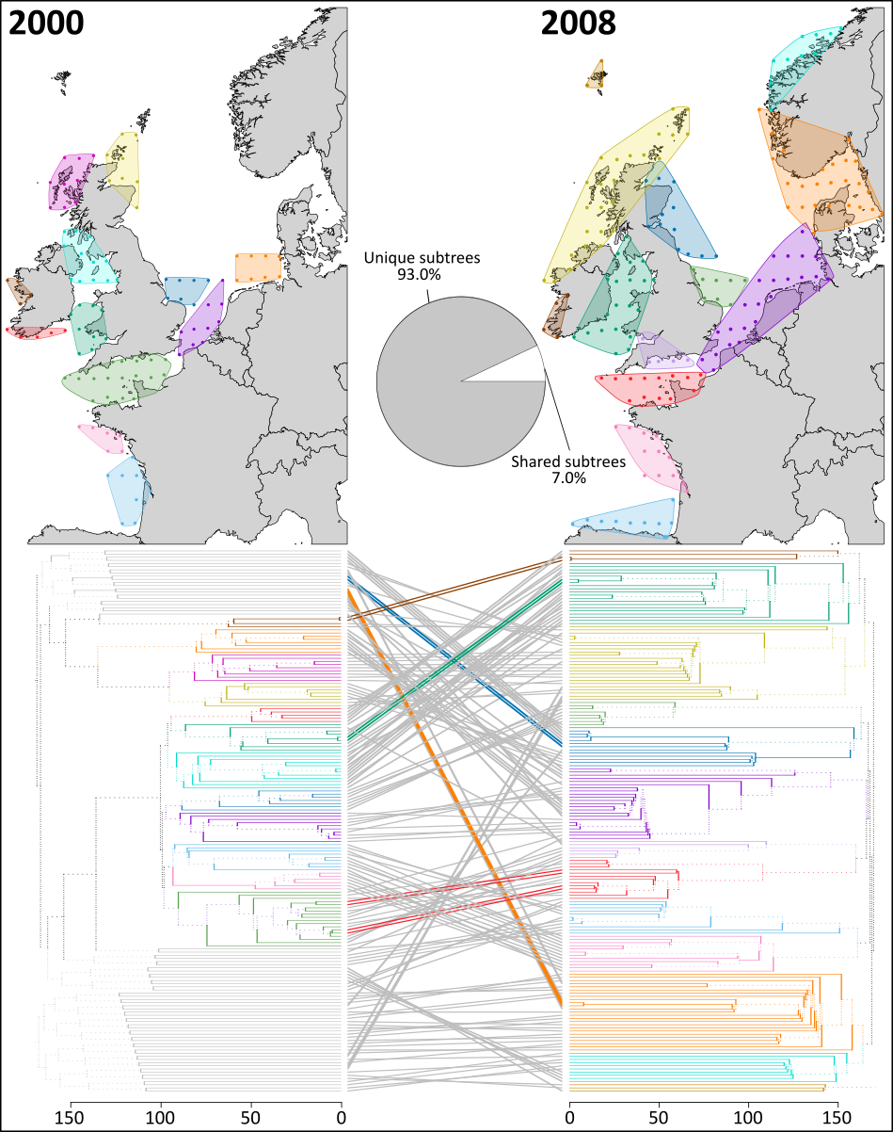
Figure S6. A comparison of the two years with the lowest value of Baker’s Gamma Index, and therefore the least similar node clustering: 2000 and 2008. The spatial arrangement of clusters is shown in maps. Hierarchical clustering of the nodes from both years are compared through the use of a tanglegram, where each leaf indicates an individual node. Dashed lines indicate branches that are not shared between the two trees. Branch and leaf colours correspond to the colour of the cluster on the map to which that node belongs. Coloured lines connecting the two trees indicate shared subtrees and are coloured corresponding to the cluster within which the node belongs in the year 2008. Grey lines indicate unique subtrees. Also shown is a pie chart indicating the percentage of subtrees that are common or unique.

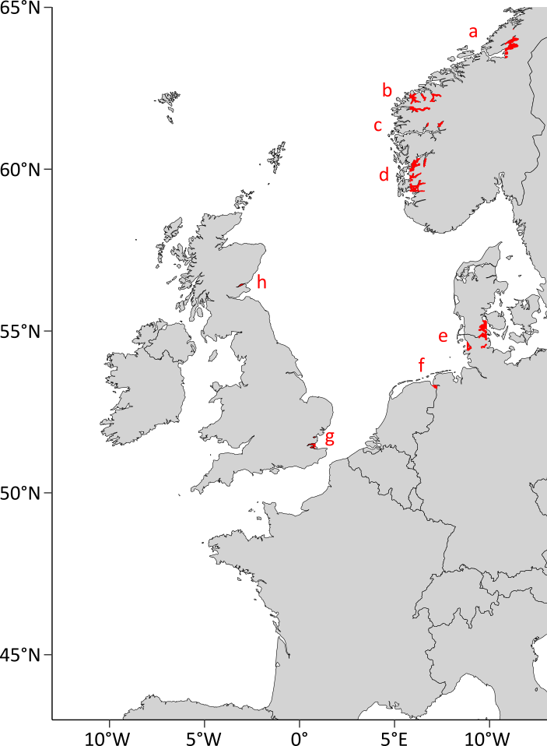
Figure S7. The locations of the eight grid polygons in the habitat grid that remained ‘uncolonised’ at the end of the 13 years. Approximate locations are (a) Beitstadfjorden and Trondheim Fjord, Norway; (b) Storfjorden, Sunnylvsfjorden, Hjørundfjorden and Nordfjord, Norway; (c) Fjærlands Fjord and Lustrafjorden, Nowray; (d) Boknafjorden and Hardangerfjord, Norway; (e) Nordstrand, Shlei, Flensborg Fjord and Little Belt, Germany and Denmark; (f) Ems and Dollard, Germany and the Netherlands; (g) River Medway and River Thames, England; (h) River Tay, Scotland.

Table S2. The number of particles classed as retained within their original grid polygon when using an anisotropic grid compared to if an isotropic grid was used for each of the 13 years modelled, and the percentage error between the two.
Year | Number of particles classed as retained using the 1° × 1° anisotropic grid | Number of particles classed as retained using an isotropic grid | % of particles “incorrectly” classed as retained
2000 | 963,226 | 956,390 | 0.7%
2001 | 2,508,725 | 2,484,604 | 1.0%
2002 | 3,425,449 | 3,407,523 | 0.5%
2003 | 4,061,690 | 4,042,250 | 0.5%
2004 | 2,738,528 | 2,703,414 | 1.3%
2005 | 3,797,304 | 3,772,309 | 0.7%
2006 | 3,461,096 | 3,438,715 | 0.6%
2007 | 4,086,983 | 4,060,389 | 0.7%
2008 | 2,348,874 | 2,321,151 | 1.2%
2009 | 2,956,808 | 2,929,839 | 0.9%
2010 | 2,912,042 | 2,885,136 | 0.9%
2011 | 3,652,363 | 3,620,757 | 0.9%
2012 | 3,230,256 | 3,196,910 | 1.0%
All years | 40,143,344 | 39,819,387 | 0.8%

