Pen Direct Writing of Multiplex-LFIA for Detection of Thiamphenicol and Tylosin in Milk
Alida Russo ª, Simone Cavalera ^{b}, Richard Murray ª, Aidan J. Quinn ª, Laura Anfossi ^{b}, Daniela Iacopino ^{a*}
ª Tyndall National Institute, University College Cork, Lee Maltings Complex, Dyke Parade, T12R5CP, Cork, Ireland
^{b} Department of Chemistry, University of Turin, Via P. Giuria 5, 10125, Turin, Italy
*Corresponding author: daniela.iacopino@tyndall.ie

Abstract
Therapeutic and misuse of veterinary drugs, such as antibiotics, can increase the potential risk of residue contamination in animal-derived food products. For milk, these residual antibiotics can have an impact on efficiency in dairy processing factories, as well as economic loss, and can also cause side effects on consumer health. Lateral flow immunoassays (LFIAs) are gaining popularity for their ease of use, low cost and their fulfilment to the REASSURED (real time connection/monitoring, easy sampling, affordable, specific, user-friendly, rapid/robust, equipment free, deliverable to end user) criteria. At the same time, direct writing of functional materials has been recently used for facile applications on point-of-care test (POCT) fabrication.
Herein, a novel multiplex-LFIA has been developed for the simultaneous detection of two antibiotics in milk: thiamphenicol and tylosin. In contrast to the traditional automated dispensers, a direct pen writing method was used to deposit control and test lines. The response of each antibiotic was tested, as well as the selectivity of the test during cross-testing. For both antibiotics, the test was successful in distinguishing between safe and unsafe milk samples, according to the maximum residue limits (MRLs) set for both antibiotics. The visual LOD obtained was 100 ppb for the two antibiotics and the IC₅₀ were lower than the set maximum residue limits (MRLs).

Keywords: LFIA – gold nanoparticles – milk – antibiotics – direct writing

Graphical abstract

- Introduction
The use of veterinary drugs in food-producing animals has the potential to release residues in animal-derived products, such as milk, meat, honey and eggs, creating a health threat to consumers [1]. As well as the threat to human health, the extensive and inappropriate use of antibiotics in food animals are contributing factors in the emergence and spread of antimicrobial resistance (AMR), which has been declared by the World Health Organization (WHO) as one of the top 10 public health threats facing humanity [2]. For the specific case of milk, the presence of antibiotic residues may lead to potential adverse side effects, such as allergic reactions in hypersensitive people or may cause long-term effects on human health, because of their toxicity or potential carcinogenicity [3]. Furthermore, presence of antibiotic residuals in milk can impact negatively on the production efficiency of cheese or fermented dairy products (i.e. yoghurts, cream, etc.) [4]. The presence of antibiotics in milk below established maximum residue limits (MRLs) should be guaranteed by well-established withdrawal periods, i.e. time needed after drug administration for the residue of toxicological concern to reach a safe concentration, as defined by the tolerance. However, antibiotic residues can be found in food products, due to factors such as improper use of the withdrawal time, use of excess veterinary drug dosages, poor farming practices resulting in contamination, poor record of treatment and separation or marking of treated cows [5].
Among veterinary drugs, thiamphenicol (amphenicols) and tylosin (macrolides) are widely used antibiotics for the treatment of bovine infections [6], accounting for a total of 11.2% of overall antibiotics sales, (2.7% amphenicols and 8.5% macrolides) in Europe [7]. To improve the quality of dairy products and ensure the safety of the final consumers, the European Commission has set MRLs of 50 μg kg⁻¹ for thiamphenicol and 100 μg kg⁻¹ for tylosin residues in milk [8], [9].
Residual thiamphenicol and tylosin detection in milk has been achieved via several chromatographic techniques, such as liquid chromatography [10], liquid chromatography-tandem mass spectrometry [11], liquid chromatography-diode array detection [12]. Faster screening methods, via optical and immunochemical biosensors, have also been developed for detecting amphenicols, especially chloramphenicol [13], [14]. Recently, sensitive detection of tylosin in food has been achieved by Shan et al, through an enzyme-linked immunosorbent assay (ELISA) combined with a double signal amplification [15]. Also, microarrays have been used for individual [21], and simultaneous detection of tylosin and chloramphenicol [18]. However, overall, these methodologies require the use of expensive instruments, trained personnel, complex sample preparation and are time-consuming. Therefore, there is a need for point-of-care (POC) tests that can be used by farmers to ensure the quality and safety of their food products in a rapid, low-cost and reliable manner.
Lateral flow immunoassays (LFIA) are POC tests gaining increasing popularity for their low cost, ease of use and complete fulfilment of the REASSURED (real time connection/monitoring, easy sampling, affordable, specific, user-friendly, rapid/robust, equipment free, deliverable to end user) criteria [19]. The LFIA working principle consists of a liquid sample migrating through a porous nitrocellulose membrane, on which capture molecules are printed, giving a visual detection through formation of coloured lines. Test and control coloured lines are formed by consequent capillary migration of biomolecules linked with a label (typically gold nanoparticles, Au NPs, in the most common visual readout format), as signal reporters/detection bioreagents [20].
LFIAs for detection of thiamphenicol in milk have been developed using both colorimetric and fluorescent readouts. Both single-test line assay [21] and multiplex assays with other similar chemical structures (chloramphenicol and florfenicol) [22] or with other antibiotics classes [23] have been proposed. Similarly, LFIA tests for tylosin have been developed using Au NPs, fluorescent particles and also latex microspheres, but not in a multiplex assay format [24], [25]. Recently, commercial pens have been identified as a viable alternative and reliable route to deposit the biochemical reagents required for the LFIA assay, replacing the use of typically utilized automatic dispensers [31]. The method of direct pen writing of biochemicals for POC tests has conferred further simplicity, affordability and do-it-yourself applicability by sensibly lowering the cost of production and expanding the usage of such tests to different scenarios and underdeveloped countries [28].
In this paper, we have developed a novel handwritten multiplex-LFIA, for simultaneous detection of thiamphenicol and tylosin in milk. Competitive tests were developed using commercial fountain pens to write the tests (T₁ and T₂) and control (C) lines onto hand assembled strips. This do-it-yourself (DIY) process allowed the fast, sensitive and simultaneous detection of two antibiotics with limits of detection below the recommended residue limits for milk.

- Materials and methods
  - Immunoreagents, chemicals and materials
Tetrachloroauric (III) acid, Tween 20, Bovine serum albumin (BSA), tylosin tartrate and thiamphenicol antibiotics, anti-sheep immunoglobulins (rabbit polyclonal antibodies), and all salts for buffer preparation were purchased from Sigma-Aldrich (Arklow, Ireland). The buffer solutions were all prepared using Milli-Q water (resistivity 18.2 MΩ·cm). The antigen Spiramycin-BSA (Spi-BSA) was purchased from Squarix GmbH (Marl, Germany), while the antigen Thiamphenicol-HS-BSA (Thiam-HS-BSA) was synthesized as described in SI1. The anti-Thiamphenicol (anti-Thiam) and anti-Tylosin (anti-Tyl) (both sheep polyclonal antibodies) were bought from Fitzgerald Industries International (Acton, MA, USA). Nitrocellulose membranes Hi-Flow Plus 180, glass fiber conjugate pad and cellulose adsorbent pad were obtained from MilliporeSigma (Burlington, MA, USA). Glass fiber sample pad GFBR4 was procured from Advanced Microdevices Pvt. Ltd. (Ambala Cantt, India).
The Parker© fountain pens (Vector model, fine nib), and their standard ink cartridges were acquired at a local art supplies shop. Whole milk was purchased from a local company, farmed and produced in the Republic of Ireland, approved by the National Dairy Council.

  - Characterization
A Zeiss Supra scanning electron microscope (SEM) was used to obtain scanning electron microscopy images (accelerating voltage of 5 kV). For attaining nanoparticle SEM images, diluted solutions have been deposited on n-doped Si wafers. A Zeiss Axioscope 5 was utilized to acquire microscope images of the LFIA nitrocellulose (light source Colibri 5, objective 10X, camera Axiocam 208 color).
UV-vis spectra were acquired using an Agilent/HP 8453 UV-vis Spectrophotometer (190 nm-1100 nm, spectral bandwidth 1 nm). Hydrodynamic diameter and zeta potential of the Au NPs aqueous solutions were obtained using Zetasizer Nano-ZS (Malvern Instruments, Malvern Panalytical, UK), based on dynamic light scattering (DLS) and electrophoretic light scattering (ELS), respectively. Bare Au NPs were measured undiluted, while surface-modified particles were diluted to obtain a range of 0.8-1 optical density (OD). An equilibration time of 120 s was maintained between each sample. Specifically, for each solution, three samples were averaged using 3 measurements with 15 runs per sample.
ImageJ and Origin 2022 were used for data analysis and scientific plotting.

  - Synthesis of Au NPs
Au NPs were synthesised through citrate reduction of tetrachloroauric (III) acid according to Turkevich-Frens [29], [30] method, as previously described by Anfossi et al [31]. Briefly, sodium citrate 1% w/v (1 mL) was added to a 0.01% w/v solution of tetrachloroauric acid (100 mL), under boiling and vigorous stirring. After the addition, a change in the solution colour was observed in order from pale yellow to grey, black, purple and up to a brilliant red colour, indicating the formation of Au NPs. After cooling to room temperature, the colloidal solution was stored at 4°C for further use.

  - Preparation of labelled immunogold nanoparticles
The ideal pH and quantity of antibodies, to cover the surface of the particles without causing their aggregation, were determined through a flocculation stress, as described in paragraph 3.2 [32].
Before proceeding with the conjugation with antibodies, the pH of the Au NPs solution (4.6 initially) was adjusted to pH 8, using CB, 50 mM, pH 9.6. Antibody conjugation to Au NPs was completed through passive adsorption of proteins onto the surface of the NPs as reported by Anfossi et al.[31] with some modifications. Briefly, 4 µg of anti-Thiam/anti-Tyl was added to Au NPs solution (1 mL), together with 100 µL of borate buffer (BB) 20 mM pH 8 and incubated for 30 min at 37 °C. A second incubation at the same temperature was performed for 10 min after addition of 100 µL of BB supplemented with 1% w/v BSA. Then, the mixture was centrifuged at 25 °C at 16,100 rcf for 10 min. Firstly, the pellet was washed by resuspension in 0.1% w/v BSA BB and, secondly, in BB containing 1% w/v BSA, 2% w/v sucrose, 0.25% v/v Tween 20 and 0.02% w/v sodium azide. The final antibody-Au NPs pellet was stored at 4 °C until further use.

  - Fabrication of multiplex LFIA strips
The LFIA strips were made up of four main components: sample pad, conjugate pad, nitrocellulose membrane, and adsorbent pad. These components were fixed on a PVC adhesive backing layer and overlapped to ensure solution flow as shown in Scheme 1A. Strips were prepared from nitrocellulose membranes via direct writing of the capture materials using different fountain pens filled with the respective solutions (Scheme 1B). The antigens Thiam-HS-BSA (0.3 mg mL⁻¹) and Spi-BSA (0.2 mg mL⁻¹) formed the test line 1 and 2 (T₁ and T₂), respectively. These were tested for their binding/competition capacity as described in SI2. The control line was constituted by 0.2 mg mL⁻¹ of anti-sheep antibodies. Both antigens and antibodies were diluted in phosphate buffer (PB) 20 mM pH 7.4. All the reagents were written with a Parker Vector fountain pen keeping a 4 mm separation between the lines.
The conjugate pad was dried for 1 h at 60 °C, after pre-treatment with BB containing 1% w/v BSA, 2% w/v sucrose, 0.25% v/v Tween 20 and 0.02% w/v sodium azide. Then, it was saturated with a mixture of antiTyl-Au NPs (OD 1.5) and antiThiam-Au NPs (OD 3) and dried at room temperature for at least 3 hours. For cross-reactivity evaluation, each probe Ab-NPs was applied to the conjugate pad separately.
The nitrocellulose membranes were dried at 37 °C for 1 hour and then laminated with sample, conjugate, and adsorbent pads. The assembled membranes were cut into 4 mm width strips, inserted into plastic cassettes, and stored in plastic bags at room temperature until further use. The digital picture of the assembles multiplex-LFIA is reported in Figure SI3.
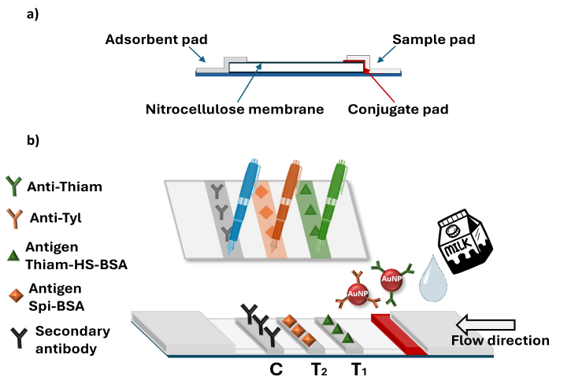
Scheme 1: a) Schematic side view of a lateral flow immunoassay strips; b) Schematic top view representation of the developed multiplex-LFIA with details on materials used, with a zoom on the direct pen-written nitrocellulose.

  - Test procedure
The test was carried out at room temperature by adding 120 μL of diluted milk sample into the sample well.
The fresh milk was diluted 1:1 with a buffer solution (PB 20 mM pH 7.4, 0.2% v/v Tween 20) and it was spiked with standard solutions of thiamphenicol and/or tylosin (0 to 500 ppb). The dilution was chosen to obtain minimal treatment for the milk matrix, since undiluted milk reduced the flow rate and influenced the test results.
The qualitative results of the tests were read by visual inspection after 15 min. At the same time, photographs of the strips were taken using a smartphone camera (48 MP) inside a 3D printed chamber illuminated with 9 LED lights to ensure reproducible illumination conditions [27].
The pictures were then processed using the software ImageJ to obtain quantitative results.

- Results and discussion
  - Direct pen writing on nitrocellulose
The lines in the LFIA were written using Parker© fountain pens, which are constituted by a metallic fine nib and an ink reservoir for aqueous solutions that together, through a combination of gravity and capillary action, allow the release of the ink. The constituent reagents of the three LFIA lines were loaded in the reservoir of three different pens, to avoid any reagent contamination. Figure 1a shows the digital image and optical microscopy images for the three lines of a developed multiplex test. The images display formation of lines with widths of ~ 650 µm and two focal depths, one for the surface and one for the furrow indented in the nitrocellulose. A similar behaviour was found as well by Warren et al., who observed the characteristic “W” shape of the nib of a fountain pen directly writing carbon nanofibers on paper [33]. As visible from Figure 1a, T₁ and C results are homogenous under the microscope, while T₂ presents some fractures along the furrow, that were probably determined by the hand pressure used for writing the pen or during positioning of the nib onto the nitrocellulose. However, these fractures do not influence the quality of generated response as observed from the symmetrical and narrow plot profiles shown in Figure 1b.
To measure the quantity of reagent material released during direct writing onto the nitrocellulose, the weight of the pen was recorded before and after writing the lines. It was calculated that, on average, 13 ± 2 µL were released per 30 cm membrane per line (about 0.43 µL cm⁻¹). Thus, the use of the pen approximately halves the amount of reagent normally used during deposition of the reagents with the automatic dispenser (1 µL cm⁻¹). Similarly, the minimal quantity necessary to deposit the reagents onto the nitrocellulose is also lower while “writing” rather than using the automatic deposition. The former requires a minimum load of 250 µL into the cartridge while the latter requires around 500-800 µL to fill the tubing system (see SI4). In fact, the pen does not require filling any tubes and therefore has no waste of precious reagents. This could make the difference in case of limited access to biomaterials.
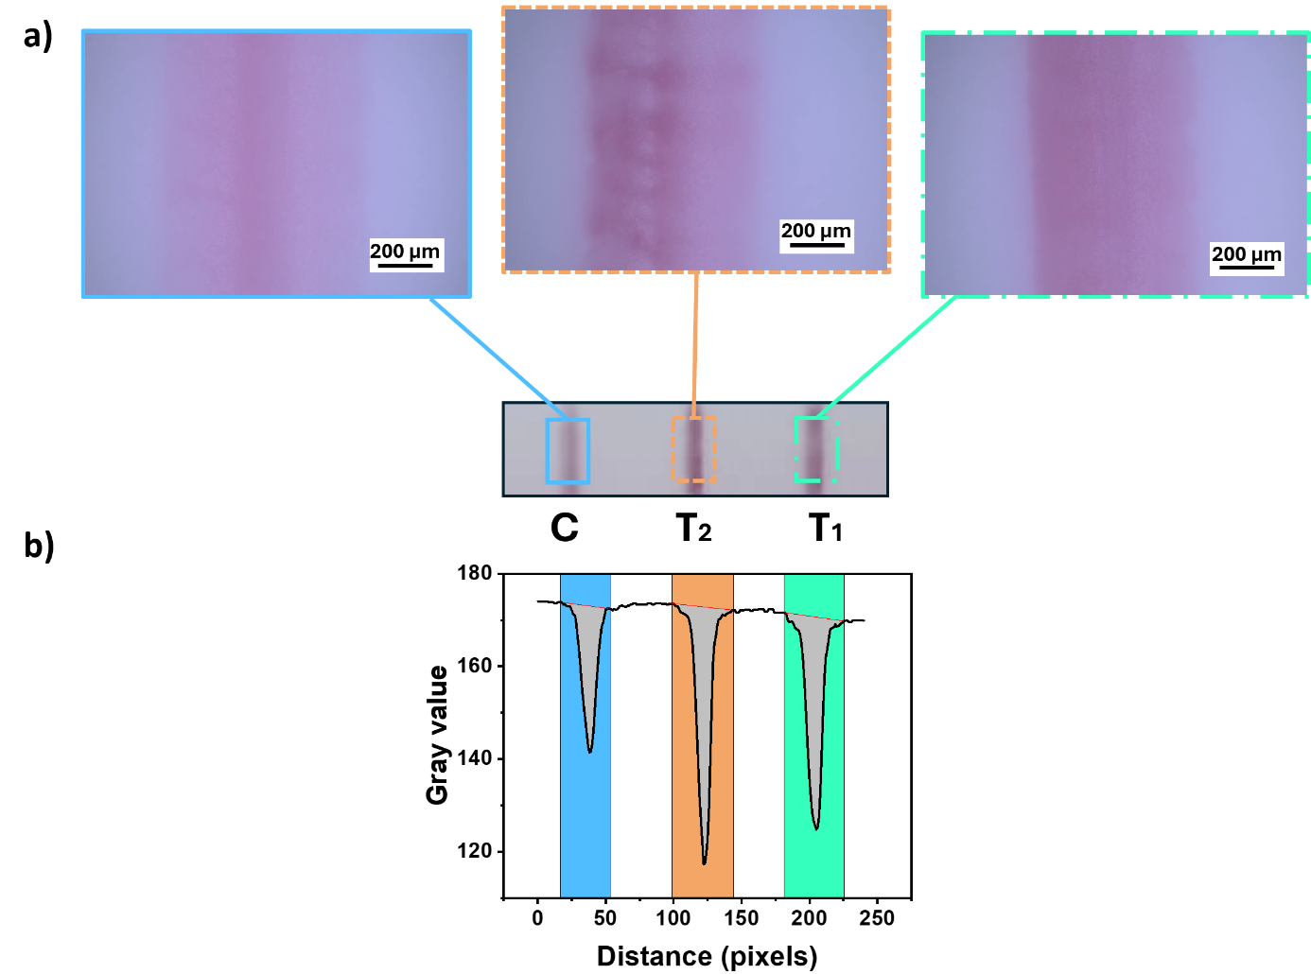
Figure 1: a) Visualisation of the multiplex-strip under the microscope (10X objective); from right to left: test line 1 (green, dash dotted line), test line 2 (orange, dashed line) control line (blue, solid line); b) plot profile obtained along the strip related to the intensity of the colour of the lines.
  - LFIA immunoprobes preparation and characterisation
Figure 2a shows the scanning electron microscope (SEM) image of synthesised Au NPs displaying spherical shape with an average diameter of 25 nm ± 5 nm (Figure 2a, inset). UV-vis characterization showed that as-synthesized NPs had a Localised Surface Plasmon Resonance (LSPR) band centred at 524 nm (Figure 2b, black curve). Bare Au NPs were functionalised with two antibodies, antiThiam and antiTyl, to allow the detection of thiamphenicol and tylosin, respectively. The surface modification was achieved by passive adsorption of the antibodies and caused a small shift of the max LSPR to 530 nm and 529 nm for Au-antiThiam and Au-antiTyl, respectively (Figure 2a, red and blue curves). The ideal pH of the Au NPs solution (pH 8) and quantity of antibodies (4 µg for 1 mL of Au NPs OD ~ 1) for the conjugation were chosen through a flocculation stress test. Specifically, the pH of the as-synthesized particles solution was adjusted to 6, 7 and 8 using a sodium bicarbonate-sodium carbonate buffer (CB, 50 mM, pH 9.6). 500 μL of Au NPs OD 1 were incubated for 30 min at 37 °C with increasing volumes (0-10-20-30-40-50 μL) of the two antibodies (0.1 mg mL⁻¹ in PB) in presence of decreasing amount of PB to balance the volumes. Then, 50 μL of NaCl 10% w/v were added to each solution, reacting for 10 min and causing a colour transition from red to purple/ blue-grey in case of aggregation of unstable Au NPs, corresponding to an LSPR transition from 540 to 620 nm. After an initial visual inspection, the absorbance of these solutions was recorded at 540 nm and 620 nm. The former absorbance is related to the non-aggregated fraction of Au NPs, the latter to the aggregated one. The results are reported in the SI in Table SI1, Table SI2 and Figure SI5.
A final choice of pH 8 conditions was done considering the stability of the Au NPs with the two antibodies as well as the necessity to mix the two conjugates. For both antibiotics the optimal quantity of antibody to get stable Au NPs was in the range 4-6 μg per 1 mL Au NPs. Finally, considering the competitive layout of the test, 4 μg antibodies per 1 mL of Au NPs (OD 1) was chosen for both antiThiam and antiTyl.

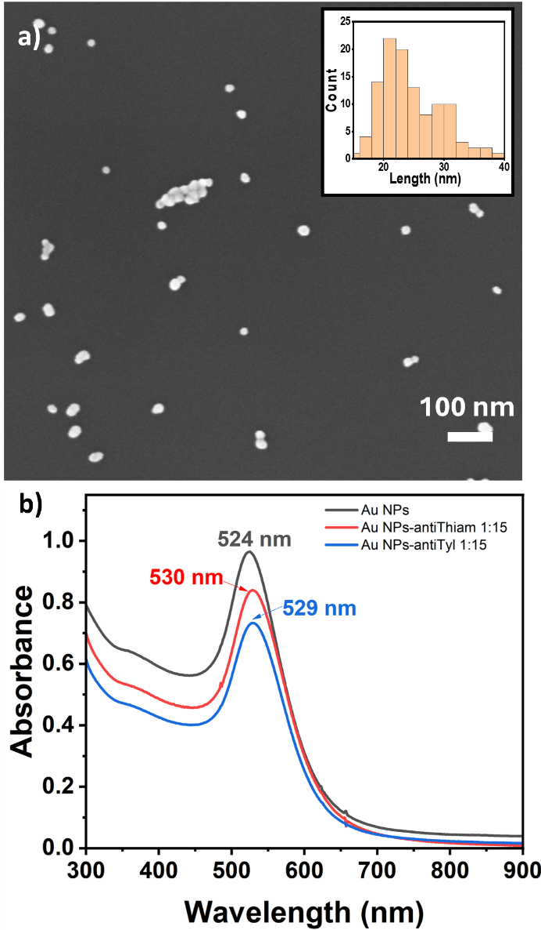
Figure 2: A) SEM image of Au NPs solutions deposited on n-doped Si wafer with nanoparticles size distribution (inset); B) UV-vis spectra of the bare Au NPs (black) and the conjugates Au NPs-antiThiam (red) and Au NPs-antiTyl (blue).

For characterizing the probes, also DLS and zeta potential measurements were performed. The former one gives information about the hydrodynamic diameter of Au NPs and their conjugates at 25 °C. The results (see Table 1) were obtained as an average of three samples per material. The DLS measurements showed that the adsorption of antibodies onto the Au NP surface caused an increase of the particle size, larger for the adsorption of antiThiam than antiTyl. Since the size of antibodies is comparable to the size of cylinders (6-7 nm diameter, 8 nm length) [34], the results obtained suggest formation of multilayers and/or random attachment onto the surface causing protuberances that modify the scatter of light. These results agree with antibody conjugation through passive adsorption on the NP surface; even though this random orientation could affect the test sensitivity, decreasing the quantity of antibody available, it is far more rapid, easy and inexpensive compared to strategies that would allow a certain orientation of the antibody, such as covalent conjugation or mediated by a layer of binding protein [35]. Table 1 as well reports the results for zeta potential, parameter connected to the surface charge of the Au NPs. The results show a decrease in the surface charge of the Au NPs following antibodies’ conjugation (zeta potential increase).

Table 1. Hydrodynamic diameters and zeta potentials of the bare and biomodified gold nanoparticles.
Material | Hydrodynamic diameter (nm) | Zeta potential (mV)
Au NPs (pH 8) | 41 ± 3 | -42.2 ± 2.8
Au NPs-antiThiam | 102 ± 11 | -24.2 ± 0.9
Au NPs-antiTyl | 84 ± 8 | -24.5 ± 1.1

  - Optimization of the multiplex-LFIA parameters
Different parameters were evaluated during the design and optimization of the test, including the use of different nitrocellulose membranes, sample pad, the composition of the running buffer, the amount of the reagents deposited on the two test lines and on the control line, the optical density for the conjugates and the pre-treatment of the sample.
The choice of nitrocellulose membrane is key as pore size, capillarity speed rate and protein binding capability influence the flow of the conjugate into the membrane, yielding an optimal reaction time. After testing CNPC-10µm (Advances Microdevices LTD, India) and Hi-Flow Plus 180 Millipore (MilliporeSigma) membranes, the latter was chosen as more suitable for this work (Figure SI6a). A glass fiber sample pad GFBR4 (Advances Microdevices LTD, India) was chosen instead of the commonly-used cellulose pad in order to improve the sample flow. Further, the thinner glass pad also allowed a consistent contact with the conjugate pad and the use of a reduced sample volume (Figure SI6b).
Considering the composition of utilized whole milk (3.5 g fat, 3.3 g protein, 4.8 g sugars per 100 mL), the matrix had enough complexity to interfere with the flow of the assay. Therefore, it was necessary to dilute the milk sample 1:1 with a running buffer (phosphate buffer (20 mM, pH 7.4) containing 0.2% v/v Tween 20). The presence of a mild non-ionic surfactant, such as Tween 20, on the buffer can greatly improve the LFIA sensitivity and specificity by reducing nonspecific interaction and easing the transportation of the conjugate from its pad to the membrane. Other additives, such as casein or BSA proteins, usually added to the buffer, were not included as they are already present in the milk matrix.
Considering the detection of two antibiotics simultaneously, they were previously studied individually (see SI7 for thiamphenicol and SI9 for tylosin) and they were tested for a hypothetical cross-reactivity, before merging within the same test (see SI9).
Prior to line tests, simpler dot tests were employed to optimise the concentration of the antigens and secondary antibody on the nitrocellulose membrane, using 1 μL/dot of reagent. These concentrations were adjusted to increase the performance of the test, while using the least feasible amount of bioreagents. In particular, the final concentration for the three lines, in order of flow direction, were 0.3 mg mL⁻¹ Thiam-HS-BSA (T₁), 0.2 mg mL⁻¹ Spi-BSA (T₂), 0.2 mg mL⁻¹ secondary antibody (C). All the lines were handwritten, using their bio-constituents as “ink” inside the reservoir of fountain pens.
Lastly, another parameter to optimize was the concentration of the conjugates Au NPs-antiThiam and Au NPs-antiTyl used in the conjugate pad to maintain a good intensity on the colour of the lines, while keeping constant the concentration of the lines. Mostly, this parameter was modified during the development of the multiplex test, to have similar colour intensity for the two test lines in a negative test. The final concentrations were OD 3 for Au NPs-antiThiam and OD 1.5 for Au NPs-antiTyl. This optimization was considered important to overcome the already counterintuitive readout of a competitive test, avoiding further confusion for the observer. Using two separate conjugate pads, one on top of the other, was also considered a possibility (see SI10); although to prevent one of the two conjugates from having a “preferential run” towards the lines, it was decided to mix them in the same pad.

  - Detection of Thiamphenicol and Tylosin in milk
Since the antibiotics are small molecules, LFIA detection was performed in a competitive format whereby the presence of target antibiotics was associated to the disappearance of the test lines. In the developed multiplex assay, there would be two test lines on the same test, T₁ related to the presence of thiamphenicol and T₂ for tylosin. All the possible results observable with this multiplexed assay are shown in Figure 3.
Prior to conducting quantitative analysis, the multiplex-LFIA strips were tested for the cross-reactivity of the labelled antibodies. Figure 4a,b displays the visual results and the plot profiles obtained using a conjugate pad containing only Au NPs-antiThiam OD 3 and only Au NPs-antiTyl OD 3, respectively. Accordingly, only one red line corresponding to detection of thiamphenicol and tylosin was observed in each test. No signals on the line corresponding to the other antibiotic were visible.

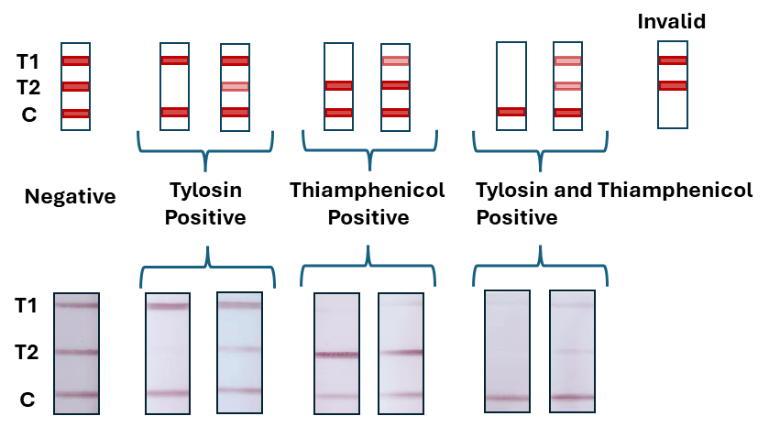
Figure 3: Schematic (top) and digital photographs (bottom) of the possible results obtained with this multiplex-LFIA. From left to right: negative sample (no antibiotics in milk), 500 ppb and 50 ppb Tylosin in milk, 500 ppb and 50 ppb Thiamphenicol in milk, both antibiotics at the concentration of 500 ppb and 50 ppb in milk. In case of non-visible control line, the test results invalid (no sample gave invalid results, thus no digital photograph).

Moreover, the negative and positive responses were also examined, as shown in Figure 4c,d. Three intense coloured lines were formed in the negative test (Figure 4c), since there were no antibiotics in the sample competing for the binding of the capture antibodies, as visible also from the plot profile. In contrast, the positive response (Figure 4d) for both antibiotics showed just one coloured control line, since the Au NP-labelled antibodies bound preferentially to the antibiotics present in the milk sample, instead of binding to the two antigens deposited on the test lines.
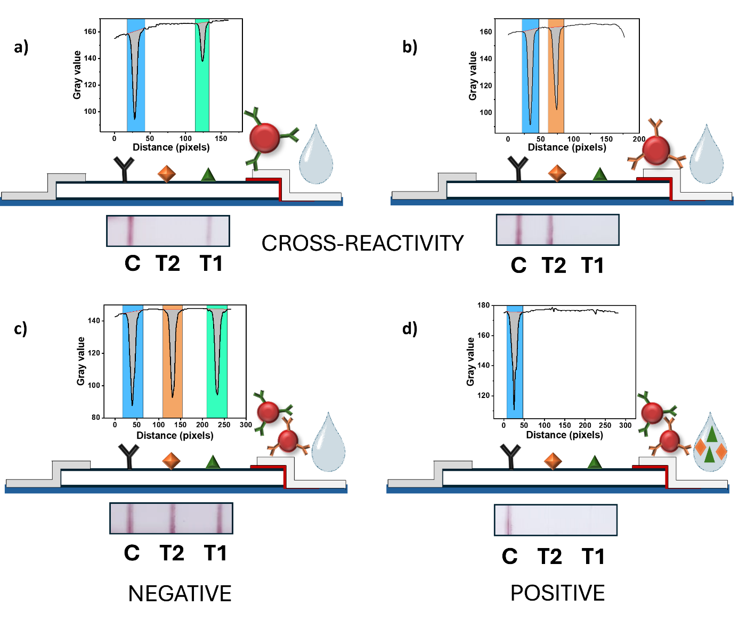
Figure 4: Plot profiles, schematics and digital pictures of the developed multiplex-LFIA for four LFIA tests: a) cross-reactivity using only Au NPs-antiThiam; b) cross-reactivity using only Au NPs-antiTyl; c) negative sample; d) positive sample.
Following the optimization steps described above, the quantitative capabilities of the multiplex-LFIA tests were investigated towards the individual presence of thiamphenicol or tylosin in milk samples. Figure 5a,d show photographs of LFIA strips obtained with milk samples spiked with standard solutions (0-1-5-10-50-100-250-500 ppb) of thiamphenicol and tylosin, respectively. As anticipated, the intensity of the diagnostics lines (T1, thiamphenicol and T2 tylosin) decreased with increased concentrations of the two antibiotics.
The pictures were processed using ImageJ to obtain quantitative results. Considering the red colour given by the gold nanoparticles, to obtain higher sensitivity, the image was split into RGB (red-green-blue) channels for analysing the green one. Using the “straight” command along the membrane, the plot profile was extracted and exported in the data analysis software (Origin 2022). From the plot profile, it was possible to calculate the peak areas corresponding to the colour intensity of the lines.
A sigmoidal dependence of the intensity of the test lines T (also when normalised for the intensity of the control line T/C) vs. the logarithm of the antibiotic concentration was found for the range analysed. The curves represented in Figure 5b,c,e,f were obtained through a nonlinear regression analysis of the data using a 4-parameter logistic equation. Except for the curve in Fig. 5e, all the curves obtained have a correlation coefficient R² ≥ 0.95.
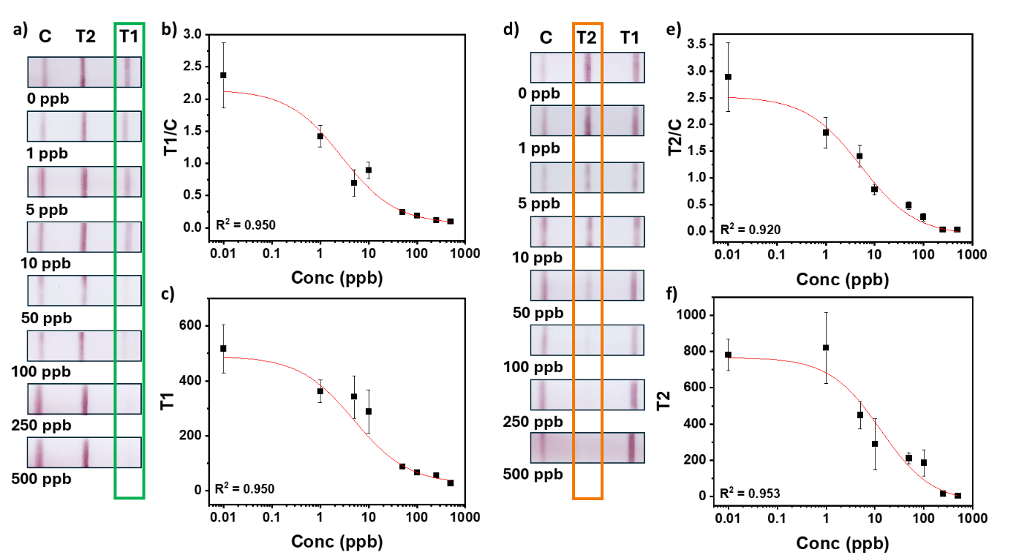
Figure 5: Quantitative analysis of multiplex-LFIA for thiamphenicol and tylosin, individually spiked in milk samples. For both antibiotics are reported the calibration curves obtained for both the normalised intensity of the test line (T/C) (thiam, a; tyl, d) and the intensity itself (T) (thiam, b; tyl, e), and the visual readout of the strips at different levels of antibiotic concentrations (thiam, c; tyl, f). The error bars refer to three measurements.

Finally, Figure 6 shows the quantitative results of the multiplex-LFIA for simultaneous detection of thiamphenicol and tylosin in milk samples. In particular, Figure 6a shows photographs of the LFIA strips obtained through analysis of milk samples spiked simultaneously with standard solutions of thiamphenicol and tylosin (0, 1, 5, 10, 50, 100, 250, 500 ppb). In this case, it is possible to observe the decrease of the colour intensity for both test lines increasing the concentration of both.
Similarly, the images have been processed using ImageJ and the data obtained was processed through Origin 2022, plotting the curves in Figure 6b,c,d,e obtained through a nonlinear regression analysis using a 4-parameter logistic equation. In this case, all the curves have a correlation coefficient R² ≥ 0.97.
Further details on the analysis of the data are reported in Table SI3. The visual limit of detection (vLOD), defined as the analyte concentration which give an initial test line coloration, was 100 ppb for both antibiotics. The sensitivity of the test was defined as the IC₅₀, corresponding to the concentration of the analyte producing 50% signal inhibition. For both thiamphenicol and tylosin, the IC₅₀ obtained were lower than the MRL values in bovine milk set by the European commission, 50 μg kg⁻¹ (50 ppb) and 100 μg kg⁻¹ (100 ppb), respectively [1] [9]. The results obtained are compared with other detection methods in Table SI4.
The stability of the test was analysed at day 1, day 7 and day 30 at room temperature at three different concentrations of antibiotics (0-10-100 ppb) as reported in Figure SI11.
Moreover, Figure SI12 shows the comparison between the response of a negative sample and the results obtained spiking milk with three antibiotics different from the investigated ones: tetracycline, penicillin g and streptomycin.
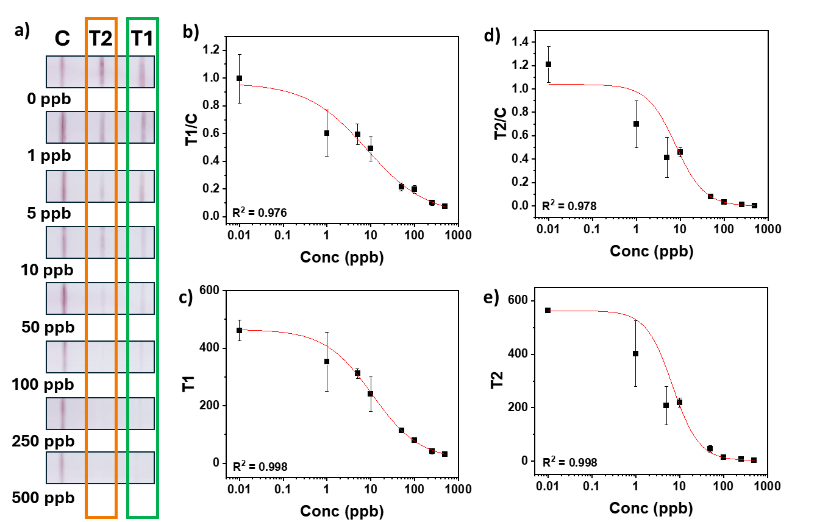
Figure 6: Quantitative analysis of multiplex-LFIA for simultaneous presence of thiamphenicol (T₁) and tylosin (T₂) in milk samples. For both antibiotics are reported the calibration curves obtained for both the normalised intensity of the test line (T/C) (thiam, a; tyl, c) and the intensity itself (T) (thiam, b; tyl, d), and the visual readout of the strips at simultaneous presence of both antibiotics at different levels of concentrations (e). The error bars refer to three measurements.

- Conclusions
In summary, an affordable, resource-efficient handwritten multiplex-LFIA has been developed for simultaneous detection of thiamphenicol and tylosin in bovine milk using readily available dispensing device (fountain pens) and visual/smartphone inspection. The test allowed fast and sensitive detection of the two antibiotics, only with a slight sample pre-treatment. The developed LFIA tests is opening the possibility to monitor the quality of milk in different settings, also by minimally trained personnel. The test gave a visual LOD of 100 ppb for both antibiotics and the IC₅₀ obtained through calibration curves were lower than the MRLs set by the European Commission for both of them.
The direct writing method, used for the fabrication of the test instead of the automatic dispenser, indicated the potential to produce screening tests, such as LFIA, in low-income regions with limited laboratory facilities.
The multiplex configuration helped decreasing the diagnostic cost, improving the efficiency and high-throughput detection. Furthermore, the classical visual detection provides a simple and cost-effective opportunity to apply this technology in real-world applications, but gives also the flexibility to expand the method with a dual detection, either changing the labels or modifying the surface of Au NPs, thus further improving the sensitivity.

AUTHOR INFORMATION
Corresponding Author
*daniela.iacopino@tyndall.ie
Data Availability Statement
The data presented in this article are available from the author upon reasonable request.
Author Contributions
The manuscript was written through contributions of all authors. All authors have given approval to the final version of the manuscript.
Funding Sources
This publication has emanated from research conducted with the financial support of Science Foundation Ireland (SFI) under the Department of Agriculture, Food and Marine on behalf of the Government of Ireland under Grant Number 16/RC/3835 (VISTAMILK) and 13/RC/2077-P2 (CONNECT). LA and SC acknowledge financial support from the project TECH4MILK (Regione Piemonte, F.E.S.R. 2014/2020 e F.S.E. 2014/2020).
References
[1] Commission Regulation (EU) No 37/2010 of 22 December 2009 on pharmacologically active substances and their classification regarding maximum residue limits in foodstuffs of animal origin, vol. L 15. 2009, pp. 1–72. [Online]. Available: https://eur-lex.europa.eu/legal-content/EN/TXT/?uri=CELEX%3A32010R0037
[2] M. Ibrahim et al., ‘Chapter 4 - Current trends of antimicrobials used in food animals and aquaculture’, in Antibiotics and Antimicrobial Resistance Genes in the Environment, vol. 1, M. Z. Hashmi, Ed., in Advances in Environmental Pollution Research series, vol. 1. , Elsevier, 2020, pp. 39–69. doi: 10.1016/B978-0-12-818882-8.00004-8.
[3] F. Conzuelo et al., ‘Integrated disposable electrochemical immunosensors for the simultaneous determination of sulfonamide and tetracycline antibiotics residues in milk’, Biosensors and Bioelectronics, vol. 50, pp. 100–105, Dec. 2013, doi: 10.1016/j.bios.2013.06.019.
[4] B. G. Knecht, A. Strasser, R. Dietrich, E. Märtlbauer, R. Niessner, and M. G. Weller, ‘Automated Microarray System for the Simultaneous Detection of Antibiotics in Milk’, Analytical Chemistry, vol. 76, no. 3, pp. 646–654, 2004, doi: 10.1021/ac035028i.
[5] S. A. McEwen, A. H. Meek, and W. D. Black, ‘A Dairy Farm Survey of Antibiotic Treatment Practices, Residue Control Methods and Associations With Inhibitors in Milk’, J Food Prot, vol. 54, no. 6, pp. 454–459, Jun. 1991, doi: 10.4315/0362-028X-54.6.454.
[6] ‘Health Products Regulatory Authority - Use of Antibiotics in Dairy Cows’. [Online]. Available: https://www.hpra.ie/homepage/veterinary/special-topics/use-of-veterinary-medicines-in-food-producing-animals/article---use-of-antibiotics-in-dairy-cows
[7] ‘Sales of veterinary antimicrobial agents in 31 European countries in 2022 - Trends from 2010 to 2022 - Thirteenth ESVAC report’, Nov. 2023. [Online]. Available: https://www.ema.europa.eu/en/documents/report/sales-veterinary-antimicrobial-agents-31-european-countries-2022-trends-2010-2022-thirteenth-esvac-report_en.pdf
[8] Commission Regulation (EC) No 508/1999 of 4 March 1999 amending Annexes I to IV to Council Regulation (EEC) No 2377/90 laying down a Community procedure for the establishment of maximum residue limits of veterinary medicinal products in foodstuffs of animal origin, vol. 060. 1999. Accessed: May 26, 2023. [Online]. Available: http://data.europa.eu/eli/reg/1999/508/oj/eng
[9] ‘Codex Alimentarius - Maximum Residue Limits (MRLs) and Risk management recommendations (RMRs) for residues of veterinary drugs in foods’. [Online]. Available: https://www.fao.org/fao-who-codexalimentarius/codex-texts/maximum-residue-limits/en/
[10] J. Hassan, G.-R. Shams, M. Pourrastegar, and A. Pourshaban-Shahrestani, ‘Application of salting-out assisted liquid-liquid extraction for the determination of oxytetracycline, tetracycline, tilmicosin, and tylosin in cow milk by liquid chromatography with photodiode array detection’, MethodsX, vol. 12, p. 102616, Jun. 2024, doi: 10.1016/j.mex.2024.102616.
[11] M. Hu, Y. Ben, M. H. Wong, and C. Zheng, ‘Trace Analysis of Multiclass Antibiotics in Food Products by Liquid Chromatography-Tandem Mass Spectrometry: Method Development’, J. Agric. Food Chem., vol. 69, no. 5, pp. 1656–1666, Feb. 2021, doi: 10.1021/acs.jafc.0c05778.
[12] V. Samanidou, L.-D. Galanopoulos, A. Kabir, and K. G. Furton, ‘Fast extraction of amphenicols residues from raw milk using novel fabric phase sorptive extraction followed by high-performance liquid chromatography-diode array detection’, Analytica Chimica Acta, vol. 855, pp. 41–50, Jan. 2015, doi: 10.1016/j.aca.2014.11.036.
[13] C. S. Thompson, I. M. Traynor, T. L. Fodey, P. Barnes, D. V. Faulkner, and S. R. H. Crooks, ‘Screening method for the detection of residues of amphenicol antibiotics in bovine milk by optical biosensor’, Food Additives & Contaminants: Part A, vol. 37, no. 11, pp. 1854–1864, Nov. 2020, doi: 10.1080/19440049.2020.1809718.
[14] T. L. Fodey et al., ‘Approaches for the simultaneous detection of thiamphenicol, florfenicol and florfenicol amine using immunochemical techniques’, Journal of Immunological Methods, vol. 393, no. 1, pp. 30–37, Jul. 2013, doi: 10.1016/j.jim.2013.04.003.
[15] S. Shan et al., ‘Integrated double signal amplification systems with ELISA assay for sensitive detection of tylosin in food’, Food and Agricultural Immunology, vol. 35, no. 1, p. 2292971, Dec. 2024, doi: 10.1080/09540105.2023.2292971.
[16] Y. Bang-Ce, L. Songyang, Z. Peng, and L. Xiao-hong, ‘Simultaneous detection of sulfamethazine, streptomycin, and tylosin in milk by microplate-array based SMM–FIA’, Food Chemistry, vol. 106, no. 2, pp. 797–803, Jan. 2008, doi: 10.1016/j.foodchem.2007.06.006.
[17] N. Liu et al., ‘Simultaneous and rapid detection of multiple pesticide and veterinary drug residues by suspension array technology’, Biosensors and Bioelectronics, vol. 41, pp. 710–716, Mar. 2013, doi: 10.1016/j.bios.2012.09.050.
[18] Z. Peng and Y. Bang-Ce, ‘Small molecule microarrays for drug residue detection in foodstuffs’, J Agric Food Chem, vol. 54, no. 19, pp. 6978–6983, Sep. 2006, doi: 10.1021/jf061105+.
[19] K. J. Land, D. I. Boeras, X.-S. Chen, A. R. Ramsay, and R. W. Peeling, ‘REASSURED diagnostics to inform disease control strategies, strengthen health systems and improve patient outcomes’, Nat Microbiol, vol. 4, no. 1, pp. 46–54, Jan. 2019, doi: 10.1038/s41564-018-0295-3.
[20] A.-C. Mirica, D. Stan, I.-C. Chelcea, C. M. Mihailescu, A. Ofiteru, and L.-A. Bocancia-Mateescu, ‘Latest Trends in Lateral Flow Immunoassay (LFIA) Detection Labels and Conjugation Process’, Front. Bioeng. Biotechnol., vol. 10, Jun. 2022, doi: 10.3389/fbioe.2022.922772.
[21] L. Guo, S. Song, L. Liu, J. Peng, H. Kuang, and C. Xu, ‘Comparsion of an immunochromatographic strip with ELISA for simultaneous detection of thiamphenicol, florfenicol and chloramphenicol in food samples’, Biomedical Chromatography, vol. 29, no. 9, pp. 1432–1439, 2015, doi: 10.1002/bmc.3442.
[22] J. Wang et al., ‘Development of a quantitative fluorescence-based lateral flow immunoassay for determination of chloramphenicol, thiamphenicol and florfenicol in milk’, Food and Agricultural Immunology, vol. 29, no. 1, pp. 56–66, Jan. 2018, doi: 10.1080/09540105.2017.1359498.
[23] X. Lei et al., ‘Gold-nanoparticle-based multiplex immuno-strip biosensor for simultaneous determination of 83 antibiotics’, Nano Res., vol. 16, no. 1, pp. 1259–1268, Jan. 2023, doi: 10.1007/s12274-022-4762-z.
[24] X. Li et al., ‘Three lateral flow immunochromatographic assays based on different nanoparticle probes for on-site detection of tylosin and tilmicosin in milk and pork’, Sensors and Actuators B: Chemical, vol. 301, p. 127059, Dec. 2019, doi: 10.1016/j.snb.2019.127059.
[25] Y. Wang et al., ‘Development of Time-Resolved Fluorescence Immunochromatographic Assays for Simultaneously Detecting Tylosin and Tilmicosin in Milk in Group-Screening Manner’, Foods, vol. 10, no. 8, p. 1838, Aug. 2021, doi: 10.3390/foods10081838.
[26] Y. L. Han, J. Hu, G. M. Genin, T. J. Lu, and F. Xu, ‘BioPen: direct writing of functional materials at the point of care’, Sci Rep, vol. 4, no. 1, Art. no. 1, May 2014, doi: 10.1038/srep04872.
[27] A. Russo et al., ‘Pen direct writing of SERRS-based lateral flow assays for detection of penicillin G in milk’, Nanoscale Adv., vol. 6, no. 5, pp. 1524–1534, Feb. 2024, doi: 10.1039/D3NA00846K.
[28] Z. Li, H. Liu, X. He, F. Xu, and F. Li, ‘Pen-on-paper strategies for point-of-care testing of human health’, TrAC Trends in Analytical Chemistry, vol. 108, pp. 50–64, Nov. 2018, doi: 10.1016/j.trac.2018.08.010.
[29] J. Turkevich, P. C. Stevenson, and J. Hillier, ‘A study of the nucleation and growth processes in the synthesis of colloidal gold’, Discuss. Faraday Soc., vol. 11, p. 55, 1951, doi: 10.1039/df9511100055.
[30] G. Frens, ‘Controlled Nucleation for the Regulation of the Particle Size in Monodisperse Gold Suspensions’, Nature Physical Science, vol. 241, no. 105, Art. no. 105, Jan. 1973, doi: 10.1038/physci241020a0.
[31] L. Anfossi, M. Calderara, C. Baggiani, C. Giovannoli, E. Arletti, and G. Giraudi, ‘Development and application of a quantitative lateral flow immunoassay for fumonisins in maize’, Analytica Chimica Acta, vol. 682, no. 1, pp. 104–109, Dec. 2010, doi: 10.1016/j.aca.2010.09.045.
[32] Y.-R. Guo, S.-Y. Liu, W.-J. Gui, and G.-N. Zhu, ‘Gold immunochromatographic assay for simultaneous detection of carbofuran and triazophos in water samples’, Analytical Biochemistry, vol. 389, no. 1, pp. 32–39, Jun. 2009, doi: 10.1016/j.ab.2009.03.020.
[33] H. Warren, R. D. Gately, H. N. Moffat, and M. In Het Panhuis, ‘Conducting carbon nanofibre networks: dispersion optimisation, evaporative casting and direct writing’, RSC Adv., vol. 3, no. 44, p. 21936, 2013, doi: 10.1039/c3ra43743d.
[34] A. San Paulo and R. García, ‘High-Resolution Imaging of Antibodies by Tapping-Mode Atomic Force Microscopy: Attractive and Repulsive Tip-Sample Interaction Regimes’, Biophysical Journal, vol. 78, no. 3, pp. 1599–1605, Mar. 2000, doi: 10.1016/S0006-3495(00)76712-9.
[35] F. Di Nardo, S. Cavalera, C. Baggiani, C. Giovannoli, and L. Anfossi, ‘Direct vs Mediated Coupling of Antibodies to Gold Nanoparticles: The Case of Salivary Cortisol Detection by Lateral Flow Immunoassay’, ACS Appl. Mater. Interfaces, vol. 11, no. 36, pp. 32758–32768, Sep. 2019, doi: 10.1021/acsami.9b11559.

