Table S1.
Average values of chemical soil properties across different soil types and depths, including pH, total nitrogen (N_tot), total carbon (C_tot), soil organic carbon (SOC), K and P obtained by Morgan extraction (K_mor and P_mor), Al, Ca, Fe, K, Mg, and P obtained by Mehlich-3 test (Al_M3, Ca_M3, Fe_M3, K_M3, Mg_M3 and P_M3)

Soil type | Depth  (cm) | pH | N_tot  (%) | C_tot  (%) | SOC  (%) | K_mor  (mg/L) | P_mor  (mg/L) | Al_M3  (mg/kg) | Ca_M3  (mg/kg) | Fe_M3  (mg/kg) | K_M3  (mg/kg) | Mg_M3  (mg/kg) | P_M3  (mg/kg)
Brown Earth | 0-15 | 6.46 | 0.28 | 3.11 | 2.96 | 107.37 | 5.57 | 774.52 | 1743.99 | 287.24 | 157.15 | 144.45 | 65.53
Brown Earth | 15-30 | 6.63 | 0.19 | 2.08 | 1.98 | 73.69 | 3.87 | 828.94 | 1448.41 | 241.11 | 104.52 | 114.06 | 45.24
Brown Earth | 30-45 | 6.85 | 0.10 | 0.99 | 0.94 | 42.64 | 1.18 | 947.98 | 988.26 | 189.26 | 62.53 | 78.61 | 19.37
Brown Earth | 45-60 | 6.96 | 0.06 | 0.59 | 0.54 | 36.23 | 1.17 | 960.55 | 839.01 | 164.59 | 49.82 | 69.72 | 18.28
Luvisol | 0-15 | 6.72 | 0.29 | 2.99 | 2.83 | 104.85 | 4.70 | 654.84 | 2250.20 | 280.58 | 158.12 | 179.55 | 44.42
Luvisol | 15-30 | 6.93 | 0.17 | 1.79 | 1.73 | 55.28 | 2.36 | 709.17 | 1771.67 | 211.23 | 89.15 | 136.72 | 24.44
Luvisol | 30-45 | 7.29 | 0.10 | 1.15 | 0.89 | 27.34 | 0.86 | 744.86 | 1954.08 | 159.31 | 58.26 | 109.78 | 10.47
Luvisol | 45-60 | 7.57 | 0.07 | 1.60 | 0.72 | 25.81 | 0.66 | 664.72 | 4655.84 | 134.46 | 52.28 | 105.61 | 8.02
Brown Podzolic | 0-15 | 5.91 | 0.38 | 5.27 | 5.07 | 77.20 | 2.82 | 664.50 | 1668.57 | 401.36 | 113.98 | 154.78 | 43.74
Brown Podzolic | 15-30 | 5.79 | 0.22 | 2.78 | 2.67 | 39.98 | 0.47 | 979.72 | 980.11 | 279.35 | 56.56 | 78.03 | 18.80
Brown Podzolic | 30-45 | 5.96 | 0.14 | 1.70 | 1.55 | 19.57 | 0.42 | 1217.55 | 683.81 | 246.93 | 27.62 | 42.59 | 8.01
Brown Podzolic | 45-60 | 6.04 | 0.11 | 1.14 | 0.84 | 22.64 | 0.74 | 1312.13 | 491.98 | 296.80 | 31.40 | 33.86 | 11.27
Surface-water Gley | 0-15 | 6.41 | 0.37 | 4.27 | 4.04 | 64.69 | 4.96 | 601.97 | 2466.84 | 339.35 | 95.62 | 177.59 | 29.92
Surface-water Gley | 15-30 | 6.86 | 0.23 | 2.85 | 2.59 | 34.22 | 3.53 | 609.37 | 2511.78 | 229.73 | 52.49 | 147.64 | 19.08
Surface-water Gley | 30-45 | 7.17 | 0.07 | 1.12 | 0.80 | 23.40 | 0.75 | 615.89 | 2108.27 | 144.12 | 44.74 | 153.96 | 6.07
Surface-water Gley | 45-60 | 7.39 | 0.04 | 0.99 | 0.48 | 21.12 | 0.57 | 584.89 | 2344.92 | 120.54 | 44.58 | 165.52 | 4.38
Ground-water Gley | 0-15 | 6.14 | 0.44 | 5.45 | 5.20 | 54.64 | 3.34 | 711.83 | 2264.56 | 343.90 | 88.92 | 137.98 | 56.38
Ground-water Gley | 15-30 | 6.40 | 0.27 | 3.38 | 3.26 | 38.17 | 1.07 | 745.51 | 1881.20 | 253.85 | 61.06 | 91.72 | 25.13
Ground-water Gley | 30-45 | 6.87 | 0.08 | 0.69 | 0.68 | 30.74 | 0.37 | 802.38 | 911.46 | 147.77 | 47.90 | 96.18 | 7.90
Ground-water Gley | 45-60 | 7.01 | 0.06 | 0.57 | 0.43 | 28.27 | 0.38 | 841.86 | 1473.11 | 125.04 | 48.79 | 136.04 | 3.49
Alluvial | 0-15 | 6.75 | 0.49 | 6.40 | 6.01 | 119.64 | 4.26 | 401.40 | 3258.99 | 296.94 | 150.50 | 194.86 | 43.52
Alluvial | 15-30 | 7.13 | 0.32 | 4.43 | 3.63 | 29.86 | 2.10 | 451.22 | 4462.67 | 197.25 | 41.94 | 139.87 | 21.62
Alluvial | 30-45 | 7.39 | 0.29 | 5.63 | 4.59 | 19.01 | 1.17 | 675.22 | 10964.38 | 149.46 | 38.58 | 157.75 | 13.72
Alluvial | 45-60 | 7.50 | 0.09 | 2.66 | 1.39 | 17.98 | 0.87 | 620.45 | 11446.52 | 128.11 | 28.43 | 128.83 | 12.20

Table S2.
Descriptive statistics of predominant soil types on Signpost farms
Soil type | Number of observations | Range  (t C ha⁻¹) | Mean  (t C ha⁻¹) | Standard deviation  (sd) | Coefficient of variation  CV (%)
Brown Earth | 68 | 48-189 | 93 | 24 | 26
Luvisol | 29 | 63-127 | 97 | 18 | 19
Brown Podzolic | 8 | 92-145 | 110 | 17 | 15
Surface-water Gley | 23 | 62-186 | 116 | 36 | 31
Groundwater Gley | 7 | 85-275 | 129 | 66 | 51
Alluvial | 8 | 81-347 | 165 | 86 | 52

Table S3.
Summary statistics and predictive error metrics across terminal nodes or rules of the Regression Tree (RT) for estimating SOC stocks (t C ha⁻¹) in Irish agroecosystems. Including Number of observations (n), Confidence intervals (CI), Mean Absolute Error (MAE), Root Mean Squared Error (RMSE), and RMSE/MAE ratio.
Rule | n | Mean | CI Lower | CI Upper | MAE | RMSE | RMSE/MAE
R5B | 135 | 9.46 | 8.64 | 10.28 | 3.72 | 4.83 | 1.30
R5A | 135 | 14.73 | 13.56 | 15.89 | 5.34 | 6.92 | 1.30
R4 | 16 | 26.39 | 15.72 | 37.06 | 15.62 | 21.08 | 1.35
R3B | 49 | 25.20 | 22.89 | 27.52 | 5.86 | 8.08 | 1.38
R3A | 83 | 32.39 | 30.09 | 34.69 | 8.25 | 10.60 | 1.28
R2C | 38 | 33.94 | 31.34 | 36.54 | 6.09 | 8.27 | 1.36
R2B | 45 | 40.59 | 37.63 | 43.55 | 7.43 | 10.03 | 1.35
R2A | 49 | 48.05 | 45.97 | 51.73 | 8.09 | 10.83 | 1.34
R1 | 22 | 79.44 | 66.74 | 92.15 | 24.63 | 29.70 | 1.21

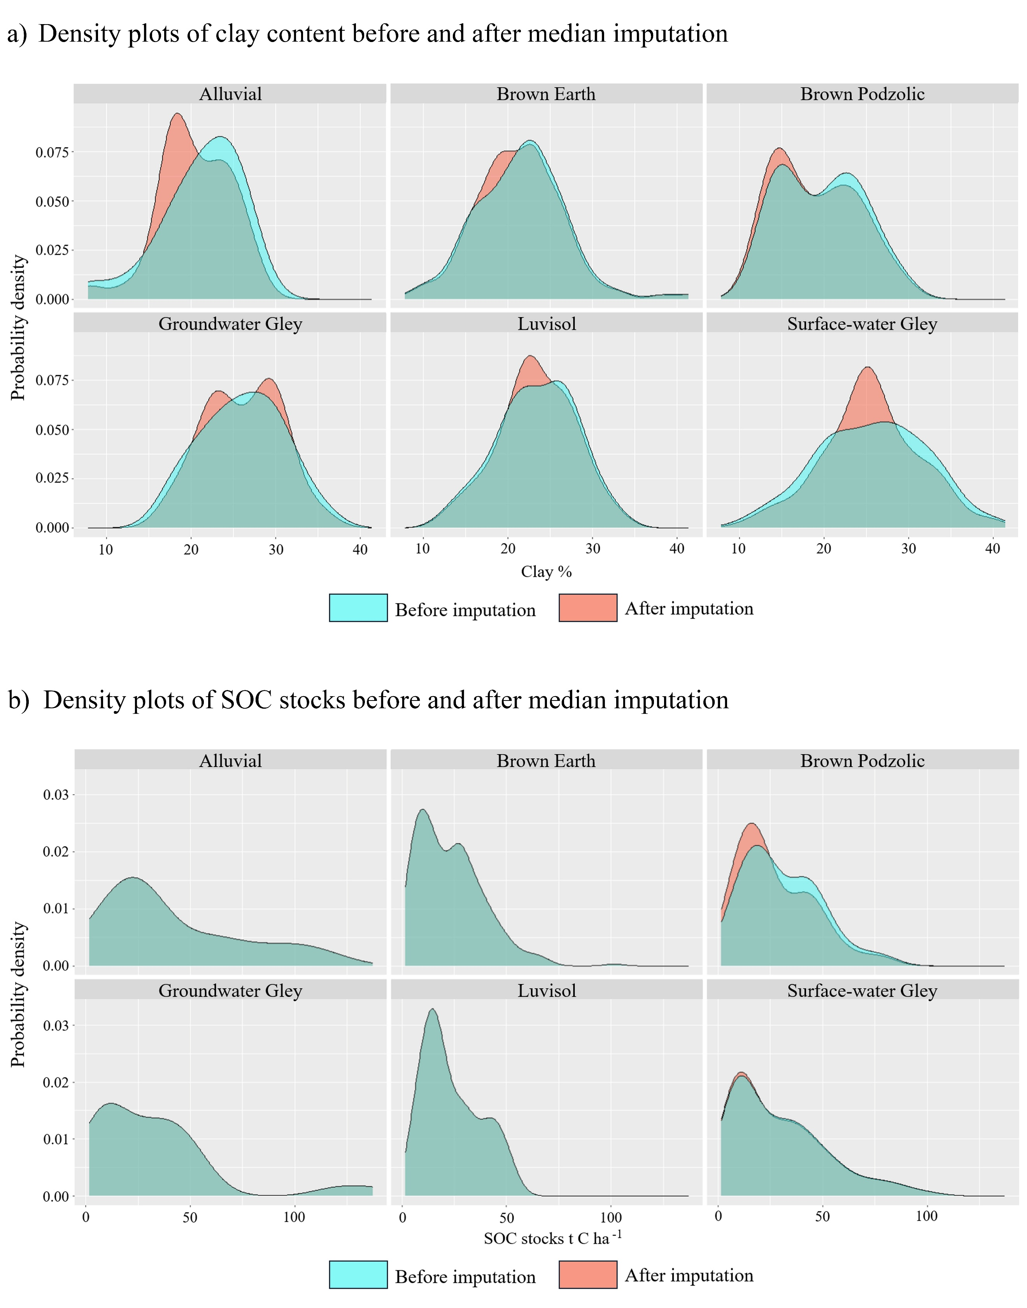
Figure S1. Comparison of density plots of clay content and SOC stocks before and after median imputation. These plots are continuous frequency curves (or smoothed histograms), that describe the population probability distribution of a) clay content, and b) SOC stocks within the dataset before and after the median imputation process.

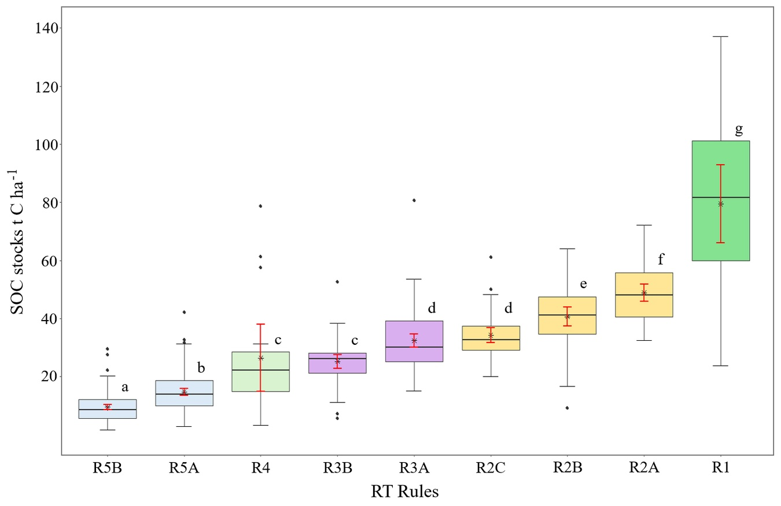

Figure S2. Regression Tree decision rules of SOC stocks (t C ha⁻¹). Boxes show the interquartile range (Q1–Q3) with the median as a central line. Whiskers extend to 1.5× IQR. Black points indicate outliers. Red lines represent 95% confidence intervals for the mean, and the asterisk (*) indicates the mean value. Pairwise comparisons were performed using the Wilcoxon rank sum test with Benjamini-Hochberg correction. Different letters above boxes indicate significant differences at $p<0.05$.

