Supplementary Material
Biexciton Initialization by Two-Photon Excitation in Site-Controlled Quantum Dots: the Complexity of the Antibinding State Case
Gediminas Juska, Iman Ranjbar Jahromi, Francesco Mattana, Simone Varo, Valeria Dimastrodonato, Emanuele Pelucchi
Tyndall National Institute, University College Cork, Lee Maltings, Dyke Parade, Cork, T12R5CP, Ireland
Corresponding author: gediminas.juska@tyndall.ie

Sample structure
The quantum dots (QDs) are grown by metalorganic vapour phase epitaxy (MOVPE) on (111)B oriented GaAs substrates pre-patterned with 7.5 μm pitch tetrahedral recesses (Fig. 1S). The exposed walls of the recesses are (111)A. Several epitaxial layers of Al_{x}Ga_{1-x}As, GaAs and In_{x}Ga_{1-x}As(N) performing different function are grown at 730◦C (thermocouple reading). For example, Al_{0.8}Ga_{0.2}As acts as a wet-etching stop layer which enables selective substrate removal for the measurements of the pyramids in an apex-up geometry – a configuration which enhances light extraction by 2 or 3 orders of magnitude, and which was used in this work. The QD layer is confined by outer Al_{0.45}Ga_{0.55}As and inner GaAs confinement barriers. The QD layer is In_{0.25}Ga_{0.75}As(N) – during the growth the layer is exposed unsymmetrical dimethylhydrazine, which in this case appears to act as a surfactant improving QD symmetry. All the given concentration and thickness values are nominal, as the growth dynamics on non-planar surfaces is very complex. During the complex growth process, a single QD is formed at the centre of every pyramid. The active layer material also forms other nanostructures (3 lateral quantum wires and 3 lateral quantum wells) interconnected with a QD.

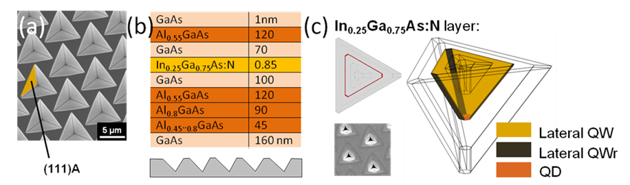
Figure 1S. (a) Patterned (111)B oriented GaAs substrate. (b) A stack of epitaxial layers grown on the non-planar patterned substrate. (c) An ensemble of nanostructures which forms inside the pyramidal recess.
Other representative QD cases of TPE
Fig. 2S(a) shows three other representative QDs excited by two-photon excitation (TPE). In all measured QDs we have observed the same phenomena taking place, i.e. phonon-assisted excitation competing with the biexciton-exciton recombination cascade, as can be seen from the always brighter exciton (X) transition. Fig. 2S(b) presents linear polarization analysis of the exciton and biexciton (XX) emission. In a very good agreement with our findings presented in the main text, we see fully linearly polarized emission of the exciton part originating from the phonon-assisted excitation. Noteworthy, the biexciton intensity, in comparison to the slightly polarized case presented in the manuscript, is fully isotropic suggesting that no intrinsic phenomena, such as heavy-light hole mixing, are taking place,.
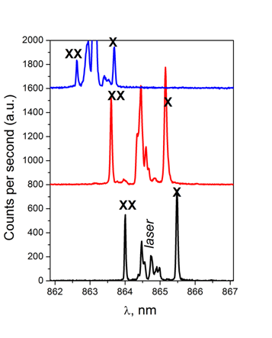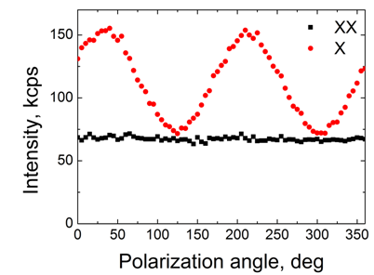
Figure 2S. (a) Spectra of 3 different QDs under TPE excitation. (b) Linear polarization analysis of X and XX transitions emitted from a different QD showing well reproducible behaviour presented in the main text.
(b)
(a)
Off-resonance excitation
Fig. 3S shows power dependence of the biexciton (XX) and phonon-assisted (X-XX) exciton when the laser is tuned precisely to the two-photon resonance and off-resonance, i.e. positively and negatively detuned by +0.175 meV and -0.185 meV, respectively. As can be seen, the coherent nature of the state initialization characterized by Rabi oscillations is compromised, and the biexciton initialization, in analogy to the exciton case, is expected to be induced by phonons,. X-XX intensity changes can be attributed to different phonon density distribution. Fig 3S(b) shows X-XX under the resonant TPE condition plotted as a function of power (the logarithmic scale helps to visualize the initial part of the power dependence).
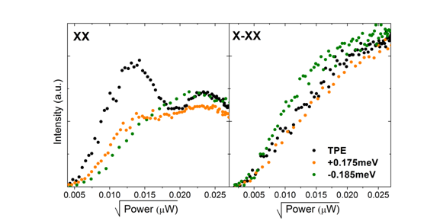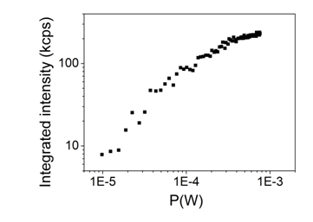
Figure 3S. (a) Power dependence of the biexciton and phonon-assisted exciton emission under different laser energy tuning conditions. (b) Phonon-assisted exciton under resonant TPE as a function of power.
(b)
(a)
Fig. 4S shows the exciton intensity dependence on the laser energy detuning. We stress that the exciton here fully originates from the biexciton recombination cascade. This was possible because, as we show in Fig. 2S(b), the phonon-assisted exciton is fully linearly polarized, and thus can be fully blocked with a cross-polarized polarizer. As the biexciton (and the subsequently recombining exciton) intensity is isotropic, such configuration will fully block phonon-induced excitons, however will transmit half of the light originating from the cascade. This study can give a good insight on the phonon-assisted TPE process.
The motivation for this study is the following. The competition of the two QD population phenomena is not favourable for practical applications as true deterministic generation of non-classical light becomes compromised. A possible solution to this problem has been proposed by Barth et al. (ref. 5). Large area pulses (>20π) positively detuned to the respect of both, the exciton and biexciton, are expected to excite the biexciton state with a near unity probability. Our experiment with ~π pulses detuned positively from the biexciton (Fig. 5S) shows that we can excite the exciton (and biexciton) state even with big (~2.5 meV) detuning values which in principle would allow to test the mentioned idea above. However, due to the experimental limitations (specifically, the power loss in the 4f pulse shaping set-up and laser light filtering issues) we could not achieve the required power levels. The results serve as a good indicator that such experiment is feasible and can be implemented with different experimental approaches.
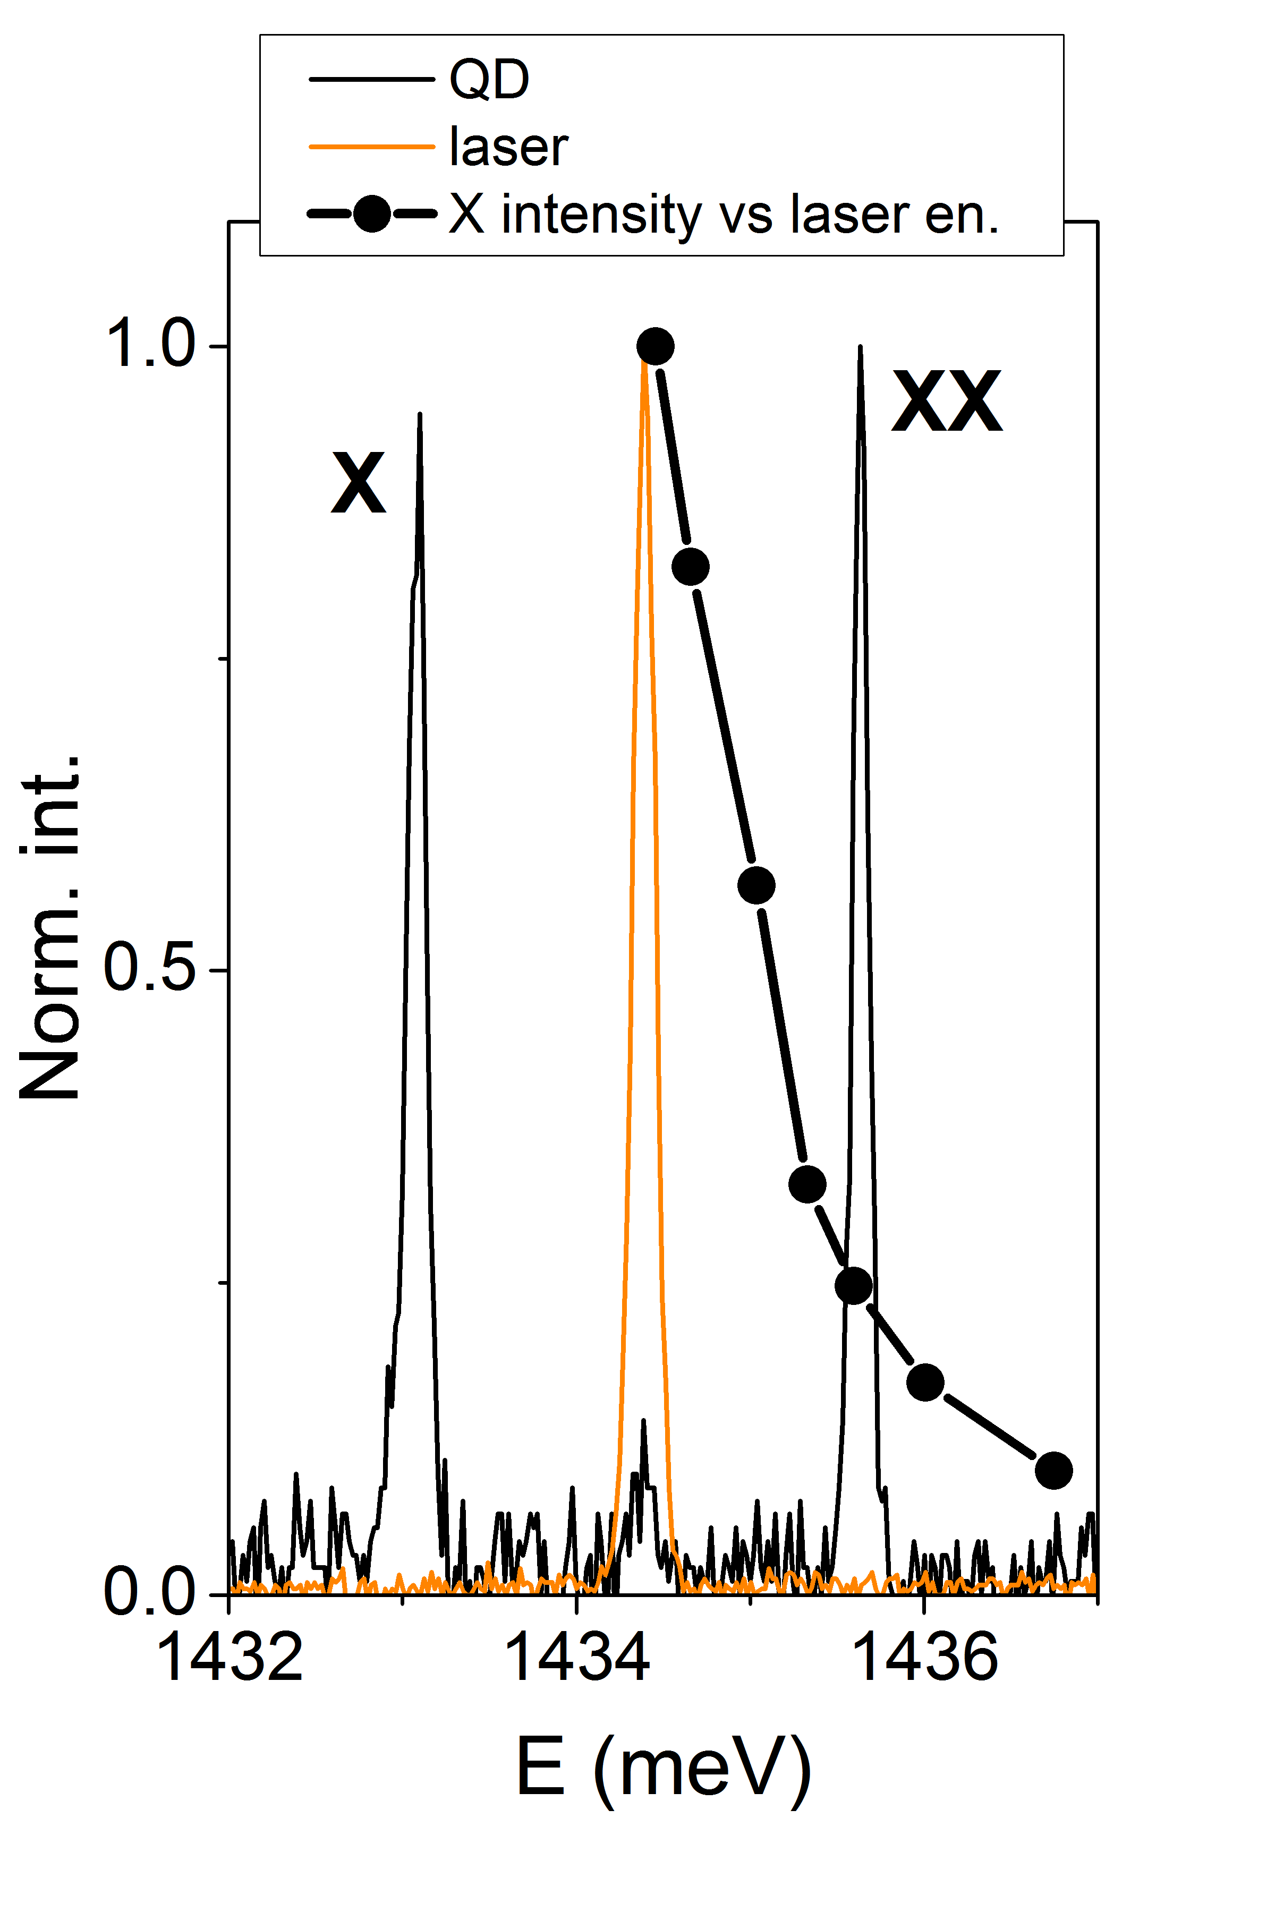
Figure 4S. The exciton intensity dependence as a function of a laser pulse energy detuning. The spectrum is linearly polarized in a way to transmit photons originating from the biexciton recombination cascade only.
Biexciton excitation channel suppression
We checked also another issue – the suppression of the biexciton recombination cascade which should be achieved utilising circularly polarized excitation light (Fig. 5S(a)). Because of the Pauli exclusion principle, TPE processes of the biexciton by circularly co-polarized photons are fundamentally forbidden. We indeed observe a strong suppression of the biexciton state. The experimentally observed weak signal from the biexciton in Fig. 5S(a) can be attributed to a non-perfect preparation of the laser polarization state. Otherwise, in an ideal case, the laser light couples only to the exciton state. As the electron-phonon interaction is spin independent, the polarization state of the laser is initially mapped on the Bloch sphere of the exciton, which, in the presence of a fine-structure splitting, starts to precess. The inset of Fig. 5S(a) shows linear polarization behaviour for the exciton photons. The non-uniform distribution of linear polarization components indicates that the polarization state of the ensemble of photons is not purely circularly polarized due to the FSS of a few μeV in that specific dot. Fig. 5S(b) shows non-polarized spectra obtained under circularly and linearly polarized excitation.
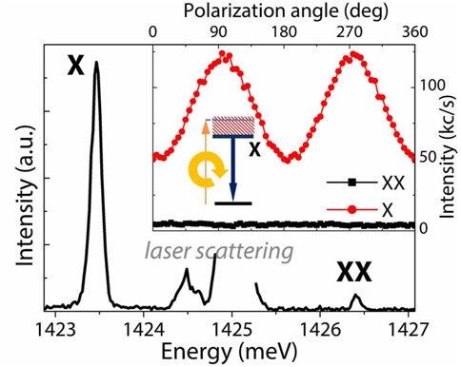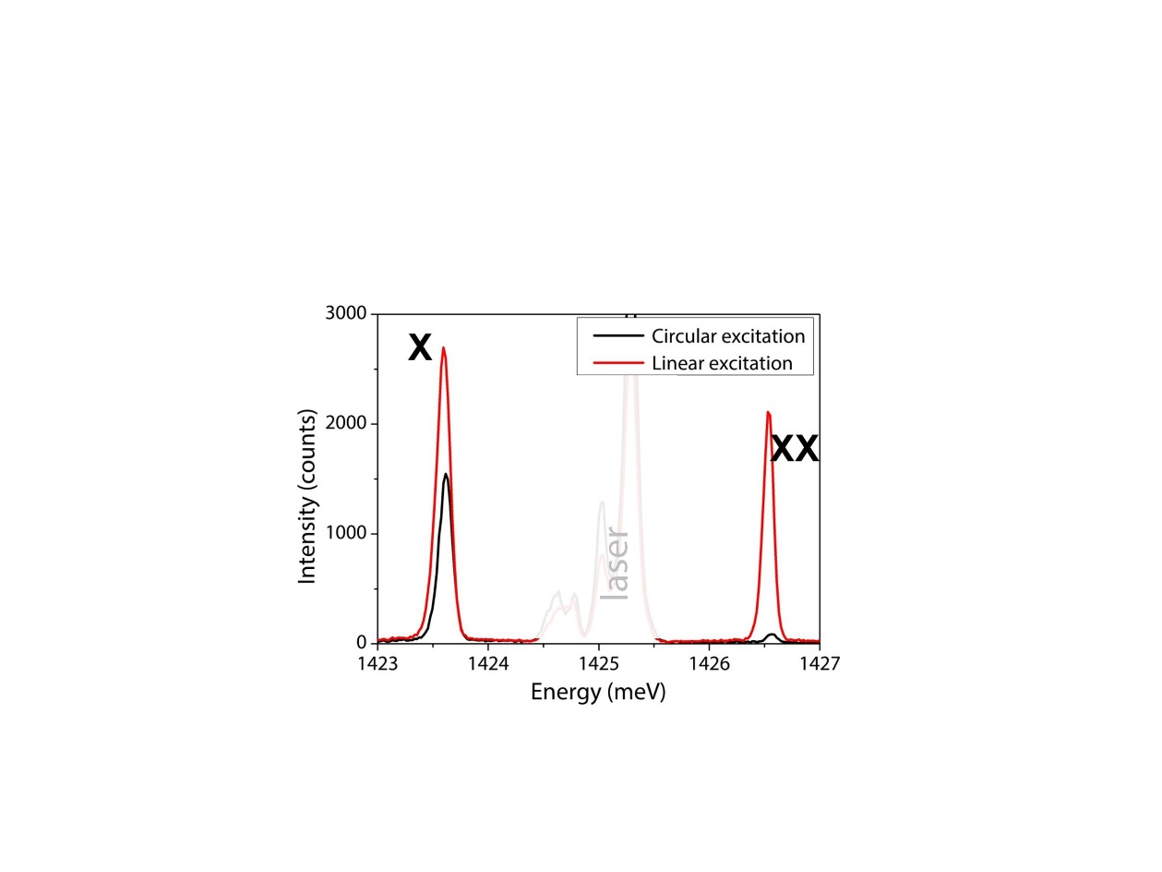
Figure 5S. (a) QD photoluminescence under circularly polarized TPE showing strong suppression of the biexciton recombination cascade. Here a different QD was used than the one discussed in the main text. (b) Comparison of non-polarized spectra obtained under circularly and linearly polarized laser light tuned to the TPE resonance (π pulse area for the biexciton transition).
(a)
(b)
Processing of the second-order correlation curves:
- Polarization-resolved
Fig. 6S(a) shows linear polarization analysis of the exciton and biexciton transition. As we discuss in the main manuscript, exciton photons created by phonon-assisted excitation are strongly polarized as the laser polarization state is directly mapped onto the spin state of the exciton. Being strongly polarized, phonon-assisted events invalidate the conventional normalization procedure to calculate the second-order correlation function value as an intensity of the projected two-photon polarization state. For example, Fig. 6S(b) shows a comparison of correlation curves between horizontally and vertically co-polarized biexciton and exciton photons. While the g⁽²⁾(0) peak is composed of events originating only from the biexciton and exciton recombination cascade, the side (uncorrelated) peaks arise due to contributions from all the events. As shown, horizontally polarized exciton photons originating from phonon-assisted excitation paths increase the side peak intensity nearly twice. Conventionally, when the source is not polarized, the two-photon polarization state intensity is obtained by normalizing the g⁽²⁾(0) peak using an average value of the side peak integrated intensity. However, this method is only valid when the source is not-polarized. To overcome this issue, every individual curve has been integrated for the same duration, i.e. 10 minutes, and raw detection counts of the g⁽²⁾(0) peak were used as the two-photon polarization state intensity. The comparison of the two-photon polarization state intensity obtained by the two methods is shown in the Table S1.
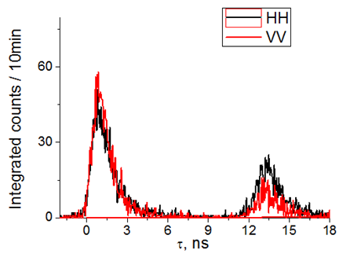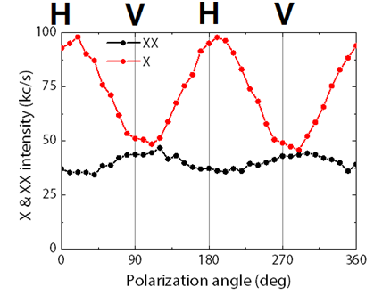
Figure 6S. Polarization-resolved g⁽²⁾(τ) (a) Linear polarization analysis of exciton and biexciton transitions. (b) Comparison of correlation curves between horizontally and vertically co-polarized biexciton and exciton photons.
(a)
(b)
Table S1. Two-photon polarization state intensity: g⁽²⁾(0) vs. raw counts
 | g⁽²⁾(0) | Σn_{i} |  |  | g⁽²⁾(0) | Σn_{i} |  |  | g⁽²⁾(0) | Σn_{i}
HH | 1.77 | 1710 |  | DD | 2.47 | 1750 |  | RR | 0.94 | 622
HV | 0.92 | 573 |  | DA | 0.95 | 696 |  | RL | 1.82 | 1761
VV | 3.65 | 1811 |  | AA | 1.89 | 1739 |  | LL | 0.81 | 740
VH | 0.53 | 453 |  | AD | 1.04 | 787 |  | LR | 2.22 | 1698
Sum: | 6.87 | 4547 |  |  | 6.35 | 4972 |  |  | 5.79 | 4821

- Lifetime extraction
The intrinsic lifetimes of the biexciton and exciton were extracted from the second order correlation measurements, by correlating two APD signals (the conventional Hanbury Brown-Twiss arrangement) and deconvoluting the corresponding state population function.

The extracted biexciton lifetime was found to be 0.44 ns in the representative case studied in the main manuscript. As the state is created coherently by the laser, we deconvoluted the measured instrument response function (IRF) – using the autocorrelation signal of the 10 ps pulse laser – from the correlation curve of the laser and the biexciton photons(Fig. 7S(a)).

The intrinsic exciton lifetime, on the other hand, cannot be extracted using similar correlations. While typically a lifetime trace is defined as a histogram of correlated events between a fast electric laser synchronisation signal (or an optical laser signal like in our case) and the transition of interest, such measurement not necessarily can directly provide the intrinsic lifetime of the state. In our case, the measured trace is the result of a convolution between the biexciton decay function and the exciton decay. After deconvoluting the biexciton state, we extracted an exciton lifetime of 0.77 ns (Fig. 7S(b)). However, in this particular case, extra care has to be taken because, due to the presence of phonon-assisted events, the exciton population function is either from the laser or from the biexciton decay.

To rule out the contribution of phonon-assisted events, the exciton lifetime can be reliably extracted from the g⁽²⁾(0) peak of the correlation curve obtained between the biexciton and exciton cascade. The g⁽²⁾(0) peak is composed of correlation events originating only from the biexciton-exciton recombination cascade events, and it is only convoluted with the IRF (Fig. 7S(c)). After the deconvolution procedure, we obtained the exciton lifetime of 0.78 ns, close enough to our previous result.

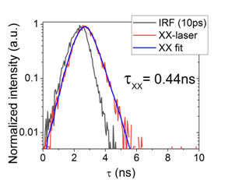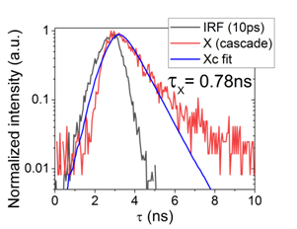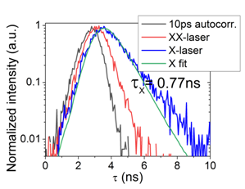
Figure 7S. Lifetime extraction. (a) The biexciton-laser correlation. (b) Correlations with the laser signal. (c) Exciton lifetime from the biexciton-exciton recombination cascade, i.e. the g⁽²⁾(0) peak.
(a)
(b)
(c)
References

V. Dimastrodonato, E. Pelucchi, D.D. Vvedensky, “Self-Limiting Evolution of Seeded Quantum Wires and Dots on Patterned Substrates”, Phys. Rev. Lett. 108, 256102 (2012).
T. Belhadj, T. Amand, A. Kunold, C.-M. Simon, T. Kuroda, M. Abbarchi, T. Mano, K. Sakoda, S. Kunz, X. Marie, and B. Urbaszek, "Impact of heavy hole-light hole coupling on optical selection rules in GaAs quantum dots." Applied Physics Letters 97, 051111 (2010).
Oliver Marquardt, Eoin P. O'Reilly, Stefan Schulz " Electronic properties of site-controlled (111)-oriented zinc-blende InGaAs/GaAs quantum dots calculated using a symmetry-adapted k⋅p Hamiltonian ", J. Condens. Matter Phys. 26, 3, 035303 (2013).
Marcus Reindl, Klaus D. Jöns, Daniel Huber, Christian Schimpf, Yongheng Huo, Val Zwiller, Armando Rastelli, and Rinaldo Trotta, “Phonon-Assisted Two-Photon Interference from Remote Quantum Emitters”, Nano Lett. 2017, 17, 7, 4090 (2017).
M. Barth, S. Lüker, A. Vagov, D. E. Reiter, T. Kuhn, and V. M. Axt, "Fast and selective phonon-assisted state preparation of a quantum dot by adiabatic undressing", Phys. Rev. B 94, 045306 (2016).

