Supporting Information

Orientation-engineered PtTe₂ Schottky FETs: Quantum transport insights for dopant-free advanced technology nodes

Lida Ansari¹, Paul K. Hurley^{1,2}, and Farzan Gity^{1,*}
¹ Tyndall National Institute, University College Cork, Lee Maltings, Dyke Parade, Cork, T12 R5CP, Ireland
² School of Chemistry, University College Cork, Cork, Ireland
* Corresponding author: Farzan.Gity@Tyndall.ie

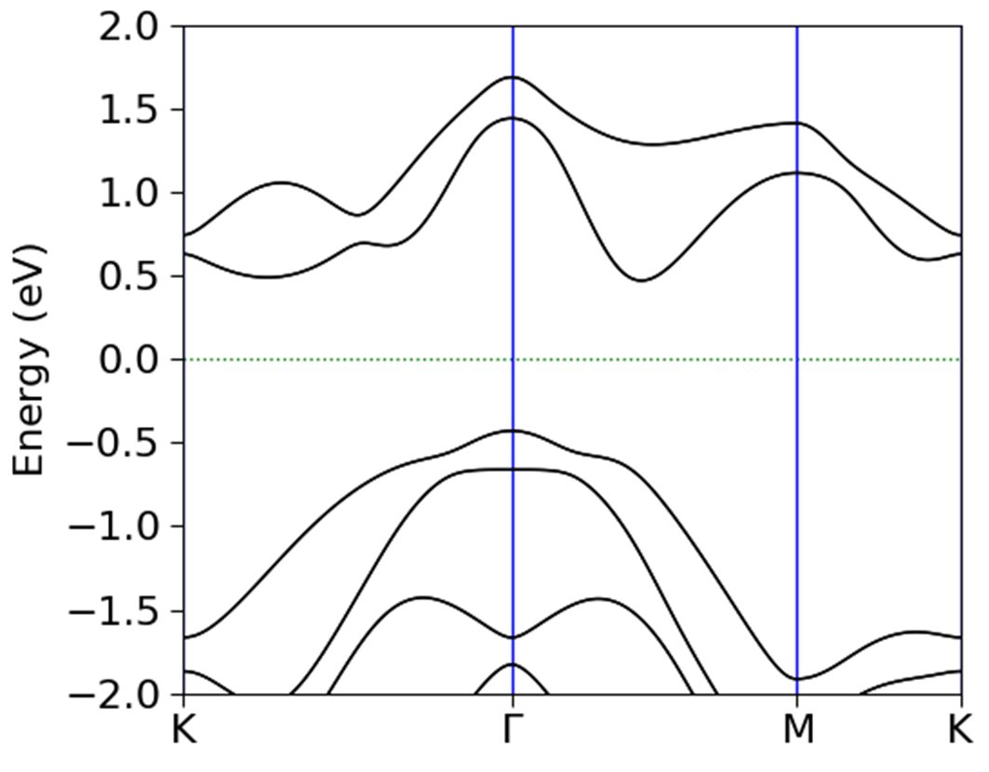 | 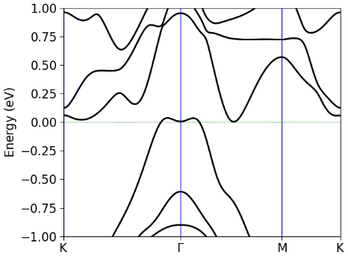 | 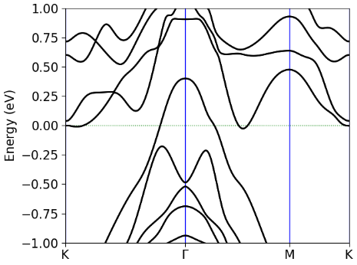
(a) | (b) | (c)
Figure S1. Electronic structure of few-layer PtTe₂. Electronic band structures of (a) monolayer, (b) bilayer, and (c) trilayer PtTe₂ calculated using fully relativistic DFT including spin-orbit coupling. Energies are referenced to the Fermi level. The transition from semiconducting (monolayer) to semimetallic (bilayer/trilayer) behavior confirms the thickness-dependent phase transition discussed in the main text.

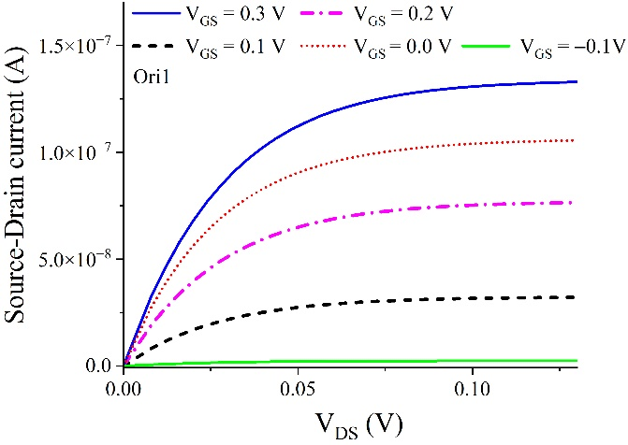 | 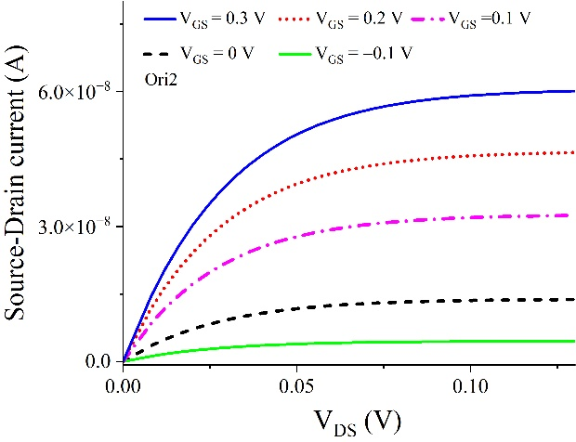
(a) | (b)
Figure S2. Simulated output characteristics (I_{DS}–V_{DS} curves) for monomaterial PtTe₂ Schottky FETs under different gate voltages. Results are shown for (a) Γ-M (Ori 1) and (b) Γ-K (Ori 2) orientations at gate lengths of 2 nm. Calculations employ the Landauer–Büttiker linear-response formalism using the converged NEGF results. The curves exhibit quasi-linear behavior at small biases and saturation at higher V_{DS}, consistent with ballistic transport trends shown in the transfer characteristics (Figure 2 of the main manuscript).

