SUPPLEMENTARY FIGURE 1:
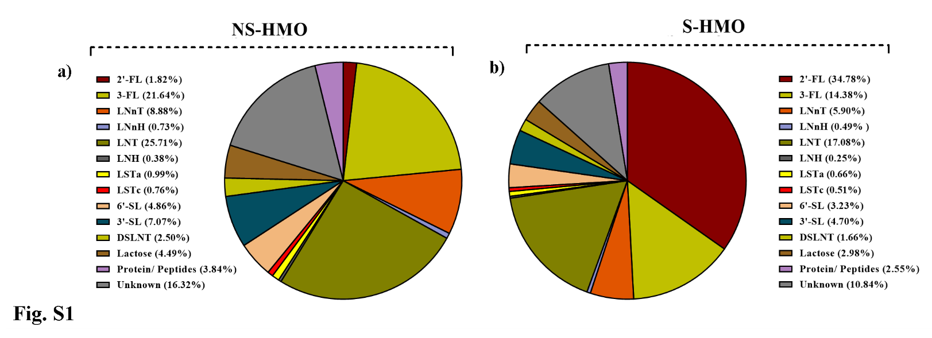
The pie charts show the relative abundance of the major oligosaccharides found in a) NS-HMO and
b) S-HMO which were detected via HPAEC-PAD analysis by comparing to the following external HMO standards: lactose, 3-fucosyllactose (3-FL), 2’-fucosyllactose (2'-FL), lacto-N-neotetraose (LNnT), lacto-N-neohexaose (LNnH), lacto-N-tetraose (LNT), lacto-N-hexaose (LNH), sialyllacto-N-tetraose a (LSTa), sialyllacto-N-tetraose a (LSTc), 6’-siallylactose (6'-SL), 3’-siallylactose (3'-SL), disialyllacto-N-tetraose (DSLNT). Data represents average concentrations of technical duplicate data from biological triplicate experiments.

SUPPLEMENTARY FIGURE 2:
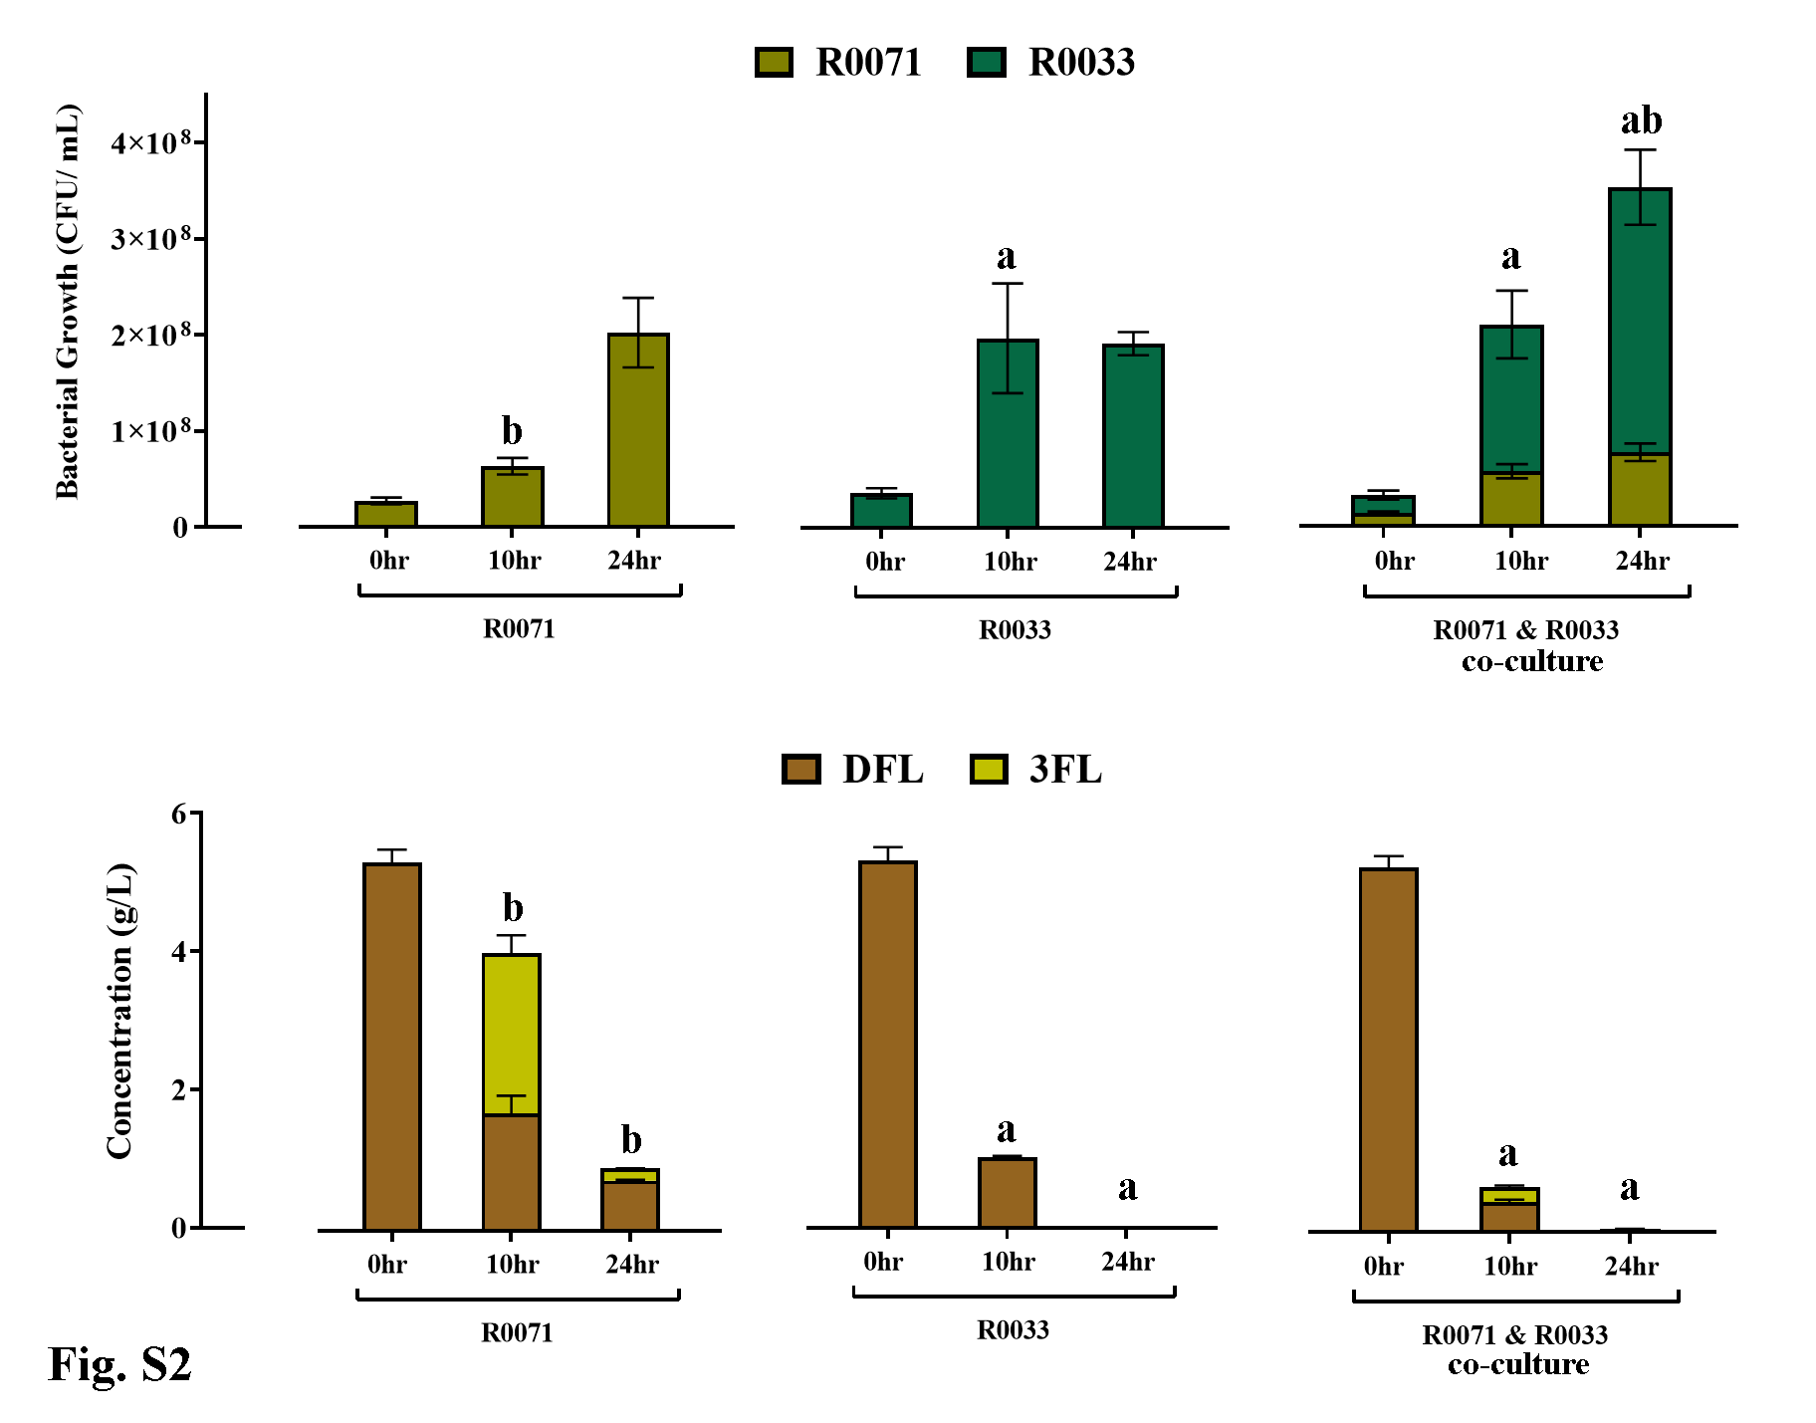
Growth profiles in CFU/mL (top) and glycoprofiles in g/L HMO (bottom) of Bifidobacterium bifidum R0071 and Bifidobacterium infantis R0033 as mono-cultures and as a two strain co-culture with 5g/L difucosyllactose (DFL) as the sole carbon source. Bacterial cell numbers were assessed using colony counts at 0 hr, 10 hr, and 24 hr. Definitive differences in colony characteristics between R0071 & R0033 allowed for strain-level quantification during co-cultivation of strains. The concentrations of oligosaccharides in the culture supernatants was determined by HPAEC-PAD. The sugars were identified from their elution times relative to those of external standards. Analysis was calculated using technical triplicate data from biological triplicate experiments and data are means +/- SD. Univariate analysis of variance (ANOVA) and post-hoc Tukey tests were performed to determine the significant differences between the groups (a = p <0.05 versus R0071 mono-culture, b = p <0.05 versus R0033 mono-culture)

SUPPLEMENTARY FIGURE 3:
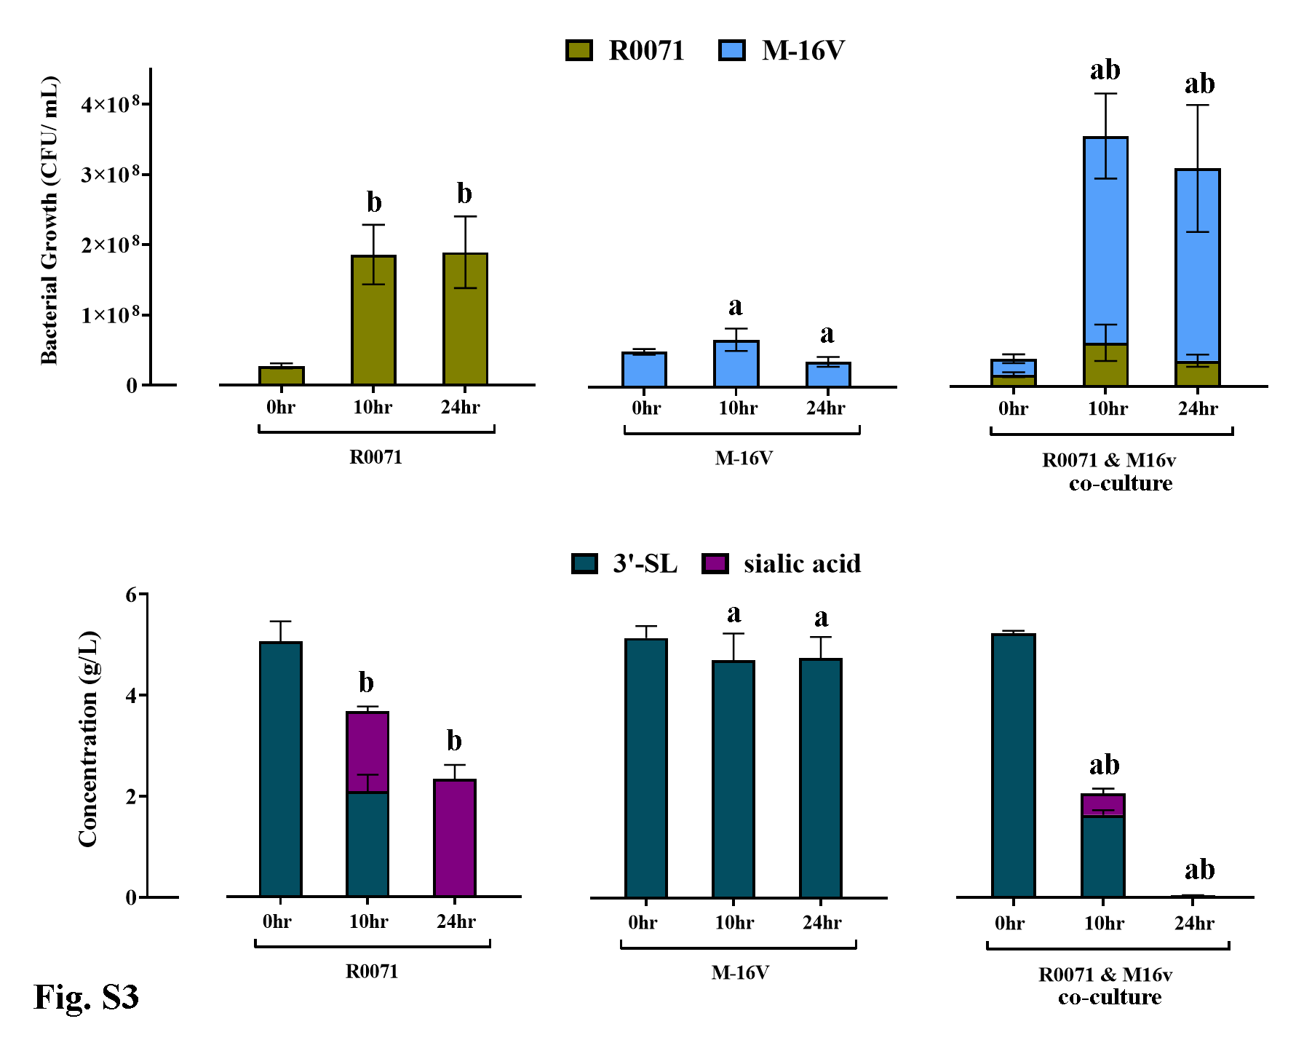
Growth profiles in CFU/mL (top) and glycoprofiles in g/L HMO (bottom) of Bifidobacterium bifidum R0071 and Bifidobacterium breve M-16V as mono-cultures and as a two strain co-culture with 5g/L 3’-siallylactose (3’-SL) as the sole carbon source. Bacterial cell numbers were assessed using colony counts at 0 hr, 10 hr, and 24 hr. Definitive differences in colony characteristics between R0071 & M-16V allowed for strain-level quantification during co-cultivation of strains. The concentrations of oligosaccharides in the culture supernatants was determined by HPAEC-PAD. The sugars were identified from their elution times relative to those of external standards. Analysis was calculated using technical triplicate data from biological triplicate experiments and data are means +/- SD. Univariate analysis of variance (ANOVA) and post-hoc Tukey tests were performed to determine the significant differences between the groups (a = p <0.05 versus R0071 mono-culture, b = p <0.05 versus M-16V mono-culture)

SUPPLEMENTARY FIGURE 4:
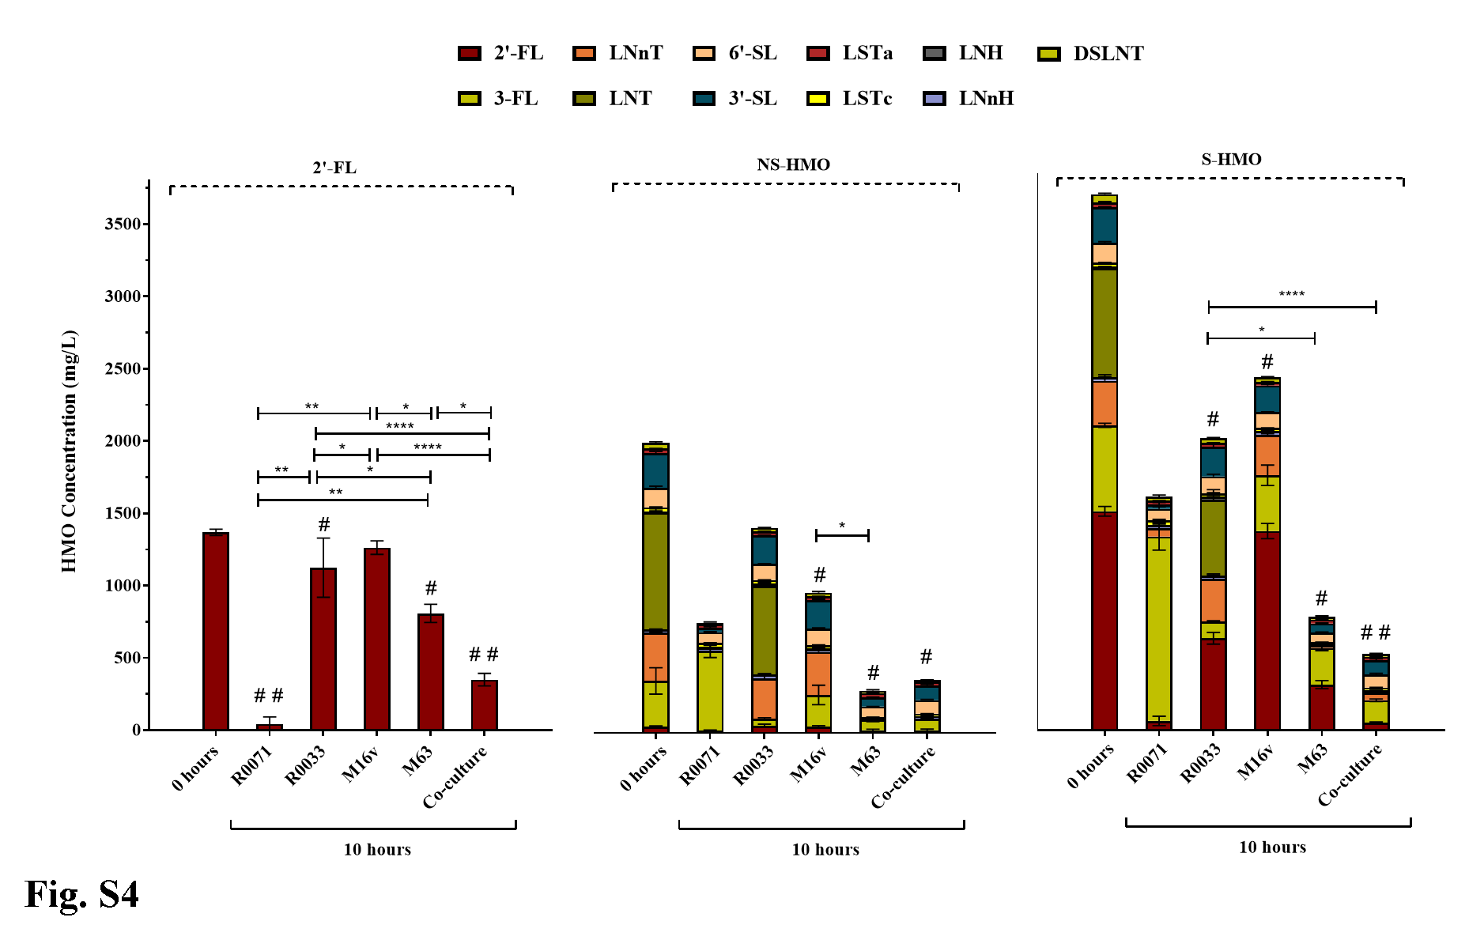
Concentration of HMO (2’-FL, NS-HMO and S-HMO) before and after 10 hours of bifidobacterial fermentation detected via HPAEC-PAD analysis by comparing to the following external HMO standards: 3-fucosyllactose (3-FL), 2’-fucosyllactose (2'-FL), lacto-N-neotetraose (LNnT), lacto-N-neohexaose (LNnH), lacto-N-tetraose (LNT), lacto-N-hexaose (LNH), sialyllacto-N-tetraose a (LSTa), sialyllacto-N-tetraose a (LSTc), 6’-siallylactose (6'-SL), 3’-siallylactose (3'-SL), disialyllacto-N-tetraose (DSLNT). R0071= Bifidobacterium bifidum R0071, R0033= Bifidobacterium infantis R0033, M-16V= Bifidobacterium breve M-16V, M-63= Bifidobacterium infantis M-63. Analysis was calculated using technical duplicate data from biological triplicate experiments and data are means +/-SD. Univariate analysis of variance (ANOVA) and post-hoc Tukey tests were performed to determine the significant differences between the groups (# = p <0.05, ## = p <0.001 versus Time 0) (* = p <0.05, ** = p <0.01, *** = p <0.001, **** = p <0.0001 between strain combinations).

SUPPLEMENTARY FIGURE 5:
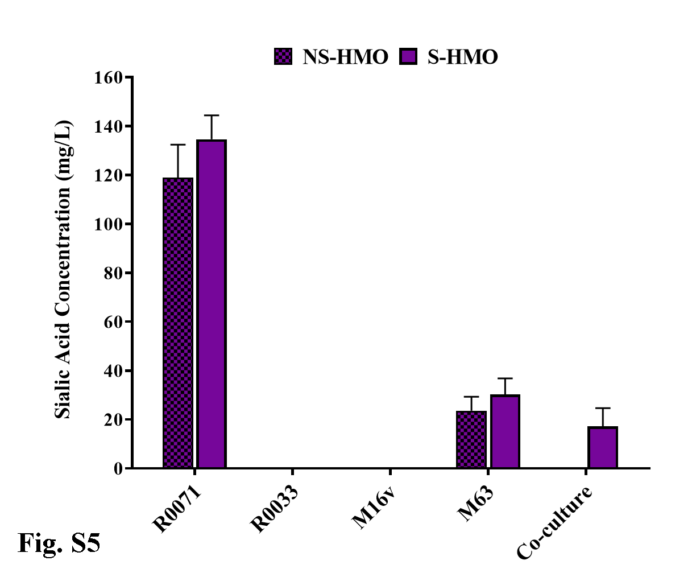
Quantification of free sialic acid following 10 hours of bifidobacterial fermentation on NS-HMO and S-HMO detected via HPAEC-PAD analysis by comparing to an external sialic acid standard. R0071= Bifidobacterium bifidum R0071, R0033= Bifidobacterium infantis R0033, M-16V= Bifidobacterium breve M-16V, M-63= Bifidobacterium infantis M-63. Analysis was calculated using technical duplicate data from biological triplicate experiments and data are means +/-SD.

SUPPLEMENTARY FIGURE 6:
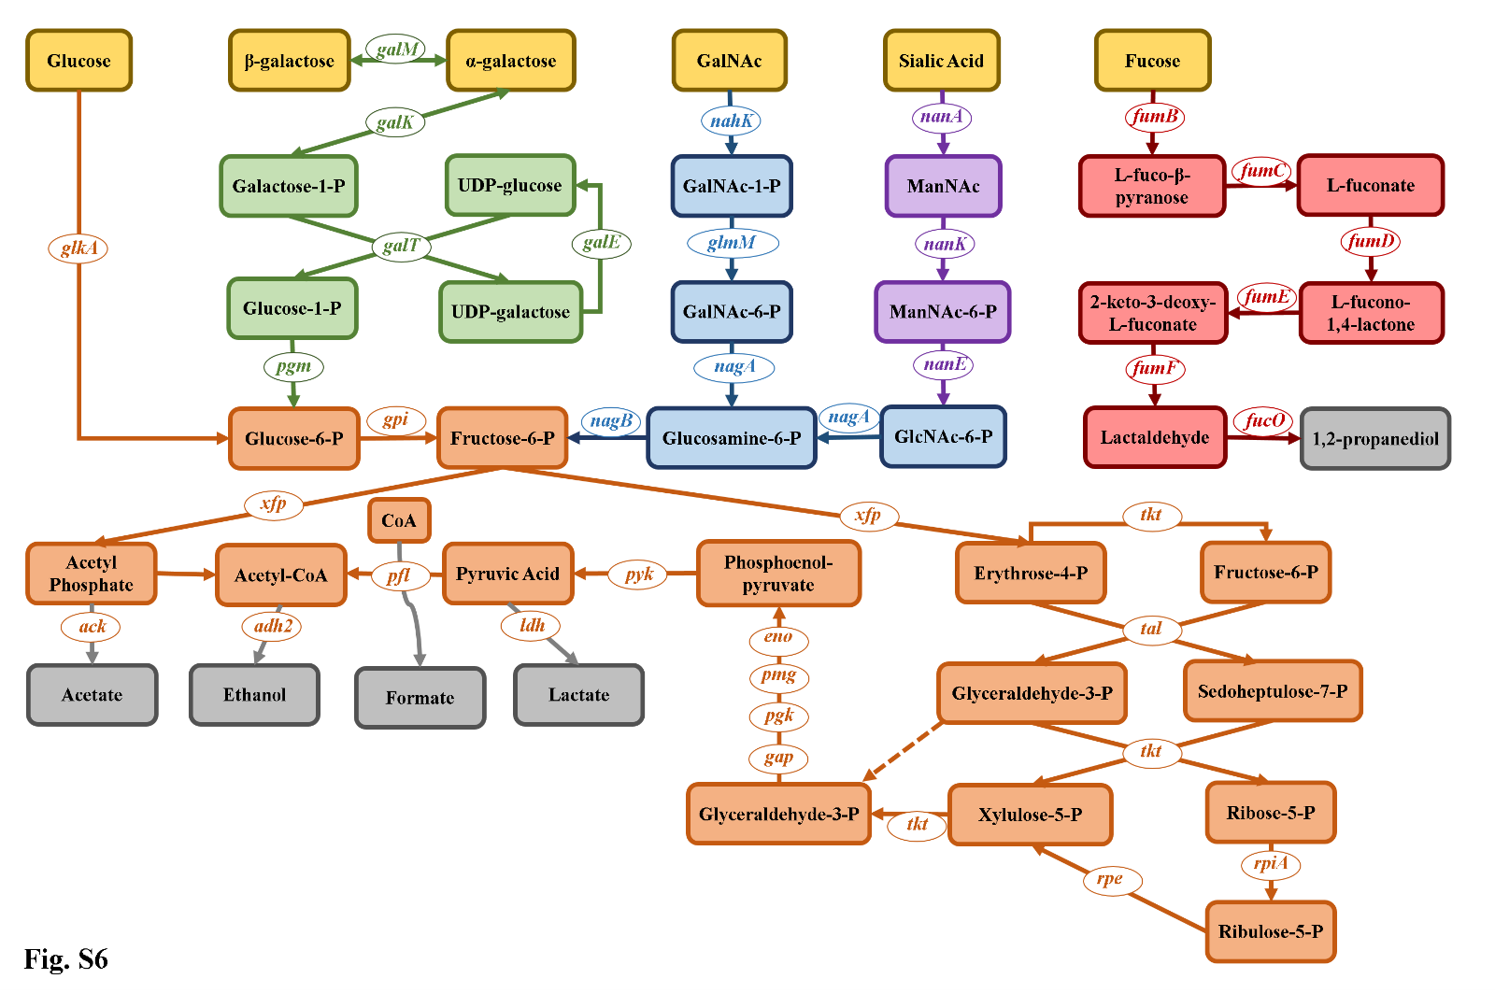
A schematic representation of carbohydrate degradation through the “bifid shunt” and related pathways in bifidobacteria. Gene names: Leloir genes (green): galM galactose mutarotase; galK galactokinase; galT galactose-1-phosphate uridylyltransferase; pgm phosphoglucomutase. Central fermentative pathway genes (orange): glkA glucokinase; gpi glucose-6-phosphate isomerase; xfp fructose-6-phosphate phosphoketolase/ xylulose-5-phosphate phosphoketolase; tkt transketolase; tal transaldolase; rpiA ribose 5-phosphate isomerase; rpe ribulose 5-phosphate epimerase; gap glyceraldehyde-3-phosphate dehydrogenase; pgk phosphoglycerate kinase; pmg phosphoglycerate mutase; eno enolase; pyk pyruvate kinase; ack acetate kinase; adh2 aldehyde-alcohol dehydrogenase; pfl formate acetyltransferase; ldh lactate dehydrogenase. N-acetylglucosamine genes (blue): nahK N-acetylhexosamine 1-kinase; GlmM phosphoglucosamine mutase; nagA N-acetylglucosamine-6-phosphate deacetylase; nagB glucosamine-6-phosphate isomerase. Sialic Acid genes (purple): nanA N-acetylneuraminate lyase; nanK N-acetylmannosamine kinase; nanE N-acetylmannosamine-6-phosphate 2-epimerase. Fucose genes (red) (as proposed by Dedon et al. 2020): fumB L-fucose mutarotase; fumC L-fucose dehydrogenase; fumD L-fuconolactone hydrolase; fumE L-fuconate dehydratase; fumF aldolase; fumO lactaldehyde reductase. Monosaccharide HMO derivatives depicted in yellow. End metabolites depicted in grey.

Supplementary Table 1: Organic Acid Concentrations
 |  | Acetate (mM) |  |  |  | Lactate (mM) |  |  |  | Formate (mM) |  |  |  | 1,2-propanediol (mM)
 |  | 2'-FL | NS-HMO | S-HMO |  | 2'-FL | NS-HMO | S-HMO |  | 2'-FL | NS-HMO | S-HMO |  | 2'-FL | NS-HMO | S-HMO
Bbif R0071 |  | 4.6 ± 1.4 | 19.7 ± 5.4 | 24.4 ± 0.8 |  | 3.5 ± 0.6 | 8.5 ±  0.2 | 12.7 ± 0.9 |  | 2.9 ± 0.2 | 6.7 ±  0.2 | 9.0 ± 1.4 |  | <LOD | <LOD | <LOD
BInf R0033 |  | 3.9 ± 1.8 | 3.1 ±  1.0 | 11.6 ± 3.3 |  | 0.2 ± 0.1 | 1.0 ±  0.2 | 5.6 ± 1.0 |  | 2.7 ± 0.2 | 3.2 ±  0.9 | 6.7 ± 0.8 |  | <LOD | <LOD | 2.4 ±  0.3
Bbrev M-16V |  | 2.4 ± 0.8 | 7.2 ±  2.0 | 6.9 ± 2.1 |  | 0.2 ± 0.2 | 1.0 ±  0.3 | 2.3 ± 0.7 |  | 4.0 ± 0.7 | 5.3 ±  1.5 | 4.3 ± 0.5 |  | <LOD | <LOD | <LOD
Binf M-63 |  | 7.8 ± 2.2 | 19.9 ± 1.5 | 23.1 ± 4.5 |  | 1.4 ± 0.2 | 15.5 ±  0.5 | 14.9 ± 12.7 |  | 2.8 ± 0.5 | 3.3 ±  1.2 | 5.4 ± 1.2 |  | <LOD | 2.1 ±  0.3 | 2.1 ±  0.6
4Bif co-culture |  | 11.6 ± 5.5 | 23.6 ± 3.1 | 25.6 ± 2.1 |  | 3.2 ± 0.1 | 13.9 ± 1.1 | 17.3 ± 1.7 |  | 5.3 ± 1.2 | 7.2 ±  1.8 | 8.1 ± 0.5 |  | 1.7 ± 0.0 | 2.4 ±  0.4 | 3.0 ±  0.3
<LOD= below the limit of detection

